Issue - 1:

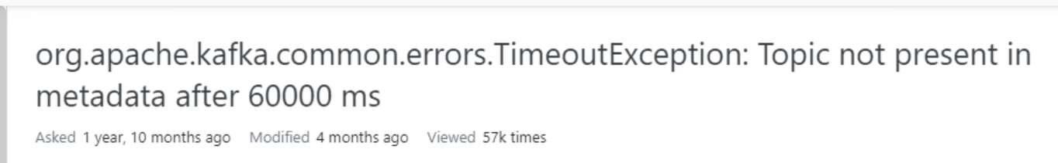

Solution:

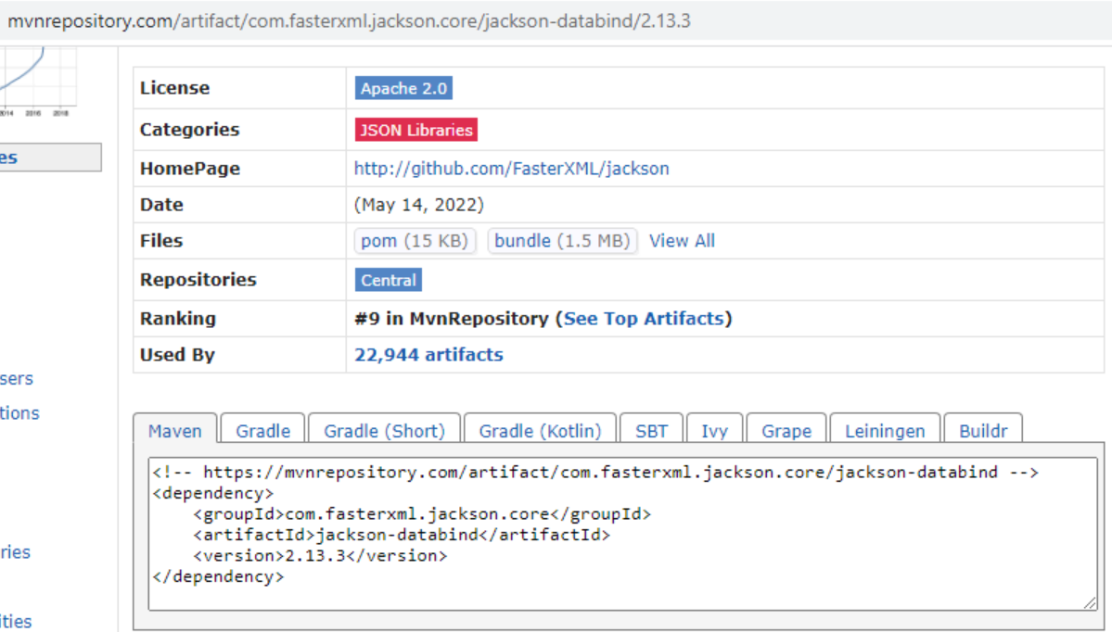

Issue - 2:



Solution:

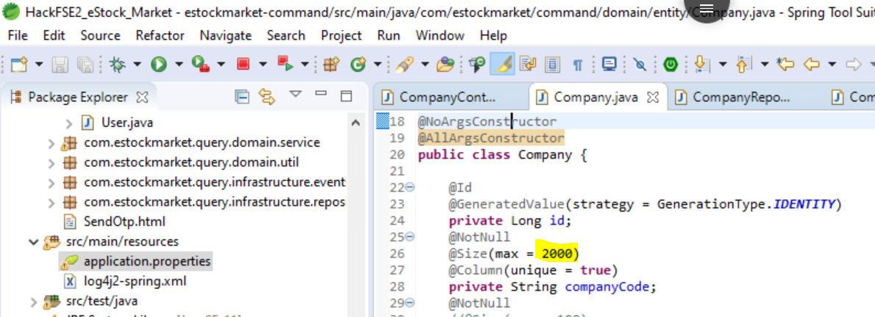

Issue – 3:

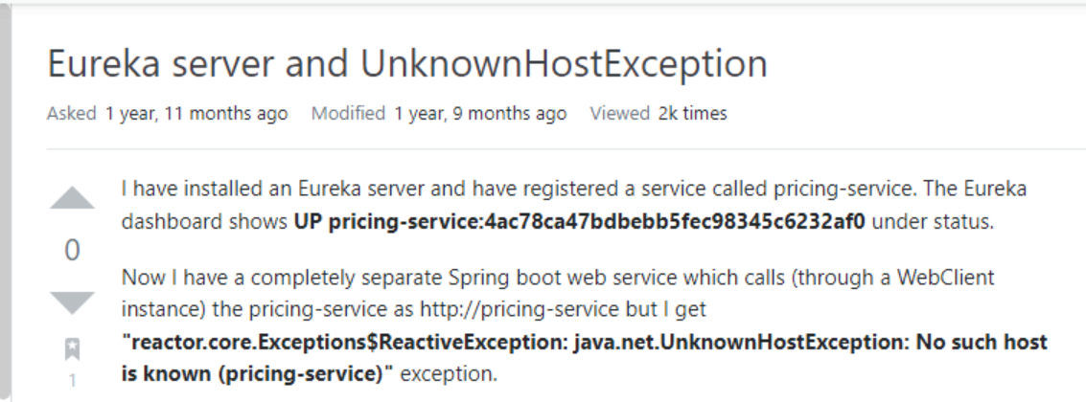

Solution:

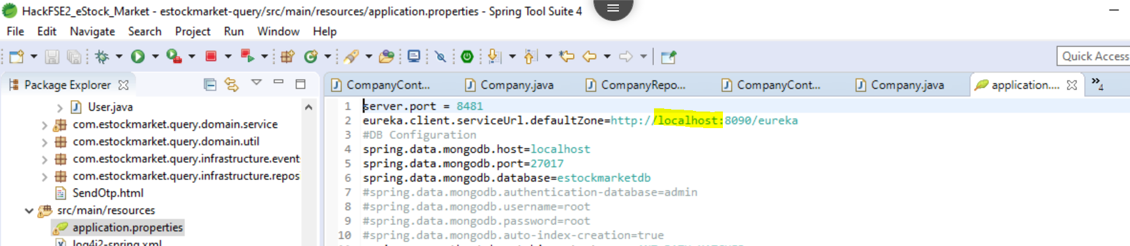

Issue – 4:

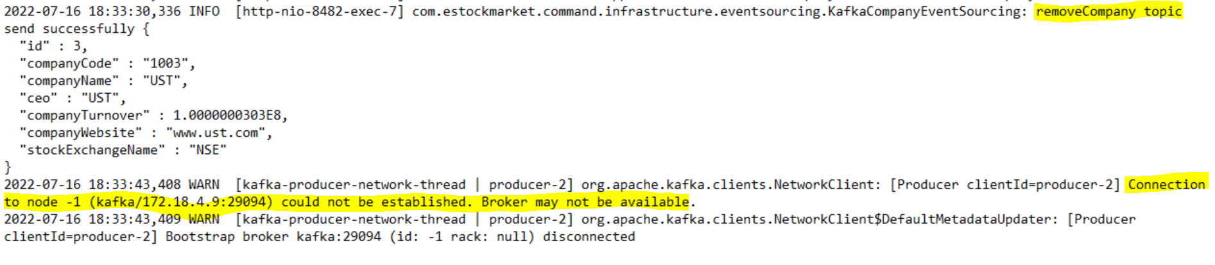

Solution:

Used –bootstrap-server localhost:9092 instead of –zookeeper localhost:2181

Issue – 5:

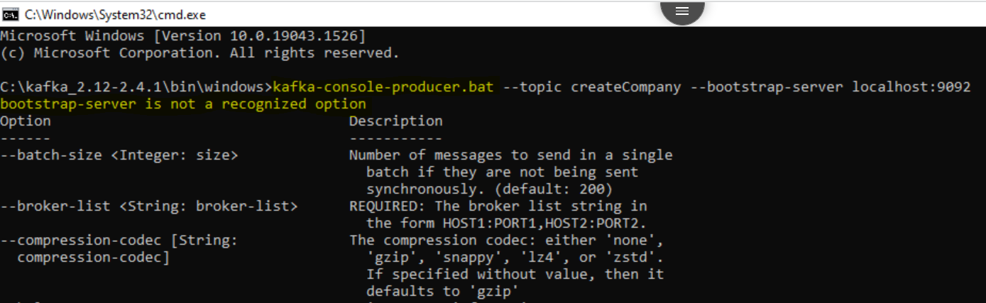

Solution:

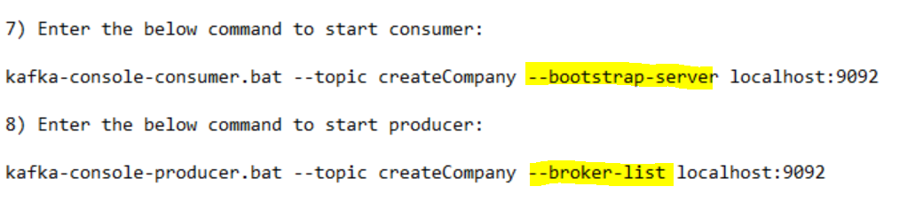

Issue - 6:

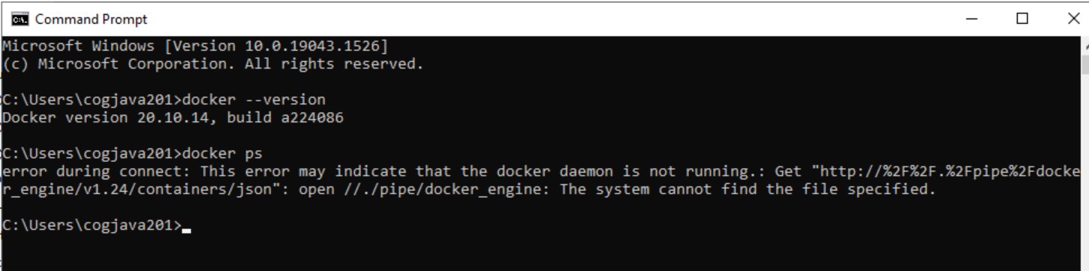

Solution: Access Docker Desktop

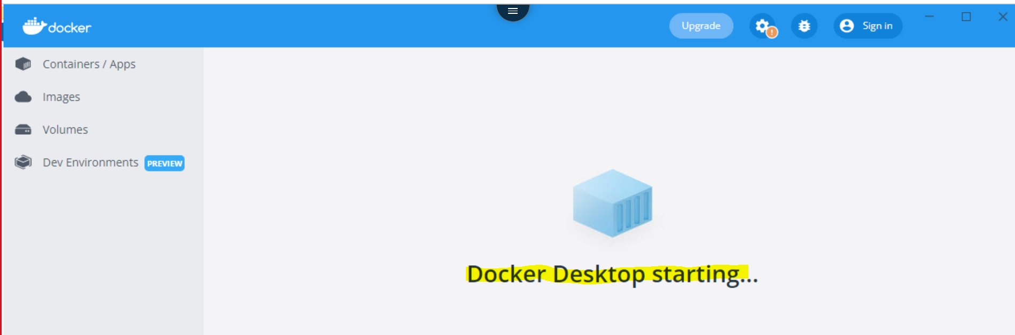

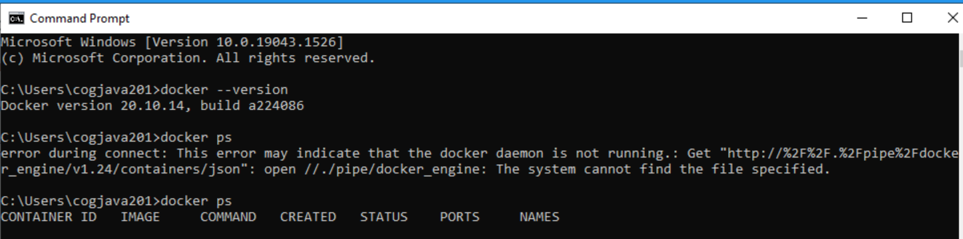

Issue – 7:

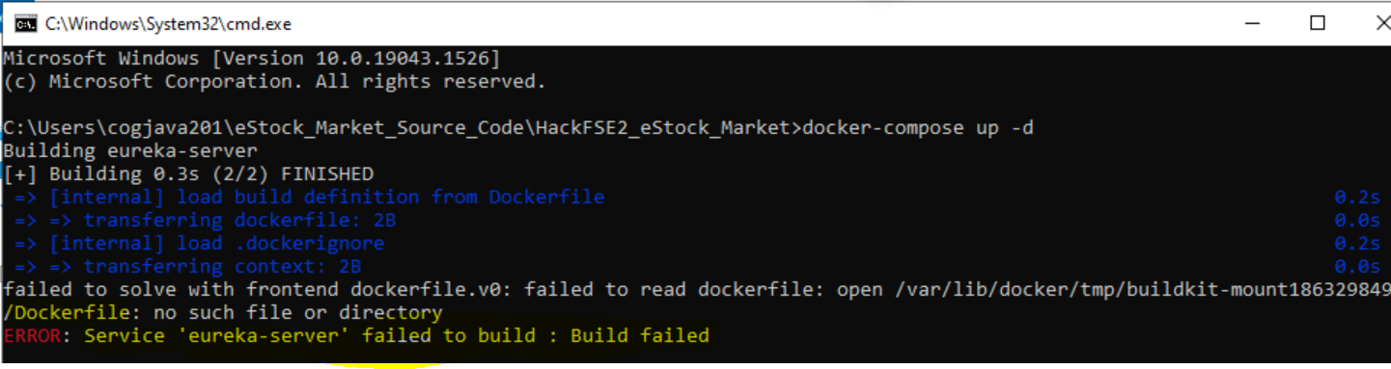

Solution:

Placed Dockerfile in directory



Issue – 8:

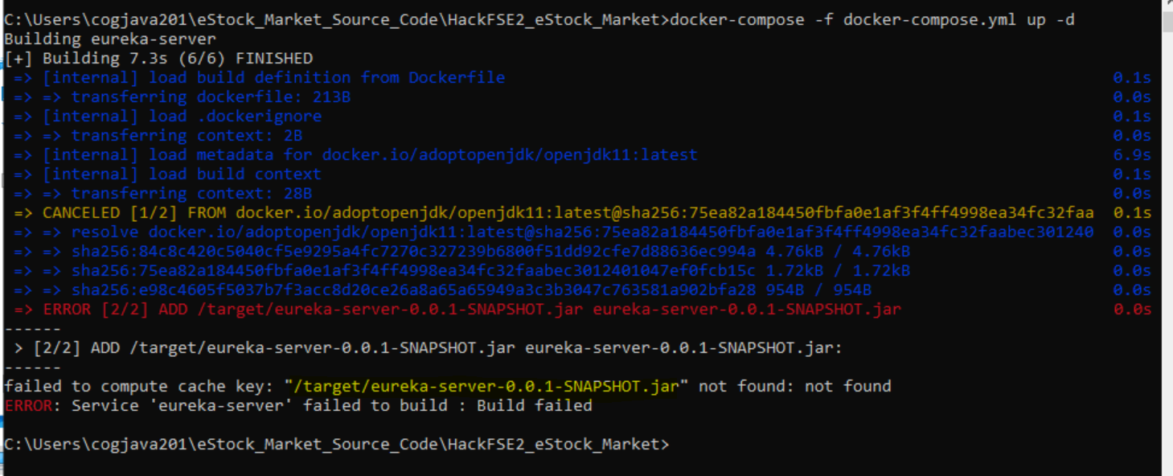

Solution:

Updated the docker-compose.yml file as given below

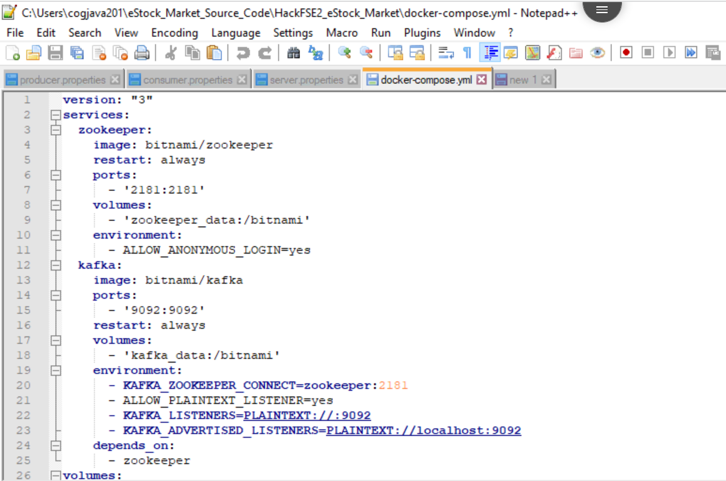

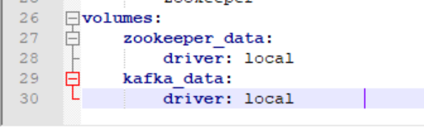

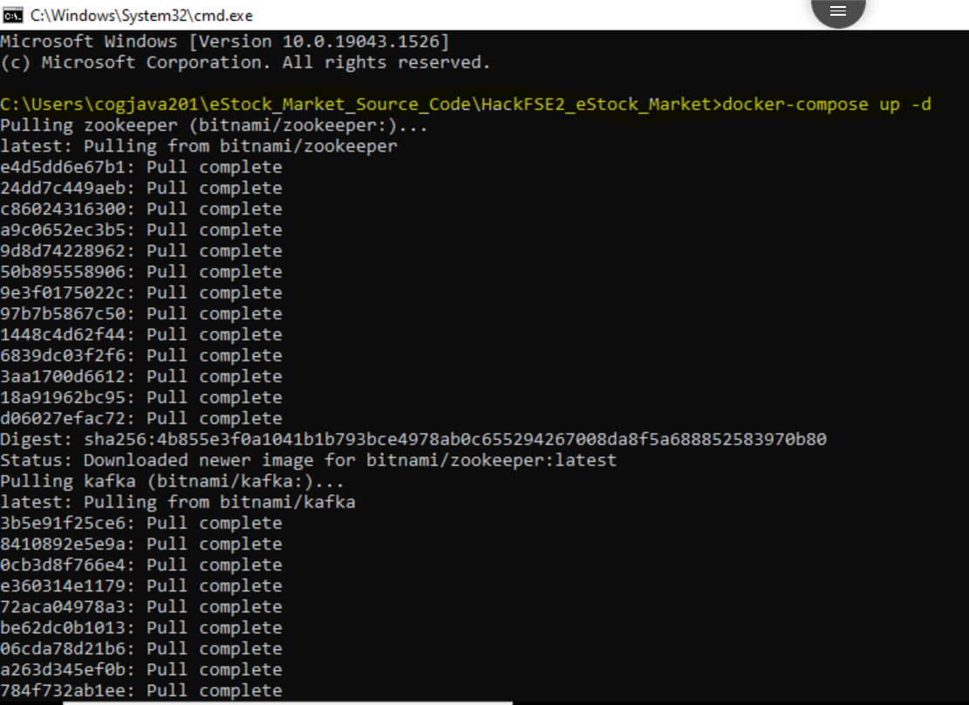

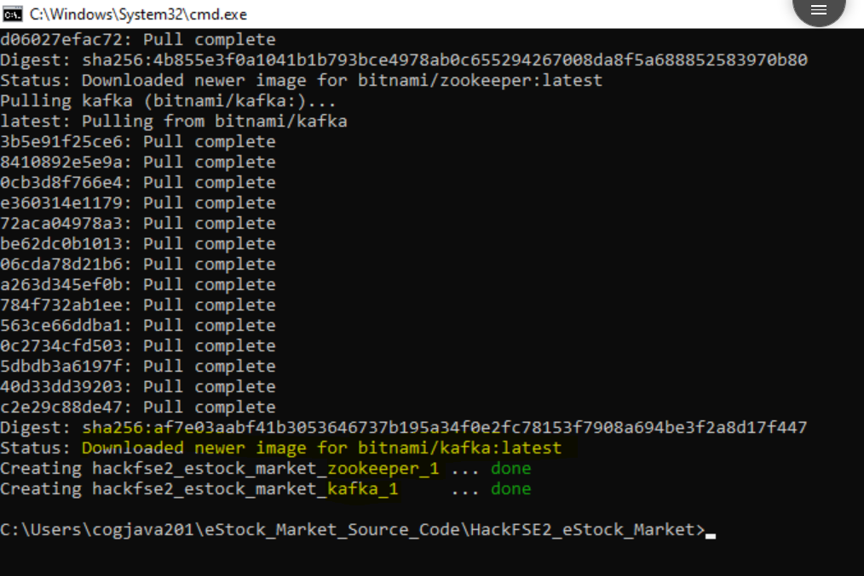

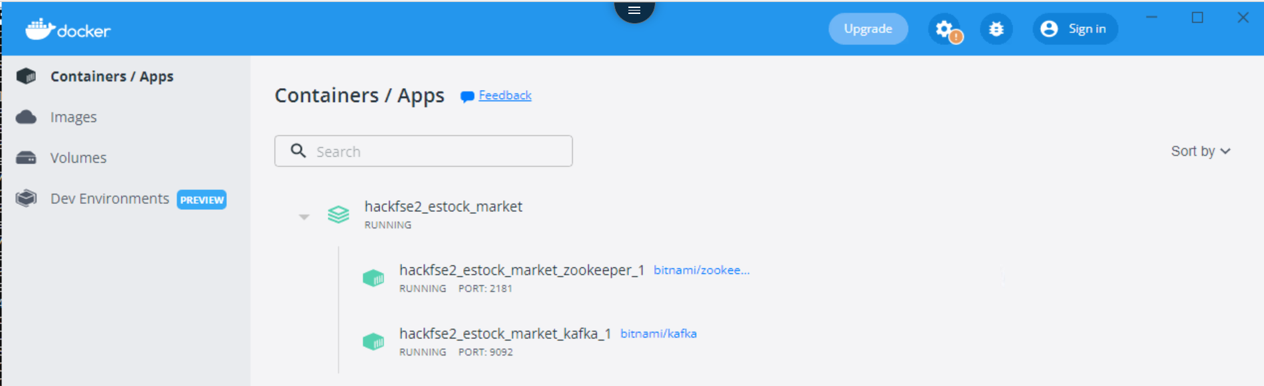

Issue – 9:

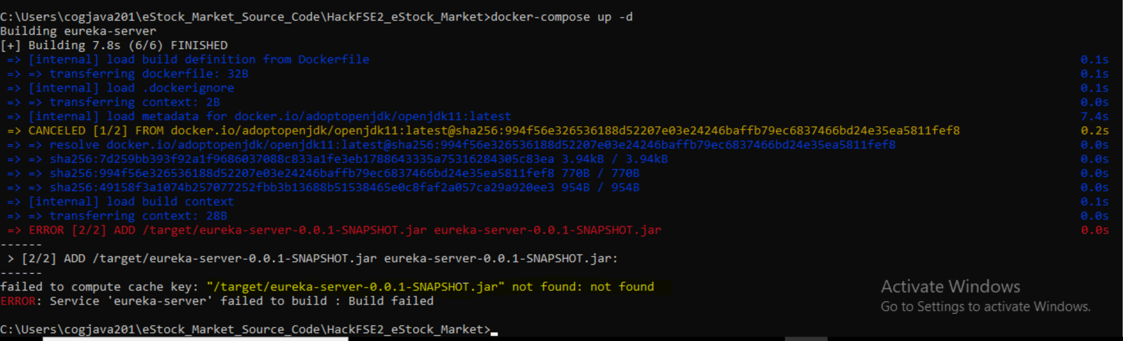

Solution:

Replaced the pom.xml file of eureka-server

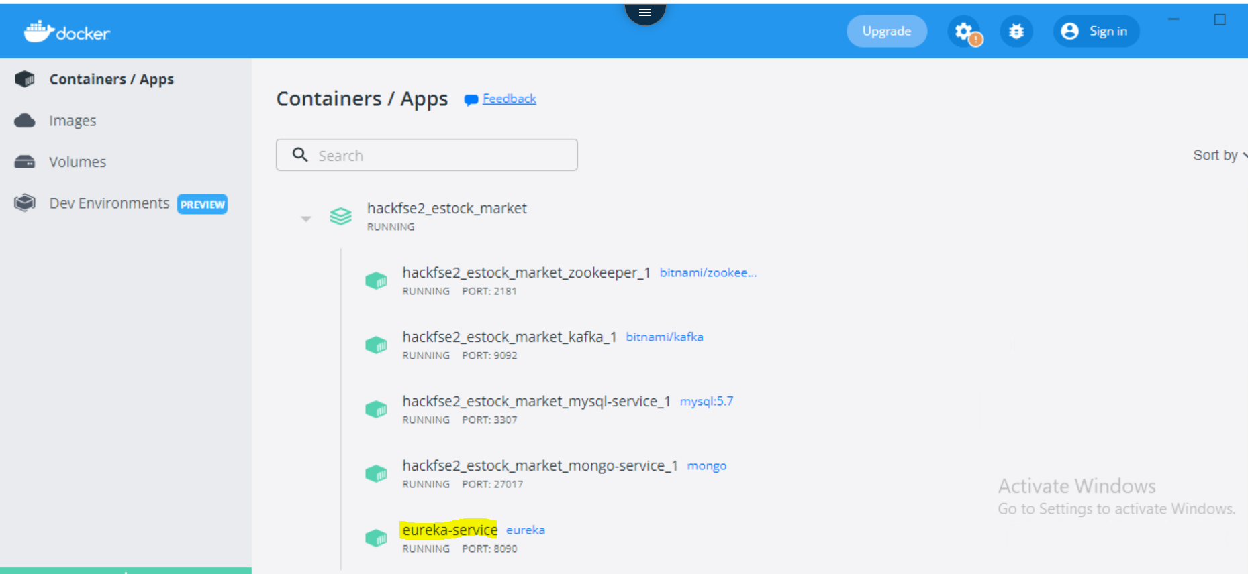

Issue – 10:

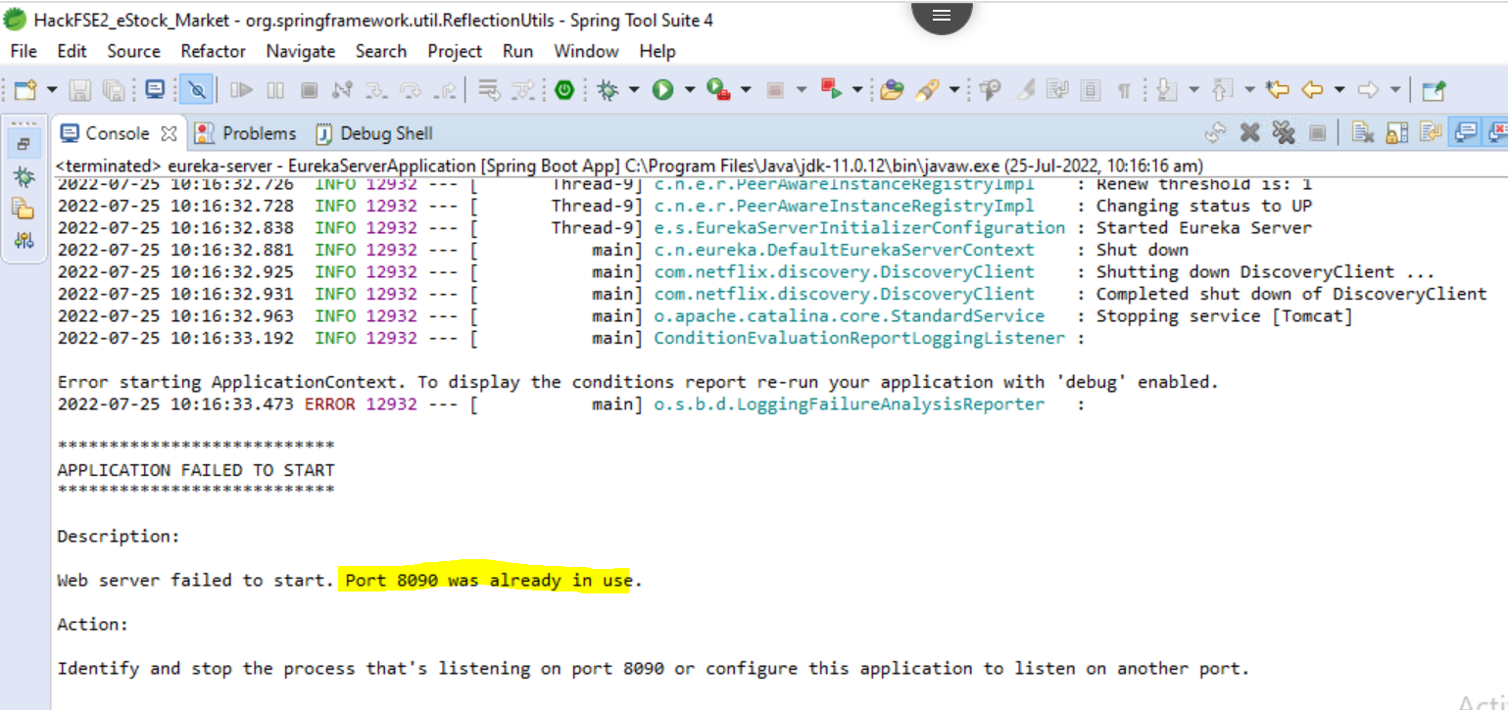

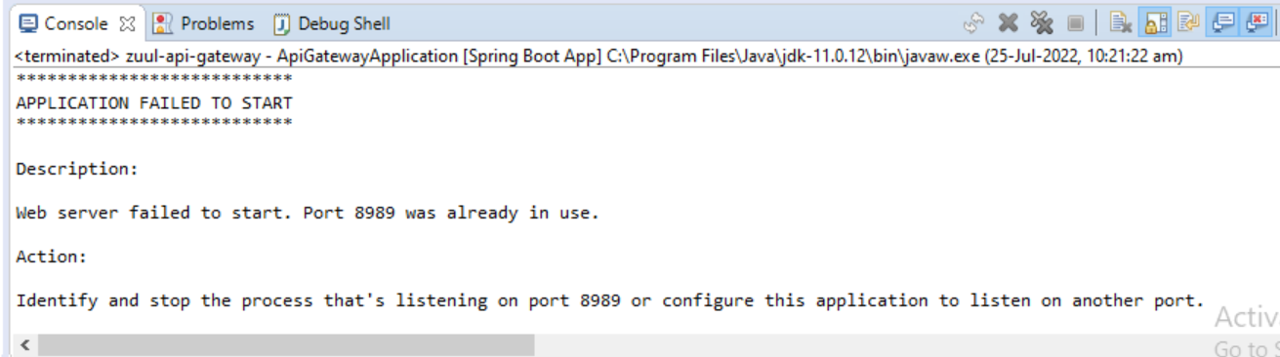

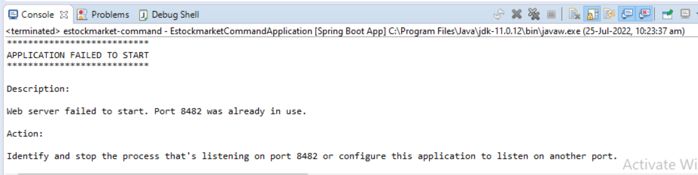

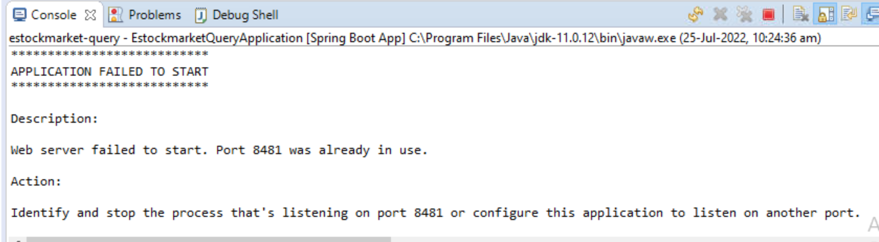

Solution:

Issue – 11: