HEALTHCARE DATA VISUALIZATION
Cost Relationships and Policy Insights

Name : Vedhavarshini priya E.A.S
Register no : 26BSC107
Course : BSC.CS(AI & DS)
Dataset : Healthcare Dataset
Tool Used : Python
Submission Date : 10.10.2026

OBJECTIVE :
To analyze patient demographics, billing patterns, monthly admissions, and relationships between patient age, length of stay, and billing amount. The analysis aims to identify useful patterns for healthcare resource planning and financial review, while noting that associations in the data do not establish cause and effect.

DATASET OVERVIEW :
Describe the dataset’s source, record count, time period, and relevant fields. For this report, useful fields include patient age and gender, admission date, discharge date or length of stay, billing amount, diagnosis or medical condition, admission type, and insurance provider.

PATIENT DEMOGRAPHIC ANALYSIS :

visualization: Bar chart of patient count by age group, with gender shown using grouped bars or separate colors. A second option is a gender-count bar chart.

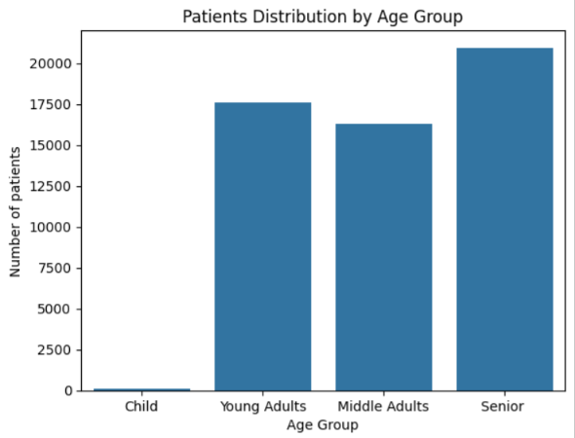

OBSERVATION :
Write what the chart actually shows—for example, which age group has the most records and whether the gender distribution differs across age groups. Avoid claiming that a group has greater healthcare need based only on record counts; the dataset may not represent the wider population.

BILLING ANALYSIS :
visualization: Box plot of billing amount by medical condition, admission type, or insurance provider. A box plot helps show typical costs and unusually high or low values .
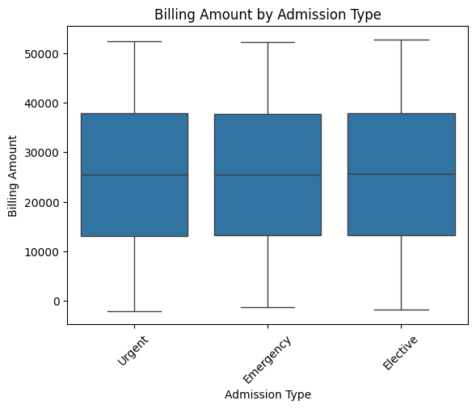

OBSERVATION :
Report the groups with the highest and lowest median or average billing, describe the spread, and note any outliers. If billing amounts differ between groups, describe this as an association; differences may reflect missing factors such as treatment intensity or patient complexity.

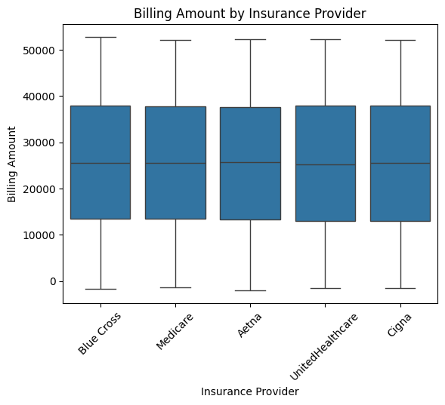

OBSERVATION :
Report the groups with the highest and lowest median or average billing, describe the spread, and note any outliers. If billing amounts differ between groups, describe this as an association; differences may reflect missing factors such as treatment intensity or patient complexity.

TEMPORTAL ADMISSION TREND ANALYSIS :
visualization: Line chart of the number of admissions per month, with months in chronological order. If the dataset spans multiple years, distinguish year from month so that the timeline is not collapsed into one January-to-December average.

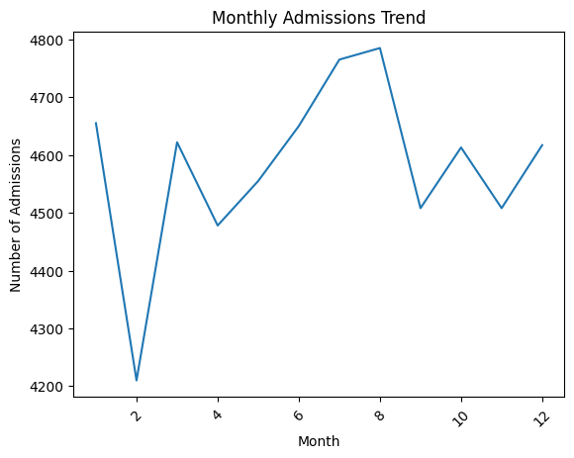

OBSERVATION :
Identify months or periods with higher or lower admission counts and describe any visible trend or recurring seasonal pattern. Do not infer a cause for peaks without additional evidence.

COST RELATIONSHIP AND COORELATION ANALYSIS :

CHART 1:
Scatter plot of age vs. billing amount, with a fitted trend line if appropriate.

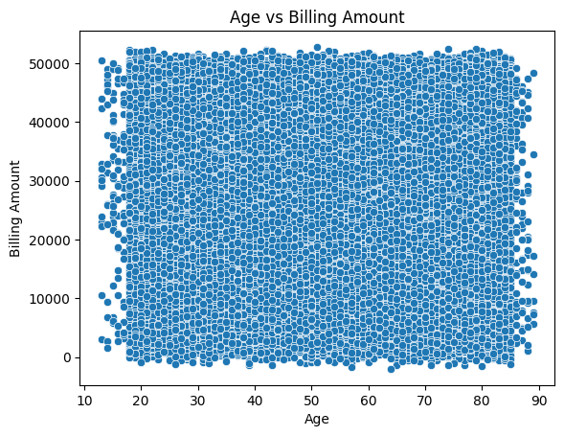

CHART 2:
Scatter plot of length of stay vs. billing amount, with a fitted trend line if appropriate.

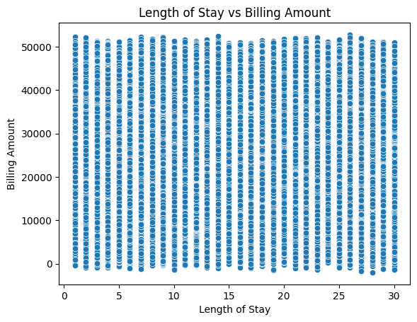

CHART 3:
Correlation matrix heatmap for numerical variables such as age, length of stay, and billing amount.

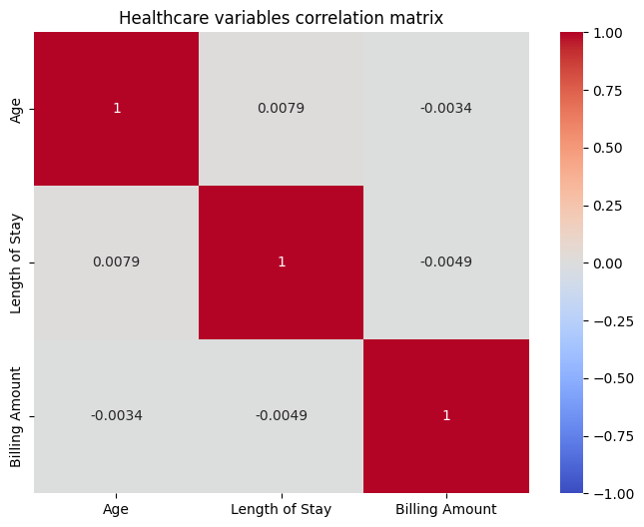

OBSERVATION :
For each scatter plot, describe whether the relationship appears positive, negative, or weak, and note substantial outliers. In the heatmap, state the correlation coefficients and explain that correlation measures linear association; it does not prove that age or length of stay causes a change in billing. Calculate these values from your own dataset rather than copying results from another report.

KEY FINDINGS :
Use five concise, data-supported findings. Replace the brackets with your actual results:
- The largest patient age group was [age group], representing [count or percentage] of records.
- The [category] group had the highest median billing amount at [amount], compared with [amount] for [comparison group].
- Admissions peaked in [month/period], with [count] records, and were lowest in [month/period].
- Age and billing amount had a [positive / negative / weak / negligible] correlation of [coefficient].
- Length of stay and billing amount had a [positive / negative / weak / negligible] correlation of [coefficient].

HEALTHCARE MANAGEMENT RECOMMENTIONS :
RESOURCE PLANNING
- Use observed monthly admission patterns to inform staffing and bed-capacity planning, then validate patterns against additional years and operational records.
- Review patient-volume differences by age group and service area before proposing changes to staffing or service availability.

BILLING ANALYSIS
- Review unusually high or low bills for coding, data-entry, or billing-process issues.
- Compare costs across similar diagnoses and admission types, where those fields are available, before interpreting group differences.
- Do not treat a correlation between length of stay and billing as proof that reducing stay duration will reduce costs safely.
FURTHER INVESTIGATION
- Repeat the analysis with verified, real-world records and document the data’s coverage and limitations.
- Add fields such as diagnosis severity, procedures, comorbidities, and discharge outcome to better explain cost differences.
- Validate key findings with clinical and finance teams before using them to guide policy.

CONCLUSION :
Summarize the demographic, billing, and admission patterns that your charts actually show. State the strongest observed cost relationships and acknowledge limitations such as missing variables, data quality issues, or synthetic data. Conclude with recommendations that are proportionate to the evidence; do not present descriptive patterns as causal findings.

