**CA-1**

**Q-1:**

package com.CA1.CA1;

import org.openqa.selenium.By;

import org.openqa.selenium.WebDriver;

import org.openqa.selenium.WebElement;

import org.openqa.selenium.chrome.ChromeDriver;

import org.openqa.selenium.chrome.ChromeOptions;

import io.github.bonigarcia.wdm.WebDriverManager;

public class q1 {

public static void main(String[] args) throws InterruptedException {

ChromeOptions co=new ChromeOptions();

co.addArguments("--remote-allow-origins=*");

WebDriverManager.*chromedriver*().setup();

WebDriver driver=new ChromeDriver(co);

driver.get("https://www.amazon.in/gp/cart/view.html?ref_=nav_cart");

driver.manage().window().maximize();

String CurrentTitle=driver.getTitle();

String ExpectedTitle="Amazon.in Shopping Cart";

if(CurrentTitle.equals(ExpectedTitle))

{

System.***out***.println("TITLE MATCHED.");

}

else

{

System.***out***.println("TITLE NOT MATCHED.");

}

driver.get("https://www.amazon.in/Campus-Womens-Claire-Running-Shoes/dp/B08NF5XCG4/ref=sr_1_2_sspa?keywords=shoes%2Bfor%2Bwomen&qid=1681288729&sprefix=shoes%2Caps%2C473&sr=8-2-spons&sp_csd=d2lkZ2V0TmFtZT1zcF9hdGY&th=1&psc=1");

WebElement sub=driver.findElement(By.*xpath*("//input[@id=\"add-to-cart-button\"]"));

sub.click();

driver.get("https://www.amazon.in/Fire-Boltt-Bluetooth-Calling-Assistance-Resolution/dp/B0BF54LXW6/ref=sr_1_5?keywords=watches%2Bfor%2Bwomen&qid=1681290777&sr=8-5&th=1");

WebElement s=driver.findElement(By.*xpath*("//input[@id=\"add-to-cart-button\"]"));

s.click();

driver.get("https://www.amazon.in/gp/cart/view.html?ref_=sw_gtc");

driver.findElement(By.*xpath*("//*[@id=\"a-autoid-0-announce\"]")).click();

Thread.*sleep*(5000);

driver.findElement(By.*xpath*("//*[@id=\"quantity_2\"]")).click();

Thread.*sleep*(5000);

driver.findElement(By.*xpath*("//*[@id=\"sc-buy-box-ptc-button\"]/span/input")).click();

Thread.*sleep*(5000);

}

}

**OUTPUT:**

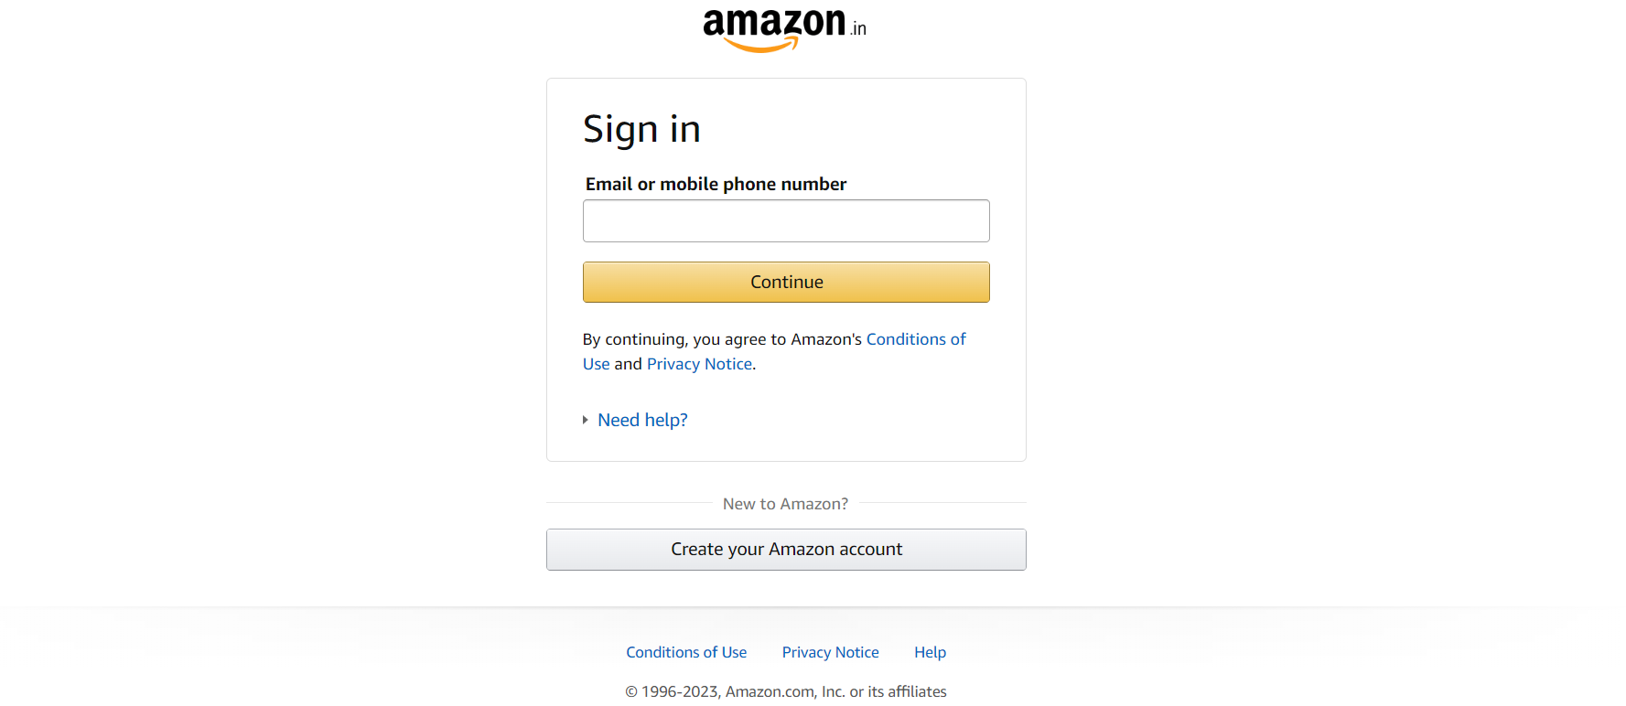

**Q-2:**

package com.CA1.CA1;

import java.util.List;

import org.openqa.selenium.By;

import org.openqa.selenium.WebDriver;

import org.openqa.selenium.WebElement;

import org.openqa.selenium.chrome.ChromeDriver;

import org.openqa.selenium.chrome.ChromeOptions;

import io.github.bonigarcia.wdm.WebDriverManager;

public class q2 {

public static void main( String[] args ) throws InterruptedException

{

ChromeOptions co=new ChromeOptions();

co.addArguments("--remote-allow-origins=*");

WebDriverManager.*chromedriver*().setup();

WebDriver driver=new ChromeDriver(co);

driver.get("https://www.amazon.in/");

driver.manage().window().maximize();

String CurrentTitle=driver.getTitle();

System.***out***.println(CurrentTitle);

String ExpectedTitle="Online Shopping site in India: Shop Online for Mobiles, Books, Watches, Shoes and More - Amazon.in";

if(CurrentTitle.equals(ExpectedTitle))

{

System.***out***.println("Title Matched.");

}

else

{

System.***out***.println("Title not Matched");

}

driver.findElement(By.*xpath*("//*[@id=\"twotabsearchtextbox\"]")).sendKeys("sneakers");

driver.findElement(By.*xpath*("/html/body/div[1]/header/div/div[1]/div[2]/div/form/div[3]/div/span/input")).click();

List<WebElement> li=driver.findElements(By.*className*("s-line-clamp-1"));

for(int i=0;i<5;i++) {

System.***out***.println(li.get(i).getText());

}

driver.findElement(By.*xpath*("/html/body/div[1]/div[2]/div[1]/div[2]/div/div[3]/span/div[1]/div/div/div[5]/ul/li[2]/span/a/span")).click();

}

}

**OUTPUT:**

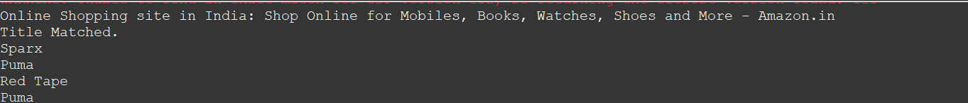

**Q-3:**

package com.CA1.CA1;

import org.openqa.selenium.By;

import org.openqa.selenium.WebDriver;

import org.openqa.selenium.chrome.ChromeDriver;

import org.openqa.selenium.chrome.ChromeOptions;

import io.github.bonigarcia.wdm.WebDriverManager;

public class q_3 {

public static void main(String[] args) throws InterruptedException {

ChromeOptions co=new ChromeOptions();

co.addArguments ("--remote-allow-origins=*");

WebDriverManager.*chromedriver*().setup ();

WebDriver driver=new ChromeDriver(co);

driver.get ("https://www.amazon.in/");

driver.manage().window().maximize();

String currentTitle=driver.getTitle();

System.***out***.println(currentTitle);

String expectedTitle="Online Shopping site in India: Shop Online for Mobiles, Books, Watches, Shoes and More - Amazon.in";

if(currentTitle.equals(expectedTitle)) {

System.***out***.println("Title Matched");

}

else {

System.***out***.println("Title not Matched");

}

driver.findElement(By.*xpath*("//*[@id=\"nav-link-accountList\"]")).click();

driver.findElement(By.*xpath*("//*[@id=\"ap_email\"]")).sendKeys("vedhavarsini21@gmail.com");

driver.findElement(By.*xpath*("//*[@id=\"continue\"]")).click();

driver.findElement(By.*xpath*("//*[@id=\"ap_password\"]")).sendKeys("Varshu21");

driver.findElement(By.*xpath*("//*[@id=\"signInSubmit\"]")).click();

Thread.*sleep*(1000);

driver.findElement(By.*xpath*("//*[@id=\"nav-orders\"]")).click();

String order = driver.findElement(By.*xpath*("//*[@id=\"a-page\"]/section/div[1]/div[4]/form/label")).getText();

System.***out***.println("Your last Order:"+order);

}

}

**OUTPUT:**

