Dash Board pages and brief:-

Things to be add at left side menu bar :-

1. Dashboard

2. Learning Page ( Recorded Session)

3. Learning Page (Live Session)

4. Value Based Education

5. Calendar view to choose date

5. Profile

6. Progress Report

7. Chat with us

8. Settings

1. Home page – ( Page 1 )

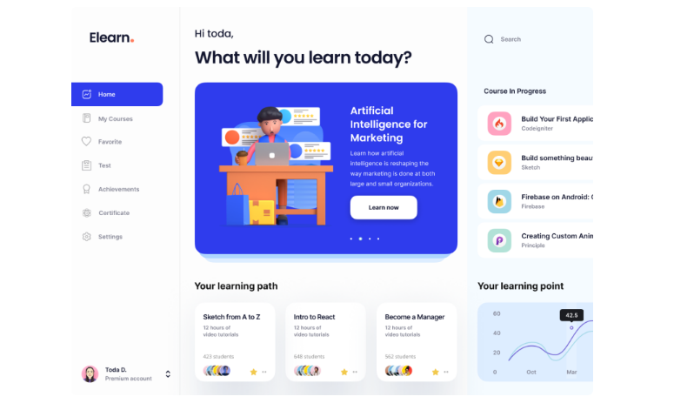Things to change :-

1. Add Image with some course shortcuts
2. Replace you’re Learning path with 2 Box with title – Live section, Value based Section
3. Replace your Learning point with Day wise calendar
4. Head line to be added ”Welcome Dear Lokesh ( Kids name )”

2 Learning page 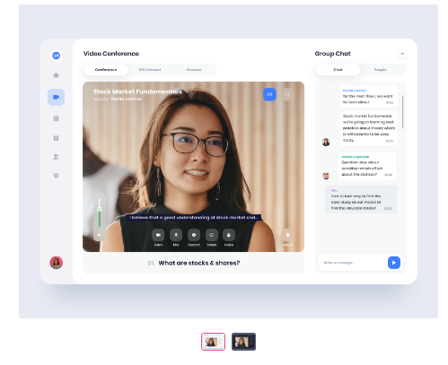

Things to be changed :-

1. Replace the girl image with a record video ( Size will be same as the image )
2. Replace group chat with YouTube links in form of thumbnails
3. Add a big rectangle with two partition below the Image of the girl
4. Left side of the rectangle will contain assignment links
5. Right side of the rectangle with be a image back linked with a game or worksheet