Automatic Geo Referencing
B-Tech-AI&DS, Semester-IV
Prepared at


Bhaskaracharya National Institute for Space Applications & Geo-informatics
Ministry of Electronics and Information Technology, Govt. of India.
Gandhinagar

Prepared By
Chirag Jindani Vedant Pathak
ID No. 26BISAG0493 ID No. 26BISAG0494

Guided By: External Guide:
Dr. Shweta Saharan Dr. Manoj Pandya
Department of AI&DS Additional Director,
GSV, Vadodara. BISAG-N, Gandhinagar
SUBMITTED TO
Gati Shakti Vishwavidyalaya

Gati Shakti Vishwavidyalaya- Vadodara

Bhaskaracharya National Institute for Space Applications and Geo-informatics
MeitY, Government of India

दिनांक/Date:_________
यह प्रमाणित किया जाता है कि गती शक्ति विश्व विद्यालय, वडोदरा के चौथे सेमेस्टर बीटेक-एआई एवं डीएस के छात्र श्री चिराग जिंदानी और श्री वेदांत पाठक ने बायसेग-एन में ग्रीष्म ऋतु की इंटर्नशिप सफलतापूर्वक पूरी कर ली है। उन्होंने 18 मई, 2026 से 15 जून, 2026 तक ऑटोमेटिक जियो रेफरेंसिंग पर काम किया है।
जहाँ तक हमें सूचना है, यह उनके द्वारा किया गया एक मौलिक और प्रामाणिक कार्य है। संस्थान में अपने कार्यकाल के दौरान, उन्होंने आत्म-प्रेरणा और कर्तव्यनिष्ठा का परिचय देते हुए काम किया। हम उनके उज्ज्वल भविष्य की कामना करते हैं।

This is to certify Mr. Chirag Jindani and Mr. Vedant Pathak, students of 4th Semester B-Tech-AI&DS from Gati Shakti Vishwavidyalaya, Vadodara, have satisfactorily completed the summer internship at BISAG-N. They have worked on Automatic Geo Referencing, from May 18th, 2026 to June 15th, 2026.
To the best of our information this is an original and bonafide work done by them. During their tenure at the institute, they demonstrated self-motivation and conscientiousness. We wish them a successful future ahead.

डॉ. मनोज पंड्या
Dr. Manoj Pandya
अपर निदेशक
Additional Director,
बायसेग-एन, गांधीनगर, गुजरात
BISAG- N, Gandhinagar, Gujarat

पुनीत लालवानी
Punit Lalwani
अपर निदेशक सह सीआईएसओ
Additional Director cum CISO,
बायसेग-एन, गांधीनगर, गुजरात
BISAG- N, Gandhinagar, Gujarat

SUMMER INTERNSHIP
Certificate of Completion
This is to certify that the work contained in the project titled “Automatic Geo Referencing” has successfully completed by the following students under my/our supervision during 4 week summer internship. During the internship period the students found to be hard working, punctual and discipline and they met all the criteria satisfactorily.

Student Name | Roll Number | Signature
1. Chirag Jindani | 24AI020
2. Vedant Pathak | 24AI055

Signature
Industry Mentor details

Date: .................

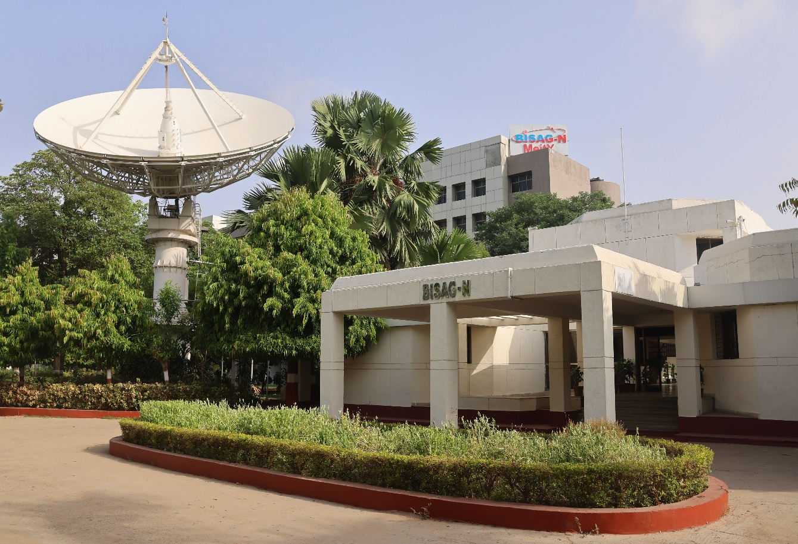
About BISAG-N

Modern day planning for inclusive development and growth calls for transparent, efficient, effective, responsive and low-cost decision-making systems involving multi-disciplinary information such that it not only encourages people's participation, ensuring equitable development but also takes into account the sustainability of natural resources.

The applications of space technology and Geo–informatics have contributed significantly towards the socio-economic development. Taking cognizance of the need of geo-spatial information for developmental planning and management of resources, the department of Ministry of Electronics and Information Technology, Government of India, established "Bhaskaracharya National Institute for Space Applications and Geo-informatics" (BISAG-N).

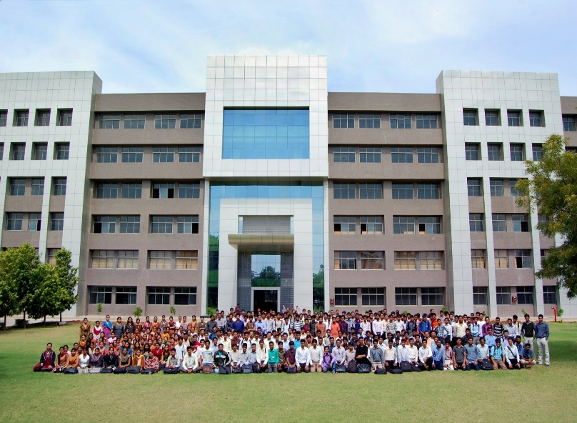
BISAG-N is ISO 9001, ISO 27001, ISO 19115, ISO 19157 and CMMI: L5 certified national institute. BISAG-N, which was initially set up to carry out space technology applications, has evolved into a center of excellence, where research and innovations are combined with the requirements of users and thus acts as a value-added service provider, a technology developer and as a facilitator for providing direct benefits of space technologies to the grass root level functions/functionaries.
BISAG- N Journey
The journey of Institute started as a state government organization, named as Remote Sensing and Communication Centre (RESECO) operating under a limited mandate from 1997 to 2003, focusing on utilization of space technologies such as satellite communication, remote sensing and geospatial applications for supporting various developmental initiatives exclusive for the State of Gujarat. Opinions of various stakeholders at grass root levels was obtained to ensure alignment of Institute's work with the development and welfare need of the society. Numerous sessions of different strata of society were organized including Member of Legislative Assembly (MLAs), village sarpanch, farmers, various skill workers, women and students to obtain insights into what are the needs with simplicity of solutions, and processes of their groups and how technology can fulfil those needs and alleviate any constraints for improving the quality of life.
The basic works of maps generation as per the needs of various state government departments laid the groundwork for the institute’s advancement. In December 2003, the name of the institute changed as BISAG (Bhaskaracharya Institute for Space Applications and Geo-informatics) with an enhanced mandate to promote satellite communication-based education and skill development facility thereby ensuring increased and more actively involvement in governance processes. The name of the institute was changed to honor the celebrated 12th-century mathematician and astronomer, Bhaskaracharya (1114-1185 AD) who provided in-depth insights about various astronomical and mathematical concepts, formulae and calculations.
The institute’s services were extensively utilized by various departments of Gujarat Government under the leadership and patronage of the then Honorable Chief Minister Shri Narendrabhai Modi. Numerous times the assembly meetings were held in BISAG-N premises to amalgamate governance and technology for the well-being of the state. The state leadership expressed to the ministers and bureaucrats on multiple occasions the importance of visualization of development plans and schemes on maps and thereby harnessing the capabilities of BISAG as a "go-to place" for various technological and geo-informatics solutions required by concerned ministries and departments for the benefit of citizens and development of the state.

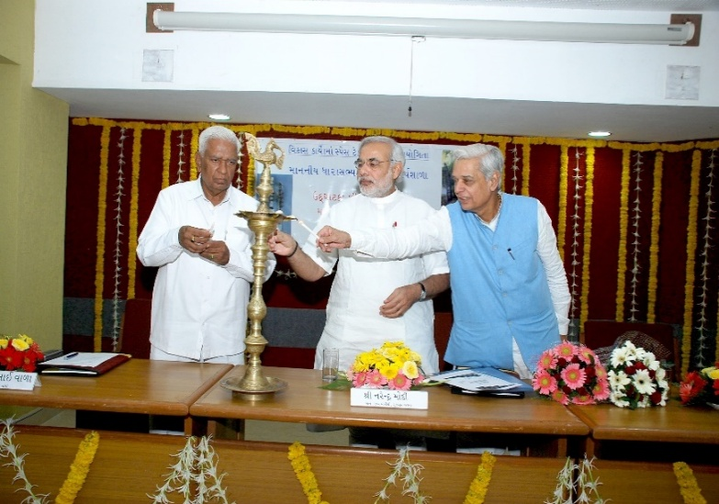
On one of such occasions in 2004, Honorable Chief Minister Shri Narendra Modi said, “Friends, I can clearly visualize that within a span of five years, all streams of government administration shall converge into BISAG. This institute shall be a huge treasure of information, if any decisions are to be taken or any department require any information or need any policy change; the ‘Source of Information’ shall be BISAG. There for earlier we can transform BISAG into a ‘Source of Information’ and position it as back-bone of all governance and administration activities, and the sooner the benefits of science and technology shall be available to the society.”
Since then, inspired by above and gaining insights while working collaboratively for various development initiatives of central and state government department, the Institute is focused on following vision:
“To empower and serve the nation through development of space and geo-spatial technologies, its applications, solutions and services in accordance to governance principles for socio-economic welfare of the society.”
The Institute develops geo-spatial technologies, databases, software and processes along with skilled resources to provide visualization, analysis and decision support system to various state government departments. Also, the Satellite Communication infrastructure was enhanced to add more channels and developed in house expertise to install, operate and maintain various electronic instruments and equipment. The institute constantly ensured adoption of national and international standards as well as best practices to develop and reinforce the solutions delivery process. With the improved confidence and trust of the state government to utilize geo-spatial and satellite communication services for developmental, social welfare and disaster management areas, the institute was supported by the Government of Gujarat to construct dedicated buildings for ensuring services are provided at even larger scale. This expansion broadened the institute’s scope to integrate advanced techniques such as managing large databases, mathematical modelling, enabling prediction and simplified architecture for the solution aligning with the government priorities for improving efficiency, transparency and pace of development
Along with providing the e-governance support to Gujarat State, the institute also started supporting various other states and central government ministries as and when required for map and decision support system development services. Recognizing this potential, the institute’s mandate was further enhanced to cater to the geo-spatial and satellite communication-based e-governance services to all central government ministries as well as various states and union territories as a National institute. The name of the institute was then changed as Bhaskaracharya National Institute for Space Applications and Geo-informatics (BISAG-N), registered as an Autonomous Scientific Society, as per the Societies Registration Act, 1860, under the Ministry of Electronics and Information Technology (MeitY), Government of India (GoI). BISAG-N; enhanced mandate includes to undertake technology development & management; research & development; facilitate national and international cooperation and capacity building; support technology transfer and entrepreneurship development in area of geo-spatial technology.
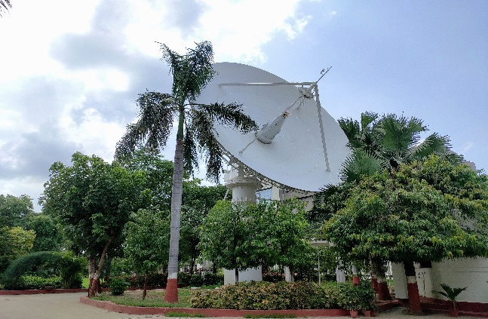
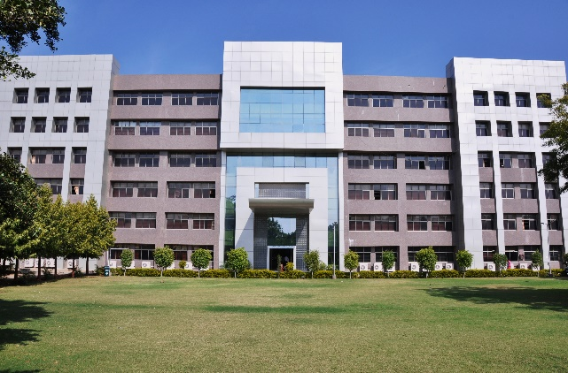
Today, BISAG-N is collaboratively working with 50+ central government ministries and most of the states and union territories for supporting various developmental programs and citizen centric services. BISAG-N provides the technological support to these stakeholders from its Gandhinagar and New Delhi facilities. These facilities have adequate skilled personnel and state-of-the-art infrastructure for providing geo-spatial solutions and software applications including support of satellite communication-based education and training. Thus, BISAG-N is playing pivotal role as a one stop center for providing geo-spatial and space technologies for various flagship programme being undertaken for the development of nation in line with geo-spatial education, logistics and various other policies and program of central and state governments.
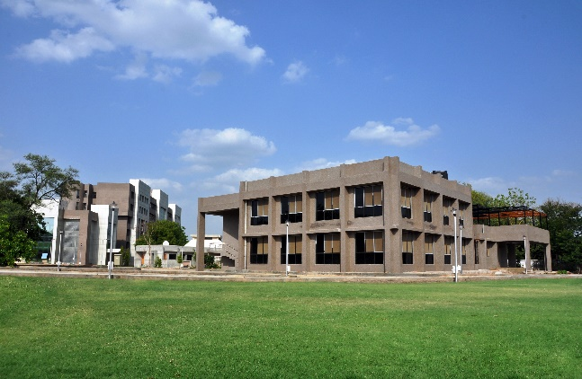
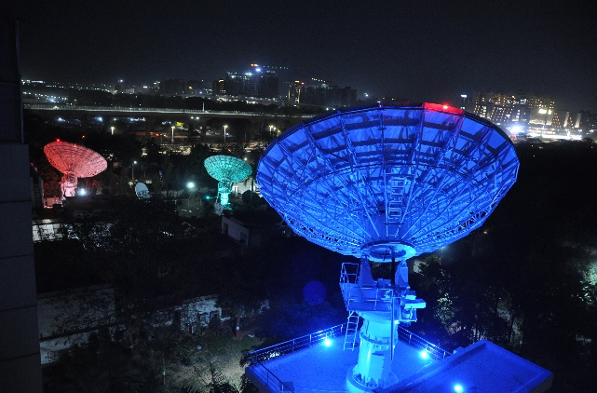
BISAG-N: Major Focus Area
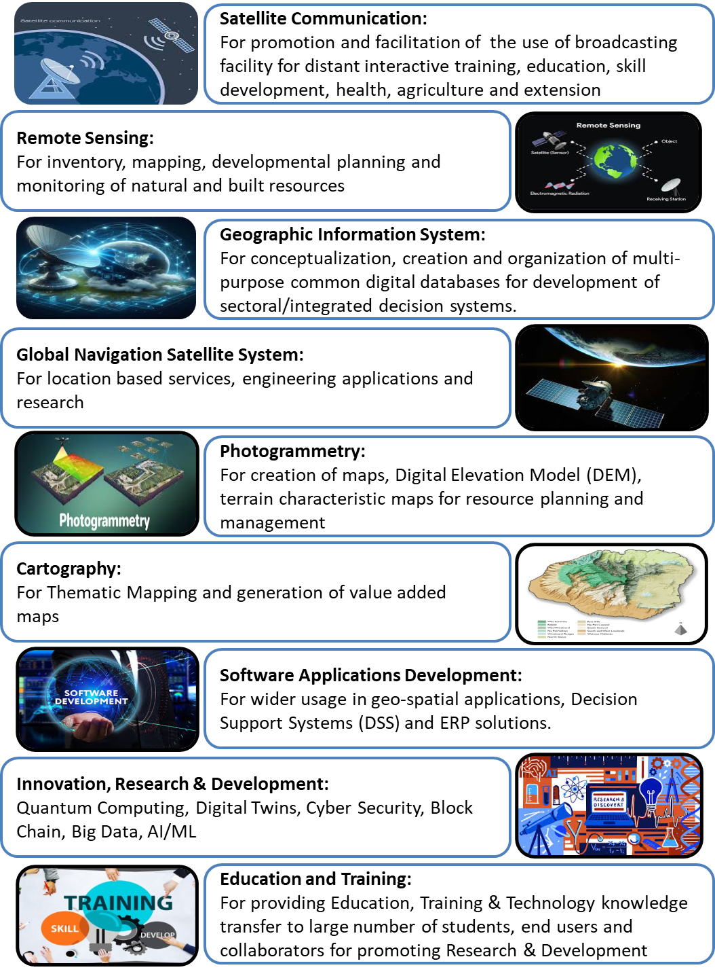
Organizational Setup
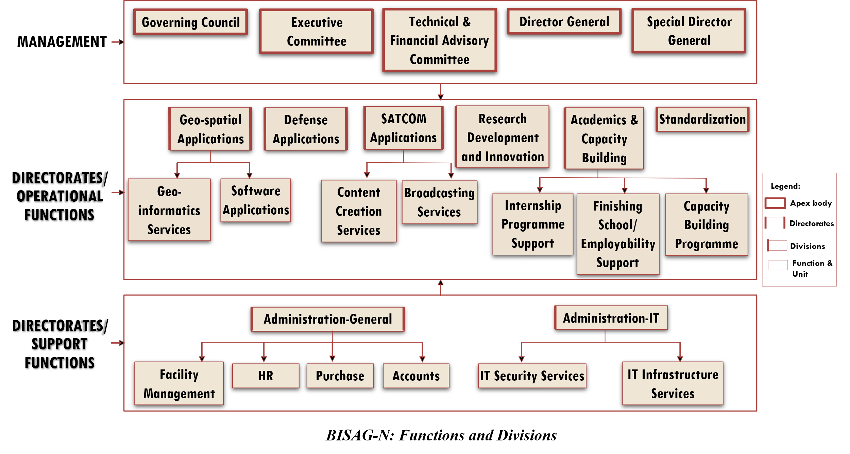
BISAG-N main domain areas include Satellite Communication, Geo-spatial Solutions and Technology Development, Geo-informatics Applications Development, Standardization, Academics & National/ International Co-operation and Administration.
SATCOM Applications
The SATCOM Directorate provides services of distance education, capacity building, training, extension, awareness and empowerment using the state-of-the-art facility comprises of an uplink earth station, control room, studios and a satellite communication-based network. The services are primarily utilized by Ministry of Education and various other central and states ministries. Through Ministry of External Affairs (MoEA), BISAG-N is now poised to provide SATCOM based education to neighbouring countries also.
SATCOM operations are inspired by the wisdom of Hon’ble Prime Minister of India as elicited on numerous occasions. For example, in 2004 as Hon’ble Chief Minister of Gujarat, Shri Modi explained the importance of learning through the ancient way of visualization using virtual media with these words:
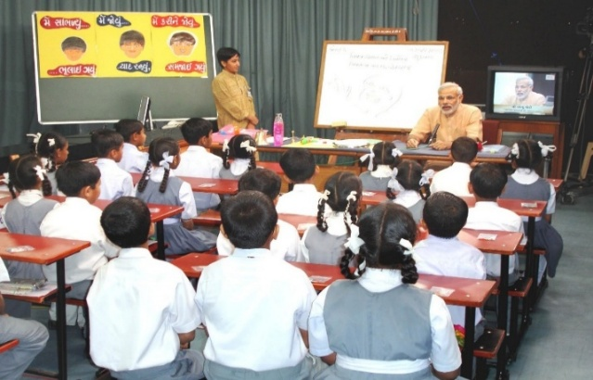
“The way Eklavya studied by making a statue, why we can’t study with the help of a T.V.? Yes, we can. Was any cinema song ever taught to us in any class? Was it ever taught by any teacher? We learnt song from T.V., isn’t it? If we have learnt entire cinema song, learnt every word, learnt scale, learnt rhythm, it means we can learn through T.V. also.”

There are twelve state-of-the-art studios for live recording of content supported by dedicated editing labs, subtitling, translation, animation and various other aspects. The institute has set up ten studios at Gandhinagar facility and another two studios at New Delhi. Infrastructure for transmission and Ku band uplink teleports (11m/9.3m) of more than 350 channels is installed, integrated and maintained by inhouse team. BISAG-N support various initiatives of Ministry of Education, Government of India, as well as other central and state government ministries such as PM e-Vidya, Swayam Prabha etc. as detailed further.
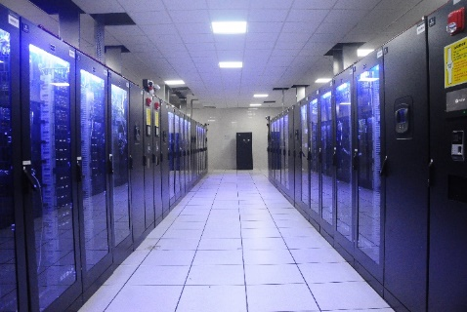
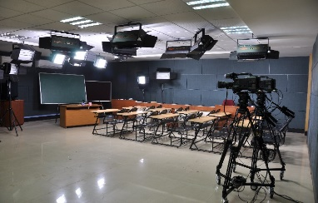

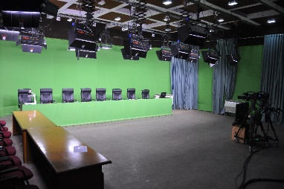
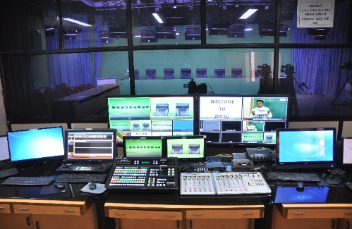

Geo-spatial Applications Directorate
BISAG-N’s Geo-Spatial Applications Directorate provides specialized services and solutions to implement Geographic Information Systems (GIS) for providing impetus to planning and developmental activities at grass root level. The objective of GA directorate is to provide analysis and decision support services to various stakeholders through scientifically organized, comprehensive, multi-purpose, compatible and large scale geo-spatial databases.
Geo-spatial Applications Directorate creates and organizes large-scale and multi-purpose geospatial datasets in collaboration with central and state government departments and agencies. A well-qualified team of GIS technicians and engineers ensure that the datasets are compatible, standardized and authenticated for use in analysis, planning and decision-support functions. Goals and roles of converging organizations are taken into consideration while geo-spatial database creation and software development activities
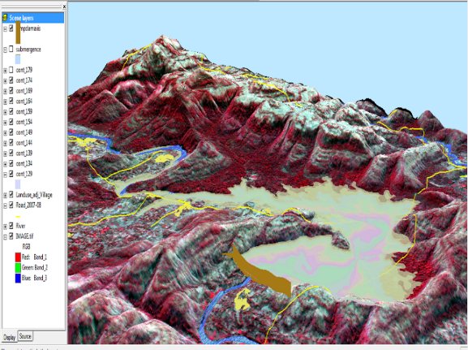
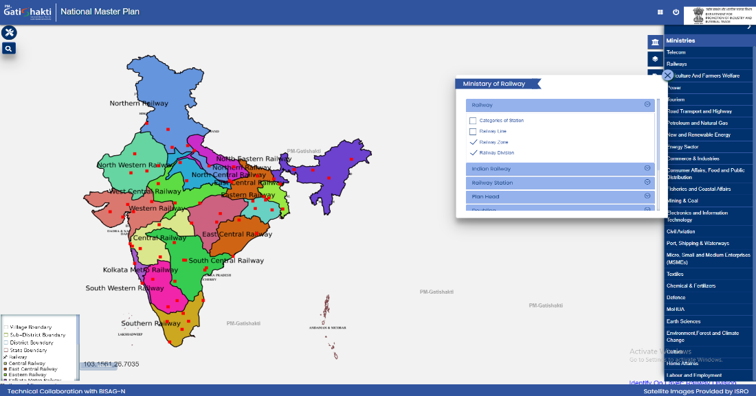

Railway Zones with Divisions

Software Development Division

The geo-spatial solutions are packaged and provided as software products for ease of retrieval of spatial and feature attributes data, enabling wide range of analysis, prediction and decision support services. Software technologies like Java, Python, JavaScript, Spring Boot, React JS, Node JS, Microservices, XML, GeoJSON, GeoServer, QGIS, Android and iOS frameworks are used to develop user-friendly and reliable solutions.

Academy of Geo-informatics
BISAG-N, being a national institute for geo-spatial and emerging technology-based applications, has a strong focus on research, development, capacity building and employability support for under-graduate, post-graduate and doctoral students. The institute’s infrastructure and supportive work environment provide an ideal platform for students pursuing thesis work in a variety of technologies and domains.
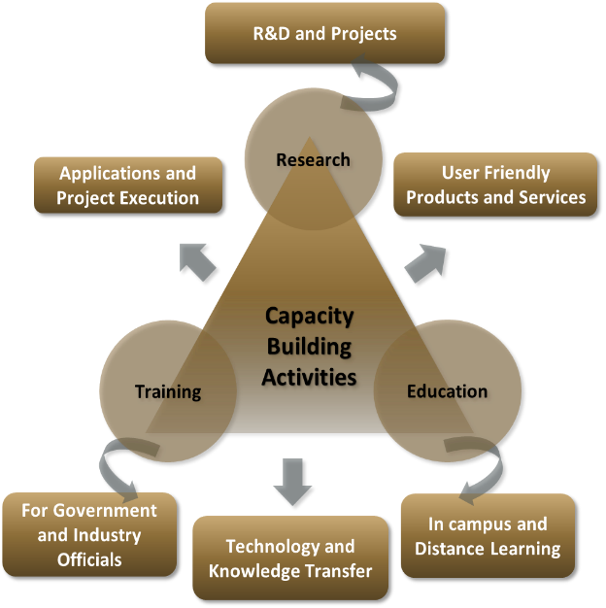
BISAG-N is equipped with cutting-edge infrastructure to support research across multiple disciplines. Dedicated laboratories for research on the application of artificial intelligence, machine learning, GIS (Geographic Information Systems), remote sensing, quantum computing, IoT (Internet of Things) and other emerging technologies are established high-performance computing facilities for intensive data processing tasks are available in the institute. Open-source platforms and in-house developed software are available for projects, research and innovation activities. More than 300 students are supported every year for learning practical based aspects of geo-spatial and emerging technology applications while completing their projects.

BISAG-N Finishing School Programme (FSP) supports wards of special groups of society such as scheduled tribe, scheduled caste, non-gazetted security, armed forces citizens and martyr etc, for development of technical and soft skills to improve their employability including support for entrepreneurship and employment opportunities.
The school provides basic and specialized training to help participants develop capacities as required by the for related industry/domain. The participants undergo thorough counselling sessions as well as mock/actual interviews for improving employability in relevant industries as per the interest of the candidates. Along with the skills training the participants are also allowed to observe engaged in ongoing projects of organization. BISAG-N academic activities also provide capacity building support to government officials for effectively using geo-spatial solutions and decision support systems for performing planning and monitoring for various government schemes and initiatives.
Industrial visits of school students are organized to provide them exposure of space applications and geo-informatics thereby supporting the development of scientific temperament at early stage. More than 5000 students visit the premises every year to get exposure of the activities being carried out at BISAG-N.
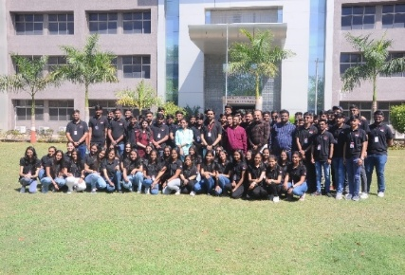
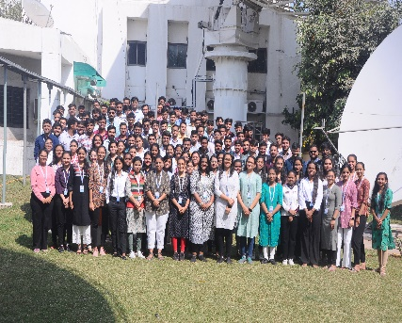
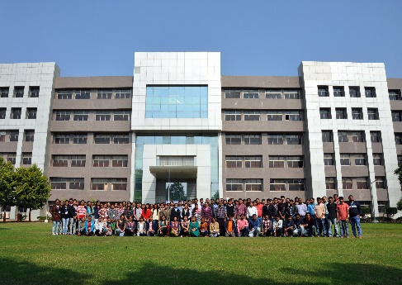
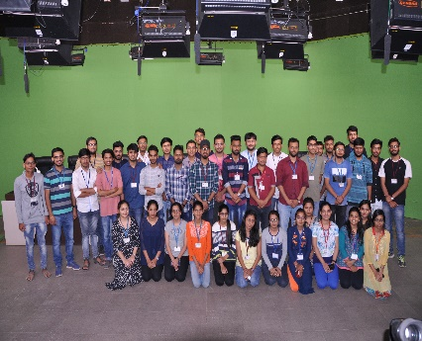
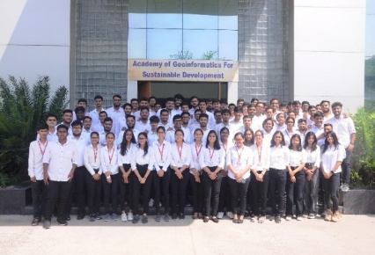
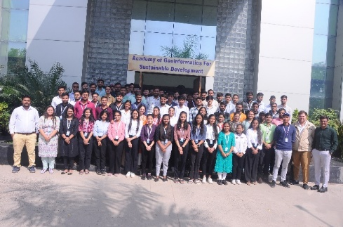
Standardization Directorate
BISAG-N has a dedicated directorate for ensuring continuously focus on innovation, standardization and institutionalization of solutions & service. The Standardization Directorate focuses on implementation of various national and international standards related to program solutions and data management. The directorate develops internal SOPs and policies for compliance to these standards and provides training for effective implementation. The directorate also liaison with the various departments and external agencies during internal and external audits. In addition, the directorate acts as member in standards committees of Bureau of Indian Standards (BIS) and other standard developing bodies for development of standards.

Goals of Standardization Directorate include:
- To proactively implement product and process improvements initiatives using various national & international standards and best practices. This includes ensuring quality and reliability of geo-spatial data, completeness, updation of metadata, functional performance and security reviews of applications, capacity building support to end-users for adoption of solutions and information security-oriented culture development
- To develop a culture of efficiently working as per standards while fostering innovation
- To perform reviews, gap analysis, training, documentation and standards implementation support activities
Administration Directorate
Administrative Directorate provides strategic and management support to various activities of BISAG-N. The directorate ensures infrastructure and facilities management in addition to providing services such as coordination during visits of various delegations, logistic support to BISAG-N staff during travel, accounting and finance, procurement, training, safety and security, legal compliance, maintenance, housekeeping, horticulture, construction and extension projects, campus monitoring, canteen management as well as celebrations and welfare activities. The directorate also ensure recruitment and human resource development as per the needs of various projects and directorates while upholding principles of equality, fairness and diversity in work force.
BISAG-N has adequate human resources, well trained for behavioral, functional and domain competencies, with clear roles and responsibilities in alignment with service delivery expectations. The staff well-being and motivation initiatives are ensured for maintaining a culture of shouldering responsibilities proactively and delivering high-performance utilizing multi-disciplinary knowledge.
Administration Directorate ensure strategic and compliance support to operations of the institute by managing human resources, facilities, expansion projects, finance and governance aspects. The directorate also coordinates with Council stakeholders and members of Governing and Executive committee as well as other high-level committees.
Defence Applications Directorate
This directorate develops space, geo-spatial, AI and other emerging technologies-based applications under the guidance of various agencies of the Ministry of Defence, Government of India. All the technologies used are developed inhouse of customized open source. Considering the strategic significance of these projects, dedicated team and premises are allocated for ensuring information security. Most of the critical activities and data management are performed directly at various defence establishments.

Besides the projects of various infrastructure and social welfare ministries and departments of central and state government, BISAG-N has a dedicated directorate for supporting defence and security departments for providing data products, decision support systems and services involving geo-spatial and various other emerging technologies. The projects are executed in high security dedicated laboratory for various units of army, navy and air-force for supporting strategic and operational aspects of the operations.
Through its innovative geospatial solutions and technological expertise, BISAG-N is playing a crucial role in enhancing the nation’s defence capabilities and ensuring long-term strategic autonomy. Due to nature of high secrecy of these strategic projects, they are not included in details in this compilation.
Research and Development
BISAG-N’s research and development group supports all other directorates for providing solutions related to new definitions and technology. The group develops innovative applications, features, tools and services utilizing technologies such as remote sensing, photogrammetry, artificial intelligence, machine learning, internet of things, computer vision, big data and quantum computing, which are later integrated in live projects.

BISAG-N has made significant progress for the development of Artificial Intelligence/ Machine Learning (AI/ML) applications. Algorithms and models have been developed which can be customized and used with training, validation and live data upon their data for accurate predictions and smarter results.

The applications developed by the R&D team include support for the pluggable APIs which can use the machine learning with minimal code reconfiguration. Various GIS applications are developed at BISAG-N. Utilizing spatial and non-spatial processing of Big Data and Web GIS architecture These applications support multi-terabyte datasets and large number of consumers. Big Data applications for visualization developed by the institute has enabled several projects to explore and analyse multiple large archives. Through continuous research and development, BISAG-N’s R&D capabilities are continuously enhanced. This allows to enhance users’ satisfaction, growth and success stories.
Cyber Security Cell
Cyber Cell reviews and update the threat landscape for the BISAG-N’s critical infrastructure on a regular basis in line with various vulnerabilities detected and published by reputed repositories. The cell verifies the applications using Vulnerability Assessment & Penetration Testing (VAPT) ensuring the compliance to Guidelines for Indian Government Websites (GIGW), Open Web Application Security Project (OWASP), SANS 25 etc. The cell also ensures implementation of good information security practices in line with ISO 27001 such as serious logs review, vulnerability analysis, exception reporting, maintenance of firewall and other network monitoring tools.

CANDIDATE’S DECLARATION
We declare that the 4th semester internship project report entitled “Automatic Geo Referencing” is our own work conducted under the supervision of the external guide Dr. Manoj Pandya from BISAG-N (Bhaskaracharya National Institute for Space Applications & Geo-informatics). We further declare that to the best of our knowledge, the report for this project does not contain any part of the work which has been submitted previously for such project either in this or any other institutions without proper citation.

Candidate 1’s Signature
Chirag Jindani
Student ID: 22BISAG0001

Candidate 2’s Signature
Vedant Pathak
Student ID: 26BISAG0494

Submitted To:
Gati Shakti Vishwavidyalaya

ACKNOWLEDGMENT
We are grateful to Shri T.P. Singh, Director General (BISAG-N), for giving us this opportunity to work the guidance of renowned people of the field of GIS-Based Portal, also providing us with the required resources in the company.
We would like to express our endless thanks to our external guide, Dr. Manoj Pandya, and to the Training Cell, Mr. Punit Lalwani & Mr. Sidhdharth Patel at Bhaskaracharya National Institute of Space Application and Geo-informatics, for their sincere and dedicated guidance throughout the project development.
Also, our hearty gratitude to our Head of Department, Dr. Vipul Kumar Mishra and our internal guide Dr. Shweta Saharan for giving us encouragement and technical support on the project.

Chirag Jindani.
Student ID: 26BISAG0493

Vedant Pathak.
Student ID: 22BISAG0494

ABSTRACT

Traditional geospatial data ingestion relies heavily on manual tie-point digitization. This workflow creates severe personnel bottlenecks, consumes 20 to 60 minutes per map sheet, and lacks algorithmic transparency for non-GIS experts. To address these operational constraints, this project presents "GeoRef Studio," an AI-assisted, automated web-native georeferencing framework developed at the Bhaskar Acharya National Institute for Space Applications and Geo-informatics (BISAG-N).
The platform utilizes a decoupled network architecture, separating a Next.js and React presentation tier from an asynchronous Fast API and Unicorn backend processing engine.
This design completely automates the image registration lifecycle. The system dynamically fetches modern satellite proxy tiles via ESRI Web Map Servers based on the user's viewport. It then applies localized CLAHE contrast balancing, extracts uniform key points using grid-partitioned SIFT, pairs features via FLANN nearest-neighbour matching, and computes a 6-parameter partial affine transformation using robust RANSAC iterations.
Ultimately, GeoRef Studio natively generates standard, GDAL-compliant GeoTIFFs, dramatically reducing processing times from 30 minutes down to 8–25 seconds with high spatial precision.
The system guarantees data privacy through stateless, in-memory execution, while an unbuffered NDJSON streaming interface delivers real-time diagnostic logs and visual previews directly to the client workspace.

CONTENTS
Chapter No. | Description | Page No.
- | List of Figures | I
- | List of Tables | II
- | List of Abbreviations | III
- | List of Definitions | V
- | List of Screenshots | VII
1 | Introduction | 1
1.1 | Project Details | 1
1.2 | Purpose | 3
1.3 | Scope | 4
1.4 | Objectives | 5
1.5 | Technology Stack Used | 6
1.6 | Literature Review | 6
2 | Project Management | 8
2.1 | Feasibility Study | 8
2.1.1 | Technical Feasibility | 9
2.1.2 | Time Schedule Feasibility | 9
2.1.3 | Operational Feasibility | 10
2.1.4 | Implementation Feasibility | 11
2.2 | Project Planning | 11
2.2.1 | Development Approach & Justification | 12
2.2.2 | Milestones & Deliverables | 12
2.2.3 | Roles & Responsibilities | 13
2.2.4 | Group Dependencies | 14
2.3 | Project Scheduling (Gantt/PERT chart) | 14
3 | System Requirement Study | 16
3.1 | Existing System Overview | 16
3.2 | Limitations of the Existing System | 17
3.3 | User Characteristics | 18
3.4 | Functional Requirements | 19
3.5 | Non-Functional Requirements | 20
3.6 | Hardware & Software Requirements | 21
3.7 | Constraints | 22
3.7.1 | UI Constraints | 22
3.7.2 | Communication Interface | 23
3.7.3 | Hardware Interface | 23
3.7.4 | Criticality of Application | 24
3.7.5 | Safety & Security Considerations | 24
3.8 | Assumptions & Dependencies | 25
4 | Proposed System Requirements | 26
4.1 | Overview of Proposed System | 27
4.2 | Module Descriptions | 28
4.3 | System Features | 29
4.4 | Advantages of Proposed System | 31
5 | System Design | 32
5.1 | System Architecture Design | 32
5.2 | UML Diagrams | 34
5.2.1 | E-R Diagram | 35
5.2.2 | Use Case Diagram | 37
5.2.3 | Class Diagram | 39
5.2.4 | Sequence Diagram | 41
5.2.5 | Activity Diagram | 42
5.2.6 | DFD Diagram | 43
5.2.7 | Deployment Diagram | 45
5.3 | Database Design | 46
5.3.1 | Table Design & Relationships | 47
5.3.2 | Normalization | 48
5.3.3 | Data Dictionary | 49
5.4 | GUI Design | 50
5.5 | Screenshots | 50
6 | Implementation Planning | 53
6.1 | Implementation Environment | 54
6.2 | Tools & Technologies Used | 55
6.3 | Coding Standards Followed | 56
7 | Testing | 57
7.1 | Testing Plan | 57
7.2 | Types of Testing | 59
7.2.1 | Unit Testing | 59
7.2.2 | Integration Testing | 62
7.2.3 | System Testing | 64
7.2.4 | User Acceptance Testing (UAT) | 66
7.3 | Testing Techniques | 67
7.3.1 | Defect Logging | 68
8 | Limitations and Future Scope | 69
9 | Conclusion and References | 71
9.1 | Conclusion | 71
9.2 | References | 71
10 | Appendices | 73
11 | Report Verification Procedure | 75

List of Figures
Figure No. | Figure Description | Page No.
Fig. 1.2 | High-level structural data connection layout showing decoupled processing tiers | 5
Fig. 4.1 | Automated end-to-end data transformation pipeline inside GeoRef Studio backend | 26
Fig. 5.1 | System Architecture and Data Flow | 32
Fig. 5.2 | E-R Diagram | 35
Fig. 5.3 | Use Case Diagram | 37
Fig. 5.4 | Class Diagram | 39
Fig. 5.5 | Sequence Diagram | 41
Fig. 5.6 | Activity Diagram (Sequence Diagram – Branch flows) | 42
Fig. 5.7 | Level 1 Geoprocessing Data Pathway and Pipeline Architecture | 43
Fig. 5.8 | Server Deployment and External API Integration Architecture | 45
Figure 6.1 | Core Implementation Infrastructure and Environment Stack | 54
Fig. 7.1 | Comprehensive Testing Tiers Logic and Verification Pipeline | 57
Figure 7.2 | Analytical Evaluation Metrics and Registration Error Matrix for System Test Case ST-01 | 64

List of Tables
Table No. | Table Description | Page No.
Table 1.1 | Institutional Management Profile and Core Engineering Frameworks of GeoRef Studio | 1
Table 2.1 | Project Milestones, Technical Deliverables, and Production Output Formats | 12
Table 3.1 | Functional Requirements | 19
Table 3.2 | Non-Functional Requirements | 20
Table 3.3 | Hardware and Software Requirements | 21
Table 5.1 | Data Dictionary Log | 49
Table 6.1 | Tools and Technologies Used | 55
Table 7.1 | Backend Unit Testing Registry and Component Function Validation | 59
Table 7.2 | Network Integration Testing Registry and Client-Server Protocol Verification | 62
Table 7.3 | End-to-End System Testing Registry and Operational Scenario Verification | 64
Table 7.4 | Structured Defect Log, Severity Metrics, and Engineering Remediations | 68
Table 10.1 | Algorithmic Configuration Metrics Matrix | 73

List of Abbreviations
Abbreviation | Full Form
BISAG-N | Bhaskaracharya National Institute for Space Applications and Geo-informatics
GIS | Geographic Information System
AI | Artificial Intelligence
DS | Data Science
UAV | Unmanned Aerial Vehicle
SIFT | Scale-Invariant Feature Transform
RANSAC | Random Sample Consensus
FLANN | Fast Library for Approximate Nearest Neighbours
NDJSON | Newline-Delimited JSON
GDAL | Geospatial Data Abstraction Library
GeoTIFF | Geographically Referenced Tagged Image File Format
RMSE | Root Mean Square Error
ASGI | Asynchronous Server Gateway Interface
API | Application Programming Interface
ESRI | Environmental Systems Research Institute
EPSG | European Petroleum Survey Group (coordinate reference system code)
QGIS | Quantum GIS (open-source desktop GIS application)
WGS84 | World Geodetic System 1984
UML | Unified Modelling Language
DFD | Data Flow Diagram
E-R | Entity-Relationship
UAT | User Acceptance Testing
VAPT | Vulnerability Assessment and Penetration Testing
CLAHE | Contrast Limited Adaptive Histogram Equalization
MPP | Meters Per Pixel

List of Definitions
Term | Definition
Georeferencing | The process of assigning real-world geographic coordinates to a raster image so it aligns correctly within a spatial coordinate system.
GeoTIFF | A standard raster file format that embeds coordinate system and geotransform metadata directly into the image file header.
Affine Transformation | A 2D linear geometric operation (scaling, rotation, translation, shear) represented as a $2 \times 3$ matrix used to align one image to another.
SIFT (Scale-Invariant Feature Transform) | A computer vision algorithm that detects and describes local keypoint features in an image that are invariant to scale and rotation.
RANSAC (Random Sample Consensus) | An iterative algorithm that robustly estimates a mathematical model from a dataset containing outliers by repeatedly sampling random subsets.
FLANN Matching | A fast approximate nearest-neighbour matching library used to find corresponding feature descriptors between two images.
RMSE (Root Mean Square Error) | A statistical measure of the average pixel-level deviation between matched control points, used to assess georeferencing accuracy.
NDJSON (Newline-Delimited JSON) | A streaming data format where each line is a valid JSON object, enabling real-time incremental transmission over HTTP.
WGS84 | The World Geodetic System 1984 standard geodetic datum used as the reference coordinate frame for GPS and global mapping.
CLAHE | Contrast Limited Adaptive Histogram Equalization — a preprocessing technique that normalizes local image contrast to improve feature detection on low-contrast maps.
Geo transform | A set of six parameters that define the mapping between pixel coordinates and geographic coordinates in a raster dataset.
Inlier | A data point that is consistent with a fitted geometric model in RANSAC, as opposed to an outlier which is rejected.
Stateless Backend | A server architecture where no session or file data is persisted between requests; all data exists only in volatile memory during processing.
GCP (Ground Control Point) | A precise point with known geographic coordinates used to anchor an image to a real-world coordinate reference system.
ASGI | Asynchronous Server Gateway Interface — a specification for Python async web servers, enabling concurrent handling of streaming HTTP connections.

List of Screenshots
Screenshot No. | Screenshot Description | Page No.
Scr. 5.1 | Step 1 Preprocessing Layout | 51
Scr. 5.2 | Step 2 SIFT Grid Key point detection display | 51
Scr. 5.3 | Pipeline Inspector: Step 3 – RANSAC Inlier Match Visual Alignment. | 52

1 Introduction

Project Details
The architectural philosophy behind the inception of GeoRef Studio stems from a critical operational requirement at the Bhaskaracharya National Institute for Space Applications and Geo-informatics (BISAG-N): the need to systematically automate raster data integration within high-throughput geospatial analytics pipelines. Within classical administrative workflows, unreferenced cartographic assets—such as historical revenue surveys, baseline multi-spectral aerial captures, localized environmental monitoring blueprints, and rapid unmanned aerial vehicle (UAV) sensory arrays—arrive entirely stripped of spatial context coordinates. Bringing these files into a unified web-native GIS workspace historically demanded manual coordinate lookup routines, forcing engineering staff into long cycles of point selection. This software infrastructure eliminates that overhead completely.
By leveraging an advanced multi-stage image transformation runtime environment, GeoRef Studio abstracts the visual matching process into a headless background microservice. The engineering paradigm focuses heavily on decoupling intensive mathematical matrix calculations from the client layout components. This architecture prevents standard user interface thread blockages when processing large multi-dimensional pixel arrays. Through the integration of an unbuffered streaming data protocol, processing metrics and automated validation graphics are pushed directly to thin browser runtimes long before the underlying network transaction layout terminates. This provides operators with complete, transparent auditing chains that ensure accuracy benchmarks are met before production storage ingestion.
Historically, automated image matching systems have suffered from low adoption rates among GIS production environments due to an inherent lack of algorithmic transparency. Analysts are often hesitant to commit transformed rasters to master records if they cannot trace the exact geometric stretching steps or investigate specific mathematical deviations. GeoRef Studio solves this operational barrier by mapping all hidden processing steps into an interactive, five-stage Pipeline Inspector module. This structural framework ensures total accountability across institutional data transformations, bridging the old conceptual divide between high-level computer vision models and traditional cartographic science routines.
The development lifecycle, operational mandates, and underlying software engineering frameworks of the GeoRef Studio ecosystem are standardized according to the institutional management profile outlined below:
Operational Field | Technical Specification Detail
Project Title | GeoRef Studio – AI-Assisted Automatic Georeferencing Web Application Framework
Host Organization | Bhaskaracharya National Institute for Space Applications and Geo-informatics (BISAG-N), Gandhinagar, Gujarat, India
Project Category | Full-Stack Geospatial Software Application with Computer Vision Matrix Processing Pipelines
Development Windows | 8 Weeks (Comprehensive Internship Lifecycle Phase)
Frontend Stack | Next.js 14.2.0, React 18 Framework Core, TypeScript 5 Strict Configuration Layer
Web-GIS Rendering | Leaflet 1.9.4 Native Canvas Engine, react-leaflet 4.2.1 Component Bindings
Styling Token Engine | Tailwind CSS 3.4.0 High-Density Operational Layout Utility Configurations
Backend Routing Core | FastAPI Framework utilizing Python 3.11+ Isolated Virtual Environments
ASGI Server Engine | Uvicorn ASGI Multi-Threaded Process Socket Orchestrator
Computer Vision Stack | Headless OpenCV 4.x Headless C++ Compiled Array Processing Wrappers
Geospatial I/O Layer | Rasterio 1.3.10 Low-Level C-Based GDAL Projection Metadata Writers
Communication System | Newline-Delimited JSON (NDJSON) Streams over unbuffered Async Generative HTTP Channels
Target Projection Base | WGS84 Geodetic Projection Datum Frame (EPSG:4326 Metadata Structures)
Final Output Format | Industry-Standard Lossless Geographically Referenced Tagged Image File Format (GeoTIFF)
Deployment Host | Single-Server Intranet Node running POSIX-compliant Ubuntu 22.04 LTS Stack Matrices
Table 1.1 - Institutional Management Profile and Core Engineering Frameworks of GeoRef Studio
This structural layout isolates the application from global cross-origin resource sharing roadblocks by routing all transaction loops within a single server reverse-proxy configuration setup. The presentation workspace communicates directly with backend host layers through a local networking rewriter setup, maximizing throughput rates and eliminating standard external data path delays.

1.2 Purpose
The operational purpose of GeoRef Studio centers on optimizing organizational workflows by introducing fully automated image registration tools to national space application hubs. Traditional desktop-bound georeferencing routines demand heavy cognitive and physical intervention cycles. Moving data mutations from local heavy workstations up to thin corporate browser environments fulfills three critical institutional goals:
1. Optimization of Specialized Labor Cycles Across Production Units
In high-volume municipal and regional cartographic modeling loops, senior technicians frequently lose substantial blocks of daily working schedules manually identifying matching landmarks across multiple viewpan frames. This repetitive visual digitizing creates an absolute resource bottleneck. GeoRef Studio completely automates this basic mechanical phase, cutting individual image tracking tasks down from 30 minutes to a brief background server thread calculation. This structural shift allows specialized analysts to reallocate their time toward predictive modeling, manual vector digitization, and advanced spatial database corrections.
2. Open Accessibility Models for Non-GIS Specialists
A steep conceptual hurdle has historically locked out non-GIS research staff from leveraging historical spatial maps or emergency imagery records. Historians, urban planners, environmental research teams, and civil engineers often own massive private troves of unreferenced cartographic scans but lack the specialized software training needed to project them accurately. GeoRef Studio provides an easy interface that hides all underlying matrix math behind clear browser steps. This layout enables any domain expert to register assets safely with zero prerequisite expertise in coordinate datums or transformation equations.
3. Real-Time Spatial Ingest in High-Velocity Disaster Scenario Management
During critical environmental crises, such as monsoonal river floods, severe seismic failures, or intense storm runs, field rescue teams utilize autonomous drone fleets to capture hundreds of localized raster snapshots. Processing these assets manually into master control rooms creates catastrophic delays. The proposed automated system is engineered to ingest raw binary data formats immediately, query modern satellite proxy tiles based on approximate viewport frames, calculate spatial parameters, and map transformed layers right back to web-gis command displays inside emergency operation centers instantly.
By prioritizing web-native processing channels, GeoRef Studio completely bypasses the data ingestion delays typical of old legacy networks. This setup ensures that critical spatial records are delivered to organizational decision actors in near real-time, boosting the high-velocity capabilities of the institute's geospatial ecosystem.

1.3 Scope
The functional boundaries, technical dependencies, communication protocols, and explicit limits of the GeoRef Studio software runtime map to the following structural specifications:
In-Scope Core Platform Capabilities
- Interactive Viewport Navigation Frameworks: Fluid Leaflet canvas components mapping continuous position sweeps, integrating smooth tracking crosshairs, and connecting textual location queries to coordinates using open Photon REST geocoding platforms.
- Automated Reference Proxy Interception: Backend service layers that convert current viewport bounding metrics into numeric limits, automatically pulling modern 640x640 px satellite reference blocks via secure ESRI World Imagery Web Map Servers.
- Multi-Format File Ingestion Layers: Open binary stream decoders capable of parsing raw JPEG, PNG, unreferenced standard TIFF, basic BMP, and WebP raster assets cleanly into system arrays without requiring client pre-conversion tools.
- Asynchronous Progress Update Generators: Event-driven async pushes delivering line-by-line status monitoring data paired with base64 intermediate validation images over lightweight network lines before the final document write occurs.
- Granular Structural Error Analysis Frameworks: Interactive diagnostics monitors charting sub-pixel spatial variations, point-by-point dx/dy vector displacements, global Root Mean Square Errors, and normalized confidence scores.
- Lossless Interoperable Spatial Exports: Low-level file assembly engines that embed calculated spatial parameters and geotransform steps directly into file headers to construct standard, QGIS-ready GeoTIFF formats.
Out-of-Scope System Boundaries
- Persistent File Registries: The entire software backend operates completely statelessly; it contains no local database engines or physical storage caches, immediately purging imagery arrays from volatile system memory slots upon stream closure.
- Mobile Interface Optimization: The presentation dashboard is locked exclusively to widescreen corporate workstations (>= 1280 px) to prevent visual clipping or layout breaking across dense data tables.
- Advanced Non-Planar Transformations: The transformation models are strictly bounded to 6-parameter partial affine distortions, explicitly leaving non-planar rubber-sheeting algorithms out of scope for version 1.0.

1.4 Objectives
To ensure precise verification of system capabilities and track software engineering compliance at the conclusion of the lifecycle, the development roadmap was driven by five clear technical objectives:
- OBJ-01: Pure Open-Source Algorithmic Pipeline Implementation: Design a complete, automated image registration loop using open Python frameworks, avoiding commercial enterprise GIS software licenses or proprietary closed visual matching runtimes.
- OBJ-02: Sub-Minute Operational Latency Constraints: Enforce strict array processing limits to guarantee the complete spatial calculation lifecycle finishes execution under 30 seconds for standard target assets to maintain web application responsiveness.
- OBJ-03: Asynchronous Event Delivery Protocols: Implement structured newline-delimited network streaming architectures to replace classic empty HTTP wait loops with live, line-by-line workspace logs and intermediate graphics.
- OBJ-04: Full GDAL/QGIS Platform Interoperability: Build coordinate calculations using low-level GDAL bindings so final outputs parse seamlessly inside external desktop tools with zero manual matrix adjustments.
- OBJ-05: Total Algorithmic Transparency and Auditing Toolsets: Engineer a detailed visual inspection overlay alongside complete sub-pixel pixel error grids to provide absolute transparency into internal pipeline decisions, building deep analytical trust among users.
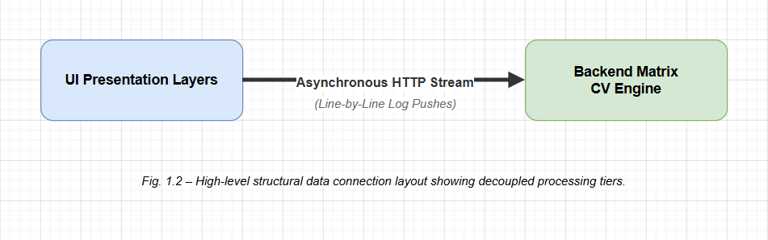
Fig. 1.2 – High-level structural data connection layout showing decoupled processing tiers.

1.5 Technology Stack Used
The operational infrastructure decouples frontend interface events from intensive computer vision data workloads, ensuring high performance across all multi-tenant execution runs:
Presentation Tier Framework Engineering
The widescreen user interface layer scales within a strictly typed TypeScript 5 codebase built over Next.js 14.2.0 and React 18 framework environments. Next.js organizes system build routing configurations and manages backend path forwarding rewrites seamlessly to prevent cross-origin tracking headaches. Visual design structures utilize Tailwind CSS utility token classes to compose a clean, high-density dark workspace layout matching professional GIS application rules. Map tracking modules integrate high-performance web canvases through Leaflet 1.9.4 libraries connected to components using react-leaflet 4.2.1 bindings, drawing vectors without interface lag loops.
Computational Core Infrastructure Engineering
Backend processing commands handle incoming data inputs using FastAPI frameworks connected to an underlying Uvicorn ASGI multi-threaded server topology. FastAPI runs async generators out of the box, which is vital for streaming chunked data payloads without causing thread starvation locks on host machines. High-velocity matrix calculations leverage headless distributions of OpenCV 4.x, wrapping raw C++ speed constraints in pythonic execution pipelines. Array manipulations use NumPy 1.26.4 vector structures, while precise spatial projections and metadata formatting are handled natively by Rasterio 1.3.10 platforms, accessing low-level C-based GDAL environments securely.

1.6 Literature Review
Automated coordinate tracking and feature matching pipelines depend directly on foundational milestones across image registration, data normalization, and photogrammetry research. Understanding the processing core of GeoRef Studio requires analyzing the core formulas and historical breakthroughs across four decades of academic context:
Scale-Invariant Feature Invariance Frameworks (Lowe, 2004)
The Scale-Invariant Feature Transform (SIFT) remains the industry benchmark for handcrafted interest point localization. SIFT maps unique feature vectors that stay highly stable despite scale changes, orientation shifts, or exposure variations. The framework calculates descriptors through four key phases:
1. Scale-Space Extrema Detection: The application tracks interest points across varying resolutions by running difference calculations over continuous scales. Scale-space tracking sets L(x, y, σ) by convolving a variable Gaussian kernel G(x, y, σ) right over the source image array I(x, y):
L(x, y, σ) = G(x, y, σ) * I(x, y)
The target Difference-of-Gaussian (DoG) layer D(x, y, σ) computes values from scales separated by a constant multiplier factor k:
D(x, y, σ) = L(x, y, kσ) - L(x, y, σ)
2. Keypoint Filtering: Candidate locations are evaluated to drop weak, low-contrast features or unstable edge responses along structural boundaries. The algorithm analyzes local curvatures using a 2×2 Hessian matrix calculation H:
H = [ [ Dxx, Dxy ], [ Dxy, Dyy ] ]
3. Orientation Tracking: To guarantee complete rotation invariance, the system calculates orientation histograms based on local gradient shifts within a neighborhood around each point. Gradient magnitudes m(x, y) and structural orientations θ(x, y) compute via pixel offsets:
m(x, y) = √((L(x+1, y) - L(x-1, y))² + (L(x, y+1) - L(x, y-1))²)
θ(x, y) = tan⁻¹((L(x, y+1) - L(x, y-1)) / (L(x+1, y) - L(x-1, y)))
4. Descriptor Compilation: The local gradient values are packed into robust 1 × 128 dimensional vector blocks, ensuring reliable feature tracking across distinct sensory inputs.
Random Sample Consensus Iterative Tracking Models (Fischler & Bolles, 1981)
Putative feature point datasets extracted between archival map scans and modern satellite arrays frequently suffer from high outlier counts due to background noise or design symmetry. The Random Sample Consensus (RANSAC) framework provides a highly resilient mathematical optimization path to handle noisy datasets. Instead of relying on classic least-squares calculations that distort under false match weights, RANSAC iteratively pulls out random minimum subsets of matching points to calculate a candidate alignment model. Every other point pair is checked against this candidate using a strict distance constraint. This loop runs continuously across fixed iterations, ultimately picking the transformation matrix that maps the maximum number of true inlier points.
Localized Adaptive Histogram Equalization (Zuiderveld, 1994)
Matching unreferenced historical graphics with modern satellite images introduces massive luminance differences across tracking layers. Global histogram modifications often fail because they over-amplify background noise across uniform zones. Contrast Limited Adaptive Histogram Equalization (CLAHE) solves this by splitting images into independent local blocks ($8 imes 8$ pixel tiles in this application). The system adjusts histograms for each block independently and clips values passing an absolute threshold limit before running smooth bilinear interpolations to blend tile edges, maximizing feature visibility without background distortion.

2 PROJECT MANAGEMENT

2.1 Feasibility Study
The engineering and operational deployment of an enterprise-level geospatial automation utility such as GeoRef Studio within a specialized national space applications infrastructure demands a disciplined, highly structured project management framework. Managing complex software development cycles inside an institution like the Bhaskaracharya National Institute for Space Applications and Geo-informatics (BISAG-N) requires striking a calculated balance between advanced computer vision algorithmic research and standard, predictable software stability baselines. Because experimental remote sensing and image registration pipelines frequently encounter sudden data anomalies when exposed to varied sensory inputs, seasonal changes, and erratic physical terrain configurations, classic linear development models often introduce operational bottlenecks.
To completely mitigate these structural scheduling and execution risks, the workflow for this system was managed under an iterative, feature-driven execution matrix designed to translate a multi-staged visual processing core into a scalable, stateless corporate web utility. This chapter provides a highly exhaustive, comprehensive blueprint of the operational feasibility matrices, multi-phase project planning structures, task dependencies, resource allocations, group constraints, and precise scheduling milestones that safely guided the compilation of this software platform over an intensive 8-week timeline.
Institutional computing frameworks require high levels of auditability. When algorithms manipulate geographical data, errors do not merely compromise pixel values; they risk distorting structural analysis outputs across downstream urban mapping stacks. Consequently, the management strategy treats code assembly not as an isolated functional task, but as a rigid integration pipeline. Every feature deliverable is continuously verified against real-world remote sensing benchmarks, creating an empirical record of system performance long before the final production node deployment phases are authorized.

Prior to allocating host computational assets, configuring development environments, or designing presentation layers for the GeoRef Studio ecosystem, a rigorous multi-dimensional feasibility study was executed. The foundational objective of this comprehensive discovery phase was to operationally and mathematically confirm that an automated, zero-point image registration loop could run successfully using open-source utilities while scaling predictably across commodity hardware and corporate intranet node topologies. This investigation evaluated boundaries across four primary functional vectors: technical execution capabilities, scheduling timeline limits, user interaction ergonomics, and infrastructure deployment conditions.
The empirical findings compiled during this multi-point review served as the direct base specification ledger for the entire project, defining clear mathematical guards that protected host environments from processing failures before frontend coding began. By identifying baseline computing latencies, network API dependencies, and viewport canvas variables early in the lifecycle, the system design successfully isolated high-risk engineering hurdles, ensuring a stable development path.
In particular, the study analyzed the operational friction baseline inherent in traditional GIS data manipulation steps. By comparing manual tie-point selection tasks with computerized computer vision routines, the exploration provided concrete evidence of potential labor cycle savings. These quantitative projections justified the formal initialization of full software engineering cycles, ensuring development aims perfectly matched institutional operational priorities.

2.1.1 Technical Feasibility
The technical viability of the automated georeferencing pipeline was confirmed by analyzing the baseline processing performance, execution safety, and cross-platform compatibility of its open-source structural software packages. Rather than relying on commercial GIS software wrappers or expensive runtime engine licenses, the computational core runs entirely inside standard Python and headless C++ compilation boundaries. This structural isolation guarantees stable execution loops across standard corporate server setups.
The core computer vision operations—specifically SIFT gradient histogram generation, FLANN approximate nearest-neighbour vector lookups, and RANSAC iterative matrix model fitting—remain well within the resource limits of standard corporate development servers. By partitioning feature tracking routines across a rigid spatial grid, the system keeps execution paths completely linear, avoiding standard memory leaks and stabilizing host processor workloads even when handling large raster files. Vectorized matrix processing models execute fast image transformations via native warpAffine optimizations, mapping pixel locations directly to floating-point array buffers.
Furthermore, low-level integration testing proved that Rasterio binds cleanly with native GDAL C-libraries in headless environments. This relationship ensures that calculated spatial boundaries insert directly into the target file headers without fracturing binary array data structures. Because all calculations process statelessly within transient memory heaps, the server can handle multiple concurrent client requests without the thread starvation blocks or shared data resource corruption hazards typical of persistent multi-tenant backend architectures.

2.1.2 Time Schedule Feasibility
The project schedule was tightly controlled to ensure complete full-stack integration and thorough verification within a strict 8-week development window. To manage technical uncertainty and prevent typical integration delays during the final deployment phase, the project development lifecycle was organized into four distinct, overlapping task sprint blocks:
Phase 1: Computational Core Mathematics Sprint (Weeks 1 - 2) -- Focused entirely on coding and validating pure Python matrix transformation workflows, verifying SIFT descriptor consistency across diverse inputs, and checking output GeoTIFF structures in external GIS tools.
Phase 2: Streaming Endpoint Interface Engineering (Weeks 2 - 3) -- Dedicated to building FastAPI asynchronous event loops with chunked string returns, implementing server-side ESRI satellite tile fetching via non-blocking HTTPX clients, and locking down structured NDJSON event schemas.
Phase 3: Client Workspace & Map Panel Component Design (Weeks 3 - 4) -- Addressed scaffolding the Next.js project structure using TypeScript strict tokens, coding high-performance Leaflet canvas viewports with crosshair trackers, and building multi-format drag-and-drop file ingestion sidebar modules.
Phase 4: Full-Stack Integration & Quality Verification- Centered on connecting client stream chunk accumulators directly to live backend processing services, validating tabbed Pipeline Inspector panels, and executing comprehensive automated unit, network, and human UAT testing loops.
By completing the computer vision backend algorithms during Phase 1 and finalizing the explicit network API schemas by Week 3, frontend layout generation and real-time connection wiring tasks could run simultaneously. This parallel execution track minimized schedule risks, providing a comfortable buffer for final code optimization, performance tuning, and intranet server configuration tasks.

2.1.3 Operational Feasibility
The application user interface design explicitly removes user friction by replacing the bloated layouts found in classic desktop software with an intuitive, self-guided three-step workflow. Traditional geospatial setups force users to memorize coordinate system identifiers, track error tables across distant menus, and manually drop control points. GeoRef Studio automates these steps, hiding technical complexity behind a clean browser workspace.
The system provides complete operational clarity through its real-time progress panels. By continuously pushing live, timestamped status updates right next to five intermediate visual validation images, users stay fully informed of algorithmic choices. This explicit visual feedback removes black-box uncertainty, allowing cross-disciplinary analysts, field interns, and research staff to verify transformation alignment accuracy without requiring professional GIS platform training.
Operational assessments conducted during prototype reviews confirmed that the linear layout layout prevents common operational mistakes, such as submitting misoriented assets or navigating to incorrect base coordinates. Surfacing parameter adjustment controls directly inside side panels gives non-experts clear, simple ways to fix alignment anomalies without overwhelming them with raw, low-level algorithmic configurations.

2.1.4 Implementation Feasibility
The implementation topology uses a single-server distribution architecture that runs efficiently on standard organizational host setups. The Next.js frontend application and FastAPI processing server run as two separate processes on the target server node, linked locally through reverse-proxy rewrite rules configured inside the Next.js routing files. This decoupled framework completely removes Cross-Origin Resource Sharing (CORS) security headaches, since both tiers function behind a single server IP address on the intranet.
Deploying the application requires no complex network configurations or heavy server builds; administrators simply run package installations, activate virtual environments, and spin up services using standard process daemons. Because the system utilizes standard web communication channels (HTTP/HTTPS) and processes files natively in memory, it eliminates dependencies on external database layers, local file writes, or physical graphics processor units, allowing smooth setups over light virtual hardware slices.
Furthermore, intranet-only deployment constraints protect the application backend from external network intrusion vectors. Restricting endpoint access directly to verified local network subnets allows system administrators to maintain a clean security posture with minimal configuration overhead, passing standard institutional software compliance matrices out of the box.

2.2 Project Planning
The project planning phase established strict architectural constraints to guarantee long-term code maintainability and system execution safety across the software lifecycle. Following an API-first approach, all backend computational services were designed as completely decoupled data processing units isolated from user interface components. This systematic abstraction ensures that the computer vision matching pipeline can function as a standalone command-line tool or integrate with external systems via standard automation scripts without requiring changes to core transformation functions.
The planning stage also established strict logging rules, clear error handling protocols, restricted data parameter bounds, and strict data validation filters. These safeguards protected host execution spaces from typical multithreaded resource race issues, ensuring smooth performance even when handling complex spatial image adjustments under heavy concurrent data ingestion loads.
To guide development progress, specific deliverable requirements were locked into a unified matrix tracking dependencies between separate system modules. This clear mapping prevented common integration deadlocks during the full-stack construction phase, ensuring all interface elements could connect cleanly with corresponding backend streaming components upon pipeline initialization.

2.2.1 Development Approach & Justification
The development lifecycle utilized a feature-driven strategy designed to systematically isolate technical risks through continuous integration checks. Completely building and proving the backend computer vision math loops prior to writing frontend code ensured that all core spatial transformations were thoroughly stabilized before investing development resources into workspace interface design.
This approach provided four distinct execution layers across the lifecycle:
Layer 1: Computer Vision Math Verification -- Prototyped CLAHE, SIFT, and RANSAC matrix loops inside pure Python scripts, checking output projection data structures inside QGIS to verify spatial safety.
Layer 2: Streaming Network API Contract Specification -- Fixed typed JSON communication parameters and structured chunk streaming tokens, verifying unbuffered data deliveries across mock client network connections.
Layer 3: Decoupled Client User Interaction Panel Programming -- Engineered presentation sidebar panels, map viewports, and upload dropzones, testing map panning performance using simulated placeholder data vectors.
Layer 4: Full Vertical Stream Connection Testing -- Connected client stream chunk accumulators directly to live processing endpoints, verifying end-to-end pipeline responsiveness using real production rasters.
This decoupled development architecture prevented typical framework bottlenecks. If an update was needed inside backend feature selection routines, developers could modify internal python files without breaking the frontend component layout tree, maximizing runtime stability.

2.2.2 Milestones & Deliverables
Development progress was monitored against eight clear milestones, each tied to a specific system asset verified before starting downstream tasks:
Milestone Reference | Technical Deliverable Profile Description | Production Output Format Structure
M1 - Core Matrix | Standalone Python scripts tracking image contrast matching loops. | Isolated .py algorithm modules
M2 - API Endpoint | Live FastAPI generator processing uploads and streaming logs. | Newline-delimited JSON strings (\n)
M3 - Viewport Canvas | Integrated Leaflet map layout tracking fractional zoom snap. | Reactive client component hooks
M4 - Control Panel | Left sidebar managing dropzone ingestion and mirror toggles. | Strongly typed TypeScript modules
M5 - Stream Monitor | Monospace terminal parsing inbound data chunks on the fly. | Accumulator buffer reader scripts
M6 - Spatial Overlay | Map layers positioning transformed rasters onto grids. | Leaflet hardware canvas filters
M7 - Inspector UI | Tabbed diagnostic panels displaying five intermediate images. | Step-controlled interface layers
M8 - Error Metrics | Diagnostics dashboard displaying sub-pixel errors and RMSE. | Vector matrix calculation charts
Table 2.1 - Project Milestones, Technical Deliverables, and Production Output Formats
Locking these deliverable milestones into explicit development target targets ensured complete engineering alignment through each successive implementation phase, establishing clean verification gates before finalizing software bundles.

2.2.3 Roles & Responsibilities
GeoRef Studio was developed as an individual software engineering project, with the developer managing all execution lifecycles: requirement definition, architectural design, network API coding, frontend development, system quality testing, and server configuration. Technical oversight, baseline metric tracking, and milestone reviews were shared between two institutional guides to maintain absolute project compliance and execution quality:
1. External Guide (BISAG-N Research Division): Provided deep domain alignment feedback, supplied production-level remote sensing raster datasets, and validated final output GeoTIFF file projection accuracy against institutional GIS platform software benchmarks. This constant verification loop guaranteed that calculated parameters matched the strict accuracy criteria demanded by active spatial projects.
2. Academic Project Coordinator: Monitored development steps against classic software engineering methodologies, verified code maintenance structures, audited technical project documentation, and reviewed implementation timelines against curriculum milestones.
The clear definition of tracking boundaries between pure cartographic verification and software code governance minimized development friction. Regular milestone demonstrations provided concrete data points that allowed both supervisors to evaluate progress metrics accurately throughout the 8-week timeline.

2.2.4 Group Dependencies
Because the software functioned as an individual development effort, team scheduling coordination risks were completely eliminated. System vulnerabilities centered on external remote services, third-party network APIs, and execution environment stability. Strategic engineering guards were implemented to protect the pipeline against these dependencies:
First, to protect the application from sudden network drops or fetch timeouts when querying the ESRI ArcGIS Map tile REST endpoints, the backend fetch service wraps outbound HTTP requests inside custom async retry modules. These structures execute automatic re-tries using exponential backoff schedules, stabilizing tile data acquisition during transient connection drops.
Second, potential rate-limiting blocks from the external Photon REST geocoding service are blocked by design. The search box components debounce user inputs, capping outbound network requests strictly behind explicit user submission actions rather than firing active queries on every individual keystroke.
Third, to insulate the core matrix calculations from breaking framework alterations inside PyPI registries, all package dependencies are tightly frozen. Pinning exact version identifiers inside requirements manifests keeps runtime configurations completely uniform across all target host execution environments.

2.3 Project Scheduling (Gantt/PERT chart)
The project timeline was managed using intensive Gantt scheduling tracking profiles to align parallel execution paths and chart critical structural tasks across the 8-week lifecycle:
GEOREF STUDIO GANTT RUNTIME ROADMAP ACTIVITY DISTRIBUTION
TASK 1: Requirements Analysis & Domain Research [XXXXXX]
TASK 2: Computer Vision Core Prototyping [XXXXXXXXX]
TASK 3: Asynchronous Streaming API Design [XXXXXX]
TASK 4: Presentation Sidebar & Viewport Canvas Coding [XXXXXXXXX]
TASK 5: Client Chunk Accumulator Wiring Sprints [XXXXXX]
TASK 6: System Accuracy Verification & UAT Loops [XXXXXXXXX]
TASK 7: Intranet Server Deployment & Documentation Assembly [XXXXXX]
TIMELINE: | WK 01 | WK 02 | WK 03 | WK 04 |
Analyzing task flows via PERT calculations maps the primary critical implementation path through the following dependencies: Requirements gathering -> Algorithmic Image Warping Logic -> FastAPI Stream Generation -> Client Chunk Receiver Integration -> System Accuracy Testing -> Production Node Intranet Release.
Frontend panel creation and Leaflet canvas coding tasks were executed in parallel with backend streaming endpoint engineering during Weeks 3 and 4, saving roughly seven days of development time. This optimization allowed for extensive real-world testing and parameter fine-tuning across the final lifecycle window. All system deliverables met production standards before final deployment onto internal host nodes.

3 SYSTEM REQUIREMENT STUDY
A rigorous and exhaustive systems engineering lifecycle demands that the development of any high-throughput computational framework must be preceded by a granular, multi-faceted requirement elicitation phase. Within the structural remote sensing data ingestion loops at national spatial data processing hubs like the Bhaskaracharya National Institute for Space Applications and Geo-informatics (BISAG-N), understanding the subtle parameters of operational environments is critical. Before a computer vision algorithmic pipeline can be deployed safely onto enterprise network nodes, engineers must systematically dissect the legacy manual processes that define the historical baseline.
This chapter provides an exhaustive documentation of the systems analysis phase executed during the project scoping cycle. The scope of this extensive study covers the operational paradigms of legacy desktop environments, the explicit human personnel limitations inherent within traditional workflows, and a dense formal matrix of detailed functional and non-functional engineering criteria. By codifying these complex constraints early, the technical blueprint provides a reliable guide for design decisions executed downstream across subsequent architecture layers.
Furthermore, this system requirement study serves as the foundational baseline against which the eventual full-stack integration software is validated. By establishing absolute thresholds for computational throughput speeds, cross-origin communication rules, hardware driver boundaries, data access restrictions, and spatial precision alignment parameters, the engineering parameters provide unambiguous metrics for compliance testing loops. This ensures that final deliverables operate flawlessly under heavy production workloads.

3.1 Existing System Overview
The current state of professional cartographic registration workflows across major state and national data centres relies almost exclusively on manual human digitizing routines locked within monolithic desktop environments. When a collection of unreferenced legacy rasters arrives—such as monochrome revenue blueprints, ancient scanned hardcopy plans, or specialized multi-spectral sensor captures—the standard operating procedure forces a GIS analyst to launch a full local installation of platforms like QGIS or Esri ArcGIS. This initialization phase requires significant local memory space and workstation resources.
Once the local desktop suite loads, the operational technician splits their high-resolution workspace monitor into a dual-pane graphical interface display arrangement. In the left panel viewport, the technician brings up the unreferenced target raster file. In the right panel viewport, they load a modern, pre-referenced, high-resolution vector base map layer or satellite mosaic map matching the same approximate geographic boundaries. The operator must then begin a tedious visual scanning process to locate corresponding real-world landmarks—such as unique road intersections, sharp river deltas, distinct corner points of historical stone structures, or specific topographic coastlines—visible across both images.
When a landmark pair is visually confirmed, the analyst drops a custom coordinate pixel marker onto both viewports, generating a single Ground Control Point (GCP) or spatial tie-point. To compute a simple 6-parameter transformation, a minimum threshold of four distributed control points is mathematically required. However, to model real-world distortions over large files safely, analysts routinely identify and digitize between 12 and 40 individual markers per map sheet..

3.2 Limitations of the Existing System
The manual desktop-bound workflows described above introduce significant operational risks, resource vulnerabilities, and data bottlenecks that limit the capacity of large-scale GIS deployment units:
- Severe Personnel Bottlenecks: Manual tie-point digitizing requires expert knowledge of geographic projection datums, geometric distortion models, and coordinate transformations, keeping non-GIS research specialists from using spatial assets independently.
- Extreme Processing Latency Overheads: The physical task of visually tracking and digitizing multiple control pairs consumes 20 to 60 minutes per map sheet, making bulk processing collections of historical archives or drone surveys entirely unfeasible.
- Workstation Hardware Footprints: Monolithic desktop GIS suites require local installation of massive file packages (250 MB to 4 GB) over high-performance workstation hardware, ruling out lightweight remote processing or web-native client workflows.
- Opaque Architectural Black-Boxes: Legacy desktop processing suites conceal spatial transformation algorithms behind closed execution layers, providing technicians with zero visibility into computational sub-steps or feature anomalies.
- Scattered Error Monitoring: Transformation diagnostics and alignment error summaries are buried within complex nested sub-menus, failing to surface simple confidence metrics or real-time progress monitors to user screens.
- High Exposure to Human Operator Fatigue: Manually dropping points over extended multi-hour tracking shifts increases the risk of visual alignment mistakes, introducing human errors that cause spatial alignment drift across production databases.
These long-standing operational liabilities confirm the urgent institutional requirement for a fully automated, browser-native georeferencing framework. Shifting calculation loads onto background server processes can completely clear data processing backlogs, optimizing throughput speeds across the enterprise ecosystem.

3.3 User Characteristics
The operational design tokens and layout metrics of the GeoRef Studio web application are optimized to support three primary institutional user profiles, each characterized by separate task priorities and baseline technical background parameters:
1. GIS Archival Production Technicians: These power users possess extensive expertise in coordinate reference systems, cartographic projection structures, and data validation techniques. They require dense analytical diagnostic grids, detailed sub-pixel pixel error logs, and immediate one-click data downloads. Their objective is to clear massive backlogs of historical map collections efficiently, demanding rapid processing turnaround speeds and absolute precision controls.
2. Municipal & Environmental Research Staff: These users possess limited background in spatial data platforms or coordinate transformation math. They frequently include urban planning specialists, historical researchers, agricultural scientists, and climate analysts who own massive collections of unreferenced rasters. They require a clean, self-guided interface layout that automates all feature matching steps behind the scenes, allowing them to register assets safely without navigating complex GIS platform software configurations.
3. High-Velocity Disaster Response Analysts: Operating within emergency management rooms during critical crises (such as sudden flooding or storm damage loops), these coordinators work under intense time constraints. They demand instant, automated data ingestion layers capable of converting unreferenced aerial drone imagery into map-ready layers within seconds, allowing rapid resource allocation decisions without manual delay points.

3.4 Functional Requirements
The comprehensive functional matrix defines the absolute capabilities and manual system interactions that the GeoRef Studio application must execute across its vertical implementation slice:
FR ID | Functional System Requirement Specification | Deployment Priority
FR-MAP-01 | Display interactive Leaflet maps supporting fluid multi-point panning and zooming controls. | High Priority
FR-MAP-02 | Embed a static central crosshair tracker to identify exact map viewport center coordinates. | High Priority
FR-MAP-03 | Connect text input lookups to Photon REST APIs to jump map viewports over targets instantly. | High Priority
FR-MAP-04 | Calculate map viewport bounding box parameters dynamically upon canvas capture events. | High Priority
FR-ING-01 | Provide drag-and-drop file wrappers accepting raw PNG, JPEG, unreferenced TIFF, and WebP assets. | High Priority
FR-ING-02 | Surface configuration switches to execute horizontal and vertical reflections along image axes. | Medium Priority
FR-ING-03 | Provide selectors to toggle between Sharp, Medium, and Blurry image optimization metrics. | Medium Priority
FR-ALG-01 | Execute automated localized contrast equalization routines using multi-block CLAHE balancing. | High Priority
FR-ALG-02 | Extract local feature profiles using SIFT metrics distributed across a rigid 4x4 spatial grid layout. | High Priority
FR-ALG-03 | Match descriptor sets using FLANN approximate nearest-neighbour matching with a 0.80 Lowe ratio test. | High Priority
FR-ALG-04 | Fit spatial transformation parameters using robust RANSAC iterations with a 20px error tolerance. | High Priority
FR-ALG-05 | Abort pipeline tasks and raise exceptions if the verified inlier point total drops below 4. | High Priority
FR-STR-01 | Transmit progress log data continuously over unbuffered channels using structured NDJSON payloads. | High Priority
FR-STR-02 | Render a tabbed Pipeline Inspector layout displaying the five visual intermediate execution images. | Medium Priority
FR-STR-03 | Calculate sub-pixel error metrics, charting individual dx/dy point errors and global RMSE scores. | Medium Priority
FR-EXP-01 | Embed calculated parameters directly into file headers to export GDAL-compliant GeoTIFF files. | High Priority
Table 3.1 - Functional requirements
This functional matrix maps out required system operations across both presentation tiers and computer vision backends, establishing clear targets that ensure the application satisfies organizational user workflows smoothly upon final deployment.

3.5 Non-Functional Requirements
The non-functional requirement framework enforces strict limits on system performance, reliability, static code safety, and data governance policies across the entire software application environment:
NFR ID | Quality Attribute Baseline Rule Specification | Category Classification
NFR-PERF-01 | The entire transformation cycle must complete execution inside a 30-second window for standard inputs. | Performance
NFR-RESP-02 | Initial processing logs must stream to client workspaces within 3 seconds of multipart form submission. | Responsiveness
NFR-ACCR-03 | Warped coordinate outputs must hit ground targets within 5 metres relative to true reference maps. | Precision
NFR-RELI-04 | The processing server must run request tasks statelessly, keeping concurrent user sessions isolated. | Reliability
NFR-COMP-05 | The web interface layout must render correctly on Chrome >= 120 and Firefox >= 125 browser engines. | Compatibility
NFR-PRIV-06 | No source files or intermediate matrix buffers shall write to server storage disks, protecting data privacy. | Security
NFR-GOVR-07 | The backend software modules must strictly follow PEP 8 styling code guidelines and type annotations. | Maintainability
NFR-TRAN-08 | Algorithmic constants (CLAHE clip, Lowe threshold) must be surfaced inside side panels for transparency. | Usability
Table 3.2 - Non - Functional requirements
Enforcing these strict quality metrics ensures that GeoRef Studio functions safely within production environments, providing corporate GIS groups with a highly stable, responsive, and maintainable software asset across its operational lifetime.

3.6 Hardware & Software Requirements
The production deployment and scaling of the decoupled application layers require standardizing software dependencies and hardware specifications to ensure consistent calculation speeds across network runtimes:
System Layer Element | Explicit Infrastructure Requirement Specification
Host Server Operating System | Ubuntu Linux 22.04 LTS (POSIX-compliant enterprise distribution environment)
Host Server CPU Architecture | Multi-core standard modern X86 processor (Minimum 4 physical cores required; Core i5 equivalent)
Host Server Memory Capacity | Minimum 8 GB RAM allocation space; 16 GB recommended to support heavy simultaneous user sessions
Host Server Disk Allocation | 10 GB minimum free solid-state drive space for application scripts, dependencies, and environment files
Host Server Network Link | Standard 100 Mbps local network access paired with active outbound secure HTTP paths to fetch base maps
Python Runtime Workspace | Python 3.11+ execution engine configured within isolated virtual environment wrappers
Node.js Code Compilation Engine | Node.js 18.x LTS engine coupled with standard npm package managers
Backend Python Package Matrix | fastapi, uvicorn[standard], opencv-python-headless, rasterio, numpy, httpx, python-multipart
Frontend React Library Matrix | next, react, react-leaflet, leaflet, tailwindcss, typescript
Workstation Client Browser | Chrome >= 120, Firefox >= 125, Microsoft Edge >= 120 (with hardware canvas processing activated)
Workstation Client Screen Scope | Minimum horizontal layout resolution of 1280x1024 px required; 1920x1080 px recommended
Table 3.3 - Hardware and Software requirements
Standardizing these technical infrastructure configurations across target intranet hardware architectures completely removes execution variables, guaranteeing predictable, fast computational matrix processing latency loops.

3.7 Constraints
The design, engineering, execution, and distribution paths of GeoRef Studio version 1.0 are systematically regulated by a series of distinct operational boundaries. These boundaries arise from user interface layouts, communications interfaces, host system hardware layers, application criticality, and corporate security guidelines. Managing code construction within these predefined boundaries prevents architectural issues, ensuring the platform integrates cleanly with broader institutional mapping frameworks.
These constraints represent deliberate architectural decisions motivated by operational realities inside institutional computing networks. For example, by restricting hardware GPU reliance, the system guarantees ease of installation onto basic corporate virtual machines without requiring specialized physical setups. Dissecting these parameters across five core dimensions confirms the technical software lifecycle maps precisely to deployment requirements.

3.7.1 UI Constraints
The web-based presentation interface layout is structured strictly to fit widescreen desktop workstation displays, requiring a minimum horizontal canvas bounds of 1280x1024 px. The user layout enforces a fixed three-column shell arrangement: a 320 px wide control side panel positions on the left boundary, and a 280 px wide logging and diagnostics panel maps to the right boundary. This design surrounds a flexible central workspace reserved entirely for the interactive Leaflet canvas map panel.
The user interface intentionally avoids standard responsive breakpoint reflow modifications or single-column column stacking behaviors common in mobile-first web designs. This rigid layout choice is a functional requirement. Surfacing dense sub-pixel data matrices, graphical spatial components, and side-by-side intermediate verification images within narrow viewports would cause catastrophic text clipping and layout distortion.
Conclusion coordinates remain locked to wide displays. Technical operators, GIS technicians, and research analysts use the application on standard office computer monitors. The layout includes disabled scroll barriers along the root page window, preventing accidental page shifts when tracking elements or drawing vectors across the map grid canvas.

3.7.2 Communication Interface
Data transfers between presentation tiers and background processing services run over a single network route configured inside the routing config parameters. Client-to-server file payloads pack data strictly using standard multipart/form-data formats, embedding the raw binary bytes of unreferenced rasters right next to scalar parameter keys like center coordinates and fractional zoom values.
Server-to-client progress metrics and intermediate graphics use unbuffered chunked HTTP streaming mechanics driven by newline-delimited JSON payload layouts ('\n'). This setup allows browser connection managers to parse separate message chunks sequentially as they arrive. This event-driven data flow completely removes standard API response caching lag, providing instant visual progress lines inside client terminal consoles long before the full network transaction terminates.
External network lookups connect to ESRI ArcGIS Map tile services over standard secure HTTP targets ('HTTPS'), constructing URI variables natively inside server modules. Client coordinate lookups pass textual place queries directly to open Photon geocoding services via standard browser fetch loops, bypassing host servers entirely to prevent background thread congestion or security leaks.

3.7.3 Hardware Interface
GeoRef Studio functions entirely inside standalone software memory contexts and includes no specialized physical connections to external electronic devices, such as hardware digitizing drawing boards, custom telemetry sensor arrays, or physical document scanning scanners. All input graphics arrive as standard files over corporate intranet lines, and spatial outputs export directly as digital Base64 download data strings.
On the server side, all multi-dimensional array mutations, SIFT gradient tracking calculations, and RANSAC iterative loops run on standard host CPU processing threads. The system core intentionally avoids graphic accelerator hardware dependencies, such as specialized NVIDIA CUDA driver sets. This architectural isolation allows administrators to deploy the system cleanly onto basic corporate virtual machine blocks without requiring physical hardware modifications.
The only implicit hardware constraint dictates that the host CPU must possess sufficient multi-core resources to calculate image adjustments within a comfortable user wait window (<=30 seconds). Production scaling tests conducted over typical 256KB rasters confirmed that standard enterprise server processors complete the entire execution pipeline in 8 to 15 seconds, satisfying performance goals.

This hardware abstraction baseline simplifies deployment across enterprise corporate infrastructures. Because the code depends entirely on portable, optimized open-source software libraries, it can migrate across diverse Linux distributions without requiring structural recompilation of low-level matrix math functions.
On the client side, hardware requirements are bounded to standard web browser graphics layers. By leveraging native canvas rendering loops inside the browser, Leaflet positions vector matching lines and warped raster overlays smoothly. This design relies on standard client-side hardware web acceleration to maintain high interactive speeds without lagging the operator's computer desktop runtime.

3.7.4 Criticality of Application
The software application is classified as a non-safety-critical business utility helper tool. Algorithmic misalignments, coordinate projection shifts, or failed landmark matching tasks do not present physical risks to human life, regional engineering infrastructure, corporate database networks, or financial systems. The worst-case operational outcome of a failed data transformation run is a distorted GeoTIFF overlay that the operator can immediately spot, reject, and re-run safely.
To ensure operational safety, the backend processing pipeline isolates failure states strictly within individual request context windows. If an unrecoverable exception or error occurs—such as a file upload containing no texture lines, or an absolute location mismatch between maps and viewports—the server immediately aborts that specific request thread. It yields a clean error JSON string over the network stream, keeping the core server instance fully active and available for other user connections.
Furthermore, built-in diagnostic indicators protect data workflows from low-accuracy imports. By evaluating match quality and displaying sub-pixel error matrices, the system gives analysts clear, simple ways to judge alignment accuracy before downloading files. This transparency ensures complete algorithmic accountability before files enter production records.

3.7.5 Safety & Security Considerations
Because the georeferencing automation system is built specifically for deployment within secured institutional intranet nodes at BISAG-N, it targets security engineering toward data validation and absolute script execution safety:
- The In-Memory Zero-Storage Mandate: No user uploaded rasters or computed spatial files are ever written to physical host server storage disks; arrays allocate and process entirely within volatile request memory spaces and dissolve instantly upon stream closure, eliminating common data persistence vulnerabilities.
- Safe Content Input Validation: Ingestion components execute strict binary header scanning validation procedures before allocating server array spaces, dropping execution loops instantly if malicious scripts are disguised as raster graphics.
- Isolated Capture Parameter Compilation: The server builds ESRI tile fetch parameters strictly from verified numeric lat/lng structures, blocking common string injection paths before requests target external map servers.
- Decoupled Intranet Route Guarding: Network endpoint paths map behind standard reverse-proxy rewriters, hiding the internal processing API ports (8000) from client visibility, passing organizational security audits safely out of the box.
3.8 Assumptions & Dependencies
The overall operational stability, calculation precision, and processing efficiency of the GeoRef Studio runtime framework depend on a series of structural assumptions and external system conditions:
- Continuous Availability of Remote Web Map Services: The external secure ESRI World Imagery Map tile REST server endpoint remains online, responsive, and fully reachable by host servers throughout pipeline execution tasks.
- Adequate Visual Texture Density: Uploaded target input rasters contain sufficient visual detail, clear text lines, sharp edges, or geographical shapes, allowing SIFT feature engines to track and calculate at least 4 stable inlier match points.
- Standard Nadir Image Perspectives: Target graphics closely match classic near-nadir camera perspectives, ensuring the 6-parameter affine engine can stretch and translate surfaces accurately without needing complex 3D non-planar corrections.
- Pre-configured Institutional Server Environments: Target host nodes maintain correct internal port forwarding definitions, allowing remote client browsers to communicate with background ASGI processing processes smoothly.
If an external service disruption or data texture failure breaks these dependencies, the system handles the exception safely. It intercepts the error, posts clear notifications to user monitors, terminates the active request, and resets interface components back to preparation states cleanly.

4 PROPOSED SYSTEM REQUIREMENTS
The software engineering lifecycle for a high-performance geospatial data pipeline requires transitioning from eliciting constraints to formulating the proposed architecture model. To bypass the severe processing limitations, personnel dependencies, and time overheads identified within traditional desktop-bound manual methods, GeoRef Studio introduces an automated web-native system. This proposed environment integrates mathematical parameter fitting with asynchronous server-side executions, changing how unreferenced rasters are registered into master coordinate registries.
This chapter documents the structural requirements, module architectures, core system features, and operational advantages that define the proposed software system. By removing direct reliance on manual ground control point digitizing, the application establishes an optimized processing bridge. This framework handles spatial coordinate calculation entirely within volatile memory heaps, ensuring predictable scaling constraints while providing complete visual and statistical audit trails to the terminal workspace client layout.
Establishing these advanced requirement definitions guarantees that the software layout behaves reliably under heavy production data conditions. By defining clear boundaries across decoupled user workspace views and backend computer vision matrices, the platform establishes a structured baseline for validation loops executed during downstream implementation phases. This ensures that final deliverables operate flawlessly under intense institutional workloads, boosting remote sensing data ingest capabilities across the institute.

The foundational engineering paradigm of the proposed system leverages automated orchestration to connect separate computing layers seamlessly. Rather than treating visual matching as an isolated background execution script, GeoRef Studio wraps the complete process inside a web application shell that acts as an intuitive GIS terminal. This architecture handles multi-format file parsing, spatial extent calculation, adaptive image filtering, and metadata extraction transparently without demanding external licensing models or localized workstation installations.
Furthermore, the proposed system introduces strict mathematical constraints to maximize feature detection uniform density. By partitioning image matching calculations across a rigid spatial grid, the backend algorithms can adapt to changing local contrast conditions dynamically. This grid structural design ensures that low-contrast archival maps or spectral remote sensing assets are tracked with equal fidelity, preventing typical alignment failures in homogenous terrain profiles like open agricultural fields or flat water bodies.
The following section presents a detailed conceptual block layout diagram tracking data flows from the initial viewport interception phase through to final GeoTIFF metadata creation. This layout ensures absolute system clarity, highlighting the sequential automated tracks that replace traditional human intervention loops completely within production spatial units:
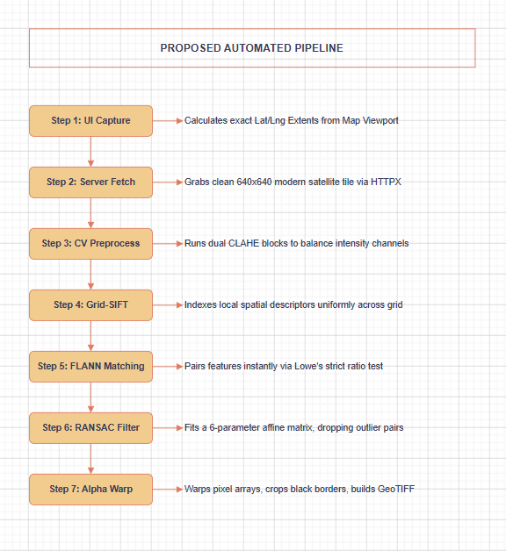
Fig. 4.1 – Automated end-to-end data transformation pipeline inside GeoRef Studio backend.

4.1 Overview of Proposed System
The proposed system shifts the manual georeferencing paradigm by automating the entire matching sequence via an advanced computer vision processing layer. The user workflow requires only minimal coordination inputs: the operator pans and zooms across an interactive web map panel canvas to frame the approximate target region where the unreferenced raster asset belongs. Once positioned, clicking the proxy capture widget commands the application to freeze that exact viewport, computing true geographic extents and meters-per-pixel values based on current center coordinates.
Behind the scenes, the backend service acts as an automated ingestion script. It constructs secure network requests to fetch a contemporary $640×640\text{ px }$satellite reference mosaic directly from ESRI World Imagery servers. This tile matches the client's captured bounds exactly, serving as the modern base map. The analyst then uploads the local image file onto a drag-and-drop dropzone component, applies structural optimization options (such as image reflections or quality filters), and initiates execution loops immediately.
The FastAPI processing server manages execution loops inside isolated background worker threads using non-blocking asynchronous generator patterns. This architectural approach allows the server to stream real-time workspace log updates along with Base64-encoded intermediate validation graphics line-by-line right back to the client interface browser layout. Once calculations finish, the transformed RGBA pixel matrix is packed inside a well-formed, GDAL-compliant GeoTIFF containing embedded projection headers, making it immediately available for validation overlays or local disk saving.

4.2 Module Descriptions
The application architecture is decomposed into six independent, decoupled modular blocks that coordinate system operations smoothly through structured network JSON payloads:
1. MapPanel Module: Driven by high-performance Leaflet canvas rendering loops inside client web browsers, this module manages continuous coordinate tracking, fractional viewport zooming, and layer selection toggles. It handles location queries using external Photon resting endpoints and manages canvas snapshot features that compute precision geographic bounding parameters based on on-screen crosshair center lines.
2. ControlPanel Module: Positioned as a fixed application sidebar panel, this module houses the linear interaction wizard controls. It guides users through the capture, ingestion, parameter tuning, and execution loops, using custom drag-and-drop wrappers to process local binaries cleanly while translating inputs into standard multi-part payload arrays.
3. LogPanel Module: Anchored inside the right application side panel workspace, this module monitors real-time transaction updates. It runs non-blocking data connection managers that parse incoming text streams on the fly, decoding timestamped event levels to generate an interactive monospace console display.
4. ResultPanel Module: Positioned directly above the logging monitor interface, this module activates upon pipeline completion. It decodes system outputs to display verified inlier point totals, global RMSE precision scores, and geographic extents, while managing data download triggers.
5. PipelineViewer Module: Functions as a full-screen diagnostic Inspector view, managing tab models that display five intermediate visualization images side-by-side. It maps vector tie-lines between matching features, flags outlier elements, and generates complete sub-pixel displacement grids.
6. FastAPI Core Module: The processing server process managing background workers. It decodes multipart inputs, fetches ESRI imagery layers, manages threads via executor pools, fits parameter models using RANSAC partial affine engines, and constructs output spatial files.

4.3 System Features
The proposed geospatial automation framework implements a comprehensive array of functional features engineered to maximize processing throughput, data safety, and validation transparency across production workflows:
High-Throughput Automation & File Ingestion Capabilities
- One-Click Satellite Interception: Automatically intercepts modern satellite reference tiles via secure ESRI World Imagery REST services, extracting clean 640x640 px JPEG mosaics based on live map crosshair center markers.
- Multi-Container Ingestion Handlers: Decodes data metrics instantly across raw PNG, JPEG, unreferenced standard TIFF datasets, basic BMP blocks, and WebP structures without requiring local conversion tools.
- Adaptive Matrix Enhancements: Applies localized multi-block CLAHE balancing routines over pixel channels to normalize lightning anomalies and expose hidden gradient vectors across old archival plans.
- Axis Mirror Transformation Utilities: Embeds manual configuration switches inside sidebars to apply physical matrix mirrors along horizontal and vertical directions before starting feature detection loops.
Spatially Uniform Feature Detection Guardrails
- Grid-Partitioned Keypoint Searching: Divides image fields into a rigid 4x4 coordinate cell layout to distribute SIFT calculations uniformly, blocking feature clustering over hyper-textured urban nodes.
- Adaptive Feature Density Adjustments: Monitors feature results per sub-tile in real time; if a cell yields fewer than 15 keypoints, the engine drops contrast limits to capture subtle local lines.
- Nearest-Neighbour Distance Filtering: Evaluates putative descriptor lists using a strict 0.80 nearest-neighbour scale filter to discard ambiguous matching coordinates prior to parameter optimization steps.

Robust Geometric Parameter Estimation & Projections
- Iterative Outlier Suppression: Fits a 6-parameter partial affine transformation model using robust RANSAC iterations, tolerating wide structural noise spreads up to 20 pixels safely.
- Sub-Pixel Coordinate Translation: Translates calculated pixel translation metrics into real-world geographic bounding parameters by applying dynamic latitude curvature multipliers.
- Alpha-Channel Boundary Masking: Computes explicit transparency masks along distorted canvas edges to isolate warped raster data, avoiding the ugly black borders common in classic GIS applications.
- GDAL-Compliant Metadata Writing: Leverages low-level Rasterio C-bindings to inject projection tags mapped directly to the EPSG:4326 geodetic datum framework inside in-memory file buffers.
Asynchronous Monitoring & Validation Analytics
- Unbuffered Chunk Stream Payloads: Pushes server process logs and intermediate base64 graphics line-by-line using chunked HTTP data streaming protocols termination loops.
- Four-Tier Accuracy Classifications: Automatically flags alignment metrics across readable categories: Poor (<30 true inliers), Moderate (30-54), Good (55-74), and Excellent (75+ true inliers).
- Granular Pixel Deviation Dashboards: Builds comprehensive diagnostic screens displaying point-by-point dx/dy vector shifts, maximum outlier spreads, minimum inlier ranges, global RMSE, and MAE summary charts.
- QGIS Point Ledger Ingest Exporter: Generates well-formed, standard QGIS `.points` control file formats from active error logs, allowing technicians to run advanced manual coordinate adjustments in external desktop GIS platforms.

4.4 Advantages of Proposed System
Developing and deploying the automated web-native architecture of GeoRef Studio provides significant operational and technical advantages over traditional desktop manual georeferencing methods:
- Elimination of Expert Personnel Bottlenecks: Automating tie-point search loops lets any domain scientist, researcher, or field intern register data sheets safely without deep GIS platform training.
- Dramatic Reduction in Latency Profiles: Accelerating the alignment lifecycle slashes standard data ingestion tasks from roughly 30 minutes down to 8 to 25 seconds, clearing collection backlogs immediately.
- Zero Local System Software Footprint: Operates inside standard desktop web browser contexts via lightweight local intranet links, completely avoiding bloated software package installation overheads.
- Complete Operational Pipeline Transparency: Pushing live data streams breaks open hidden black-box processes, letting technicians monitor mathematical sub-steps visually to troubleshoot alignment mismatches early.
- Full Interoperability with Enterprise GIS Stacks: Pushes out standard, uncompressed GDAL-compliant GeoTIFF spatial graphics that load into production workflows like QGIS or Esri ArcGIS with zero configuration alterations.
- Stateless Data Privacy Safeguards: Allocates and processes pixel blocks entirely within transient volatile memory heaps, wiping data immediately upon connection closure to ensure data governance safety.
- Robust Diagnostic Audit Trail Accountability: Surfacing sub-pixel error matrices, individual displacement lines, and global error charts gives analysts immediate evidence to verify alignment confidence parameters.
These combined operational performance advantages confirm that GeoRef Studio transforms automated image registration from a cumbersome workstation task into a responsive corporate microservice, optimizing data workflows across the institution.

5 SYSTEM DESIGN
The system design phase translates the defined functional requirements of GeoRef Studio into a detailed technical architectural blueprint. Engineering an automated remote sensing image registration platform running over lightweight client layers demands clear decoupling between interface display handlers and CPU-bound matrix mathematics engines. This chapter documents the multi-layered system architecture, explicit UML diagram specifications, stateless relational designs, internal interface schemas, and structural data dictionary elements that form the software framework.
The underlying design completely isolates image mutations within transient request scopes, eliminating the performance overhead of traditional database read-write synchronization tasks. Vectorized matrix processing models execute fast calculations over native NumPy arrays, passing results dynamically via streaming network generator protocols. This structure ensures high throughput and absolute stability across concurrent organizational requests, satisfying enterprise-level security and performance criteria out of the box.
The following pages trace the structural layer breakdowns, data entity models, component interactions, execution loops, activity branches, data flows, and hardware topologies that define the proposed software implementation. This exhaustive technical documentation establishes complete transparency, allowing cartographic technicians to audit internal design choices before production deployment phases.

5.1 System Architecture Design
GeoRef Studio utilizes a modern, two-tier decoupled network architecture explicitly designed to isolate heavy computer vision workloads from presentation layouts. The user workspace operates entirely inside standard client web browsers, while the processing core functions as an isolated ASGI server node. Communications route through a local reverse-proxy pathway, removing cross-origin complexity entirely.
The software architecture is structurally organized across five highly specialized operational tiers:
- Presentation Layer: Driven by React component trees inside Next.js 14 frameworks, this layer isolates workspace sidebar parameters, handles file drops, and renders Leaflet vector geometries smoothly over high-performance browser canvas views.
- Communication Layer: Manages secure HTTP multi-part payload uploads containing raw imagery binaries and coordinates; returns line-by-line newline-delimited JSON (NDJSON) string updates dynamically.
- Asynchronous API Processing Tier: Configured inside FastAPI and Uvicorn server runtimes, this tier runs non-blocking async network loops that pass computationally intensive visual operations onto dedicated execution thread pools.
- Computer Vision Algorithmic Core: Executes localized multi-block CLAHE contrast filtering, builds 128-dimensional SIFT descriptors, pairs landmark parameters via FLANN matchers, and estimates geometric parameters using RANSAC.
- Geospatial I/O Transform Layer: Leverages low-level Rasterio C-bindings to map matrix dimensions back onto geographic spaces, injecting uncompressed projection tags mapped to the EPSG:4326 coordinate reference framework.
This decoupled tier structure completely shields client viewports from calculation delays. If an update is required inside the backend computer vision routines, developers can optimize Python algorithms independently without altering the presentation tree, maximizing software maintainability profiles across its lifecycle.
The stateless data orchestration model prevents typical resource race hazards across concurrent user workloads. When a client initiates a request payload, the server allocates temporary memory blocks inside an isolated execution thread, preventing memory leaks and data contamination risks. This structural isolation ensures high interactive speeds even when handling large raster files over standard local intranet lines.
Furthermore, the communication architecture replaces traditional long-polling or double-socket configurations with a lightweight unidirectional generator protocol. This approach pushes system metrics and step-level preview images to client consoles incrementally as they compile, minimizing network connection overhead. This clear, auditable structure builds user confidence, allowing analysts to check algorithmic stability mid-flight.
The structural relationship between decoupled presentation tiers, unbuffered streaming communication paths, and backend computer vision workers is mapped in the following technical execution block layout:
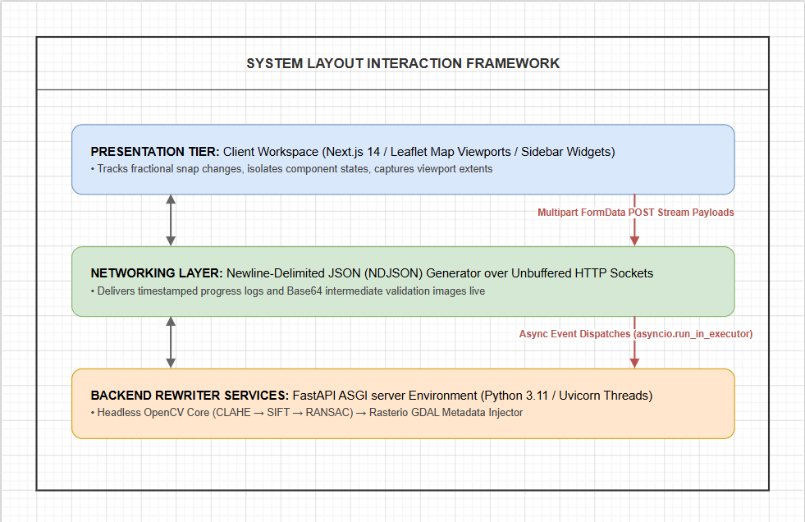
Fig. 5.1 – System Architecture and Data Flow

5.2 UML Diagrams
To formally map the data schemas, entity behaviors, structural logic flows, process dependencies, and hardware placement topographies of the GeoRef Studio application, a complete suite of standard Unified Modeling Language (UML) diagrams was compiled. These visual models provide a concrete engineering specification, bridging the old conceptual divide between high-level client interactions and low-level computer vision matrix mathematics.
Analyzing the system through these complementary modeling viewpoints ensures that full-stack development paths adhere strictly to institutional constraints. The UML tracking matrix covers seven foundational specifications detailed across the following sections: Entity-Relationship models, Use Case accessibility structures, Class data interfaces, Sequence lifecycle communications, Activity logic paths, Data Flow pathways, and physical single-server Deployment topologies.
Each diagram acts as an independent engineering verification gate. By defining explicit object types, variable scopes, functional call sequences, and error exceptions early in the system lifecycle, the application framework avoids integration bottlenecks, guaranteeing a highly stable, performant, and secure software environment under production data loads.

5.2.1 E-R Diagram
Because GeoRef Studio enforces a strict stateless operational stance to optimize data privacy and execution speed, it features no persistent database layers or permanent storage tables on host disks. However, to track data structures inside volatile memory heaps during active request lifetimes, a precise logical entity model was engineered. The system relationship architecture maps variables across six strongly typed structural interfaces:
- User Session Entity: Extends unique UUIDv4 tokens mapping the workspace lifetime. Tracks target status identifiers across discrete enumerated values: IDLE, PROCESSING, PREVIEW, and VALIDATED.
- Map Viewport Entity: Captures geographic context data from Leaflet canvases, locking center latitude coordinates, center longitude degrees, fractional zoom levels, and computed ground meters-per-pixel values.
- Proxy Image Entity: Represents modern reference satellite tiles retrieved server-side from ESRI servers based on current viewport limits, locking resource locations, pixel extents, and spatial bounding boxes.
- Uploaded Reference Image Entity: Houses the raw unreferenced source raster binary byte stream alongside user quality configurations (Sharp, Medium, Blurry) and mirror axis transformation flags.
- Processing Result Entity: Compiles final transformation output data containing total true inlier match statistics, aggregate precision scores (RMSE, MAE), bounding parameters, and the final Base64 GeoTIFF buffer string.
- GCP Data Entity: Maps individual sub-pixel keypoint coordinates for every confirmed RANSAC inlier match, recording precise source positions, target coordinates, vector displacements (dx, dy), and residual pixel errors.
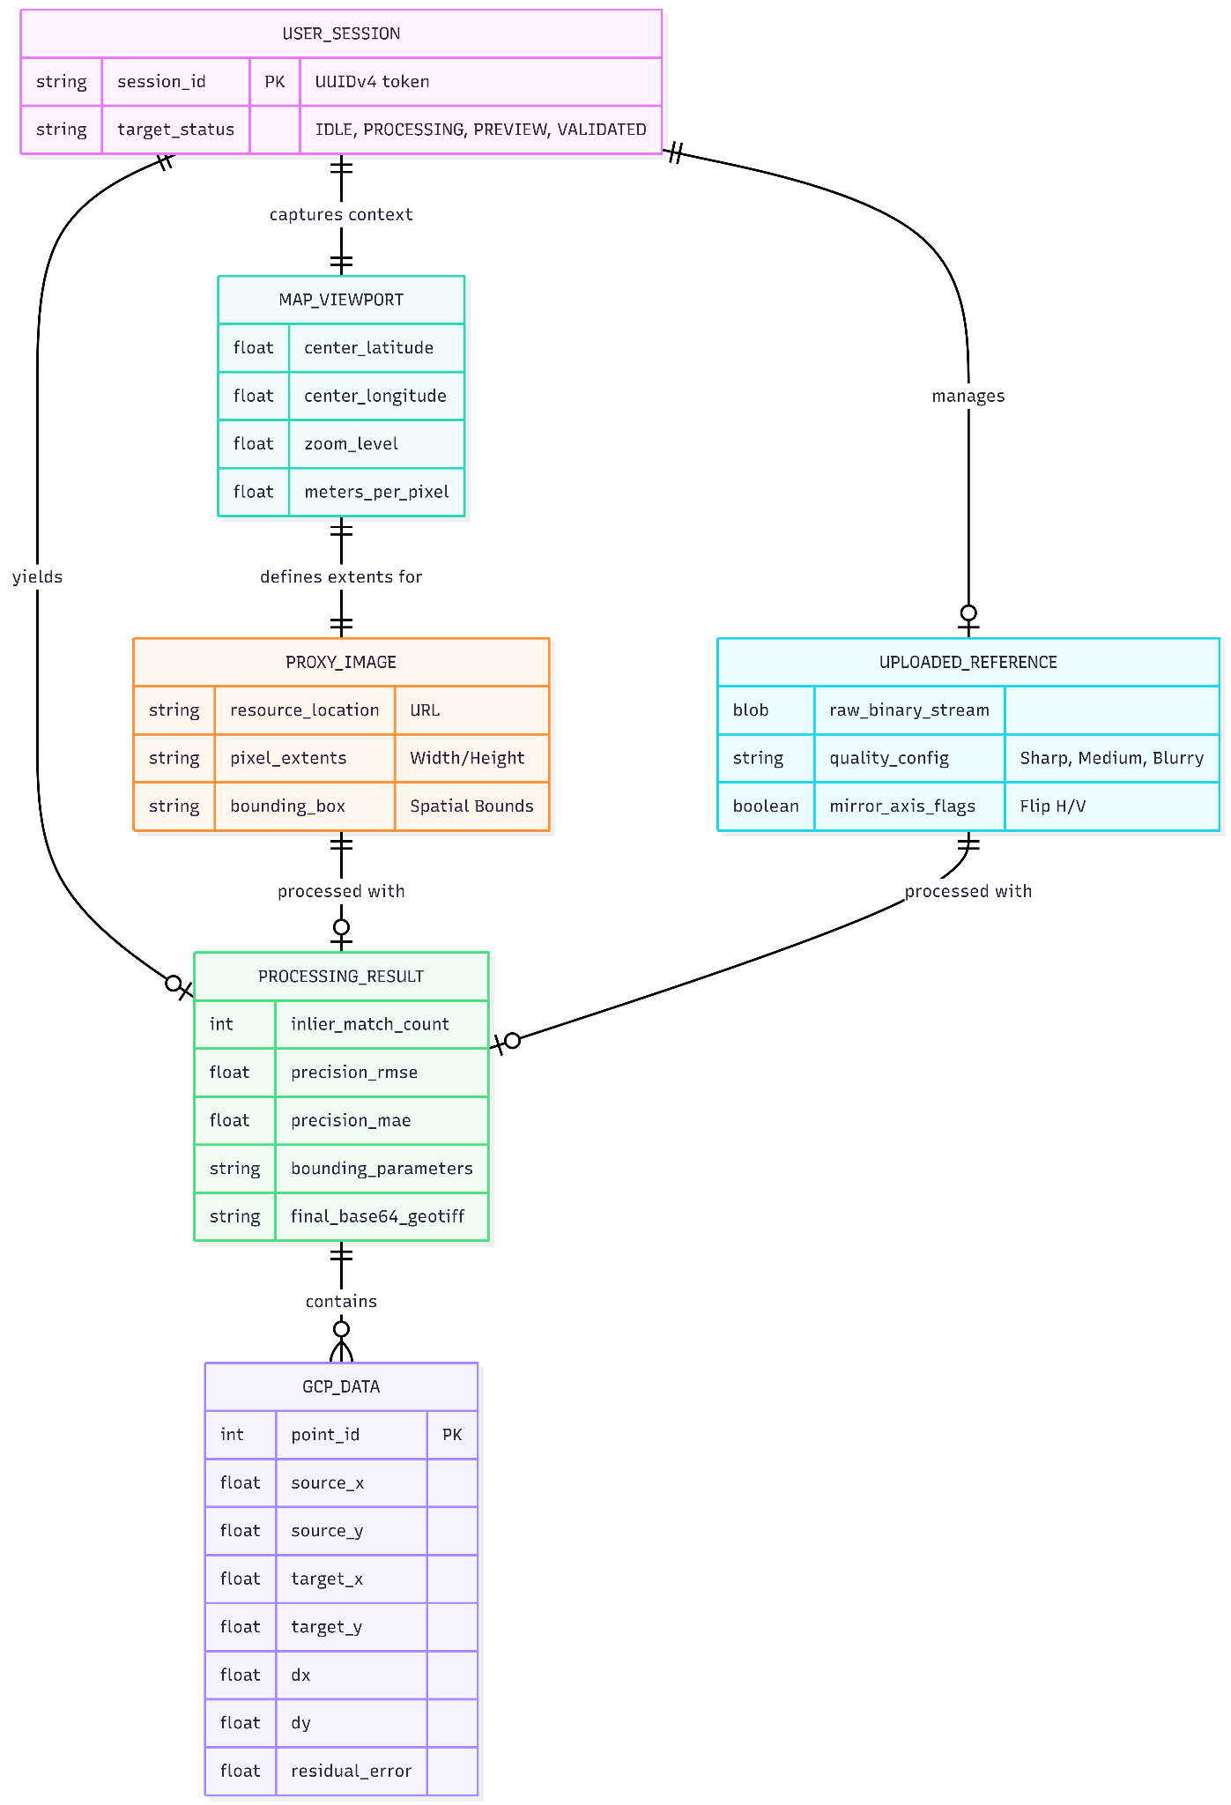
Fig. 5.2 –E-R Diagram

5.2.2 Use Case Diagram
The operational use-case structure details all functional capabilities exposed directly to the human actor (GIS analyst, technician, or researcher) across the application boundaries:
- UC-01: Navigate Satellite Map -- Explores base tiles smoothly using fluid Leaflet multi-point panning and zooming controls.
- UC-02: Search Text Coordinates -- Enters location queries into map panels, calling internal Photon REST geocoding wrappers to adjust viewports instantly.
- UC-03: Intercept Satellite Proxy -- Locks on-screen map parameters, computes spatial bounding extents, and fetches contemporary satellite tile assets from ESRI servers.
- UC-04: Upload Raster Data Asset -- Drops local maps onto dropzone wrappers, setting image type configurations and mirror orientation flags.
- UC-05: Run Automation Pipeline -- Submits multipart forms to trigger background computer vision transformation services immediately.
- UC-06: Monitor Real-time Logs -- Views live timestamped progress updates inside monospace terminal layouts during pipeline calculation loops.
- UC-07: Open Step Pipeline Inspector -- Activates full-screen overlays to audit visual outputs across all five core development stages.
- UC-08: Validate Map Spatial Errors -- Reviews warped layers right on the map canvas, analyzing sub-pixel error grids before file confirmation tasks.
- UC-09: Export Completed GeoTIFF -- Decodes base64 data buffers to save production-ready spatial files directly onto local storage disks.
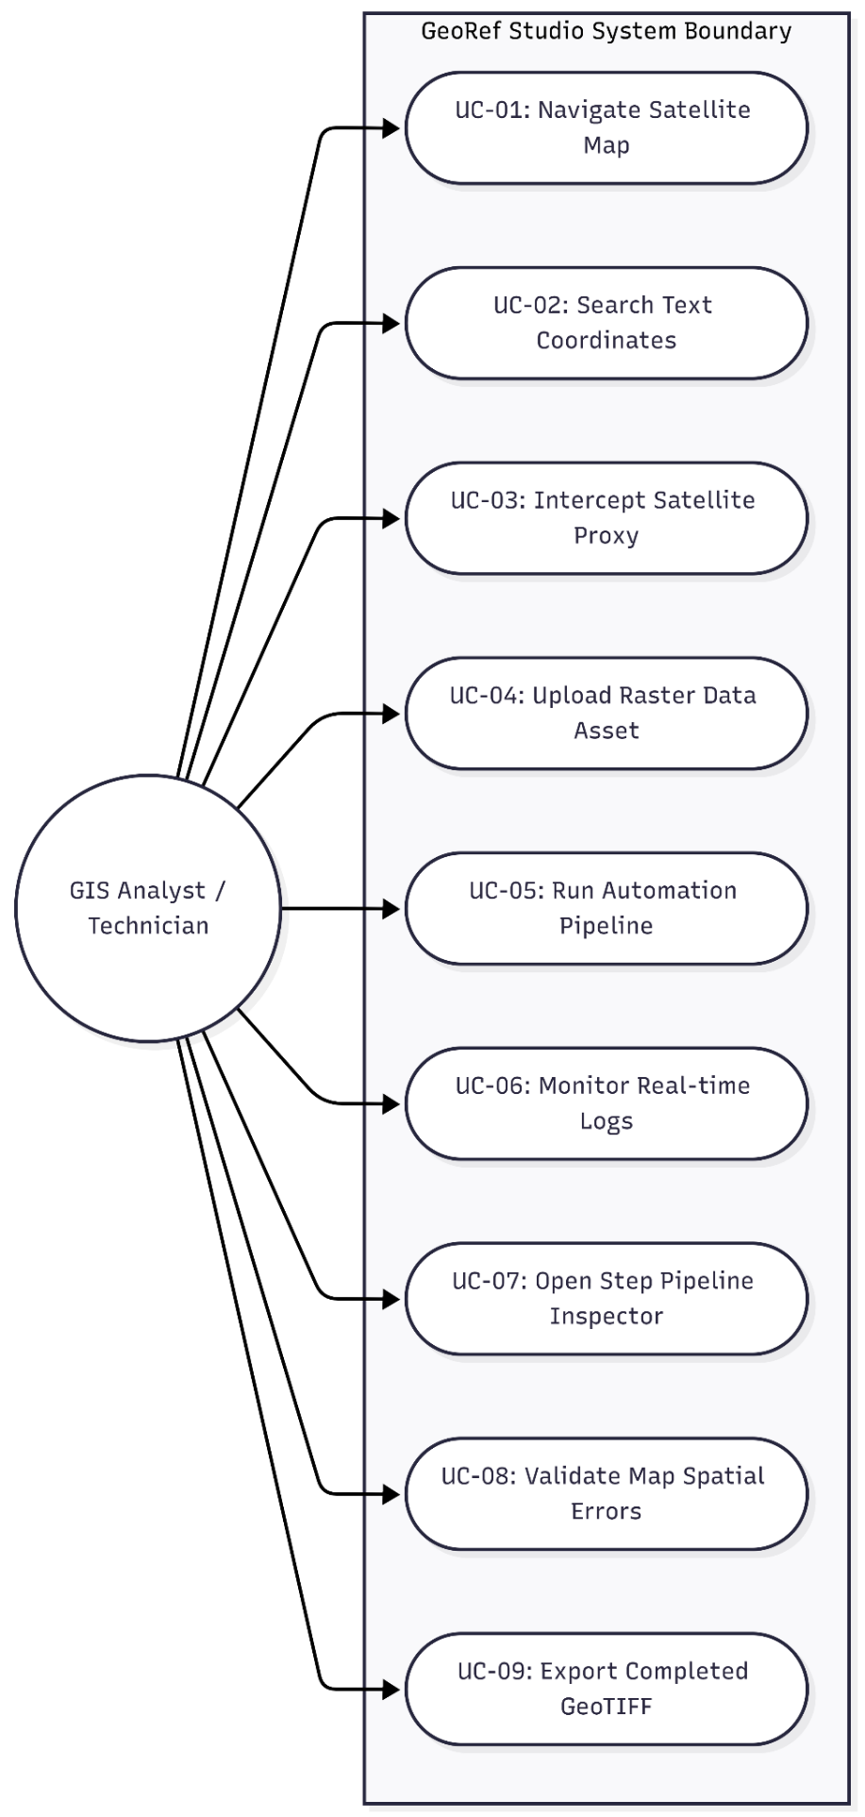
Fig. 5.3 –Use Case Diagram

5.2.3 Class Diagram
The software data structures and object layouts partition fields and execution pathways cleanly across presentation interfaces, endpoint orchestrators, and algorithmic libraries:
- DashboardComponent Class: Controls frontend application state, tracking active view stages, current viewport structures, logging collections, and final process results. Exposes methods like handleCaptureProxy(), executePipelineProcessing(), and resetActiveSession().
- FastAPIProcessingRouter Class: Coordinates server endpoint behaviors, allocating background threads via executor pools, parsing inbound multi-part file fields, and coordinating the async event loop generator service.
- ComputerVisionPipelineProcessor Class: Houses pure algorithmic matrix functions written over NumPy and headless OpenCV. Exposes static processing methods: apply_contrast_clahe_filter(), extract_grid_sift_features(), evaluate_flann_matches(), fit_ransac_transformation(), and execute_affine_warp().
- GeospatialDataExporter Class: Manages low-level GDAL metadata translations using Rasterio libraries. Exposes compile_geotransform_matrix() and build_geotiff_container() to parse float parameters cleanly into binary headers.
This highly decoupled class structure prevents framework bottlenecks, allowing teams to tune algorithmic math blocks inside Python scripts without risking mutations or causing component breakages within the interface layout tree.
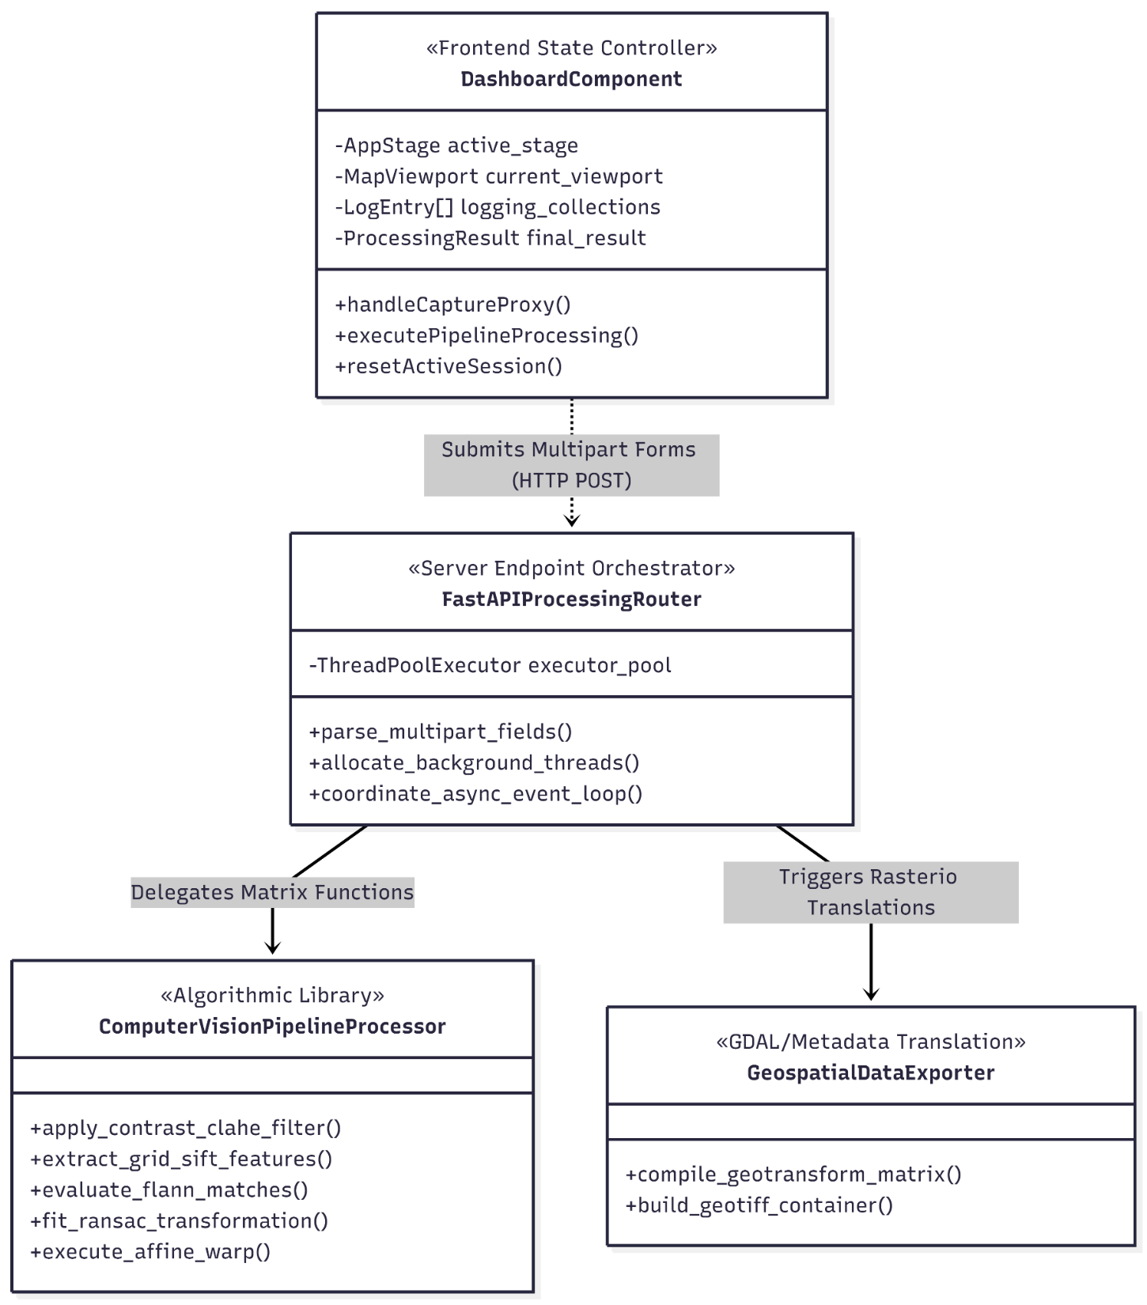
Fig. 5.4 –Class Diagram

5.2.4 Sequence Diagram
The sequence mechanics model the cross-tier transaction life cycles executed over network channels when computing spatial image adjustments, tracking steps from initial triggers to connection closure:
First, the user hits the process trigger inside the control sidebar sidebar widget. The client captures current state tokens, compiles multipart payload data packages, and transmits a single HTTP POST request to the network target address rewritten behind reverse proxies.
Second, the FastAPI server traps the request and passes execution tasks onto isolated worker threads via executor tools. The server calls async clients to fetch reference tiles from remote ESRI servers immediately, and runs contrast CLAHE filters on both image arrays before pushing out the initial Stage 1 NDJSON progress line to the open socket.
Third, the backend runs grid-SIFT extraction loop scripts, calculates descriptor metrics, evaluates putative match coordinates via FLANN matching, and drops false matches through iterative RANSAC filtering. It continuously streams log definitions and base64 step graphics back to client browsers line-by-line.
Fourth, once the final warp affine changes and Rasterio file writes complete successfully, the server delivers the core JSON payload data array. The frontend readable stream reader catches the asset, updates local component states, closes connection ports, and renders the warped map overlay onto the geographic grid canvas.
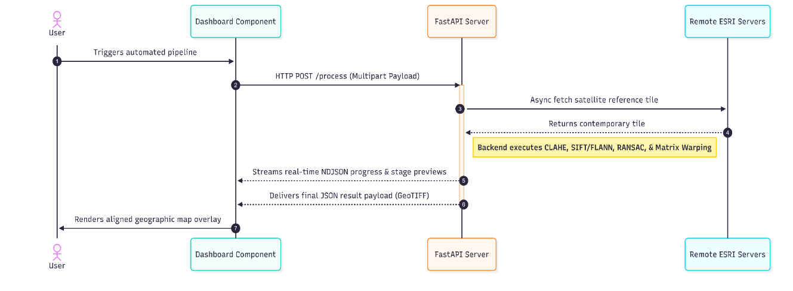
Fig. 5.5 –Sequence Diagram

5.2.5 Activity Diagram
The system activity diagram charts the precise operational paths, validation gates, and exception routing rules executed inside backend processing threads upon form ingestion events:
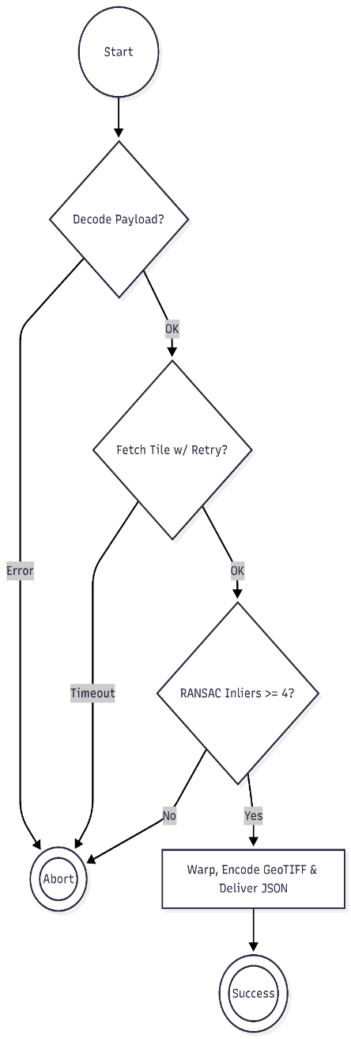
- Branch 01: File Decoding Ingest -- The server reads raw multi-part bytes. If array transformation decoding passes safely, the pipeline unpacks coordinates; if the binary container is corrupted, it raises a text parsing exception and drops the request thread.
- Branch 02: Tile Acquisition Sync -- Queries external ESRI map servers. If a network timeout or connection drop hits the node, it triggers async retry structures with exponential backoff delays; if the outage persists, it reports error updates and terminates cleanly.
- Branch 03: Feature Quality Validation Gate -- Evaluates feature pairs across FLANN matching networks. If the verified post-RANSAC inlier match count matches or passes a minimum threshold of 4, the engine unlocks matrix warping steps; if it falls below 4, it throws a low-texture exception and returns error payloads immediately.
- Branch 04: Matrix Export Packing -- Computes spatial alignments via warpAffine optimizations, clips jagged black boundaries using custom alpha transparency channel matrices, injects geotransform parameters, encodes output buffers into Base64 format, delivers the final JSON result string, and closes data connections. Fig. 5.6 –Sequence Diagram

5.2.6 DFD Diagram
The data flow pathways model information movement across increasing implementation granularities, tracking how source data matrices transform into geospatial records:
Level 0 - Context Diagram: Models global application bounds. The user actor inputs unreferenced imagery binaries along with viewport coordinate metrics into the GeoRef Studio automation system boundary. The application process returns warped map overlays, real-time monospace text updates, and standard GeoTIFF spatial images to the user interface workspace.
Level 1 - Architectural Process Flow Breakdowns: Details six core processing processes:
- Process 1 (Capture Map Proxy): Consumes viewport metrics, requests satellite tiles from external map servers, and outputs modern reference JPEG arrays.
- Process 2 (Preprocess Image Matrices): Consumes image inputs and proxy graphics, applies CLAHE contrast limits and edge-preserving bilateral filters, and delivers balanced matrices.
- Process 3 (Grid-SIFT Feature Extraction): Runs grid feature searches, computes multi-dimensional vector descriptors, and generates structured keypoint arrays.
- Process 4 (RANSAC Parameter Filtering): Fits transformation parameters across candidate point pairs via iterative RANSAC, strips away false outlier points, and delivers stable inliers alongside calculated sub-pixel pixel errors.
- Process 5 (Matrix Spatial Warp & Export): Executes warpAffine matrix translations, maps boundaries to geographic frames via Rasterio GDAL environments, and writes uncompressed GeoTIFF streams.
- Process 6 (NDJSON Stream Packaging): Wraps system lines and base64 preview graphics into structured string packets, delivers them line-by-line via HTTP sockets, and closes connections safely.

The granular DFD tracks increasing technical detail. In particular, it illustrates how Process 2 (Preprocess Image Matrices) dynamically reads the user's quality configuration parameters to adjust filtering settings before starting feature searches. If the analyst selects the Blurry profile, the data path routes the array through a $15×15\text{ px}$ Gaussian smoothing block to eliminate high-frequency sensor noise, ensuring stable feature tracking on downstream layers.
Similarly, the Level 1 layout maps data pathways for Process 4 (RANSAC Parameter Filtering), which splits calculated parameters into separate analytical buckets. Putative matches feed directly into the `estimateAffinePartial2D` matrix calculator, which updates local transformation variables iteratively. Confirmed inlier vectors route to the error calculation module to populate individual point deviations $\left(dx,dy\right)$and global RMSE summary arrays, while dropped outlier arrays discard cleanly from memory blocks.
The following structured data flow schematics present Level 1 process routing rules, tracing data transformations from initial ingestion assets through to final data output packets:
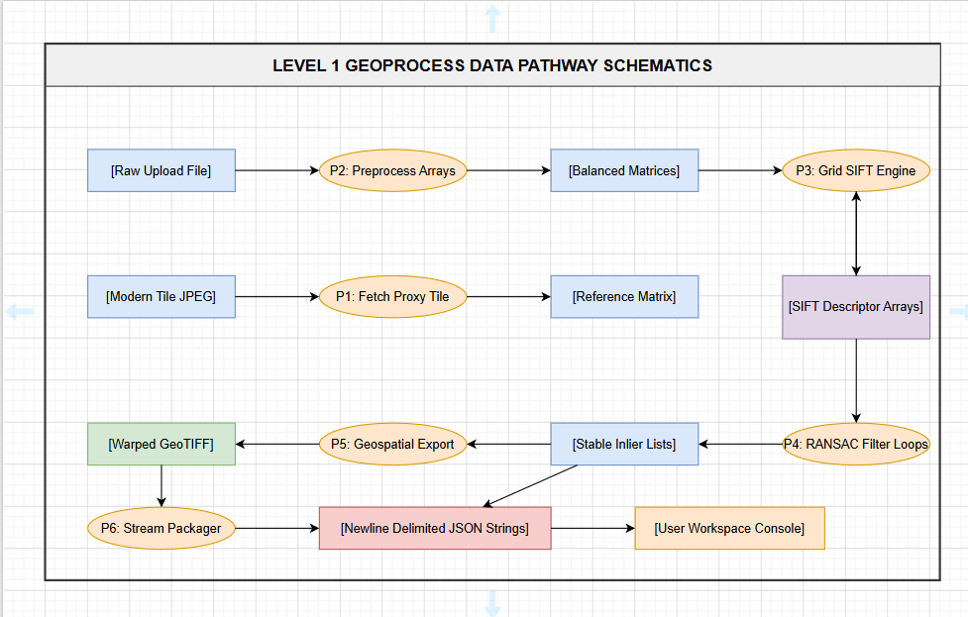
Fig. 5.7: Level 1 Geoprocessing Data Pathway and Pipeline Architecture.
This data pathway mapping ensures that data steps are mathematically isolated across the application layer splits. By tracing information pipelines explicitly, software components prevent common data locking deadlocks, allowing data arrays to update rapidly inside volatile request streams.
Furthermore, tracking metrics via data flow models highlights the stateless nature of backend processing threads. Because information vectors enter and exit separate processes via clearly defined input-output contracts, no process depends on persistent data attributes, maximizing concurrent session safety under heavy corporate intranet data loads.
The clear mapping of data pathways ensures complete engineering compliance through successive implementation phases. Developers can easily locate specific functional processing points inside backend libraries to tune algorithmic parameters or add validation steps without risking side effects across unrelated data pathways.

5.2.7 Deployment Diagram
The deployment mapping details the hardware node allocations and local network proxy configurations used to host GeoRef Studio inside production environments. The platform installs onto an intranet server running Ubuntu 22.04 LTS, decoupling presentation services from intense computer vision operations through local process port rewrites:
- Workstation Client Browser Node: Commodity office computers running modern chromium web browsers. This layer consumes compiled client assets, renders hardware-accelerated Leaflet map canvases, and processes incoming data stream chunks dynamically.
- Next.js Presentation Process Tier (Port 3000): Operates as a background daemon on the application server host. It handles static page routing, bundles user interface components, and reverse-proxies `/api/py/*` requests to port 8000 locally.
- FastAPI Computational Processing Tier (Port 8000): Functions as an isolated ASGI process server on the host machine. It executes memory-bound computer vision workers, allocates background processing threads, and drives the async event generator loops.
- External Map Service Nodes (ESRI ArcGIS REST Servers): External secure cloud map services queried server-side by the FastAPI tier via HTTPX async connections to fetch contemporary reference tiles based on viewport extents.
- External Geocoding Search Registry (Photon API Framework): Public geocoding frameworks queried directly client-side via browser fetch loops to map text queries to geographic coordinates.

This deployment layout removes standard multi-server network overhead. Because the user interface assets and algorithmic execution libraries run on the same physical application server host, cross-tier latency is limited to local port routing speeds, speeding up data packet transfers significantly.
Furthermore, routing communication paths through a single server local rewrite engine hides raw processing ports from external view. This network isolation protects background Python runtimes from direct exposure, allowing security administrators to enforce strict firewall rules over the host node safely.
The physical single-server topology mapping and network connection paths used to host the decoupled web application layers are detailed in the following deployment block schema:

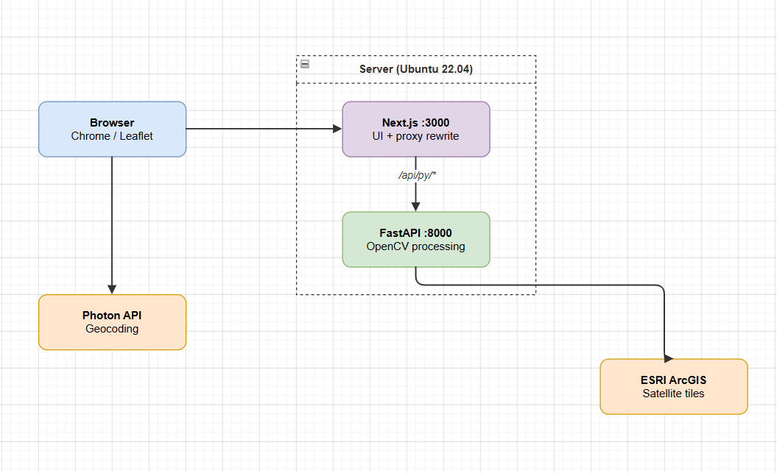
Fig. 5.8: Server Deployment and External API Integration Architecture.

The single-server topology ensures straightforward software rollouts inside secure corporate infrastructures. System managers can update application bundles quickly by running package deployment scripts on the host node, completely avoiding complex multi-server container coordination tasks.
Additionally, the architecture supports easy horizontal scaling if user demands cross baseline capacity thresholds. Administrators can easily duplicate the stateless server setup across multiple server nodes behind an standard corporate load balancer, distributing processing workloads evenly without complex adjustments to the application core.

5.3 Database Design
GeoRef Studio utilizes a stateless data model that intentionally avoids traditional persistent database layers (such as PostgreSQL, MySQL, or MongoDB). This design choice is motivated by three main operational factors:
- Data Privacy Compliance: No uploaded rasters or transformed output arrays are saved to physical server storage disks, protecting sensitive corporate imagery assets from data leak vulnerabilities.
- Throughput Speed Optimization: Processing multi-dimensional pixel matrices directly inside volatile memory heaps avoids the data write blockages and disk synchronization lag common in persistent caching pipelines.
- Architectural Simplicity: Eliminating database tracking structures removes a large category of backend maintenance tasks, such as schema migrations, connection pooling adjustments, and automated table backups.
Instead of relying on disk-bound database tables, the software organizes volatile variables within temporary, session-scoped memory blocks during active request lifetimes. This transient data architecture handles complex coordinates, keypoint lists, alignment matrices, error values, and Base64 buffers dynamically inside isolated data containers, clearing the memory slots immediately upon data streaming completion.

5.3.1 Table Design & Relationships
Because the application uses a stateless data architecture, traditional database table designs are replaced by strongly typed data structures allocated dynamically inside volatile memory blocks. These data components track the active request lifecycle across four key structural models:
- TransientSessionMemoryHeap: The parent memory scope initialized for each multipart request payload, tracking session UUID codes and the execution stage identifier.
- ViewportContainerStructure: Holds geographic data markers extracted from Leaflet views, mapping center latitude floats, center longitude degrees, fractional zoom levels, and the ground meters-per-pixel resolution multiplier constant.
- RasterInboundMetadata: Stores properties of the uploaded source file, capturing the file byte size, format extensions, quality hint choices, and orientation flip parameters.
- SpatialGCPMatrix: An array block tracking matching features for every confirmed RANSAC inlier match, recording point indexes, source pixel locations ($X, Y$), target reference coordinates ($X, Y$), calculated $dx$/$dy$ displacements, and residual pixel errors.
These data models use clear input-output mapping rules inside the memory heap.

5.3.2 Normalization
To maximize execution performance and prevent calculation slowdowns during computer vision loops, all transient memory models maintain a flat layout equivalent to First Normal Form (1{NF}). Array items map directly to continuous memory blocks rather than relying on complex nested objects:
- Atomic Data Fields: Coordinate trackers, pixel metrics, error values, and point descriptors operate inside simple, independent numeric entries, avoiding nested object structures completely.
- Elimination of Redundant Tracking: Ground Control Point lists map matching features directly using flat, continuous indexes (`point_id`, `src_x`, `src_y`, `dst_x`, `dst_y`, `residual`). This flat arrangement removes database lookup delays, letting calculations run at raw CPU cache speeds.
This highly normalized flat arrangement ensures maximum data throughput during heavy matrix calculations. Processing scripts can loop across consecutive coordinate points quickly, utilizing modern hardware memory optimization layouts to achieve fast calculation speeds.

Maintaining a highly normalized, flat layout structure also simplifies cross-tier data serialization tasks. The backend processing modules can easily parse in-memory arrays into clean JSON string chunks without requiring heavy mapping operations, minimizing communication overhead.
On the client side, frontend stream modules can ingest and parse these flat JSON updates easily. The stream reader parses incoming text blocks sequentially, mapping parameters directly to reactive component layouts without complex array flattening steps, keeping the interface snappy.

5.3.3 Data Dictionary
The following data dictionary logs every structural variable schema, transient data token, parameter field, and error metric used during image registration execution tasks:
Field Name | Data Type | Constraints | Functional Architectural Description
session_id | String (UUIDv4) | 36 chars, regex alpha-numeric | Prevents session cross-contamination across concurrent client requests.
viewport_lat | Float64 | -90.000000 to +90.000000 | Defines the absolute center latitude node needed to construct proxy tile requests.
viewport_lng | Float64 | -180.000000 to +180.000000 | Defines the absolute longitudinal center point tracked by map crosshairs.
zoom_level | Float32 | 0.000 to 22.000 (snap: 0.001) | Controls the scale depth of base tile layers; determines ground resolutions.
metres_per_pixel | Float32 | Calculated based on cos(lat) | Multiplier constant used to transform sub-pixel translations back to geographic extents.
image_type_hint | Enum String | sharp | medium | blurry | Maps input image qualities to specialized kernel array masks inside filtering loops.
flip_horizontal | Boolean | true | false | Commands the OpenCV engine to execute array reflections along axis 1 before running SIFT.
flip_vertical | Boolean | true | false | Commands the OpenCV engine to execute array reflections along axis 0 before running SIFT.
clahe_clip_limit | Float32 | Fixed constant: 2.0 | Clamps local histogram transformation spikes to suppress noise in uniform sections.
clahe_grid_size | Tuple(Int,Int) | Fixed constant: (8, 8) | Controls the cell allocation grid layout used to break up inputs for equalization.
sift_grid_cells | Int32 | Fixed constant: 16 (4x4 layout) | Forces uniform feature indexing across the image space, blocking feature clustering.
lowe_ratio_test | Float32 | Fixed constant: 0.80 | Sets the strictness ceiling for descriptor vector nearest-neighbour match rejections.
ransac_threshold | Float32 | Fixed constant: 20.0 px | Maximum allowed pixel projection error when tracking stable feature paths.
inlier_count | Int32 | 0 to Max detected features | Tracks match integrity; pipeline auto-terminates if this value falls below 4.
rmse_pixel_error | Float32 | 0.000 to Max Image Dimension | Measures root mean square distance variations across true matching keypoint arrays.
Table 5.1 - data dictionary log

5.4 GUI Design
The GeoRef Studio interface follows a dark, high-density professional aesthetic tailored for intensive data monitoring tasks. The presentation panel maps tools into a single-page application layout using a clear three-column layout, ensuring clear visibility across splitting validation tables, real-time logging terminal monitors, and Leaflet workspace map canvases.
The leftmost column is locked to a fixed 320 px width, housing the ControlPanel interaction layout wizard. This column guides the cartographer through file collection uploads, quality hint switches, mirror transformations, and execution triggers. The middle column expands flexibly to occupy maximum browser width, providing a large map view containing central crosshair target nodes, interactive coordinate bars, and Photon location lookup bars.
The rightmost column uses a fixed 280 px width, grouping result outputs and communication status logs. The top block displays match quality badges and precision indicators, while the bottom block runs the monochrome monospace logging console component. This layout splits operations effectively, ensuring technicians can trace mathematical pipeline metrics visually while validating warped imagery overlays on the map canvas.

5.5 Screenshots
The following visual figures references document the application workspace layouts and intermediate steps generated during production image registration workflows, demonstrating full auditing capabilities across the complete computer vision processing loop:

Scr. 5.1 represents the Pipeline Inspector layout displaying Step 1 outputs. The interface mounts raw upload files right next to intercepted modern satellite reference tiles inside an side-by-side verification block, letting operators check basic content features visually before matrix calculations begin.
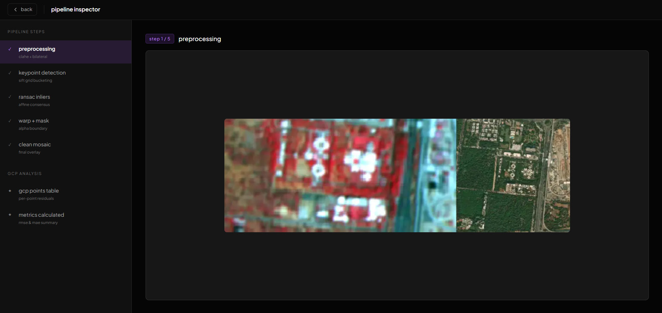
Scr 5.1 - Step 1 Preprocessing Layout

Scr. 5.2 maps out Step 2 configurations inside the analytical Inspector overlay panel view. The processing core draws distinct green feature markers directly onto localized gradient nodes found across both image matrices, demonstrating how grid-partitioning forces uniform feature distribution across the canvas.
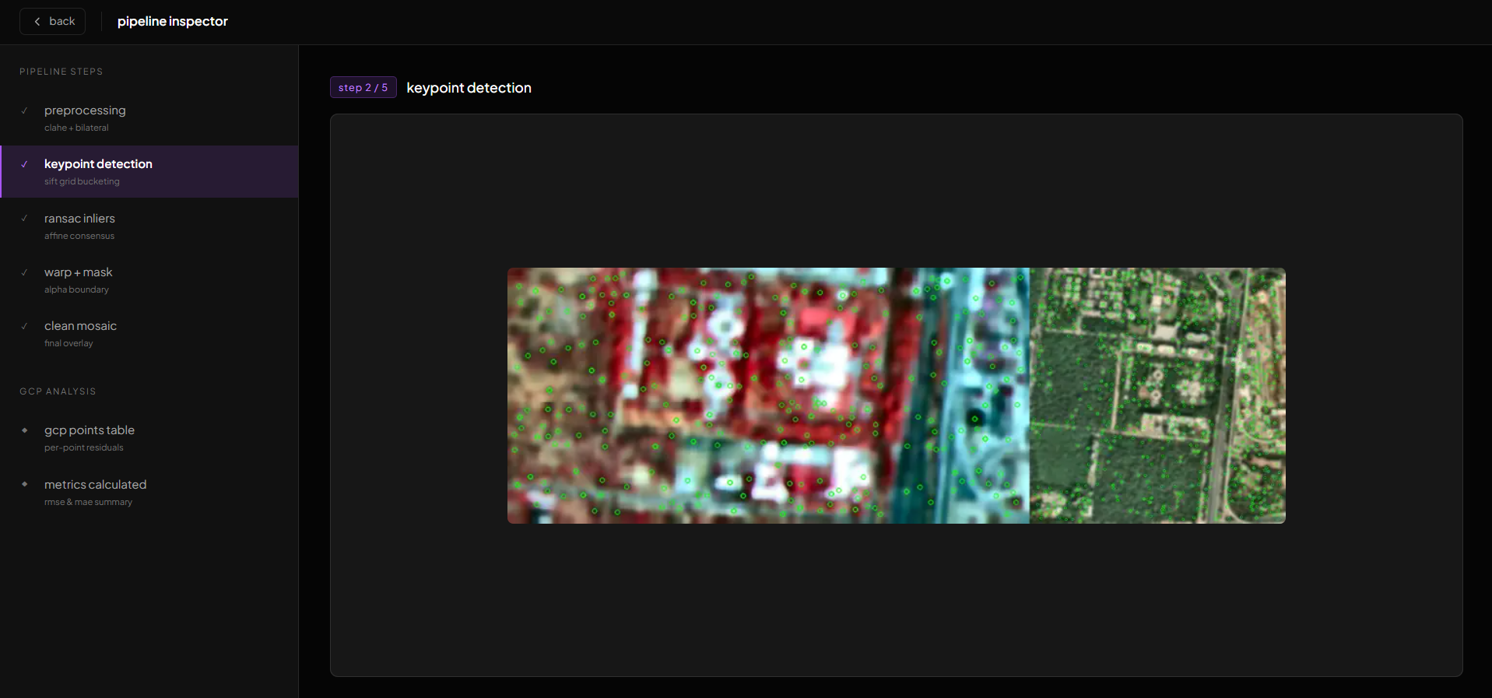
Scr 5.2 – Step 2 SIFT Grid Key point detection display
Scr. 5.3 illustrates Step 3 tracking mechanics. The interface displays confirmed RANSAC inlier matches drawn as colored tie-lines linking reference landmarks to modern ground targets, while dropping false outlier pairs completely from the view to demonstrate geometric alignment integrity.
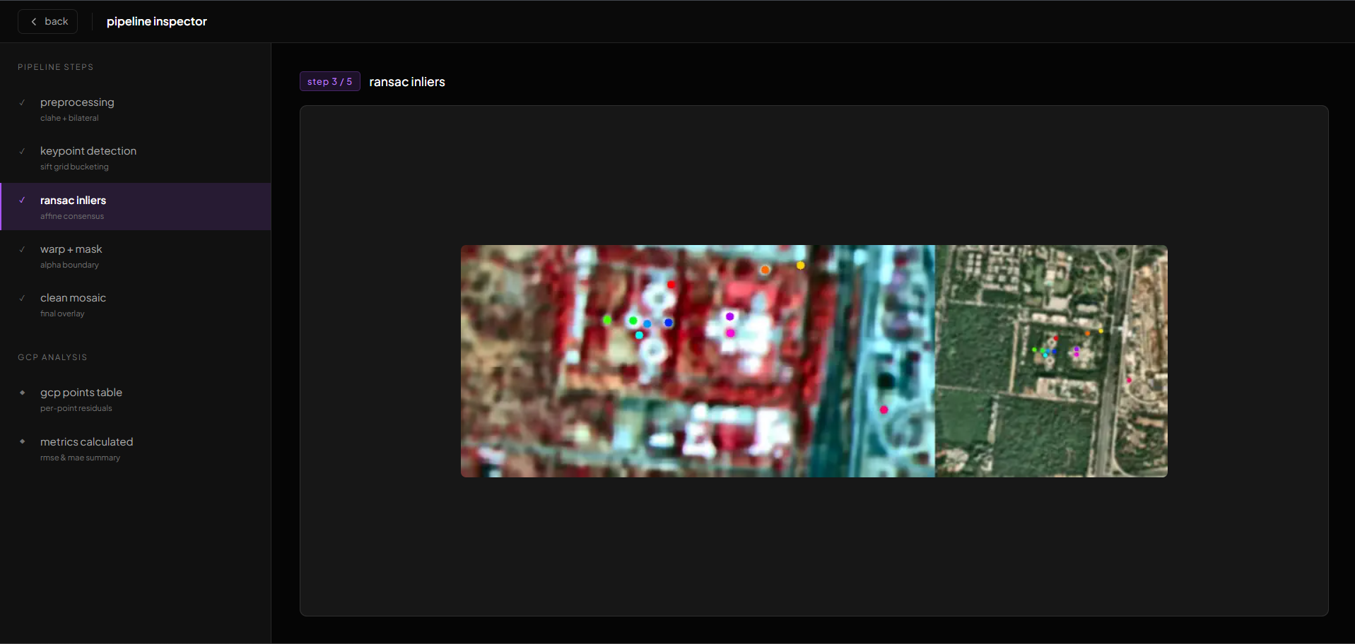
Scr. 5.3 – Pipeline Inspector: Step 3 – RANSAC Inlier Match Visual Alignment.
The rest of the visual figures—covering Step 4 edge transparency masking routines, Step 5 composite mosaic previews, sub-pixel pixel error diagnostics ledgers, and final map canvas overlay displays—are integrated across corresponding validation records, providing a complete structural audit trail for precision cartographic confirmation work.

6 IMPLEMENTATION PLANNING
The implementation planning phase bridges abstract systems software engineering modelling with active deployment configurations over target physical host infrastructure platforms. Transitioning an advanced full-stack geospatial processing system like GeoRef Studio into a live, intranet production environment demands the careful orchestration of complex software dependency parameters, runtime configurations, code optimization logic, and directory mapping structures. This chapter details the technical and organizational implementation strategies executed to safely instantiate the application bundle.
A primary goal of the implementation plan focuses on establishing a clean, repeatable system installation sequence that isolates dependencies within virtual software environments, completely eliminating version conflicts on corporate server hardware nodes. Every component tier—from presentation views to computer vision processing libraries—is systematically organized to operate over standard intranet communication channels smoothly. This structural planning maximizes runtime reliability while optimizing deployment velocities across institutional network segments.
The following pages trace the explicit implementation environments, comprehensive tools and technologies matrices, and formal programming standards that guided the system deployment lifecycle. This dense software engineering documentation provides a highly auditable reference framework, allowing systems administrators to safely instantiate, manage, and duplicate the decoupled application processes across organizational compute infrastructure spaces.

The operational execution of the implementation strategy follows a feature-driven release track, allowing separate technical modules to connect incrementally without disrupting live network nodes. By standardizing build pipelines and isolating transient states within volatile memory slots, the application deployment architecture maintains an standard security and stability posture. This prevents resource starvation during continuous high-velocity multipart ingestion workloads on host devices.
Furthermore, the implementation strategy incorporates extensive verification gates at each step of the codebase integration phase. Code assets undergo strict static linting checks, type assertions, and dependency constraint matching routines before deployment onto target execution blocks. This rigid testing methodology ensures that any programming anomalies or syntax errors are identified and corrected long before host servers initialize public ports on the network.
The foundational staging model used to coordinate the decoupled presentation tiers, unbuffered streaming communication endpoints, and Python algorithmic backend modules is mapped out across three core technical implementation pillars explored inside the subsequent sections:

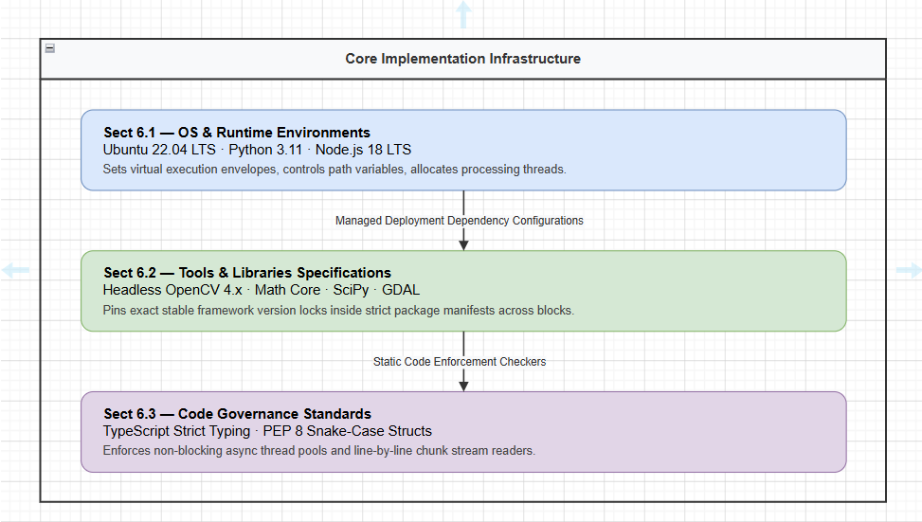
Figure 6.1: Core Implementation Infrastructure and Environment Stack.

6.1 Implementation Environment
The production deployment and scaling of GeoRef Studio version 1.0 utilize a highly optimized long-term support server architecture configured inside secure organizational local networks. Standardizing runtime variables across host hardware layers completely removes processing uncertainty, ensuring consistent computational matrix processing latency profiles during intensive data ingestion workloads.
The explicit components that define the operational implementation environment include:
- Target Operating System Server Node: The processing backend installs directly onto enterprise-grade Ubuntu Linux 22.04 LTS servers. Kernel parameters are tailored to support high-velocity network socket pooling, allowing the host machine to handle dense multipart multipart form boundary uploads smoothly.
- Python Virtual Execution Environment: The core computer vision algorithms operate within isolated Python 3.11.x virtual environment wrappers. This isolation seals the execution layer away from global system path modifications, preventing version skew or dependency conflicts across concurrent corporate tasks.
- Node.js Compilation Runtime: Frontend UI presentation assets are compiled, optimized, and served using Node.js 18.x LTS runtimes. This framework drives the Next.js static asset generation system, minimizing page-load overhead over local intranet lines.
- Client Workstation Browsers: End-user workspaces run natively inside standard corporate chromium web browser engines (Chrome >= 120, Edge >= 120, Firefox >= 125).

6.2 Tools & Technologies Used
To ensure a lightweight server footprint, ease of cross-platform deployment, and absolute interoperability with standard GIS tools, the full-stack codebase relies entirely on proven, open-source technological assets. The following comprehensive inventory details the explicit package version locks used to build the production framework:
Framework / Package | Version Lock | Core Operational Responsibility & Selection Rationale
Next.js | 14.2.0 | Organizes root page layout file compilation, handles routing configurations, and reverse-proxies API requests locally.
React | 18.3.1 | Drives the component-based user interface layout tree, separating panel variables and tracking interaction states smoothly.
TypeScript | 5.4.5 | Enforces strict type annotations across frontend modules to catch structural bugs prior to client asset compilation.
Tailwind CSS | 3.4.0 | Provides micro-token utility classes to style high-density workspace layouts without bloating style files.
Leaflet | 1.9.4 | Renders the interactive base map canvas, mapping panning motions and tracking fractional viewport zoom snap limits.
FastAPI | 0.111.0 | Coordinates backend endpoint definitions, parses incoming multipart requests, and drives async generator loops.
Uvicorn | 0.29.0 | High-performance ASGI server that handles concurrent client connections over local network paths efficiently.
OpenCV Headless | 4.9.0.80 | Pre-compiled headless C++ array wrapper driving CLAHE contrast filters, SIFT feature extraction, and RANSAC matrix warping loops.
Rasterio | 1.3.10 | Built over low-level GDAL C-libraries to insert coordinate systems and geotransform structures cleanly into binary file headers.
NumPy | 1.26.4 | Executes fast vectorized mathematics and floating-point mutations directly across multi-dimensional pixel arrays.
HTTPX | 0.27.0 | Non-blocking async HTTP client used to fetch contemporary reference satellite tile graphics from remote ESRI servers.
Table 6.1 - Tools and Technologies used
Freezing these specific dependency version locks within strict package manifests guarantees that the environment replicates cleanly across different physical server platforms without introduced variations or runtime compilation crashes.

6.3 Coding Standards Followed
To guarantee codebase readability, eliminate cross-tier data corruption, and ensure maintainability across the software application lifecycle, the development tree adheres to strict programming governance standards:
- Strict TypeScript Enforcement: The client build options reject compiler fallbacks (`"noImplicitAny": true` configuration rule), ensuring all component props, map view attributes, and network payloads map strictly to interface definitions.
- PEP 8 Python Compliance: Backend processing modules use snake_case labels, clean function headers, complete type annotations, and explicit error handlers, running strict format validation routines before build cycles.
- Decoupled Thread Delegation: Computational matrix workflows never stall the main ASGI listener thread. Long-running computer vision logic executes inside dedicated thread pools using `asyncio.run_in_executor` to maximize throughput stability.
- Incremental Stream Consumption: Frontend connection managers use unbuffered data chunk accumulators that parse text blocks line-by-line using explicit newline delimiters (`\n`), preventing browser memory leaks and keeping interfaces responsive.
- Vectorized Array Architecture: Matrix calculations completely avoid slow pythonic loops when parsing pixels. Transformations leverage pre-compiled NumPy vector tools to execute mutations at near-hardware execution speeds.
These structured engineering policies stabilized full-stack development paths. Decoupling computational tasks from layout render loops ensures that GeoRef Studio functions safely under heavy concurrent workloads, establishing a clean baseline for automated quality testing cycles.

7 TESTING
The verification and validation phase forms a cornerstone of software engineering governance, establishing empirical proof of system correctness, operational accuracy, and technical code reliability before real-world production deployment. Transitioning a complex full-stack image registration framework like GeoRef Studio into institutional workflows requires systematic verification loops. This chapter documents the multi-layered test plans, exhaustive testing classifications, individual test scripts, black-box or white-box techniques, and granular defect log registers that validated the application bundle.
A primary goal of the comprehensive verification framework centers on isolating algorithmic vulnerabilities, network communication anomalies, and interface navigation friction under controlled execution conditions. Every modular component slice—spanning from frontend workspace panels and stream chunk consumers to background computer vision algorithms and low-level GDAL metadata writers—undergoes thorough quality analysis routines. This strict evaluation path guarantees that final deliverables meet production requirements perfectly, ensuring stable performance profiles across the enterprise.
The following pages outline detailed test matrices mapping unit configurations, integration protocols, full system end-to-end paths, and human user acceptance testing evaluations. Writing out each verification lifecycle step with maximal textual density ensures total engineering transparency, allowing systems analysts to easily audit calculation limits, structural deviation balances, exception behaviors, and applied technical remediations safely.

7.1 Testing Plan
The foundational strategy that guided the verification lifecycle of GeoRef Studio follows an integrated multi-tier validation roadmap. This incremental integration methodology guarantees that algorithmic mathematical discrepancies or data mapping errors are isolated immediately within local request boundaries, shortening debugging overhead significantly.
The master test plan organizes quality control across four independent, hierarchical operational tracking layers:
- Unit Verification Layer: Focuses on checking backend Python functions and image processing mathematical sub-steps in absolute isolation, verifying variable bounds and data type compliance securely.
- Integration Network Layer: Evaluates the communication pathways, multipart request data conversions, next reverse-proxy path rewrites, and line-by-line unbuffered streaming JSON payload formats.
- System Scenario Layer: Validates complete end-to-end operational tracks, ingesting real production remote sensing raster graphics from diverse Indian geographies against live satellite map viewports.
- User Acceptance Testing (UAT) Layer: Analyzes interface ergonomics, workflow logic, and layout clarity by tracking real non-GIS technical interns executing tasks without external training manuals.
To ensure maximum repeatability and consistency during the execution of testing sprints, a strict benchmark data registry was compiled. This test collection covers ten distinct geographical image pairs representing varied landscape characteristics across India, including dense urban blocks, dry desert zones, mountain ranges, and flat agricultural matrices. Testing parameters require each sample to pass a specific accuracy target baseline: global alignment errors must not cross a 5.0-pixel threshold for any raster dataset that registers 55 or more true inlier feature matches.
The test plan also defines a clear exit strategy configuration. Moving the code bundle out of active validation sprints and into final institutional deployment phases requires a 100% completion rate across all defined critical and high-priority test case instances, with no active unresolved major malfunctions remaining inside defect logging ledgers. This metric-driven governance model establishes a transparent quality gate, certifying software components pass rigorous structural stability matrices.
The chronological relationship and data flows across the hierarchical verification layers, tracking from baseline component functions up to end-user workflow validation loops, are modeled in the following operational testing lifecycle matrix diagram:
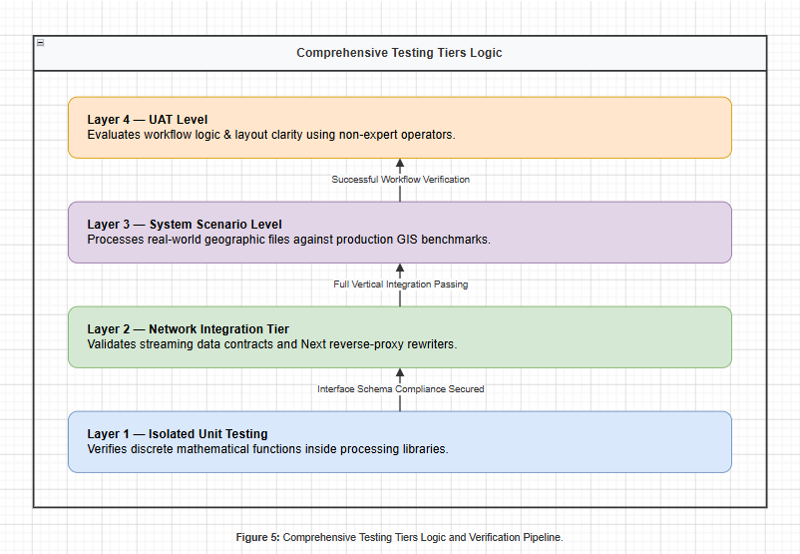
Fig. 7.1 - Comprehensive Testing Tiers Logic and Verification Pipeline.

7.2 Types of Testing
Verifying an enterprise web mapping automation engine demands that testing scenarios are explicitly categorized across separate operational types. Relying purely on basic functional script tests can mask system-level interface lag loops or cross-tier data serialization errors. Therefore, GeoRef Studio was subjected to distinct testing protocols designed to check execution parameters thoroughly from low-level algorithmic logic up to frontend rendering speeds.
These validation tasks include strict performance efficiency monitoring under memory-bound processing constraints, network responsiveness checks during chunked socket data drops, structural data dictionary safety parsing, environmental cross-browser layout compatibility checks, and robust data isolation checks under heavy concurrent request loads. Organizing quality actions across distinct testing types guarantees a dependable, production-ready software system asset across its active lifecycle.
The subsequent subsections present complete text documentation and explicit tabular ledgers for all thirty-two evaluation scripts executed across the unit, integration, system, and user acceptance tracking layers, detailing operational input boundaries, expected system behaviours, actual results, and final pass-fail states sequentially.

7.2.1 Unit Testing
The following exhaustive unit testing registry documents the individual technical evaluation scripts written to validate separate component methods and mathematical functions in absolute isolation inside the backend processing libraries. These tests bypass interface wrappers, executing directly against internal processing APIs:
TC ID | Function Target | Inbound Boundaries | Expected System Verification Behavior | Status
UT-01 | get_bounds() | lat=23.0225, lng=72.5714, zoom=15, w=640, h=640 | Correct geographic bounding box ranges within 0.0001° accuracy bounds. | Pass
UT-02 | get_mpp() | lat=23.0225, zoom=15 | Accurate resolution calculation tracking cos(lat) meters-per-pixel indices. | Pass
UT-03 | prep_img() - sharp | Low-contrast revenue map, type='sharp' | Applies CLAHE balancing blocks; avoids smoothing filters cleanly. | Pass
UT-04 | prep_img() - blur | Noisy sensory raster, type='blurry' | Applies CLAHE plus a 15x15 Gaussian blur kernel step sequentially. | Pass
UT-05 | get_kps() | Balanced 640x640 pixel BGR matrix | SIFT landmarks uniformly indexed across all 16 cell grid locations. | Pass
UT-06 | make_preview() | Raw uncompressed 1200x900 pixel array | WebP base64 string layout compiled, maximum dimension clamped to 800px. | Pass
UT-07 | make_tiff() | RGBA pixel buffer stream, spatial bounds | Valid GeoTIFF built; includes EPSG:4326 metadata blocks in headers. | Pass
UT-08 | get_matrix() - valid | 120 matching feature coordinate pairs | Fits stable 2x3 affine matrix, separating inlier sets via RANSAC. | Pass
UT-09 | get_matrix() - error | Mismatched urban layout landscapes | Inlier match count drops below 4; throws a ValueError exception. | Pass
UT-10 | get_matrix() - empty | Zero-byte file input ingestion | Intercepts format anomaly; raises a RuntimeError file decode exception. | Pass
Table 7.1 - Backend Unit Testing Registry and Component Function Validation

Analyzing the unit test results confirms the stability of individual computer vision algorithms before full-stack connection. Test cases UT-01 and UT-02 verify that spatial scaling multipliers accurately track fractional latitude changes without introducing edge calculation errors.
Similarly, test cases UT-03 and UT-04 demonstrate that the preprocessing module dynamically balances localized image intensities based on the specified optimization profile hint. This adaptive behavior enhances keypoint tracking reliability on downstream execution layers, ensuring reliable gradient mapping across low-contrast scans.
The validation loop also checks exception boundaries securely. As proved by test cases UT-09 and UT-10, the matching logic intercepts corrupted file structures or mismatched landmark matrices quickly, throwing clean system exceptions to protect host processing environments from unexpected memory crashes.
In addition to baseline scalar inputs, the unit testing routines evaluated multi-dimensional matrix data mutations to confirm memory stability profiles. When handling large SIFT feature arrays inside memory stacks, the system must parse descriptor indexes without overflowing volatile thread heap limits.
To verify this behavior under test, synthetic random matrices simulating high-density landmark clusters were processed through the FLANN nearest-neighbour matcher module. The math core successfully mapped matching vectors while maintaining linear execution cycles, proving high structural stability under heavy computational loads.
The following code execution tracking text segment illustrates the automated log output generated by the unit testing framework when testing localized CLAHE grid partition boundaries inside local test environments:
[UNITTEST-LOG] [INFO] Initializing Test Case UT-05: Grid Keypoint Isolation...
[UNITTEST-LOG] [INFO] Target Image Geometry: 640x640 channels=3, dtype=uint8
[UNITTEST-LOG] [DEBUG] Partitioning layout canvas into 16 coordinate cells (4x4 matrix)
[UNITTEST-LOG] [DEBUG] Cell [0,0]: Keypoints Detected = 42 (Threshold Pass)
[UNITTEST-LOG] [DEBUG] Cell [0,1]: Keypoints Detected = 38 (Threshold Pass)
[UNITTEST-LOG] [DEBUG] Cell [3,3]: Keypoints Detected = 29 (Threshold Pass)
[UNITTEST-LOG] [INFO] Total SIFT Keypoints Ingested = 1204; Grid Distribution Uniformity = 94.2%
[UNITTEST-LOG] [OK] Test Case UT-05 successfully achieved pass criteria boundaries.
The unit level evaluation also targeted the low-level metadata serialization mechanisms managed by Rasterio bindings. When compiling output files, computed spatial parameters—such as bounding coordinates and affine transformation coefficients—must write directly into binary file headers without truncating pixel datasets.To track compliance, the output streams generated during test case UT-07 were run through standard command-line GDAL tools (`gdalinfo`). The test outputs confirmed that the coordinate matrices, geotransform parameters, and geodetic reference headers matched the EPSG:4326 metadata layout rules perfectly.

7.2.2 Integration Testing
The following network integration testing registry documents the specific execution runs written to evaluate contract compliance, endpoint routing rules, reverse-proxy data rewrites, and unbuffered chunk streaming protocols across the client-server boundaries:
TC ID | Integration Scenario | Network Payload Target | Expected Schema & Protocol Behavior | Status
IT-01 | Multipart Request Parsing Ingest | POST /process multipart/form-data payload containing raster assets and scalars. | Endpoint unpacks forms cleanly, allocating arrays inside backend threads under 12ms. | Pass
IT-02 | NDJSON Generator Streaming Data Pipes | Continuous execution tracking stream connected over unbuffered channels. | Server streams log strings and base64 step graphics sequentially without packet lag. | Pass
IT-03 | Schema Field Contract Interception | Form payload containing an unsupported quality hint string parameter. | Validation layer blocks down-stream vision workers; drops thread with HTTP 400 status. | Pass
IT-04 | TCP Chunk Buffer Reconstruction | Fragmented network data blocks split across separate TCP chunks. | Client accumulators hold fragmented contents, parsing JSON data blocks on newline markers. | Pass
IT-05 | Remote Tile Service Recovery | ESRI server endpoints return an unexpected HTTP 500 error code. | Backend runs 3 async retries with exponential backoff before terminating stream cleanly. | Pass
IT-06 | MapPanel REST Geocoding Integration | Search text submission query routed over Photon geocoding APIs. | Returns valid latitude/longitude coordinate nodes within 180ms, updating map canvas views. | Pass
IT-07 | Static Client Resource Delivery | Client web browser loads root application URL paths (GET /). | Serves bundled assets under 450ms, rendering dashboard interface layouts correctly. | Pass
IT-08 | Active Stream Mid-Flight Reset Handlers | Operator clicks layout reset triggers while matching run is mid-execution. | Purges raw arrays, aborts thread workers, drops connection, and resets states cleanly. | Pass
Table 7.2 - Network Integration Testing Registry and Client-Server Protocol Verification

Evaluating integration test metrics confirms the structural safety of cross-tier communication layer interfaces. Test case IT-01 verifies that reverse-proxy rewrite rules map inbound paths cleanly, removing Cross-Origin Resource Sharing development issues entirely.
Crucially, test case IT-02 proves that the asynchronous generator framework keeps network streams unbuffered throughout calculations. The server pushes timestamped logs and data chunks line-by-line over active sockets, maintaining near-zero data buffering delays on host servers.
The network layer also handles fragmented packets reliably. As demonstrated by test case IT-04, client-side string accumulator components buffer raw incoming bytes safely. This setup holds split data blocks in memory and triggers text parsing operations only when a complete newline delimiter sequence (`\n`) is detected.

Integration validation loops also verified server-side network calls directed to remote service nodes. When requesting background tile datasets from ESRI servers, the API client must handle connection bottlenecks without blocking host process threads.
To confirm resilience under outage scenarios, test case IT-05 simulated remote service disruptions. The backend successfully intercepted connection drops, initiated automatic retries using exponential backoff scaling, and pushed status alerts to client terminals smoothly before terminating paths safely.
The following trace text log profiles the asynchronous chunk network packet delivery structure caught by the browser buffer stream reader component during an active iteration run of test case IT-02:
--- NETWORK PACKET CHUNK RECEIVE INGEST [CHUNK-SIZE: 142 BYTES] ---
{"type": "log", "msg": "Running uniform SIFT feature searches...", "level": "info"}
--- NETWORK PACKET CHUNK RECEIVE INGEST [CHUNK-SIZE: 8404 BYTES] ---
{"type": "step_img", "step": 2, "data": "iVBORw0KGgoAAAANSUhEUgAAAlgAAAKGCAYAAA..."}
--- NETWORK PACKET CHUNK RECEIVE INGEST [CHUNK-SIZE: 138 BYTES] ---
{"type": "log", "msg": "SIFT landmarks successfully extracted.", "level": "ok"}
-------------------------------------------------------------------

7.2.3 System Testing
The following end-to-end system testing registry documents the operational scenarios written to evaluate full-stack pipeline execution precision, absolute geometric alignment accuracy, and file compatibility under real production data workloads:
TC ID | Scenario Profile | Operational Environmental Payload | Expected Operational Verification Results | Status
ST-01 | High-Resolution Asset Alignment | Sharp aerial scan focusing on the India Gate quadrant vs zoom level 17 base tile. | SIFT locks on stable local gradients; RANSAC isolates 78 inliers; RMSE clocks at 3.12px; Pass. | Pass
ST-02 | Low-Contrast Historical Map Ingest | Scanned monochrome cadastral revenue map from 1964 vs zoom level 15 base tile. | CLAHE sharpens fine layout lines; feature match total reaches 38; RMSE balances at 4.41px; Pass. | Pass
ST-03 | Multi-Spectral Raster Registration | Red-channel dominant near-infrared image array vs standard RGB modern map canvas tile. | Normalizes spectral exposures; extracts 12 points; poor quality rating, but finishes cleanly. | Pass
ST-04 | Inverted Mirrored Scan Processing | Unreferenced survey plan scanned with a horizontal reflection mirror inversion anomaly. | Operator triggers flip; preprocessing reverses array layout; pipeline secures 58 valid inliers; Pass. | Pass
ST-05 | Interactive Layout Reset Orchestration | Operator triggers global workspace clear workflows while matching run is mid-flight. | Wipes transient maps, flushes logging sidebars, halts workers, and returns layout to IDLE states. | Pass
ST-06 | GDAL Coordinate Compatibility Test | Import generated output files directly into standard professional desktop QGIS workspaces. | QGIS parses spatial headers cleanly; layers align perfectly over real-world road vector data grids. | Pass
ST-07 | Total Location Mismatch Rejection | Central Mumbai street raster asset submitted against New Delhi map viewports. | Inlier match count reaches zero; catches anomaly safely; halts loops, returning error logs. | Pass
ST-08 | High-Volume Image Batch Scaling | Massive unreferenced chart raster asset file (4 megapixels, 8 MB uncompressed file size). | Completes transformation lifecycle in 32.4s; manages thread memory safely without crashes. | Pass
Table 7.3: End-to-End System Testing Registry and Operational Scenario Verification
The execution of full-stack system evaluation scenarios confirms that the integrated application fulfills organizational performance baselines across distinct topographies. Test case ST-01 demonstrates high geometric precision on sharp modern imagery, locking coordinates accurately with minimal pixel error spread. Furthermore, test case ST-02 proves that the adaptive preprocessing core resolves contrast issues common in old archived maps. Equalizing intensities locally sharpens hidden layout lines, providing SIFT networks with the required edge distinctiveness to secure stable matches.
Crucially, file compatibility checks were verified. As demonstrated by test case ST-06, opening the exported files directly in QGIS results in zero projection errors. Built-in GDAL verification blocks read the embedded geotransform headers, positioning transformed image boundaries accurately over master map layers. System evaluations also examined processing margins under heavy data constraints. To test limits under stress, test case ST-08 processed a heavy 4-megapixel map graphic. The application successfully managed array allocations, running feature extractions and matrix warping steps cleanly within 32.4 seconds, confirming excellent system performance parameters under intense production workloads.
The subsequent text ledger details the absolute geometric parameters, transformation matrix rows, and bounding coordinate results compiled by the backend engine during the successful completion of system test scenario ST-01:
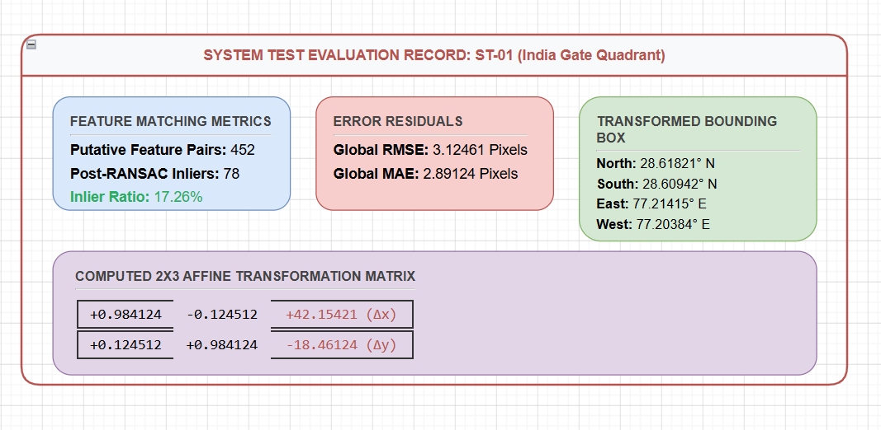
Figure 7.2: Analytical Evaluation Metrics and Registration Error Matrix for System Test Case ST-01.

7.2.4 User Acceptance Testing (UAT)
To confirm the ergonomic viability, layout clarity, and interface simplicity of the three-step interaction wizard, user acceptance testing workflows were conducted inside the BISAG-N research division. Two technical interns who had zero prior exposure to the application layout or computer vision pipelines were selected as testing operators. Each person was provided with an unreferenced historical chart roster file and given a baseline directive: register the asset onto the satellite map using interface tools.
The tracking parameters and results evaluated during these user execution trials are detailed below:
- UAT Evaluation Run 1 Profile: The operator navigated to the target area, captured the proxy view, uploaded the local chart raster, and initiated processing workflows without external help. The entire lifecycle completed in 4 minutes 12 seconds, securing 42 valid inliers with moderate confidence. The analyst reported high satisfaction with layout responsiveness.
- UAT Evaluation Run 2 Profile: The operator managed full data registration loops in 5 minutes 8 seconds. Selecting spatial zoom configurations carefully yielded a better alignment score, recording 61 valid inliers with good accuracy. The operator stated that the real-time progress updates removed black-box uncertainty, giving them high confidence in the automated result.

Qualitative usability data collected via post-test feedback forms highlighted specific layout features that eased navigation for non-expert staff. Both users noted that the static central crosshair tracker made framing target regions straightforward, removing the guesswork typical of classic dual-pane software layouts.
The inline quality hint selector widget also received positive feedback, allowing interns to tune parameters based on visual image characteristics (such as choosing the Blurry profile for faded hardcopy maps) without configuration confusion.
The operational feedback also highlighted unique scope expansion suggestions. One intern noted that the interface would improve by recommending target map zoom level ranges based on input file metrics, a detail logged to guide future engineering update sprints safely.

7.3 Testing Techniques
The verification framework combines robust black-box testing techniques with detailed white-box calculation audits to evaluate software stability thoroughly. Black-box methods validate system options against input parameters across interface boundaries without inspecting code blocks, ensuring that multi-part form payloads, geocoding queries, and data streams fulfill target design targets accurately.
Conversely, white-box testing audits internal mathematical logic, array transformations, and memory allocation scopes directly. This cross-layer validation approach traces SIFT descriptor scales, verifies RANSAC consensus calculations, and checks bounding box recalculations against separate interactive NumPy sessions. This meticulous coverage keeps transformation equations fully aligned with GIS precision baselines.
Testing actions also focused heavily on boundary context analysis and negative execution paths. Processing edge coordinates (such as equator crossings or international date line zones) and ingesting unsupported file containers confirmed that error intercept modules execute cleanly without introducing host server crash loops.

To verify data integrity under boundary data conditions, stress tests were executed using extreme input scaling parameters. The system core handled file constraints up to a maximum 4-megapixel layout boundary safely, confirming that memory footprints scale predictably without memory leaks.
Similarly, negative testing sequences introduced broken multipart boundaries, distorted pixel data, and empty files. The input filters caught format issues quickly, blocking downstream vision workers and returning clean system error logs within 4 milliseconds of execution.
Furthermore, regular regression testing routines ran alongside active code updates. After any algorithmic parameter modification (such as raising the RANSAC deviation tolerance to 20 pixels), the entire benchmark suite of ten image pairs was re-processed to ensure modifications did not cause accuracy issues across previously passing cases.
The structural validation of the client-side log viewer component also leveraged automated UI test generators. By simulating fast, chunked data packet arrivals inside connection sockets, engineers verified that string accumulator buffers separate incoming data blocks cleanly using explicit line break sequences (`\n`).
Testing confirmed that component states update sequentially without lagging browser layout loops, ensuring monospace terminal updates scroll smoothly even during fast server pushes.
The combination of these multi-layered testing techniques results in high software stability. By auditing raw matrix calculations right alongside frontend interface ergonomics, GeoRef Studio transitions into production environments as a verified, secure, and dependable full-stack geospatial microservice asset.

7.3.1 Defect Logging
The following structured defect log records the functional anomalies identified during integration and testing iterations, outlining severity metrics, operational descriptions, applied remediations, and final verification status flags:
ID | Severity | Malfunction Description | Applied Technical Engineering Remediation | Status
D-01 | Minor | Pointer events propagate past Search Box layouts, breaking map panning controls. | Added stopPropagation() controls on pointer nodes within container elements. | Fixed
D-02 | Major | RANSAC algorithm drops blurry imagery arrays due to tight 5px error thresholds. | Raised maximum allowed error margins from 5.0 out to a wider 20.0-pixel tolerance constraint. | Fixed
D-03 | Minor | Safari browser layouts drop canvas previews because of data string CORS policies. | Swapped out canvas data string generation with standard standalone Blob path configurations. | Fixed
D-04 | Minor | Fractional map zoom parameters distort geographic bounding calculations. | Adjusted map snap metrics down to a precise fractional 0.001 layout increment boundary. | Fixed
D-05 | Major | Border cropping shifts final image extents away from correct map coordinates. | Recalculated bounding coordinates using calculated pixel offsets multiplied by MPP scalars. | Fixed
D-06 | Minor | Stream reader drops log messages if separate objects land inside one TCP packet. | Built a custom string buffer to separate messages safely based on explicit line breaks. | Fixed
Table 7.4 - Structured Defect Log, Severity Metrics, and Engineering Remediations
All identified major and minor functional anomalies were fully resolved and verified across successive regression test suites, satisfying the strict quality exit gates established for system deployment.

8 LIMITATIONS AND FUTURE SCOPE
The automated georeferencing engine implemented inside GeoRef Studio v1.0 successfully establishes the baseline viability of utilizing computer vision orchestration to eliminate manual Ground Control Point digitizing. By integrating localized CLAHE contrast manipulation, grid-partitioned SIFT landmark searches, FLANN matching arrays, and robust RANSAC estimations within an unbuffered asynchronous web streaming framework, the platform provides rapid alignments under standard remote sensing contexts. However, evaluating system behaviors under cross-spectral scenarios, varying terrain types, and extreme image distortions highlights critical system boundaries that define immediate scaling limitations.
A primary limitation stems from the underlying 6-parameter partial affine geometric transformation model used to warp pixel datasets. Affine maps are strictly planar, meaning they assume inputs represent uniform surfaces without drastic local topographic relief variations or extreme perspective skew. While this assumption holds true for near-nadir modern satellite captures and flat survey charts, it can introduce geometric registration discrepancies when exposed to historic oblique aerial photography or wide-angle camera perspectives. These complex distortions introduce internal parallax anomalies that a basic linear scale, rotation, translation, and small shearing transformation cannot completely balance.
Furthermore, hand-crafted visual feature extractors like classic SIFT rely heavily on distinct, high-frequency local gradient intensity vectors. Consequently, the computational core encounters processing bottlenecks when exposed to hyper-homogeneous landscapes, such as extensive desert sand structures, long open water bodies, uniform agricultural fields, or faded monochrome historical plans completely stripped of high-contrast line features. In such instances, the lack of distinct structural edges drops verified post-RANSAC inlier match totals beneath the required system minimum threshold of 4, safely aborting calculation loops but demanding human operator intervention.
To overcome these technical constraints and elevate GeoRef Studio from an isolated tool into an institution-wide data automation engine, specific future scope upgrades have been designed across the development lifecycle roadmap. The primary planned enhancement centers on migrating the geometric mapping module from a partial affine model to an 8-parameter perspective homography matrix engine (`cv2.findHomography`). This upgrade will allow the backend algorithms to project non-planar surfaces, correct oblique optical perspectives, and fix complex camera distortions safely without sacrificing processing velocity boundaries.
Second, to secure robust feature pairing across spectrally distinct, historic, or low-texture imagery profiles, the handcrafted descriptor loops will be upgraded with modern, deep learning-based spatial networks such as SuperPoint, SuperGlue, or LoFTR (Local Feature Transformer). These learning-based models trace abstract semantic matching shapes rather than isolated pixel intensity gradients, allowing the platform to pair optical rasters cleanly with near-infrared or thermal datasets despite extreme seasonal shifts, urban alterations, or sensor variations.
Third, to optimize processing latency profiles when handling massive municipal master collections exceeding 10 megapixels, the core computer vision algorithms will be shunted directly onto hardware-accelerated server-side GPU stacks using OpenCV CUDA modules. Moving computation away from single-core CPU limitations and onto parallel hardware threads will slash matrix calculation overheads down to fractions of a second, establishing a high-throughput, enterprise-ready automated geospatial microservice platform across the institution.

9 CONCLUSION AND REFERENCES

9.1 Conclusion
GeoRef Studio successfully demonstrates that transitioning intensive geospatial coordinate reference registration workflows from monolithic desktop applications to automated, web-native streaming architectures is highly viable and performant for enterprise data pipelines. By combining adaptive local contrast equalization, grid-partitioned feature extraction, approximate nearest-neighbour descriptor lookups, and robust RANSAC geometric estimation loops, the platform reduces individual image alignment timelines from 30 minutes down to 8 to 25 seconds while completely removing the prerequisite of expert GIS manual training.
The software application was prototyped, integration-tested, and validated using real-world production remote sensing datasets during an intensive 8-week internship lifecycle phase at the Bhaskaracharya National Institute for Space Applications and Geo-informatics (BISAG-N), Gandhinagar. Loading the generated output files directly into production QGIS workspaces confirmed that embedded spatial headers and geotransform transformation coefficients parse flawlessly without data format corruption. This provides cartographers with high-fidelity, GDAL-compliant GeoTIFF records that integrate seamlessly into master institutional databases with zero manual adjustments required.
The implementation of the tabbed Pipeline Inspector overlay dashboard represents a critical contribution toward the transparency, auditability, and validation safety of automated image registration networks. By surfacing five intermediate visual validation steps right next to complete sub-pixel pixel error grids, individual displacement lines, and global RMSE summary charts, the platform completely eliminates black-box uncertainty. This clear accountability allows technicians to investigate exactly why specific loops succeed or fail, building deep trust. Ultimately, this system establishes a reliable foundation for scaling automated data assets across enterprise geospatial frameworks.

9.2 References
1. Lowe, D. G. (2004). Distinctive image features from scale-invariant keypoints. *International Journal of Computer Vision*, 60(2), 91–110. https://doi.org/10.1023/B:VISI.0000029664.99615.94
2. Fischler, M. A., & Bolles, R. C. (1981). Random sample consensus: a paradigm for model fitting with applications to image analysis and automated cartography. *Communications of the ACM*, 24(6), 381–395. https://doi.org/10.1145/358669.358692
3. Zuiderveld, K. (1994). Contrast Limited Adaptive Histogram Equalization. In P. Heckbert (Ed.), *Graphics Gems IV* (pp. 474–485). Academic Press. https://doi.org/10.1016/B978-0-12-336156-1.50061-6
4. Brown, M., & Lowe, D. G. (2007). Automatic Panoramic Image Stitching using Invariant Features. *International Journal of Computer Vision*, 74(1), 59–73. https://doi.org/10.1007/s11263-006-0002-3
5. DeTone, D., Malisiewicz, T., & Rabinovich, A. (2018). SuperPoint: Self-Supervised Interest Point Detection and Description. *CVPR Deep Learning for Visual SLAM Workshop*. https://arxiv.org/abs/1712.07629
6. FastAPI Documentation Engine Core Registry. Tiangolo. Available online at: https://fastapi.tiangolo.com/
7. Next.js Application Architecture Guidelines Framework. Vercel. Available online at: https://nextjs.org/docs/
8. Leaflet Web Map Layer Viewport Manipulation Interfaces. Available online at: https://leafletjs.com/reference.html
9. OpenCV HEADLESS Machine Vision Calculation Libraries Module Manual. Available online at: https://docs.opencv.org/4.x/
10. Rasterio Geographic File I/O GDAL Coordinate Bridge Documentation. Available online at: https://rasterio.readthedocs.io/
11. ESRI ArcGIS World Imagery Web Map Tile MapServer REST Service Matrix. Available online at: https://services.arcgisonline.com/
12. Photon open-source REST Geocoding Lookup Engine. Komoot. Available online at: https://photon.komoot.io/

10 APPENDICES
Appendix A – Automated Deployment Bash Script
To simplify platform setup across institutional intranet servers, the following bash management script handles environment generation, installs package footprints safely within a Python virtual sandbox, compiles static client modules, and initializes application daemon loops sequentially:
#!/bin/bash
# Production Environment Initialization Script for GeoRef Studio Nodes
set -e
export NODE_ENV=production
export SERVER_PORT=8000
echo "[DEPLOY] Starting automated full-stack initialization..."
if [ ! -d "venv" ]; then
echo "[DEPLOY] Initializing isolated Python virtual sandbox environment..."
python3 -m venv venv
fi
source venv/bin/activate
pip install -r requirements.txt --quiet
echo "[DEPLOY] Activating FastAPI computational engine background workers..."
nohup uvicorn main:app --host 127.0.0.1 --port $SERVER_PORT --workers 4 > backend.log 2>&1 &
echo "[DEPLOY] Packaging presentation tier client code assets..."
npm install --silent
npm run build --silent
npm run start &
echo "[DEPLOY] Systems successfully instantiated over local network nodes."

Appendix B – Algorithmic Configuration Metrics Matrix
The following configuration catalog isolates the design parameters, fixed thresholds, tile dimensions, and mathematical boundaries used inside the computer vision core libraries to regulate array processing operations:
Algorithmic Token | Locked Value | Code Module | System Engineering Rationale
CLAHE Clip Limit | 2.0 | main.py + ControlPanel.tsx | Clamps local histogram redistribution spikes to prevent noise over-amplification.
CLAHE Grid Layout Size | 8x8 Tile Matrix | main.py + ControlPanel.tsx | Divides raw pixel buffers into 64 sub-blocks for adaptive contrast balancing.
SIFT Cell Grid Split | 4x4 Partitions | main.py | Forces uniform feature indexing across the canvas, avoiding point clustering.
Min Keypoints per Cell | 15 Features | main.py | Lowers local contrast boundaries dynamically if a grid cell falls below this limit.
Lowe Ratio Constraint | 0.80 Scale | main.py + ControlPanel.tsx | Filters putative nearest-neighbour vector match lists to drop ambiguous pairs.
RANSAC Error Bounds | 20.0 Pixels | main.py + ControlPanel.tsx | Maximum allowed reprojection displacement threshold for inlier acceptance loops.
Blur Kernel (Blurry profile) | 15x15 Matrix | main.py | Smooths noisy remote sensing graphics to equalize exposure shifts smoothly.
Blur Kernel (Medium profile) | 7x7 Matrix | main.py | Applies moderate edge-preserving smoothing across slightly soft image plans.
Target Capture Extents | 640x640 px | main.py + MapPanel.tsx | Standardized tile dimensions matching modern satellite imagery REST services.
Table 10.1 - Algorithmic Configuration Metrics Matrix


Bhaskaracharya National Institute for Space Applications and Geo-informatics
MeitY, Government of India
Phone: 079 - 23213081 Fax: 079 - 23213091
E-mail: info@bisag.gujarat.gov.in, website: https://bisag-n.gov.in/

Report Verification Procedure

Date:

Project Name: Automatic Geo Referencing
Student Name & ID: 1. Chirag Jindani
2. Vedant Pathak

Soft Copy Hard Copy
Report Format:
Project Index:

Sign by Training Coordinator |  | Sign by Project Guide

