VISVESVARAYA TECHNOLOGICAL UNIVERSITY
Jnana Sangama, Belagavi - 590018

Project Report on

“INDOOR NAVIGATION SYSTEM WITH OBJECT & FACE IDENTIFICATION FOR VISUALLY IMPAIRED INDIVIDUALS”
Submitted in partial fulfillment of the requirements for the award of the degree of

BACHELOR OF ENGINEERING
in
COMPUTER SCIENCE & ENGINEERING
by
ROHAN A S 4MT22CS132
SINCHANA 4MT22CS140
SAMEEKSHA 4MT22CS159
VEDIKA L GIRAP 4MT22CS181

Under the Guidance of Mr. Annappa Swamy D R Associate Professor


DEPARTMENT OF COMPUTER SCIENCE & ENGINEERING

MANGALORE INSTITUTE OF TECHNOLOGY & ENGINEERING
(A Unit of Rajalaxmi Education Trust ®, Mangalore)
Autonomous Institute Affiliated to V.T.U, Belagavi, Approved by AICTE, New Delhi
Accredited by NAAC with A+ Grade & ISO 9001:2015 Certified Institution

2025-26


CERTIFICATE
Certified that the project work entitled Indoor Navigation System with Object and Face Identification for Visually Impaired Individuals carried out Ms. SAMEEKSHA (USN: 4MT22CS140), the bonafide student of Mangalore Institute of Technology and Engineering in partial fulfillment for the award of Bachelor of Engineering in Computer Science & Engineering of the Visvesvaraya Technological University, Belagavi, during the year 2025-26. It is certified that all corrections/suggestions indicated for Internal Assessment have been incorporated in the Report deposited in the departmental library. The project report has been approved as it satisfies the academic requirements in respect of Project Work prescribed for the said Degree.

Signature of the Guide | Signature of the HOD | Signature of the Principal
Mr. Annappa Swamy D R | Dr. Ravinarayana B | Dr. Prashanth C M
 | External Viva
Name of the Examiners |  | Signature with Date
1.
2.


DECLARATION
I, SAMEEKSHA (4MT22CS140), student of 7th semester BE in Computer Science & Engineering, Mangalore Institute of Technology and Engineering, Moodabidri, hereby declare that the project work entitled “Indoor Navigation System with Object and Face Identification for Visually Impaired Individuals”, submitted to the Visvesvaraya Technological University, Belagavi during the academic year 2025-26, is a record of an original work done by me under the guidance of Mr. Annappa Swamy D R, Associate Professor, Department of Computer Science & Engineering , Mangalore Institute of Technology and Engineering Moodabidri. This project work is submitted in partial fulfillment of the requirements for the award of the degree of Bachelor of Engineering in Computer Science & Engineering. The results embodied in this report have not been submitted to any other University or Institute for the award of any degree.

Date: SAMEEKSHA
Place: Moodabidri

ABSTRACT

Indoor navigation is an important issue in large buildings where GPS is weak or not available, especially for individuals who are blind or visually impaired. Advances in computer vision make providing smarter assistance for safe movement in indoor spaces possible. Visually impaired users are often unable to detect obstacles, navigate new indoor spaces, and recognize people in their visual surroundings, all of which can reduce the level of independence and, much like a person without a disability, the confidence to engage socially. Existing aids, such as a white cane or guide dog, provide support, but most are limited in complex indoor environments. This project aims to provide real-time, voice-based navigation, local objects within the range of the human eye, and identification of known individuals with facial recognition. Additionally, unknown faces will also be stored in the database for previously unknown personal identification, which supports long- term interaction with assistance. The proposed project uses an application to interface with YOLO- based object detection, a CNN-based facial recognition, and a floor-map based navigation using the A* algorithm. The mobile application is built on React Native-Expo, and Python APIs process the camera input in real-time. It intends to be a portable, cheap, and widely available assistive tool.

ACKNOWLEDGEMENTS
The satisfaction and the successful completion of this project would be incomplete without the mention of the people who made it possible, whose constant guidance encouragement crowned our efforts with success.

This project is made under the guidance of Mr. Annappa Swamy D R, Associate Professor, in the Department of Computer Science & Engineering. I would like to express my sincere gratitude to our guide for all the helping hand and guidance in this project.

I would like to thank our project coordinator Ms. Sunitha N V, Assistant Professor in the Department of Computer Science & Engineering, for her cordial support, valuable information and guidance, which helped me in completing this project through the various stages.

I would like to express appreciation to Dr. Ravinarayana B, Professor and Head, Department of Computer Science and Engineering, for his support and guidance.

I would like to thank our Principal Dr. Prashanth C M, for encouraging me and giving me an opportunity to accomplish the project.

I also thank our management who helped me directly or indirectly in the completion of this project. My special thanks to faculty members and others for their constant help and support.

Above all, I extend my sincere gratitude to my parents and friends for their constant encouragement with moral support.

SAMEEKSHA (4MT22CS140)

TABLE OF CONTENTS

Contents | Page No
ABSTRACT ACKNOWLEDGEMENT TABLE OF CONTENTS LIST OF TABLES  LIST OF FIGURES | i ii iii v vi
Chapter no | TITLE
- INTRODUCTION 1-3
  - Problem Statement 1
  - Objectives 2
  - Scope of the project 2
  - Organization of the report 2-3

2 | LITERATURE SURVEY | 4-8
2.1 | Existing System | 4-7
2.2 | Limitations of existing systems | 8
2.3 | Proposed System | 8
3 | SYSTEM REQUIREMENTS SPECIFICATION | 9-14
3.1 | Overall description | 9
 | 3.1.1 Product Perspective | 10
 | 3.1.2 Product Functions | 10-11
 | 3.1.3 User classes and Characteristics | 11
 | 3.1.4 Design and Implementation constraints | 11-12
 | 3.1.5 Assumptions and Dependencies | 12-13
3.2 | Specific Requirements | 13-14
 | 3.2.1 Hardware Requirements | 13
 | 3.2.2 Software Requirements | 13-14
 | 3.2.3 Functional Requirements | 14
 | 3.2.4 Non-functional Requirements | 14

4 | GANTT CHART | 15-16
5 | SYSTEM DESIGN | 17-23
5.1 | Architectural Diagram | 17-18
5.2 | Class Diagram | 18-19
5.3 | Use Case Diagram and Description | 19-20
5.4 | Sequence Diagram | 20-21
5.5 | Activity Diagram | 21-23
5.6 | Data flow Diagram | 23
6 | IMPLEMENTATION | 24-34
6.1 | Module implementation | 24-26
6.2 | Code Snippet | 26-32
7 | TESTING | 33-37
7.1 | Test Levels | 33-35
 | 7.1.1 Unit Testing | 34
 | 7.1.2 Integration Testing | 34
 | 7.1.3 System Testing | 34-35
 | 7.1.4 Acceptance Testing | 35
7.2 | Test cases | 36-37
8 | RESULTS AND SNAPSHOTS | 38-44
9 | CONCLUSION AND FUTURE WORK | 45
9.1 | Conclusion | 45
9.2 | Future Work | 45
REFERENCES 46-47

LIST OF TABLES

Table No. | Title | Page No.
Table 4.1 | Gantt Chart of Planning and Scheduling of Project | 15
Table 7.2 | Test Cases | 36-37

LIST OF FIGURES

Figure No. | Title | Page No.
Figure 4.1 | Gantt Chart of Planning and Scheduling of Project | 16
Figure 5.1 | Architectural Diagram | 18
Figure 5.2 | Class Diagram | 19
Figure 5.3 | Use Case Diagram | 20
Figure 5.4 | Sequence Diagram | 21
Figure 5.5 | Activity Diagram | 22
Figure 5.6 | Data Flow Diagram | 23
Figure 6.1 | Code Snippet of Smart Vision Fast API Backend | 26
Figure 6.2 | Code Snippet of Map Meta Structure | 27-28
Figure 6.3 | Code snippets of a list of nodes extracted from a floor map. | 29
Figure 6.4 | Code for Uploading Patient Report | 29-30
Figure 6.5 | Code snippets of Core Logic for Face Recognition | 30-31
Figure 6.6 | Code snippets of Test Script for Nonexistent Process Endpoint | 31-32
Figure 8.1 | Main Menu/ Feature Selection | 38
Figure 8.2 | Detecting the Object | 39
Figure 8.3 | Selecting the floor map for navigation | 39
Figure 8.4 | Assigning the source and the destination for navigating | 40
Figure 8.5 | Navigation Started from Source | 41
Figure 8.6 | Under Navigation Process | 41
Figure 8.7 | UI interface for managing the map | 42
Figure 8.8 | Saving the face for future recognition | 43
Figure 8.9 | UI for additional settings | 43

Chapter – 1 INTRODUCTION

CHAPTER 1

INTRODUCTION

Indoor navigation has become more crucial over the last few years in large and complex settings, especially within colleges, shopping centers, airports, and hospitals, where GPS signals are either weak or nonexistent. For those who are visually impaired, navigating comfortably and safely in such spaces poses a significant challenge and concern. The project will propose and demonstrate the development of an Indoor Navigation System meant to facilitate independent navigation for visually impaired users, with new features including real-time voice directions, object detection, and facial recognition. The system will use computer vision to detect potentially dangerous objects in the user's environment, providing voice notifications to prevent collisions. The system also identifies familiar faces and notifies the user when someone they know is nearby, while also remembering unknown faces for future identification.[12] The proposed solution focuses on cost, portability, and accessibility by using available smartphone-based vision and speech technologies (rather than using new hardware specifically made for the task). Overall, the project aims to develop a practical, inclusive navigational assistant to improve individual safety and independence and social interaction for visually impaired individuals in indoor environments.[9]

Problem Statement

Individuals who are blind or visually impaired encounter significant obstacles when traveling unconstrained throughout indoor environments. Mobility aids, such as white canes or guide dogs, have limitations, particularly in situational contexts identified as unfamiliar, active, or crowded. These barriers often lead to accidents, loss of autonomy, and decreased social interaction. In addition to difficulties of navigation, users who are blind or visually impaired struggle to recognize people who are around them, which further diminishes their confidence in social situations. To enhance mobility and accessibility, the project will create an Indoor Navigation System that will include an Object Detection and Facial Recognition system. Computer Vision technologies will be used to assist users in detecting obstacles and recognizing faces of people they know. The final output of the Indoor Navigation System will provide real-time voice directed navigation and alerts to hazards that the user may encounter while traversing independent of other supports. The Indoor Navigation System promotes safety, independence, and social engagement to help people with visual impairments navigate indoor environments safely while alleviating human error and enhancing pedestrian awareness.

Objectives

    - To provide safe indoor navigation through real-time voice guidance: The system uses computer vision to map the surroundings and create a virtual path. It guides users with continuous voice instructions and alerts them of any obstacles in their path, ensuring safety during indoor movement.
    - To enable identification of known individuals using facial recognition: The system detects faces in real time and informs users when familiar people are nearby, promoting confident and natural social interaction.
    - To store and manage unknown face data for future recognition: When the system detects unfamiliar faces, it saves their data for future reference, helping users build familiarity and improving long-term interaction.

Scope of the Project

The project is focused on creating an intelligent and accessible Indoor Navigation System that aims to support mobility, safety, and social inclusion for a visually impaired user. In particular, we aspire to create a full assistive solution that combines real-time voice-guided navigation, object detection, and facial recognition in the indoor environment where GPS-based navigation is not possible.[9] The system will be built on a smartphone to ensure cost-effective, portable, and more accessible navigation where no specialized or expensive hardware is needed. The functional scope of the project will include mapping indoor spaces using computer vision, guiding users through audio-based instructions, identifying and notifying users of obstacles, and recognizing a user’s frequent social contacts to assist social interaction. Further, for known social contacts, the project grants a user the ability to store facial data upon first identification and recognition to recognize those individuals in the future, which might allow users to feel more familiar with their navigation or social interaction[11]. The performance of the system will be affected by lighting, camera capability, and environmental complexity which may reduce accuracy due to user crowdedness or noise. Overall, the functional scope will produce a smart, user-friendly, inclusive navigation device or aid that balances technology and accessibility to better enable visually impaired users to navigate indoor spaces independently with increased confidence and safety.

Organization of the Project

Chapter 1 introduces the topic, providing an overview and a comprehensive study of the project work. It states the problem statement specifying the problem which is faced and objectives of the project work. The objectives would highlight the importance, scope, and organization of the project

and set the stage for the next chapters.
Chapter 2 provides an in-depth literature survey by outlining existing systems, their drawbacks, and specifying the proposed system. While this chapter outlines the pertinent studies, methods, and technologies, through the literature survey, it describes the gaps the project attempts to address.
Chapter 3 describes the system requirements, and offers an overall description and a detailed specification. Product perspective, product functions, user characteristics, constraints, assumptions, and dependencies are described, along with hardware, software, functional, and non-functional requirements needed for a successful implementation.
Chapter 4 provides a Gantt chart, which is a visual indication of the phases, tasks, and milestones of the project, and can be used to track progress, check dependencies, and support the completion- on-time.
Chapter 5 discusses system design by providing the architectural, class, use case, sequence, activity, and data flow diagrams. The diagrams represent the structural and behavioral characteristics of the system, showing how different aspects of the system work together to produce the required functionality.
Chapter 6 focuses on the implementation phase and explains each of the developed modules, along with their intended functionality and how they were implemented and integrated. Reasoning is provided for each module including some key sections of code, demonstrating the translation of design ideas into a running system.
Chapter 7 examines the specification of the testing of the system, defining the levels of testing, including unit, integration, system and acceptance testing. Sample cases are included to demonstrate that all specification requirements had been achieved and that system performed correctly under the condition of constant and variable changes to inputs.
Chapter 8 presents the results and snapshots of the system showing the functionality and key features of the system. The chapter highlights the outputs of the developed solution and examines the performance of the system architecture.
Chapter 9 outlines the conclusions of the report by revisiting the aims and objectives of the project and the achievements and contributions made. There are also recommendations for further development which aim to address the existing limitations and extend the developed system in future iterations.

Chapter – 2 LITERATURE SURVEY

CHAPTER 2

LITERATURE SURVEY

Existing Systems

Juile J et al. (2024) [1] proposed a smartphone-based augmented reality navigation system as a way of dealing with disorientation that can occur in indoor, large environments (such as malls or offices) where GPS does not work. Using ARCore, Unity, and NavMesh technologies, they implemented a system where the user can receive feedback and update their path in real-time. Through AR-Core’s capability of Simultaneous Localization and Mapping, the navigation system is able to create a 3D model of the space and determine where the user is located in that space. Using Unity’s capability of NavMesh, the navigation paths are determined and then shown to the user through augmented reality overlays from their mobile device. Additionally, Natural Language Processing enables voice-based interaction for overall increased accessibility. The prototype system has been successful at seamlessly navigation and updating in real-time while using solely smartphone sensors, however, the system does experience screen jitter and can need to be calibrated initially. This solution stands out for its low-cost, scalability, and accessibility. Future directions will involve GPS integration, dynamic AR content, and addressing displacement/shifts and screen jitter associated with tracking. Together, these improvements will broaden applicability for shared content across applications..
Wensheng Zhang, et al. (2020) [2] presented a cost-effective indoor navigation system that is smartphone-based, based on Building Information Modeling (BIM) and Augmented Reality (AR). The system assists pedestrians in navigating complex indoor environments, such as airports or shopping malls, in venues without Global Positioning System (GPS) capabilities. The system uses a 3D BIM model, which undergoes a bridging technique to form a 2D map through 3D triangulated prism based spatial division, and by placing AR nodes throughout the venue for visual positioning, which the user tracks through a smartphone camera. Included is a novel Indoor Augmented Reality Navigation Algorithm (IARA) that explores the best possible routes - balancing characteristics such as length, AR node usage, and visibility, and supports semantic interactions to better current state of user orientation. Based on testing, the results suggested that although the IARA routes may be longer than a baseline route, designated the Shortest Path Algorithm, the usability and engagement increased with enough interaction with AR. The licorice elements presented within the study pointed to the technology's accuracy, easy understanding of navigation, and costs associated with the hardware. Issues noted were the APR node manual setup, and time taken developing the BIM model concepts. Future work as noted, will attempt to address these issues, as well as ability to adapt dynamically, operate within multiple buildings, and link both the AR and

BIM updates automatically to offer a live performance which could afford a different participant experience altogether.
R.G. Baldovino, et al. (2024) [3] introduced a smart visual aid system to assist blind and visually impaired people in indoor environments through image processing, deep learning, and audio-haptic feedback. The system's interaction is based on three modules: input, analysis, and feedback. The input of the system is live visual data sent through a CCTV camera; the analysis is made with a YOLO-based deep model that detects nearby objects such as humans, chairs, and tables; and finally, feedback is given via an audio alert or a vibration alert when the user is within less than
0.3 meters of the detected object. Technologies such as Roboflow, Albumentations, Jupyter Lab, and Django were used for the dataset, training the model, and deploying the system in real time on the web. The model achieved a mean average precision (mAP) of 0.92 while maintaining high object detection accuracy, which was then integrated into a web application called "Project MATA" for monitoring. Experimental testing confirmed the detection of objects and timely feedback to individuals, although caveats included less than perfect timing with slight latency response times, reduced edge detection precision, and slower computational efficiency and outcomes based upon the hardware. In summary, these researchers proved their system was low- cost, accurate, and hands-free as an assistive solution, allowing users to navigate in real time with proper feedback, and suggested better camera systems, enhanced environmental data using depth sensors, and improved overall quality of haptic feedback mechanisms as the next steps for developing their prototype further.
Izzat N. Jarudi, et al. (2023) [4] studied the difficultly of recognizing familiar faces from afar. Face recognition studies rarely study this problem, as they tend to concentrate on images taken from close proximal positions with high-resolution images. The authors presented both human and computational studies on how recognition performance changed as distance increased, disentangling the contributions of the internal (eyes, nose, mouth) and external (head shape, hairline) features. Each human participant was shown either full, internal, or external face configurations using Gaussian blur to simulate the effect of increasing distance in a real-distance setting. Fully-faces configurations were consistently recognized most accurately, while performance decreased when we only displayed either internal (nose, mouth, eyes) or external features (hairline, head shape). Our findings suggested the integrity of the spatial relation between face components was critical to recognition, replicating the face inversion effect. In a parallel experiment, we tested AlexNet CNNs that we trained on the FaceScrub dataset to determine if the machines would also struggle with either the distance blur or the internal or external feature manipulations, if they had no access to recognized holistic face knowledge. The machines, like human participants, completed the assessments more accurately when they had full access to facial features. Ultimately, the findings suggest that recognition of a face from distance relies on spatially integrated information rather than isolated features, which has important consideration for creating

An AI face recognition models for real-world conditions. Future studies will include datasets that exhibit more authentic conditions of the real world and other improvements in machine learning models that use spatial.
R. M. S, A. M. R, et al. (2023) [5] developed a smartphone enhanced AR indoor navigation system, which aims to address the shortcomings associated with GPS usage in indoor settings like malls, universities, and airports. The system uses ARCore, Flutter, and Firebase in order to provide users with real-time, markerless, AR navigation, where the user receives guidance via virtual arrows on their smartphone displays. The architecture includes a user interface for the user interaction (built using Flutter), a cloud-based middleware for path storage and retrieval (Firebase), and a back-end that handles motion tracking, spatial mapping, and 3D rendering (using ARCore). The prototype of the system allows for near-seamless indoor navigation with real-time updates, QR-based location detection, and a user-friendly way of viewing paths and routes. Although the system was shown to be a viable and engaging user experience, it is important to note that there were issues with battery usage, compatibility with low-end or non-ARCore devices, and stable internet connection at all locations. The study concludes that AR based navigation has the potential to greatly improve user experience and quality of independence and explains the next steps involve hybrid indoor-outdoor navigation, performance improvement, and improving the security of location data.
R. Goud, et al. (2022) [6] designed a low-cost augmented reality-based indoor navigation system, intending to provide efficient guidance in any large indoor spaces, such as malls, airports, and hospitals, where GPS signal is non-existent. The system is low-cost and easy to use because it does not rely on sophisticated AI or machine learning models, but instead uses AR, SLAM (simultaneous localization and mapping), and image recognition through a smartphone interface. During use, a user is advised to scan their surroundings to realize their local self-location in real- time, and then the A* Algorithm determines the shortest path to their destination that is ultimately presented in AR in real-time overlaid on the live camera. The prototype was built using Unity 3D, AR SDKs (ARCore and Vuforia), Firebase for the backend management, and proof of the system's success was demonstrated with smooth localization, navigation, and destination confirmation without specialized hardware. Specifically, the innovation is effective because it is low-cost, easy- to-use, && reusable, while still providing persistent virtual markers and the potential to be incorporated into health or accessibility apps. Downsides include its effectiveness being impacted by lighting, repetitiveness of structures, and low-end hardware. Future work can include gamfication, obstacle detection, cross-compatibility, and AI support for producing a more interactive and intelligent system.
S. C. J., et al. (2020) [7] the authors of this indoor navigation system based on augmented reality proposed the system as a solution to the imprecise feature of GPS while navigating in enclosed

environments such as malls, airports, and hospitals. Their proposed system utilizes ARCore-based SLAM for localization, QR codes to reset the users position, and path computation using Unity NavMesh while being aware of obstacles. The proposed navigation path is indicated by AR arrows overlaying the live feed of the camera providing users with an interactive but tactile human-guided experience via smartphone. The general workflow begins with the user scanning a QR code to determine their initiation point or starting position. Users can then select a destination and the A* search algorithm computes the optimal path to the destination. The computed path is indicated to the user using dynamic AR visuals and a minimap for environmental awareness and spatial location awareness all being displayed in real time. The authors implemented the proposed indoor navigation system using ARCore and Unity, NavMesh and web programming technologies (HTML, CSS, and JavaScript) to manage the layout of the building schema and QR code marker documentation. Testing of the proposed system and SLAM based tracking produced a highly accurate tracking resolution (≈0.08 m error). Compared to marker based tracking and GPS based tracking methods. There were major advantages of the system which included precise and high accuracy location sensing without any external hardware required, cost-effictiveness and user interactivity and proximity to scale. There were limiting factors which included its dependency on AR user interface stability and capture, lighting dependent, battery life limitations. There are several improvements suggested in the near future including integrating real-time approaches to detecting moving obstacles, including an iOS version for accessibility, guilded accessibility, and specific applications for visual impaired users to find their way indoors.
Rakesh Chandra Joshi, et al. (2020) [8] The study demonstrates the limitations of traditional mobility aids such as canes and GPS technology, in that neither provides real-time object recognition or intelligent navigation. The proposed approach couples the YOLO-v3 (You Only Look Once) deep learning model with a DSP processor, a camera, and ultrasonic sensors, enabling real-time obstacle avoidance and identification and auditory feedback. A dataset was built with imagery of the objects targeted for recognition by the visually impaired participants, which required their annotation using LabelImg, and augmented through transformations such as rotation, flipping, and noise addition as part of the dataset population process to ensure robustness. The YOLO-v3 model was trained, utilizing both transfer learning and direct training, achieving an object detection accuracy of 95.19% and an object recognition accuracy of 99.69%. Audio results were communicated efficiently when the speech module provided auditory feedback of compact information (i.e., "three persons," as opposed to relaying "person" repetitions) to minimize processing volume and lag time. The hardware portion of the project was implemented on Intel i9– NVIDIA Tesla K80 for training and tested on a DSP board coupled with an 8 MP camera for real- time computations in indoor and outdoor settings.

Limitations of existing systems

Even though today’s indoor navigation and assistive systems are cutting-edge, they are still unable to accomplish the real-world tasks that visually impaired people require. Many users utilize navigation models developed primarily for sighted users with heavy reliance on visual aspects (AR arrows, maps, etc.) and not much (or any) voice cue access. Technical issues such as the instability of AR's objects, functionality in low-lighting conditions, high battery and memory usage, and reliance on network connectivity often take precedence. Some solutions use manuals that required leap through scanning QR codes or depend on pre-aligned AR marker, limiting the solution each system could bring to the user within indoor conditions. Additionally, there is a use of some approaches for AI based object detection, but the typically are not full indoor navigation, obstacle detection, or facial recognition solutions, all features that are needed to provide socially-inclusive support for navigation. Existing models do not enable identifying known individuals and storing unknown faces to provide support for potential future identification which is less than useful for practical support within social settings. Ultimately, at this stage of model development, none of the systems provide an integrative solution that provides real-time AR-based indoor navigation, obstacle detection, and face identification combined with a voice-based support approach, which is required to ensure safe, independent, and socially confident navigation for individuals who are visually impaired.

Proposed System

The proposed system is developed to help visually impaired people to navigate safely and independently in indoor environments, employing object detection and face recognition techniques. Conventional mobility aids, such as white canes or guide dogs, might be useful, but they are inadequate when navigating places indoors that are unfamiliar, dynamic, or crowded. This environment can pose challenges navigating, increase the risk of falling, and reduce confidence socially. The proposed system utilizes computer vision to identify and map the existing environment, creates virtual paths for navigation, and continuously provides users
with voice-guided instructions in real time. The system detects and provides an audible warning of objects nearby that may pose a threat to safe mobility. Additionally, the solution uses facial recognition technology to help identify known individuals nearby to facilitate social exchanges. When unknown individuals are encountered, the system also securely stores their data to later recognize a new face over time. Ultimately, the proposed system improves visual impaired individuals' safety, independence, and social inclusion through improved navigation in indoor environments that is intuitive, efficient, and empowered.

Chapter – 3 SYSTEM REQUIREMENTS
SPECIFICATION

CHAPTER 3

SYSTEM REQUIREMENTS AND SPECIFICATION
A Software Requirements Specification (SRS) outlines the functional requirements and nonfunctional requirements of the Augmented Reality (AR)-Based Indoor Navigation System with Object Detection and Facial Recognition. The SRS facilitates a shared understanding of the system objectives, functionally, and limitations among developers, stakeholders, and end users. The SRS will serve as the key foundational document for the development of an intelligent, assistive navigation solution for people who are visually impaired. The solution uses Augmented Reality, Computer Vision, and Artificial Intelligence to provide an intelligent indoor navigation system providing real-time indoor navigation correlated with obstacle detection and facial recognition. Users will be provided a guided approach to navigation through voice-assisted technology, while the system tracks and alerts the user to the presence of surrounding obstacles for safe movement. Additionally, the voice-assisted navigation system will identify familiar faces within the premises and notify visually impaired users of their presence, therefore supporting social confidence and awareness. Secure memory retention capabilities will store faces that the subject does not know for identification upon seeing that person again. In doing so, the system is continually growing and adapting to become increasingly useful to the user over time. The systematic definition of technical specifications, operational workflows, and system behaviors allow the SRS to develop a reliable, safe, relevant, and user-friendly indoor navigation system that promotes people who are visually impaired to move successfully, independently, and with confidence in complex indoor environments.

Overall Description
The Software Requirements Specification (SRS) outlines the functional and non-functional requirements for the Indoor Navigation System with Object Detection and Facial Recognition. This document provides a thorough understanding of the system’s purpose, use cases, and environments of constraints to facilitate a common understanding among developers, stakeholders, and users. The purpose of the system is to support visually impaired individuals in navigating indoor spaces, such as shopping malls, hospitals, universities, and airports, wherein GPS signals are absent or diminished. By combining computer vision, and voice technologies, the system aims to provide real-time voice navigation support, obstacle detection, and facial recognition for improved safety, independence, and socialization.The application is designed as a mobile device- based assistive technology that uses the cameras and sensors on a mobile phone to map the proximity space and navigate without using external devices. This design will help minimize the expense, contribute to accessibility, and enhance scalability in order for blind users to use the application.

Product Perspective
The proposed system operates in the form of an interactive mobile app that employs the smartphone's camera and sensors to facilitate indoor navigation. The user's surroundings will be streamed from the camera and represented as an augmented scene in real-time, along with voice feedback to aid navigation. The system includes object detection to recognize objects in the user's environment, as well as voice alerts, to warn of dangers to ensure the user avoids a collision with that object. The system also includes facial recognition that identifies recognized people, as well as saves faces of people encountered to be recognized later, assisting the user in maintaining a level of social awareness in the environment. This system provides autonomous, intelligent, and interactive assistance, unlike a simple assistive tool, such as a white cane or guide dog, thus minimizing human dependency. The system is designed to operate fully on smartphones and significantly reduces the need for expensive hardware, thereby solving the problem of attachable components or bulkiness of blind person mobility aids given the ability to easily develop, deploy, and transport a solution on a smartphone. The actual architecture is modular and consists of indoor navigation, computer vision (object and face detection), and audio interaction (voice feedback).

Product Function

The core functions of the system include:

      - System Initialization: When the application is launched, the camera is activated, and the system initializes all core modules such as object detection, face recognition, and voice assistance. The environment scanning begins immediately to capture real-time visual data from the surroundings.
      - Environment Mapping (Floor Map-Based): Instead of using AR-based mapping, the system utilizes a digital floor map of the building as input. The Python-based navigation algorithm processes this floor map to assign coordinates for key locations (rooms, corridors, exits, etc.) and determines optimal routes between them.
      - Path Generation and Navigation: Based on the user’s selected source and destination, the navigation module computes the shortest and safest route using pathfinding algorithms (A* algorithm). The system then provides continuous voice guidance through the mobile interface, assisting the user to follow the correct path indoors.
      - Object Detection and Obstacle Avoidance: Using AI-based models such as YOLO (You Only Look Once) integrated through Python and TensorFlow, the system performs real-time detection of obstacles like furniture, walls, and other objects.

      - Facial Recognition: The system incorporates a face recognition module that identifies known individuals in real time. When a familiar person is recognized, the user receives a voice notification mentioning the person’s name, thereby improving social interaction and confidence in shared spaces.
      - Unknown Face Storage: If an unrecognized individual is detected, the system captures and securely stores their facial features in a local or cloud-based database for future recognition. This enables the system to learn and enhance its familiarity with people over time.
      - Voice-Based Assistance: Throughout navigation, the system interacts with the user using voice commands and speech output. This includes providing direction updates, obstacle alerts, and recognition feedback. The voice assistance ensures a fully hands-free and accessible user experience.
      - Data Management and Security: All captured data, including facial images, object information, and navigation maps, are handled securely using encryption and controlled access mechanisms. The system prioritizes privacy, ensuring that user data and environment recordings remain protected and confidential.

User Classes and Characteristics
      - Primary Users: The main users will be staff and students with visual impairments who use the system to help themselves navigate the college campus in an efficient and safe manner. They will utilize a mobile application that provides audio and haptic feedback to provide real- time navigation, obstacle detection, and identity recognition. For example, of familiar faces. The system is designed to be simple to use with minimum technical expertise in mind.
      - Administrator: The administrator's role is to manage indoor maps, object recognition, facial recognition database and system maintenance. They will ensure that navigation routes, and recognition data are accurate and up to date. The administrator will need a moderate level of technical knowledge for the configuration and maintenance of the system.

Design and Implementation Constraints
      - Hardware Dependency: The performance of the system is affected by smartphone hardware such as the camera quality, processing capability, and built-in sensors (gyroscope, accelerometer). Low-end devices will experience reduced accuracy or frame lag.
      - Lighting and Environmental Conditions: Accuracy of object detection or facial recognition depends on adequate indoor illumination. Poor lighting, glare, or congestion may affect reliability of detection

      - Network and Connectivity: The system must have consistent access to Wi-Fi or mobile internet to function properly, particularly if cloud computing for processing (if applicable) or public database access is being relied upon. If each user is only connected through limited means, then navigation updates or recognition will be much slower or simply not work.
      - Voice and Audio Feedback: The system must ensure clear and low-latency voice guidance appropriate for those who are visually impaired. If there is significant background noise that may compromise voice feedback or speech recognition, that could also compromise the reliability of the feedback.
      - Data Privacy and Storage: Capturing and storing personal data is a requirement of facial recognition technology. The system must meet privacy requirements and secure any and all stored data to discourage misuse.

Assumptions and Dependencies Assumptions
      - The user has a camera that can be used for object detection and face recognition.
      - The device has the processing capacity and RAM to run object/face detection and rendering tasks in real-time.
      - Light conditions are suitable for the camera to conduct accurate object and face detection.
      - The indoor setting (whether it be at a mall or institution) has stable features and environments that can assist AR tracking and mapping.
      - A stable Internet connection and/or local connection is available to synchronize data, allow for updated experiences and/or cloud recognition (if applicable).
      - The object detection model (e.g., YOLO) has been trained on relevant and sufficient datasets corresponding to standard indoor objects.
      - The prototype is tested in a controlled indoor environment; this performance may vary in highly variable or crowded environments. The user has access to a device that supports AR- Core and has a camera that can be used for object detection and face recognition.
      - The device has the processing capacity and RAM to run object/face detection and rendering tasks in real-time.
      - Light conditions are suitable for the camera to conduct accurate object and face detection.
      - The indoor setting (whether it be at a mall or institution) has stable features and environments that can assist AR tracking and mapping.
      - A stable Internet connection and/or local connection is available to synchronize data, allow

for updated experiences and/or cloud recognition (if applicable).
      - The object detection model (e.g., YOLO) has been trained on relevant and sufficient datasets corresponding to standard indoor objects.
      - The prototype is tested in a controlled indoor environment; this performance may vary in highly variable or crowded environments.

Dependencies

      - YOLO11n: Pre-trained object detection model for identifying indoor obstacles and objects in real time.
      - CNN using face_recognition library: Used for facial feature extraction and recognition to identify registered user.
      - React Native Expo: To develop a cross-platform mobile application that integrates augmented reality, object detection, and face recognition features in a unified and user- friendly interface.

Specific Requirements

    - Hardware Requirements

- Processor: Multi-core processor (Intel i5 / AMD Ryzen 5 or higher).

- RAM: Minimum 4 GB (recommended 8 GB).

- Storage: At least 20 GB free.

Software Requirements
      - Operating System: Windows 10/11 (for development), Android 10+ or iOS 13+ (for deployment and testing).
      - Development Framework: React Native (with Expo SDK) for cross-platform mobile application development.
      - Programming Languages: JavaScript (ES6+) and JSX for frontend logic, python 3.8+ and UI.
      - Integrated Development Environment (IDE): Visual Studio Code (recommended) or Android Studio.
      - Web Framework/Server: FastAPI, Uvicorn.
      - Object Detection: ultralytics.
      - Core Libraries: opencv-python (cv2), face-recognition, numpy.

      - Build Dependencies: cmake and a C/C++ Compiler.

Functional Requirements

      - Application Home Screen: The app displays key options such as Ziya (voice assistant), Navigation System, Object Detection, and Facial Management.
      - Floor Map Management: Users can add or delete floor maps, select source and destination rooms, and the system prepares the navigation route.
      - Indoor Navigation: The system provides voice-guided navigation using waypoint-based (footstep) instructions for safe indoor movement.
      - Real-Time Object Detection: The app detects obstacles through the camera and alerts the user via voice feedback.
      - Facial Recognition: Known faces are identified in real time, while unknown faces can be saved for future recognition.
      - Voice Assistance: All major interactions—navigation, detection, and face recognition—are supported with clear voice feedback.
      - Modular Operation: Navigation, object detection, and facial recognition modules can work independently or together as needed.
      - User Settings: The app includes additional settings to enhance accessibility and usability for visually impaired users.

Non-Functional Requirements
      - Performance: The system should provide real-time object detection, face recognition, and navigation updates with minimal delay.
      - Security: User data such as stored face details and floor maps must be securely stored and accessed only by authorized users.
      - Scalability: The system should support adding new buildings, floors, and user data without affecting performance.
      - Transparency: All detected objects, faces, and navigation instructions should be clearly communicated through voice feedback.
      - Usability: The app must be simple, accessible, and easy to use for visually impaired users with clear audio guidance and minimal manual input.

Chapter – 4 GANTT CHART

CHAPTER 4

GANTT CHART

Gantt chart is a type of bar chart, developed by Henry Gantt that illustrates a project schedule. Gantt charts illustrate the start and finish of the terminal elements and summary elements of the project. Terminal elements and summary elements comprise the work breakdown structure of the project. The following is the Gantt chart of the project “Gantt chart of planning and scheduling of Project”.
Table 4.1: Gantt Chart of Planning and Scheduling of Project

SL.No. | Task | Start | End | Duration  (days)
1 | Title Presentation | 03/03/2025 | 07/03/2025 | 5
2 | Synopsis Preparation | 08/03/2025 | 10/03/2025 | 2
3 | Literature Survey | 11/03/2025 | 03/05/2025 | 50
4 | Review | 24/03/2025 | 28/03/2025 | 5
5 | Problem Definition &  Objectives | 05/05/2025 | 10/05/2025 | 5
6 | Software Requirement  Specification | 12/05/2025 | 17/05/2025 | 6
7 | Phase-1 Presentation | 19/05/2025 | 23/05/2025 | 5
8 | System Design | 04/08/2025 | 14/08/2025 | 10
9 | Module Development &  Integration | 15/08/2025 | 16/10/2025 | 60
10 | Review | 08/09/2025 | 13/09/2025 | 7
11 | Testing & Evaluation | 17/10/2025 | 25/10/2025 | 10
12 | Report Preparation | 26/10/2025 | 19/11/2025 | 25
13 | Final Presentation | 10/11/2025 | 15/11/2025 | 6

ACTIVITY/MONTH | MAR | APR | MAY | AUG | SEP | OCT | NOV
TITLE PRESENTATION
SYNOPSIS
LITERATURE SURVEY
REVIEW
PROBLEM DEFINITION & OBJECTIVES
SOFTWARE REQUIREMENTS SPECIFICATION
PHASE PRESENTATION
SYSTEM DESIGN
IMPLEMENTATION
REVIEW
TESTING & EVALUATION
REPORT
FINAL PRESENTATION
Figure 4.1: Gantt Chart of Planning and Scheduling of Project

Chapter – 5 SYSTEM DESIGN

CHAPTER 5

SYSTEM DESIGN

The architecture, modules, interface, data flow, and components needed to build the suggested indoor navigation system with object detection and facial recognition are described in the system design. The goal of system design is to develop a systematic strategy to guarantee that the system achieves the functional goals of safely and precisely helping individuals with visual impairments navigate indoor spaces, such as college campuses. The Navigation Module and the Object and Face Detection Module are the two primary modules. Using floor maps that have been uploaded, the Navigation Module generates a virtual route and uses voice navigation to help the user navigate. It also recognizes obstacles in the route and advises the user to avoid them. In addition to identifying familiar faces and objects the user is close to, the Object and Face Detection Module may ask the user to add the unknown individual for future recognition. The design describes how the modules interface with the hardware components (mobile camera, sensors, and user audio output) to provide the user with a seamless experience where guidance uses the navigation system while communicating as needed. To enable effective development, simple testing, and smooth integration of the components into the overall system, the system design permits the system's components to be divided into smaller, more manageable single components. Accessibility, scalability, and performance are generally given top priority in the system architecture, ensuring that the application can be enhanced, maintained, and modified to fit different indoor environments as needed.

Architectural Diagram
The Indoor Navigation System with Object and Face Identification for Visually Impaired Individuals' general layout and how its main parts interact are depicted in the architectural diagram. The system uses voice interaction, facial recognition, and real-time object detection to help visually impaired people navigate indoor spaces safely. Voice commands and the camera on the mobile device, which records live video of the environment, are how the user interacts with the system. The Frontend Layer, created with React Native Expo, manages camera input and saves local information for offline use, including floor maps and faces that have been identified. The data is then utilized by the API Layer, which is made up of three lower-level modules: the Navigation module which deploys the floor maps, an Object Detection module which uses computer vision models such as YOLO, and the Voice/I/O module which is responsible for recognizing commands and system feedback. The Backend Layer provides support for the API layer in functioning correctly by storing metadata (saving information about the user), synchronizing the maps and face data, and service requests from the mobile app to the server. The Voice and AI Layer incorporates

speech recognition and text to speech processing, allowing the system feedback to be converted to voice instructions to enable hands-free navigation. At the end of the day, these three layers ensure data flows seamlessly, the environment is intelligently aware, and audio directions/feedback are provide in real-time, making moving about indoors safer and more accessible for individuals with visual impairments.
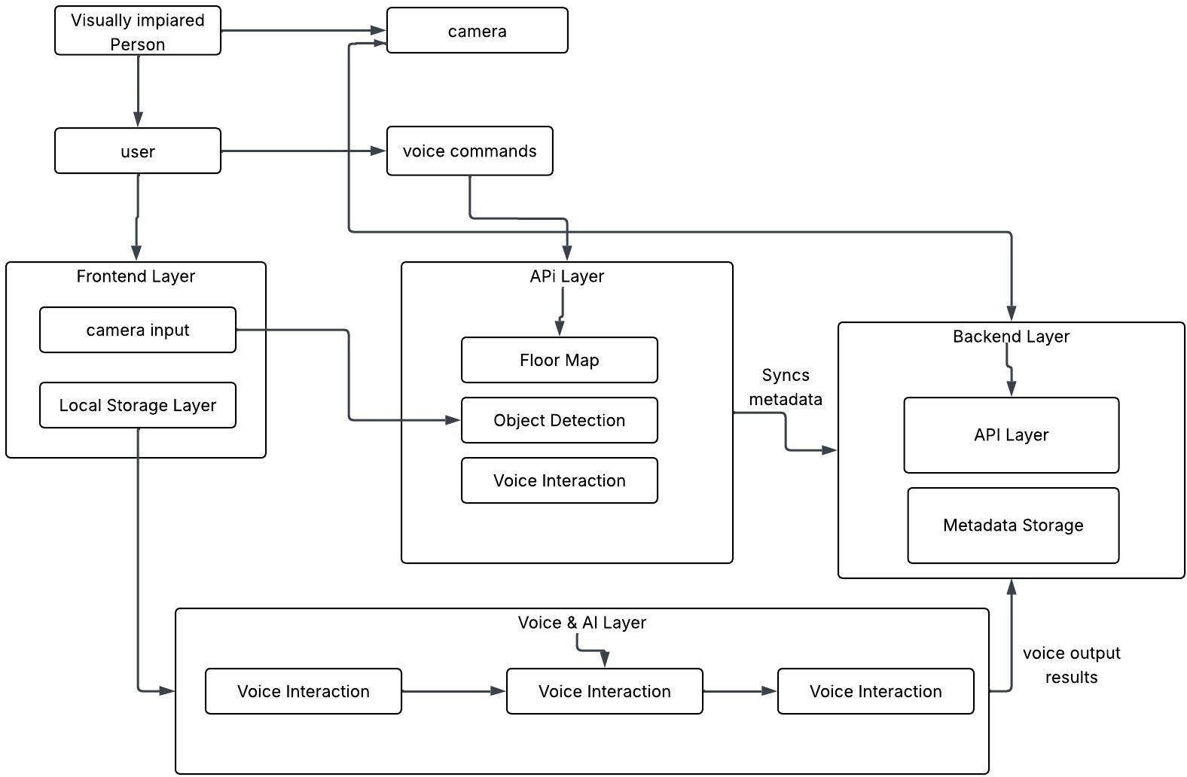

Figure 5.1 Architectural Diagram

Class Diagram
The diagram highlights dependencies where one class relies on another to perform its function The User initiates commands received by the MobileApplication, and the user's preferences are also managed by the BackendServer. The MobileApplication relies on the NavigationModel for calculating routes, the ObjectDetection module to sense the environment, and the VoiceAssistant to communicate output to the user. The core sensory and cognitive modules, ObjectDetection and FaceRecognition, are essential for situational awareness. They depend on LocalStorage (using
+cacheModels and +cacheMaps) to load and save their respective machine learning models and map data.The NavigationModel feeds instructions to the VoiceAssistant, which uses methods like
+convertTextToSpeech() to generate the final audio guidance for the user. In summary, the diagram illustrates a tightly integrated, voice-controlled system where the MobileApplication coordinates location and input data, passes it to the NavigationModel for path computation and to the Detection/Recognition modules for environmental analysis, and finally delivers instructions via the VoiceAssistant.

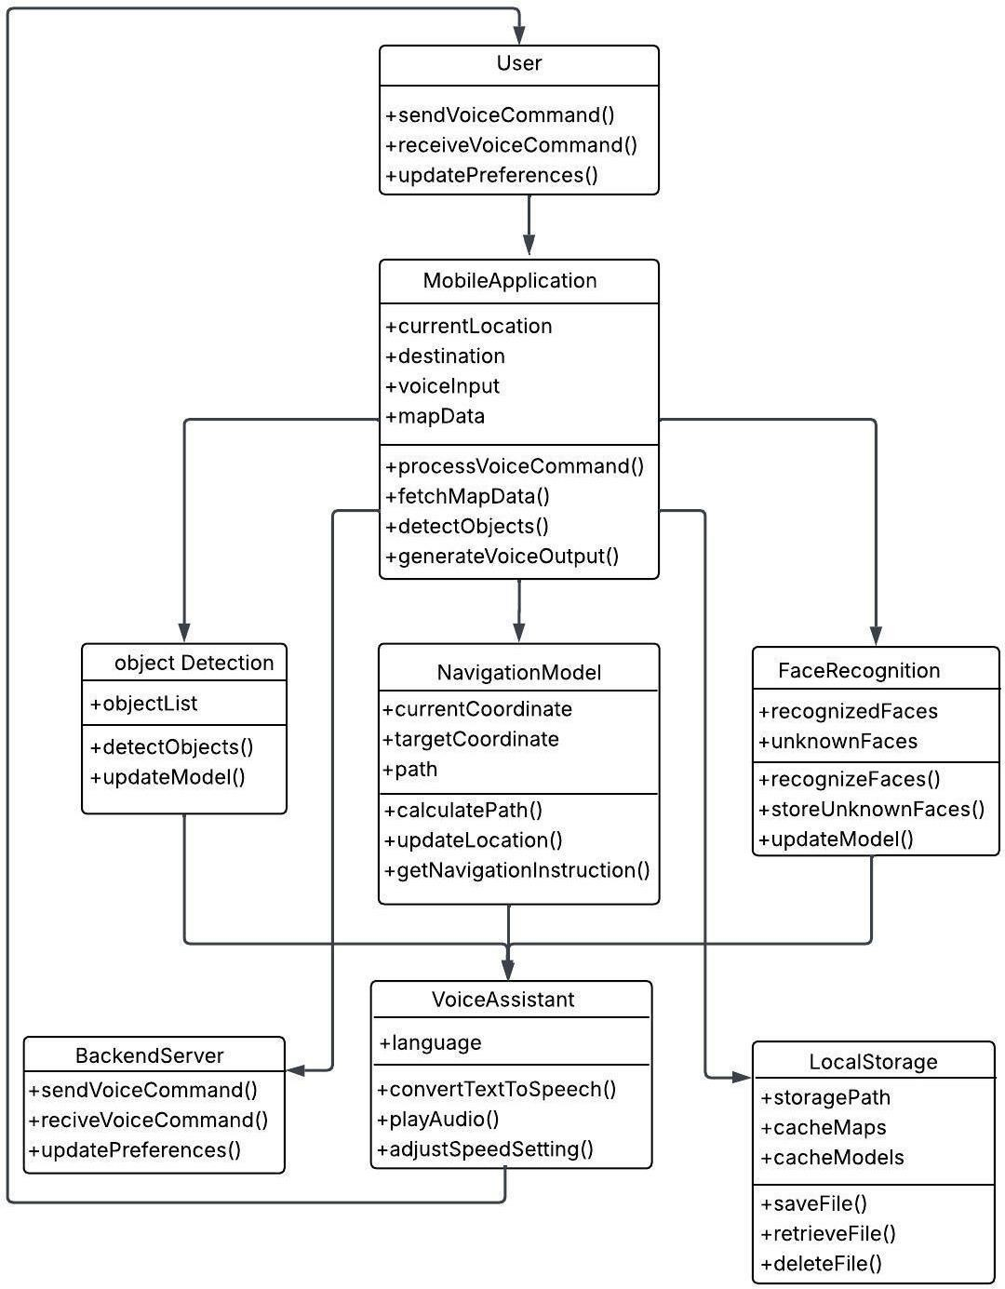

Figure 5.2 Class Diagram

Use Case Diagram and Description
Showing two primary actors: the Visually Impaired User and the Administrator. The Visually Impaired User drives the operational flow, starting by using the Start Application use case to access the system's core features. The main goal, Indoor Navigation, is inherently dependent on three other functionalities: it «includes» Voice Feedback to provide auditory instructions, and it is closely related to Object Detection for real-time safety alerts regarding obstacles, and Facial Recognition for identifying nearby individuals, both of which also rely on Voice Feedback for communication. Separately, the Administrator is responsible for system maintenance, exclusively

performing the Manage Floor Maps use case to ensure the underlying map data used for navigation remains current and accurate. This structure effectively separates the day-to-day user experience features from the essential system maintenance functions.
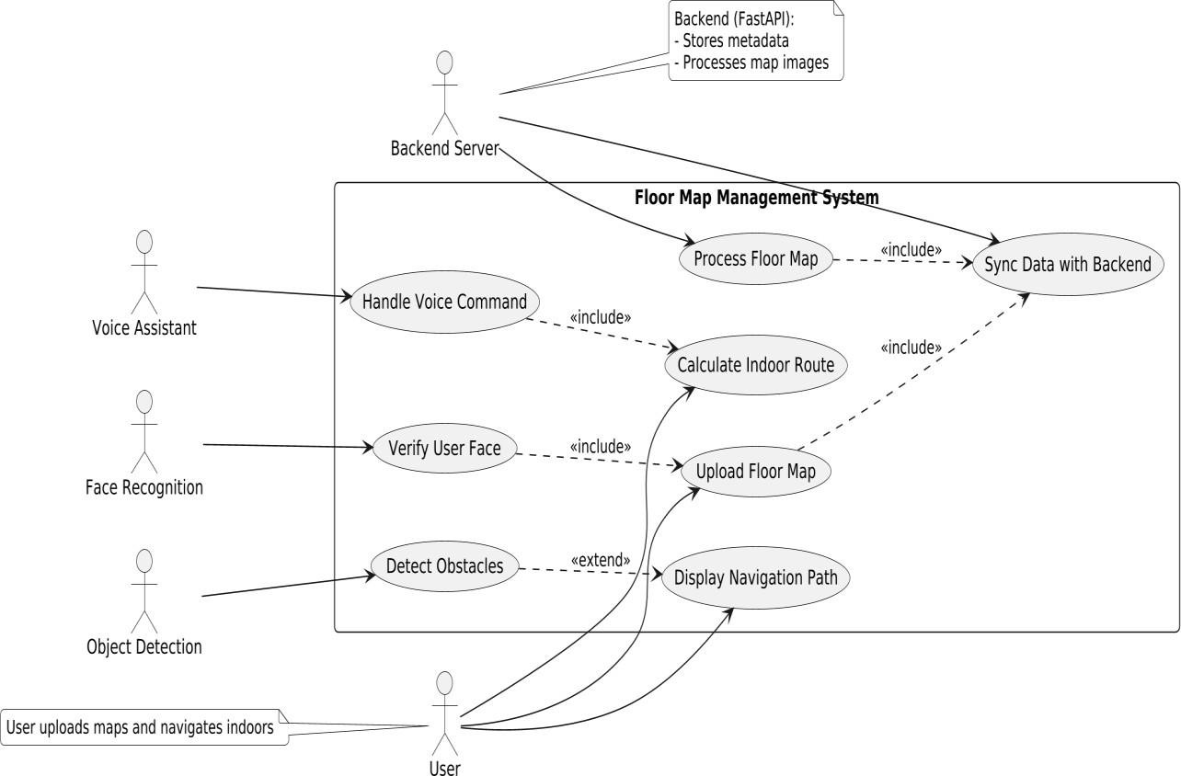

Figure 5.3: Use Case Diagram

  - Sequence Diagram
The Sequence Diagram clearly shows how the system coordinates multiple modules to serve the user. The process is initiated by the User selecting a mode on the Mobile App Interface. This leads to a central Conditional Flow that dictates the subsequent sequence:

    - Navigation Flow (If Mode = Navigation): The Mobile App Interface sends a Route Request to the Navigation System. The Navigation System then interacts with the Floor Map Database Retrieve Map Data, runs the pathfinding algorithm to Calculate Optimal Path, and sends the resulting Instructions to the Voice Assistance System. The Voice Assistance System then Provides Voice Guidance back to the User.
    - Detection Flow (Running Continuously): In parallel with navigation, the system activates the Object Detection Module and Facial Recognition Module. The Camera constantly feeds Live Video Feed to these modules.
      - Object Detection processes the feed, Detects Objects/Obstacles, and sends Alert

Data to the Voice Assistance System for immediate Voice Alert output to the User.
      - Facial Recognition processes the feed, interacts with the Face Recognition Database to Identify Face and sends either a Known Face Identity or Unknown Face Alert the Voice Assistance System. The system handles an Unknown Face by prompting the user for Save/Label Command, which is then sent back to the Facial Recognition Module to Store New Face in the database for future recognition.
    - In essence, the diagram highlights the asynchronous nature of the system: a single action from the user triggers a complex, orchestrated sequence where the Navigation System provides turn-by-turn instruction while the Detection Modules run continuously on the live camera feed to provide concurrent safety warnings and social context via the Voice Assistance System.

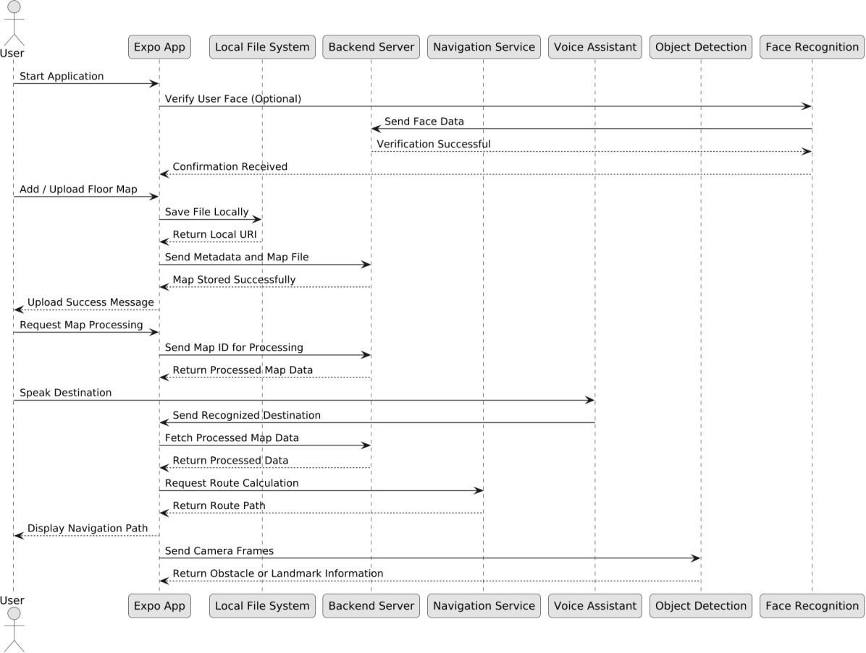
Fig 5.4:Sequence diagram

  - Activity Diagram
The provided Activity Diagram visually charts the operational workflow of the Indoor Navigation System, detailing the sequence and concurrency of user and system actions across three lanes: User, System, and Detection Module. The flow begins with the User opening the application and selecting a mode.

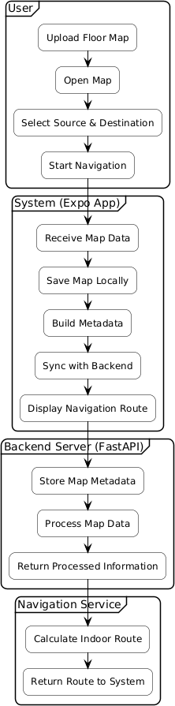
Figure 5.5 : Activity Diagram

This triggers a central decision point in the System lane, where the process branches into three paths: Ziya (Assistant), Navigation, or Object Detection. If Navigation is chosen, the system must sequentially Load/Modify the Floor Map, Compute the Best Route, and Provide AR-Based Guidance. This navigation sequence then runs concurrently with the Detection Module, which continuously Activates the Camera, Detects Surrounding Objects, and alerts the user. A key decision point within the detection flow is the Facial Recognition process: if an Unknown Face is

detected, the process temporarily shifts back to the User to Prompt them to save or label the new face. All successful guidance and alert activities, regardless of the path, converge into a continuous loop for Real-time Detection & Guidance (Voice Feedback) before the entire operation terminates. This visualization ensures the logical and efficient execution of the system's dual functions: goal- oriented navigation and real-time environment awareness.

Data Flow Diagram
The Level 1 Data Flow Diagram for the Indoor Navigation System illustrates the decomposition of the core functionality into three interdependent processes that interact with the User and two data stores. The flow is initiated by a Voice Command from the User to the Mobile App Interface (Process 1). This interface acts as the command interpreter, translating the command into either a Navigation Request directed to the Navigation System (Process 2), or an activation instruction sent to the Recognition Module (Process 3). The Navigation System retrieves Map Data from the Floor Map Database (Data Store 1) to calculate a route, generating Navigation Instructions which are output as Voice Guidance to the User. Simultaneously, the Recognition Module operates autonomously, receiving Live Camera Feed to perform visual analysis against the Face Recognition Database (Data Store 2), culminating in two real-time outputs back to the User: Real- Time Obstacle Alerts for safety and Face Recognition Results for social context. This entire structure highlights the system's dual, integrated function of goal-oriented navigation and continuous environmental awareness.

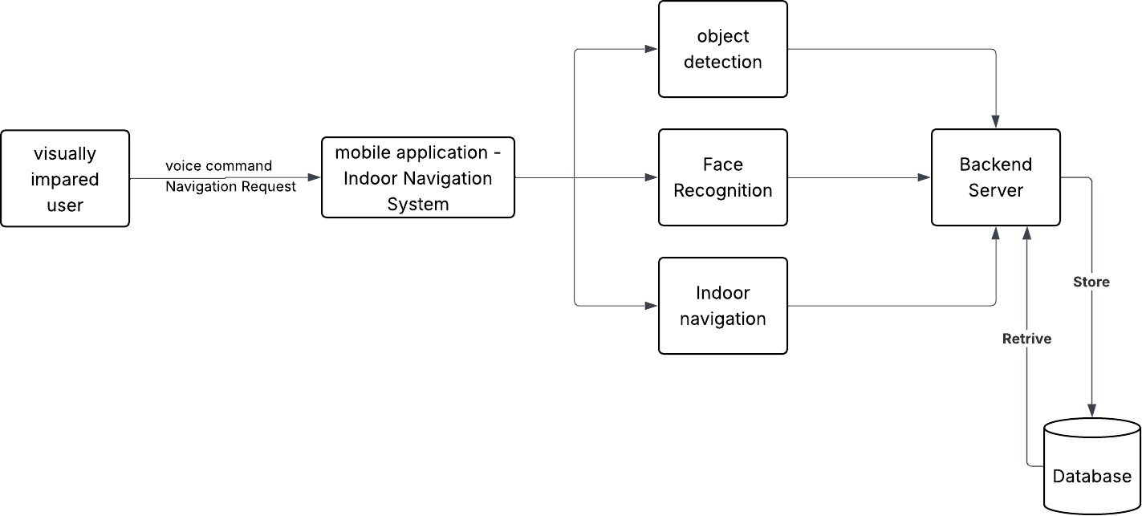

Figure 5.6 Data Flow Diagram

Chapter – 6 IMPLEMENTATION

CHAPTER 6

IMPLEMENTATION

Module implementation
Implementation is the act of converting designed system architecture into a working application. This entails integrating software components and prescribed technologies while achieving a functional application as described. The focus of implementation in this project was developing an Indoor Navigation System with Object Detection and Facial Recognition Systems to assist visually impaired users to navigate indoor contexts, such as indoor college campuses. The developed application included the navigation module, the YOLO11n module for object and face detection, and React Native Expo; the app is placed on a local device for processing and data management and is completely functional in a college environment.
The implemented system has provided the user with a real-time guide to indoor navigation, obstacle alerts to alert the user of obstacles within the walking space, and finally, face identification to create a safer experience as they navigate for enterprise and friendships.

Steps Involved in the Project
    - Problem Identification: The project begins by identifying the major challenges faced by visually impaired individuals while navigating indoor environments, particularly in college campuses where GPS signals are unavailable. Traditional mobility aids like white canes and guide dogs provide limited support in unfamiliar or dynamic settings. Understanding these difficulties helps define a system that offers safe, independent, and technology-driven indoor navigation with real-time assistance.
    - Requirement Analysis: In this stage, the functional and non-functional requirements of the system are analyzed. This includes determining the need for floor-map–based navigation, object detection, facial recognition, and voice-based interaction. The analysis also considers performance, reliability, usability, and accessibility requirements to ensure the system is practical and effective for visually impaired users.
    - System Design: The overall architecture of the system is designed, including the mobile application built using React Native (Expo), the Python FastAPI backend, the navigation engine, object detection components, and the facial recognition module. The design also defines how data flows between the app and backend, how voice assistance interacts with user actions, and how floor maps are processed for navigation.
    - Model Development and Training: The necessary AI models are developed and trained using Python. YOLO is trained for detecting indoor obstacles in real time, and face-recognition libraries are used to prepare the system for identifying known individuals. These models

form the core of the computer vision capabilities in the system.
    - Backend Development: The Python backend is developed using FastAPI to handle all server- side operations. This includes implementing APIs for object detection, facial recognition, face registration, floor map management, and navigation processing. The backend ensures smooth communication between the mobile app and the AI modules.
    - Navigation Module Development: The indoor navigation system is created using digital floor maps instead of AR. The navigation algorithm processes the map, assigns coordinates to rooms and pathways, and calculates the shortest and safest route using techniques such as the A* algorithm. This module prepares waypoint-based directions that are later converted into voice instructions.
    - Mobile App Development: The mobile application is developed using React Native with Expo to ensure cross-platform compatibility and ease of deployment. The app includes the main menu, screens for managing floor maps, navigation interfaces, object detection views
using the camera, facial management sections, and voice feedback integration to support visually impaired users.
    - Integration of Object Detection: The trained object detection model is connected to the mobile application. The app captures live camera feed and sends frames to the backend for detection. The backend returns identified objects, and the app provides corresponding voice alerts to help users avoid obstacles during movement.
    - Integration of Facial Recognition: Facial recognition capabilities are integrated into the system. When a user points the camera at a person, the system checks whether the face is known. If recognized, the user is informed through voice feedback. If not, the system prompts the user to save the face for future identification, enhancing social interaction and safety.
    - Voice Assistance System: A voice guidance system is implemented to support completely hands-free interaction. Voice assistance provides navigation instructions, object alerts, face identification results, and menu interactions.
    - Testing and Debugging: All individual modules are tested thoroughly to identify errors and ensure proper functioning. After unit testing, integration testing is conducted to verify how navigation, detection, and recognition systems work together. Bugs such as incorrect path calculation, missed object detection, or inaccurate face recognition are corrected to ensure system stability.
    - Final Integration: All components — navigation engine, object detection, facial recognition, and voice assistance — are integrated into one unified application. This final integration ensures that the system works smoothly, providing real-time assistance across all functionalities simultaneously.

    - Deployment: The fully integrated system is deployed on an Android device using Expo’s build tools. The deployed app is then tested inside real indoor environments within college buildings to evaluate its performance during actual usage scenarios.
    - User Evaluation: The system is tested with real users, including visually impaired individuals, to gather feedback about navigation accuracy, object detection reliability, facial recognition performance, and overall usability. Their feedback helps refine the system and ensures that the application truly meets the needs of the target users.

Code Snippets

The main() function in Code Snippet 6.1 launches the FastAPI backend using Uvicorn, running by default on 0.0.0.0:8000 with optional hot-reload enabled through the DEV_RELOAD environment variable. It serves as a simple and configurable entry point for executing the backend in both development and production environments. Runtime behaviour can be customized using the HOST, PORT, and DEV_RELOAD environment variables.
def main():
"""
Run the FastAPI backend server for the Floor Map Management System.
Starts uvicorn on 0.0.0.0:8000 by default — set PORT or HOST env vars to override.
"""
import os
import uvicorn
host = os.environ.get("HOST", "0.0.0.0")
port = int(os.environ.get("PORT", 8000))
reload_flag = os.environ.get("DEV_RELOAD", "false").lower() in ("1", "true", "yes")
# In development you can enable reload; in production set DEV_RELOAD to false.
uvicorn.run(
"backend.server:app", # module:path — adjust if your file/module name differs
host=host,
port=port,
log_level="info",
reload=reload_flag
)
if __name__ == "__main__":
main()
Figure 6.1: Code Snippet of SmartVision FastAPI Backend

This main() function in Code Snippet 6.2 loads a user maps metadata JSON file and provides a small CLI (stats, list, get <map_id>) for inspecting floor-map entries.It serves as a lightweight utility to validate uploaded/processed maps, display summary statistics (total/active maps, buildings, floors), and print per-map metadata for debugging or reporting.
def load_maps(filepath: str) -> Dict[str, Any]:
"""Load maps JSON file and return parsed dict."""
if not os.path.exists(filepath):
raise FileNotFoundError(f"Maps file not found: {filepath}")
with open(filepath, "r", encoding="utf-8") as f:
return json.load(f)

def print_stats(data: Dict[str, Any]) -> None:
"""Print summary statistics for the loaded maps."""
maps = data.get("maps", [])
total = len(maps)
active = len([m for m in maps if m.get("is_active", True)])
buildings = {m.get("building_name") for m in maps if m.get("building_name")}
floors = {m.get("floor_number") for m in maps if m.get("floor_number")}
print(f"Total maps: {total}")
print(f"Active maps: {active}")
print(f"Unique buildings: {len(buildings)} -> {sorted(buildings)}")
print(f"Unique floors: {len(floors)} -> {sorted(floors)}")

def list_maps(data: Dict[str, Any]) -> None:
"""List map_id and map_name for each map."""
for m in data.get("maps", []):
print(f"-{m.get('map_id')}:{m.get('map_name')} (active={m.get('is_active',
True)})")

def get_map(data: Dict[str, Any], map_id: str) -> None:
"""Pretty-print a single map entry by map_id."""
entry = next((m for m in data.get("maps", []) if m.get("map_id") == map_id),
None)
if not entry:
print(f"Map '{map_id}' not found.")
return
print(json.dumps(entry, indent=2, ensure_ascii=False))

def main():
"""
Simple CLI for inspecting floor maps metadata.
Usage examples:
python backend/floor_maps_cli.py --file demo_user_123_maps.json stats
python backend/floor_maps_cli.py --file demo_user_123_maps.json list
python backend/floor_maps_cli.py --file demo_user_123_maps.json get map_1762416462880
"""
parser = argparse.ArgumentParser(description="Inspect floor maps metadata")
parser.add_argument("--file", "-f", required=True, help="Path to user's maps JSON file")
parser.add_argument("command", choices=["stats", "list", "get"],
help="Command to run")
parser.add_argument("map_id", nargs="?", help="Map ID (required for 'get' command)")
args = parser.parse_args()
try:
data = load_maps(args.file)
except Exception as e:
print(f"Error: {e}")
return
if args.command == "stats":
print_stats(data)
elif args.command == "list":
list_maps(data)
elif args.command == "get":
if not args.map_id:
print("Error: 'get' requires a map_id argument.")
return
get_map(data, args.map_id)
if __name__ == "__main__":
main()

Fig 6.2 : Code Snippet for MapMeta Structure

The main() function in Code Snippet 6.3 reads the user's floor-map metadata JSON file and prints key details such as mapID, mapname, timestamps, andstatus. It acts as a lightweight viewer to quickly inspect stored metadata inside the backend/floor_maps_metadata directory. This utility helps in validating map uploads and ensuring that stored metadata is properly formatted and accessible.

{
"maps": [
{
"map_id": "map_1762382397224",
"map_name": "A",
"building_name": null,
"floor_number": null,
"local_uri": "file:///data/user/0/host.exp.exponent/files/floor_maps/map_176238239

7224.png",
"metadata": {
"original_name": "2ND Floor.png",
"file_size": 1948513,
"added_at": "2025-11-05T22:39:57.260Z"
},

"added_at": "2025-11-05T22:39:57.260Z",
"last_accessed": "2025-11-06T04:23:43.895333",
"is_active": true
}
]
}
Figure 6.3: Code snippets of Map JSON Record

The main() function in Code Snippet 6.4 loads the label detection output stored in labels.json and print search room name along with its (x, y) coordinates. It acts as a simple verification tool to inspect OCR/label extraction results generated during the map-processing stage. This utility helps ensure that detected room labels are correctly parsed and ready for use in indoor navigation.
def main():
"""
Code Snippet 6.3:
A simple utility to load and display detected room labels
from backend/indoor_navigation/data/labels.json.
"""

filepath = "backend/indoor_navigation/data/labels.json"
if not os.path.exists(filepath):
print(f"Labels file not found: {filepath}")
return
with open(filepath, "r", encoding="utf-8") as f:
labels = json.load(f)
print(f"Total labels detected: {len(labels)}\n")
for item in labels:
print("Label Name :", item.get("name"))
print("Coordinate X:", item.get("x"))
print("Coordinate Y:", item.get("y"))
print("-" * 40)
if __name__ == "__main__":
main()

Figure 6.4 : Code snippets of a list of nodes extracted from a floor map.

This main() function in Code Snippet 6.5 serves as a simple test runner for the face-recognition module, allowing developers to load a sample image and view detection results directly from the backend. It executes both the global recognition pipeline and the user-specific recognition pipeline to verify encoding accuracy and face-matching behaviour. This utility helps ensure that face detection, encoding, and matching work correctly before integrating with the Expo application.

def main():
"""
Code Snippet 6.5:
A simple runner that loads an image, executes face recognition,and prints
detected faces for backend testing purposes.
"""
test_image_path = "test_images/sample_face.jpg"
if not os.path.exists(test_image_path):
print(f"Test image not found: {test_image_path}")
return
# Read image as bytes
with open(test_image_path, "rb") as f:image_bytes = f.read()
# Run basic recognition (global known faces)
result_basic = run_face_recognition(image_bytes)
print("\n[RESULT] Basic Face Recognition:")

print(result_basic)
# Run user-specific recognition with user_id
user_id = "demo_user_123"
result_user = run_face_recognition_with_user_faces(image_bytes, user_id)
print("\n[RESULT] User-Specific Face Recognition:")
print(result_user)
if __name__ == "__main__":
main()

Fig 6.5: Code snippets of Core Logic for Face Recognition

The main() function in Code Snippet 6.6 creates a synthetic floor-map image and submits it to the backend/floor_maps/process API to verify the map-processing pipeline. It tests contour detection, label extraction, and processed-map output by printing the response returned by the FastAPI server.
This utility helps validate backend functionality without requiring physical floor-map images.

def main():
"""
Code Snippet 6.6:
Generates a synthetic floor-map image, sends it to the backend/floor_maps/
process API, and prints the processing response.
"""
# Create test map image
h, w = 800, 1200
img = np.full((h, w, 3), 255, dtype=np.uint8)
# Draw sample rooms
cv2.rectangle(img, (50, 50), (350, 300), (0, 0, 0), -1)
cv2.rectangle(img, (370, 50), (750, 300), (200, 200, 200), -1)
cv2.rectangle(img, (50, 320), (600, 700), (0, 0, 0), -1)
cv2.rectangle(img, (620, 320), (1100, 700), (200, 200, 200), -1)
# Labels
cv2.putText(img, "Room301", (70, 80), cv2.FONT_HERSHEY_SIMPLEX,
1.0, (255, 255, 255), 2)
cv2.putText(img, "Washroom", (380, 80), cv2.FONT_HERSHEY_SIMPLEX,
0.8, (0, 0, 0), 2)
# Save temp image
path = "test_map.png"
cv2.imwrite(path, img)

# Call backend API
url = "http://127.0.0.1:8000/floor_maps/process"
print(f"Posting to {url}")
with open(path, "rb") as f:
files = {"file": f}
data = {"user_id": "test_user", "map_id": "test_map"}
r = requests.post(url, files=files, data=data)
print("Status:", r.status_code)
print("Content-Type:", r.headers.get("content-type"))
# Print response
try:
print(r.json())
except Exception:
print("Response Text:", r.text)
# Cleanup
if os.path.exists(path):
os.remove(path)
if __name__ == "__main__":
main()

Fig 6.6: Code snippets of Test Script for Nonexistent Process Endpoint

Chapter – 7 TESTING

CHAPTER 7

TESTING

Testing is an essential phase in the development life cycle of the Indoor Navigation System with Object and Face Identification for Visually Impaired Individuals. It ensures that the developed system performs accurately, providing reliable navigation, obstacle detection, and facial recognition to assist visually impaired users. Each module, including floor map–based navigation, object detection, face recognition, and voice assistance, was tested individually to verify functionality before integrating them into a complete system.

During the testing phase, issues such as incorrect path generation, delayed voice feedback, missed object detection, or misidentified faces were identified, analyzed, and resolved. The system was then retested to ensure smooth and consistent performance. Testing focused on validating both functional and non-functional requirements such as real-time response, detection accuracy, usability, and system reliability.

System testing confirmed that the navigation module accurately guided users based on floor map inputs, while the object and face detection modules worked efficiently to identify surroundings and familiar individuals. The integration of voice assistance provided clear audio feedback, allowing visually impaired users to move confidently and safely within indoor environments like college campuses.

Testing Levels
Testing is an important step in verification and validation to establish the reliability and correctness of the Based Indoor Navigation System with Object Detection and Facial Recognition.
The testing goals for this project are;

- To verify that all modules — navigation, object detection, and face detection — operate in accordance with user expectations.
- To check that, navigation interface, camera processing, and voice output modules interact properly.
- To validate that the system correctly identifies obstacles, facial detection and identifies voices without delays. Testing was preformed at the following levels:

Unit Testing
To guarantee that each module operated correctly prior to integration, unit testing was performed on each isolated module of the system. The unit tests were primarily conducted upon the system’s Navigation, Object Detection, Facial Recognition, and Voice Output modules. Additionally:
      - The Navigation module was Unit tested, under which the system properly produced routes (indoors or outside) of ""real time"" voice navigation.
      - The Object Detection module was Unit tested, during which the live camera stream properly identified objects, including a wall, door, and chair.
      - The Facial Recognition module was Unit tested, and at which point the module properly recognized known faces, prompted for saving, and properly notified the User about unknown faces.
      - The Voice Output module was Unit tested to verify the quality of voice output, and confirmed the User would receive voice output in a clear, timely, and continual manner.
Finally, each of the modules outlined were verified using sample data to confidently verify accurate detection, navigation, and expected user response.

Integration Testing
Integration testing followed all individual modules passing unit testing for each. This verification process confirmed compatibility among each of the integrated components tested navigation, object detection, facial recognition, and voice feedback.
Key integrations that were tested included:
Interaction between the camera module and object detection algorithm for real-time recognition.
      - Coordination between navigation and voice guidance for seamless communication indoors by route.
      - The synchronization of facial recognition results with the user prompt system for adding unknown faces.
The system was evaluated in multiple indoor scenario types to verify data flow, delays, and interaction among all modules throughout testing.

System Testing
The comprehensive system testing revealed the entire Indoor Navigation System with Object and Face Recognition for the Visually Impaired as one application, confirming that all four modules (navigation, object detection, face recognition, voice assistance) worked together properly under

simulated indoor conditions. This phase confirmed that:
      - The navigation module successfully read floor maps, accepted source and destination inputs, and produced the appropriate route for a user made within the building.
      - The object detection system successfully identified and alerted the user of obstacles nearby (doors, chairs, walls) in real time, allowing for safe movement.
      - The facial recognition module successfully recognized familiar faces after reading them several times and prompted the user to save unknown faces, all while handling varying lighting and environmental conditions.
      - The voice assistance feature provided timely and clear audio alerts for navigation instructions, object detection alerts, and facial recognition alerts.
System testing occurred in indoor simulated environments such as a college hallways and classrooms to evaluate the system's overall functionality, stability, and usability. The results demonstrate that the system will perform reliably to help visually impaired users navigate safely and engage with other individuals confidently in indoor environments.

Acceptance Testing
Acceptance testing was conducted to ensure that the final Indoor Navigation System with Object and Face Identification for Visually Impaired Individuals met all user expectations and functional requirements, particularly for use within college campus environments.

During this phase, visually impaired users were able to:

      - Navigate indoor areas such as hallways and classrooms using the floor map–based navigation system with voice-guided directions.
      - Detect and avoid obstacles in real time through object detection alerts.
      - Recognize familiar faces and store new ones for future identification, enhancing social interaction.
      - Operate the system independently with simple voice commands and minimal technical support.

The system successfully met all acceptance criteria, confirming its ability to improve independent mobility, safety, and confidence for visually impaired individuals during indoor navigation. The feedback from users validated that the system is user-friendly, accurate, and practical for real- world deployment in educational environments.

Testing Cases
Test cases were designed to evaluate each major functionality of the system, including navigation, object detection, facial recognition, and voice guidance.
Each test specifies the scenario, input, expected result, actual result, and status.
Table 7.2: Test Cases

Test  Case ID | Description | Input / Action | Expected Result | Result | Status
TC01 | App Launch | Open the Indoor Navigation app | App launches successfully and displays main options (Ziya, Navigation  System, Object) | As expected | Pass
TC02 | Floor Map Upload | Add a new floor map through the Navigation System module | Floor map is successfully uploaded and displayed for  navigation | As expected | Pass
TC03 | Floor Map Deletion | Delete an existing floor map | Selected floor map is removed from local  storage and list | As expected | Pass
TC04 | Navigation Path Generation | Select source and destination on the floor  map | System generates accurate path and provides voice-  guided directions | As expected | Pass
TC05 | Object Detection | Activate object detection feature | Nearby objects are detected and user is alerted via  voice feedback | As expected | Pass
TC06 | Face Recognition | A person’s face appears in front of the camera | Known faces identified and unknown faces prompted to be  saved | As expected | Pass

TC07 | Unknown  Face Storage | Save an  unrecognized face | Face data stored  securely for  future identification | As expected | Pass
TC08 | Voice Guidance | Start navigation | System provides continuous and clear real-time voice  instructions | As expected | Pass
TC09 | System Response Time | Perform navigation and detection simultaneously | System runs smoothly without lag or delay in  feedback | As expected | Pass

Testing demonstrated that the Indoor Navigation System with Object Detection and Facial Recognition achieves functional and performance goals. Each module, including navigation, including navigation, object recognition, facial recognition, and voice assistance, all performed accurately both separately and as an integrated system. The results also confirmed reliable real- time operation at all times, accurate obstacle and face detection, and seamless voice-assisted navigation. The tests confirmed that the system is designed for deployment and has the potential to provide safe, intelligent, and accessible indoor navigation assistance for individuals who are visually impaired.

Chapter – 8 RESULTS AND SNAPSHOTS

CHAPTER 8

RESULTS AND SNAPSHOTS

Figure 8.1shows the home interface of the Ziya Eyes-Free Assistant application. It presents four main modules: Object Detection, Indoor Navigation, Face Management, and Map Management. The layout uses large, colorful cards designed for easy accessibility and navigation.
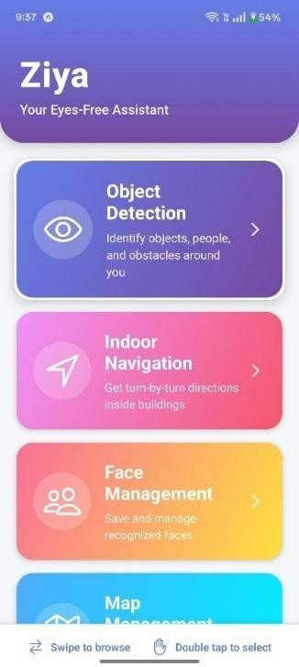
Figure 8.1: Main Menu/Feature Selection

Figure 8.2 displays the Object Detection screen with selectable detection ranges: Short, Medium, and All. The Medium range is selected, and the app shows a detected object at the bottom. The interface also includes a Start Navigation button for transitioning into guided movement. the live camera feed during object detection. Detected objects such as a laptop plant, and person are listed at the bottom. Users can adjust detection range settings while the system continuously scans the environment.

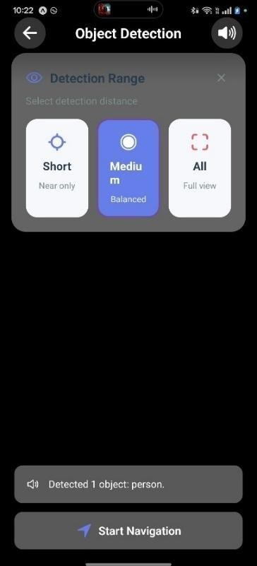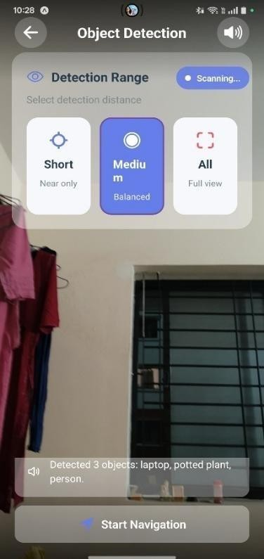
Figure 8.2: Detecting the object

The user interface of a mobile application's Indoor Navigation feature is shown in detail in Figure
8.3. A central "Choose Map" button on the main page leads the user to "1. Select Floor Map." As shown, pressing this button opens a pop-up modal called "Select Floor Map," which takes up most of the bottom portion of the screen. The "2nd floor map" and "Hostel2" maps, in particular, are listed in this modal's list of potential floor plans for selection. Entries marked with "- Processed'" indicate a difference between raw and navigation-optimized map data.
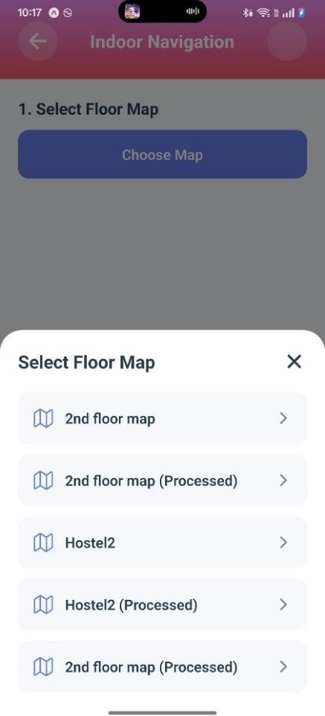
Figure 8.3: Selecting the floor map for navigation

The steps that follow the initial map selection are shown in Figure 8.4, which continues the procedure for the mobile application's Indoor Navigation feature. Step 1 is finished, indicating that "2nd floor map (Processed)" has been selected. The interface then displays "2. Select Starting Point" and "3. Select Destination," both of which use lists of buttons that may be scrolled horizontally to represent different locations, like "room_1," "room_10," and "room_11." Interestingly, "room_12" is indicated as the user's chosen location. This screen's final feature is a big green action button called "Calculate Route," which, when pushed, uses the inputs—the particular floor map, the start point, and the end point—to calculate and show the user's navigation path.
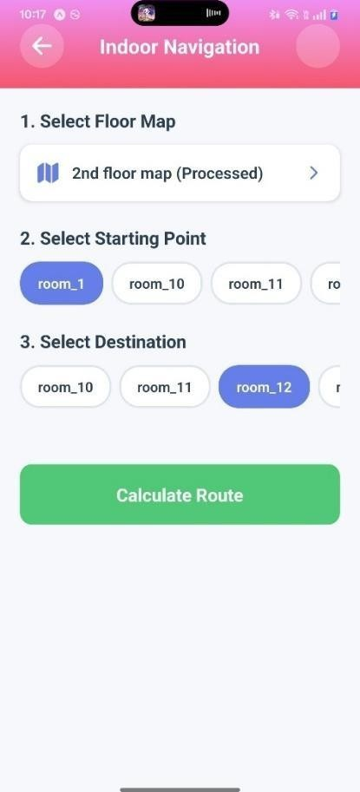

Figure 8.4: Assigning the source and the destination for

After the path has been determined, two consecutive displays of the Indoor Navigation process are shown in Figure 8.5. The results screen is displayed in the panel on the left, verifying the path from "room_1" to "room_12." It offers important parameters, such as the route's 17 steps, 85-meter distance, and estimated time of 9 minutes. The primary feature here is a green "Start Navigation" button and a "Change Route" option. Once the user has begun the journey, the panel on the right shows the current navigation screen. It displays the current command, "Start at Room 1," and labels it as "Step 1 of 17" while keeping the route metrics.

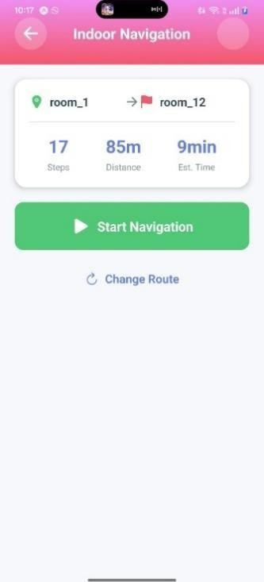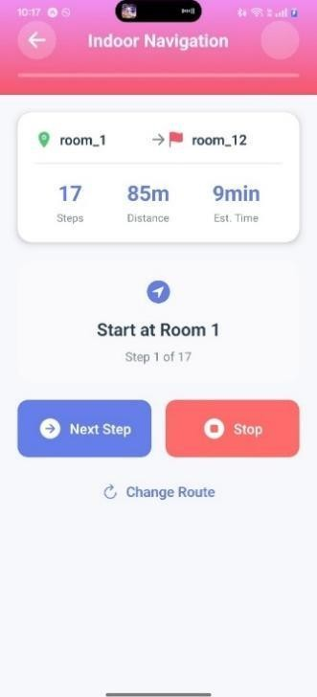
Figure 8.5: Navigation started from source

Two consecutive steps in the active Indoor Navigation process from room 1 to room 12 are shown in Figure 8.6. Step 2 of 17, which instructs the user to "Walk 25 steps and turn left," is displayed in the panel on the left. You'll arrive at Room 13. While Steps (total) and Est. Time stay the same, this screen changes the Distance remaining to 80m (down from 85m in the preceding figure). The advancement to Step 3 of 17 is depicted in the panel on the right, along with the updated instructions, "Walk 9 steps and go straight." You'll arrive in Room 29. The remaining distance is further decreased to 75 meters on this screen. The key navigation controls, "Next Step," "Stop," and "Change Route," are retained on both panels, giving the user a turn-by-turn guidance system.
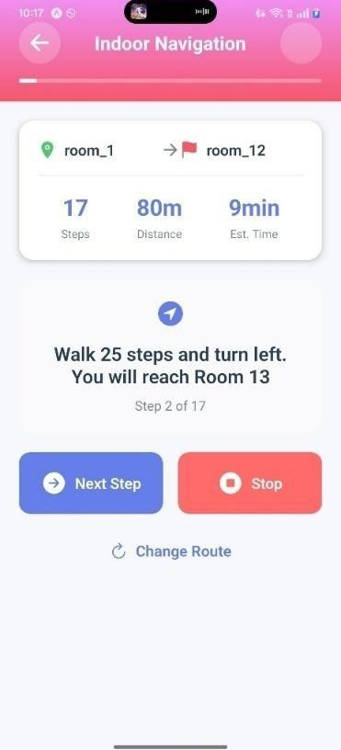
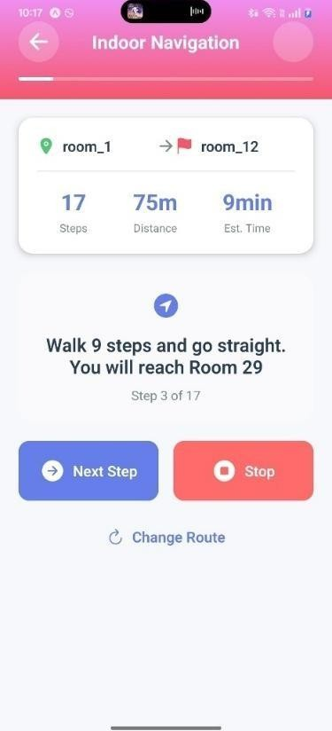
Figure 8.6: Under navigation process

The application's Map Management panel, which makes it easier to create and arrange indoor maps, is shown in Figure 8.7. "Record New Map," which directs the user to "Walk through space to create map," and "Process Floor Plan," which entails uploading and processing an image, are the two main activities displayed as separate, colored cards at the start of the page. The "Saved Maps" section, which is located beneath these creation options, presently has five maps, as shown by the blue badge. Previously stored maps, such as "2nd floor map" and "2nd floor map (Processed)," are listed in this part along with metadata, such as the number of rooms and the creation date. Icons for viewing, modifying, and removing the map are included with every saved map entry.

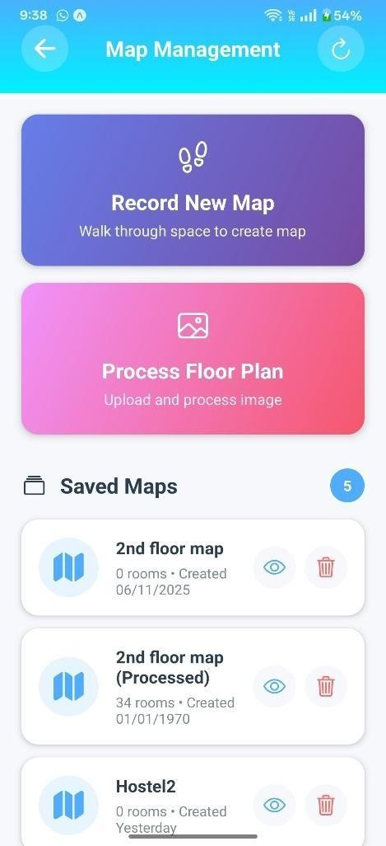

Figure 8.7: UI interface for managing the map

A composite view of multiple screens from the mobile application, emphasizing both Saved Faces and Map Management, is shown in Figure 8.8. A detailed image of a stored face named "Rohan," complete with his portrait, the time, and the date of his addition (November 6, 2025), is displayed in the top-left panel. Rohan and Santosh are among the four items in the "Saved Faces" list in the top-center panel, each of which has the ability to View, Edit, or Delete. A option to change Rohan's name appears in the upper-right panel. A list of "Saved Maps" such as "2nd floor map" and "Hostel2" appears after the "Map Management" screen, which is located in the lower half of the image and offers options to "Record New Map" or "Process Floor Plan."

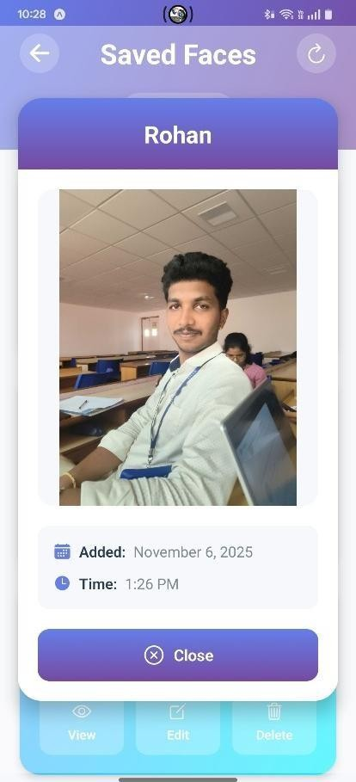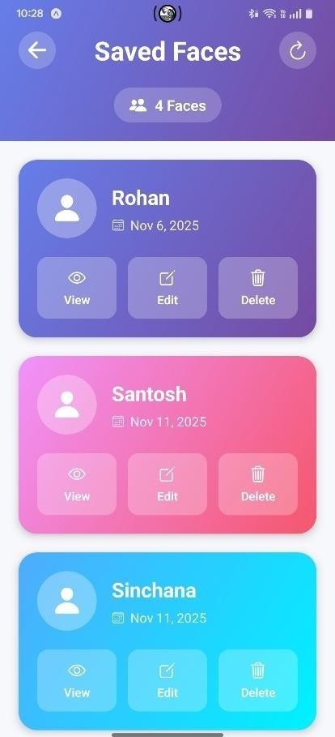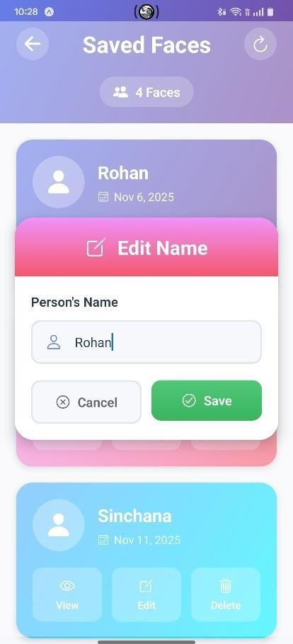

Figure 8.8: Saving the face for future recognition

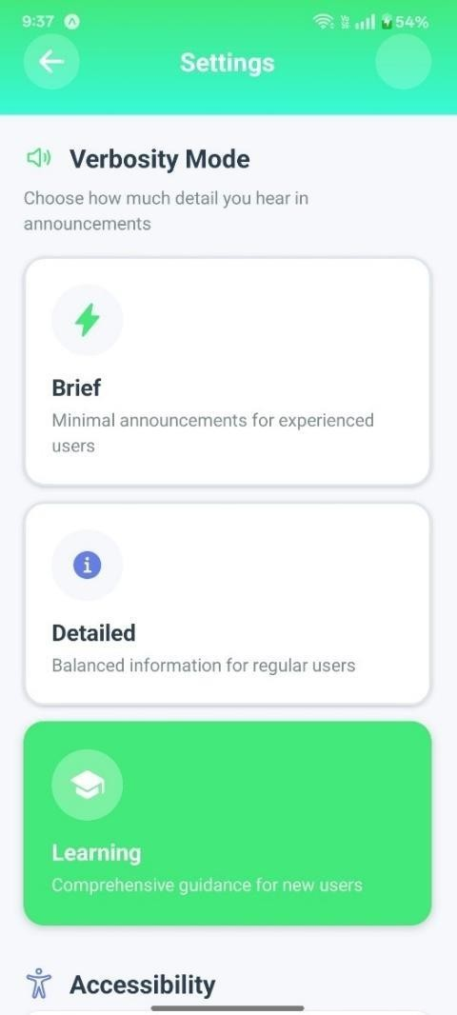
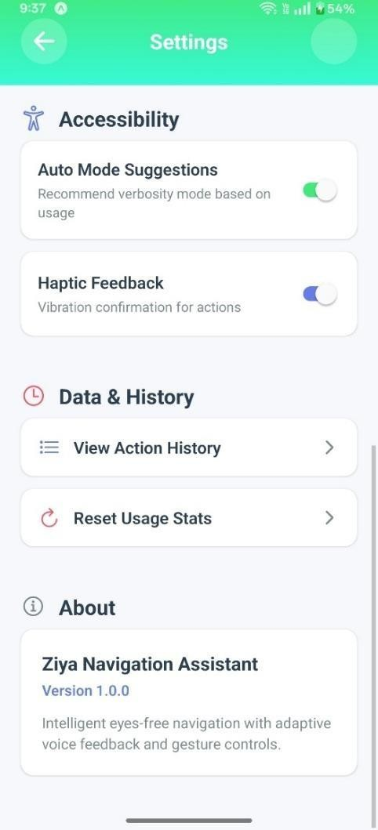

Figure 8.9: UI for additional settings

Figure 8.9 shows two consecutive windows from the application's "Ziya Navigation Assistant" settings menu. The "Verbosity Mode," which enables users to select the degree of detail in announcements, is detailed in the panel on the left. There are three options: Learning (extensive instructions for novice users), Detailed (balanced information), and Brief (minimum announcements). Additional settings are displayed in the panel on the right under the categories of About, Data & History, and Accessibility. Toggles for Haptic Feedback and Auto Mode Suggestions are accessible. Reset Usage Stats and View Action History are two options available in Data & History. Lastly, the About section verifies that the program is "Ziya Navigation Assistant Version 1.0.0," emphasizing capabilities such as "Intelligent eyes-free navigation with adaptive voice feedback and gesture controls."

Chapter – 9

CONCLUSION AND FUTURE WORK

Indoor Navigation System with Object and Face Identification for Visually Impaired Individuals

CHAPTER 9

CONCLUSION AND FUTURE WORK

Conclusion
The Navigation System with Object Detection and Face Recognition project successfully integrates advanced computer vision technologies to provide a smart, interactive, and user-friendly navigation experience. By combining real-time object detection with face recognition, the system not only guides users through indoor environments but also enhances safety, personalization, and accessibility. The integration of navigation for environment mapping, YOLO-based object detection, and face recognition modules enables the system to deliver accurate navigation assistance while identifying obstacles and familiar individuals in real time. This fusion of technologies makes the system especially beneficial in complex indoor spaces such as malls, offices, and educational institutions.
Overall, the project demonstrates how Artificial Intelligence can be combined to create intelligent navigation solutions that go beyond simple direction guidance. It establishes a strong foundation for future developments like voice assistance, gesture control, cloud-based data storage, and IoT integration, paving the way toward a smarter, safer, and more inclusive navigation ecosystem.

Future Work

Although the existing system offers robust interior navigation with multi-sensory guiding and real- time positioning, a number of improvements could greatly increase its practicality and usefulness. A more robust hybrid positioning model can be created by including Bluetooth Low Energy (BLE) beacons, which can provide sub-meter localization precision and act as a dependable backup in low-light or low-feature conditions. By enabling several users to provide waypoint data while validation procedures preserve map quality, a crowdsourced mapping platform would increase coverage even more. Adding depth-based obstacle detection with LiDAR or ToF sensors can make navigation safer and more flexible by identifying transient or unforeseen obstructions. Smooth vertical transitions within complicated structures would be made possible with support for multi- floor navigation, which would be achieved through intelligent identification of elevators, staircases, and floor markers. Lastly, natural voice requests like "Take me to the nearest restroom" or "Find the emergency exit" would be made possible by greater semantic comprehension through improved NLP, making the system more user-friendly and accessible

REFERENCES

REFERENCES

- J. Juile, S. Chandrasekaran, and S. P. R, ―ARGuide Pro: An AR-based Indoor Navigation,‖ 2024 International Conference on Emerging Techniques in Computing and Communication, 2024.
- W. Zhang, Y. Li, P. Li, and Z. Feng, ―A BIM and AR-based indoor navigation system for pedestrians on smartphones,‖ KSCE Journal of Civil Engineering, vol. 29, 2024, Art. no. 100005.
- R. G. Baldovino, J. M. Panganiban, R. G. Velasco, J. G. Mendoza, and G. D. Fajardo, ―A visual aid system using image processing and deep learning with audio haptic feedback,‖ 6th International Conference on Communication and Electronics Systems (ICCES), 2024
- I. N. Jarudi et al., ―Recognizing distant faces,‖ Vision Research, vol. 205, 2023, Art. no. 108184.
- R. M. S, A. M. R, and K. R. M, ―Indoor navigation using augmented reality for mobile application,‖ International Journal of Engineering Research & Technology (IJERT), vol. 12, no. 3,
pp. 45–50, Mar. 2023.

- R. Goud, N. Paatil, M. Patil, H. Khadakar, and S. Koparde, ―A Low Cost Indoor Navigation System using Augmented Reality,‖ International Journal of Creative Research Thoughts (IJCRT), vol. 10, no. 5, May 2022.
- S. C. J., S. Dileep, S. C. S., and L. E. Sunny, ―Indoor Navigation System UsingAugmented Reality,‖ International Research Journal of Engineering and Technology (IRJET), vol. 8, no. 6, pp. 2408–2409, June 2021.
- R. C. Joshi, S. Yadav, M. K. Dutta, and C. M. Travieso-Gonzalez, ―Efficient Multi-Object Detection and Smart Navigation Using Artificial Intelligence for Visually Impaired People,‖ Entropy, vol. 22, no. 9, Art. no. 941, Aug. 2020.
- Y. Said, M. Atri, M. A. Albahar, A. Ben Atitallah, and Y. A. Alsariera, “Indoor Signs Detection for Visually Impaired People: Navigation Assistance Based on a Lightweight Anchor-Free Object Detector,” Int. J. Environ. Res. Public Health, vol. 20, no. 6, art. no. 5011, 2020.
- Y. Muhammad, M. Ahmad Jan, and S. Mastorakis, “A Deep Learning-Based Smart Assistive Framework for Visually Impaired People,” in 2022 IEEE International Conference on Omni-layer Intelligent Systems (COINS), pp. [insert pages], 2020.

- A. Noor, H. Almukhalfi, A. Souza, and T. H. Noor, “Towards a Real-Time Indoor Object Detection for Visually Impaired Users Using Raspberry Pi 4 and YOLOv11: A Feasibility Study,” Comput. Model. Eng. Sci., vol. 144, no. 3, pp. 3085-3111, 2020.
- A. Thandu and M. Rathinam, “Enhancing Indoor Navigation for Visually Impaired Individuals with an AI Chatbot Utilizing VEO Optimized Nodes and Natural Language Processing,” Int. J. Sensors Wireless Commun. Control, vol. 14, no. 3, pp. 204-214, 2020.

