Existing Method:
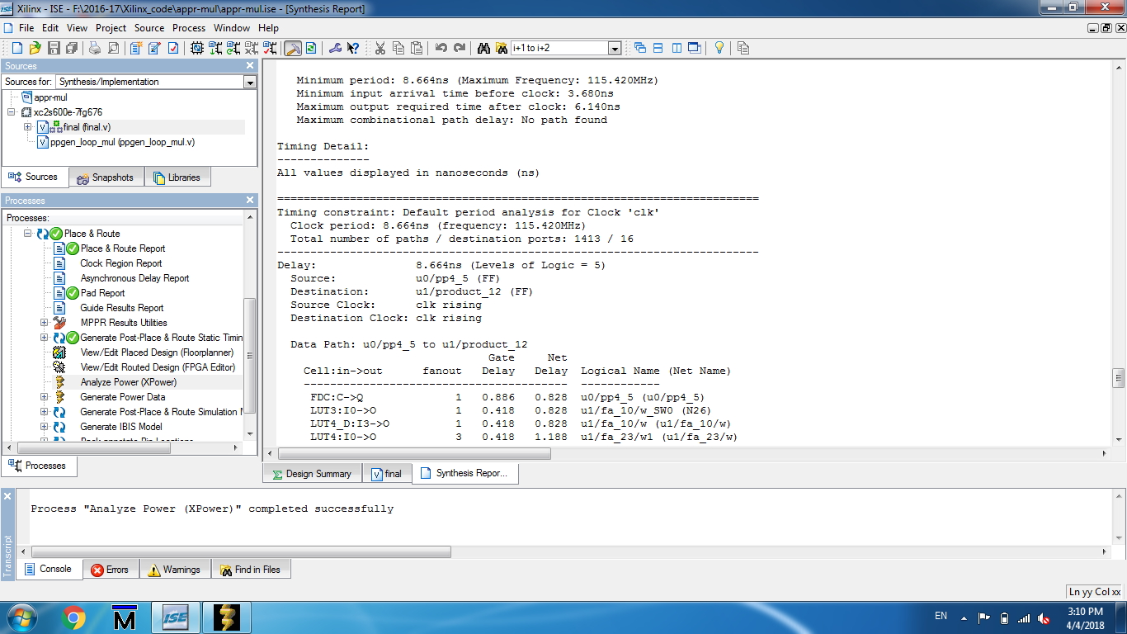
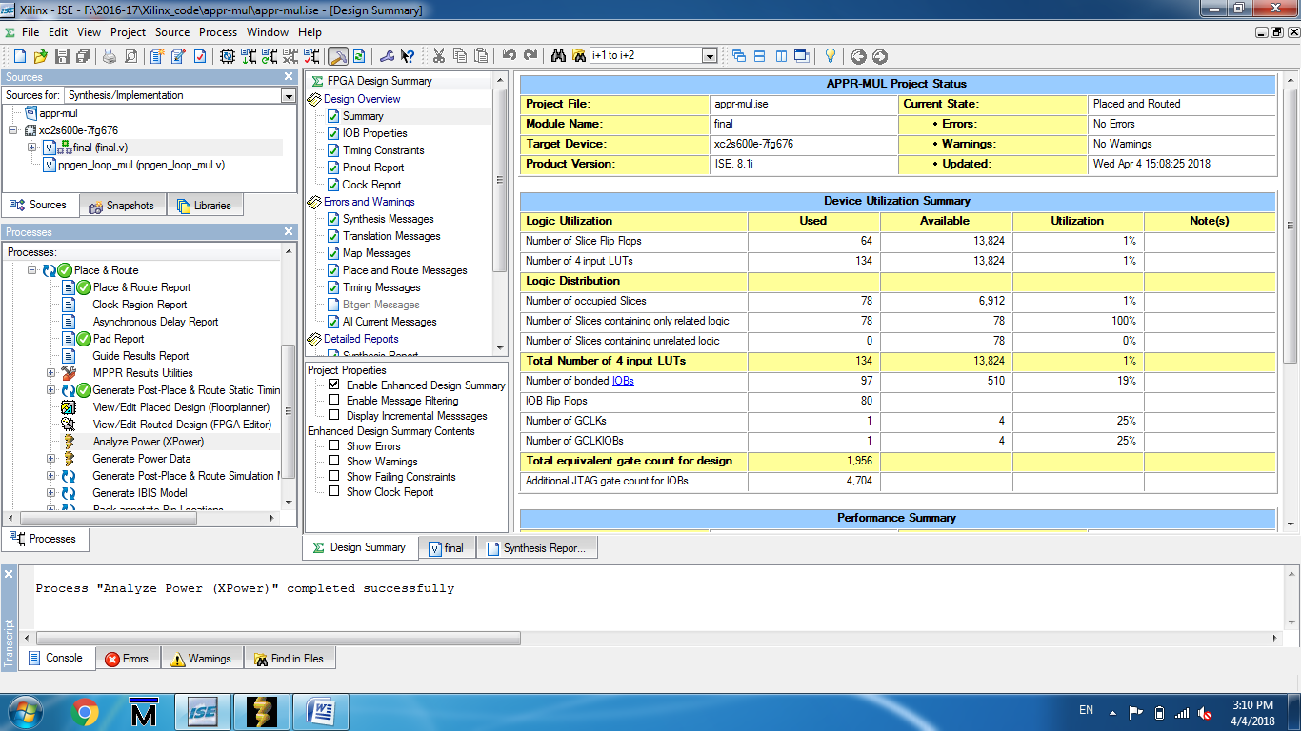
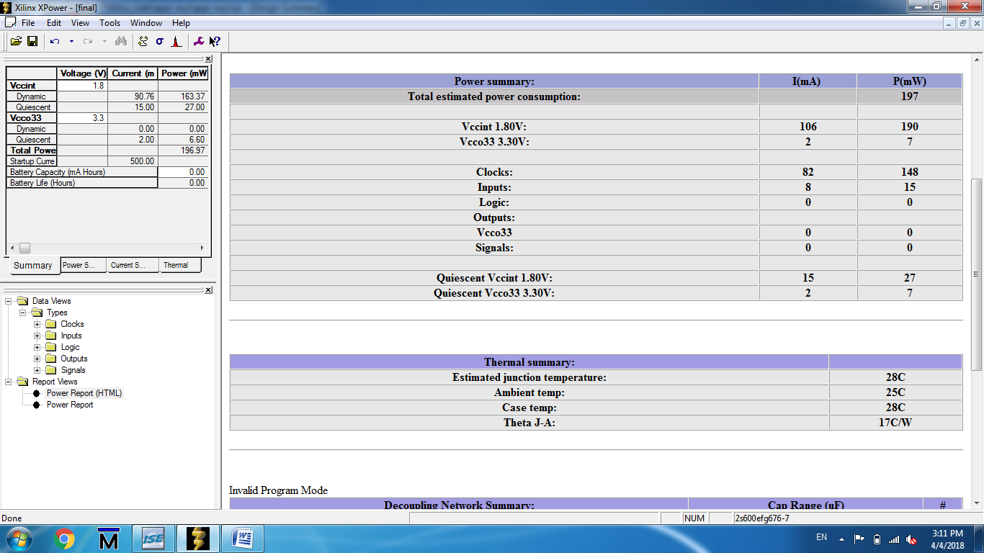

Proposed Method:

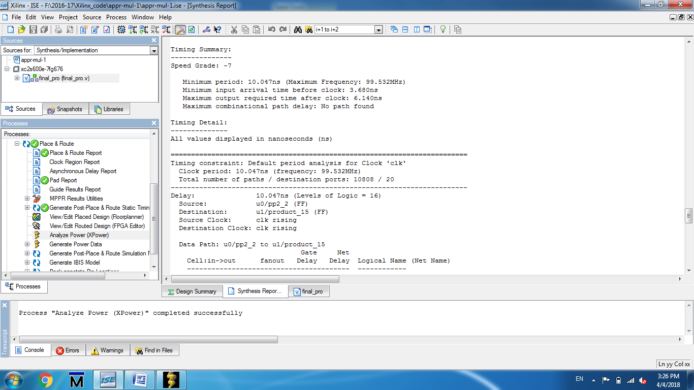

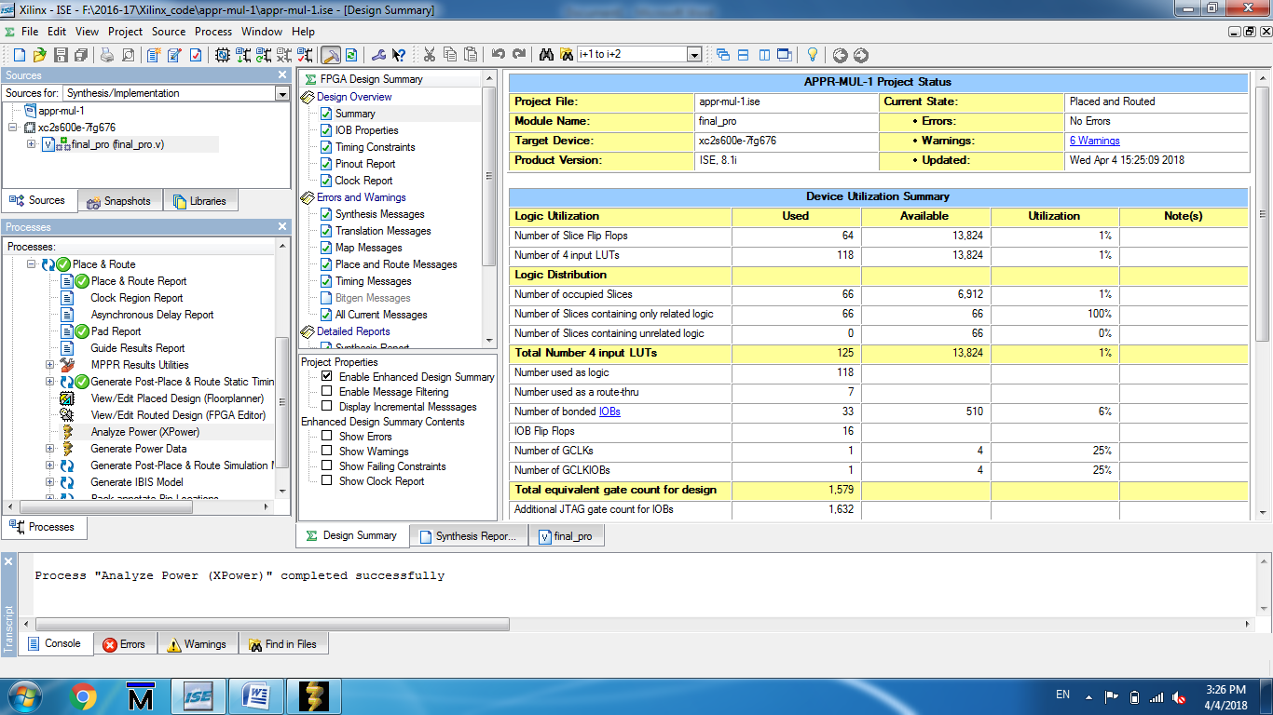

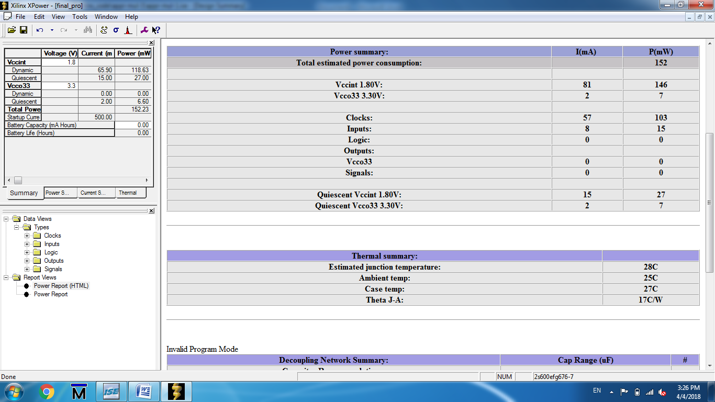

Comparison Table:

Parameters | Existing Method | Proposed Method
Slices | 78 | 66
FFs | 64 | 64
LUTs | 134 | 118
Gate Count | 1956 | 1579
Power(mW) | 197 | 152
Delay(ns) | 8.664 | 10.047

