FPGA-Based ECG Signal Denoising Using FIR Filter Implementation in Verilog
Vedika Kajal
Department of Electronics Engineering
CGC Jhanjeri, India
vedika108-m (GitHub)

Abstract
Electrocardiogram (ECG) signals are essential for cardiac health monitoring but are often affected by noise introduced during acquisition. This paper presents the design and simulation of a Finite Impulse Response (FIR) filter implemented using Verilog HDL on the Xilinx Vivado platform for ECG signal denoising. The proposed architecture utilizes shift registers and multiply–accumulate operations to generate filtered outputs. Behavioral simulation results demonstrate successful noise reduction and stable signal response, validating FPGA suitability for real-time biomedical signal processing applications.
Keywords — ECG, FIR Filter, FPGA, Verilog HDL, Digital Signal Processing, Vivado.

I. INTRODUCTION
Electrocardiogram (ECG) signals provide vital information regarding heart activity and are widely used in medical diagnostics. However, ECG signals are frequently contaminated by noise such as baseline wander, muscle artifacts, and power-line interference.
Digital filtering techniques are commonly employed to improve signal quality. Finite Impulse Response (FIR) filters are particularly advantageous due to their inherent stability and linear phase characteristics, making them suitable for FPGA implementation.
This work focuses on designing an FIR filter using Verilog HDL and verifying its operation through simulation in Xilinx Vivado.

II. OBJECTIVE
The main objective of this project is to design and simulate an FPGA-based FIR filter capable of smoothing ECG-like signals.

Supporting Objectives
- Implement FIR architecture using hardware description language
- Apply sampled inputs using a testbench
- Analyze waveform outputs for filtering verification
- Demonstrate digital signal processing on FPGA platforms

III. SYSTEM ARCHITECTURE
The FIR filter consists of delay elements, coefficient multipliers, and an adder unit forming a multiply-accumulate structure.
At every clock cycle:
- Input sample enters delay chain.
- Previous samples shift forward.
- Each sample multiplies with filter coefficients.
- Results are summed to produce filtered output.

System Design and Simulation
The project design and verification were performed using Xilinx Vivado. The RTL schematic illustrates the internal FIR filter architecture, while simulation waveforms validate functional correctness.

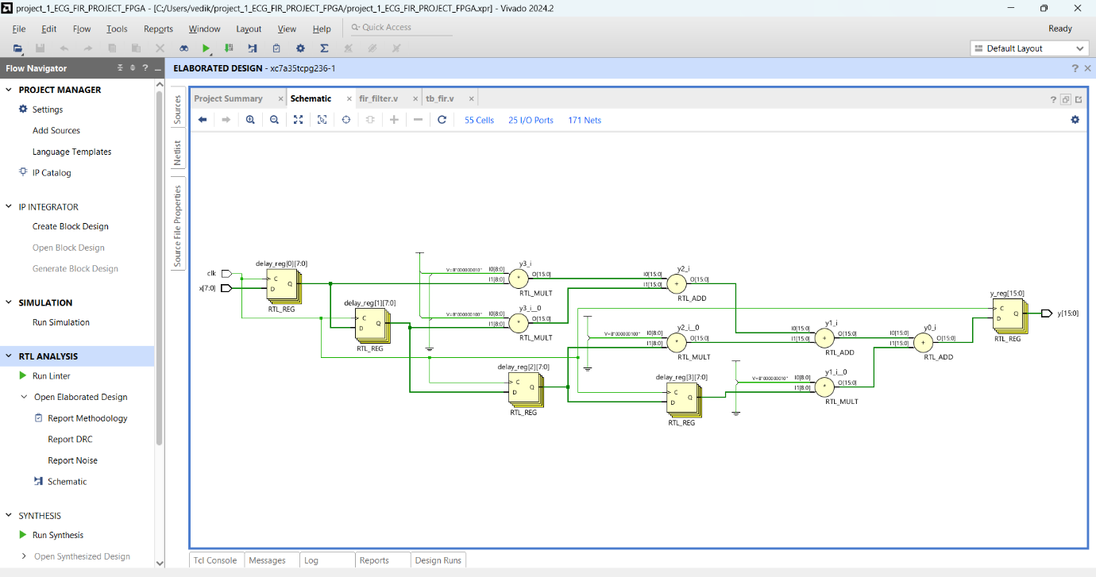Fig. 1. RTL schematic representation of FIR filter architecture.

IV. DESIGN IMPLEMENTATION
The FIR filter was implemented in Verilog using synchronous logic. Delay registers store previous inputs while coefficients determine filtering response. Multiply-and-accumulate operations generate the output signal.
Filter coefficients were initialized directly inside the design module to simplify implementation.

ECG Data Representation
The input samples emulate ECG signal characteristics based on standard biomedical datasets such as MIT-BIH Arrhythmia Database. These samples validate the filter’s ability to process biomedical signals in real-time hardware environments.

Block Diagram of Proposed System
The system architecture consists of an input signal source, delay registers, FIR filter coefficients, multiplier units, and an accumulator block. Each incoming ECG sample is delayed, multiplied by predefined coefficients, and summed to generate the filtered output.
Input → Delay Line → Multipliers → Adder → Output

V. SIMULATION METHODOLOGY
A Verilog testbench was developed to verify functionality. The testbench generates clock signals and applies varying signed input samples representing ECG-like variations.
Behavioral simulation was executed using Vivado Simulator (XSIM).
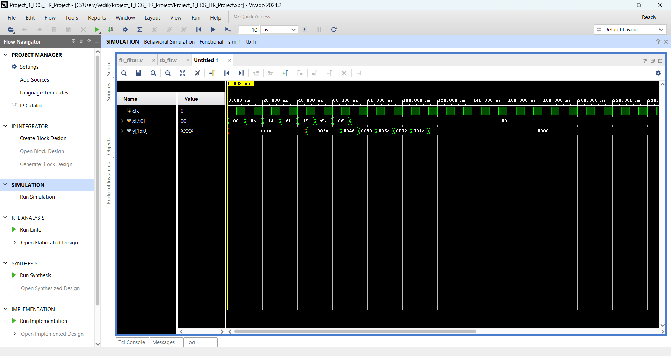Fig. 2. Behavioral simulation waveform showing input and filtered output signals.

VI. RESULTS AND DISCUSSION
Simulation results confirm correct FIR filter operation. The output signal exhibits smoother transitions compared to the input signal, demonstrating noise reduction capability.
Initial undefined values appear due to register initialization; stable filtered output follows after several clock cycles.
The implementation validates FPGA efficiency for real-time signal preprocessing tasks.

VII. APPLICATIONS
- ECG monitoring devices
- Wearable healthcare electronics
- Biomedical DSP systems
- Real-time signal filtering hardware
- FPGA-based medical instrumentation

VIII. FUTURE WORK
Future enhancements may include:
- Integration of real ECG datasets
- Higher-order FIR filter design
- Adaptive filtering techniques
- Hardware deployment on FPGA boards
- Real-time visualization interfaces

IX. CONCLUSION
This paper presented an FPGA-based FIR filter implementation for ECG signal denoising using Verilog HDL. Simulation results demonstrate successful filtering and validate FPGA platforms for biomedical signal processing applications. The proposed system forms a foundation for advanced real-time healthcare signal processing solutions.

REFERENCES
[1] A. V. Oppenheim and R. W. Schafer, Discrete-Time Signal Processing, Pearson.
[2] S. K. Mitra, Digital Signal Processing, McGraw-Hill.
[3] Removal of Noise from ECG Signal Using Digital FIR Filters, arXiv:1401.7420.
[4] Xilinx Inc., Vivado Design Suite User Guide, 2024.

