Activity Based Learning Centre Business Analysis
English and mathematics for Classes 1 to 8 | Individual project report
Prepared from the supplied sample survey and project brief | Data analytics and Streamlit dashboard

Abstract
This project evaluates a proposed physical learning centre where children in Classes 1–8 learn English and mathematics through activity-based sessions. The analysis uses the supplied 250-row parent survey sample. Its source workbook labels the responses as fake data generated for testing, so the results demonstrate an analytics workflow and do not establish demand, learning impact, or willingness to pay among real families. The prepared dataset, cleaning logic, Streamlit code, algorithm comparisons, and dashboard images are included with this report. The synthetic sample indicates a median stated fee of ₹3,700 per subject per month and 38% with interest scores of 4–5. These figures are useful only to test the pipeline. A consented local pilot is required before choosing fees, centres, or staffing.

Introduction and business idea
The business idea is to offer in-person English and mathematics learning for children in Classes 1–8, grouped by demonstrated skill level (beginner, intermediate, advanced) rather than age alone. Sessions would use games, projects, discussion, manipulatives, reading, and problem solving. The proposition responds to a parent concern about rote learning while keeping foundational skills and regular progress checks visible.
The initial business questions are whether parents show interest, what monthly fee range merits a real price test, which family segments express different needs, and what operational evidence is needed before opening a centre. Any European approach is a design inspiration, not a claim that all European schools teach alike or that a method will transfer unchanged to Indian contexts.

Objectives
- Describe the survey sample and identify data quality gaps.
- Explore relationships among interest, stated fee, income, current tuition spending, and learning preferences.
- Demonstrate fee regression, enrolment-intent classification, K-NN, tree/ensemble models, clustering, and association-rule analysis.
- Translate findings into a staged, measurable pilot plan.

Dataset and domain
The source dataset contains 250 parent-response rows and 29 fields covering child class, school board and fee tier, income band, current tuition spending, learning beliefs, interest, trial interest, stated willingness to pay, tested price, enrolment intent, and four Van Westendorp price questions. Locality and PIN code are blank in the supplied sample. The unit is one parent response; no learning outcomes, attendance, retention, actual payment, or child assessment records are provided.
Item | Value / interpretation
Rows after deduplication | 250
Median willingness to pay, one subject / month | ₹3,700 (synthetic sample)
Median existing tuition spend / month | ₹3,400
Interest score 4 or 5 | 38.4%
Trial interest = Yes | 25.2%
High enrolment intent (score 4–5) | 53.2%
Geography usable | 0 rows

Data cleaning and transformation
The pipeline removes duplicate respondent IDs, converts numeric survey fields to numeric values, imputes missing numeric values with the column median and missing board/trial responses with the mode, and keeps blank geography blank. It adds geo_available, source_is_synthetic, and high_enrol_intent fields. No row is discarded for missing locality, because geography is not required for the pricing or intent demonstrations. The source workbook and this exported dataset retain a clear fake-data warning.
Before using a live survey, validate ranges, remove test submissions, document consent, prevent duplicate households, inspect missingness, and retain a data dictionary. The current sample has no usable PIN codes, so site selection cannot be inferred. Synthetic values can also encode artificial relationships that inflate model fit.

Framework and rationale for techniques
Technique | Target / purpose | Rationale and caution
Descriptive and diagnostic EDA | Distribution and bivariate relationships | Summarizes stated preferences and spots data gaps; correlation is not causation.
Linear regression | wtp_one_subject (INR/month) | Directly models a continuous fee outcome; coefficients are associations in synthetic data.
Ridge and Lasso regression | Same fee outcome | Regularization reduces unstable coefficients when predictors are correlated; tune inside cross-validation.
Classification: logistic, K-NN, decision tree, random forest, gradient boosting, SVM, Naive Bayes | high_enrol_intent (score 4 or 5) | Compares interpretable and nonlinear models using stratified holdout and cross-validation; 250 fake rows are too few for deployment.
K-Means clustering | Standardized family / preference fields | Explores segments without a label; cluster numbers are descriptive, not established customer types.
Association rules | Discretized preference and family attributes | Finds co-occurrence patterns for hypotheses; support/confidence are not causal evidence.

Exploratory findings
The synthetic sample has a median stated one-subject fee of ₹3,700 per month. 38% report an interest score of 4–5 and 25% say they want a free trial. Those are survey intentions and may overstate real conversion. The source dashboard suggests testing price points rather than treating any stated fee as a recommended launch price; it reports an acceptable band of ₹1,750–₹4,500 and a test-point revenue index that peaks at ₹3,000. This is a scenario from the fake sample, not a business forecast.
Income band | Responses | Median fee
Under ₹25k | 18 | ₹1,700
₹25k–50k | 63 | ₹2,800
₹50k–1L | 74 | ₹3,700
₹1–2L | 58 | ₹4,100
Over ₹2L | 37 | ₹5,300
The sample summary shows willingness to pay rising with income bands. A real analysis should report uncertainty, ensure adequate group sizes, and test whether the pattern remains after controls. In the source dashboard, a multivariable regression reports positive associations for income, school-fee tier, interest, and rote-learning concern; because the dataset is fake, these coefficients should be treated as demonstration output only.

Algorithmic analysis and evaluation plan
For fee estimation, the code fits ordinary least squares plus Ridge and Lasso. Report R², MAE, and RMSE on held-out data; compare with a median-only baseline and inspect residuals. For intent, it compares logistic regression, K-NN, decision tree, random forest, gradient boosting, support vector machine, and Gaussian Naive Bayes. The positive class is intent score 4 or 5. The dashboard uses a fixed, stratified 75/25 holdout split and reports accuracy, precision, recall, F1, and ROC-AUC. For real data, tune models inside stratified cross-validation and compare against simple baselines. The sample is small and synthetic, so its holdout metrics are not generalizable. The dashboard computes these comparisons when run with the listed requirements.
K-NN is a natural classroom-level placement demonstration only after real diagnostic scores exist. It assigns a new child based on nearby assessed students, but depends on meaningful feature scaling, enough examples across levels, and a validated placement rubric. Parent survey rows are not student assessment records. The current survey is therefore not suitable for recommending a child’s learning level.
K-Means and association rules are exploratory. Choose the number of clusters using silhouette score and inspect cluster profiles before assigning names. The dashboard groups discretized preference attributes into pairs and reports support, confidence, and lift, sorted by lift. Lift above 1 indicates co-occurrence above the independence baseline, not a causal effect. Geographic clusters are unavailable because locality fields are blank.

Results from the sample run
The Streamlit dashboard was launched with the included 250-row synthetic dataset. These values come from one 75/25 holdout split with a fixed random seed. The results demonstrate the workflow and should not be generalized to real families.

Fee prediction results
Model | R² | MAE ₹ | RMSE ₹
Linear regression | 0.817 | 407 | 509
Ridge | 0.816 | 411 | 510
Lasso | 0.815 | 410 | 512
Linear regression performed marginally better on this holdout, while Ridge and Lasso were very close. The small differences do not establish a preferred pricing model; evaluate repeated cross-validation and real survey data before use.

Enrolment intent classification
Model | Accuracy | Precision | Recall | F1 | ROC-AUC
Logistic regression | 0.698 | 0.742 | 0.676 | 0.708 | 0.734
K-NN | 0.556 | 0.600 | 0.529 | 0.562 | 0.593
Decision tree | 0.524 | 0.545 | 0.706 | 0.615 | 0.550
Random forest | 0.651 | 0.667 | 0.706 | 0.686 | 0.667
Gradient boosting | 0.571 | 0.590 | 0.676 | 0.630 | 0.657
SVM | 0.667 | 0.710 | 0.647 | 0.677 | 0.708
Naive Bayes | 0.730 | 0.743 | 0.765 | 0.754 | 0.742
Naive Bayes had the highest accuracy, F1, and ROC-AUC on this split. K-NN performed less well. The target is parent survey intent (score 4–5), not child learning level. These scores are sample-specific and provide no basis for targeting real parents or placing students.

Other methods
With three K-Means clusters, the silhouette score was 0.19, indicating weakly separated groups. The highest-lift association pair was high interest with high rote-learning concern (support 0.13, confidence 0.33, lift 1.54). It is a low-support co-occurrence in fake data, not a causal finding. The sample has no usable locality or PIN code for geographic clustering.

What is working and what is not working
Working in the concept | Needs validation or redesign
Clear age span and two core subjects support a focused first pilot. | Classes 1–8 is wide; curricula, session length, and class-size limits should vary by grade band.
Activity-based learning provides a testable alternative to worksheet-only tuition. | No sample evidence measures skill gain, engagement, or retention. Use pre/post assessments and attendance.
Three skill levels create a possible pathway for differentiated instruction. | Do not place children using survey data or a model trained on parent responses. Use a teacher-reviewed diagnostic.
A free trial and price experiment are easy to pilot. | Interest and stated willingness to pay do not establish paid conversion or unit economics.
The survey includes family spending, income bands, and learning preferences. | Synthetic rows and missing geography cannot justify pricing, demand, or site choice.

Recommendations and pilot design
- Run a real, consented parent survey in the target catchment. Capture locality/PIN code, preferred schedule, subject mix, class size, accessibility needs, trial booking, and a specific price offer.
- Test one small centre before committing to multiple sites. Offer a short free/low-cost trial and track inquiry-to-trial, trial-to-paid conversion, attendance, renewal, acquisition cost, rent, teacher utilization, and contribution margin.
- Assess each learner at entry and at regular intervals in English and mathematics. Let trained teachers review initial placement and level changes.
- Build an activity bank mapped to grade-specific outcomes. Keep lesson plans, materials, teacher training, and safeguarding procedures consistent across levels.
- Compare price offers with randomized or sequential tests and actual paid enrolment. Report conversion and confidence intervals by catchment and grade band.
- Only after accumulating real student records, evaluate placement models. Split by child and time to prevent leakage; compare K-NN with transparent rubric and teacher decisions. Use fairness and error checks before any placement support.

Conclusion
The idea is testable as a small, local learning-centre pilot. The supplied files support a reproducible analytics demonstration, but their synthetic sample cannot validate market demand or learning effectiveness. The strongest next step is to collect genuine local survey and pilot data, define success measures, and use teacher-led assessment before applying predictive models to children. The Streamlit dashboard, cleaned dataset, source code, and screenshot files accompany this report.

Appendix and deliverables
The submission folder includes the Streamlit application, requirements file, cleaned dataset in Excel and CSV formats, and dashboard screenshots. The Excel file contains Cleaned Data, Read Me, and Data Dictionary sheets. To run the dashboard, install requirements and run: streamlit run app.py. See README.txt for details.

Dashboard screenshots
These dashboard previews use the supplied synthetic sample. The interactive dashboard computes the model metrics when run with the listed Python requirements.
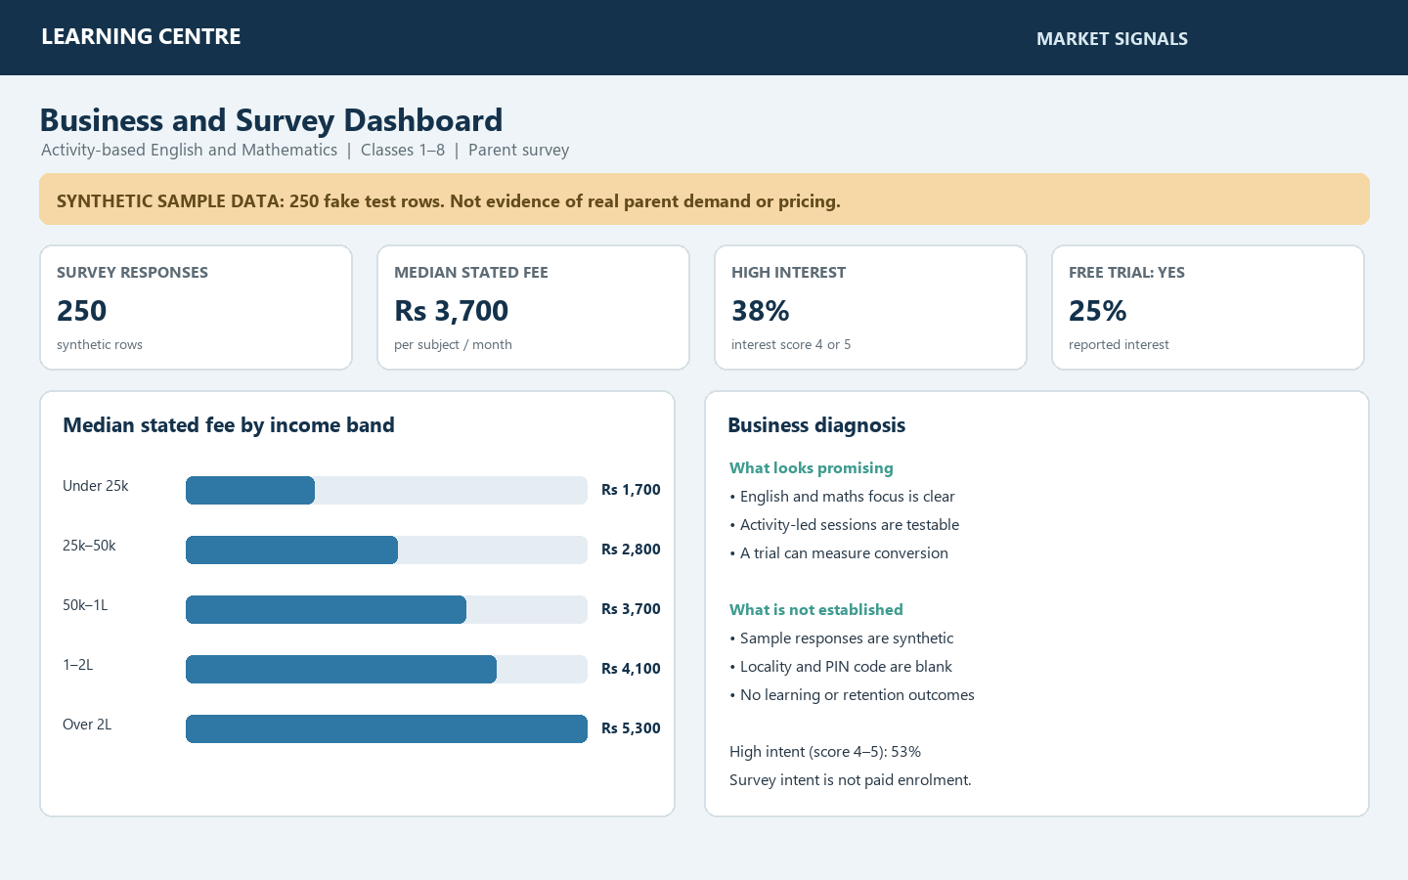
Figure 1. Market signals and business diagnosis
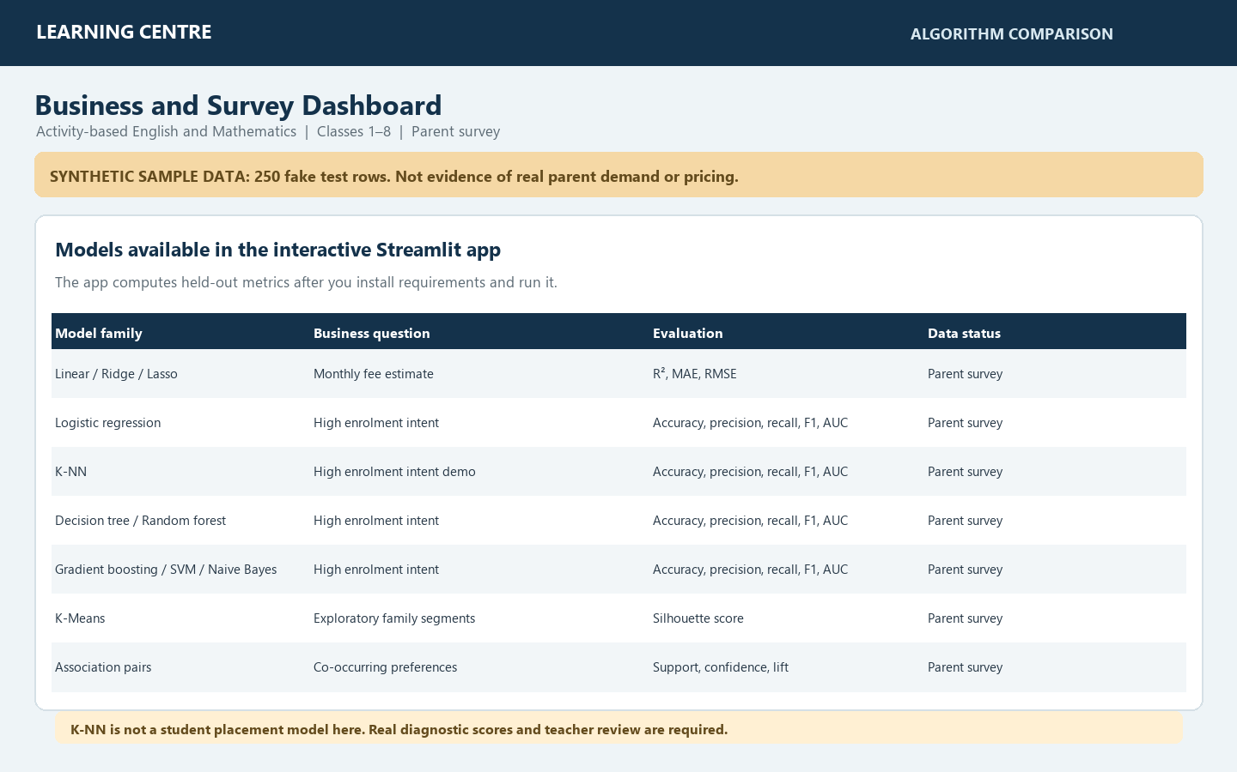
Figure 2. Algorithm comparison available in the Streamlit dashboard

Live model results screenshot
Captured values from the interactive dashboard running on the supplied synthetic sample.
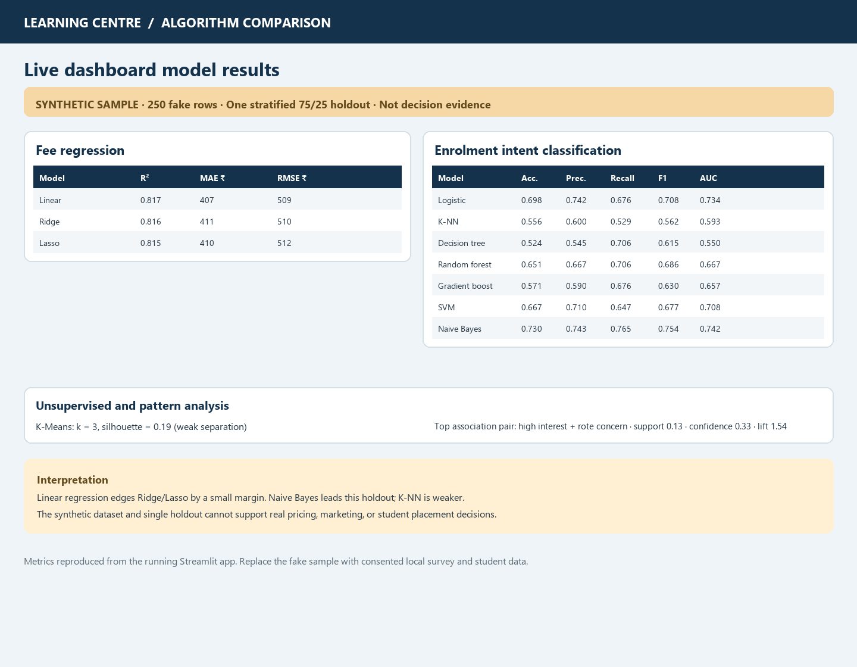
Figure 3. Regression, classification, clustering, and association results

