UNIT–1 MINI PROJECT
Enterprise Student Record and Academic Management Platform
Design Thinking & Product Planning
Prepared as per the Unit-1 Mini Project Guidelines

1. Business Requirements Document (BRD)

1.1 Business Understanding
Higher education institutions manage large volumes of student and academic information, including admissions, course registration, attendance, examinations and results. When these activities depend on disconnected or manual records, staff may face duplicate data entry, delayed updates, difficulty retrieving records, reporting effort and inconsistent information.

1.2 Problem Statement
Students, faculty and academic administrators need a centralized platform to manage student records and academic information efficiently. The proposed platform will organize core academic data and provide role-appropriate access to registration, attendance, examination, result and reporting functions.

1.3 Business Objectives
- Centralize student and academic records.
- Reduce repetitive manual record handling.
- Improve accessibility and consistency of academic information.
- Support attendance, examination and result workflows.
- Provide timely academic reports to authorized users.
- Establish a scalable foundation for future Agile and DevOps development.

1.4 Business Scope
In Scope | Out of Initial Scope
Student registration and records | Advanced AI-based academic prediction
Course registration | External payment gateway
Attendance management | Non-essential third-party integrations
Examination/result management | Advanced analytics beyond MVP
Academic report generation | Features not validated during product discovery

2. Stakeholder Analysis Report
Stakeholder | Role / Responsibility | Needs / Expectations
Students | Use academic services and view their records | Easy access, accurate records, attendance and results
Faculty Members | Manage academic/attendance information | Efficient entry, accurate student data and useful class information
Academic Administrators | Manage academic records and workflows | Centralized data, control and reporting
Examination Cell Staff | Handle examination/result processes | Accurate result processing and report generation
IT Support Personnel | Support system operation | Security, reliability, maintainability and scalability

3. User Persona Report
Persona | Goals | Responsibilities | Challenges | Expectations
Student | Register courses, track attendance, access results | Maintain academic profile and use academic services | Difficulty obtaining timely information; fragmented records | Simple, fast and reliable access
Faculty Member | Manage academic and attendance information | Record attendance and support academic activities | Repetitive data entry and record maintenance | Efficient workflows and accurate records
Academic Administrator | Maintain institutional academic records | Manage student/course information and reports | Large volume of records and reporting effort | Centralized visibility and reliable reports

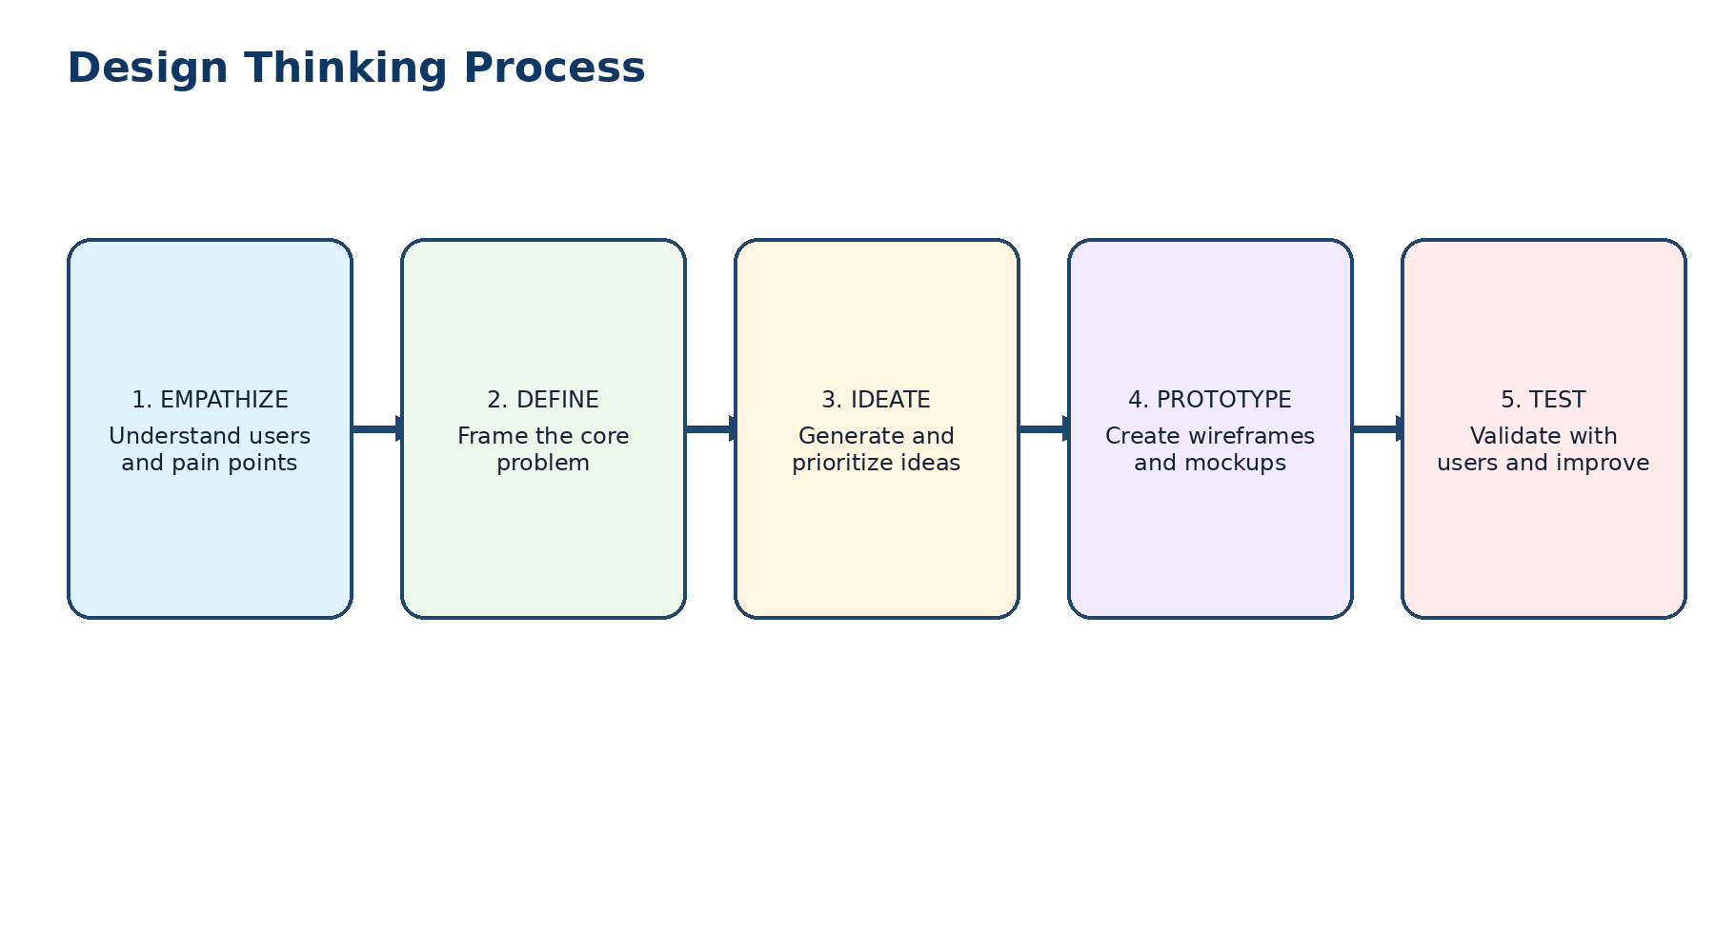

4. Design Thinking Report

4.1 Empathize
Understand the experiences of students, faculty, administrators and examination/IT staff. Focus on their goals, daily workflows, pain points and expectations.

4.2 Define
Core problem statement: Students and academic staff need a reliable, centralized way to manage student records and academic activities because fragmented/manual record handling can create delays, repeated work and difficulty accessing accurate information.

4.3 Ideate
- Centralized student profile and academic record.
- Course registration workflow.
- Attendance entry and viewing.
- Examination and result management.
- Academic report generation.
- Role-based access for different stakeholders.

4.4 Prototype
Prepare low-fidelity wireframes for the following core screens:
- Login / role selection
- Student dashboard
- Faculty attendance dashboard
- Course registration
- Examination/result module
- Administrator dashboard
- Academic report screen
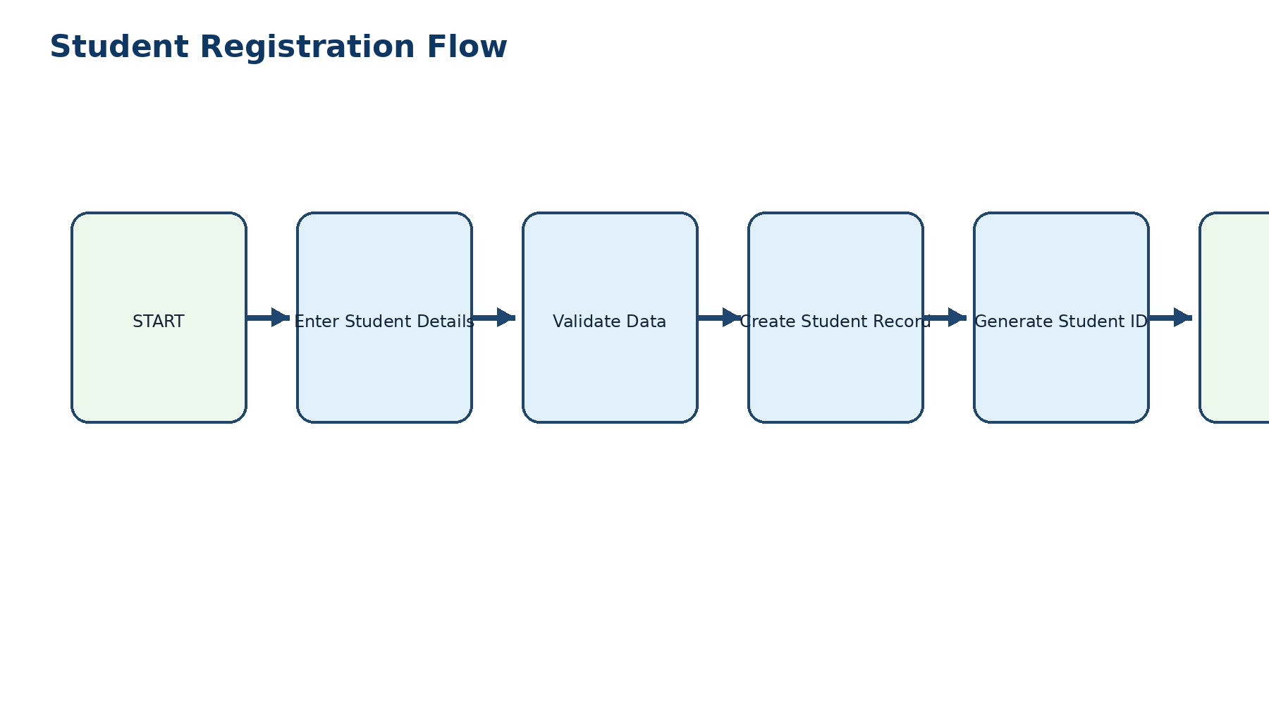

4.5 Test
Validate the prototype with representative users by checking navigation clarity, ease of completing common tasks, information visibility and whether the proposed workflow addresses the identified problems. Record feedback and revise the prototype.
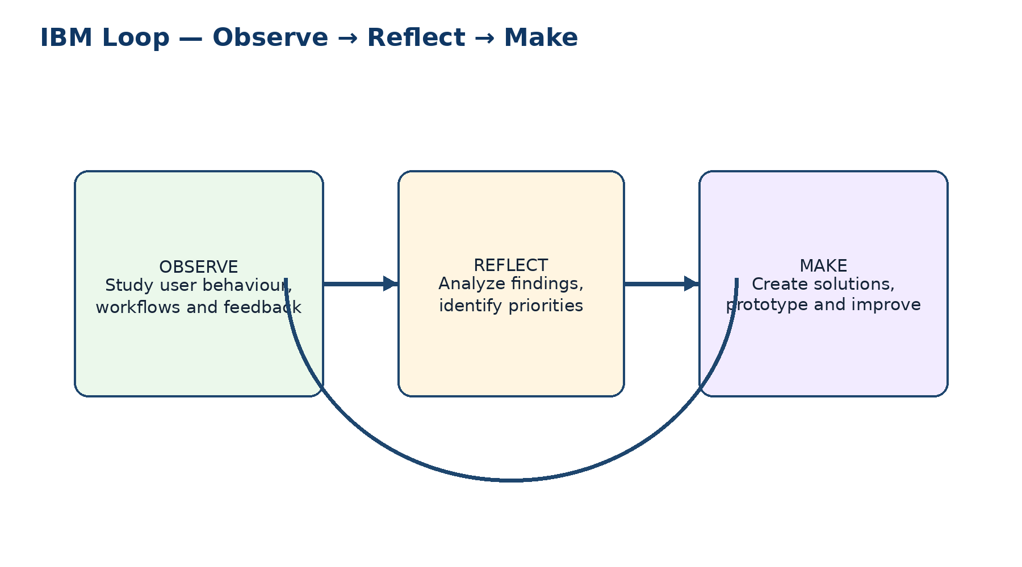

5. IBM Design Thinking Report
Principle | Application to the Project
Focus on User Outcomes | Measure success through easier academic record access, efficient workflows and useful reports rather than only technical completion.
Restless Reinvention | Use feedback and observed system usage to continuously refine workflows and features.
Diverse Empowered Teams | Bring together product/domain stakeholders, developers, UI/UX, QA, database and IT/operations roles.

IBM Loop: Observe → Reflect → Make
Observe: study user interactions, academic workflows and operational friction.
Reflect: analyze feedback and identify the highest-priority improvements.
Make: modify the design, implement validated improvements and repeat the cycle.
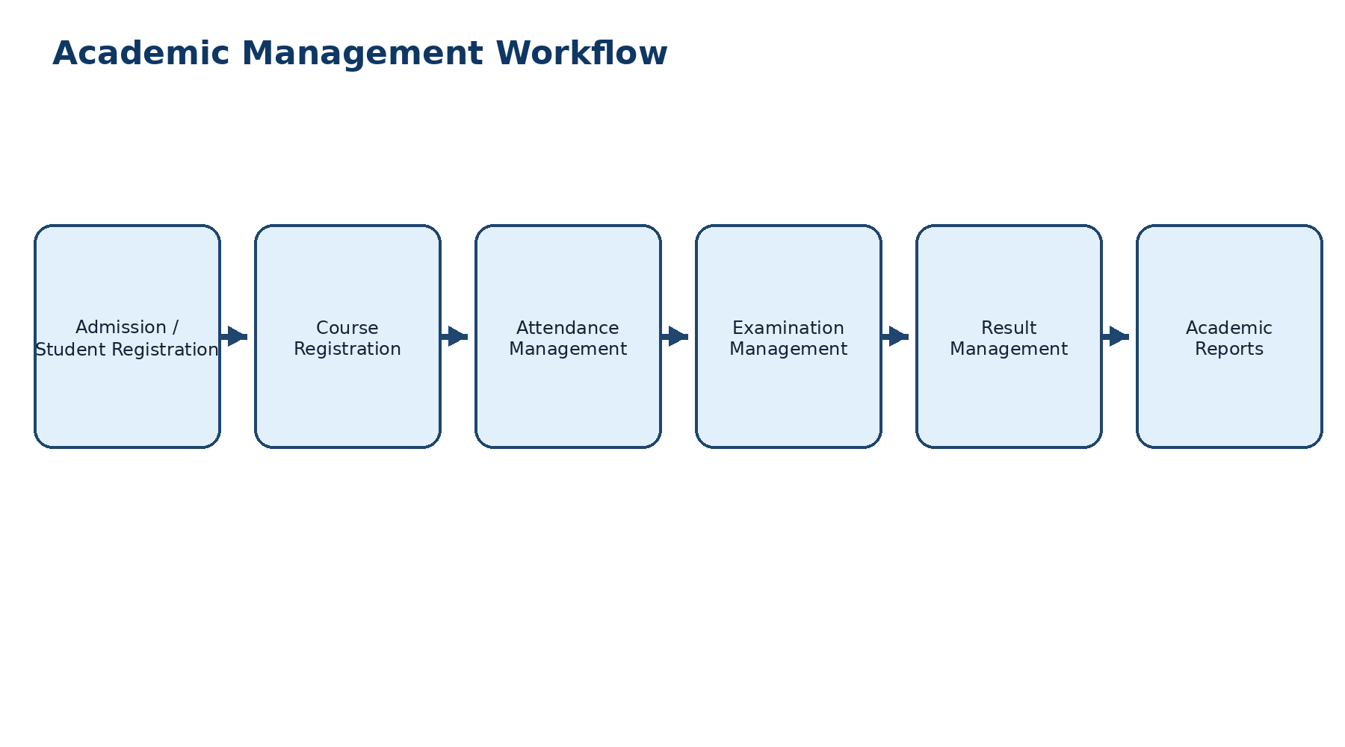

6. Functional Requirements Specification (FRS)
ID | Functional Requirement | Description
FR-01 | Student Registration | The system shall allow authorized users to create and maintain student records.
FR-02 | Student Record Management | The system shall maintain student academic information in a centralized record.
FR-03 | Course Registration | The system shall support registration of students for academic courses.
FR-04 | Attendance Management | The system shall allow authorized faculty/staff to record and manage attendance.
FR-05 | Examination Management | The system shall support management of examination-related academic information.
FR-06 | Result Management | The system shall support recording and generating student academic results.
FR-07 | Academic Report Generation | The system shall generate academic reports for authorized users.
FR-08 | Role-Based Access | The system shall provide appropriate access according to user role.
FR-09 | Record Retrieval | The system shall allow authorized users to retrieve relevant student/academic information.

7. Non-Functional Requirements Specification (NFRS)
ID | Category | Requirement
NFR-01 | Security | Student and academic information shall be protected through authenticated and authorized access.
NFR-02 | Usability | Common academic tasks should have clear, understandable and consistent user interfaces.
NFR-03 | Reliability | The system should preserve academic records accurately and provide dependable operation.
NFR-04 | Scalability | The architecture should support growth in students, courses, records and users.
NFR-05 | Maintainability | The project should use clear separation of modules and documentation to support future changes.

8. Product Vision Document

Vision Statement
To provide a centralized and user-focused platform that simplifies the management and access of student records and academic information within higher education institutions.

Mission Statement
To replace fragmented academic record handling with an organized digital workflow for student registration, academic records, attendance, examinations, results and reporting.

Success Criteria
- Core academic records are centrally accessible to authorized users.
- Students and faculty can complete common workflows with clear navigation.
- Academic reports can be generated efficiently.
- The platform provides secure, reliable and scalable foundations for later development.

9. Minimum Viable Product (MVP)
MVP Feature | Purpose
Student Registration | Create and maintain student records.
Student Record Management | Maintain core academic information.
Attendance Management | Record and access attendance information.
Academic Report Generation | Provide useful academic reports.

10. Product Roadmap
Phase | Planned Work
Phase 1 | Business/domain analysis and problem understanding
Phase 2 | Design Thinking, personas and prototype
Phase 3 | Agile planning, backlog and sprint definition
Phase 4 | Core application development
Phase 5 | Testing and quality validation
Phase 6 | DevOps automation and CI/CD
Phase 7 | Deployment, monitoring and continuous improvement

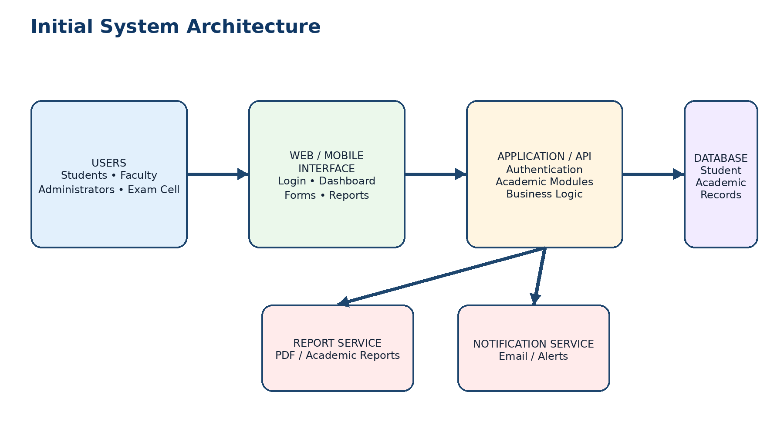

11. Initial System Architecture
Conceptual architecture:
- Users: Students, Faculty, Academic Administrators, Examination Cell and IT Support.
- Presentation Layer: Web/mobile user interface.
- Application Layer: Authentication, student records, course registration, attendance, examination, results and reporting modules.
- Data Layer: Central academic database.
- Operations Layer: Testing, CI/CD, deployment, monitoring and support.
Flow: Users → User Interface → Application/API Layer → Academic Database. Authorized reporting and administrative functions use the same controlled application layer.

12. Project Charter
Item | Details
Project Name | Enterprise Student Record and Academic Management Platform
Objective | Design a centralized platform for student records and academic information.
Primary Users | Students, Faculty Members, Academic Administrators
Supporting Stakeholders | Examination Cell Staff, IT Support Personnel
MVP | Student registration, record management, attendance and academic reports
Major Deliverables | BRD, vision, stakeholders, personas, FRS, NFRS, design thinking, IBM reports, MVP, roadmap, architecture and repository
Initial Constraint | Unit 1 focuses on planning and product discovery rather than full implementation
Future Direction | Agile development followed by testing and DevOps/deployment activities

13. Project Repository Initialization
Recommended initial repository:
- student-academic-management/
- ├── docs/
- │ ├── BRD/
- │ ├── product-vision/
- │ ├── stakeholders/
- │ ├── personas/
- │ ├── requirements/
- │ ├── design-thinking/
- │ ├── ibm-design-thinking/
- │ ├── roadmap/
- │ └── architecture/
- ├── app/
- ├── database/
- ├── tests/
- ├── .github/workflows/
- ├── README.md
- └── .gitignore

14. Product Discovery Documentation
Maintain a discovery record containing user observations/interviews or questionnaire findings, identified pain points, problem statement, ideas considered, prototype feedback, decisions made and changes resulting from testing. This section should be updated when actual user validation is performed.

15. Submission Checklist
- ☐ Business Requirements Document (BRD)
- ☐ Product Vision Document
- ☐ Stakeholder Analysis Report
- ☐ User Persona Report
- ☐ Functional Requirements Specification (FRS)
- ☐ Non-Functional Requirements Specification (NFRS)
- ☐ Design Thinking Report
- ☐ IBM Design Thinking Report
- ☐ IBM Loop Documentation
- ☐ MVP Definition
- ☐ Product Roadmap
- ☐ Initial System Architecture Diagram
- ☐ Project Charter
- ☐ Project Repository Initialization
- ☐ Project Folder Structure
- ☐ Product Discovery Documentation

Source basis: Prepared from the uploaded Unit-1 Mini Project brief. The assignment requires planning and product discovery before subsequent Agile development.

Appendix — Embedded Project Diagrams
The following diagrams are embedded directly in this Word report and are part of the submission: Design Thinking flow, IBM Loop, academic management workflow, student registration flow, and initial system architecture.

Design Thinking Flow


IBM Loop


Academic Management Workflow


Student Registration Flow


Initial System Architecture


