**SUBJECT : PROJECT BASED LEARNING**

**PROJECT TOPIC : DigiDetOX**

Group Number : 14

Group Members : Tejal Pawar (Roll No:- 54)

Mrunmayee Wani (Roll No:-73)

Vedika Yadav (Roll No:- 75)

Lavanya Zute (Roll No:-77)

**Scenario :**

E-Waste Management System: Web Development Project Scenarios

This project offers a web platform for e-waste collection, with customer and employee interfaces. Here are some scenarios to consider:

**Customer Interface:**

Schedule a Pickup: A customer can register or login and schedule a pickup for their e-waste. They can specify the type, quantity, and location of the e-waste. The system can display estimated pickup windows based on location and availability.

Track Pickup: Customers can track the status of their scheduled pickup in real-time.

View Rewards: The system displays the customer's accumulated points or rewards earned from e-waste submissions. Customers can view reward details and potentially redeem them for discounts or benefits.

E-waste Information: The platform offers educational resources about different types of e-waste, responsible disposal methods, and the environmental impact of e-waste.

Employee Interface:

Manage Pickups: Employees can view and manage scheduled pickups, assigning routes and optimizing schedules.

Record E-waste: Employees can record collected e-waste by type and quantity during pickups. The system can prompt for specific details based on e-waste categories.

Data Analysis: Employees can access dashboards to visualize e-waste collection data, including the amount collected, sorted, recycled, and decomposed. This helps monitor progress and identify areas for improvement.

Performance Tracking: The system can track employee performance metrics, such as the number of pickups completed, e-waste collected, and adherence to protocols.

Scenario 1: Residential E-waste Pickup

John, a resident, wants to dispose of his old laptop and printer responsibly. He logs in to the platform, schedules a free pickup for his e-waste, and specifies their location and condition. The system assigns a pickup for the next day. John receives a notification when the pickup is on its way and can track the driver's location in real-time.

Scenario 2: Corporate E-waste Collection

A large office is upgrading its computers. They contact the e-waste management company through the platform and arrange a bulk pickup. Employees can record the specific types and quantities of e-waste collected during the pickup. The company receives points for their e-waste contribution, which they can redeem for discounts on future pickups.

Scenario 3: Employee Performance Tracking

The company manager uses the platform to track employee performance on e-waste pickups. They identify Sarah, a consistent top performer, for exceeding monthly collection targets and maintaining accurate data records.

Scenario 4: Data-Driven Insights

By analyzing e-waste collection data, the company identifies a surge in specific e-waste types like mobile phones. They use this information to launch targeted awareness campaigns encouraging responsible disposal of these devices.

**User Requirements :**

1. Reviews and Ratings: Enable users to leave reviews and ratings for e-waste recycling facilities based on their experiences, helping others make informed decisions.

2. User Contributions: Allow users to contribute new e-waste or update existing information, ensuring the database remains accurate and up-to-date.

3. Integration with Other Services: Integrate with other services or platforms, such as transportation apps, to provide seamless access to e-waste recycling facilities.

4. Notification Alerts: Send notification alerts to users about nearby e-waste recycling events, promotions, or changes in facility status.

5. Feedback Mechanism: Provide a feedback mechanism for users to report any issues or suggest improvements related to the e-waste locator system.

6. Educational Resources: Offer educational resources and tips on responsible e-waste disposal and recycling practices to users, promoting environmental awareness.

7. Social Sharing: Enable users to share information about e-waste recycling facilities and their experiences on social media platforms, encouraging others to participate in e-waste recycling efforts.

**ER Diagram :**

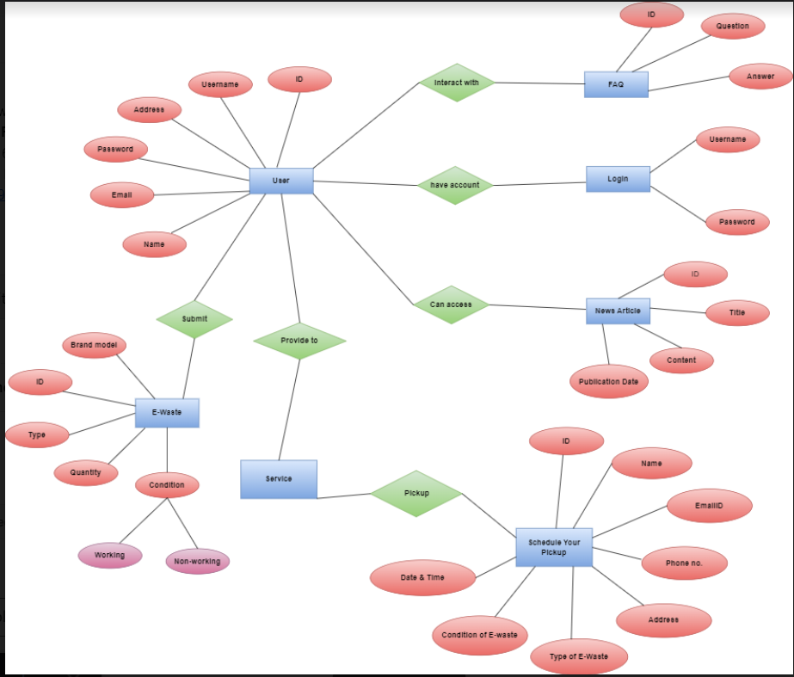

**Schema Diagram :**

