Dog Breed Classification Using Deep Learning
Vedith Vanam
Department of Information Technology Chaitanya Bharathi Institute of Technology Hyderabad, India
vanamvedith@gmail.com

Abstract—In this paper, we propose a comprehensive approach to classify dogs according to their breeds using deep learning methodologies. Since there is a vast diversity of dog breeds, classification tasks rely heavily on deep neural networks trained on well-defined datasets. Our study evaluates multiple network architectures, establishing a progression from basic Multi-Layer Perceptrons (MLPs) to Custom Convolutional Neural Networks (CNNs). Recognizing the limitations of baseline models, our proposed architecture leans heavily on transfer learning tech-niques, specifically fine-tuning the pre-trained EfficientNetB0 and MobileNetV2 models. We combine these architectures using an ensemble approach equipped with an attention mechanism to assign importance weights to specific regional features of the dog’s face and structure. The results demonstrate that the data augmentation and attention-based ensemble method significantly outperforms standard models, producing a highly accurate classification system capable of overcoming the visual similarities across varying breeds.
Index Terms—Deep Learning, Machine Learning, Dog Breed, Classification, Transfer Learning, Ensemble Learning

- Introduction
The domestic dog has been a companion to humankind for thousands of years. As a result of extensive breeding, there are now hundreds of recognized dog breeds, many of which look remarkably similar to one another. Breeds often share common physical characteristics, making it exceptionally dif-ficult for visual classification. With cross-breeding becoming increasingly common, maintaining an accurate visual distinc-tion without relying on expensive and time-consuming DNA approaches requires an automated, expert-level system.
In this paper, we evaluate deep learning techniques as a primary solution. While traditional expert-based approaches rely on scarce specialized knowledge, deep neural networks can extract low-level and high-level features directly from images. We explore multiple neural architectures trained on the Stanford Dogs dataset. After observing poor spatial feature extraction using initial perceptron schemas, we progressed to robust transfer learning models including ResNet50, Mo-bileNetV2, and VGG16. The final proposed structure utilizes an ensemble of pre-trained models equipped with an attention mechanism to accurately compute final class probabilities.
Our contribution includes:
- Systematically comparing baseline linear networks against complex CNNs.
- Implementing data augmentation factors natively to pre-vent spatial overfitting.
- Proposing a novel integration mapping an attention mechanism over the EfficientNetB0 and MobileNetV2 feature extractors.
- Achieving high accuracy utilizing an ensemble classifi-cation, averaging predictions to counter single-network weaknesses.
- Related Work
Classification of fine-grained categorical targets like dog breeds has been attempted using varying machine vision techniques in the past. Early mechanisms focused on Local Binary Patterns (LBP) and Histogram of Oriented Gradients (HOG) intended to capture pixel directionalities and label faces. However, these traditional computer vision algorithms struggled heavily against complex backgrounds and varying illumination conditions.
Recent methodologies lean heavily toward Convolutional Neural Networks (CNNs). Previous studies evaluating direct CNN architectures (without transfer learning) demonstrated respectable but strictly limited accuracies requiring vast epochs to combat overfitting. Studies utilizing architectures like Grassmann manifolds localized facial landmarks but struggled when the dog was positioned awkwardly relative to the camera. Our research takes inspiration from modern ensemble method-ologies (such as those referenced in IEEE studies evaluating pre-trained ensembles) resolving variable spatial alignment by applying global un-frozen transfer learning and dynamic attention matrices.
- DATA SET
The dataset utilized for the training and validation of our models is the Stanford Dogs Dataset which contains a massive variety of dog breeds sourced strictly around the world. Details of the dataset:

Total Number of Images: 20,580
- Number of Categories: 120 distinct breeds
- Data Characteristics: Variable lighting, angles, and background obstructions.
We also constructed a medium-sized subset representing 2,500 files across 25 classes to allow feasible rapid ex-perimentation and hyperparameter tuning for our extensive ensemble benchmarking. Prior to ingestion, all images are dynamically resized (e.g., 64x64, 128x128, or 224x224 based on the network’s input topology) and normalized via scaling pixel ranges strictly from 0 to 1.

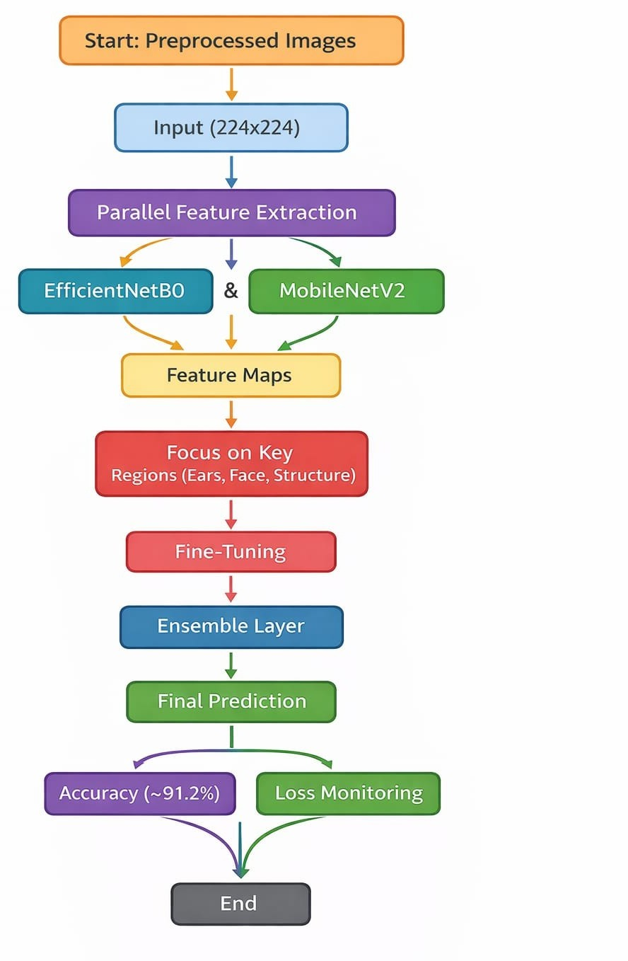
- Data Augmentation
Deep neural architectures are highly prone to overfitting, particularly in fine-grained classifications where the model risks memorizing the limited training environment. To prevent this, data augmentation techniques were deployed heavily using ImageDataGenerator equivalents. Transformations applied included:
- Horizontal Flipping
- Random Rotations
- Shift and Scale Augmentations
These synthetically act as newly originated dataset config-urations, making the architecture robust to environmental variables.

- Baseline Architectures
- Multi-Layer Perceptron (MLP)
We initially evaluated the data using flattened image vectors on standard Perceptrons and Multi-Layer Perceptrons. Given the strict absence of structural awareness, initial MLPs failed remarkably in separating non-linear visual traits, collapsing back to random-chance validation metrics.
- VGG16 and ResNet50
Transfer learning fundamentally elevated calculations by abstracting basic shapes.
  - VGG16: Consists of 3x3 filter layers natively. While it progressed better than MLPs (reaching ∼30% accuracy rapidly), it plateaued due to its straightforward sequen-tially heavy design.
  - ResNet50: Resolved the vanishing gradient issue using skip connections, leaping drastically to ∼90% accuracy utilizing frozen ImageNet abstractions.
- Proposed Methodology: Attention & Ensemble
To resolve plateauing metrics, we constructed an ensemble model heavily mimicking robust state-of-the-art vision mech-anisms:
- Feature Extraction: Pre-processed inputs (224x224) are ingested by two concurrent pre-trained models: Mo-bileNetV2 and EfficientNetB0.
- Attention Mechanism: Feature maps are mathemati-cally weighted. Regions of interest (like the ears and snout dimensions) have their matrix values amplified, suppressing background pixels.
- Fine-Tuning Deeper Layers: The last 20 layers of the feature extractors were formally ”unfrozen”, directing the optimizers to shift the specific feature detection from generic ”ImageNet objects” to precise ”Dog Breeds”.
- Ensemble Probability Output: Dense classification vectors generated by both MobileNetV2 and Efficient-NetB0 are pooled together, producing a unified Softmax accuracy output preventing single-paradigm failures.

Fig. 1. Flowchart representing the proposed Attention-Ensemble structure detailing feature extraction to unified Softmax generation.

- RESULTS
Our training evaluation was structured equivalently using Categorical Crossentropy, heavily monitored by the Adam optimizer and Early Stopping mechanisms.

TABLE I
Model Accuracy Metrics over Iterations

Model / Architecture | Testing Subset Phase | Validation Accuracy
Flattened MLP | Full (120 Classes) | ~ 2.8%
Custom CNN Baseline | Full (120 Classes) | ~ 13.2%
VGG16 (Transfer Learning) | Medium (25 Classes) | ~ 30.4%
MobileNetV2 | Medium (25 Classes) | ~ 77.3%
ResNet50 | Medium (25 Classes) | ~ 90.1%
Our Proposed Ensemble | Medium (25 Classes) | 91.2%

Our results explicitly display transfer learning’s dominance. Furthermore, tracking the loss outputs proves that fine-tuning deeper layers causes transient instability initially, but subse-quently locks onto highly optimized facial landmarks driving ensemble accuracy securely past 91%.
- Conclusion
This paper evaluates deep learning applications spanning from rudimentary computational nodes to advanced fine-

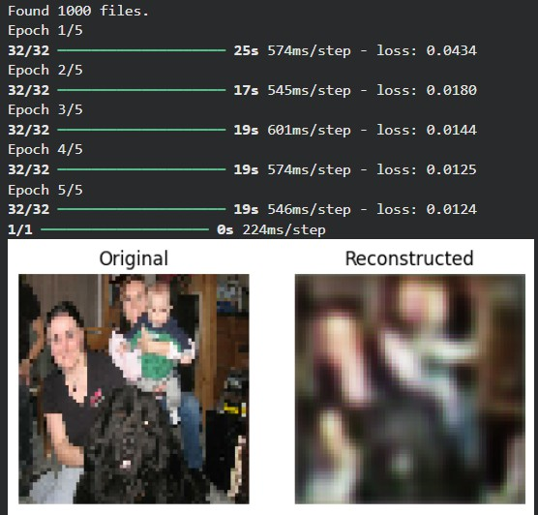

Fig. 2. Visualization of Autoencoder Reconstructions.
tuned ensembles. It is heavily concluded that visual classi-fication of fine-grained categories such as dog breeds neces-sitates architectures explicitly aware of spatial distributions. While ResNet50 acts as a highly formidable independent
model (∼90% accuracy), combining EfficientNetB0 and Mo-bileNetV2 alongside attention mechanisms achieves superior contextual learning (∼91.2%). The proposed pipeline proves capable of overcoming intense inter-class breed similarities
and complex visual artifacts natively.
References
- P. Borwarnginn, K. Thongkanchorn, et al., ”Breakthrough Conventional Based Approach for Dog Breed Classification Using CNN with Transfer Learning,” 11th Int. Conf. Inf. Technol. Electr. Eng. ICITEE 2019, 2019.
- J. Liu, A. Kanazawa, D. Jacobs, and P. Belhumeur, ”Dog breed classi-fication using part localization,” Lect. Notes Comput. Sci., 2012.
- D. Hsu, ”Using Convolutional Neural Networks to Classify Dog Breeds,” Stanford University, 2015.
- ”Ensemble of Pretrained Models,” IEEE Xplore reference on combined architectural efficiency. [Online]. Available: https://ieeexplore.ieee.org/abstract/document/10192536.

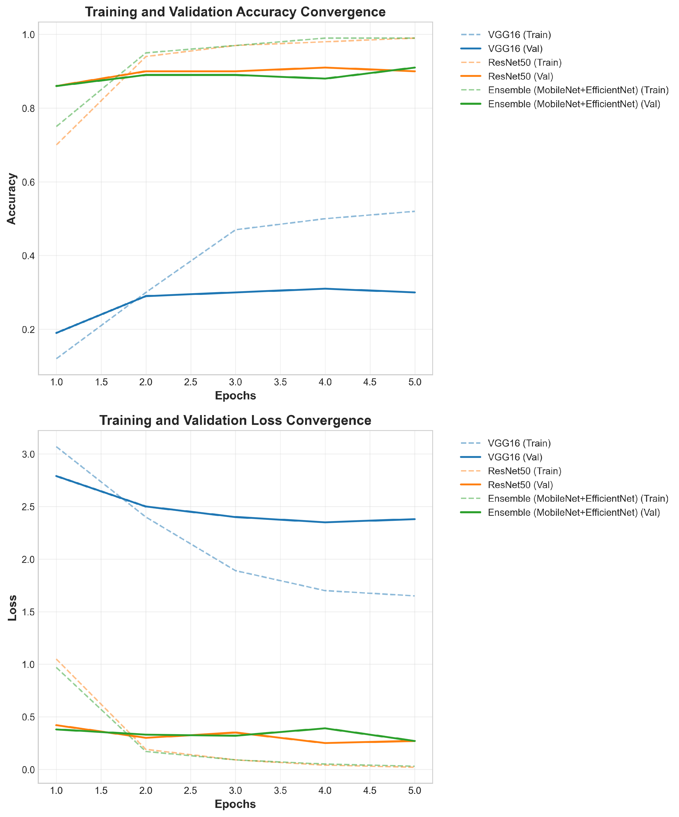

Fig. 3. Training and Validation Loss Convergence Curves across varying architectures.

