
P. R. Pote Patil College of Engineering and Management, Amravati

Title of Project

“WeatherScope – Weather Analysis and Visualization ”

Name of Students
Mr. Vedant Jagannath Puri (Roll No. AIDSU2422)

Guided By
Dr. P. G. Angaitkar
Assistant Professor

Department of Artificial Intelligence and Data Science B.Tech. Second Year -4th Sem
2025-26



CERTIFICATE
This is to certify that following group of students of have successfully completed the AI&DS Lab project titled “WeatherScope – Weather Analysis and Visualization System”for the requirements of the
Bachelors of Technology (B.Tech) program in AI&DS Laboratory during the academic year 2025– 26.

Sr. No Student Name Roll No.

- Vedant J. Puri AIDSU24222

Dr. A. G. Angaitkar Dr. A. B. Gadicha Guide HOD

P. R. Pote Patil College of Engineering & Management, Amravati Session 2025 – 26

Abstract
Weather data analysis plays a crucial role in understanding climate patterns and predicting future atmospheric conditions. This project focuses on analyzing historical weather data to identify trends, variations, and relationships between different meteorological parameters such as temperature, humidity, rainfall, and wind speed.

The dataset used in this study is processed and analyzed using Python libraries such as Pandas, NumPy, and Matplotlib. Various statistical techniques including mean, median, standard deviation, and data visualization methods like histograms, line graphs, and box plots are applied to interpret the data effectively.

The results of this analysis help in identifying seasonal patterns, detecting anomalies, and understanding weather fluctuations over time. This project demonstrates how data analysis techniques can be applied to real-world environmental data for better decision-making and forecasting.

ACKNOWLEDGEMENT

It is our supreme duty and desire to express acknowledgement to the various torchbearers, who have rendered valuable guidance during the preparation of our project.

First of all, we extend our deepest gratitude to our revered Principal Dr. P. M. Jawandhiya
without whose support; our project could not have been transformed into present form.

We are grateful to Dr. A. B. Gadicha HOD, Artificial Intelligence and Data Science Department; and guide Dr. A. G. Angaitkar for providing immense support and guidance. We are beholden for guiding us at every step in the project. His has most honestly guided us throughout; never leaving us unanswered for any of our doubts. It was his constant persuasion, encouragement, inspiration and able guidance that helped us in completing our project successfully.

Table of Contents
CHAPTER NO. TITLE PAGE NO. Chapter 1 INTRODUCTION 7
  - Objective 7
  - Introduction 7

Chapter 2
PROPOSED WORK
8-10

  - Basic Idea 8
  - System Architecture / Workflow 9
  - Methodology 10
Chapter 3 RESULT 11-13
  - Result 11
  - Demostration 11 - 13
Chapter 4 CONCLUSION 14
  - Conclusion 14

List of Figure

Sr. No. | Figure number | Title
1 | Figure 2.2.1 | System Architechture
2 | Figure 2.2.2 | Methodology
3 | Figure 2.3.1 | Demonstration
4 | Figure 3.2.1 | Index Page
5 | Figure 3.2.2 | Region Analysis Page
6 | Figure 3.2.3 | Monthly Analysis Page
7 | Figure 3.2.1 | Final Full Region Data

.

Chapter 1 INTRODUCTION

Objective

- To collect and understand weather data Gather historical weather data including temperature, humidity, rainfall, and wind speed for analysis.

- To clean and preprocess the dataset Handle missing values, remove errors, and prepare the data for accurate analysis.

- To perform statistical analysis Calculate measures such as mean, median, mode, variance, and standard deviation to understand data distribution.

- To visualize weather patterns Use graphs like line charts, bar charts, histograms, and box plots to represent weather trends clearly.

- To identify trends and seasonal variations Analyze how weather parameters change over time and detect seasonal patterns.

- To detect anomalies in weather data Identify unusual or extreme weather conditions in the dataset.

- To build basic predictions (optional) Use simple techniques to forecast future weather trends based on past data.

Introduction

Weather data analysis is the process of collecting, organizing, and interpreting atmospheric data to understand climate behavior and patterns. It plays an important role in various fields such as agriculture, transportation, disaster management, and environmental studies. By analyzing weather data, we can make informed decisions and predict future weather conditions more accurately.
In this project, historical weather data consisting of parameters like temperature, humidity, rainfall, and wind speed is analyzed using data analysis techniques. With the help of programming tools such as Python and libraries like Pandas, NumPy, and Matplotlib, the data is cleaned, processed, and visualized to extract meaningful insights.
The main aim of this study is to identify trends, seasonal variations, and unusual patterns in weather conditions over a specific period. Visualization techniques such as graphs and charts are used to represent the data in an easy-to-understand format

Chapter 2 PROPOSED WORK

Basic Idea

The basic idea of this project is to analyze historical weather data to understand patterns and changes in atmospheric conditions over time. Weather parameters such as temperature, humidity, rainfall, and wind speed are collected and studied to identify trends, seasonal variations, and unusual behaviors.
Using data analysis tools like Python along with libraries such as Pandas, NumPy, and Matplotlib, the raw data is cleaned, processed, and visualized in the form of graphs and charts. This helps in converting complex data into simple and meaningful insights.
The project aims to show how data analysis techniques can be applied to real-world weather data for better understanding and forecasting. It also highlights the importance of data-driven decision-making in areas like agriculture, disaster management, and environmental planning.

Key features :

- Real-world dataset usage: The project uses actual or realistic weather data, making the analysis practical and relevant.

Data preprocessing and cleaning
Handles missing values, duplicates, and inconsistent data to ensure accurate results.

Statistical analysis
Calculates important measures like mean, median, mode, variance, and standard deviation. Data visualization

Trend and pattern identification
Identifies seasonal variations and long-term weather trends.

Anomaly detection
Detects unusual or extreme weather conditions in the dataset.

Use of Python tools
Implements analysis using libraries like Pandas, NumPy, and Matplotlib.

User-friendly interpretation
Presents results in a simple and understandable format for better insights.

Basic forecasting (optional)
Provides simple predictions based on historical data.

System Architecture/ Workflow

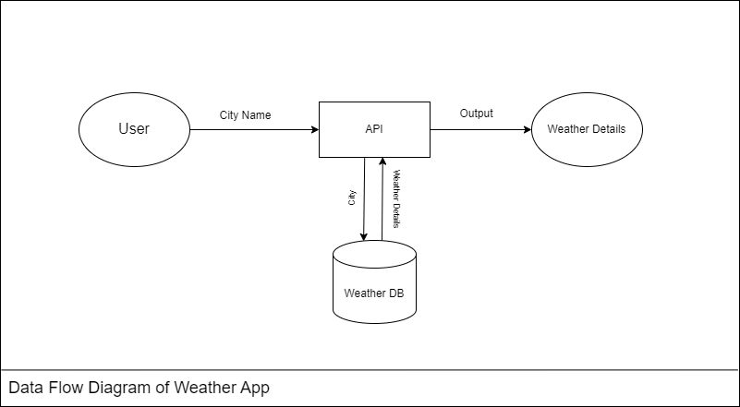

Figure 2.2.1: System Architecture

2.1 Methodology

- Data Collection
Weather data was collected from reliable sources such as meteorological departments, open datasets (e.g., government portals), or APIs. The dataset includes parameters like temperature, humidity, rainfall, wind speed, and atmospheric pressure over a specific time period.

- Data Preprocessing
Before analysis, the dataset was cleaned and prepared Handling missing values (removal or imputation) Removing duplicate records ,Converting date/time into proper format, Standardizing units (e.g., Celsius, mm rainfall) ,Filtering irrelevant or inconsistent data.

- Exploratory Data Analysis (EDA)
EDA was performed to understand patterns and trends, Summary statistics (mean, median, standard deviation) ,Time-series analysis (daily, monthly, yearly trends) ,Correlation analysis between variables (e.g., temperature vs humidity) ,Identifying seasonal patterns and anomalies .

- Data Visualization
Visual representations were used to better understand the data, Line charts for temperature trends ,Bar charts for rainfall comparison ,Heatmaps for correlation analysis ,Histograms for distribution of variables.

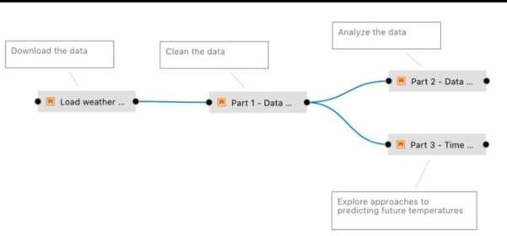

Figure 2.2.2:Methodology

  - Result

Chapter 3 Result

The analysis of the weather dataset revealed clear patterns and relationships among different parameters such as temperature, humidity, rainfall, and wind speed. Visualizations like line graphs and histograms showed noticeable seasonal trends, where temperature and humidity varied across different time periods. The statistical analysis indicated that the data was distributed within a reasonable range, with few extreme values detected through box plots.

Furthermore, the study helped in identifying correlations between variables, such as the impact of humidity on rainfall and temperature fluctuations. Some anomalies and unusual weather conditions were also observed, which could be important for future forecasting. Overall, the results demonstrate that data analysis techniques are effective in extracting meaningful insights from weather data and can support better prediction and decision-making.

Demostration



Figure 3.2.1: Index Page

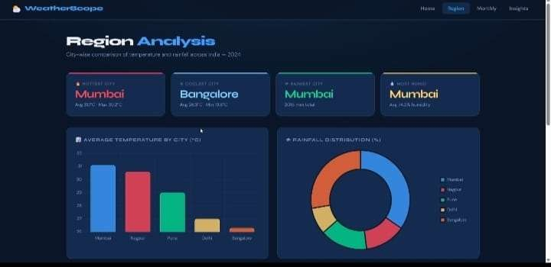

Figure 3.2.2: Region Analysis Page

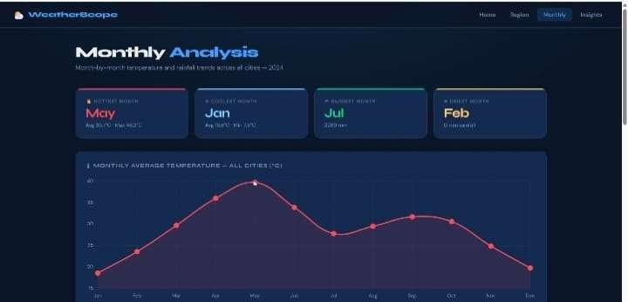

Figure 3.2.3: Monthly Analysis Page

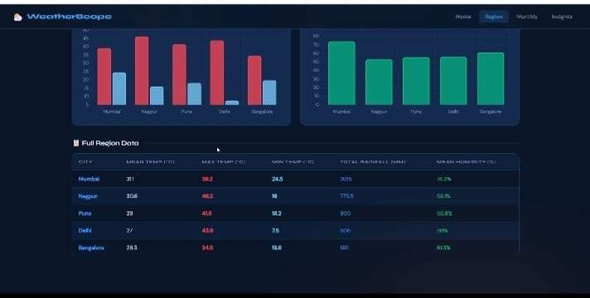

Figure 3.2.4:Final Full Region Data

Chapter 4 CONCLUSION

Conclusion
- In this project, weather data was successfully analyzed to understand patterns and trends in different atmospheric parameters such as temperature, humidity, rainfall, and wind speed. By applying data analysis techniques and visualization methods, meaningful insights were obtained from the dataset.
- The analysis helped in identifying seasonal variations, detecting unusual weather conditions, and understanding the overall behavior of weather over a period of time. Statistical measures such as mean, median, and standard deviation provided a better understanding of data distribution.

- This project also demonstrated the effectiveness of using Python libraries like Pandas, NumPy, and Matplotlib for handling and analyzing real-world data. Overall, weather data analysis is a powerful tool that can assist in forecasting, planning, and decision- making in various fields like agriculture and disaster management.

