Containerized Rainwater Harvesting Maintenance Tracker
DevOps Project Report
WEEK 3
Requirements, Architecture and Technology Setup

Vedant Kulkarni
Roll No: 23102B0067

1. Selected Technology Stack
Layer | Choice | Reason
Language/Framework | Java 21 + Spring Boot 3 | Maps directly to the Maven/Tomcat toolchain required by the brief
Build tool | Maven | Standard for Spring Boot; simpler dependency management than Ant for this scope
Frontend | Thymeleaf + Bootstrap 5 + DataTables.js | Server-rendered, single build artifact; DataTables gives free search/sort for the dashboard
Database | PostgreSQL 15 | Relational fit for structured maintenance/schedule data
Local dev server | Embedded Tomcat (spring-boot:run) | Zero-config local runs
Production deploy target | Apache Tomcat 10.1 (WAR) behind Nginx | Nginx handles TLS termination and reverse proxy; Tomcat runs the app

2. Software Requirements Specification (SRS) Summary

Functional Requirements
- FR1: User can register/log in.
- FR2: User can create a system and add components to it (data/event entry).
- FR3: User can log a maintenance event against a component.
- FR4: Dashboard lists all components with search/filter by name, type, or status (searchable dashboard).
- FR5: Dashboard shows summary indicators — counts of healthy, due-soon, overdue components.
- FR6: User can click a summary indicator or component to drill into its full history (status drill-down).
- FR7: A dedicated view lists all overdue/exception items needing attention (alert/exception view).
- FR8: System recalculates next-due-date automatically after a log entry.

Non-Functional Requirements
- NFR1: Dashboard loads in under 2 seconds for up to 500 components.
- NFR2: Passwords hashed (bcrypt); no plaintext storage.
- NFR3: App runs on a single small VM (2 vCPU / 2GB RAM) for MVP cost constraints.
- NFR4: Responsive UI down to mobile width.
- NFR5: All API errors return structured JSON with a clear message, not stack traces.

3. Use-Case Summary
Actor | Use Case | Trigger
User | Register system and components | Onboarding a new tank/setup
User | Log maintenance event | After cleaning/inspecting a component
User | Search/filter dashboard | Finding a specific component or system
User | View summary indicators | Daily/weekly check-in
User | Drill into component status | Clicking a summary count or component row
User | View alert/exception list | Checking what is overdue
Scheduler (system actor) | Recalculate due dates and flag overdue | Runs on a schedule (e.g. nightly cron)

4. Architecture Diagram
Requests flow from the browser through Nginx to the Spring Boot application running on Tomcat, which reads and writes to PostgreSQL. All business logic (schedule calculation, alert flagging) lives inside the app itself, keeping the MVP deployable as a single artifact.
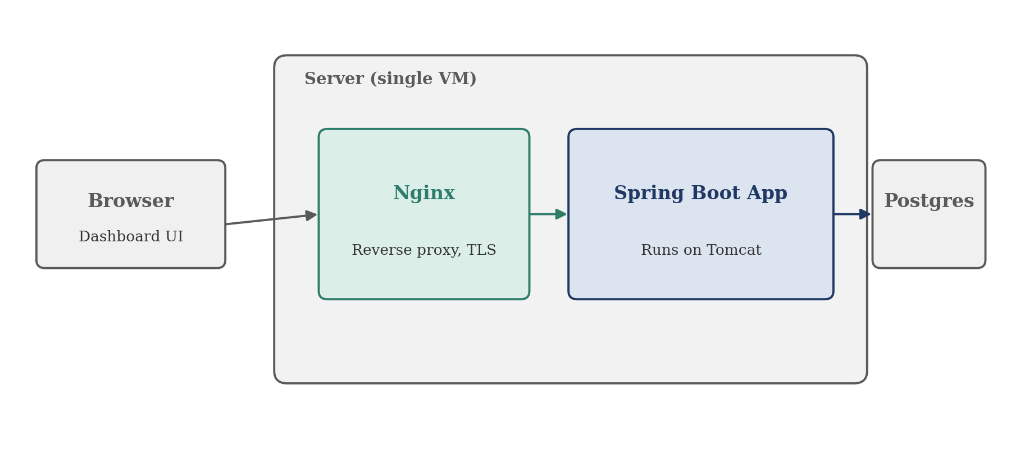

5. Data Model
Entity | Key Fields | Relationship
USERS | id (PK), email, password_hash | One user has many systems
SYSTEMS | id (PK), user_id (FK), name, location | One system has many components
COMPONENTS | id (PK), system_id (FK), type, interval_days, last_maintained_at | One component has many logs and alerts
MAINTENANCE_LOGS | id (PK), component_id (FK), performed_at, notes, photo_url | Belongs to one component
ALERTS | id (PK), component_id (FK), due_date, status | Belongs to one component

6. API List
Method | Endpoint | Purpose
POST | /api/auth/register | Create account
POST | /api/auth/login | Authenticate
GET / POST | /api/systems | List / create systems
GET / PUT / DELETE | /api/systems/{id} | Read, update, delete a system
GET / POST | /api/systems/{id}/components | List / add components
PUT / DELETE | /api/components/{id} | Update, remove a component
GET / POST | /api/components/{id}/logs | View / add maintenance logs
GET | /api/dashboard/summary | Healthy/due-soon/overdue counts
GET | /api/dashboard/search?q= | Searchable dashboard query
GET | /api/alerts?status=overdue | Alert/exception view

7. Working Local Setup
- Install JDK 21 and Apache Maven; verify with java -version and mvn -version.
- Install PostgreSQL 15 locally; create a database named rwh_tracker.
- Clone the project repository and set the datasource URL, username, and password in application.properties.
- Run mvn clean install to compile and run unit tests.
- Run mvn spring-boot:run to start the app on the embedded Tomcat server.
- Open http://localhost:8080 to verify the application loads.
- Run mvn clean package to produce a deployable WAR file for production Tomcat.

