Name : Ved khode PRN : 25070521176

    - Area of a circle
Algorithm
- Start
- Read the radius value from the user.
- Set the value of π (pi) as 3.14.
- Calculate area using formula . Area = pi x radius x radius
- Display the area formatted to 4 decimal places.
- Stop
Flowchart
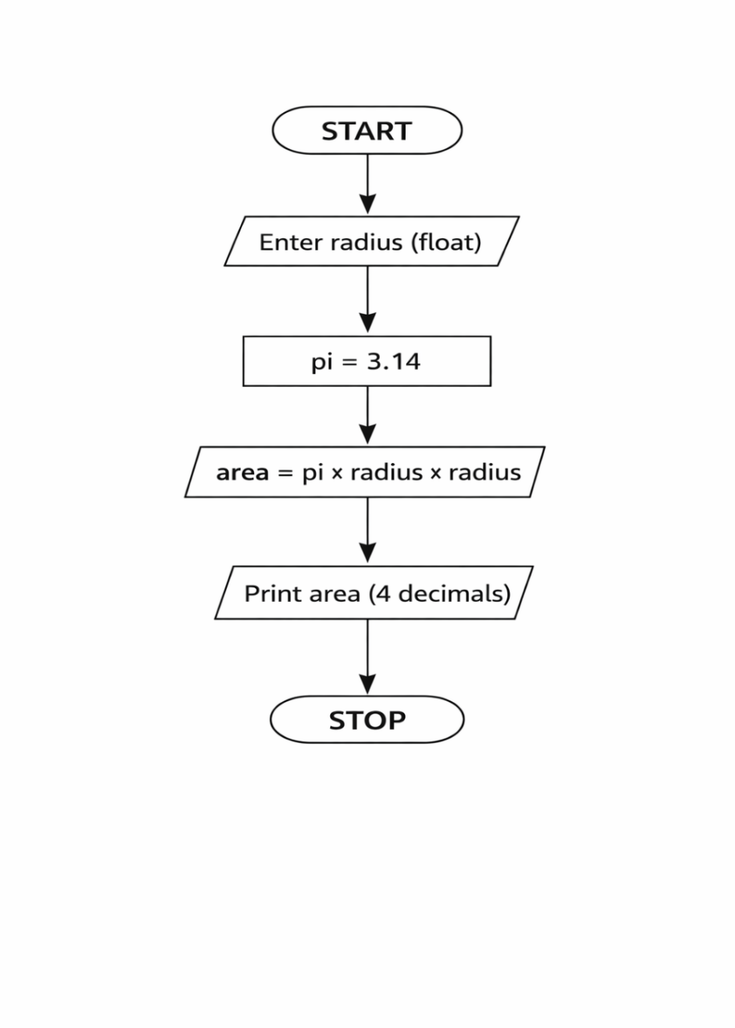
Pyton code
radius = float(input())
pi = 3.14
area = pi * radius * radius
print(f"{area:.4f}")

Execution
