Name : ved khode PRN : 25070521176

1.1.2 Area of a Rectangle
A] Algorithm
1] Start
2 ]Read the length of the rectangle.
3] Read the width of the rectangle.
4] Calculate the area using the formula
$$\text{area}=\text{length}×\text{width}$$
5] Display the area formatted to 2 decimal places.
6] Stop
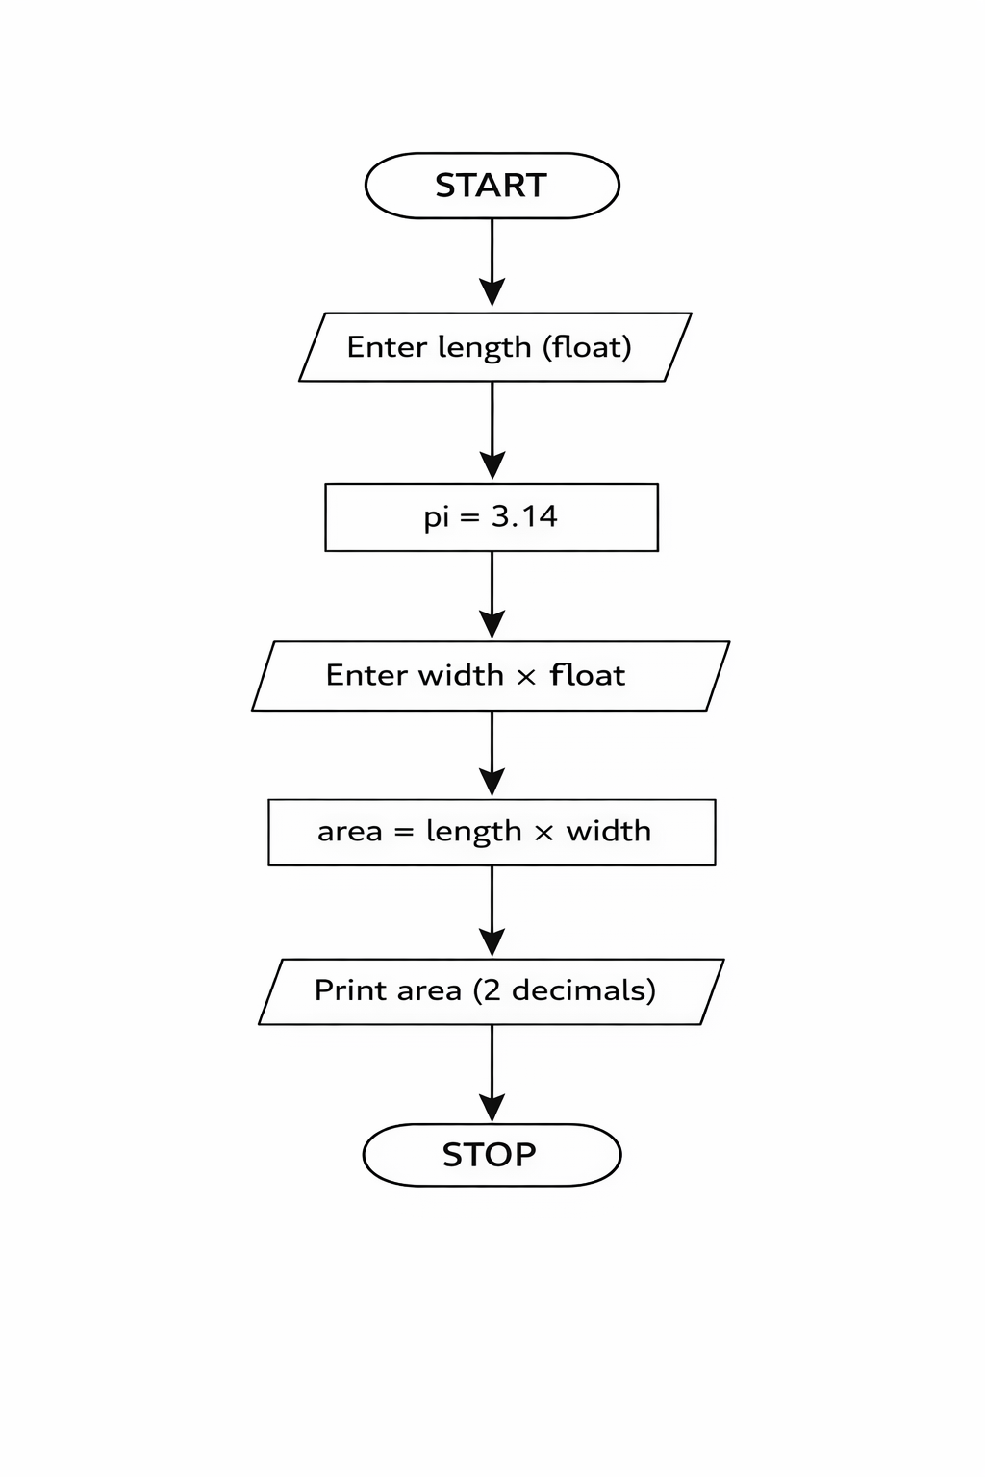
PYTHON CODE
length = float(input())
width = float(input())
area = length * width
print(f"{area:.2f}")

EXCECUTION

