Name : Ved khode PRN : 25070521176
1.1.4 AREA OF TRIANGLE
ALGORITHM
- Start
- Read the base of the triangle.
- Read the height of the triangle.
- Calculate the area using the formula
- $\text{area}=0.5×\text{base}×\text{height}$
- Display the area formatted to 2 decimal places.
- Stop

Flowchart
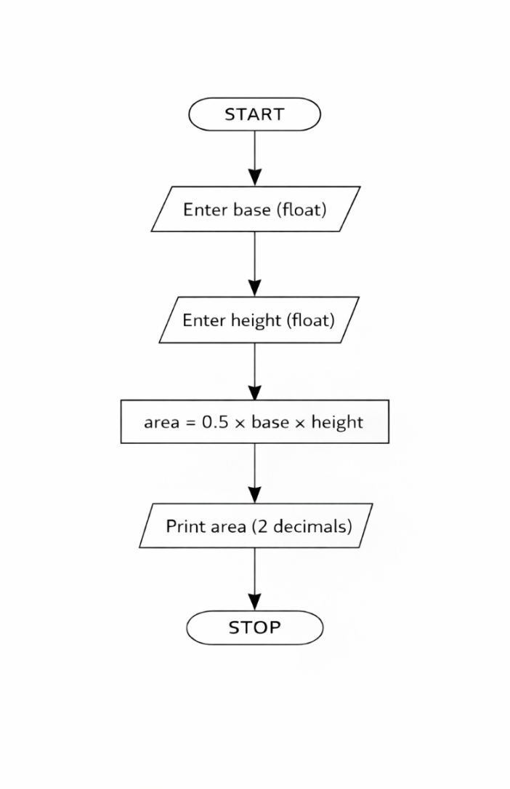

Python Code
base = float(input())
height = float(input())
area = 0.5 * base * height
print(f"{area:.2f}")

EXCECUTION

