Lab 4 Lunar Lander Chat History
Ved Mudkavi | PES1UG24CS522 | 30 September 2026
This transcript records the lab prompts and assistant replies, including progress updates, from assignment review through the four implementation tasks and submission preparation. Messages remain in chronological order. The four attached screenshots appear at the end.
The transcript ends with the student confirming that the videos were added to Lab 4. All times are India Standard Time. Tool execution logs are not reproduced in this document.
Shared conversation: https://chatgpt.com/s/cx_6abcb1c898a08191acd4534e7f35c86b
Game repository: vedmudkavi/32_lunarLander
Submission repository: vedmudkavi/SE-Labs-PES1UG24CS522

Message 1 User
11:40:59 AM IST
https://github.com/SETAPESU26/32_lunarLander
this is my lab 04
read this and tell me what this is and dont start because i will have to give a track of the rpompts tht i use
my teacher wants a shareable link for the prompts i use
Attachment 1 is reproduced in the screenshot section.

Message 2 Assistant update
11:41:04 AM IST
I’ll read the repository and explain the lab requirements without starting any coding. I’ll also check how to preserve a shareable record of your prompts, using the OpenAI docs skill.

Message 3 Assistant
11:41:52 AM IST
I’ve read the repository README and your screenshot. I haven’t cloned, run, or changed any code.
Your Lab 04 is an individual AI-assisted debugging assignment. You’re given a Python/Pygame Lunar Lander game, where you steer a spacecraft onto landing pads while managing fuel, speed, and angle.
The repository lists four tasks:
1. Fix landing detection: the game currently accepts landings even when the spacecraft is moving sideways too fast.
2. Add fuel-based ship colour: change the spacecraft’s colour as fuel decreases.
3. Add a landing celebration: for example, a sound or fireworks after a successful landing.
4. Enable bonus lives: award extra lives at score milestones, such as every 1,500 points.
The README calls the features optional initially, but lists all four as tasks; your lab sheet explicitly asks for all listed features. Repository README
Your screenshot requires you to:
- Record 10 seconds before changes and 10 seconds after changes.
- Use prompts to make the changes, reviewing the results.
- Make a separate commit for each task.
- Push to your own repository, with the deliverables under Lab-4.
- Do not open a pull request to SETAPESU26.
For your prompt record: keep all lab prompts and responses in this conversation. This app has a tool I can use to create a shareable snapshot of the conversation when you’re ready. Generate the final link after the work is complete, because a snapshot won’t include later messages.
The README requests a complete chat-history link, while your screenshot also requests a DOC/PDF export. Plan to submit both, alongside the videos and updated code.
I’ll wait for your next prompt before starting the lab.

Message 4 User
11:43:23 AM IST
ok now manually tell me wht to do fork or this tht?

Message 5 Assistant update
11:43:30 AM IST
I’ll walk you through forking the repo and running the original game so you can record the “before” video first.

Message 6 Assistant
11:43:46 AM IST
Yes—fork first, then clone your fork. Forking creates your copy on GitHub; cloning downloads that copy onto your Mac.
1. Open the assigned repository.
2. Click Fork at the top right.
3. Choose your personal GitHub account as Owner.
4. Keep the name 32_lunarLander and click Create fork.
5. Confirm the new page shows your username / 32_lunarLander. GitHub’s instructions
Next, open Terminal on your Mac. Run these commands one at a time, replacing YOUR-USERNAME with your actual GitHub username:
cd ~/Documents
git clone https://github.com/YOUR-USERNAME/32_lunarLander.git
cd 32_lunarLander
Check Python:
python3 --version
The project requires Python 3.10 or newer. If your version meets that requirement, create an environment, install Pygame, and launch the original game:
python3 -m venv .venv
source .venv/bin/activate
python -m pip install pygame
python game.py
Controls: ← / → rotate, ↑ thrust, R reset, and Space continue after landing or crashing. Project instructions
Before editing anything, record your 10-second “before” video. Try to capture the bug: a landing accepted despite excessive sideways speed.
Stop there for now. Keep your next lab prompts in this conversation so the record stays together. Later, you’ll make the four changes with separate commits and put the submission materials in your lab repository’s Lab-4 folder. Do not create a pull request to the teacher’s repository.
If a command fails, paste the error here before continuing.

Message 7 User
11:45:30 AM IST
done now what?
Attachment 2 is reproduced in the screenshot section.

Message 8 Assistant
11:45:39 AM IST
Your clone succeeded, and you’re already inside 32_lunarLander. Next, run the original game.
Paste this first:
python3 --version
If it says 3.10 or newer, run these commands one at a time:
python3 -m venv .venv
source .venv/bin/activate
python -m pip install pygame
python game.py
When the game opens:
- ← / → rotate the ship.
- ↑ fires the engine.
- R resets.
- Space continues after landing or crashing.
Record the “before” video before changing any code:
1. Press Command + Shift + 5.
2. Choose Record Selected Portion and select the game window area.
3. Click Record, play for at least 10 seconds, then stop using the menu-bar stop button.
4. Save the recording as before.mov.
The intended bug to demonstrate is a landing accepted while the ship is moving sideways too fast.
If any command gives an error, paste it here. Otherwise, tell me once the game opens and your recording is saved.

Message 9 User
11:47:22 AM IST
Attachment 3 is reproduced in the screenshot section.
Attachment 4 is reproduced in the screenshot section.

Message 10 Assistant
11:47:33 AM IST
The setup worked—Pygame installed successfully and the game is running. The pip update notice isn’t an error.
Now record your before video:
1. Press Command + Shift + 5.
2. Choose Record Selected Portion and select the game area, including the speed readings and landing pads.
3. Start recording, click the game window, and press R to reset.
4. Play for at least 10 seconds using ← / → to rotate and ↑ to thrust.
5. Stop recording using the menu-bar stop button and rename the video before.mov.
Your README asks for the bug to be visible: a successful landing despite excessive sideways speed. A normal crash alone won’t demonstrate that bug.
Keep the code unchanged until you’ve saved this recording. Tell me when it’s saved—or if you need help reproducing the landing bug.

Message 11 User
11:51:04 AM IST
do i have to land it i cant?

Message 12 Assistant
11:51:16 AM IST
The README asks for a successful landing that exposes the bug, but you don’t need to master the game right now.
Try this:
- Tap ↑ to slow your fall.
- Use ← / → to tilt toward a green landing pad.
- Straighten the ship before touching down.
- Keep tapping ↑ so you descend gently.
The bug is that the game accepts a landing even when you’re drifting sideways too fast.
If that’s too difficult, record 10 seconds of your attempts and keep it as baseline footage. It shows the original game, although it won’t fully demonstrate the required bug. We can then work out a repeatable way to demonstrate it before changing the game’s logic.

Message 13 User
11:57:07 AM IST
done

Message 14 Assistant
11:57:20 AM IST
Now we can move to Task 1: fixing the landing bug. Keep before.mov safe and close the game.
To keep your coding request in the chat history, send this as your next message—you can adjust the wording:
In my cloned repository at /Users/vedmudkavi/Documents/32_lunarLander, fix only Task 1: the touchdown validation bug. Inspect game.py and ensure a successful landing checks horizontal speed, vertical speed, and angle against their defined limits, as well as being over a landing pad. Explain the change and verify that excessive sideways speed causes a crash while a valid landing still succeeds. Leave the three feature tasks for later, and keep this fix as a separate commit.
That will be your first implementation prompt. We’ll handle each feature separately afterward.

Message 15 User
11:58:57 AM IST
In my cloned repository at /Users/vedmudkavi/Documents/32_lunarLander, fix only Task 1: the touchdown validation bug. Inspect game.py and ensure a successful landing checks horizontal speed, vertical speed, and angle against their defined limits, as well as being over a landing pad. Explain the change and verify that excessive sideways speed causes a crash while a valid landing still succeeds. Leave the three feature tasks for later, and keep this fix as a separate commit.

Message 16 Assistant update
11:59:01 AM IST
I’ll inspect the landing logic, add the missing check, and verify both a valid landing and a crash caused by excessive sideways speed. Then I’ll commit Task 1 separately.

Message 17 Assistant update
11:59:15 AM IST
I reproduced the bug: at sideways speed 26, above the limit of 25, the original code awards a successful landing. The fix is to add abs(self.vel.x) <= MAX_SPEED_X to the existing landing condition.
Your clone is outside this task’s writable folder, so the filesystem sandbox requires access approval before I can edit it and create the commit.

Message 18 Assistant update
11:59:40 AM IST
All 13 direct landing checks passed. Excessive sideways speed now causes a crash in either direction, while valid landings—including speeds exactly at the limits—still succeed. I also checked scoring, life loss, angle limits, and pad placement. I’m committing the fix now.

Message 19 Assistant update
11:59:44 AM IST
The fix is verified, but the sandbox blocked Git from writing its index. I need write access to this repository’s .git folder to create the requested commit.

Message 20 Assistant
11:59:56 AM IST
Task 1 is complete and committed.
The landing condition now requires:
- The ship to be over a landing pad.
- Horizontal speed ≤ 25 in either direction.
- Vertical speed magnitude ≤ 40.
- Angle within 0.25 radians of upright.
Previously, the horizontal-speed check was missing.
Verification: All 13 direct logic checks passed, covering valid landings, excessive sideways speed, limits, angle, pad placement, scoring, and life loss.
Commit: b0ec23f — Fix Task 1 touchdown horizontal speed validation
The three feature tasks remain untouched. The commit is local; it hasn’t been pushed.
Close any running game and restart it to load the fix:
python game.py

Message 21 User
12:00:49 PM IST
still says crashed too fast

Message 22 Assistant
12:00:58 PM IST
“Crashed: too fast” is expected if either speed exceeds the limit. The fix makes excessive sideways speed cause a crash too.
For a successful landing, you need:
- Vx: between −25 and +25.
- Vy: between −40 and +40.
- Angle: roughly −14° to +14°.
- The ship fully over a green pad.
Watch the readings at the top left: red means that value is unsafe. Tap ↑ while upright to slow your descent.
Send a screenshot of the crash showing Vx, Vy, and Angle, and I’ll check whether it’s behaving correctly.

Message 23 User
12:02:16 PM IST
okay after i get it now wht

Message 24 Assistant
12:02:23 PM IST
Once you’ve checked the landing fix, move to Task 2: ship colour based on fuel.
Send this as your next implementation prompt:
Implement only Task 2 in my cloned Lunar Lander repository: ship_color(fuel_ratio). Make the ship smoothly change from its default pale colour at full fuel to red at empty fuel. Return a valid RGB tuple, handle fuel ratios outside 0–1 safely, and verify the colours at full, half, and empty fuel. Explain the change and create a separate commit. Leave Tasks 3 and 4 untouched.
Keep your before.mov. Record the final after video once all four tasks are complete.

Message 25 User
12:02:39 PM IST
Implement only Task 2 in my cloned Lunar Lander repository: ship_color(fuel_ratio). Make the ship smoothly change from its default pale colour at full fuel to red at empty fuel. Return a valid RGB tuple, handle fuel ratios outside 0–1 safely, and verify the colours at full, half, and empty fuel. Explain the change and create a separate commit. Leave Tasks 3 and 4 untouched.

Message 26 Assistant update
12:02:42 PM IST
I’ll add the fuel-based colour transition, check the colours at full, half, and empty fuel, and commit Task 2 separately.

Message 27 Assistant update
12:02:50 PM IST
The ship’s full-fuel colour is (230, 230, 240). I’ll blend it toward red (255, 0, 0) as fuel falls, clamping the input to 0–1.
The previous filesystem approval lasted only for that turn. The sandbox requires access again to edit your clone and create the commit.

Message 28 Assistant
12:03:22 PM IST
Task 2 is complete and committed.
The ship now smoothly changes from pale to red as fuel decreases. Inputs outside 0–1 are clamped safely, and the function returns integer RGB values.
| Fuel | Verified colour |
|---|---|
| Full | (230, 230, 240) — pale |
| Half | (242, 115, 120) — pink |
| Empty | (255, 0, 0) — red |
All five input checks and three rendering checks passed.
Commit: d2b6027 — Implement Task 2 fuel-based ship colour
Tasks 3 and 4 remain untouched. Nothing has been pushed.
Restart the game to see the change:
python game.py

Message 29 User
12:05:23 PM IST
done now wht

Message 30 Assistant
12:05:29 PM IST
Next is Task 3: a celebration after a successful landing. A short sound is a simple option.
Send this as your next prompt:
Implement only Task 3 in my cloned Lunar Lander repository: on_landing(score). Play a short celebratory sound after a successful landing, using a generated tone without external audio files. Make higher-scoring landings sound distinct. Handle unavailable audio gracefully so the game keeps running. Explain and verify the change, then create a separate commit. Preserve Tasks 1 and 2, and leave Task 4 untouched.

Message 31 User
12:05:35 PM IST
Implement only Task 3 in my cloned Lunar Lander repository: on_landing(score). Play a short celebratory sound after a successful landing, using a generated tone without external audio files. Make higher-scoring landings sound distinct. Handle unavailable audio gracefully so the game keeps running. Explain and verify the change, then create a separate commit. Preserve Tasks 1 and 2, and leave Task 4 untouched.
12:05 PM

Message 32 Assistant update
12:05:40 PM IST
I’ll add a generated landing chime, with a distinct version for higher scores, and verify that the game continues when audio is unavailable. Then I’ll commit Task 3 separately.

Message 33 Assistant update
12:06:09 PM IST
I’ll use a three-note chime for landings worth up to 400 points and a higher-pitched, four-note chime above 400. Both will be generated in memory. If audio is unavailable, the landing will still score normally.
The sandbox needs fresh write access to your clone and its Git folder because the earlier approval applied only to the previous turn.

Message 34 Assistant update
12:06:49 PM IST
Verification passed: both chimes generated distinct audio and played through Pygame’s test audio backend. Simulated audio failures did not interrupt scoring, and crashes did not trigger a chime. Tasks 1, 2, and 4 are unchanged.
I haven’t checked the sound through your speakers. I’m creating the separate commit now.

Message 35 Assistant
12:06:57 PM IST
Task 3 is complete and committed.
- Up to 400 points: a three-note landing chime.
- Above 400 points: a higher-pitched, four-note chime.
- Sounds are generated in memory; no audio files or new dependencies.
- If audio is unavailable, the game continues normally.
Verified both chimes using a test audio backend, plus audio-failure handling, scoring, and no celebration on crashes. Speaker playback still needs your listening check.
Commit: d89219e — Implement Task 3 generated landing celebration sounds
Tasks 1 and 2 are preserved; Task 4 remains untouched. Nothing has been pushed.
Restart the game to try it:
python game.py

Message 36 User
12:08:08 PM IST
done now wht

Message 37 Assistant
12:08:17 PM IST
Next is Task 4: bonus lives, the last coding task.
Send this as your next prompt:
Implement only Task 4 in my cloned Lunar Lander repository: bonus_life_threshold(). Return 1500 so the existing game logic awards an extra life at each new 1,500-point milestone. Verify that crossing a milestone awards a life, staying above it doesn’t repeatedly award lives, and resetting starts the tracking fresh. Preserve Tasks 1–3, explain the change, and create a separate commit.
After that, we’ll record the after video, push your commits, and prepare the chat link and submission files.

Message 38 User
12:08:29 PM IST
Implement only Task 4 in my cloned Lunar Lander repository: bonus_life_threshold(). Return 1500 so the existing game logic awards an extra life at each new 1,500-point milestone. Verify that crossing a milestone awards a life, staying above it doesn’t repeatedly award lives, and resetting starts the tracking fresh. Preserve Tasks 1–3, explain the change, and create a separate commit.

Message 39 Assistant update
12:08:31 PM IST
I’ll set the bonus-life threshold to 1,500 points, verify milestone awards and reset behaviour, then create a separate Task 4 commit.

Message 40 Assistant update
12:08:38 PM IST
The existing code already tracks which milestones have awarded lives; this task only needs return 1500. One detail: the bonus appears when you press Space to start the next round, because the check runs during active play.
The sandbox requires fresh write access to your clone and its Git folder for this turn’s edit and commit.

Message 41 Assistant
12:09:27 PM IST
Task 4 is complete and committed. bonus_life_threshold() now returns 1500.
Verified that:
- Below 1,500 points, no life is awarded.
- Reaching 1,500 and crossing 3,000 each award one life.
- Repeated frames don’t award duplicate lives.
- Reset clears the tracking so milestones can award lives again.
The bonus appears after pressing Space to begin the next round, following the existing game logic.
Commit: 5ebdd10 — Implement Task 4 bonus lives every 1500 points
Tasks 1–3 are unchanged. All four tasks now have separate local commits; nothing has been pushed.
Next: restart the game, record your after video, then prepare the submission and push your commits.

Message 42 User
12:10:25 PM IST
in this video wht do i do just land it? also after this we will make the commits and done right?

Message 43 Assistant
12:10:35 PM IST
Try to show the fixes and features, not just a normal landing. Your after video should capture:
- The ship changing colour as fuel decreases.
- A successful landing and its celebration sound.
- A bonus life after reaching 1,500 points and pressing Space.
- If possible, a sideways-too-fast landing being rejected.
That’s difficult to fit into 10 seconds of manual gameplay. You can record a longer attempt and trim it, but keep enough footage to clearly show the results. For the sound, enable Microphone in the recording options and use your speakers.
The commits are already made—one for each of the four tasks. After the video, you still need to:
1. Push those commits to your GitHub fork.
2. Put the updated code and both videos in your lab repository’s `Lab-4` folder.
3. Include the shareable conversation link and DOC/PDF chat export.
Then your submission is ready. No pull request to the teacher’s repository.

Message 44 User
12:16:22 PM IST
done now what to do

Message 45 Assistant
12:16:30 PM IST
Next, push the four commits to your GitHub fork.
Close the game, then run these in Terminal:
cd ~/Documents/32_lunarLander
git push origin main
If GitHub asks you to sign in, follow the sign-in instructions. If it fails, paste the error here—don’t share any passwords or tokens.
Then open your fork and refresh it. You should see the latest commit: “Implement Task 4 bonus lives every 1500 points.”
Send me the link to your main lab repository—the one containing your previous labs. We’ll then organise its Lab-4 folder with:
- Updated code
- before.mov and after.mov
- Chat-history DOC/PDF
- Shareable conversation link
The four commits already exist, so you don’t need to create them again.

Message 46 User
12:18:28 PM IST
https://github.com/vedmudkavi/SE-Labs-PES1UG24CS522

Message 47 Assistant update
12:18:32 PM IST
I’ll check how your lab repository is organised so I can give you the right steps for adding Lab-4.

Message 48 Assistant
12:19:09 PM IST
That’s your submission repository. Create a fresh local clone and add `Lab-4`.
Run these commands one at a time:
cd ~/Documents
git clone https://github.com/vedmudkavi/SE-Labs-PES1UG24CS522.git
cd SE-Labs-PES1UG24CS522
mkdir -p Lab-4
cp ~/Documents/32_lunarLander/game.py Lab-4/
cp ~/Documents/32_lunarLander/README.md Lab-4/
open Lab-4
The last command opens the folder in Finder. Copy your two recordings into it, naming them before.mov and after.mov.
Copy only the videos—the commands already copied the code. You don’t need the .venv folder.
Once that’s done, we’ll add the chat-history export and shareable link, then commit and push this submission folder. Your four separate coding commits remain in your Lunar Lander fork.

Message 49 User
12:22:33 PM IST
ya i added the original videos to the lab04 file

Attachment 1
Screenshot supplied by the user at 11:40:59 AM IST
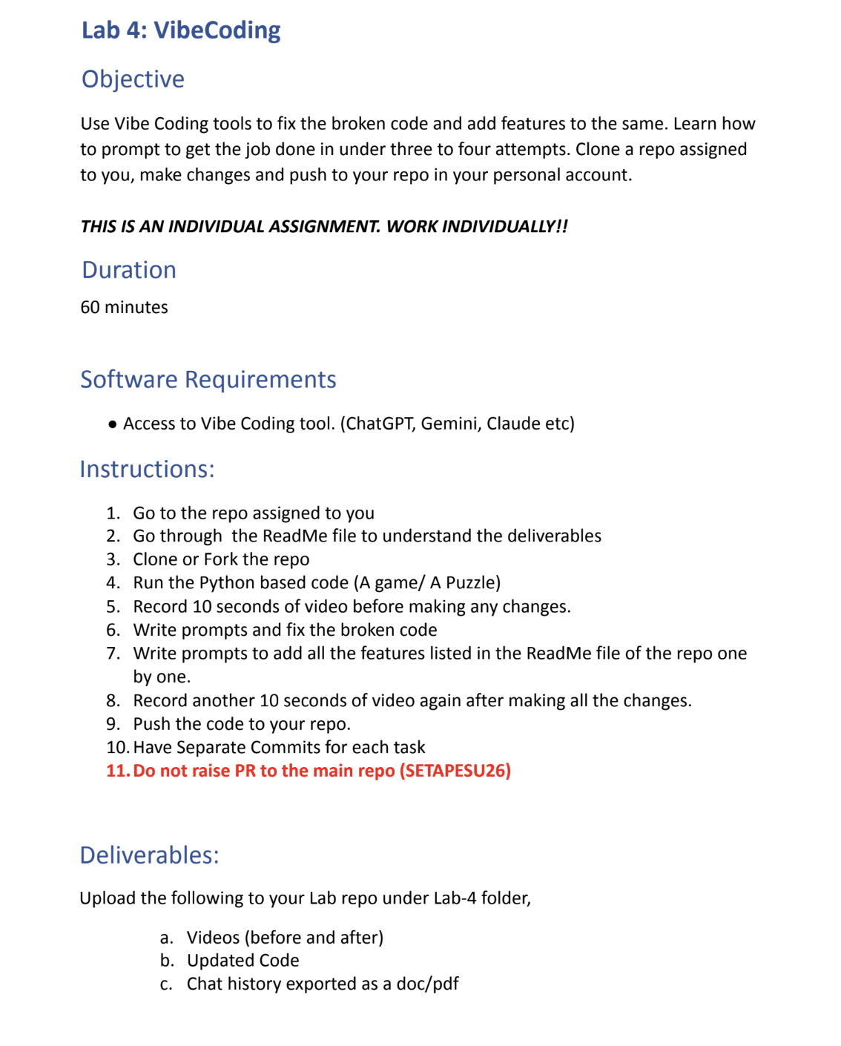

Attachment 2
Screenshot supplied by the user at 11:45:30 AM IST
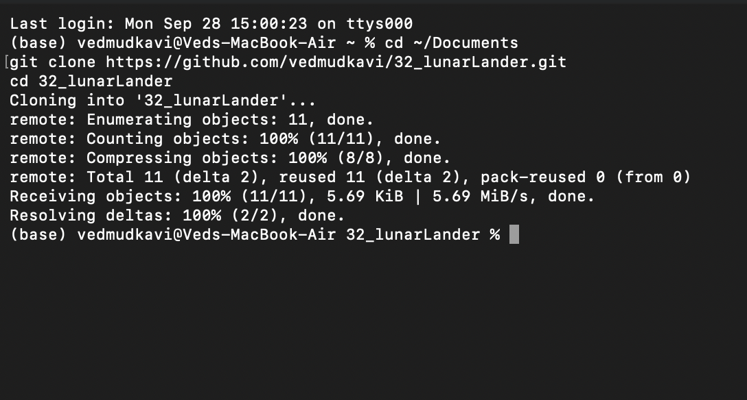

Attachment 3
Screenshot supplied by the user at 11:47:22 AM IST
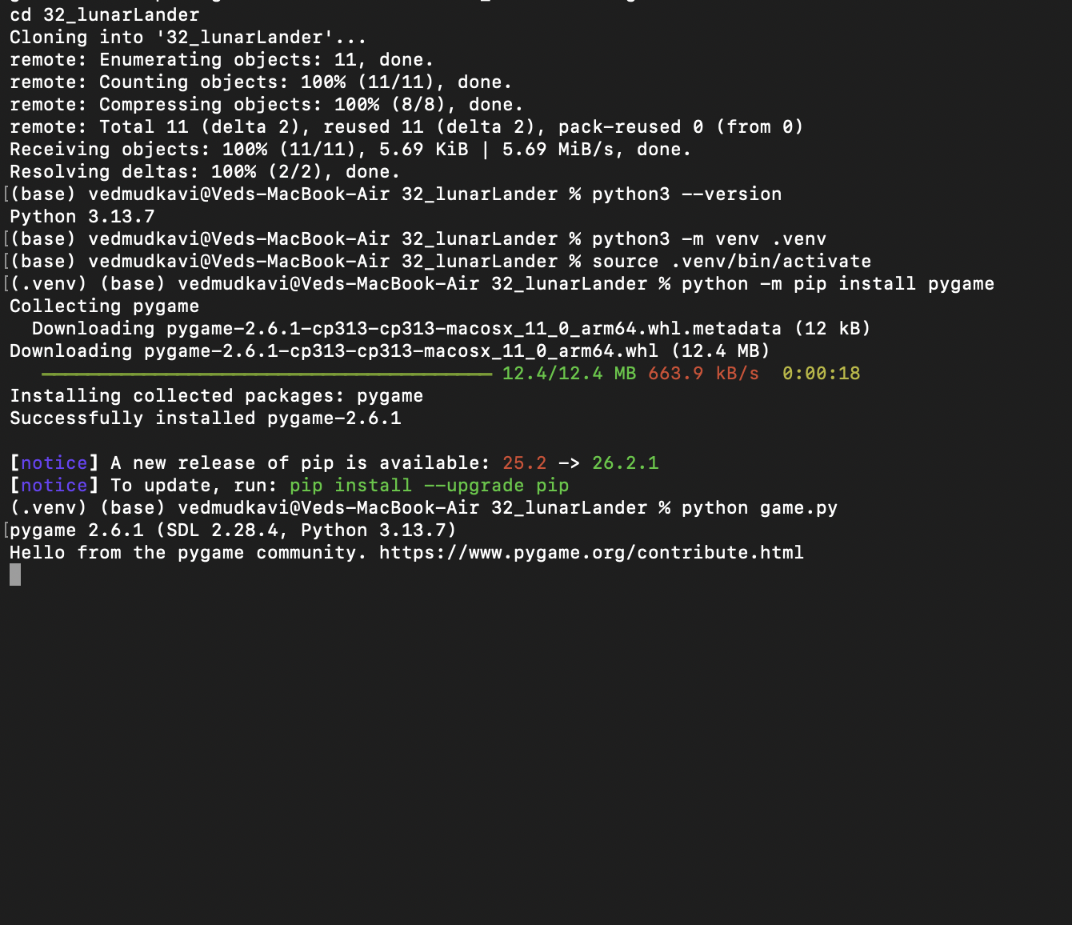

Attachment 4
Screenshot supplied by the user at 11:47:22 AM IST
