SOFTWARE ENGINEERING LAB 1
Requirements Engineering &
UML Use-Case Modelling
Problem Statement #32
Personal Subscription & Recurring Expense Auditor
Retail, E-Commerce & Finance

Student Name | Ved Mudkavi
SRN | PES1UG24CS522
Section | I
Submission | Lab 1 deliverables through public GitHub repository

1. Problem Context and Scope
A personal-finance micro-application that imports transaction records, identifies recurring charges, tracks renewal dates, calculates subscription burn rates, alerts users before renewals, and provides cancellation guidance. The system supports informed spending decisions without requiring storage of raw online-banking credentials.
Primary actors: Individual User and Finance Auditor
Scope boundary: Subscription discovery, review, reporting, renewal alerts, and cancellation guidance. The system does not execute bank transactions or cancel services automatically.

2. Complete Requirements Table
The matrix contains exactly five functional requirements (FR-001 to FR-005) and two non-functional requirements (NFR-001 to NFR-002).
ID | Type | Description | Priority | Acceptance Criteria | Rationale
FR-001 | Functional | The system shall import CSV or OFX transaction logs, validate their structure, identify recurring billing patterns, and record the service name, estimated amount, billing frequency, and next renewal date. | High | Given a supported file containing at least three repeated monthly charges, the import completes successfully, each recurring service is identified with its next renewal date, and an isolated one-time payment is not classified as a subscription. | Automated discovery reduces manual effort and establishes the data needed for every other feature.
FR-002 | Functional | The system shall allow an individual user to review detected subscriptions and add, edit, categorize, confirm, or dismiss subscription records. | High | A user can correct a service name or amount, assign a category, confirm a valid subscription, dismiss a false positive, and see the revised record persist after reopening the subscription list. | Detection can be imperfect; user review keeps the subscription inventory accurate and useful.
FR-003 | Functional | The system shall calculate and display the current monthly subscription burn rate, projected annual cost, and spending totals grouped by category. | High | For a controlled set of monthly, quarterly, and annual subscriptions, the displayed monthly equivalent and annual projection match independently calculated totals to two decimal places; category totals equal the sum of their subscriptions. | Normalized totals help users understand the true financial impact of recurring expenses.
FR-004 | Functional | The system shall let users choose an alert lead time and shall issue a renewal alert for each confirmed subscription before its estimated renewal date. | High | When the test clock enters a configured seven-day alert window, exactly one alert is generated with the service name, expected amount, and renewal date; no alert is generated for a dismissed subscription. | Advance notice gives users time to evaluate or cancel unwanted renewals.
FR-005 | Functional | The system shall provide a cancellation guide for a selected subscription, including provider-specific steps or a verified support link, while requiring the user to perform and confirm the cancellation. | Medium | Selecting “View cancellation guide” opens the correct provider guidance; marking the subscription cancelled requires confirmation and changes its status without initiating an external transaction. | Clear guidance lowers cancellation friction while avoiding unsafe claims of automatic cancellation.
NFR-001 | Security & Privacy | The system shall process imported financial records securely, use encrypted transport and storage for protected data, avoid storing raw banking credentials, and restrict each user to their own records. | High | Security testing confirms TLS-protected communication, encrypted stored records, no plaintext credentials in storage or logs, and denial of attempts to access another user’s subscription data. | Transaction histories contain sensitive personal information and require confidentiality and strict access control.
NFR-002 | Performance | The system shall provide responsive import and dashboard operations under the expected personal-use workload. | Medium | On the reference test device, a file of 10,000 transactions is validated and analyzed within 5 seconds, and the subscription dashboard loads within 2 seconds for at least 500 subscription records in 95% of test runs. | Predictable response time makes transaction review practical and keeps the application usable as data grows.

3. UML Use-Case Diagram
The diagram models both assigned actors and the primary system interactions. Required UML relationships are shown using dashed dependency arrows.
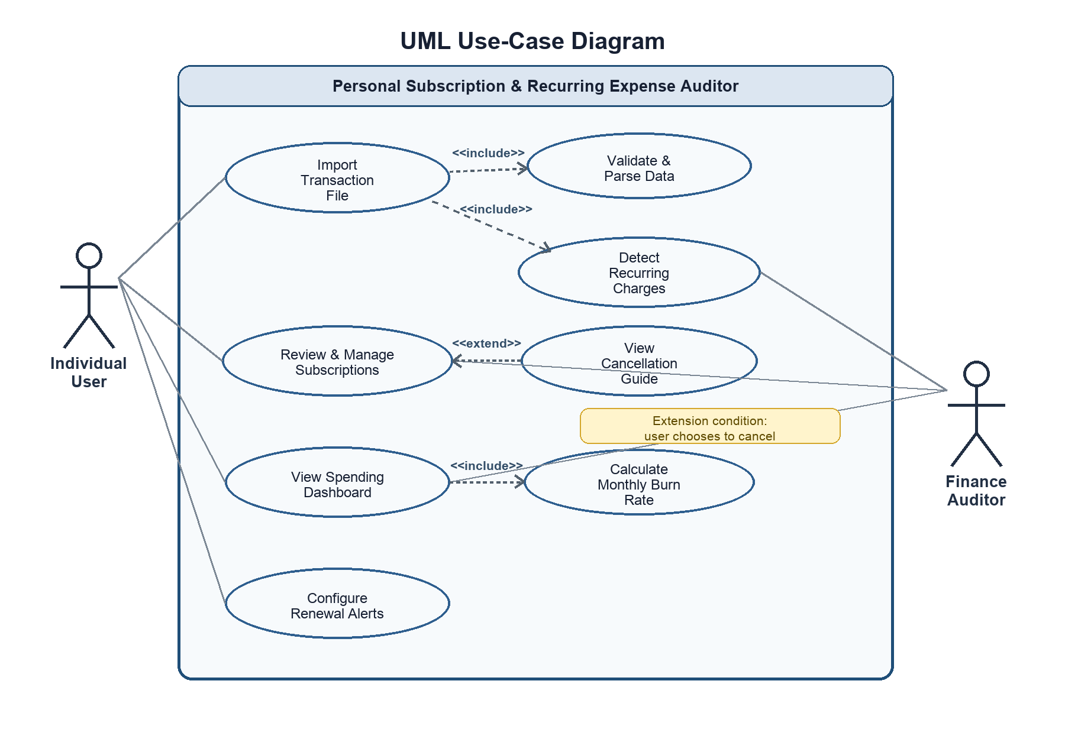
Figure 1. Use-case model for the Personal Subscription & Recurring Expense Auditor.
Relationship check: three <<include>> relationships and one <<extend>> relationship are explicitly represented.

4. Use-Case Flow Specification
UC-01: Import and Identify Recurring Charges
Primary actor | Individual User
Supporting actor | Finance Auditor (reviews flagged or uncertain classifications)
Trigger | The user chooses “Import transactions” and selects a supported CSV or OFX file.
Preconditions | The user is authenticated; the file is accessible and follows a supported format.
Postconditions | Valid transactions are stored securely; recurring charges and estimated renewal dates are recorded; the dashboard totals are recalculated; the import result is logged.

Main Success Scenario
- The user opens the import screen.
- The system displays supported formats and a file-selection control.
- The user selects a CSV or OFX transaction file and confirms the import.
- The system validates the file type, required fields, and record structure.
- The system parses valid transactions without requesting or storing online-banking credentials.
- The system groups similar merchant charges and evaluates amount and timing patterns.
- The system creates candidate subscription records with frequency, expected amount, confidence, and estimated renewal date.
- The system excludes isolated one-time payments and flags uncertain matches for review.
- The system recalculates monthly burn rate and projected annual cost.
- The system displays an import summary, and the user reviews and confirms the detected subscriptions.

Alternate Flow A1 - Invalid or Incomplete File
- At Step 4, validation detects an unsupported format or missing required fields.
- The system rejects the import without saving partial transaction data and identifies the specific validation errors.
- The user selects a corrected file and resumes at Step 3, or cancels the use case with no changes to existing records.

