**Football Club Project**

Vedad Kruho – 220302139

Mustafa Sinanović – 220302170



**DESCRIPTION**

This database is about football club management system. The system manages various aspects of football clubs, including: clubs, players, coaches, matches, training, club history, stadiums, sponsors, and injuries.

Each club is uniquely identified by a club_id and has attributes including name, foundation year, stadium name, city, and country. Each club can have many players, coaches, sponsors, can play a lot of matches, and can have club history records. Additionally, each club is associated with one stadium, which is uniquely identified by stadium_id and has attributes including name, capacity, city, country, and club_id.

Players are uniquely identified by player_id and have attributes including name, goals scored, games played, yellow cards, red cards, place of birth, telephone number, and club_id. Each player belongs to one club but can participate in multiple matches, attend multiple trainings, and have multiple injury records. Injuries are uniquely identified by injury_id and have attributes including description, date of injury, estimated recovery date, and player_id.

Coaches are uniquely identified by coach_id and have attributes including name, place of birth, experience years, salary, and club_id. Each coach belongs to one club and can manage multiple trainings. Trainings are uniquely identified by training_id and have attributes including date, location, duration in hours, coach_id, and players_present. Each training session is conducted by one coach and can have multiple players attending it.

Matches are uniquely identified by match_id and have attributes including date, opponent, venue, result, and club_id. Each match is associated with one club and can have multiple players participating in it. Club history records are uniquely identified by history_id and have attributes including club_id, year, league position, trophies won, and top scorer (player_id). Each club history record is associated with one club and one player as the top scorer for that year.

Sponsors are uniquely identified by sponsor_id and have attributes including name, industry, contract start date, contract end date, and club_id. Each sponsor can sponsor one club, but a club can have multiple sponsors.

The relationships between the entities are as follows:

Each club can have many players, coaches, matches, training sessions, club history records, and sponsors, but each of these entities belongs to one club.

Each stadium belongs to one club, and each club has one stadium.

Each player can participate in many matches and attend many training sessions, but each match and training session can have many players.

Each coach can manage many training sessions, but each training session is managed by one coach.

Each player can have multiple injuries, but each injury is associated with one player.

Each club history record is associated with one player, and each player can be the top scorer in multiple club history records.

This football club management system ensures comprehensive tracking and management of all aspects related to the football clubs, providing a detailed and organized approach to handling data.

**RELATIONAL SCHEMA**

**Player**

* **player_id** (Primary Key)
* name
* goals_scored
* games_played
* yellow_cards
* red_cards
* place_of_birth
* telephone_number
* **club_id** (Foreign Key referencing Club)

**Coach**

* **coach_id** (Primary Key)
* name
* place_of_birth
* experience_years
* salary
* **club_id** (Foreign Key referencing Club)

**Club**

* **club_id** (Primary Key)
* name
* foundation_year
* stadium_name
* city
* country

**Match**

* **match_id** (Primary Key)
* date
* opponent
* venue
* result
* **club_id** (Foreign Key referencing Club)

**Club_History**

* **history_id** (Primary Key)
* **club_id** (Foreign Key referencing Club)
* year
* league_position
* trophies_won
* **top_scorer** (Foreign Key referencing Player)

**Training**

* **training_id** (Primary Key)
* date
* location
* duration_hours
* **coach_id** (Foreign Key referencing Coach)
* players_present (Comma-separated list of player_ids referencing Player)

**Stadium**

* **stadium_id** (Primary Key)
* name
* capacity
* city
* country
* **club_id** (Foreign Key referencing Club)

**Sponsor**

* **sponsor_id** (Primary Key)
* name
* industry
* contract_start_date
* contract_end_date
* **club_id** (Foreign Key referencing Club)

**Injury**

* **injury_id** (Primary Key)
* description
* date_of_injury
* estimated_recovery_date
* **player_id** (Foreign Key referencing Player)

**Junction Tables**

**Player_Training**

* **player_id** (Foreign Key referencing Player)
* **training_id** (Foreign Key referencing Training)

**Player_Match**

* **player_id** (Foreign Key referencing Player)
* **match_id** (Foreign Key referencing Match)

**RELATIONSHIPS**

**Player <-> Club (Many-to-One)**

Each player belongs to one club. Add a foreign key **club_id** in the Player table referencing Club.

**Coach <-> Club (Many-to-One)**

Each coach belongs to one club. Add a foreign key **club_id** in the Coach table referencing Club.

**Match <-> Club (One-to-Many)**

Each match is associated with one club. Add a foreign key **club_id** in the Match table referencing Club.

**Player <-> Training (Many-to-Many)**

Each player can participate in many training sessions, and each training session can have many players. Create a junction table **Player_Training** with columns **player_id** (Foreign Key referencing Player) and **training_id** (Foreign Key referencing Training).

**Coach <-> Training (One-to-Many)**

Each training session is conducted by one coach, but a coach can conduct many training sessions. Add a foreign key **coach_id** in the Training table referencing Coach.

**Player <-> Match (Many-to-Many)**

Each player can participate in many matches, and each match can have many players. Create a junction table **Player_Match** with columns **player_id** (Foreign Key referencing Player) and **match_id** (Foreign Key referencing Match).

**Stadium <-> Club (One-to-One)**

Each club has one stadium. Add a foreign key **club_id** in the Stadium table referencing Club.

**Sponsor <-> Club (Many-to-One)**

Each sponsor can sponsor one club, but a club can have many sponsors. Add a foreign key **club_id** in the Sponsor table referencing Club.

**Injury <-> Player (Many-to-One)**

Each injury is associated with one player, but a player can have multiple injuries. Add a foreign key **player_id** in the Injury table referencing Player.

**Club_History <-> Club (Many-to-One)**

Each club history record is associated with one club. Add a foreign key **club_id** in the Club_History table referencing Club.

**Club_History <-> Player (Many-to-One)**

The top_scorer in each club history record is associated with one player. Add a foreign key **top_scorer** in the Club_History table referencing Player.

**ER Diagram**

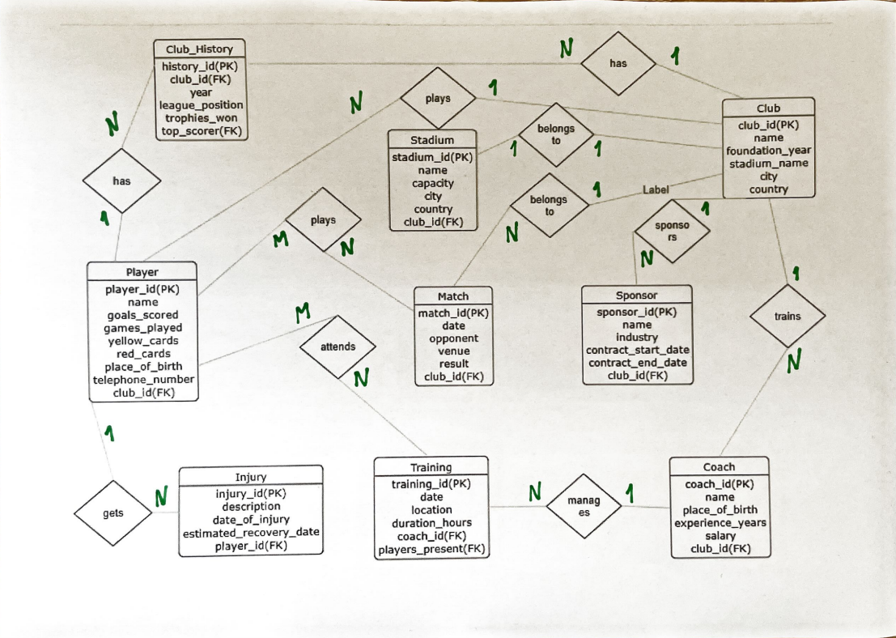

**20 questions and answers in SQL**

1. **How many players are there in the database?**

SELECT COUNT(*) AS number_of_players FROM Player;

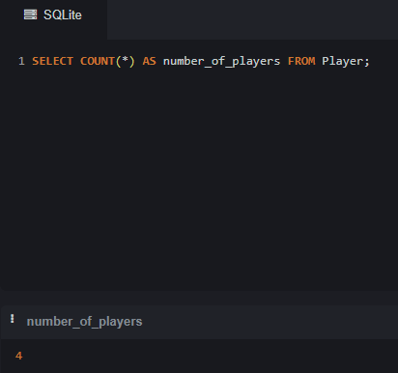

1. **What is the average salary of the coaches?**

SELECT AVG(salary) AS average_salary FROM Coach;

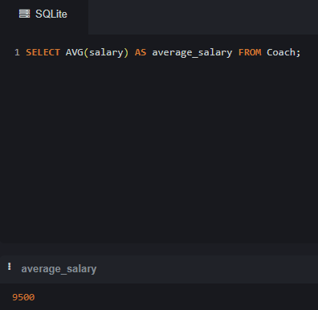

1. **List all clubs along with their foundation year.**

SELECT name, foundation_year FROM Club;

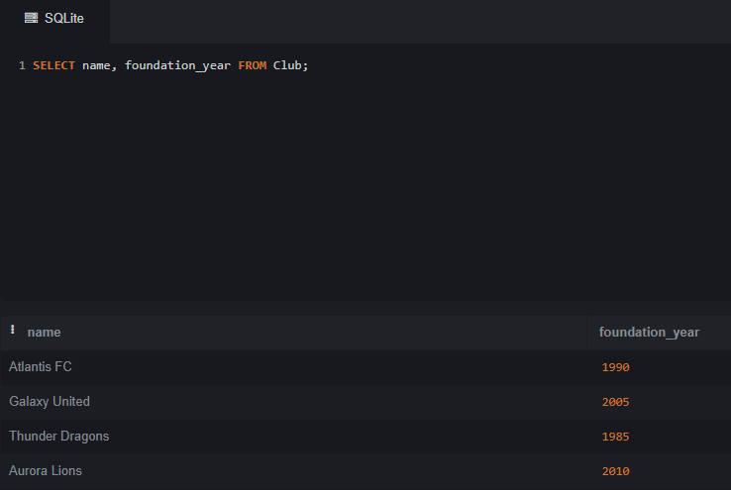

1. **Find the total number of goals scored by all players.**

SELECT SUM(goals_scored) AS total_goals FROM Player;

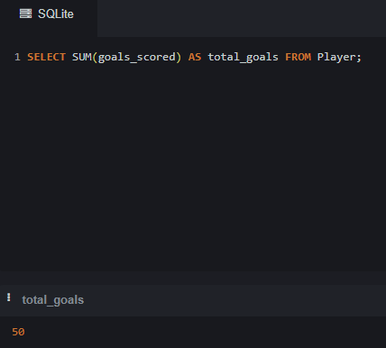

1. **List the names of players who have received more than 1 red cards.**

SELECT name FROM Player WHERE red_cards > 1;

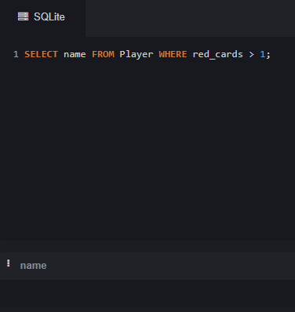

1. **Retrieve all matches played by a specific club (e.g., club_id = 1).**

SELECT * FROM Match_ WHERE club_id = 1;

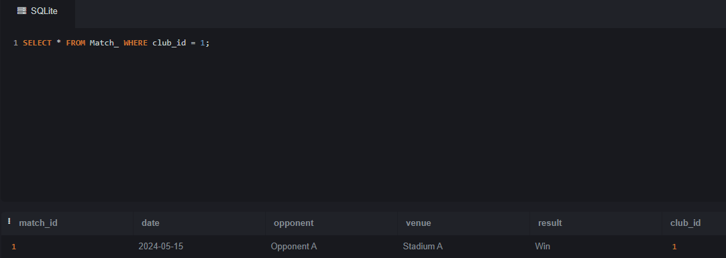

1. **Find the player with the most goals scored.**

SELECT name, goals_scored FROM Player ORDER BY goals_scored DESC LIMIT 1;

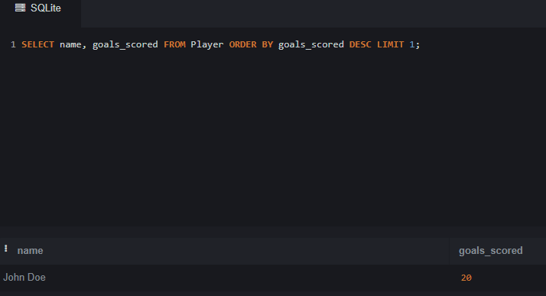

1. **List all coaches who have more than 10 years of experience.**

SELECT name FROM Coach WHERE experience_years > 10;

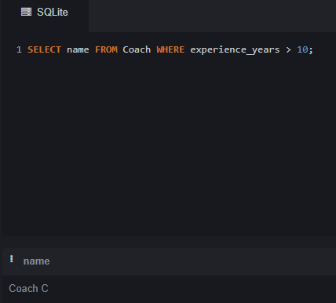

1. **Find the club that has the most players.**

SELECT club_id, COUNT(*) AS number_of_players FROM Player GROUP BY club_id ORDER BY number_of_players DESC LIMIT 1;

1. **List all injuries for a specific player (e.g., player_id = 3).**

SELECT * FROM Injury WHERE player_id = 3;

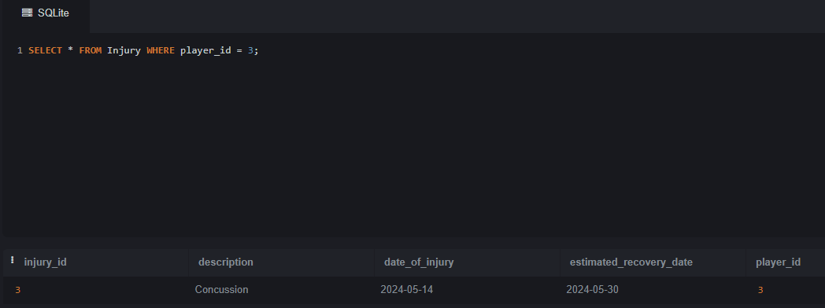

1. **Retrieve the details of the training sessions conducted by a specific coach (e.g., coach_id = 2).**

SELECT * FROM Training WHERE coach_id = 2;

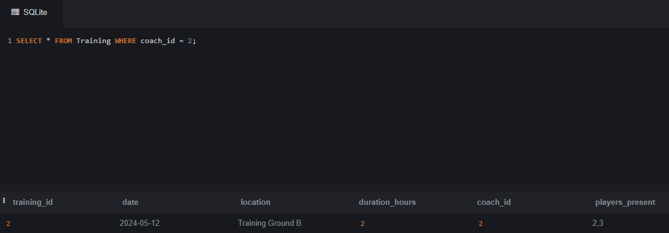

1. **Find the average number of goals scored per match.**

SELECT AVG(goals_scored) AS average_goals_per_match FROM ( SELECT SUM(goals_scored) AS goals_scored FROM Player_Match GROUP BY match_id ) AS match_goals;

1. **List all sponsors for a specific club (e.g., club_id = 3).**

SELECT name FROM Sponsor WHERE club_id = 3;

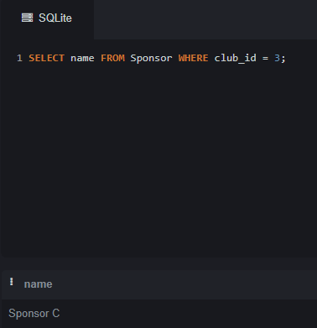

1. **Find the total number of matches played by a specific player (e.g., player_id = 2).**

SELECT COUNT(*) AS number_of_matches FROM Player_Match WHERE player_id = 2;

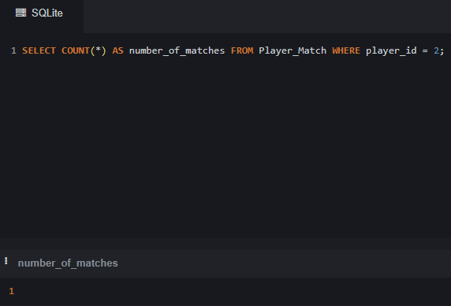

1. **Retrieve all club history records for a specific year (e.g., year = 2020).**

SELECT * FROM Club_History WHERE year = 2020;

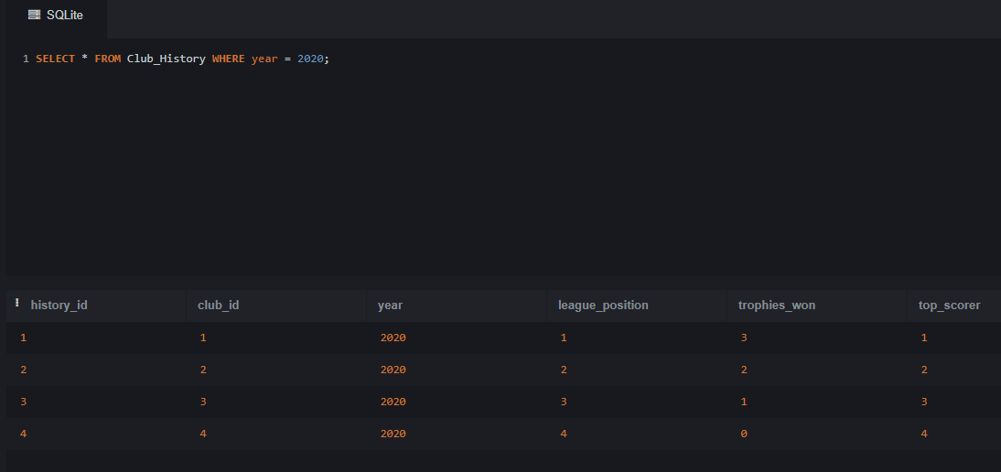

1. **List all players who belong to a specific club (e.g., club_id = 4).**

SELECT name FROM Player WHERE club_id = 4;

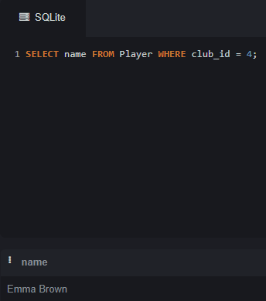

1. **Find the club with the highest league position in a specific year (e.g., year = 2020).**

SELECT club_id, league_position FROM Club_History WHERE year = 2020 ORDER BY league_position ASC LIMIT 1;

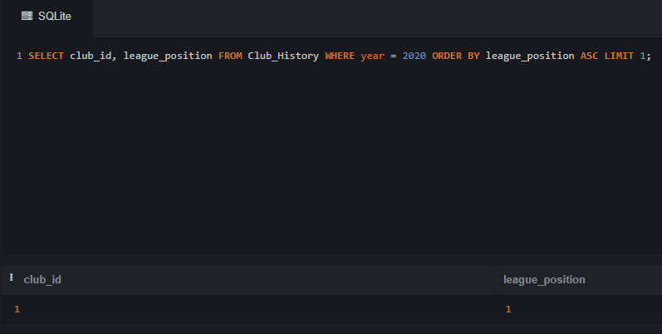

1. **Retrieve the name and capacity of the stadium of a specific club (e.g., club_id = 2).**

SELECT name, capacity FROM Stadium WHERE club_id = 2;

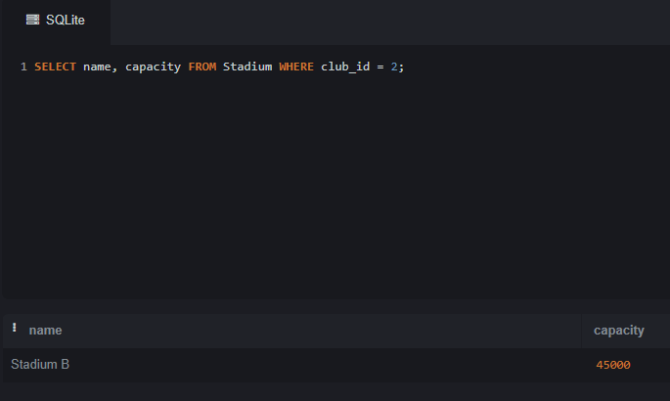

1. **List all training sessions that took place on a specific date (e.g., '2024-05-12').**

SELECT * FROM Training WHERE date = '2024-05-12';

1. **Find the players with the most yellow cards.**

SELECT name, yellow_cards FROM Player ORDER BY yellow_cards DESC;

