Drones in Agriculture: Bibliometric State of the Art and Growth Forecasts to 2035

Marko Jelić*, Vedran Uroš†, Sandra Mandinić‡
* University of Applied Sciences "Marko Marulić" in Knin, Knin, Croatia
† Faculty of Organization and Informatics, University of Zagreb, Varaždin, Croatia
‡ University of Zagreb, Faculty of Agriculture, Zagreb, Croatia
* mjelic99@gmail.com

Abstract—Unmanned aerial vehicles (UAVs) are promoted as a cornerstone of precision agriculture, both as sensing platforms and, increasingly, as actuators for spraying, yet the pace and the likely saturation of this adoption have not been quantified. We compiled annual counts of peer-reviewed articles combining UAV terms with agricultural terms from the open bibliographic index OpenAlex for 2005 to 2025 (18,506 articles after noise filtering), together with four normalising denominators and seven application sub-domains, and fitted four growth models (exponential, logistic, Gompertz and Bass diffusion) by Poisson deviance in a toolbox-free MATLAB pipeline. Models were compared with a quasi-likelihood information criterion, validated by rolling-origin backtesting and bootstrapped for forecast intervals. Output grew at 28.5 percent per year (29 articles in 2005, 4,381 in 2025), with a structural break in 2009. No model dominates for absolute output: the model average predicts 8,237 articles in 2028 [90 percent interval 6,422–9,457]; over ten years the models diverge, and the long-horizon forecast consistent with the share analysis is the average of the three saturating models, 24,023 articles in 2035 [6,570–52,895]. The share of the agricultural literature that uses UAVs is saturating later than in neighbouring fields: a logistic model with weight 0.91 gives a plateau of 13.8 articles per 1,000 (11.6 without the partly artefactual 2025 observation), of which about three fifths has been reached. A like-for-like comparison with our companion study of UAVs in environmental monitoring, produced with the identical pipeline, places agriculture about four years earlier on the same adoption curve. Growth is fastest in yield prediction, irrigation and disease detection, while spraying makes the UAV an actuator with distinct regulatory constraints. Implications for UAV design and autonomy are discussed.
Keywords—unmanned aerial vehicles, precision agriculture, agricultural drones, bibliometrics, technology forecasting, growth models

Introduction
A decade after the first reviews announced small unmanned aerial vehicles (UAVs, also UAS or RPAS) as the missing high-resolution, on-demand platform of precision agriculture [1], agricultural drones monitor crops, estimate yields, detect weeds and diseases, manage irrigation and, at scale in East Asia, spray pesticides and fertilisers [2], [3]. For the robotics community two questions remain open. First, how fast is the adoption of UAVs in agriculture actually growing once the growth of the whole agricultural literature is taken into account? Second, is that growth still exponential or approaching saturation, and what does the answer imply for where sensing, actuation, autonomy and regulatory effort should be directed over the next decade?
This paper answers both questions with a reproducible bibliometric time series and a transparent forecasting pipeline, applying the methodology we developed for UAVs in ecology and environmental monitoring [20] to the agricultural domain. Our contributions are: (i) an openly queryable annual data set (2005–2025) of UAV research in agriculture, with a documented noise filter, four denominators and seven application sub-domains, built from the OpenAlex index [4]; (ii) a description of the current state of the field, including trend tests, a structural break and the distribution of output over sub-domains, countries and venues; (iii) a MATLAB algorithm, free of toolbox dependencies, that fits and compares four classical growth models, validates them out of sample and produces bootstrapped forecasts for 3, 5, 7 and 10-year horizons, openly archived together with the data set [21]; (iv) the first like-for-like comparison of two application domains — agriculture and environmental monitoring — measured with the identical query protocol, index and pipeline on the same day; and (v) a discussion of what the forecasts mean for UAV engineers, including the actuation role that distinguishes agriculture from purely observational domains.
The paper is organised as follows. Section II reviews the evidence on UAV performance in agricultural applications and the growth-curve tradition in technology forecasting. Section III describes the data and the algorithm. Section IV reports the results and Section V discusses them. Section VI concludes.

Related Work
Reviews of UAVs in precision agriculture converge on a common inventory of applications: crop growth and health monitoring with visible, multispectral, hyperspectral and thermal sensors; high-throughput field phenotyping; weed mapping for site-specific management; irrigation scheduling from canopy temperature and vegetation indices; disease and pest detection; yield estimation; and spraying [1], [2], [3], [6]. Early work already demonstrated the key building blocks: a UAV configured for early site-specific weed management [5], and multi-sensor data fusion that predicts soybean yield within a field from UAV imagery using deep learning [7]. Field-based phenotyping has become a discipline of its own, with UAVs replacing ground vehicles as the primary carrier [8]. Two recurring engineering caveats temper the enthusiasm: radiometric calibration and the gap between vegetation indices and agronomic variables limit transferability across fields and seasons [2], [9], and the economics of UAV operations only close at sufficient field sizes or service-provider models [9]. Spraying is the application in which the UAV stops being a sensor and becomes an actuator: adoption is led by East Asia, with more than 120,000 plant-protection drones operating in China and roughly 62 million hectares treated in 2021, and about a third of Japanese rice fields sprayed from unmanned helicopters as early as 2016 [17]; reviews document rapid progress but also open problems in droplet drift, deposition uniformity and dose control [6]. The closest antecedent is the bibliometric review by Rejeb et al. [22]: from 4,700 Scopus documents to September 2021 they date the exponential surge after 2010, with a peak of 1,275 publications in 2020, and identify remote sensing, precision agriculture, deep and machine learning and the Internet of Things as its keyword hotspots in six co-citation clusters. That study maps the intellectual structure of the field but leaves its dynamics unmodelled — the gap this paper fills with growth curves on a normalised series and forecasts to 2035.
Growth-curve forecasting of technology adoption has a long tradition. The Bass diffusion model [10] describes adoption per period as the sum of innovation and imitation effects; logistic and Gompertz curves describe levels approaching a ceiling; a 25-year review concluded that no single curve dominates and recommended combining models and reporting model uncertainty [11]. Publication counts are widely used as an adoption proxy, with the caveat that the scientific literature itself grows by several percent per year [12], so unnormalised counts overstate the growth of any topic. Multimodel inference with Akaike weights [13] provides a principled way to combine competing curves. We follow these recommendations: we fit four models, normalise by the growth of the field, weight the models by a quasi-likelihood information criterion, and report intervals that include model uncertainty.

Data and Methods

Bibliometric Corpus
Data were retrieved on 28 August 2026 from the OpenAlex REST API [4], aggregated by publication year (endpoint /works, group_by=publication_year) with document type restricted to articles and reviews. The core query D AND A NOT N searched titles and abstracts, where D = (drone OR drones OR UAV OR UAVs OR UAS OR "unmanned aerial" OR "unmanned aircraft" OR RPAS OR "remotely piloted aircraft"), A is a disjunction of 38 agricultural terms (agriculture, farm, crop, yield, irrigation, fertilizer, pesticide, spraying, weed, phenotyping, livestock, orchard, vineyard, "plant disease", "soil moisture" and their variants), and N is a noise filter added after a manual precision check: it removes the Drosophila GAL4/UAS genetics literature, apian "drones", and medical and institutional homonyms of the UAV acronyms. Four denominators were retrieved with identical filters: A alone (the agricultural literature searched in the same way, used as the primary denominator), the OpenAlex subfield Agronomy and Crop Science, the field Agricultural and Biological Sciences, and all indexed works; all four are used in the share analysis (Section IV.C). Seven overlapping sub-domain queries combined D with terms for crop monitoring and phenotyping, spraying, weed detection, irrigation and water stress, disease and pest detection, yield prediction, and livestock. Because OpenAlex is updated retroactively, the retrieval date is part of the data definition; the exact Boolean strings and a codebook accompany the MATLAB code.
The fitting window is 2005–2025 (n = 21 complete years); 2026 is incomplete and is excluded. The query is not perfectly precise. In a manual check of a random sample of 100 records of the unfiltered query (seed 20260828), coded with AI assistance and reviewed by the authors, 61 percent of the records surviving the noise filter [Wilson 95 percent CI 51, 70] were UAV studies with an agricultural application, a further 31 percent contained a UAV in a non-agricultural role, and 8 percent were residual noise. In an early-period sample (2005–2015, n = 35 after filtering) the relevant share was 37 percent [23, 54]; the difference is significant (two-proportion z = 2.38, p = 0.017), because the early literature is dominated by generic UAV engineering papers that mention agriculture only as a prospective application. Absolute counts should therefore be read as query-matched OpenAlex records rather than exact counts of agricultural UAV studies; any precision-adjusted value (about 0.6 times the raw counts) is an estimate, not a corrected count, and the growth of the strictly agricultural output is, if anything, faster than the growth of the query series. A stricter query that also excludes ecological and forestry terms grows at 28.5 percent per year as well, so the trend conclusions are robust. Finally, all series jump in 2025 (the agricultural denominator by 26 percent), which is partly an indexing artefact; normalisation attenuates it and a sensitivity analysis without 2025 is reported.

Descriptive Analysis
For the counts y_{t} and the share s_{t} = 1000 y_{t}/N_{t} (articles per 1,000 agricultural articles) we report the compound annual growth rate, the Mann–Kendall trend test with tie correction and Sen's slope with its 90 percent confidence interval [14], [15], and a one-breakpoint segmented log-linear regression found by grid search and tested against a single slope with a Chow-type F test (approximate, because the break is estimated).

Growth Models
Four models of the expected annual output μ(t) were fitted, with τ = t − 2005:
μ(t) = a exp(b τ) (1)
μ(t) = K / [1 + exp(−r(τ − t_{m}))] (2)
μ(t) = K exp[−exp(−r(τ − t_{m}))] (3)
μ(t) = m [F(τ+1) − F(τ)] (4)
where (1) is exponential growth without saturation, (2) the logistic and (3) the Gompertz curve with capacity K, rate r and inflection year t_{m}, and (4) the Bass diffusion model [10] with market potential m, coefficient of innovation p and coefficient of imitation q, where F(x) = [1 − e^{−(p+q)x}] / [1 + (q/p) e^{−(p+q)x}] is the cumulative adoption fraction. For the share, the same curves describe the rate g(t) with the denominator as an offset, μ_{t} = N_{t} g(t), so that share forecasts do not require a forecast of the denominator; the Bass model is omitted for the share because it describes adoptions per period, not a level.

Estimation, Model Selection and Uncertainty
Parameters were estimated by minimising the Poisson deviance
D = 2 Σ_{t} [y_{t} ln(y_{t}/μ_{t}) − (y_{t} − μ_{t})] (5)
with the Nelder–Mead simplex (MATLAB fminsearch) from multiple starting points and with positive parameters log-transformed. The deviance gives comparable weight to the small early and the large late years and yields a proper log-likelihood for information criteria. The counts are strongly overdispersed (Pearson dispersion ĉ = 14.1 for the counts, 8.6 for the share), so models were compared with the small-sample quasi-likelihood criterion
QAIC_{c} = −2 ln L / ĉ + 2k + 2k(k+1)/(n−k−1) (6)
and combined with Akaike weights [13]. Out-of-sample accuracy was assessed by rolling-origin backtesting: each model was refitted on data up to 2018, 2020 and 2022 and evaluated on the remaining years by the mean absolute percentage error (MAPE) [16]. Forecast uncertainty was obtained by a parametric negative-binomial bootstrap: 1,000 replicate series per model, every model refitted on every replicate, QAIC_{c} weights recomputed and the weighted forecast recorded, giving 90 percent intervals that include both parameter and model uncertainty. The reported model average is the median of this bootstrap distribution of weighted forecasts; because the weights are recomputed on every replicate, it is not identical to the QAIC_{c}-weighted combination of the point forecasts in Tables I and II, and the difference grows with the horizon. Backtest errors are reported per origin as well as averaged, the origins corresponding to seven-, five- and three-year evaluation horizons. Forecasts are reported for 2028, 2030, 2032 and 2035. The pipeline (ten MATLAB functions, no toolbox required, also executable in GNU Octave) was independently replicated in Python; parameter estimates and deviances agree to all reported digits.

Results

Current State
Annual output rose from 29 articles in 2005 to 4,381 in 2025, a compound annual growth rate of 28.5 percent over the whole period and 30.4 percent over the last ten years; 18,506 articles were published in 2005–2025. The Mann–Kendall test is unambiguous (S = 208, Z = 6.25, p = 4 × 10⁻¹⁰), with a Sen slope of 125 articles per year [90 percent CI 86, 171]. The segmented regression locates a break in 2009: growth accelerated from 16 percent to 32 percent per year (F = 5.2, p ≈ 0.018, approximate), coinciding with the arrival of low-cost multirotor platforms and consumer-grade multispectral cameras, consistent with the post-2010 surge dated in [22]. Normalised by the agricultural literature, the share rose from 0.21 to 8.53 articles per 1,000 (Sen slope 0.38 per 1,000 per year [0.28, 0.47]); within the UAV literature as a whole, the agricultural fraction rose from 3.0 to 17.1 percent.
Output is concentrated: China (4,421 articles with at least one Chinese author in the unfiltered query), the United States (3,239), India (1,857), Germany (737) and the United Kingdom (690) lead 164 contributing countries; Croatia contributed 34 articles, all since 2013. The leading venues are Remote Sensing (1,026), Computers and Electronics in Agriculture (582), Drones (368), Agronomy (364) and Sensors (329); 72 percent of the corpus is open access and 942 articles have more than 99 citations. Fig. 1 shows the sub-domains. Over 2015–2025 yield prediction grew fastest (6 to 372 articles, 51 percent per year), followed by irrigation and water stress (42 percent), disease and pest detection (40 percent), crop monitoring and phenotyping (38 percent) and spraying (36 percent); the smallest and slowest sub-domains are weed detection (29 percent) and livestock (25 percent).
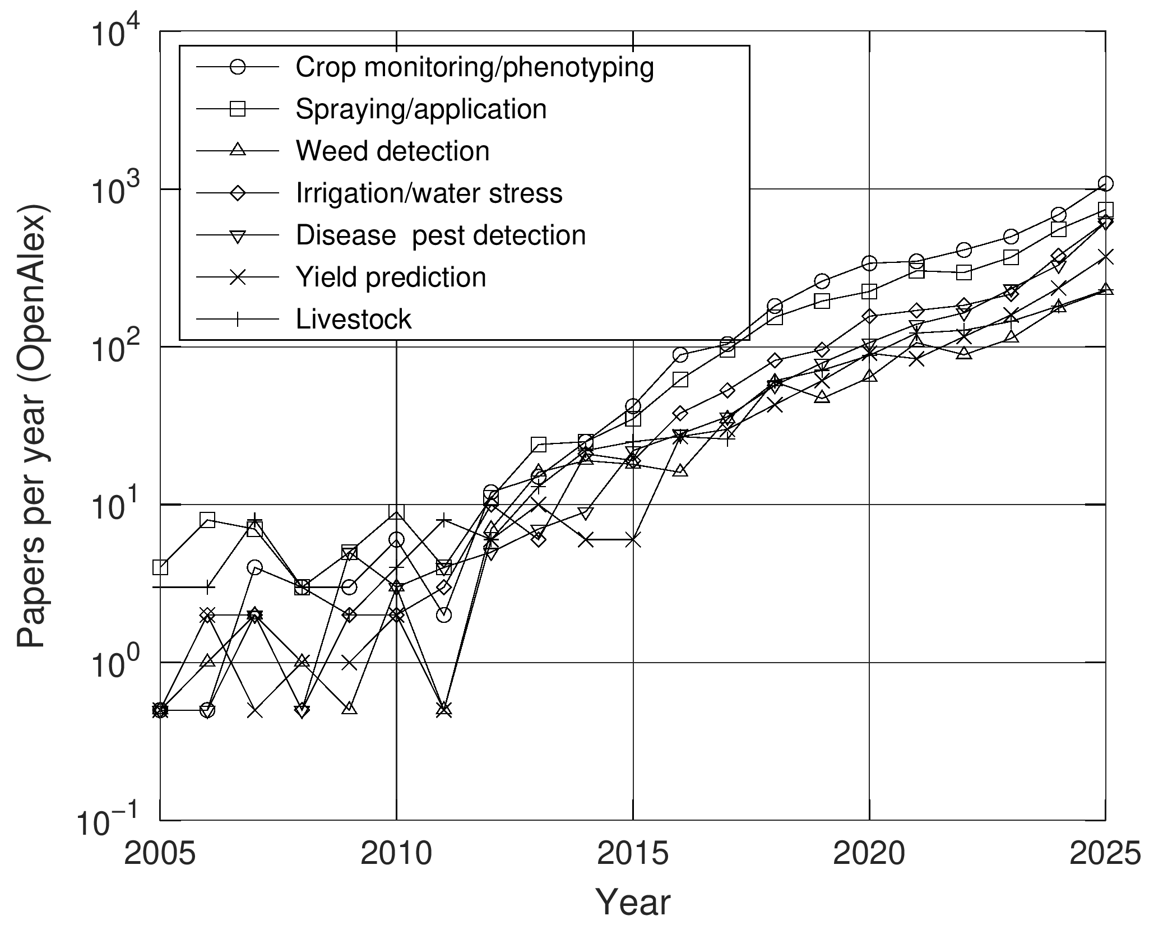
- Annual number of OpenAlex articles combining UAV terms with seven agricultural sub-domains, 2005–2025 (logarithmic scale; the sub-domain queries overlap).

Growth Models for Annual Output
Table I compares the four models fitted to the annual counts. No model dominates: the QAIC_{c} weights range from 0.15 (Bass) to 0.39 (exponential), and, unlike in neighbouring observational domains, the exponential model receives the largest weight. The logistic model places the inflection point around 2030 with a capacity of about 21,000 articles per year — far above the current level — the Bass model peaks only in 2033, and the Gompertz fit degenerates towards an exponential shape. By origin, backtest MAPE is 32–33 percent from 2018 (seven remaining years), 43–44 percent from 2020 and 11–26 percent from 2022 (three remaining years), every window containing the partly artefactual 2025 value; the Gompertz model is best from the most recent origin (11 percent) and the averages over origins are 28–34 percent.
- Growth Models Fitted to Annual Article Counts, 2005–2025
Model | k | Deviance | QAIC_{c} | Weight | Parameters
Exponential | 2 | 283.4 | 36.1 | 0.391 | a = 26.6, b = 0.253 (28.7 %/yr)
Logistic | 3 | 269.4 | 37.9 | 0.163 | K = 21,030, r = 0.269, t_{m} = 2030.4
Gompertz | 3 | 253.0 | 36.7 | 0.292 | K = 3.2 × 10⁹, r = 0.017, t_{m} = 2181
Bass | 3 | 271.0 | 38.0 | 0.154 | m = 1.9 × 10⁵, p = 1.1 × 10⁻⁴, q = 0.267

Fig. 2 shows the fits and the forecasts and Table II lists them. The models agree for the three-year horizon (7,260 to 8,850 articles in 2028; model average 8,237 [90 percent interval 6,422, 9,457]) and diverge afterwards: in 2035 the point forecasts range from 12,380 (Bass) to 51,810 (exponential). The full model average reaches 40,261 [14,213–55,954], but at this horizon it leans on the exponential model, which the share analysis contradicts; Table II therefore also lists the average of the three saturating models (renormalised weights 0.27, 0.48 and 0.25), which reaches 24,023 articles in 2035 [6,570–52,895] and is the long-horizon count forecast used in the rest of the paper. The sensitivity analysis shows the familiar dependence on the last observation: without 2025 the logistic capacity falls to about 5,400 and the Bass model places its peak already in 2027, so a single year, partly an indexing artefact, again determines the estimated ceiling.
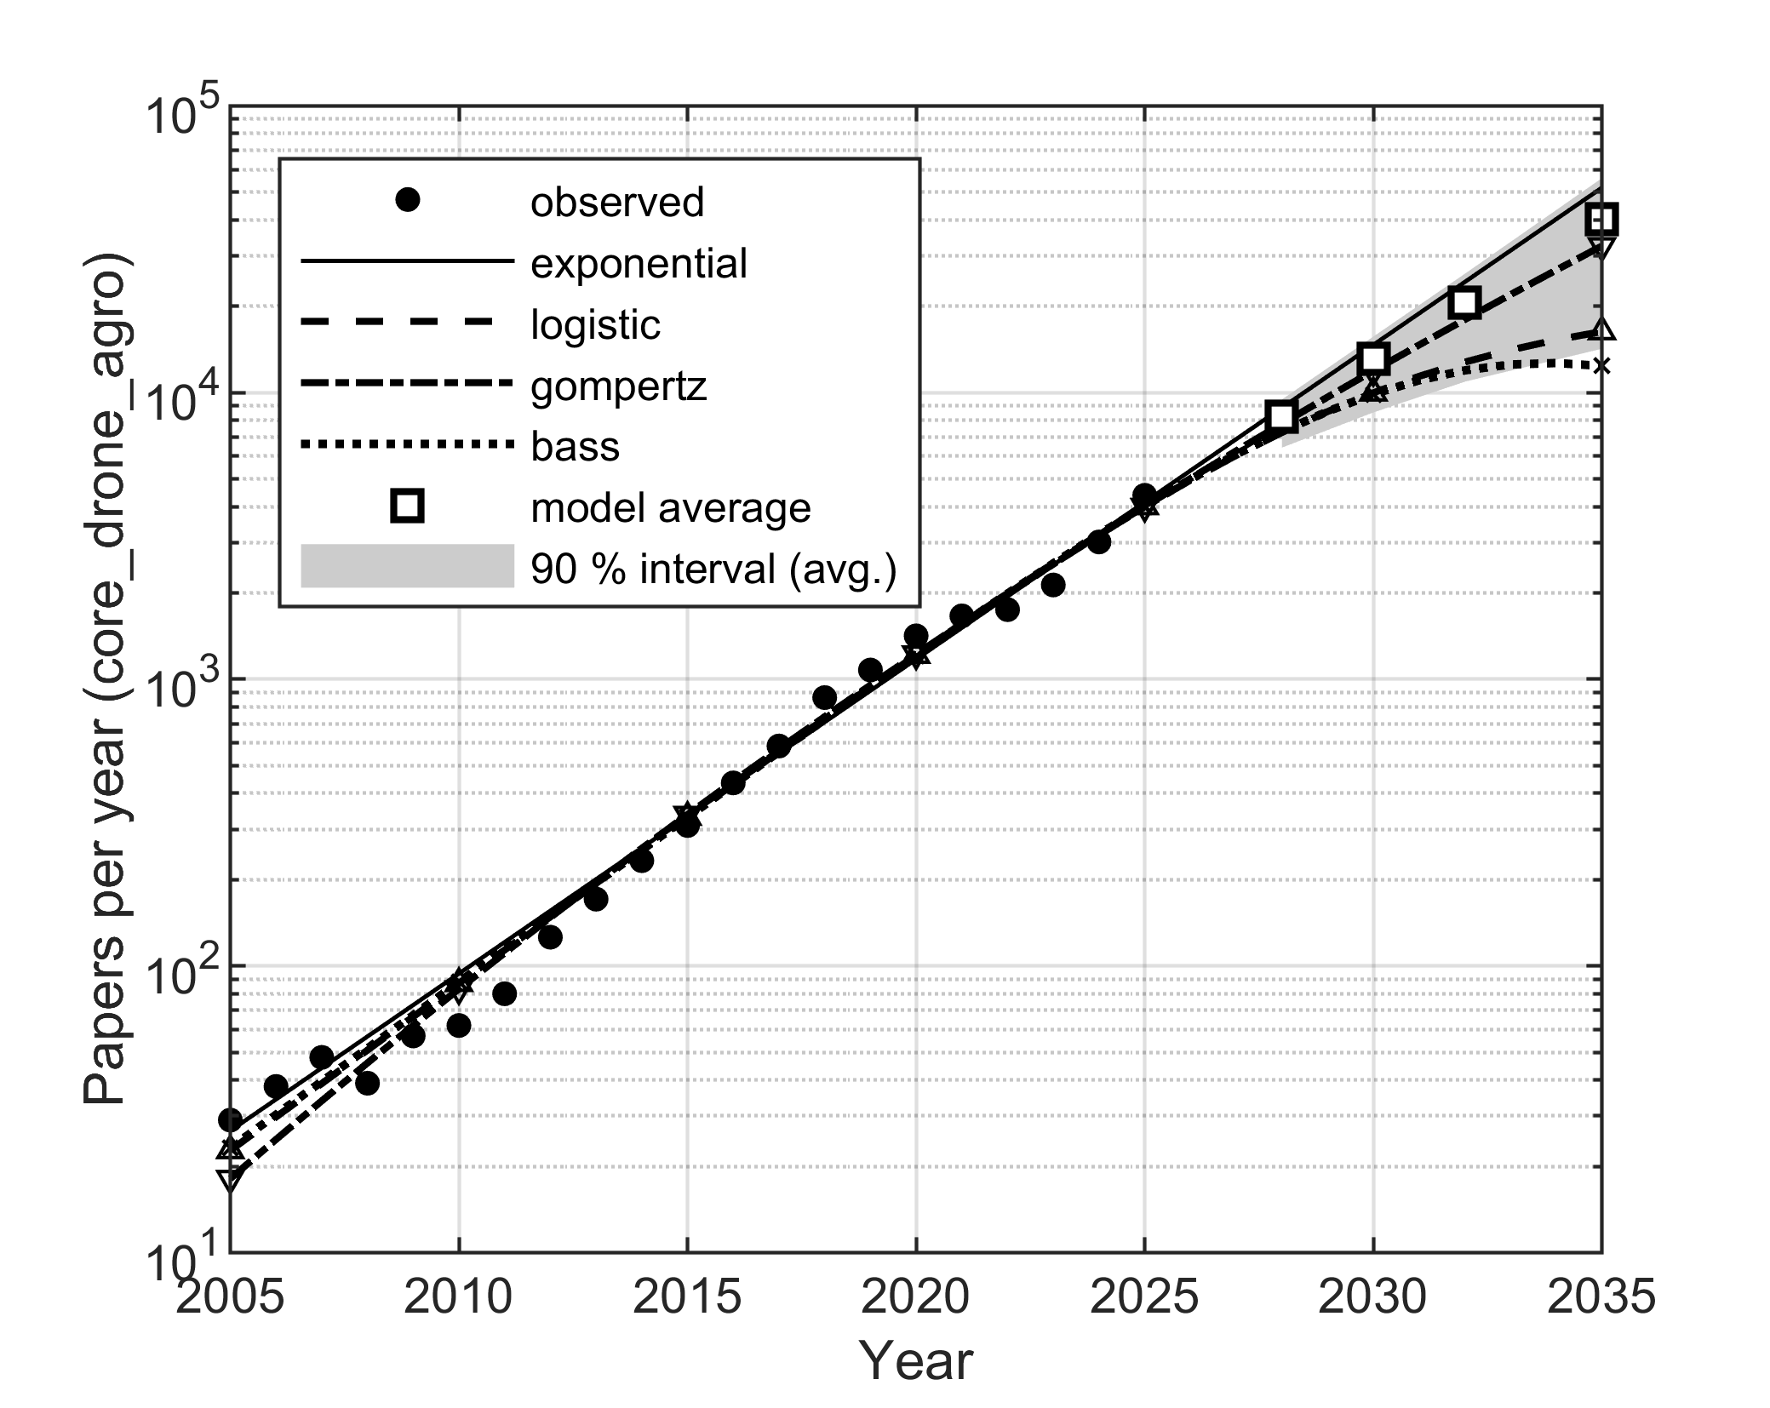
- Annual OpenAlex articles combining UAV and agricultural terms (dots), four growth models fitted by Poisson deviance (lines) and the QAIC_{c}-weighted model average with its 90 percent negative-binomial bootstrap interval (squares, shaded) for 2028–2035.
- Forecast Annual Output: Point Estimates and 90 Percent Bootstrap Intervals of the Model Average
Model | 2028 | 2030 | 2032 | 2035
Exponential | 8,850 | 14,660 | 24,290 | 51,810
Logistic | 7,258 | 9,977 | 12,770 | 16,320
Gompertz | 7,783 | 11,910 | 17,960 | 32,460
Bass | 7,304 | 9,871 | 11,950 | 12,380
Model average | 8,237 | 13,069 | 20,534 | 40,261
90 % interval | 6,422–9,457 | 8,523–15,673 | 10,910–25,949 | 14,213–55,954
Saturating average | 7,505 | 10,874 | 15,250 | 24,023
90 % interval | 5,660–9,183 | 6,775–15,191 | 7,159–25,087 | 6,570–52,895

Share of the Agricultural Literature
The share (Fig. 3) again behaves more regularly than the counts. The logistic rate model receives most of the weight (0.91; the exponential model is rejected with a QAIC_{c} difference of 18) and estimates a plateau of K = 13.8 articles per 1,000 agricultural articles with the inflection in 2023–2024. The share observed in 2025, 8.5 per 1,000, is 62 percent of that plateau — agriculture is thus visibly earlier on the adoption curve than ecology and environmental monitoring, where the same methodology finds 85 percent of the plateau already reached. The model-averaged forecast is 12.5 per 1,000 in 2028 [10.9, 14.8], 15.7 in 2030 [12.5, 20.5] and 26.0 in 2035 [16.0, 47.8], where the wide upper tail comes from the residual weight of the Gompertz curve. Backtesting from the 2022 origin gives a MAPE of 7.6 percent for the logistic model against 28.5 percent for the exponential one. The saturating shape is robust, its level less so. Refitted on 2005–2024, the logistic model still dominates (weight 0.95) with the inflection unchanged, but the plateau falls from 13.8 to 11.6 per 1,000, of which 64 percent had been reached by 2024: the position near three fifths of the curve is stable, the ceiling itself is provisional. Under the broader denominators the logistic model also dominates — field Agricultural and Biological Sciences: weight 0.87, plateau 28.9 per 1,000, inflection 2026, 42 percent reached; all indexed works: weight 0.80, plateau 1.59 per 1,000, inflection 2027, 38 percent reached — which confirms that agriculture is still on the steep part of the curve. Only under the narrow Agronomy and Crop Science subfield, where UAV articles already make up 222 per 1,000 and drive the denominator itself, can the data not yet separate the three shapes (weights 0.27–0.43).
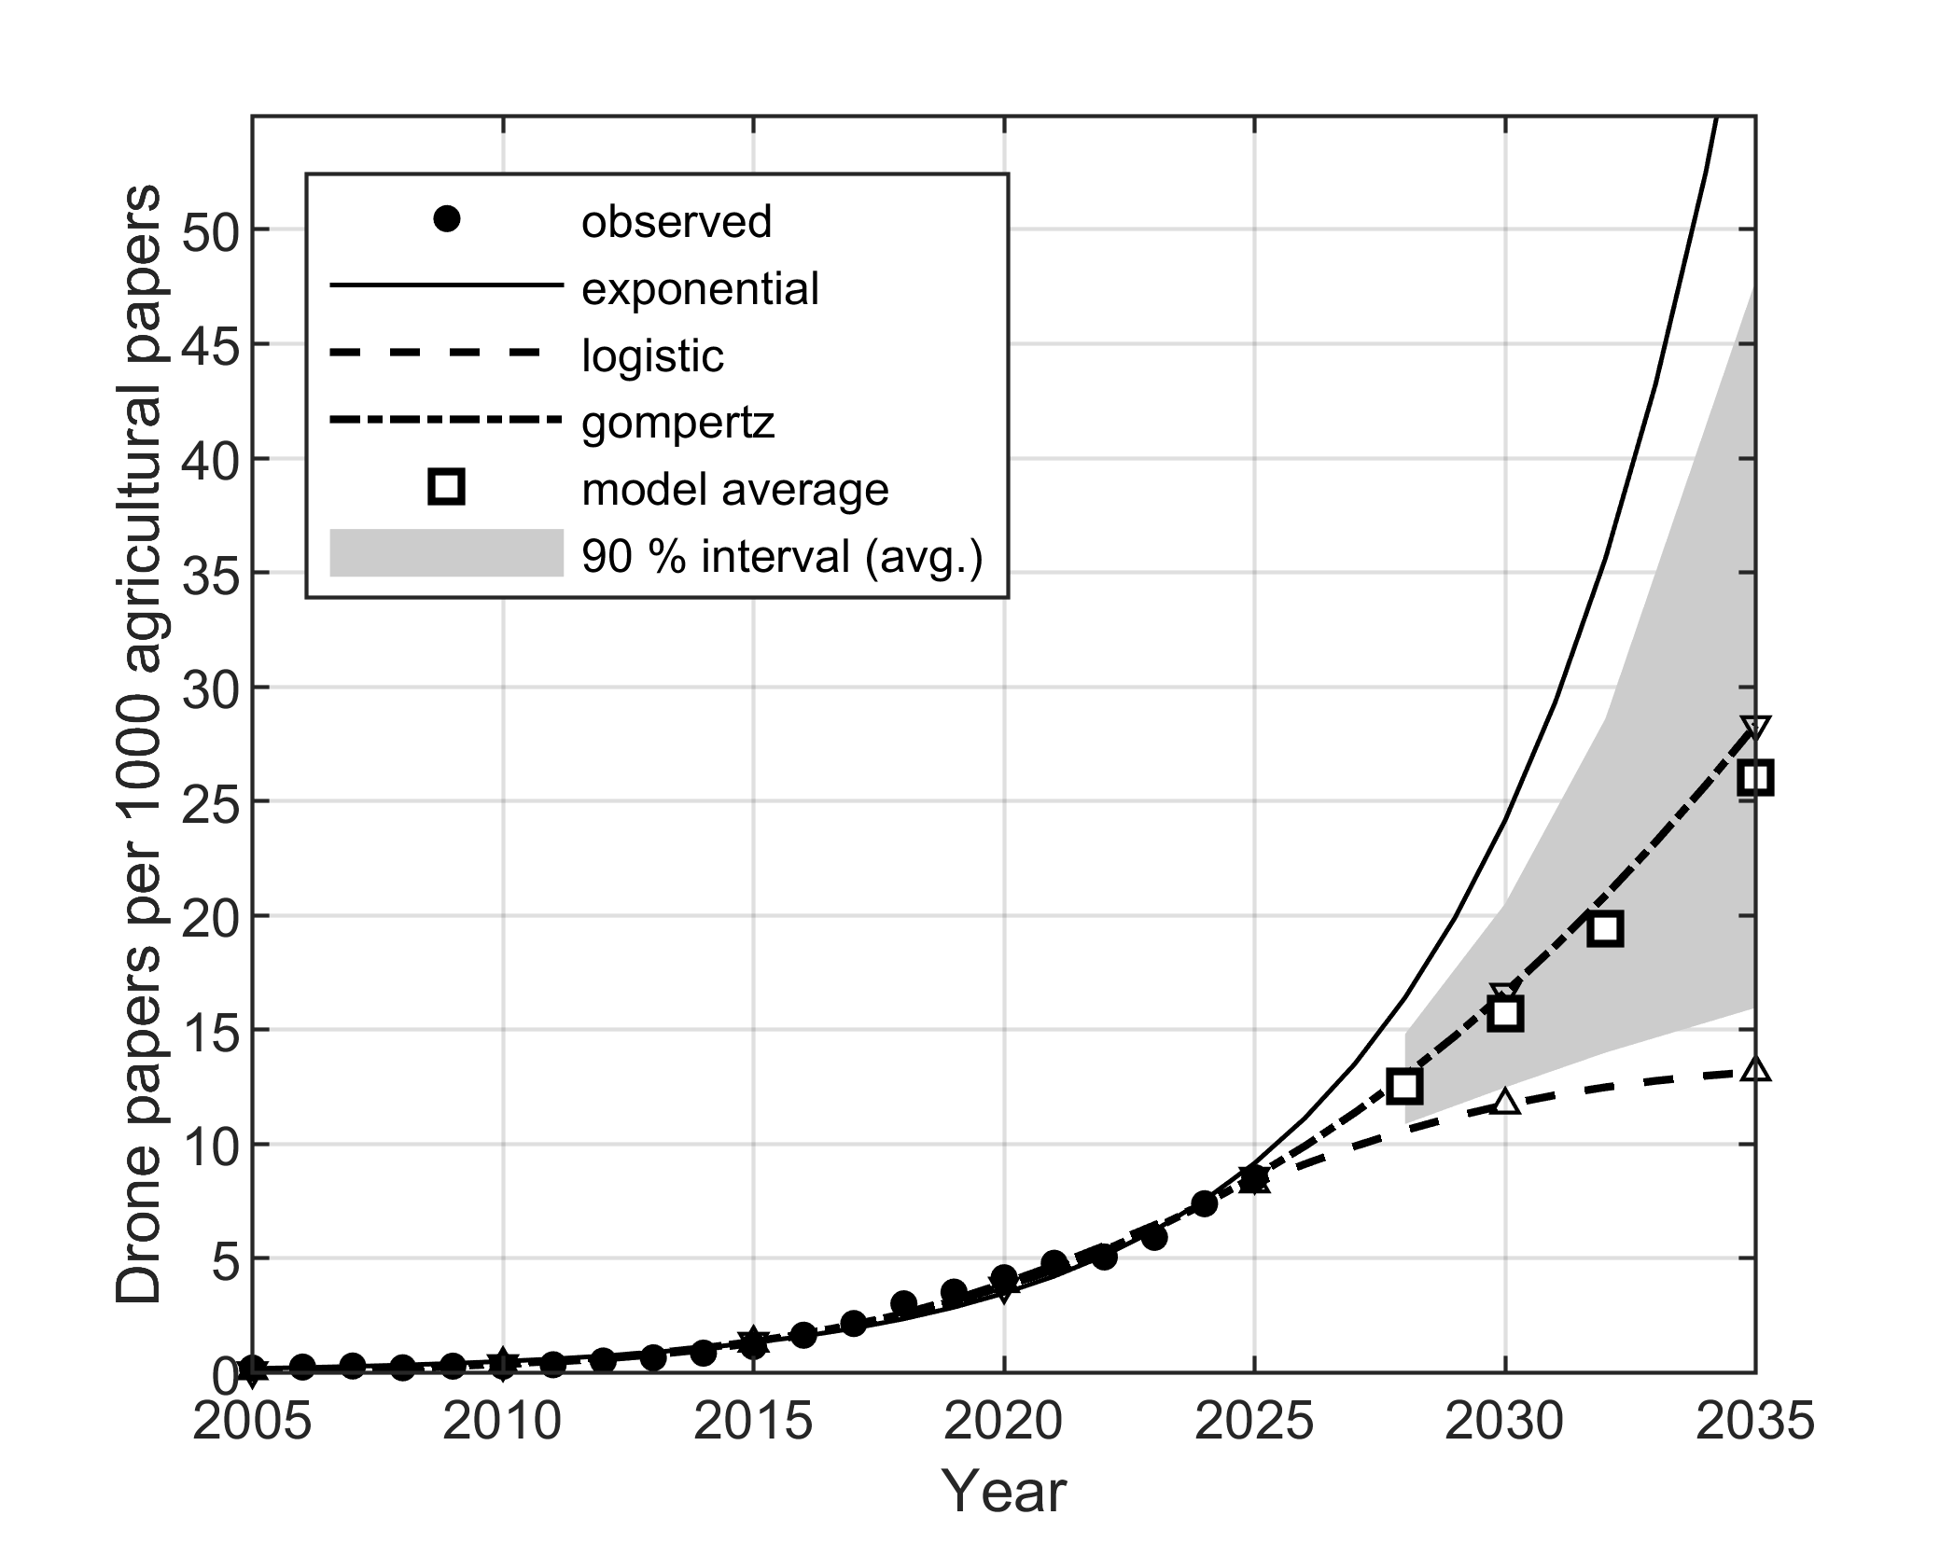
- Share of UAV-related articles per 1,000 agricultural articles (OpenAlex), fitted exponential, logistic and Gompertz rate models with the agricultural literature as offset, and the QAIC_{c}-weighted forecast with its 90 percent bootstrap interval.

Two Domains, One Instrument: Agriculture versus Environmental Monitoring
Because the companion study of UAVs in ecology and environmental monitoring [20] used the identical index, query protocol, retrieval procedure and estimation pipeline, the two domains can be compared like for like: any difference in Table III is domain signal, not method. Three differences stand out. First, the two adoption curves have nearly the same estimated ceiling — 13.8 and 13.3 articles per 1,000 of the host literature — but agriculture reached 62 percent of it in 2025 against 85 percent in environmental monitoring, with the inflection dated four years later (2023–2024 versus 2019–2020); agriculture is the same S-curve shifted right. Second, the model weights tell the same story from the other side: for absolute output the exponential model leads in agriculture (0.39) while the saturating Gompertz and logistic models lead in environmental monitoring (0.70 combined), exactly what is expected of an earlier position on the curve. Third, the precision of the query moves in opposite directions over time: in agriculture the early literature is dominated by generic UAV engineering papers that mention farming only as a prospective application (precision 37 percent before 2016 against 61 percent overall), whereas in environmental monitoring early precision was, if anything, higher (68 against 60 percent). The two domains share the structural break — 2009 in agriculture, 2010 in environmental monitoring — marking the common technology shock of low-cost multirotor platforms.
- The Same Pipeline Applied to Two Domains (This Paper and [20])
Indicator | Agriculture | Env. monitoring
Articles in 2025 | 4,381 | 4,747
CAGR 2005–2025 | 28.5 % | 29.3 %
Structural break | 2009 (16→32 %/yr) | 2010 (17→34 %/yr)
Share in 2025 (per 1,000) | 8.5 | 11.3
Logistic plateau (per 1,000) | 13.8 | 13.3
Plateau reached in 2025 | 62 % | 85 %
Share inflection | 2023–2024 | 2019–2020
Top count model (weight) | exponential (0.39) | Gompertz (0.41)
Precision, overall / early | 61 % / 37 % | 60 % / 68 %

Discussion

Reading the Forecasts: an Earlier Point on the Curve
Three findings frame the interpretation. First, the reliable forecast horizon for absolute output is again about three years — backtest errors from the most recent origin are a third to a half of those at the five- and seven-year origins — and beyond it the two forecasting approaches agree once the exponential model is set aside: if the agricultural literature continues at its 2015–2024 growth of 4.7 percent per year, the share forecast implies roughly 13,000–38,800 articles in 2035, bracketing the saturating-model average of 24,023 in Table II, whereas the exponential count model would imply a six- to sevenfold rise in share and is contradicted by the share analysis. Second, the share analysis indicates that UAVs in agriculture are still in the steep part of the adoption curve: at 62 percent of the estimated plateau, with the inflection dated only 2023–2024, the field has more headroom than neighbouring observational domains. Third, the sub-domain ranking shows where that headroom lies: the fastest growth is in data-driven agronomy — yield prediction, irrigation scheduling and disease detection — rather than in the mapping applications that dominated the first decade.

From Sensing to Actuation: Implications for Robotics
Agriculture is the domain in which the UAV is becoming an actuator, not only a sensor, and this shifts the engineering agenda. Spraying at the scale documented in East Asia [17] makes payload capacity, droplet drift control, deposition uniformity, RTK-grade positioning and multi-vehicle coordination the binding constraints, together with dose-control loops that couple perception (prescription maps from the monitoring sub-domains) to actuation on the same platform or in sensor–sprayer teams [3], [6]. On the sensing side, the fastest-growing sub-domains need transferable models rather than new cameras: radiometric calibration, cross-season and cross-field generalisation of vegetation-index and deep-learning models remain the bottlenecks identified by the reviews [2], [9] and visible in our precision check, where model-transfer papers recur. Livestock and weed detection, the slowest sub-domains, are limited by economics and by ground-robot competition, respectively. Finally, the regulatory asymmetry deserves attention: in the European Union aerial spraying of pesticides is prohibited by Directive 2009/128/EC except under derogation [18], and UAV spraying operations additionally fall in the "specific" category of Regulation (EU) 2019/947 [19], so the actuation applications that drive Asian adoption are largely closed in Europe; European growth therefore concentrates in sensing, which our European-country counts reflect. For European robotics, the near-term opportunity is monitoring and the preparation of the evidence base that regulators require for spraying derogations.

The Croatian Perspective
Croatia illustrates where a small EU country sits on this curve. All 34 Croatian articles date from 2013 onwards, 26 of them from 2020 onwards and 10 from 2025 alone — an output that mirrors the global curve with a delay of several years and is now accelerating. Croatian groups still publish almost twice as much on environmental as on agricultural UAV applications (62 against 34 articles over the same period, 18 against 10 in 2025) [20], the reverse of the global proportion. With the spraying path closed by Directive 2009/128/EC [18] and a farm structure dominated by small family holdings, the realistic national niche is the sensing side of Table III: disease, irrigation and yield monitoring services for permanent crops such as vineyards and olive groves, where per-hectare data value is highest and UAV service models close economically on small parcels [9]. For the regional robotics community this is a concrete, regulation-proof entry point into the fastest-growing sub-domains.

Limitations
Four limitations bound the conclusions. First, the corpus depends on one index and one query whose strict precision is 61 percent, and, unlike in our companion study of environmental UAVs [20], precision was significantly lower in the early period, so the earliest counts overstate agricultural activity; the noise filter removes the identifiable homonyms but not generic UAV engineering papers. Second, the 2025 observation is partly an indexing artefact and carries disproportionate weight in the saturating models. Third, the sub-domain queries overlap and describe relative growth, not a partition of the total. Fourth, model uncertainty is represented by four parametric shapes only; a regulatory change — for example a European opening towards spraying derogations — would not be captured by any of them. The adoption figures from industry and extension sources [17] are heterogeneous and are used for context only.

Conclusion
A reproducible bibliometric series shows that research on UAVs in agriculture grew by 28.5 percent per year between 2005 and 2025, with a structural acceleration in 2009, and that its share of the agricultural literature is heading towards a plateau of about 14 articles per 1,000 of which less than two thirds has been reached — the field sits on the same adoption curve as neighbouring environmental applications, measured with the identical instrument, but shifted about four years later [20]. Four growth models agree on a three-year forecast of roughly 8,200 articles in 2028; over ten years the forecast consistent with the share analysis — the average of the saturating models — reaches about 24,000 articles in 2035, with a wide interval. Growth is migrating from mapping towards data-driven agronomy and towards actuation, where payloads, precision application and regulation, rather than sensors, are the open problems. The data, the query definitions and the code are openly archived on Zenodo [21] so that the analysis can be repeated at any future retrieval date.

Acknowledgment
The authors used generative AI tools (Anthropic Claude) for statistical code generation, data retrieval scripting and language editing. All analyses were executed and verified by the authors, who take full responsibility for the content.

References
- C. Zhang and J. M. Kovacs, "The application of small unmanned aerial systems for precision agriculture: a review," Precision Agriculture, vol. 13, no. 6, pp. 693–712, 2012.
- W. H. Maes and K. Steppe, "Perspectives for remote sensing with unmanned aerial vehicles in precision agriculture," Trends in Plant Science, vol. 24, no. 2, pp. 152–164, 2019.
- D. C. Tsouros, S. Bibi, and P. G. Sarigiannidis, "A review on UAV-based applications for precision agriculture," Information, vol. 10, no. 11, art. 349, 2019.
- J. Priem, H. Piwowar, and R. Orr, "OpenAlex: A fully-open index of scholarly works, authors, venues, institutions, and concepts," arXiv:2205.01833, 2022.
- J. Torres-Sánchez, F. López-Granados, A. I. De Castro, and J. M. Peña-Barragán, "Configuration and specifications of an unmanned aerial vehicle (UAV) for early site specific weed management," PLoS ONE, vol. 8, no. 3, art. e58210, 2013.
- A. Hafeez et al., "Implementation of drone technology for farm monitoring & pesticide spraying: A review," Information Processing in Agriculture, vol. 10, no. 2, pp. 192–203, 2023.
- M. Maimaitijiang, V. Sagan, P. Sidike, S. Hartling, F. Esposito, and F. B. Fritschi, "Soybean yield prediction from UAV using multimodal data fusion and deep learning," Remote Sensing of Environment, vol. 237, art. 111599, 2020.
- G. Yang et al., "Unmanned aerial vehicle remote sensing for field-based crop phenotyping: current status and perspectives," Frontiers in Plant Science, vol. 8, art. 1111, 2017.
- E. R. Hunt and C. S. T. Daughtry, "What good are unmanned aircraft systems for agricultural remote sensing and precision agriculture?," International Journal of Remote Sensing, vol. 39, no. 15–16, pp. 5345–5376, 2018.
- F. M. Bass, "A new product growth for model consumer durables," Management Science, vol. 15, no. 5, pp. 215–227, 1969.
- N. Meade and T. Islam, "Modelling and forecasting the diffusion of innovation – A 25-year review," International Journal of Forecasting, vol. 22, no. 3, pp. 519–545, 2006.
- L. Bornmann and R. Mutz, "Growth rates of modern science: A bibliometric analysis based on the number of publications and cited references," Journal of the Association for Information Science and Technology, vol. 66, no. 11, pp. 2215–2222, 2015.
- K. P. Burnham and D. R. Anderson, Model Selection and Multimodel Inference: A Practical Information-Theoretic Approach, 2nd ed. New York, NY, USA: Springer, 2002.
- H. B. Mann, "Nonparametric tests against trend," Econometrica, vol. 13, no. 3, pp. 245–259, 1945.
- P. K. Sen, "Estimates of the regression coefficient based on Kendall's tau," Journal of the American Statistical Association, vol. 63, no. 324, pp. 1379–1389, 1968.
- R. J. Hyndman and A. B. Koehler, "Another look at measures of forecast accuracy," International Journal of Forecasting, vol. 22, no. 4, pp. 679–688, 2006.
- Ohio State University Extension, "Using drones for spray application – adoption trends in US and worldwide," Agronomic Crops Network newsletter, 2024. Accessed: Aug. 28, 2026. [Online]. Available: https://agcrops.osu.edu/newsletter/corn-newsletter/2024-06/using-drones-spray-application-adoption-trends-us-and-worldwide
- Directive 2009/128/EC of the European Parliament and of the Council of 21 October 2009 establishing a framework for Community action to achieve the sustainable use of pesticides, Official Journal of the European Union, L 309, pp. 71–86, 2009.
- Commission Implementing Regulation (EU) 2019/947 of 24 May 2019 on the rules and procedures for the operation of unmanned aircraft, Official Journal of the European Union, L 152, pp. 45–71, 2019.
- V. Uroš and M. Jelić, "drone-ecology-forecast: bibliometric data and MATLAB growth-model pipeline for UAV research in ecology and environmental monitoring (v1.0)," Zenodo, 2026, doi: 10.5281/zenodo.22119199.
- V. Uroš and M. Jelić, "drone-agriculture-forecast: bibliometric data and MATLAB growth-model pipeline for UAV research in agriculture (v1.1)," Zenodo, 2026, doi: 10.5281/zenodo.22238128.
- A. Rejeb, A. Abdollahi, K. Rejeb, and H. Treiblmaier, "Drones in agriculture: A review and bibliometric analysis," Computers and Electronics in Agriculture, vol. 198, art. 107017, 2022.

