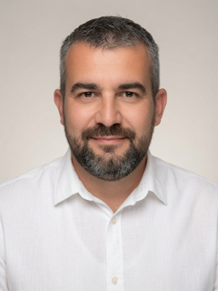 | Vedran Uroš is a Senior Lecturer in Computer Science at the University of Applied Sciences “Marko Marulić” in Knin, Croatia, where he has taught since 2012 and has held a full-time academic post since 2016. Since July 2026 he has served as Vice Dean for Research and International Cooperation, coordinating the institution's scientific activity, research projects and international partnerships.  He holds a Master's degree in Computer Engineering (mag. ing. comp., 2012) from the Faculty of Electrical Engineering, Mechanical Engineering and Naval Architecture (FESB), University of Split, and is a doctoral candidate in Information Sciences at the Faculty of Organization and Informatics (FOI), University of Zagreb. His doctoral research addresses energy efficiency in wireless sensor networks, focusing on modifications to the LEFCA/M-LEFCA clustering protocol family and the integration of unmanned aerial vehicles as mobile base stations.  His teaching covers informatics, digital transformation, business security, business information systems and business intelligence. His research interests include wireless sensor networks, IoT security and forensics, business and corporate security, cybersecurity, and artificial intelligence, with a particular focus on machine learning applications in healthcare, higher education and business, as well as the implications of generative AI for information security. He has authored or co-authored more than twenty papers presented at international conferences, including IEEE WCNC, MIPRO, SoftCOM and IEEE ICCA, published the textbook Uvod u poslovnu računalnu sigurnost (Introduction to Business Computer Security), and served as technical editor of two international conference proceedings.  He holds a Cisco CCNA certificate and has completed pedagogical, psychological and didactic training for higher education teaching. He is active in the Knin community, serving on the governing board of the Knin Museum and the supervisory board of the Scientia populo association for education and science. He is a native Croatian speaker with proficient English (C1/C2).
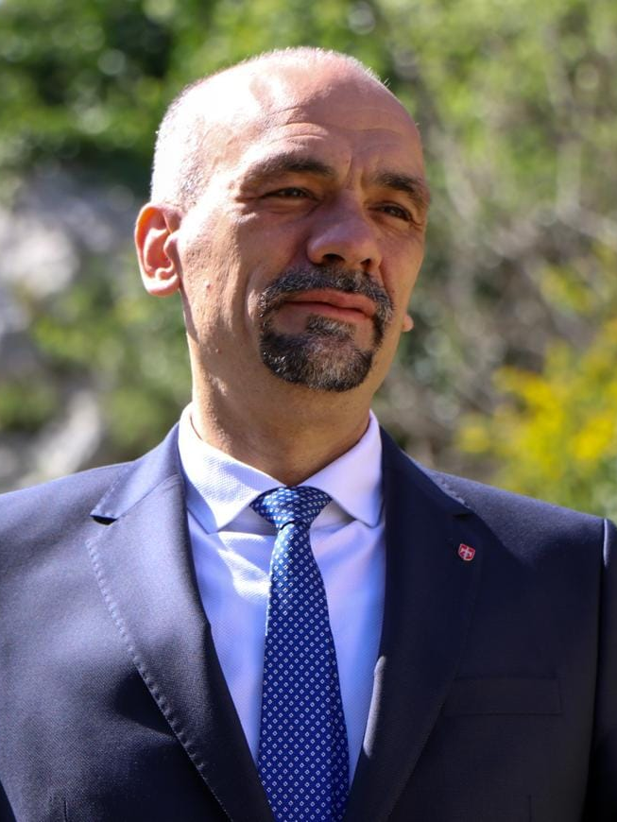 | Marko Jelić, PhD, is a tenured Professor of Applied Sciences at Marko Marulić Polytechnic in Knin, Croatia (biotechnical sciences, biology), and an Associate Professor at the Independent University of Banja Luka. He graduated in molecular biology from the Faculty of Science, University of Zagreb (2000), and earned his doctorate in molecular biology and biochemistry at Ludwig Maximilian University of Munich (2003), studying chloroplast protein import within the SFB TR1 “Endosymbiosis” programme.  Since 2005 he has taught biology, biochemistry, plant physiology, botany, environmental protection and game management. He served as acting dean and dean (2005–2011), President of the Council of Croatian Polytechnics and Colleges (2007–2011), Vice-Dean for Development and Scientific Cooperation (2011–2015) and acting dean of ASPIRA College in Split (2015–2016). He was Mayor of Knin (2017–2021) and Prefect of Šibenik-Knin County (2021–2025).  He has authored and co-authored papers in EMBO Journal, PNAS, Biochemistry, Food Chemistry and Food Technology and Biotechnology, covering cell biology, honey chemistry, the microbiology of lambskin-sack cheese and traditional meat products. He led national technology projects, is the inventor of a step-gradient forming device (patent P20080604A) and co-authored the university handbook Flora of Dinara.
 | Sandra Mandinić is a Lecturer at the University of Applied Sciences “Marko Marulić” in Knin, Croatia, where she has worked since 2021, first as a teaching assistant and since 2024 as a lecturer. Since 2021 she has also served as the institution’s Erasmus+ coordinator, responsible for planning, organizing and administering international mobility of students and staff.  She holds a Bachelor’s degree in Food Technology (2018) from the University of Applied Sciences “Marko Marulić” in Knin and a Master’s degree in Agricultural Engineering, programme Milk Production and Processing (mag. ing. agr., 2020), from the University of Zagreb Faculty of Agriculture. She is a doctoral candidate in Agricultural Sciences at the same faculty. Her doctoral research, supervised by Assoc. Prof. Iva Dolenčić Špehar, investigates how feeding high-yielding dairy cows saponified vegetable oil with added flaxseed affects the physicochemical and sensory properties of concentrated yogurt.  Her research interests include dairy technology and traditional Croatian cheeses, milk fat composition, sensory evaluation of food, functional dairy products, the circular economy and digital technologies in agriculture, including agricultural drones. She has co-authored more than ten scientific and professional papers and conference contributions, published in journals such as Fermentation and the Croatian Journal of Food Technology, Biotechnology and Nutrition and presented at international conferences including NUTRICON and the European Green Conference. She is a native Croatian speaker with C2 English.

