Received: [date of full paper submission]
Accepted: Will be filled by the publisher
Published: Will be filled by the publisher
Keyword Networks, Thematic Evolution and Growth Forecasts of Agricultural Drone Research to 2035
Vedran Uroš https://orcid.org/0009-0007-6568-0827
Marko Jelić https://orcid.org/0009-0006-4135-5221
Sandra Mandinić https://orcid.org/0009-0009-1312-5914
Abstract: This paper maps the themes of agricultural drone research and forecasts its growth to 2035. Growth models use 18,506 OpenAlex articles from 2005 to 2025, and keyword networks use 22,357 records from 2005 to 2026. Louvain clustering of the co-occurrence network identifies five stable research themes, and a thematic evolution analysis follows them across five periods. Annual output grew by 28.5 percent per year, or by about 32 percent after correcting for lower query precision in the early years. The research focus is moving from vegetation indices and mapping towards deep learning, disease detection and smart-farming systems. The share of drone studies in the agricultural literature is levelling off, so the growth forecasts combine this share with the growth of the agricultural literature. They indicate about 12,000 articles in 2035, with a 90 percent interval of 10,000-22,000.
Keywords: Agricultural drone research, Keyword networks, Thematic evolution, Growth forecasts
1. INTRODUCTION
Drones have become a standard tool of precision agriculture. Small unmanned aerial vehicles (UAVs) carry RGB, multispectral, thermal and LiDAR sensors over fields at low cost, and they increasingly apply pesticides and fertilizers (Tsouros et al., 2019; Hafeez et al., 2023). About 400,000 agricultural drones of a single manufacturer were in use at the end of 2024, 90 percent more than in 2020 (DJI Agriculture, 2025).
For farm managers, technology providers and policy makers, three questions follow. How fast is research on agricultural drones growing relative to agricultural science as a whole? Which themes drive this growth today? Is the field still in an exponential phase, or is it approaching saturation? Earlier bibliometric reviews mapped the intellectual structure of the field (Rejeb et al., 2022) or of narrower sub-fields (Gokool et al., 2023; Zhu et al., 2024), but they did not model its dynamics or forecast its growth.
This paper combines science mapping with growth forecasting on one open corpus. The sub-domain queries come from a companion study (Jelić et al., In Press). The contributions are a keyword network with validated research themes, a thematic evolution analysis from 2005 to 2026 with a heatmap of emerging keywords, a long-horizon forecast that links the share of the agricultural literature to its growth, and an interpretation for agribusiness management and policy.
The rest of the paper is structured as follows. Section 2 reviews the literature, Section 3 describes the data and methods, Section 4 presents the results, Section 5 discusses them, Section 6 outlines future research and Section 7 concludes.
2. LITERATURE REVIEW
Reviews of agricultural drones agree on a common set of applications: crop monitoring, phenotyping, weed mapping, irrigation scheduling, disease detection, yield estimation and spraying (Zhang & Kovacs, 2012; Maes & Steppe, 2019; Tsouros et al., 2019). After 2018, machine learning and deep learning became the standard way to turn UAV imagery into crop traits (Maimaitijiang et al., 2020; Shahi et al., 2022). In parallel, spraying turned the drone from a sensor into an actuator, led by China (Hu et al., 2022), while the European Union prohibits aerial spraying except under derogation (Directive 2009/128/EC, 2009).
Recent bibliometric reviews are narrower. One analyzed 234 articles on AI-integrated drones and found crop monitoring, precision agriculture and environmental sensing to be the main applications (Slimani et al., 2024). Another combined keyword co-occurrence analysis with a review of deep learning for UAV-based detection of crop diseases and pests (Zhu et al., 2024). Two scoping reviews of smallholder farms found UAVs used mainly for crop growth monitoring, fertilizer management and crop mapping (Gokool et al., 2023) and a strong rise of research on UAV-based water management (Yacoob et al., 2024). These studies map one sub-field at one point in time; the present paper adds how themes change over two decades and how far the field is from saturation.
In science mapping, association strength normalizes co-occurrence for keyword frequency (van Eck & Waltman, 2009), the Louvain method finds clusters (Blondel et al., 2008), and thematic evolution analysis links clusters across periods (Cobo et al., 2011; Aria & Cuccurullo, 2017). Growth forecasting relies on diffusion and saturation curves such as the Bass model (Bass, 1969). Because no single curve dominates, models should be combined (Meade & Islam, 2006), and publication counts should be normalized for the growth of science itself (Bornmann & Mutz, 2015).
3. DATA AND METHODS
3.1. Two Corpora and Their Quality
All data come from OpenAlex, an open index of scholarly works (Priem et al., 2022). Articles and reviews were selected by one Boolean search of titles and abstracts that combined nine drone terms (drone, UAV, UAS, RPAS and variants) with 38 agricultural terms (crop, yield, irrigation, spraying, weed, livestock and others). A noise filter removed known homonyms, such as the Drosophila GAL4/UAS system and bee drones. It was retrieved twice. Corpus A contains annual counts for 2005-2025 (18,506 articles, retrieved on 28 August 2026) and feeds the growth models and the sub-domain analysis. It also holds the agricultural literature, used as the denominator, and three alternative denominators. Corpus B contains the full records with their keywords for 2005-2026 (23,080 records, retrieved on 22 October 2026) and feeds the keyword networks. Both corpora agree closely (4,398 against 4,381 articles in 2025). Author countries were counted from OpenAlex authorship data with full counting.
Records whose keywords or topics revealed residual homonyms, mostly the molecular-biology acronym RPA (recombinase polymerase amplification), were removed from corpus B (723 records, 3.1 percent), which leaves 22,357 records with 8.5 keywords on average. These homonyms are concentrated in the early years: 14-25 percent of the records before 2011, but only 2-3 percent after 2017. Applying the same yearly shares to corpus A raises the growth rate from 28.5 to 29.6 percent per year. Refitting all models on this cleaned series keeps the logistic model dominant for the share (weight 0.92) and lowers its plateau from 13.8 to 12.2 per 1,000. The archived series remains the main analysis and the cleaned series a sensitivity check.
Manual checks of random samples put the precision of the query (the share of records that are agricultural UAV studies) at 61 percent in a random sample of the whole period (95 percent interval 51-70 percent, n = 94) and 63 percent among its 73 records from 2021-2025. Because this sample held only seven records from 2005-2015, a separate random sample of that period was drawn, with a precision of 37 percent (n = 35). Because precision rises over time, the measured growth rate is conservative. Precision weighting of the 2005 and 2025 counts raises the growth rate from 28.5 to about 32 percent per year (28-36 percent across the confidence intervals). Absolute counts are therefore query-matched records, not exact counts of agricultural drone studies.
3.2. Keyword Preparation and Networks
OpenAlex assigns keywords to each record by machine. Keywords were lower-cased, plural and singular forms were merged, and acronyms were merged with their long forms when a record lists both (for example SVM and support vector machine), together with a short manual list (CNN, IoT, SfM, precision farming). NDVI and YOLO versions were kept apart, because they name one specific index and successive model generations. Keywords that restate the query (drone, UAV, UAS, RPAS, agriculture, crop, farming) were removed, because they would otherwise dominate every cluster.
The overall network contains the 60 most frequent keywords. Two keywords are linked when they co-occur in at least 50 records, and each link is weighted by association strength (van Eck & Waltman, 2009):
$s_{ij}=\frac{Nc_{ij}}{f_{i}f_{j}}$ (1)
where c_{ij} is the number of records containing both keywords, f_{i} and f_{j} are their frequencies and N is the number of records. This threshold leaves 57 connected keywords and 183 links (density 0.12); a threshold of 3 would give an almost complete graph (density 0.75). Clusters were found with the Louvain method (Blondel et al., 2008) at a resolution of 1.25, and clusters of fewer than three keywords were merged into their closest neighbor. Over 50 random seeds, the modularity was Q = 0.41 (range 0.410-0.413), every run produced five clusters, and the mean normalized mutual information between partitions was 0.99. Modularity was highest at this threshold among those tested (3, 10, 25, 50 and 100). The map was laid out with ForceAtlas2 (Jacomy et al., 2014) on the full graph, and only links of at least 50 co-occurrences are drawn.
For the thematic evolution, corpus B was split into five periods: 2005-2014 (760 records), 2015-2019 (3,145), 2020-2022 (4,718), 2023-2024 (5,076) and 2025-2026 (8,658). In each period, the 50 most frequent keywords were clustered in the same way, with a link threshold proportional to the size of the period (3 to 19 co-occurrences). Clusters of consecutive periods were linked when their inclusion index reached 0.1 (Cobo et al., 2011). With clusters of 3 to 17 keywords, this keeps links in which shared keywords make up a tenth of the smaller cluster and drops incidental overlaps. Emerging keywords are those with at least 40 records in 2025-2026 and the highest ratio of their share in 2025-2026 to their share in 2015-2019 plus 2 per 1,000; the added constant keeps the ratio finite for terms absent before 2020. Networks were computed in Node.js (graphology) and figures drawn in MATLAB.
3.3. Growth Models and Forecasts
Exponential, logistic, Gompertz and Bass curves (Bass, 1969) were fitted to the annual counts and, with the agricultural literature as an offset, to the share of drone studies in it. The fits minimize the Poisson deviance, and the models are compared with the quasi-likelihood criterion QAIC_{c} and combined with Akaike weights (Burnham & Anderson, 2002). Rolling-origin backtests from 2018, 2020 and 2022 measure the error at seven-, five- and three-year horizons (Hyndman & Koehler, 2006), and 90 percent intervals come from a negative-binomial bootstrap with 1,000 replicates, in which every replicate refits all models to the same simulated series and recomputes their weights.
Long-horizon counts were obtained by multiplying the share forecasts by a projected agricultural literature. This denominator grew by 4.7 percent per year between 2015 and 2024 (from 269,400 to 407,400 articles), and the projection applies this rate from its 2025 level. The year 2025 was excluded only from this rate, because all series jump in that year (agricultural literature +26 percent, all indexed works +18 percent), which points to expanded index coverage. Starting from the 2025 level assumes that this wider coverage is permanent; in the share, the jump largely cancels. The data and the growth-model code are archived (Uroš & Jelić, 2026); the keyword and network code are added to the same repository as version 2.0.
4. RESULTS
4.1. Growth of the Field
Output rose from 29 articles in 2005 to 4,381 in 2025 (Figure 1a), a growth rate of 28.5 percent per year. A segmented regression places a structural break in 2009, after which growth doubled from 16 to 32 percent per year. The break coincides with the spread of low-cost multirotor platforms (Zhang & Kovacs, 2012). Normalized by the agricultural literature, the share of drone studies rose from 0.21 to 8.5 per 1,000 (Figure 1b). China, the United States and India lead 164 countries; Croatia contributed 34 articles, ten in 2025.
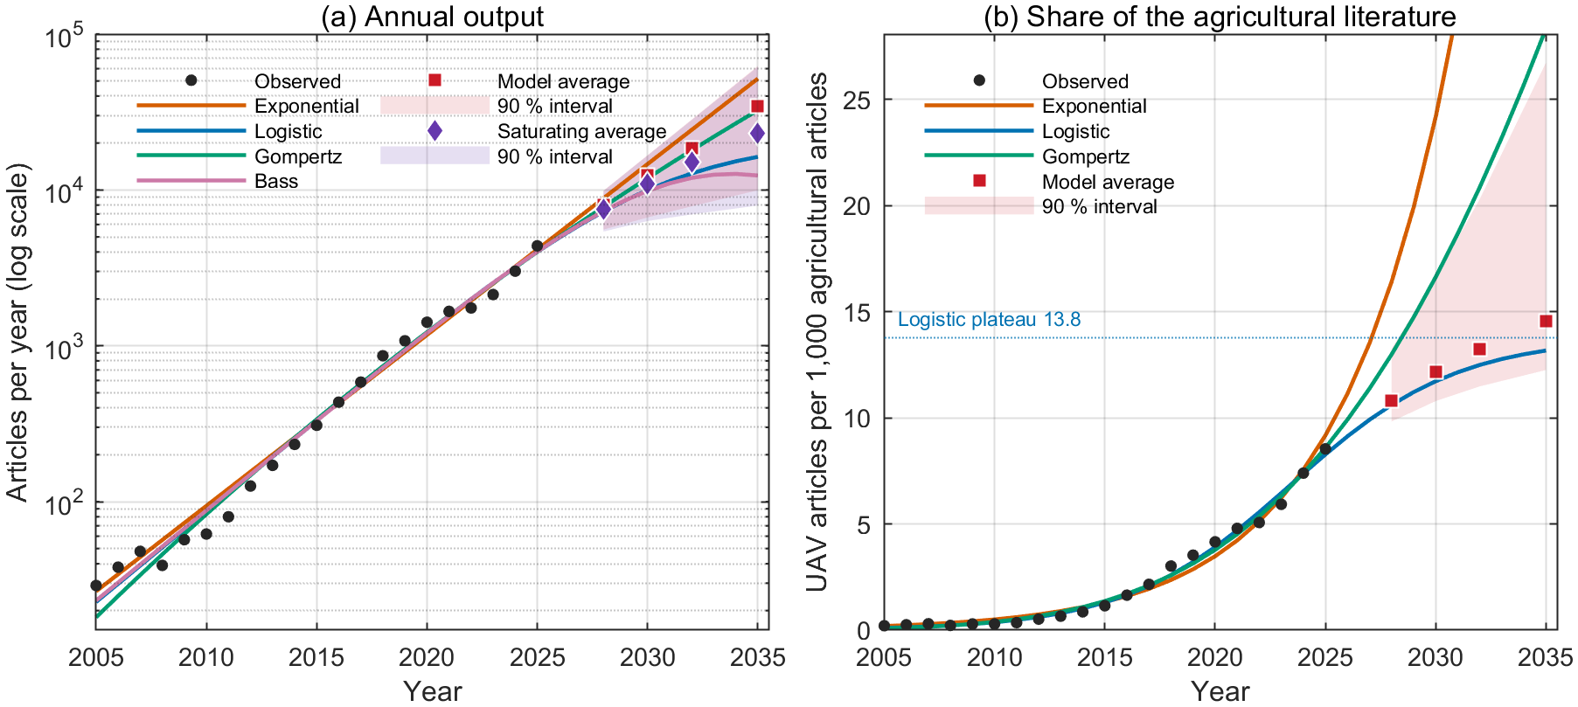
Figure 1. Drone research output (a) and its share of agricultural literature (b) to 2035
Source: Own calculations based on OpenAlex data
The seven application sub-domains, analyzed in a companion paper (Jelić et al., In Press), point in the same direction. Crop monitoring and phenotyping remains the largest, with about 250 per 1,000 drone articles in 2025. Irrigation and disease detection roughly doubled their share after 2019, and yield prediction had the fastest relative growth in article counts (51 percent per year since 2015).
4.2. Research Themes
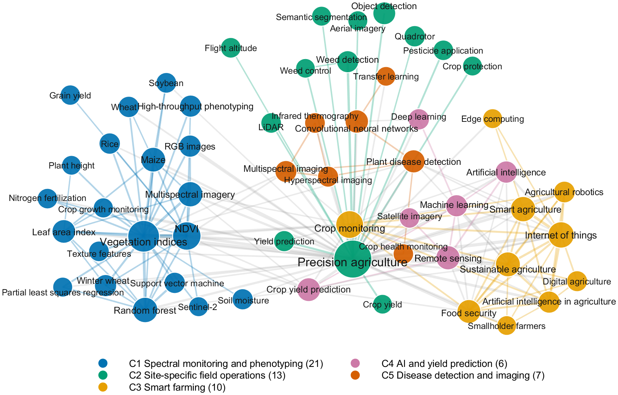
Figure 2. Keyword co-occurrence network, 57 keywords linked by at least 50 co-occurrences; node size shows frequency, color shows the Louvain cluster
Source: Own calculations based on OpenAlex data
The network (Figure 2) divides into five themes. Spectral monitoring and phenotyping (21 keywords) joins vegetation indices, NDVI, multispectral imagery and leaf area index with major crops. Site-specific field operations (13 keywords) links precision agriculture, the hub of the map, with weed and object detection, pesticide application, flight altitude and LiDAR. Smart farming (10 keywords) groups crop monitoring with the Internet of Things, sustainability, food security and digital agriculture. AI and yield prediction (6 keywords) connects machine and deep learning with remote sensing and crop yield prediction. Disease detection and imaging (7 keywords) joins convolutional neural networks and transfer learning with plant disease detection and hyperspectral and thermal imaging. Every key topic of an earlier review (remote sensing, precision agriculture, deep learning, machine learning and the Internet of Things) appears in one of these themes, although that review clustered co-cited references rather than keywords (Rejeb et al., 2022). Noise did not shape the themes: an exploratory molecular-biology cluster revealed the RPA homonym, and these records were removed (Section 3.1).
4.3. Thematic Evolution and Emerging Topics
Figure 3 follows the themes through five periods. Until 2014, one broad theme of crop monitoring with vegetation indices held 64 percent of keyword occurrences. Between 2015 and 2019 the field differentiated into vegetation indices, NDVI with leaf area index, structure from motion and phenotyping. In 2020-2022, convolutional neural networks and object detection formed a theme as large as the spectral core (29 percent each). In 2023-2024, pesticide application with crop health monitoring and machine learning with crop monitoring became separate themes. In 2025-2026, the spectral core still holds 43 percent of occurrences, while smart farming, AI, plant disease detection, small object detection and LiDAR with hyperspectral imaging form distinct smaller themes.
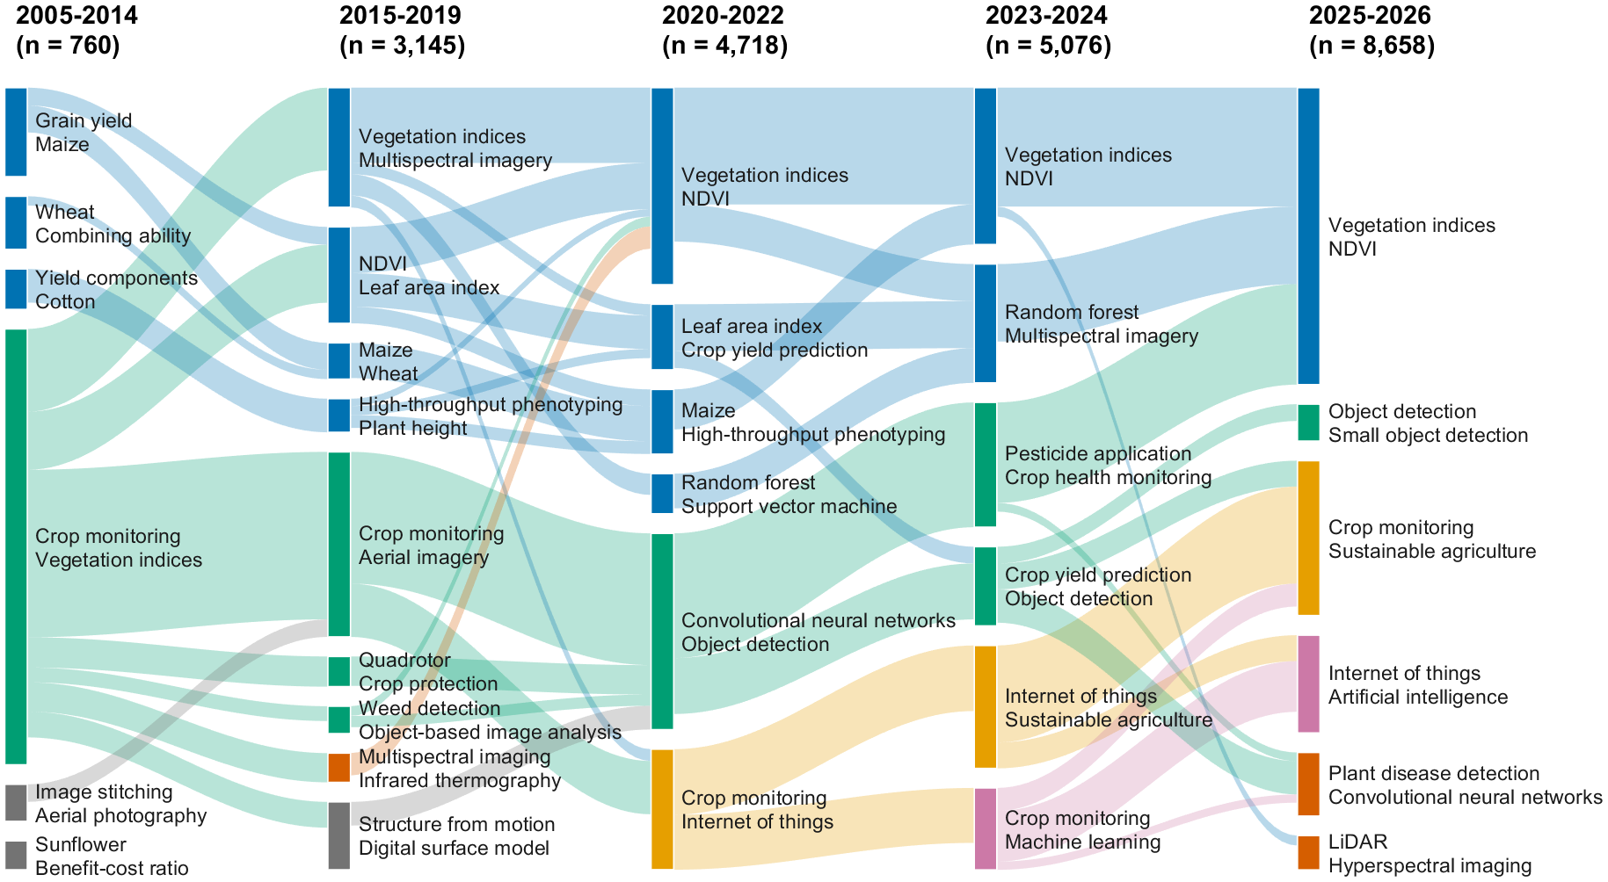
Figure 3. Thematic evolution of keyword clusters across five periods; box height shows the share of keyword occurrences in the period, bands show shared keywords
Source: Own calculations based on OpenAlex data
The heatmap (Figure 4) shows the latest shift year by year. Vegetation indices, NDVI and crop monitoring have lost share since 2021, while the Internet of Things, food security and sustainable agriculture kept rising. The fastest risers are recent detection architectures (YOLOv8 and YOLOv11), lightweight and small object detection, XGBoost, edge computing, digital twins and explainable AI. The keyword technology adoption barriers appears in at most 2 per 1,000 records before 2023, but in 4, 12 and 19 per 1,000 records in 2023, 2024 and 2025. This is a small but growing sign that the economics of adoption is entering the research agenda.
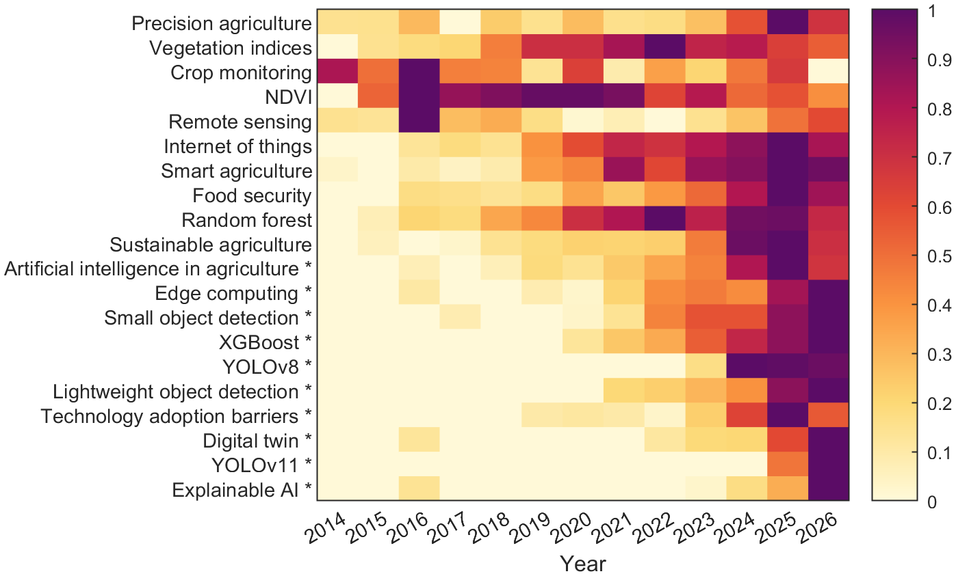
Figure 4. Established and emerging (*) keywords, articles per 1,000 agricultural drone articles per year (2026: January-October); color is scaled to the maximum of each row
Source: Own calculations based on OpenAlex data
4.4. Growth Forecasts to 2035
For annual output, no model dominates: the QAIC_{c} weights are 0.39 for the exponential model, 0.29 for Gompertz, 0.16 for logistic and 0.15 for Bass. Backtest errors at the three-year horizon (origin 2022) were 11-26 percent, against 32-44 percent at the five- and seven-year horizons, so count models are reliable only about three years ahead. Their weighted average is about 8,000 articles in 2028 (90 percent interval 5,600-9,900).
For the long horizon, the share analysis is decisive. The logistic model receives a weight of 0.91 for the share, and the exponential model less than 0.001. An exponential path for counts would imply 64 drone articles per 1,000 agricultural articles in 2035, more than seven times the 2025 share, which the share data reject, so the exponential count model is not used beyond three years. Because the logistic model dominates, the weighted share forecast stays close to it: 14.5 per 1,000 in 2035 against 13.2 for the logistic curve alone. Multiplied by the projected denominator, this gives about 12,000 articles in 2035 (90 percent interval 10,000-22,000), and the logistic curve alone gives about 11,000 (Table 1). For 2028, this approach gives about 6,400 articles against about 8,000 from the count models, because it assumes that the agricultural literature grows by only 4.7 percent per year; it is therefore the more conservative estimate. The interval is skewed upwards because the Gompertz curve, which levels off later, gains weight in some replicates. The saturating count models, which do not use the share, average about 23,000 and mark the upper end of plausible outcomes.
Table 1. Forecast annual output by approach, rounded to hundreds
Approach | 2028 | 2030 | 2032 | 2035
Share (model average) × denominator | 6,400 | 7,900 | 9,400 | 11,800
90 % interval | 5,800-7,800 | 7,000-10,700 | 8,100-14,400 | 10,000-21,700
Share (logistic) × denominator | 6,200 | 7,600 | 8,800 | 10,700
Saturating count models | 7,500 | 10,900 | 15,100 | 23,100
Exponential count model | 8,800 | 14,700 | 24,300 | 51,800
Source: Own calculations based on OpenAlex data
The saturating shape of the share is robust, but its level is not. The plateau is 13.8 per 1,000 in the main fit, 12.2 for the cleaned series and 11.6 without the 2025 observation. The latest observed share corresponds to 62, 68 and 64 percent of these plateaus. Under broader denominators the logistic model also dominates, but the field reaches only 38-42 percent of its plateau. The inflection, estimated around 2023-2024, rests on one or two later observations, so the field is near its inflection point rather than clearly past it.
5. DISCUSSION
5.1. Interpretation
Three interpretations follow. Growth continues, but once the share levels off it follows the agricultural literature. The field is moving from mapping to prediction and detection. Regulation shapes the European path: spraying, about one in six drone articles and the leading commercial use in East Asia (Hu et al., 2022), requires a derogation in the European Union (Directive 2009/128/EC, 2009) and falls into the specific category of drone operations (Commission Implementing Regulation (EU) 2019/947, 2019).
5.2. Implications for Management and Policy
For technology providers, the rise of disease detection, AI-based yield prediction and edge computing suggests that the competitive advantage is shifting from aircraft hardware to analytics and on-board processing; this is an interpretation of keyword trends, not a market measurement. For farm managers and cooperatives, the cost of own equipment remains the main barrier on small farms (Hunt & Daughtry, 2018). Shared ownership or drone services that bundle flights, trained models and agronomic advice are a plausible response, and adoption barriers are becoming a research topic.
For European policy makers and advisory services, the fastest-growing sensing applications, disease and irrigation monitoring, can expand under current rules, while spraying depends on derogations. Training, data infrastructure and advisory support therefore need not wait for regulatory change. For research funders, a literature of about 12,000 articles per year by 2035, and possibly twice as many, calls for regular evidence syntheses and open, updateable monitoring.
5.3. Limitations
The study has five limitations. It relies on one index and one query with a precision of about 61 percent, which is lower in the early years. The 2025 observation is partly an indexing artifact. OpenAlex keywords are assigned by machine and may differ from author keywords. The network depends on a link threshold, although its themes are stable across seeds. Finally, growth curves cannot anticipate regulatory shocks, such as an EU opening towards drone spraying.
6. FUTURE RESEARCH DIRECTIONS
The themes should be tested with author keywords from Scopus or Web of Science. Linking publication trends with drone sales, service prices and farm-level adoption data would show whether research leads or follows the market. The rise of computer-vision keywords calls for a study of model architectures and their transfer between crops and regions. The archived pipeline allows yearly updates of the forecasts and the theme map.
7. CONCLUSION
Research on agricultural drones grew by 28.5 percent per year between 2005 and 2025, and by about 32 percent after correcting for the lower early precision. The field is organized around five stable themes, from spectral monitoring and phenotyping to disease detection and imaging. Its focus is moving towards deep learning, disease detection and the economics of adoption. As the share of drone studies in the agricultural literature levels off, output is likely to reach about 12,000 articles in 2035 (90 percent interval 10,000-22,000). For managers and policy makers, the next decade of value lies in analytics, services and regulation-compatible sensing, not in the aircraft.
Acknowledgment
The authors used generative AI tools (Anthropic Claude) for data retrieval scripting, statistical code generation and language editing. All analyses were executed and verified by the authors, who take full responsibility for the content.
References
Aria, M., & Cuccurullo, C. (2017). bibliometrix: An R-tool for comprehensive science mapping analysis. Journal of Informetrics, 11(4), 959-975. https://doi.org/10.1016/j.joi.2017.08.007
Bass, F. M. (1969). A new product growth for model consumer durables. Management Science, 15(5), 215-227. https://doi.org/10.1287/mnsc.15.5.215
Blondel, V. D., Guillaume, J.-L., Lambiotte, R., & Lefebvre, E. (2008). Fast unfolding of communities in large networks. Journal of Statistical Mechanics: Theory and Experiment, 2008(10), P10008. https://doi.org/10.1088/1742-5468/2008/10/P10008
Bornmann, L., & Mutz, R. (2015). Growth rates of modern science: A bibliometric analysis based on the number of publications and cited references. Journal of the Association for Information Science and Technology, 66(11), 2215-2222. https://doi.org/10.1002/asi.23329
Burnham, K. P., & Anderson, D. R. (2002). Model selection and multimodel inference: A practical information-theoretic approach (2nd ed.). New York, NY: Springer. https://doi.org/10.1007/b97636
Cobo, M. J., López-Herrera, A. G., Herrera-Viedma, E., & Herrera, F. (2011). An approach for detecting, quantifying, and visualizing the evolution of a research field: A practical application to the Fuzzy Sets Theory field. Journal of Informetrics, 5(1), 146-166. https://doi.org/10.1016/j.joi.2010.10.002
Commission Implementing Regulation (EU) 2019/947 of 24 May 2019 on the rules and procedures for the operation of unmanned aircraft. (2019). Official Journal of the European Union, L 152, 45-71. http://data.europa.eu/eli/reg_impl/2019/947/oj
Directive 2009/128/EC of the European Parliament and of the Council of 21 October 2009 establishing a framework for Community action to achieve the sustainable use of pesticides. (2009). Official Journal of the European Union, L 309, 71-86. http://data.europa.eu/eli/dir/2009/128/oj
DJI Agriculture. (2025). DJI Agriculture's annual report reveals drone-powered farming revolution at Brazil's Agrishow 2025 [Press release]. https://www.mynewsdesk.com/uk/dji/news/dji-agricultures-annual-report-reveals-drone-powered-farming-revolution-at-brazils-agrishow-2025-496808
Gokool, S., Mahomed, M., Kunz, R., Clulow, A., Sibanda, M., Naiken, V., Chetty, K., & Mabhaudhi, T. (2023). Crop monitoring in smallholder farms using unmanned aerial vehicles to facilitate precision agriculture practices: A scoping review and bibliometric analysis. Sustainability, 15(4), 3557. https://doi.org/10.3390/su15043557
Hafeez, A., Husain, M. A., Singh, S. P., Chauhan, A., Khan, M. T., Kumar, N., Chauhan, A., & Soni, S. K. (2023). Implementation of drone technology for farm monitoring & pesticide spraying: A review. Information Processing in Agriculture, 10(2), 192-203. https://doi.org/10.1016/j.inpa.2022.02.002
Hu, P., Zhang, R., Yang, J., & Chen, L. (2022). Development status and key technologies of plant protection UAVs in China: A review. Drones, 6(11), 354. https://doi.org/10.3390/drones6110354
Hunt, E. R., & Daughtry, C. S. T. (2018). What good are unmanned aircraft systems for agricultural remote sensing and precision agriculture? International Journal of Remote Sensing, 39(15-16), 5345-5376. https://doi.org/10.1080/01431161.2017.1410300
Hyndman, R. J., & Koehler, A. B. (2006). Another look at measures of forecast accuracy. International Journal of Forecasting, 22(4), 679-688. https://doi.org/10.1016/j.ijforecast.2006.03.001
Jacomy, M., Venturini, T., Heymann, S., & Bastian, M. (2014). ForceAtlas2, a continuous graph layout algorithm for handy network visualization designed for the Gephi software. PLoS ONE, 9(6), e98679. https://doi.org/10.1371/journal.pone.0098679
Jelić, M., Uroš, V., & Mandinić, S. (In Press). Bibliometric penetration curves and growth forecasts to 2035 for unmanned aerial vehicles in seven agricultural sub-domains. Radovi Poljoprivredno-prehrambenog fakulteta Univerziteta u Sarajevu (Works of the Faculty of Agriculture and Food Sciences, University of Sarajevo).
Maes, W. H., & Steppe, K. (2019). Perspectives for remote sensing with unmanned aerial vehicles in precision agriculture. Trends in Plant Science, 24(2), 152-164. https://doi.org/10.1016/j.tplants.2018.11.007
Maimaitijiang, M., Sagan, V., Sidike, P., Hartling, S., Esposito, F., & Fritschi, F. B. (2020). Soybean yield prediction from UAV using multimodal data fusion and deep learning. Remote Sensing of Environment, 237, 111599. https://doi.org/10.1016/j.rse.2019.111599
Meade, N., & Islam, T. (2006). Modelling and forecasting the diffusion of innovation: A 25-year review. International Journal of Forecasting, 22(3), 519-545. https://doi.org/10.1016/j.ijforecast.2006.01.005
Priem, J., Piwowar, H., & Orr, R. (2022). OpenAlex: A fully-open index of scholarly works, authors, venues, institutions, and concepts (arXiv:2205.01833). arXiv. https://doi.org/10.48550/arXiv.2205.01833
Rejeb, A., Abdollahi, A., Rejeb, K., & Treiblmaier, H. (2022). Drones in agriculture: A review and bibliometric analysis. Computers and Electronics in Agriculture, 198, 107017. https://doi.org/10.1016/j.compag.2022.107017
Shahi, T. B., Xu, C.-Y., Neupane, A., & Guo, W. (2022). Machine learning methods for precision agriculture with UAV imagery: A review. Electronic Research Archive, 30(12), 4277-4317. https://doi.org/10.3934/era.2022218
Slimani, H., El Mhamdi, J., & Jilbab, A. (2024). Assessing the advancement of artificial intelligence and drones' integration in agriculture through a bibliometric study. International Journal of Electrical and Computer Engineering, 14(1), 878-890. https://doi.org/10.11591/ijece.v14i1.pp878-890
Tsouros, D. C., Bibi, S., & Sarigiannidis, P. G. (2019). A review on UAV-based applications for precision agriculture. Information, 10(11), 349. https://doi.org/10.3390/info10110349
Uroš, V., & Jelić, M. (2026). drone-agriculture-forecast: Bibliometric data and MATLAB growth-model pipeline for UAV research in agriculture (Version v1.1-matlab) [Data set and software]. Zenodo. https://doi.org/10.5281/zenodo.22238128
van Eck, N. J., & Waltman, L. (2009). How to normalize cooccurrence data? An analysis of some well-known similarity measures. Journal of the American Society for Information Science and Technology, 60(8), 1635-1651. https://doi.org/10.1002/asi.21075
Yacoob, A., Gokool, S., Clulow, A., Mahomed, M., & Mabhaudhi, T. (2024). Leveraging unmanned aerial vehicle technologies to facilitate precision water management in smallholder farms: A scoping review and bibliometric analysis. Drones, 8(9), 476. https://doi.org/10.3390/drones8090476
Zhang, C., & Kovacs, J. M. (2012). The application of small unmanned aerial systems for precision agriculture: A review. Precision Agriculture, 13(6), 693-712. https://doi.org/10.1007/s11119-012-9274-5
Zhu, H., Lin, C., Liu, G., Wang, D., Qin, S., Li, A., Xu, J.-L., & He, Y. (2024). Intelligent agriculture: Deep learning in UAV-based remote sensing imagery for crop diseases and pests detection. Frontiers in Plant Science, 15, 1435016. https://doi.org/10.3389/fpls.2024.1435016

University of Applied Sciences "Marko Marulić" in Knin, Petra Krešimira IV 30, 22300 Knin, Croatia; University of Zagreb, Faculty of Organization and Informatics, Pavlinska 2, 42000 Varaždin, Croatia, vuros@veleknin.hr (corresponding author)
University of Applied Sciences "Marko Marulić" in Knin, Petra Krešimira IV 30, 22300 Knin, Croatia, mjelic@veleknin.hr (corresponding author)
University of Applied Sciences "Marko Marulić" in Knin, Petra Krešimira IV 30, 22300 Knin, Croatia; University of Zagreb, Faculty of Agriculture, Svetošimunska cesta 25, 10000 Zagreb, Croatia, smandini@veleknin.hr

