Received: 22 October 2026
Accepted: Will be filled by the publisher
Published: Will be filled by the publisher
Keyword Networks, Thematic Evolution and Growth Forecasts of Agricultural Drone Research to 2035
Vedran Uroš https://orcid.org/0009-0007-6568-0827
Marko Jelić https://orcid.org/0009-0006-4135-5221
Sandra Mandinić https://orcid.org/0009-0009-1312-5914
Abstract: This paper presents a bibliometric analysis of research on agricultural drones and forecasts its growth to 2035. The corpus contains 18,506 OpenAlex articles from 2005 to 2025 that combine drone and agricultural terms, together with their keywords. A keyword co-occurrence network with Louvain clustering identifies five research themes, and a thematic evolution analysis follows them across five periods. For growth forecasting, four models (exponential, logistic, Gompertz and Bass) are compared with a quasi-likelihood criterion, backtested and bootstrapped. Annual output grew by 28.5 percent per year and reached 4,381 articles in 2025. The research focus is moving from vegetation indices and field mapping towards deep learning, object detection and disease monitoring for precision agriculture. The share of drone studies in the agricultural literature approaches a plateau of about 14 per 1,000 articles, and 62 percent of it has been reached. The saturating models forecast about 24,000 articles in 2035.
Keywords: Agricultural drones, Bibliometric analysis, Keyword co-occurrence, Thematic evolution, Growth forecasting, Precision agriculture
1. INTRODUCTION
Drones have become a standard tool of precision agriculture. Small unmanned aerial vehicles (UAVs) carry RGB, multispectral, thermal and LiDAR sensors over fields at low cost, and they increasingly apply pesticides and fertilizers (Tsouros et al., 2019; Hafeez et al., 2023). About 400,000 agricultural drones of a single manufacturer were in use at the end of 2024, 90 percent more than in 2020 (DJI Agriculture, 2025).
For farm managers, technology providers and policy makers, three questions follow. How fast is research on agricultural drones growing relative to agricultural science as a whole? Which themes drive this growth today? Is the field still in an exponential phase, or is it approaching saturation? Earlier bibliometric reviews mapped the structure of the field up to 2021 (Rejeb et al., 2022), but they did not model its dynamics or follow its themes into the deep-learning era.
This paper combines science mapping with growth forecasting on one open corpus. It contributes a keyword co-occurrence network with data-driven research themes, a thematic evolution analysis from 2005 to 2026 with a heatmap of emerging keywords, and bootstrapped growth forecasts to 2035. The growth series and the forecasting pipeline were first described in an earlier conference paper (Jelić et al., In Press-a); this paper adds the keyword-level analyses, an updated retrieval and an interpretation for agribusiness and policy.
The rest of the paper is structured as follows. Section 2 reviews the literature. Section 3 describes the data and methods, and Section 4 presents the results. Section 5 discusses their implications, Section 6 outlines future research directions, and Section 7 concludes.
2. LITERATURE REVIEW
Reviews of agricultural drones agree on a common set of applications: crop monitoring, phenotyping, weed mapping, irrigation scheduling, disease detection, yield estimation and spraying (Zhang & Kovacs, 2012; Maes & Steppe, 2019; Tsouros et al., 2019). Two limitations recur. Vegetation indices transfer poorly between fields and seasons, and drone services pay off only at sufficient scale (Hunt & Daughtry, 2018). After 2018, machine learning and deep learning became the standard way to turn UAV imagery into crop traits (Maimaitijiang et al., 2020; Shahi et al., 2022). In parallel, spraying turned the drone from a sensor into an actuator, led by China (Hu et al., 2022), while the European Union prohibits aerial spraying except under derogation (Directive 2009/128/EC, 2009).
Science mapping describes a field through networks of co-occurring keywords. Association strength normalizes co-occurrence for keyword frequency (van Eck & Waltman, 2009), the Louvain method finds clusters (Blondel et al., 2008), and thematic evolution analysis links clusters across periods (Cobo et al., 2011; Aria & Cuccurullo, 2017). Growth forecasting relies on diffusion and saturation curves, such as the Bass model (Bass, 1969). Because no single curve dominates, models should be combined (Meade & Islam, 2006), and publication counts should be normalized for the growth of science itself (Bornmann & Mutz, 2015). The closest antecedent dated the surge of agricultural drone research after 2010 (Rejeb et al., 2022), but it did not combine mapping with forecasting.
3. DATA AND METHODS
3.1. Corpus
All data come from OpenAlex, an open index of scholarly works (Priem et al., 2022). Articles and reviews were selected by a Boolean search of titles and abstracts that combined nine drone terms (drone, UAV, UAS, RPAS and variants) with 38 agricultural terms (crop, yield, irrigation, spraying, weed, livestock and others). A noise filter removed homonyms such as the Drosophila GAL4/UAS system and bee drones. Annual counts for 2005-2025 were retrieved on 28 August 2026, together with the agricultural literature found with the same terms, which serves as the denominator, and three alternative denominators. Seven overlapping sub-domain queries combined the drone terms with application terms.
For the keyword analyses, the full records of the same query, including the OpenAlex keywords, were retrieved on 22 October 2026. The retrieval reproduced the August series (4,398 against 4,381 articles for 2025) and added the first ten months of 2026. Records with residual homonyms, mostly the molecular-biology acronym RPA, were excluded (723 records, 3.1 percent), leaving 22,357 records with 8.5 keywords on average. A manual check of 100 random records estimated the precision of the query at 61 percent (95 percent interval 51-70 percent), lower in the early years, so absolute counts are read as query-matched records, while growth rates and shares are robust.
3.2. Keyword Networks and Thematic Evolution
The co-occurrence network contains the 60 most frequent keywords. Two keywords are linked when they co-occur in at least three records, and each link is weighted by association strength (van Eck & Waltman, 2009):
$s_{ij}=\frac{Nc_{ij}}{f_{i}f_{j}}$ (1)
where c_{ij} is the number of records containing both keywords, f_{i} and f_{j} are their frequencies and N is the number of records. Clusters were found with the Louvain method (Blondel et al., 2008), clusters with fewer than three keywords were merged into their closest neighbor, and the map was laid out with ForceAtlas2 (Jacomy et al., 2014). For the thematic evolution, the corpus was split into five periods, the 50 most frequent keywords of each period were clustered in the same way, and clusters of consecutive periods were linked when their inclusion index reached 0.1 (Cobo et al., 2011). Emerging keywords have the highest ratio of their share in the two latest years to their share in 2015-2019.
3.3. Growth Models and Forecasts
Four models were fitted to annual output: exponential, logistic, Gompertz and Bass (Bass, 1969). The logistic model, for example, is
$μ\left(t\right)=\frac{K}{1+exp\left(−r\left(t−t_{m}\right)\right)}$ (2)
with capacity K, growth rate r and inflection year t_{m}. For the share of the agricultural literature, the same curves model the rate per agricultural article. Parameters minimize the Poisson deviance. The counts are overdispersed, so the models were compared with the quasi-likelihood criterion QAIC_{c} and combined with Akaike weights (Burnham & Anderson, 2002). Accuracy was tested by rolling-origin backtesting from 2018, 2020 and 2022 (Hyndman & Koehler, 2006), and forecast intervals come from a negative-binomial bootstrap with 1,000 replicates. The data and the MATLAB code are openly archived (Uroš & Jelić, 2026).
4. RESULTS
4.1. Growth of the Field and Application Sub-Domains
Research output rose from 29 articles in 2005 to 4,381 in 2025, 18,506 articles in total (Figure 1a). The compound annual growth rate was 28.5 percent, and a segmented regression places a structural break in 2009, when growth accelerated from 16 to 32 percent per year. This matches the arrival of low-cost multirotor platforms (Rejeb et al., 2022). Normalized by the agricultural literature, the share of drone studies rose from 0.21 to 8.5 articles per 1,000 (Figure 1b). China, the United States and India lead 164 contributing countries, and Croatia contributed 34 articles, ten of them in 2025.
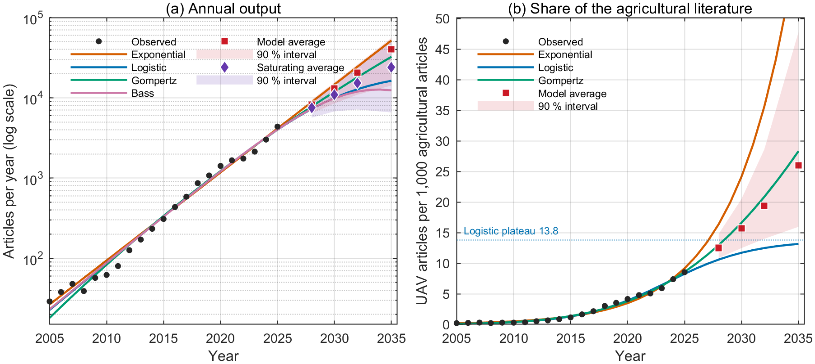
Figure 1. Annual output of agricultural drone research (a) and its share of the agricultural literature (b), with fitted growth models and forecasts to 2035
Source: Own calculations based on OpenAlex data
Figure 2 shows how seven application sub-domains penetrate the field. Crop monitoring and phenotyping is the largest: about one in four drone articles in 2025 deals with it. Spraying keeps a stable share of 160-185 per 1,000 articles. Irrigation and disease detection show the clearest upward trends, with shares that roughly doubled after 2019. Yield prediction grew fastest in absolute terms, by 51 percent per year since 2015, while weed detection and livestock lost relative weight. Penetration curves normalized by the host literature of each sub-domain are analyzed in a companion paper (Jelić et al., In Press-b).
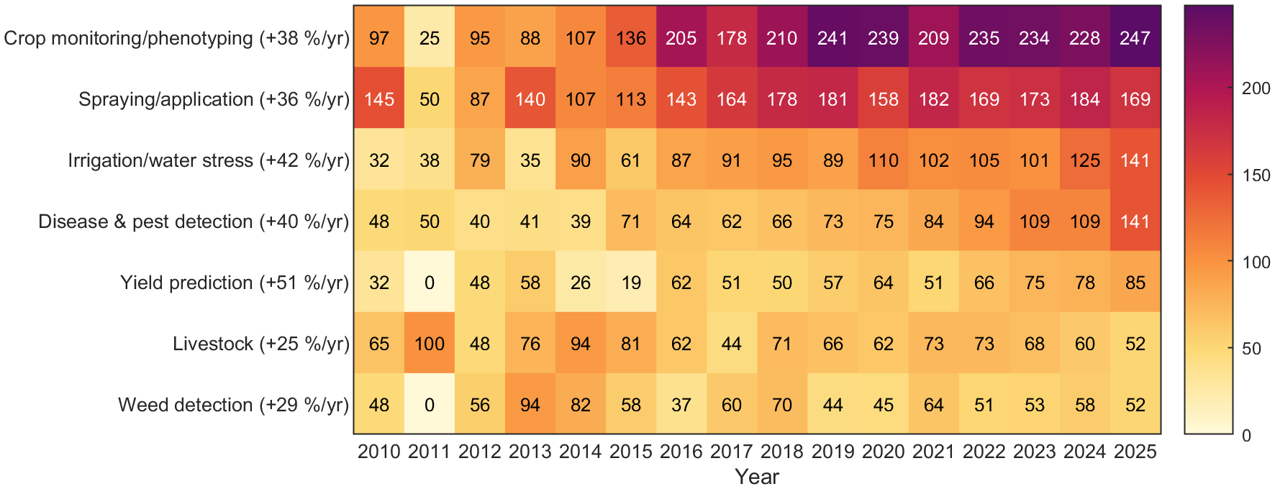
Figure 2. Penetration of seven application sub-domains, articles per 1,000 agricultural drone articles, 2010-2025 (compound annual growth 2015-2025 in brackets)
Source: Own calculations based on OpenAlex data
4.2. Keyword Structure
The co-occurrence network (Figure 3) contains 1,266 links between the 60 most frequent keywords and divides into five themes. The largest, spectral monitoring and phenotyping, groups vegetation indices, NDVI, multispectral imagery, leaf area index and random forest models with major crops (maize, wheat, rice, soybean) and with yield prediction. It is the methodological core of the field. Smart farming links crop monitoring with the Internet of Things, artificial intelligence, sustainability, food security and smallholder farmers, which is the managerial view of the field. Computer vision joins convolutional neural networks, object and small object detection, semantic segmentation and transfer learning with weed and plant disease detection and with edge computing. Spraying and flight operations links pesticide application and crop protection with flight altitude and quadrotor platforms, and it also holds precision agriculture, the hub that connects all themes. The smallest theme, imaging sensors, groups multispectral, hyperspectral and thermal imaging with LiDAR.
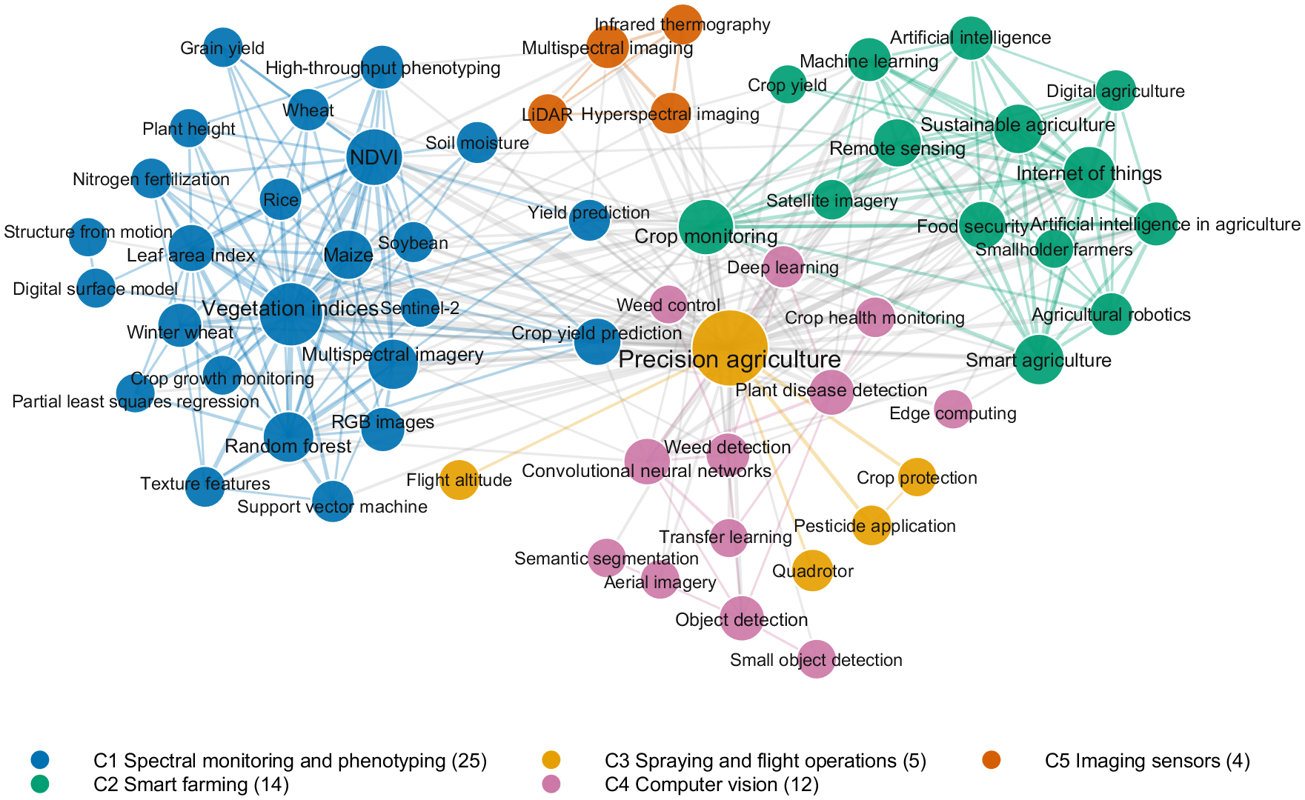
Figure 3. Keyword co-occurrence network of agricultural drone research, 60 most frequent keywords; node size shows frequency, color shows the Louvain cluster
Source: Own calculations based on OpenAlex data
4.3. Thematic Evolution and Emerging Topics
Figure 4 follows the themes through five periods. Until 2014, one broad theme of crop monitoring with vegetation indices dominated, next to small agronomic clusters and image stitching. Between 2015 and 2019 the field differentiated into vegetation indices, multispectral imagery, structure from motion and weed detection. In 2020-2022, convolutional neural networks and object detection formed a distinct theme for the first time. Since 2023, machine learning has merged with plant disease detection. In 2025-2026, the smart-farming cluster around the Internet of Things and crop monitoring holds almost half of all keyword occurrences, plant disease detection with convolutional neural networks has become the third largest theme, and LiDAR with hyperspectral imaging appears as a separate sensor theme.
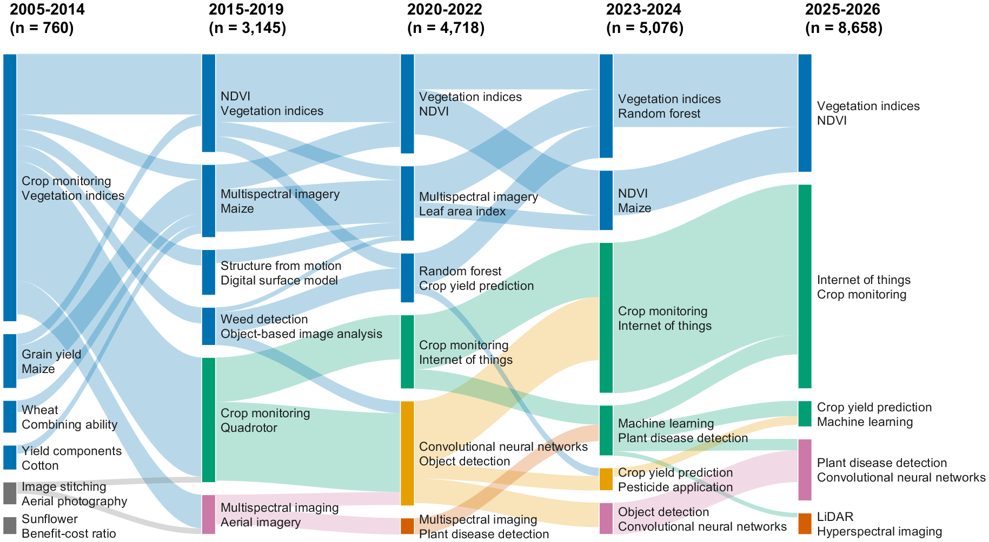
Figure 4. Thematic evolution of keyword clusters across five periods; box height shows the share of keyword occurrences in the period, bands show shared keywords
Source: Own calculations based on OpenAlex data
The heatmap (Figure 5) shows the latest shift year by year. Vegetation indices, NDVI and crop monitoring have lost share since 2021, while the Internet of Things, food security and sustainable agriculture kept rising. The fastest risers are recent detection architectures (YOLOv8 and YOLOv11), lightweight and small object detection, XGBoost, edge computing, digital twins and explainable AI. The rise of technology adoption barriers shows that the economic side of drone use is entering the research agenda.
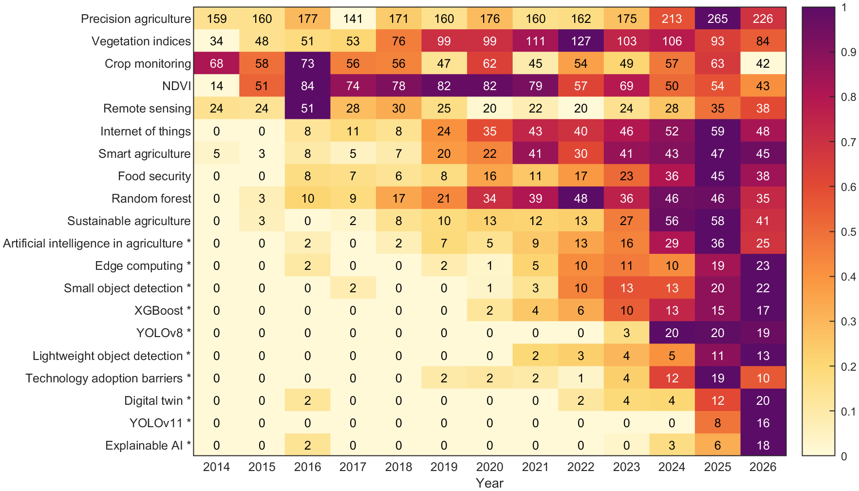
Figure 5. Established and emerging (*) keywords, articles per 1,000 agricultural drone articles per year (2026: January-October); color is scaled to the maximum of each row
Source: Own calculations based on OpenAlex data
4.4. Growth Forecasts to 2035
For annual output, no model dominates. The exponential model has the largest QAIC_{c} weight (0.39), followed by Gompertz (0.29), logistic (0.16) and Bass (0.15). Backtesting errors from the latest origin (2022) were 11-26 percent, against 32-44 percent from earlier origins, so the reliable horizon is about three years. The models agree on 2028 and diverge afterwards (Table 1). The share analysis, however, rejects the exponential path. The logistic model dominates the share (weight 0.91) and gives a plateau of 13.8 articles per 1,000 agricultural articles, with the inflection in 2023-2024. The observed share in 2025 is 62 percent of this plateau. The long-horizon forecast is therefore the average of the three saturating models, 24,023 articles in 2035.
Table 1. Forecast annual output and 90 percent bootstrap intervals
Model | 2028 | 2030 | 2032 | 2035
Exponential | 8,850 | 14,660 | 24,290 | 51,810
Logistic | 7,258 | 9,977 | 12,770 | 16,320
Gompertz | 7,783 | 11,910 | 17,960 | 32,460
Bass | 7,304 | 9,871 | 11,950 | 12,380
Model average | 8,237 | 13,069 | 20,534 | 40,261
90 % interval | 6,422-9,457 | 8,523-15,673 | 10,910-25,949 | 14,213-55,954
Saturating average | 7,505 | 10,874 | 15,250 | 24,023
90 % interval | 5,660-9,183 | 6,775-15,191 | 7,159-25,087 | 6,570-52,895
Source: Own calculations
The saturating shape is robust, but its level is provisional. Without the 2025 observation, which is partly an indexing artifact, the plateau falls to 11.6 per 1,000, and under broader denominators the field sits at 38-42 percent of its plateau. All variants place agricultural drone research on the steep part of its adoption curve.
5. DISCUSSION
The results lead to three conclusions for practice. First, the field is still growing fast, but it has passed its inflection point. If the agricultural literature keeps growing at 4.7 percent per year, the share forecast implies 13,000-38,800 articles in 2035, which brackets the saturating average. The near future is growth at a slowing rate, not an endless exponential.
Second, research is moving from mapping to prediction and detection. For agribusiness, the value of a drone lies less in the aircraft and more in the analytics that turn images into decisions. Service models that combine flights, trained models and agronomic advice are likely to capture this value, especially for small farms that cannot justify their own equipment (Hunt & Daughtry, 2018). Edge computing and lightweight detection models point to real-time decisions in the field.
Third, regulation shapes where growth can go. Spraying accounts for about one in six drone articles and dominates commercial use in East Asia (Hu et al., 2022). In the European Union it requires a derogation (Directive 2009/128/EC, 2009) and falls into the specific category of drone operations (Commission Implementing Regulation (EU) 2019/947, 2019). European adopters, including Croatian farms, should therefore focus on sensing, such as disease, irrigation and yield monitoring of vineyards and olive groves, where the value per hectare is highest.
The study has four limitations. It relies on one index and one query with a precision of about 61 percent. The 2025 observation is partly an indexing artifact. OpenAlex keywords are assigned automatically and may differ from author keywords. Finally, growth curves cannot anticipate regulatory shocks, such as a European opening towards drone spraying.
6. FUTURE RESEARCH DIRECTIONS
The keyword analysis should be repeated with author keywords from Scopus or Web of Science to test the stability of the themes. Linking publication trends with drone sales, service prices and farm-level adoption data would show whether research leads or follows the market. The rise of computer-vision keywords calls for an analysis of model architectures, including transformers, and of their transfer between crops and regions. Finally, the archived pipeline allows the forecasts to be updated every year.
7. CONCLUSION
Research on agricultural drones grew by 28.5 percent per year between 2005 and 2025. The field is organized around five themes: spectral monitoring and phenotyping, smart farming, computer vision, spraying and flight operations, and imaging sensors. Its focus is moving from vegetation indices towards deep learning, object detection and disease monitoring, while economic topics such as adoption barriers are emerging. The share of drone studies in the agricultural literature approaches a plateau of about 14 per 1,000 articles, 62 percent of which has been reached, and the saturating models forecast about 24,000 articles in 2035. For managers and policy makers, the next decade of value creation lies in analytics, services and regulation-compatible sensing rather than in the aircraft itself.
Acknowledgment
The authors used generative AI tools (Anthropic Claude) for data retrieval scripting, statistical code generation and language editing. All analyses were executed and verified by the authors, who take full responsibility for the content.
References
Aria, M., & Cuccurullo, C. (2017). bibliometrix: An R-tool for comprehensive science mapping analysis. Journal of Informetrics, 11(4), 959-975. https://doi.org/10.1016/j.joi.2017.08.007
Bass, F. M. (1969). A new product growth for model consumer durables. Management Science, 15(5), 215-227. https://doi.org/10.1287/mnsc.15.5.215
Blondel, V. D., Guillaume, J.-L., Lambiotte, R., & Lefebvre, E. (2008). Fast unfolding of communities in large networks. Journal of Statistical Mechanics: Theory and Experiment, 2008(10), P10008. https://doi.org/10.1088/1742-5468/2008/10/P10008
Bornmann, L., & Mutz, R. (2015). Growth rates of modern science: A bibliometric analysis based on the number of publications and cited references. Journal of the Association for Information Science and Technology, 66(11), 2215-2222. https://doi.org/10.1002/asi.23329
Burnham, K. P., & Anderson, D. R. (2002). Model selection and multimodel inference: A practical information-theoretic approach (2nd ed.). New York, NY: Springer. https://doi.org/10.1007/b97636
Cobo, M. J., López-Herrera, A. G., Herrera-Viedma, E., & Herrera, F. (2011). An approach for detecting, quantifying, and visualizing the evolution of a research field: A practical application to the Fuzzy Sets Theory field. Journal of Informetrics, 5(1), 146-166. https://doi.org/10.1016/j.joi.2010.10.002
Commission Implementing Regulation (EU) 2019/947 of 24 May 2019 on the rules and procedures for the operation of unmanned aircraft. (2019). Official Journal of the European Union, L 152, 45-71. http://data.europa.eu/eli/reg_impl/2019/947/oj
Directive 2009/128/EC of the European Parliament and of the Council of 21 October 2009 establishing a framework for Community action to achieve the sustainable use of pesticides. (2009). Official Journal of the European Union, L 309, 71-86. http://data.europa.eu/eli/dir/2009/128/oj
DJI Agriculture. (2025). DJI Agriculture's annual report reveals drone-powered farming revolution at Brazil's Agrishow 2025 [Press release]. https://www.mynewsdesk.com/uk/dji/news/dji-agricultures-annual-report-reveals-drone-powered-farming-revolution-at-brazils-agrishow-2025-496808
Hafeez, A., Husain, M. A., Singh, S. P., Chauhan, A., Khan, M. T., Kumar, N., Chauhan, A., & Soni, S. K. (2023). Implementation of drone technology for farm monitoring & pesticide spraying: A review. Information Processing in Agriculture, 10(2), 192-203. https://doi.org/10.1016/j.inpa.2022.02.002
Hu, P., Zhang, R., Yang, J., & Chen, L. (2022). Development status and key technologies of plant protection UAVs in China: A review. Drones, 6(11), 354. https://doi.org/10.3390/drones6110354
Hunt, E. R., & Daughtry, C. S. T. (2018). What good are unmanned aircraft systems for agricultural remote sensing and precision agriculture? International Journal of Remote Sensing, 39(15-16), 5345-5376. https://doi.org/10.1080/01431161.2017.1410300
Hyndman, R. J., & Koehler, A. B. (2006). Another look at measures of forecast accuracy. International Journal of Forecasting, 22(4), 679-688. https://doi.org/10.1016/j.ijforecast.2006.03.001
Jacomy, M., Venturini, T., Heymann, S., & Bastian, M. (2014). ForceAtlas2, a continuous graph layout algorithm for handy network visualization designed for the Gephi software. PLoS ONE, 9(6), e98679. https://doi.org/10.1371/journal.pone.0098679
Jelić, M., Uroš, V., & Mandinić, S. (In Press-a). Drones in agriculture: Bibliometric state of the art and growth forecasts to 2035. In Proceedings of the MIPRO 2026 Convention. IEEE.
Jelić, M., Uroš, V., & Mandinić, S. (In Press-b). Bibliometric penetration curves and growth forecasts to 2035 for unmanned aerial vehicles in seven agricultural sub-domains. Radovi Poljoprivredno-prehrambenog fakulteta Univerziteta u Sarajevu (Works of the Faculty of Agriculture and Food Sciences, University of Sarajevo).
Maes, W. H., & Steppe, K. (2019). Perspectives for remote sensing with unmanned aerial vehicles in precision agriculture. Trends in Plant Science, 24(2), 152-164. https://doi.org/10.1016/j.tplants.2018.11.007
Maimaitijiang, M., Sagan, V., Sidike, P., Hartling, S., Esposito, F., & Fritschi, F. B. (2020). Soybean yield prediction from UAV using multimodal data fusion and deep learning. Remote Sensing of Environment, 237, 111599. https://doi.org/10.1016/j.rse.2019.111599
Meade, N., & Islam, T. (2006). Modelling and forecasting the diffusion of innovation: A 25-year review. International Journal of Forecasting, 22(3), 519-545. https://doi.org/10.1016/j.ijforecast.2006.01.005
Priem, J., Piwowar, H., & Orr, R. (2022). OpenAlex: A fully-open index of scholarly works, authors, venues, institutions, and concepts (arXiv:2205.01833). arXiv. https://doi.org/10.48550/arXiv.2205.01833
Rejeb, A., Abdollahi, A., Rejeb, K., & Treiblmaier, H. (2022). Drones in agriculture: A review and bibliometric analysis. Computers and Electronics in Agriculture, 198, 107017. https://doi.org/10.1016/j.compag.2022.107017
Shahi, T. B., Xu, C.-Y., Neupane, A., & Guo, W. (2022). Machine learning methods for precision agriculture with UAV imagery: A review. Electronic Research Archive, 30(12), 4277-4317. https://doi.org/10.3934/era.2022218
Tsouros, D. C., Bibi, S., & Sarigiannidis, P. G. (2019). A review on UAV-based applications for precision agriculture. Information, 10(11), 349. https://doi.org/10.3390/info10110349
Uroš, V., & Jelić, M. (2026). drone-agriculture-forecast: Bibliometric data and MATLAB growth-model pipeline for UAV research in agriculture (Version v1.1-matlab) [Data set and software]. Zenodo. https://doi.org/10.5281/zenodo.22238128
van Eck, N. J., & Waltman, L. (2009). How to normalize cooccurrence data? An analysis of some well-known similarity measures. Journal of the American Society for Information Science and Technology, 60(8), 1635-1651. https://doi.org/10.1002/asi.21075
Zhang, C., & Kovacs, J. M. (2012). The application of small unmanned aerial systems for precision agriculture: A review. Precision Agriculture, 13(6), 693-712. https://doi.org/10.1007/s11119-012-9274-5

University of Applied Sciences "Marko Marulić" in Knin, Petra Krešimira IV 30, 22300 Knin, Croatia; University of Zagreb, Faculty of Organization and Informatics, Pavlinska 2, 42000 Varaždin, Croatia, vuros@veleknin.hr
University of Applied Sciences "Marko Marulić" in Knin, Petra Krešimira IV 30, 22300 Knin, Croatia, mjelic@veleknin.hr
University of Applied Sciences "Marko Marulić" in Knin, Petra Krešimira IV 30, 22300 Knin, Croatia; University of Zagreb, Faculty of Agriculture, Svetošimunska cesta 25, 10000 Zagreb, Croatia, smandini@veleknin.hr

