Product Requirements Document (PRD)
Data Model Visualizer in Reltio Data Modeler

Field | Value
Product/Feature Name | Data Model Visualizer in Reltio Data Modeler
Document Author | Somasekhar
Date | 2026-05-18
Version | 0.3 (Draft)
Status | Draft — net-new feature inside an existing product
Parent product | Reltio Multidomain Master Data Management / Reltio Intelligent 360™ (the feature ships with Reltio Data Modeler in Reltio Console)
References | Current Reltio Data Modeler UI (see Appendix · Related documents)

Executive Summary
Add a Data Model Visualizer to Reltio Data Modeler that lets users visually explore the tenant's configured data model as an interactive graph. The visualizer helps users understand how entity types, relationship types, interaction types, reference data, and sources are connected, without requiring them to inspect each object separately in list/detail pages.

The feature is added inside Data Modeler, not as a separate application, because Reltio Data Modeler is already the Console application used to review and update the tenant data model — including entities, relationships, sources, match rules, import configuration, and download configuration.

Background
Reltio tenants can contain many entity types, relationship types, interaction types, sources, and reference data objects. Today, users can manage these objects in Data Modeler, but understanding the complete model requires moving across multiple pages and mentally connecting the pieces.

Users need a visual way to answer questions such as:
- Which entities exist in this tenant?
- How are entities such as Individual, Organization, Location, Household, Product, Supplier, and Product Category connected?
- Which relationship types connect two entity types?
- Which objects are isolated or over-connected?
- Which source/schema objects are mapped to which Reltio model objects, where mapping information is available?
- Where should I go if I need to edit a specific entity type, relationship type, attribute, source, or match rule?
Reltio already describes the data model as supporting real-world entities, relationships between them, and interactions that occur against them. The Data Model Visualizer should make that structure easier to understand visually inside the Data Modeler.

Goals
The Data Model Visualizer should:
- Provide a visual graph of the tenant's configured data model.
- Show entity types and the relationships between them.
- Support discovery of interaction types, reference data, and sources where applicable.
- Allow filtering, searching, zooming, panning, and layout changes.
- Allow users to inspect object details in a side panel.
- Route edit intent to the existing Data Modeler object pages.
- Avoid duplicating existing Data Modeler configuration import/export capabilities.
- Serve as a read-only exploration and navigation experience for MVP.

Non-goals
The MVP should not:
- Replace existing Data Modeler list/detail pages.
- Support direct editing on the graph canvas.
- Introduce a separate configuration import/export flow.
- Download ontology diagrams, ontology metadata, or mapping files.
- Auto-generate or apply schema mappings.
- Modify tenant configuration from the visualizer.
- Replace Reltio Hub graph/profile relationship views — Reltio Hub already has graph-oriented experiences for visualizing profile/entity relationships, and Reltio Hub's Data Model view also provides a graphic representation of how tenant entities, relationships, and interactions relate to each other. The Data model Visualizer focuses on visualizing the configured data model inside the Data Modeler.

Recommended MVP Decision
Build the Data Model Visualizer as a read-only visual exploration layer inside Data Modeler. The MVP focuses on:
- Visualizing the model
- Helping users understand relationships
- Filtering and searching
- Inspecting object details
- Routing users to existing Data Modeler pages for edits

Acceptance Criteria
Detailed Given/When/Then acceptance criteria appear inline under each FR in §Functional Requirements. Summary-level:

AC1 — Authenticated entry into the Visualizer
- Given a Reltio Administrator / Configurator is signed into Reltio Console with permission to view Data Modeler for tenant
- When they open Data Modeler for tenant and navigate to the Data Model Visualizer tab
- Then the Visualizer renders the active L3 of the tenant as an interactive graph within the Data Modeler shell, respecting any RBAC scoping on entity types the user is not entitled to see.

AC2 — RBAC parity with Data Modeler
- Given a user has restricted role from seeing entity type
- When a user holding role opens the Visualizer
- Then the entity does not appear in the graph, in the side panel, or in any filter list, identical to how it is hidden in Data Modeler's existing surfaces.

AC3 — Click-to-edit hand-off
- Given the Visualizer has rendered the L3 graph
- When the user clicks any entity, relationship, attribute (in graph or side panel), interaction, source, or reference data
- Then an action in the side panel deep-links them into the corresponding existing Data Modeler page with that element pre-selected (see §FR17).

AC4 — Read-only on the canvas
- Given the Visualizer is the active view
- When any user attempts to mutate the model (rename, add relationship, add attribute) via the canvas
- Then no such affordance is presented; all mutation paths route through Data Modeler's existing object pages via the click-to-edit hand-off (AC3).

AC5 — Context preservation across navigation
- Given a user has applied filters, chosen a layout, selected an object, and clicked "Open entity type"
- When they navigate back to the Data Model Visualizer tab
- Then their tenant, selected object, active filters, layout, edge style, search term, and (where technically feasible) zoom level are preserved.

Target Audience & Use Case

User Personas
Solution Architect
Needs to understand the full tenant model, validate entity/relationship design, and explain the model to business and technical stakeholders.

Reltio Administrator / Configurator
Needs to manage entity types, relationship types, attributes, sources, match rules, and related configuration objects. Owns the tenant's L3 in Data Modeler and is the primary day-to-day user of the Visualizer for audit, debugging, and reviewing the model. RBAC, permissions, and SSO concerns sit with this role.

Implementation Consultant
Needs to onboard quickly to an existing tenant and identify how the customer's model is structured. Often a partner-side persona on a new engagement; the Visualizer’s value is acute here because the consultant has no prior context.

Business Data Steward
Needs a readable, visual view of business objects and relationships without reading JSON configuration. Uses the Visualizer as a reading surface inside Data Modeler (in scope for MVP read-only). Distinct from Hub-UI data quality workflows, which remain out of scope.

Data Governance Lead
Needs to review model coverage, connectedness, source participation, and ownership patterns across the tenant; uses the Visualizer for portfolio-level review and gap identification.

User Stories
Model overview
As a Solution Architect, I want to see all entity types and relationships in one diagram so that I can quickly understand the tenant model.

As a Reltio Administrator / Configurator, I want to filter the graph by entity type, relationship type, interaction type, reference data, and source so that I can focus on a specific area.

As an Implementation Consultant, I want to change graph layouts so that dense models become easier to read.

Object inspection
As a user, I want to click an entity type node and see its attributes, relationships, sources, and match-rule summary so that I can inspect the model without leaving the graph.

As a user, I want to click a relationship edge and see the relationship type, start object, end object, direction, and attributes so that I can understand the relationship definition. Reltio relationship types have start and end objects and defined direction (directed, bidirectional, unidirectional).

Editing intent
As a Reltio Administrator / Configurator, I want to open the selected object in the existing Data Modeler edit page so that I can make changes using the supported configuration workflow.

As a user, I want the Visualizer to preserve my graph context when I navigate away and return so that I do not lose my selected object, filters, or layout.

Search and discovery
As a user, I want to search for an entity type, relationship type, source, or attribute so that I can quickly locate it in a large model.

Filtering
As a user, I want to hide irrelevant object types or relationships so that I can simplify the diagram.

Edge Cases
Edge case | Handling
Very large tenant model (e.g., 200+ entity types, 5,000+ attributes) | Filter-first navigation; grouped relationship badges (§FR7); "show selected neighborhood only" mode; perf budget enforced (see §NFR Performance).
Restricted user (RBAC hides entity types) | Hidden entities, their attributes, and any relationships they participate in are removed from the graph, side panel, and filter lists. Counts in the header reflect the restricted view. The user is not told what they cannot see.
Empty tenant (no entities configured) | Empty state with copy: "No entity types or relationship types are available yet. Add entity types and relationship types in Data Modeler to visualize the model."
L3 change happens while the Visualizer is open | Either auto-refresh on tab focus or a "Model changed — refresh?" non-blocking banner (mechanism choice in §FR19). Stale state is never silently rendered.
Multi-tenant user with access to multiple tenants | The Visualizer follows Data Modeler's tenant scoping: one tenant at a time, switched via the existing top-bar tenant switcher. Cross-tenant overlay is out of scope.
Disconnected components (entity types with no relationships) | Rendered as isolated nodes in the chosen layout; not hidden. Side panel surfaces this explicitly.
Click-to-edit on an element with no edit page in Data Modeler | Side panel shows read-only details with an explicit "Edit not yet supported in Data Modeler" notice instead of a broken link.
Reference data with very large code lists | Reference-data nodes show count + first N entries in side panel; full list opens in the existing Data Modeler reference-data editor.
Multiple relationship types between the same two entities | Grouped into a single edge with a numeric badge; selecting the badge expands the list in side panel or compact popover (see §FR7, §FR14).
Color-blind users | Color paired with shape/icon for every node type (entity / interaction / reference data / source / relationship), per existing Reltio design system tokens.

Functional Requirements

FR1 — Recommended placement in Data Modeler
Primary entry: Console → Configuration applications → Data Modeler → Data Model Visualizer
Add Data Model Visualizer as a first-class tab / navigation item inside Data Modeler. Proposed Data Modeler left nav (additive — no re-ordering of existing items):
Entity types
Relationship types
Graph types
Grouping types
Sources
Data Model Visualizer ← new
──────────────
Import Configuration
Download Configuration

This placement is preferred because Data Modeler is already the primary configuration area for managing entity types, relationship types, and sources, and the Data Model Visualizer renders exactly the configuration objects those existing surfaces manage.

Secondary entry points — View in Data Model Visualizer from existing object pages
- Entity type detail page → View in Data Model Visualizer
- Relationship type detail page → View in Data Model Visualizer
- Source detail page → View in Data Model Visualizer

Why not a separate application?
The Data Model Visualizer represents the same tenant data model that Data Modeler already manages. Creating a separate application could create confusion between "Data Modeler" and a separate ontology product. The intended product model is:
- Data Modeler = configure and review the model
- Data Model Visualizer tab = visually explore the model

ID | Requirement
FR1.1 | The Data Model Visualizer tab is a new top-level entry inside the Reltio Data Modeler module sidebar, inserted in the existing left nav before the Import / Download Configuration separator (no re-ordering of existing items).
FR1.2 | The tab uses a network / node-and-edge icon distinct from the Graph types icon (per Reltio design system; final asset [AWAITING UXD INPUT]).
FR1.3 | The Data Model Visualizer uses the standard Console application shell (top bar, tenant switcher, account menu) — no custom chrome. The Data Modeler left nav (with the new Data Model Visualizer entry highlighted) remains visible.
FR1.4 | The currently selected tenant is the tenant whose model is rendered. Switching tenants via the existing top-bar tenant switcher reloads the Data Model Visualizer for the new tenant.
FR1.5 | The Data Model Visualizer URL is deep-linkable. Suggested route: console.reltio.com/<tenant>/data-modeler/visualizer. The route must accept optional query parameters for layout, edge style, filters, search term, and selected element so that context can be restored on return (§FR18). Exact route per Console URL conventions [TO BE DETERMINED - Owner: Eng].
FR1.6 | Breadcrumb / page title follows Data Modeler conventions (e.g., Data Modeler / Visualizer). The "+ CREATE NEW" affordance present on component-type pages is not shown in the Data Model Visualizer (read-only surface).
FR1.7 | Secondary entry: each supported existing Data Modeler object page gains a View in Data Model Visualizer action that opens the Data Model Visualizer with the originating object selected and (where appropriate) filtered to its immediate neighborhood. Coverage matrix per §FR17; MVP coverage decision tracked as Open Question 6.

FR2 — Data Model Visualizer tab
The Data Model Visualizer tab loads a visual graph based on the selected tenant's current data model configuration. The graph supports:
- Entity types
- Relationship types
- Interaction types
- Reference data
- Sources, where applicable
- Source schema mapping metadata, only where such mapping data is available (see §FR13)

FR3 — Read-only MVP behavior
The Data Model Visualizer must be read-only for MVP. Users must not be able to directly create, edit, or delete model objects on the graph canvas.
The Data Model Visualizer may expose actions such as:
- Open entity type
- Open relationship type
- Open source
These actions route the user to the corresponding existing Data Modeler page (see §FR17).

FR4 — Diagram and List modes
A view toggle is provided in the Data Model Visualizer header:
List | Diagram
- Diagram mode — interactive ontology graph (default).
- List mode — structured list of model objects represented in the Data Model Visualizer view; valuable for accessibility, search-heavy workflows, and users who prefer tabular inspection.
List mode is the primary accessibility-equivalent surface for users who cannot consume the canvas; it supports full keyboard navigation, semantic headings per section, and screen-reader announcements for counts and selection. List mode does not replicate the per-type pages' "+ CREATE NEW" or "ANALYZE MATCH STRATEGY" affordances — those remain on the existing per-type pages.

FR5 — Header summary (model-level counts)
Show model-level counts at the top of the Data Model Visualizer. Recommended counts:
- Entities
- Relationships
- Interactions
- Reference Data
- Sources
Counts update based on active filters and the user's RBAC-filtered view.

FR6 — Graph nodes
Each node represents a model object.

Minimum supported node types for MVP
- Entity type
- Interaction type
- Reference data

Optional node types for MVP
- Source
- Source schema object

Each node shows
- Object display name
- Object type icon
- Object category color
- Optional count badge, where useful (e.g., number of attributes on an entity)

Example node labels: Individual · Organization · Location · Household · Product · Supplier · Product Category · Material

FR7 — Graph edges
Each edge represents a relationship between model objects. For relationship edges, the graph shows:
- Direction (directed · bidirectional · unidirectional, per Reltio relationship-type definitions)
- Relationship type label
- Start object and end object
- Count badge when multiple relationships exist between the same two nodes
When multiple relationship types exist between the same two nodes, the graph groups them and shows a numeric badge. Selecting the badge shows the list of relationship types in the side panel or a compact popover.

FR8 — Layout controls
Provide layout options:
- Radial (default)
- Hierarchical
- Force
- Stress
- Tree
The user's most recent layout selection is remembered for the current browser/session and tenant.

FR9 — Edge style controls
Provide edge style options:
- Orthogonal
- Splines
- Polyline (default, unless usability testing shows another style is more readable for dense tenant models)

FR10 — Filter panel
Provide a collapsible filter panel on the left of the canvas.
Filter categories
- Entity types
- Relationship types
- Interaction types
- Reference data
- Sources
Each filter section supports
- Search within the section
- Select all
- Clear all
- Individual checkbox selection
- Object count per item
- Collapse / expand
The filter panel allows users to quickly reduce graph complexity. Filter state is session-persisted per (user × tenant); resets on tenant switch.

FR11 — Search
Provide global search within the Data Model Visualizer. Search supports:
- Entity type name
- Relationship type name
- Attribute name
- Source name
- Source schema object name, where available
- Reference data name
- Interaction type name
Selecting a result:
- Focuses the matching object in the graph.
- Highlights the object.
- Opens the details side panel for that object.

FR12 — Details side panel
Clicking a node or edge opens a right-side details panel.
Entity type details — for an entity type node:
- Entity type name
- Description
- Attribute summary
- Relationship summary
- Source summary
- Match rule summary, where available
- Actions: Open entity type · View related relationships · View sources · View match rules

Relationship type details — for a relationship edge:
- Relationship type name
- Description
- Start object · End object · Direction
- Attribute summary
- Actions: Open relationship type · View connected entity types

Source details — for a source node or source-related view:
- Source name
- Connected entity types
- Connected attributes or mappings, where available
- Action: Open source

Attribute details — for an attribute selected from the side panel:
- Attribute name
- Attribute type
- Owning entity type or relationship type
- Description, where available
- Action: Open attribute owner — navigates to the owning object page and focuses the attribute only where technically feasible.

FR13 — Source schema and mapping view (inspection-only)
The Data Model Visualizer may include a mapping-focused inspection panel when source-schema mapping metadata is available in the tenant. This is treated as an inspection capability, not as an editing or import/export capability.

Recommended panel structure
- Tabs: Attributes · Derived
- Columns: Source schema · Reltio · Match / confidence (where available)
This view helps users understand source-to-Reltio alignment but does not apply mappings directly in MVP. Inclusion of source-schema mapping in MVP vs. Post-MVP is tracked as Open Question 8.

FR14 — Highlight and dim behavior
When a user selects a node
- Highlight the selected node.
- Highlight directly connected nodes.
- Highlight directly connected edges.
- Dim unrelated nodes and edges.

When a user selects an edge
- Highlight the selected edge.
- Highlight the connected start and end nodes.
- Show relationship details in the side panel.

When a user selects a grouped relationship badge
- Show the grouped relationship types.
- Allow one relationship type to be selected for inspection.

FR15 — Zoom and pan
Support standard canvas navigation:
- Zoom in / Zoom out
- Fit to screen
- Reset view
- Pan canvas

FR16 — Configuration import/export alignment
The Data Model Visualizer must not introduce a separate tenant configuration import or export workflow. Users who need to import or download tenant configuration continue using the existing Data Modeler capabilities.
For MVP, the Data Model Visualizer does not include ontology-specific download options such as:
- Download diagram as PNG/SVG
- Download ontology metadata as JSON
- Download mapping as CSV/JSON
These are not required because Data Modeler already supports configuration import and download, and ontology-specific downloads could confuse the distinction between tenant configuration and visual artifacts. Optional future exports may be considered only after user validation and should be clearly labeled as visual or mapping exports, not configuration exports.

FR17 — Navigation to existing edit pages
The Data Model Visualizer routes all edit intent to existing Data Modeler pages.
Selected item | Primary action | Destination
Entity type node | Open entity type / Edit entity type | Existing Entity type detail/edit page
Relationship edge | Open relationship type / Edit relationship type | Existing Relationship type detail/edit page
Attribute | Open attribute owner | Owning entity or relationship type page
Source | Open source | Existing Source page
Match rule summary (in an entity type's side panel) | View match rules | Match rules section within that entity type's existing detail page in Data Modeler
Graph type reference | Open graph type | Existing Graph types page, where applicable

Reltio documentation notes that graph types can be defined in Data Modeler, so graph-type-related navigation routes to the existing Graph types area rather than creating a separate editing flow inside the ontology canvas.
The edit hand-off opens in the same Console tab by default; modifier-click (Cmd / Ctrl) opens in a new browser tab. After editing and returning, §FR18 (Context preservation) and §FR19 (Live consistency) govern the user experience.
Where Data Modeler does not currently expose an edit form for an element type (gap during rollout), the side panel shows element details with an explicit "Edit not yet supported in Data Modeler" notice rather than a broken link.

FR18 — Context preservation
When users navigate from the Data Model Visualizer to an object page and return, the Data Model Visualizer preserves:
- Selected tenant
- Selected object
- Active filters
- Layout
- Edge style
- Zoom level, where technically feasible
- Previous search term, where applicable

FR19 — Live consistency with edits
ID | Requirement
FR19.1 | When the user edits L3 in Data Modeler (via the click-to-edit hand-off or any other path) and returns to the Data Model Visualizer, the Visualizer surfaces the change without requiring a hard browser refresh.
FR19.2 | Mechanism options (pick during eng grooming): (a) auto-fetch on tab focus, (b) lightweight polling, (c) server push via existing Console real-time channel if available, (d) "Model changed — refresh?" banner with one-click refresh. [TO BE DETERMINED - Owner: Eng]
FR19.3 | The Visualizer never silently renders stale L3. If the underlying L3 version is older than the latest, surface that state.
FR19.4 | On L3 change, the Visualizer attempts to preserve user state per §FR18.

MVP scope
In scope for MVP
- Data Model Visualizer tab inside Data Modeler
- Diagram view
- List view
- Entity type nodes
- Relationship edges
- Interaction type visibility
- Reference data visibility
- Header counts
- Filter panel
- Search
- Layout selector
- Edge style selector
- Node details panel
- Edge details panel
- Highlight / dim behavior
- Zoom, pan, fit to screen
- Navigation to existing Data Modeler object pages
- Context preservation when returning from object pages
- Read-only behavior

Out of scope for MVP
- Direct graph editing
- Creating entities or relationships from the graph
- Deleting model objects from the graph
- Upload schema
- Mapping recommendation
- Download diagram
- Download ontology metadata
- Download source-to-Reltio mapping
- Separate ontology import/export
- AI-generated model changes
- Applying configuration changes from the visualizer

Behavior under different scenarios
Normal flow. A Reltio Administrator / Configurator opens Data Modeler for tenant T, clicks the new Data Model Visualizer tab, sees the model as a Radial Polyline graph, filters to organization-centric relationships, clicks Organization, reviews attributes and relationships in the side panel, finds an attribute that needs a tweak, clicks Open attribute owner, lands in the existing Data Modeler attribute form, saves, returns to Data Model Visualizer, and finds their selection / filters / layout preserved.

Restricted user. A user holds an RBAC role that hides one or more entity types in the tenant's L3. The graph renders without those entity types and without any relationships incident on them. The Entity-type count in the header decreases accordingly. Filters and side panel never reveal the hidden entity types, and the user is not told what they cannot see.

Empty tenant. A freshly provisioned tenant with no L3 yet shows the empty state copy and routes the user to add entity types via Data Modeler.

Concurrent change. The user is reviewing the Data Model Visualizer while a teammate promotes an L3 change. §FR19 kicks in — the user is notified the model changed and refreshes (or auto-refresh applies). Selected elements, filters, and layout are preserved where possible.

Edit gap. The user clicks Edit on a row for an element type that Data Modeler's current UI does not yet support editing. The side panel shows the read-only details and a clear "Edit not yet supported in Data Modeler" notice.

Large model. Tenant has 180 entity types and 4,300 attributes. The Data Model Visualizer renders progressively (entity types first, then edges), virtualizes side-panel attribute lists, and prompts the user to apply a filter or use "show selected neighborhood only" to keep the canvas readable.

Non-Functional Requirements

Performance Expectations
Metric | Target
Visualizer first paint (P75, 8 entities / 28 relationships) | ≤ 1.5s
Visualizer first paint (P75, 50 entities / 300 relationships) | ≤ 3.0s
Visualizer first paint (P75, 200 entities / 5,000 relationships) | ≤ 6.0s (with virtualization & progressive render)
Layout / Edges re-flow | ≤ 1.0s
Filter apply / clear | ≤ 300ms
Search keystroke → result list | ≤ 200ms
Side-panel open on node click | ≤ 200ms
Side-panel attribute list scroll | smooth at 60 fps with virtualization for attribute counts > 100
Click-to-edit hand-off (Visualizer → Data Modeler page) | ≤ 500ms route navigation

Scalability
- Must handle the largest tenant model in the install base today without regression of existing Data Modeler performance for users who do not open the Data Model Visualizer.
- Diagram rendering is client-side; backend impact is limited to the L3 fetch (reuses existing Configuration API).
- Attribute counts in the side panel must virtualize; entity types with > 500 attributes (e.g., Supplier-style entities) must not block the UI.
- No server-side state added by the Data Model Visualizer beyond standard request-scoped read traffic.
- Maximum model size before the Data Model Visualizer requires filtered rendering is tracked as Open Question 7.

[MANDATORY] Security & permissions
The Data Model Visualizer follows existing Data Modeler permissions:
- Users with view access to Data Modeler can view the ontology.
- Users without edit permissions do not see edit actions, or edit actions are disabled.
- Users with edit permissions see actions that navigate to existing edit pages.
- The Data Model Visualizer itself does not directly modify tenant configuration in MVP.
Additional security posture:
- Inherits Console SSO (the user is already authenticated to Console before reaching the Data Model Visualizer).
- Inherits Data Modeler RBAC: any restriction applied to Data Modeler today applies identically to the Data Model Visualizer. The Data Model Visualizer must not act as a side-channel that exposes elements a user could not see in existing Data Modeler surfaces.
- The Data Model Visualizer reads L3 configuration metadata only; it reads no record-level data (no profile content, no transactions). Blast radius for any defect is configuration metadata only.
- All Visualizer → Data Modeler hand-off URLs respect tenant scope; tenant ID is never injectable from URL alone without the SSO session validating access.
- Standard Console hardening (CSP, CORS, frame-ancestors, etc.) applies. No new third-party scripts or origins.

[MANDATORY] Compliance & legal
- No change to Reltio's existing compliance posture. The Data Model Visualizer reads configuration metadata only; it does not process PHI, PII, or any regulated record data.
- HIPAA, GDPR, CCPA, MLPS for China: unaffected; the Data Model Visualizer falls under the parent Console product's existing scopes.
- Audit logging: Data Model Visualizer access is logged consistent with Data Modeler's existing logging (who viewed which tenant's L3, when). No new audit category required.

Sub-processor determination
- No new sub-processor introduced. The Data Model Visualizer is internal Reltio code rendering data from internal Reltio services.

Infrastructure & DevOps Requirements

API/Integration Requirements
Read APIs (existing — reused)
- The Data Model Visualizer reads from Reltio's existing Configuration API (the same API surface that powers Data Modeler today). No new public APIs are introduced.
- Specific endpoints: [TO BE DETERMINED - Owner: Eng] — confirm whether a single L3-aggregated read is preferred (server-composed view model) or multiple existing endpoints assembled client-side (Open Question 3).
No new write APIs
- The Data Model Visualizer issues no mutations against the Configuration API. All writes route through the existing Data Modeler edit pages via the click-to-edit hand-off.

System Architecture and Infrastructure
Major components
Component | Responsibility
Console front-end shell | Hosts the Data Model Visualizer like any other Console module; provides SSO, RBAC, tenant switcher, top bar.
Data Modeler module | Existing module; gains the Data Model Visualizer tab + UI.
Data Model Visualizer UI | New code in the Data Modeler module; renders the diagram and side panel; calls the L3 read API.
Front-end graph rendering capability | Reltio's standard graph rendering library / component used to draw the ontology.
Configuration API | Existing; serves L3 metadata for the current tenant.
Console telemetry / analytics | Existing pipeline; the Data Model Visualizer emits standard product-analytics events (see §Event logging).

Diagram (textual)
User (browser, signed into Console)
│
▼
[Console shell / SSO / RBAC]
│
▼
[Data Modeler module]
├─► Existing Data Modeler pages (Entity types, Relationship types, Graph types, Grouping types, Sources, ...)
└─► [Data Model Visualizer UI] ───► [Front-end graph rendering capability]
│
▼
[Configuration API] ──► tenant L3 metadata
│
▼
[Telemetry pipeline] ──► product analytics

[MANDATORY] Deployment & Provisioning Considerations
- The Data Model Visualizer ships as part of the Reltio Console release train; no separate deployment cadence.
- No new cloud accounts, regions, or environments introduced. The Data Model Visualizer is hosted wherever Console is hosted today.
- Feature-flag-gated rollout strongly recommended: dark launch → internal alpha → opt-in beta tenants → GA flip. Flag owned by Data Modeler PM.
- Roll-back: feature flag off — no DB migrations to revert.

Monitoring & Alerting
- Reuse Console's existing observability: page-load latency, JS error rate, API latency to the Configuration API endpoints the Data Model Visualizer touches.
- New SLOs: Data Model Visualizer first-paint P75 (target per §Performance); Configuration API read latency added by the Data Model Visualizer's queries; click-to-edit hand-off success rate (no broken-link rate).
- Alerts: JS error rate on the Data Model Visualizer page > 1% of sessions over 15 min; Configuration API latency P95 doubles over a baseline window; click-to-edit broken-link rate > 0.5%.

Business Outcomes and Success Metrics

[MANDATORY] Financial Business Outcomes
- Revenue impact: indirect. No new SKU. The Data Model Visualizer is an included feature of Reltio Multidomain Master Data Management and Reltio Intelligent 360™ (which already include Data Modeler). Expected to lift retention / NPS for Data Modeler users and reduce time-to-value for new Reltio implementations.
- Cost impact: modest. Net new investment is the embedding work in Data Modeler, the L3 read-path integration, click-to-edit wiring, and ongoing maintenance.
- Pricing: included; no separate SKU.

Success Metrics
Measured using:
Metric | Definition | Target — first 90 days post-GA | Source
Adoption | % of Data Modeler users who open the Data Model Visualizer tab at least once / month | ≥ 50% | Telemetry
Repeat usage | % of adopters who open the Visualizer ≥ 3× / week | ≥ 30% | Telemetry
Search engagement | Number of searches performed in the visualizer per session (median) | informational baseline | Telemetry
Filter engagement | Number of filters applied per session (median) | informational baseline | Telemetry
Click-to-edit conversion | % of Visualizer sessions resulting in ≥ 1 Open in Data Modeler navigation | ≥ 40% | Telemetry
Time-to-comprehension | Time spent understanding a new tenant model (qualitative, from PS/CS interviews) | reduction vs. baseline | Field feedback
Implementation/support questions about model structure | Reduction in tickets/support questions about how the tenant model is structured | qualitative; CS dashboard | Field feedback
User satisfaction | NPS / survey signal from administrators, solution architects, and consultants | ≥ +5 NPS lift among adopters | Survey

KPIs
- KPI-1: Adoption among Data Modeler users. % of monthly Data Modeler MAUs using the Data Model Visualizer.
- KPI-2: Visualization-driven editing. Volume of edits initiated from the Data Model Visualizer (§FR17 hand-off) as a share of all Data Modeler edits.
- KPI-3: Quality. JS error rate on the Data Model Visualizer page; click-to-edit broken-link rate.

Tracking Requirement
- KPIs tracked from the dark-launch milestone; baseline established during internal alpha.
- Tenant-level adoption visibility for Customer Success (which tenants are using it, which are not) via existing Console product-analytics dashboards.

Event Logging
Event | Properties
visualizer_opened | tenant_id_hash, entry_path (direct nav / deep-link / View in Data Model Visualizer secondary entry)
view_mode_toggled | from_mode, to_mode (list / diagram)
layout_changed | layout
edges_changed | edges_style
filter_applied | filter_type (entity / relationship / interaction / refdata / source), count_selected
search_performed | result_count, selected_result_type
node_inspected | element_type, tab
edge_inspected | relationship_type_id_hash, grouped (bool)
grouped_badge_expanded | group_size
highlight_dim_applied | selection_type
edit_handoff_clicked | element_type, element_id_hash, target_route
edit_handoff_broken_link | element_type (rare; fires when an edit page doesn't exist)
model_changed_banner_shown | change_source
model_changed_banner_refreshed | dwell_ms
visualizer_error | error_class, stack_hash

Telemetry never captures L3 element names or attribute names in long-term storage (configuration metadata can leak business semantics); identifiers are hashed.

Pricing Model
Included with Data Modeler — no separate SKU, no metering. Part of Reltio Multidomain Master Data Management and Reltio Intelligent 360™.

Competitive Benchmarking
- Informatica MDM: has Hub Console / Data Director with model visualization; perceived as dated.
- IBM InfoSphere MDM: has a Workbench / Schema Visualization; desktop-installed; not embedded in the operations console.
- TIBCO EBX: strong in-app modeling and visualization; arguably the strongest of the legacy set on this dimension.
- A focused competitive scan via competitive-analysis/SKILL.md is recommended before GA to make sure the Data Model Visualizer's depth (interactivity, filters, RBAC parity, click-to-edit) is at parity or better with TIBCO EBX and clearly ahead of Informatica / IBM. Owner: PM.

User Experience (UX) & Design

Entry point
- Primary entry: Data Modeler → Data Model Visualizer
- Secondary entry: View in Data Model Visualizer action from supported object pages (Entity type detail, Relationship type detail, Source detail).

Page layout
Recommended layout for the Data Model Visualizer tab:
- Top header with tenant/model name and object counts (per §FR5)
- View toggle: List | Diagram
- Left collapsible filter panel (per §FR10)
- Center graph canvas
- Right details panel (per §FR12)
- Layout and edge controls in the top-right of the canvas
- Zoom controls in the bottom-right
- Legend in the bottom-left

Legend
Show a persistent or collapsible legend for:
- Entity type
- Interaction type
- Reference data
- Relationship
- Source, if displayed
- Grouped relationship badge

Empty state
If no model objects are available:
No entity types or relationship types are available yet. Add entity types and relationship types in Data Modeler to visualize the model.

Loading state
Show a progressive loading state:
- Skeleton header counts
- Skeleton graph canvas
- Loading message for large models

Error state
If the Visualizer cannot render the graph:
We couldn't generate the ontology view. Refresh the page or review the tenant configuration in Data Modeler.

Dense model handling
For large or complex models, the Visualizer should support:
- Filtering before full graph expansion
- Grouped relationships (per §FR7)
- Fit-to-screen (per §FR15)
- Search-first navigation (per §FR11)
- Highlighting selected neighborhood (per §FR14)
- Optional "show selected neighborhood only" mode

Wireframes/Mockups
- Current Data Modeler reference: the existing Data Modeler · Entity types page (see Appendix · Related documents) is the IA baseline the Visualizer embeds into. The new Data Model Visualizer tab (FR1) inserts per the proposed nav order.
- New embedding screens: [AWAITING UXD INPUT] — Figma frames for the new Data Model Visualizer tab, the embedded canvas (Layout / Edges / Filter / Side-panel patterns per §FR4–§FR14), and the List view sections matching Data Modeler's existing per-type page styling.
- Authoritative design source: [AWAITING UXD INPUT] — Figma file link to be added once available.

Ontology Builder reference screenshots
The screenshots below are included as visual references for the proposed Data Model Visualizer experience. They illustrate the desired list/diagram mode switch, model-level counts, layout and edge controls, graph canvas, legend, zoom controls, and filter-panel behavior.

Figure UX-1. List mode: grouped ontology inventory.
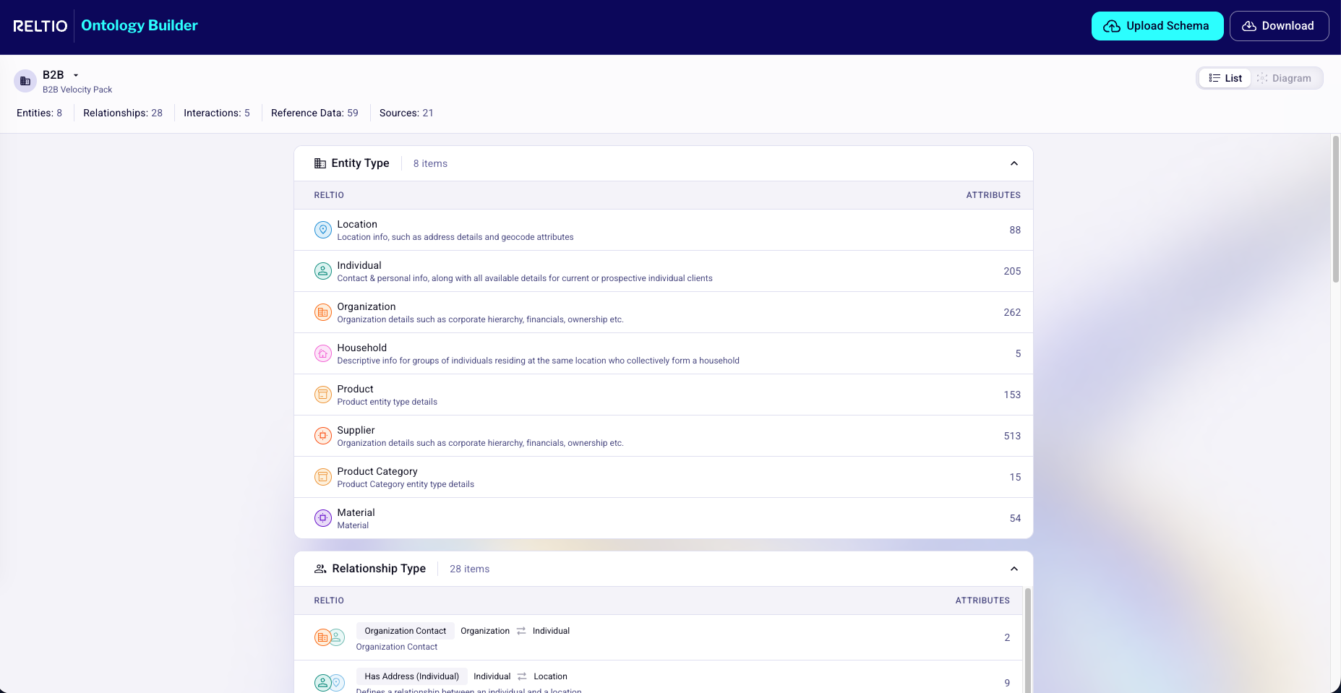

Figure UX-2. Diagram mode: radial graph canvas.

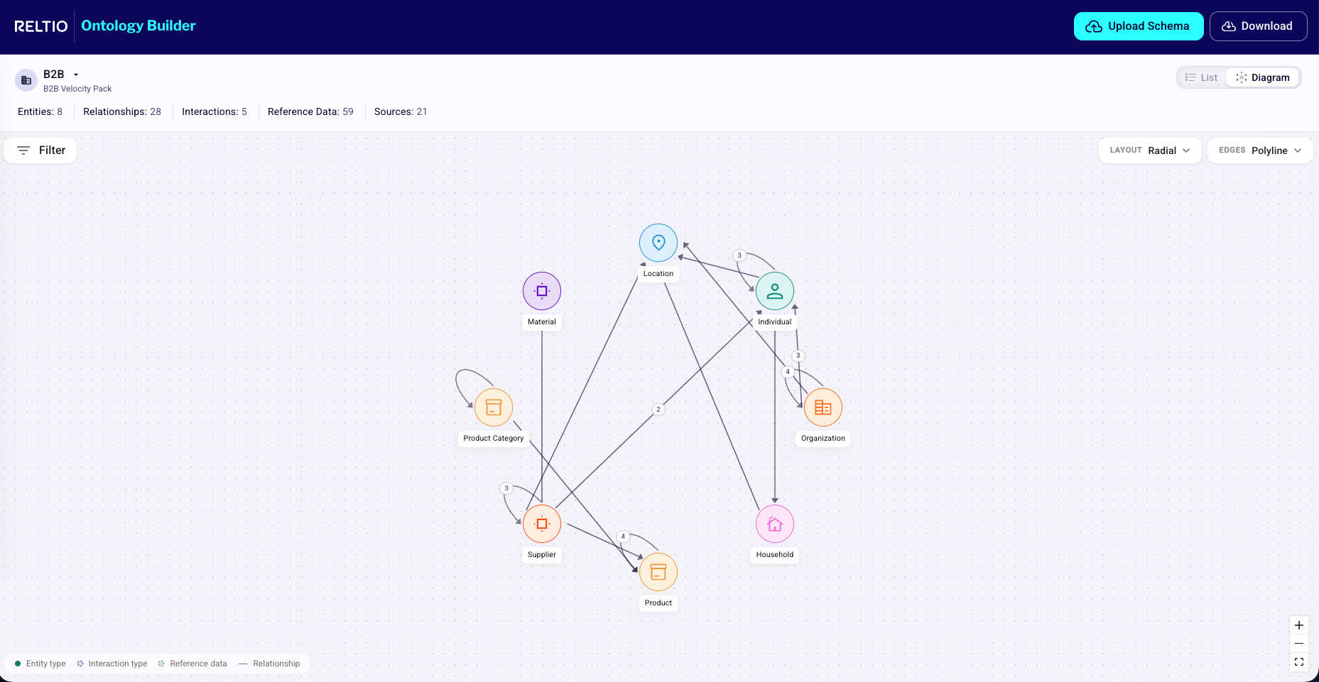

Figure UX-3. Layout selector options.

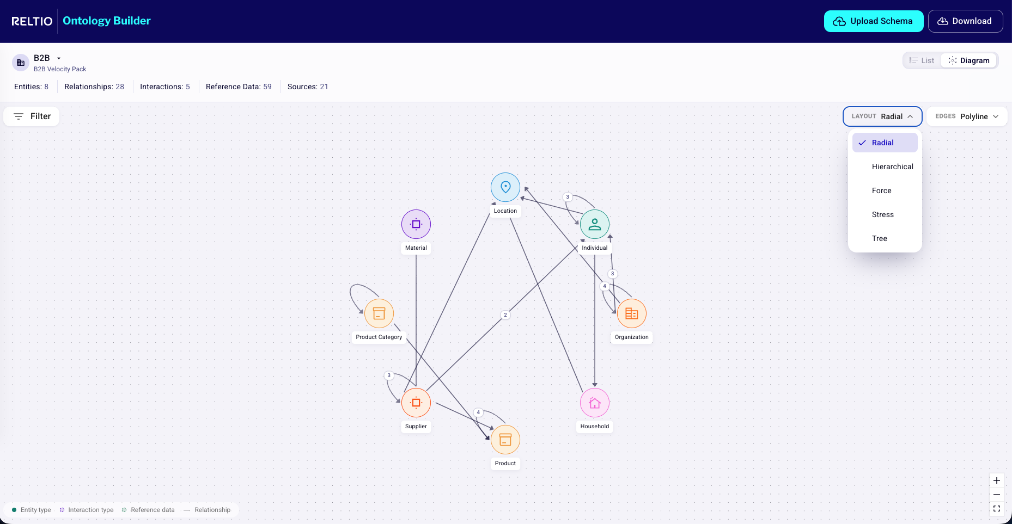

Figure UX-4. Edge style selector options.

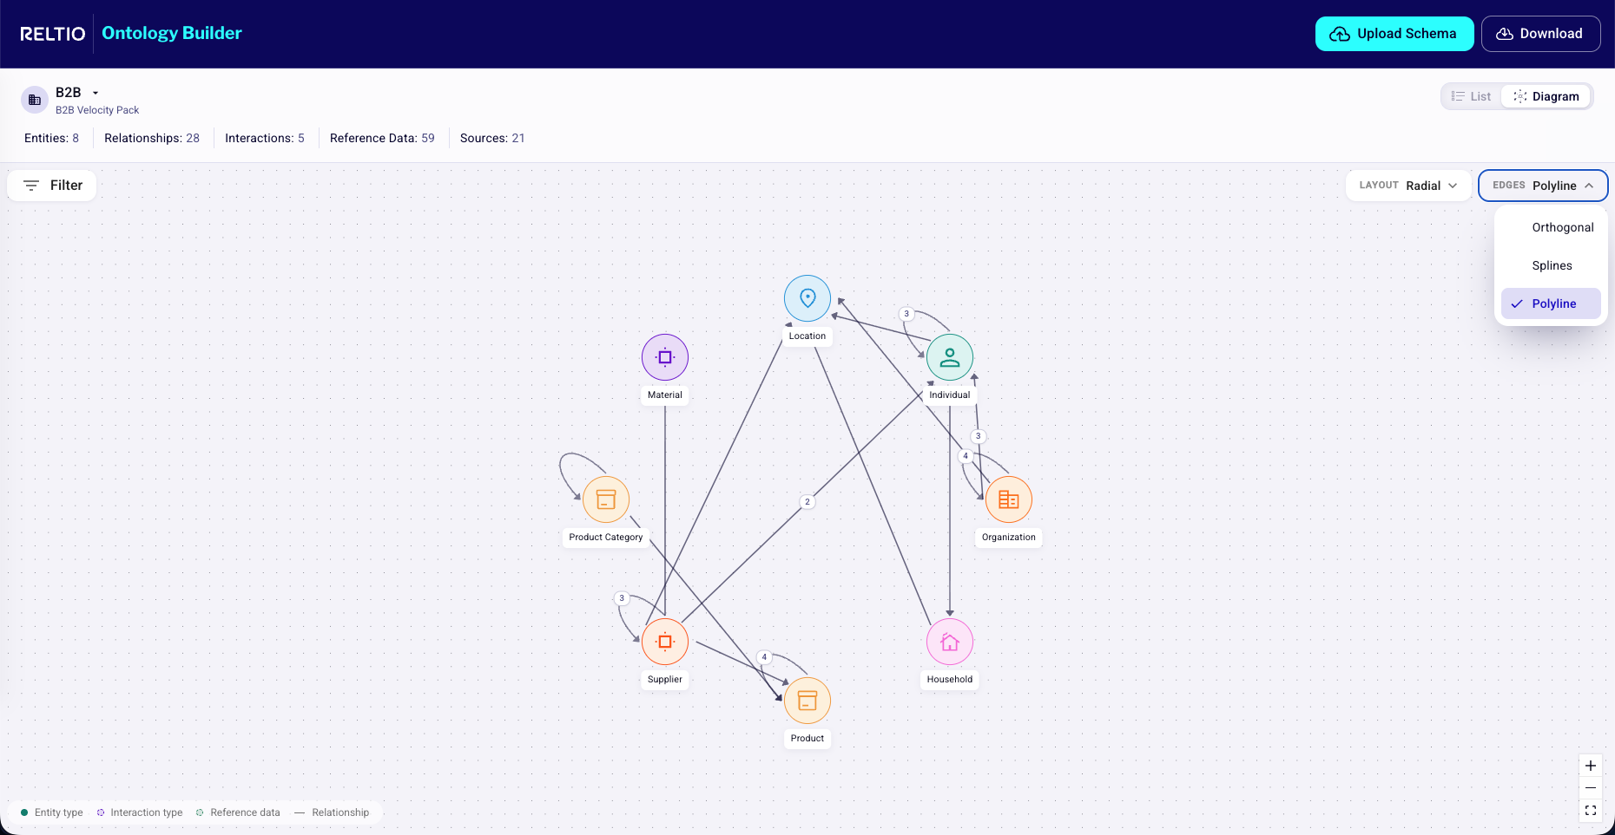

Figure UX-5. Filter panel behavior.
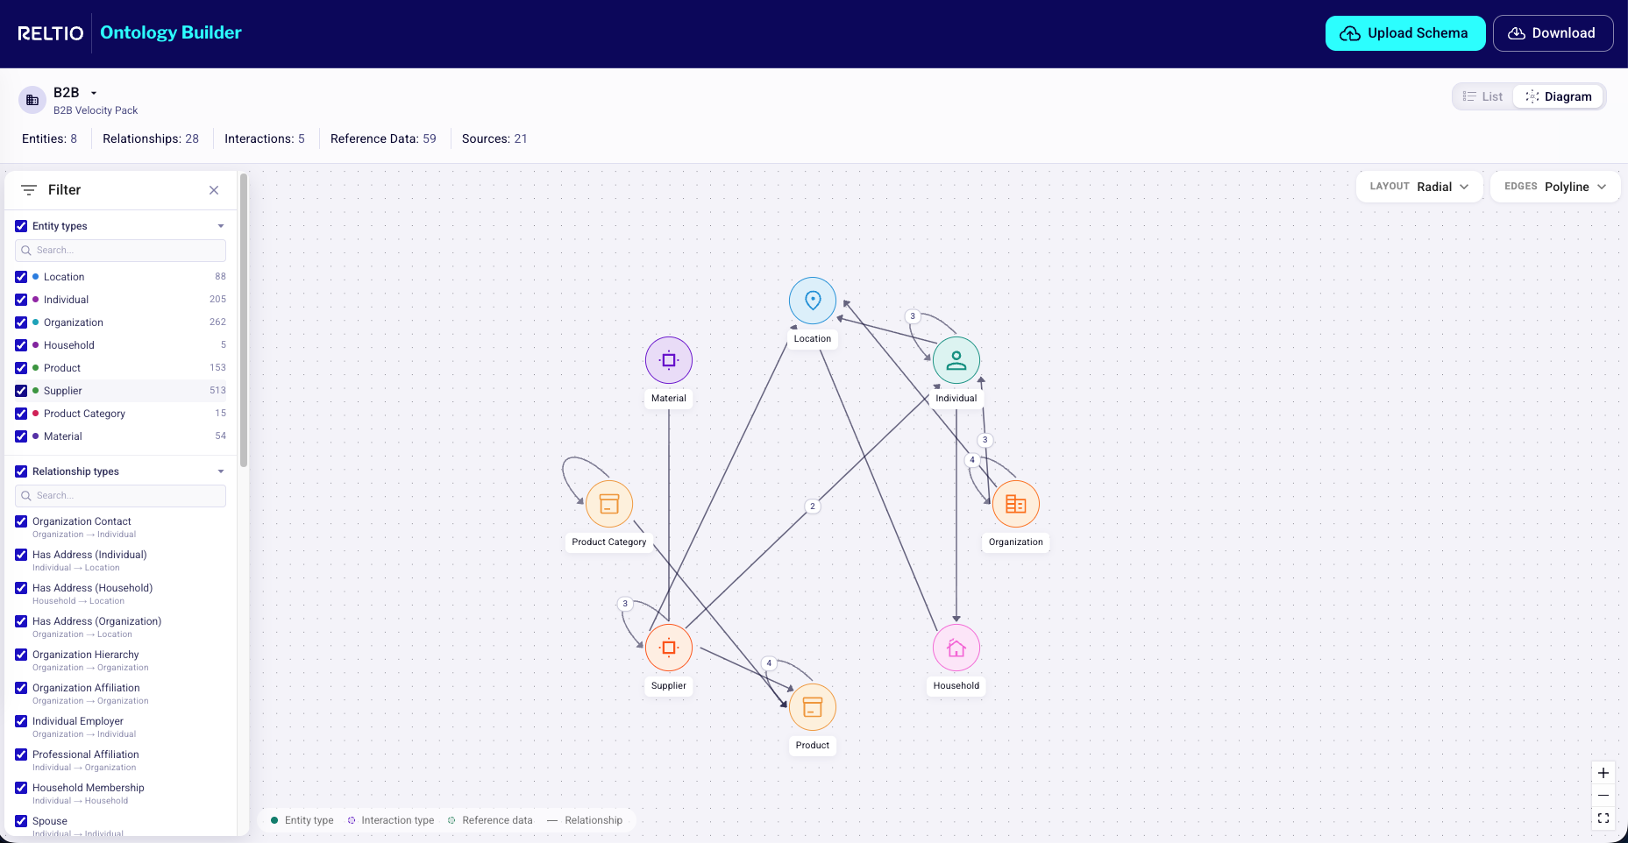

Note: These are reference screenshots only. Final production UI should follow the Reltio Console design system and the Data Modeler embedding decisions in FR1-FR14.

User Journey Mapping
Primary flow — Reltio Administrator / Configurator
Signs into Console
→ Opens Data Modeler for tenant
→ Clicks "Data Model Visualizer" in the Data Modeler nav
→ Sees Radial Polyline graph of live model
→ Switches Layout to Hierarchical to investigate organizational depth
→ Filters to a subset of relationships
→ Searches for "Phone" attribute → focuses Individual entity
→ Clicks "Open attribute owner" → lands in existing Data Modeler attribute form
→ Edits and saves
→ Returns to Data Model Visualizer — selection, filters, layout preserved (§FR18)
Secondary flow — Solution Architect
Opens a deep-link to the Data Model Visualizer tab
→ Lands in Visualizer with the same layout / filter / selection a teammate had
→ Walks the graph with the Configurator over a call
→ Identifies an architectural concern
→ Clicks Open relationship type to inspect the form together
Tertiary flow — Implementation Consultant onboarding to a new tenant
Opens Data Modeler for the customer's tenant
→ Clicks Data Model Visualizer
→ Toggles to List view to inventory entity types
→ Toggles back to Diagram, switches Layout to Force
→ Uses search and grouped relationship badges to navigate large clusters
→ Builds a mental model of the customer's data model in minutes, not hours

Accessibility Considerations
- WCAG 2.1 AA target.
- List view (§FR4) provides full parity with Diagram view for every information-bearing action.
- Color is never the sole encoding (icon + shape + label always).
- Keyboard navigation: every control (View toggle, Layout, Edges, Filter, search, node selection, side-panel tabs, Edit actions) reachable via Tab; logical focus order; visible focus rings.
- prefers-reduced-motion disables layout animations.
- Side-panel scroll regions are screen-reader-announced.
- [AWAITING UXD INPUT] for full audit and sign-off.

Usability Standards
- Reltio Console design system (typography, colors, components) — confirm version with UXD.
- Voice & style: active voice; align with Reltio's product copy standards including banned phrases ("single source of truth" → "trusted data foundation"; "golden record" → "best-version profile"). Tooltips and empty-state copy follow the same standards.
- Avoid Reltio-internal jargon in user-facing copy (e.g., "L3" stays in PM / Eng vocabulary; user-facing strings prefer "data model" or "ontology").

Timeline & Milestones

Development Timeline
Milestone | Owner | Target
PRD review + approval | PM, Eng, UX | [TO BE DETERMINED]
Data Modeler nav decision (Open Question 1) | Data Modeler PM + UX | [TO BE DETERMINED]
Design spec final (Figma) for embedding | UX | [AWAITING UXD INPUT]
Front-end graph rendering capability confirmed for Visualizer use | Front-end Platform | [TO BE DETERMINED]
L3 read-path integration | Data Modeler Eng | [TO BE DETERMINED]
Click-to-edit hand-off implementation (one route per element type, per §FR17) | Data Modeler Eng | [TO BE DETERMINED]
Internal alpha (Reltio employees on internal tenants) | PM | [TO BE DETERMINED]
Opt-in beta (5–10 customer tenants behind feature flag) | PM + Field | [TO BE DETERMINED]
GA — feature flag default-on | PM | [TO BE DETERMINED]

Dependencies
- Front-end graph rendering capability (Reltio's standard library / component). Owner: Front-end Platform.
- Configuration API read paths for L3 — confirm coverage and shape; may need a small aggregator endpoint to avoid N+1 client-side. Owner: Data Modeler Eng.
- Data Modeler edit routes for every element type listed in §FR17 — gap audit needed. Owner: Data Modeler Eng.
- Console feature flag infrastructure — reuse existing.

Phase of Delivery
- Phase 0 — Internal alpha. Dark launch behind a feature flag; on for Reltio internal tenants only; instrumentation validated.
- Phase 1 — Opt-in beta. 5–10 design-partner customers enable the flag; goal = ≥ 70% Administrator / Configurator adoption among beta tenants and zero P0 / P1 defects.
- Phase 2 — GA. Flag default-on for all customers; communications via Customer Success and the Reltio release notes.
- Phase 3 — Post-MVP enhancements (informational, not committed):
  - Source schema upload for comparison only
  - Suggested source-to-Reltio mappings
  - Mapping confidence score
  - Diagram export as PNG / SVG
  - Mapping export as CSV / JSON
  - Saved ontology views
  - Tenant configuration comparison
  - Attribute-level graph mode
  - Match rule overlay
  - Survivorship rule overlay
  - Data validation overlay
  - Usage or record-count overlay
  - Collaborative comments or annotations
  - Domain / package-based clustering
  - Impact analysis for proposed model changes

Resource Needs
- Engineering: [TO BE DETERMINED - Owner: Eng Leadership] — Data Modeler front-end (embedding, click-to-edit), Front-end Platform (graph rendering integration), back-end (Configuration API aggregation if needed).
- Design: [AWAITING UXD INPUT] — 1 designer through GA.
- PM: 1 PM (Driver).
- QA: automated tests for all click-to-edit routes; manual exploratory testing on representative customer L3 fixtures.
- DevOps: none net-new (reuses Console release train).

Risks & Mitigation

Known Risks & Mitigation Strategies
ID | Risk | Mitigation
R1 | Visualizer duplicates existing Data Modeler pages — users get confused about which surface to use for what. | Keep MVP read-only and frame the Visualizer as exploration/navigation only. List view does not replicate "+ CREATE NEW" / "ANALYZE MATCH STRATEGY" affordances; those remain only on the existing per-type pages.
R2 | Export options confuse users — ontology export gets read as a tenant configuration export. | Do not include ontology export/download in MVP (§FR16). Continue using existing Data Modeler configuration import/download flows. Re-evaluate post-MVP with explicit visual vs. configuration labeling.
R3 | Large models become unreadable. | Provide filters, search, grouped relationships, layout controls, fit-to-screen, and selected-neighborhood highlighting (§FR7, §FR10, §FR11, §FR14, §FR15).
R4 | Users expect graph editing. | Use clear labels such as Open entity type and Open relationship type instead of inline edit controls. All edit intent routes to existing Data Modeler pages (§FR17).
R5 | Source schema mapping is interpreted as configuration import. | Treat source-schema/mapping views as read-only inspection in MVP (§FR13). Do not provide apply/import actions. Inclusion in MVP vs. Post-MVP is Open Question 8.
R6 | Performance regression in Data Modeler on very large models. | Enforce a perf budget in CI; profile against a synthetic 200-entity fixture before each release; lazy-load attribute lists; virtualize side-panel scroll; do not block other Data Modeler routes on Visualizer code.
R7 | Click-to-edit hand-off coverage gaps — broken-link UX for element types without an existing edit page. | Audit Data Modeler's edit surfaces against the full L3 element taxonomy during dev. Surface "Edit not yet supported in Data Modeler" explicitly in MVP for any uncovered element. Track gap closure as a content-completeness backlog (Open Question 5).
R8 | RBAC parity bugs — Visualizer accidentally surfaces an entity type or attribute that Data Modeler hides for the same user, creating a security disclosure. | Automated tests that compare Visualizer element-list output to Data Modeler element-list output for a matrix of (user role × tenant) fixtures; any divergence fails CI.
R9 | Adoption is lower than expected — existing tabular workflow is "good enough" for daily edits and the Visualizer is only used episodically. | Instrument adoption metrics from internal alpha; if usage is below threshold at end of beta, do a focused customer-research pass to understand the workflow gap before declaring success.
R10 | Live-consistency mechanism is annoying (banner spam) or, conversely, too quiet (user reviews stale L3 and is confused). | Start with on-focus refresh + a debounced banner; A/B during beta if needed; explicit settings to disable the banner if users find it noisy.
R11 | Nav discoverability risk — adding a new top-level Data Model Visualizer tab to Data Modeler may not be immediately discovered by existing users. | Include release-note copy, an in-app first-time tour pointing at the new tab, and View in Data Model Visualizer affordances from existing object pages (§FR1) so the feature is reachable from familiar surfaces. Roll-back is a feature-flag flip.
R12 | Hub-UI expectation — users see screenshots and ask for the same view in Hub UI for data quality work. | Include in release notes that this is a Console (Data Modeler) feature for now. A Hub UI variant is on the Phase 3 roadmap; Customer Success scripts prepared.

Approval Sections

Sign-Off Required
Function | Name | Date | Status
Product (Driver / Data Modeler PM) | [TO BE DETERMINED]
Product Leadership | [TO BE DETERMINED]
Console / Data Modeler Engineering | [TO BE DETERMINED]
Front-end Platform (graph rendering capability) | [TO BE DETERMINED]
Configuration API / Platform | [TO BE DETERMINED]
UX / Design | [AWAITING UXD INPUT]
Security | [TO BE DETERMINED]
Field Engineering / Customer Success | [TO BE DETERMINED]
Marketing (release notes) | [TO BE DETERMINED]

Each signatory confirms they have reviewed the PRD and accept the scope, requirements, risks, and timeline.

Appendix

Original One Pager
[TO BE DETERMINED - Owner: PM] — link to the original one-pager, if any.

Related Documents/Links
- Parent product: Reltio Data Modeler (Console) — part of Reltio Multidomain Master Data Management and Reltio Intelligent 360™ offerings.
- Reltio Intelligent Data Graph™ — the underlying graph IP the Visualizer renders.
- Current Reltio Data Modeler UI — Entity types page, used as the IA baseline for the Data Model Visualizer tab placement (FR1).

Glossary (Reltio-internal)
- L3 — tenant-level data-model configuration object in Reltio. Authored in Data Modeler.
- Data Modeler — the Reltio Console module where the Reltio Administrator / Configurator authors and maintains a tenant's L3.
- Reltio Console — the authenticated platform shell hosting Data Modeler, UI Modeler, Workflow Modeler, Tenant Management, etc.
- Reltio Intelligent Data Graph™ — Reltio's IP underpinning the canonical model rendered by the Visualizer.
- Relationship direction — directed, bidirectional, or unidirectional, per Reltio relationship-type definitions.
- RBAC — role-based access control, managed at the Console level.

Open questions
- Within the existing Data Modeler left nav (Entity types · Relationship types · Graph types · Grouping types · Sources · Import / Download Configuration), what is the exact insertion point for the new Data Model Visualizer tab — directly after Sources and before the Import / Download separator (recommended), or elsewhere?
- Should source nodes be visible by default or only through a source-focused filter?
- Should attributes ever appear as graph nodes, or only in the side panel?
- Should the Visualizer include abstract entity types by default?
- Should graph layout preference be stored per user, per tenant, or per browser session?
- Should View in Data Model Visualizer be added to all Data Modeler object pages in MVP or only entity and relationship pages?
- What is the maximum model size the graph must support before requiring filtered rendering?
- Should source-schema mapping (§FR13) be included in MVP or explicitly moved to Post-MVP?

