Stage 2 - Data Acquisition & Understanding
RoadEye - Traffic Sign Recognition Using HOG Features and SVM
Machine Learning (3CS101CC24) - Nirma University, Institute of Technology - B.Tech CSE, Semester 5
Student: [name / roll number - add before submission]
Run scope: full_dataset | Generated: 2026-10-10

Dataset source and licence / usage terms
GTSRB is a public benchmark published for research on traffic-sign recognition. The licence / usage statement of the exact copy used must be read from the page it was downloaded from (the official site or a mirror such as Kaggle, which states its own licence). See DATASET_DOWNLOAD.md and LICENSE_NOTICE.md. The dataset is used here only for non-commercial coursework; it is not redistributed inside the project ZIP.

Dataset summary (measured)
Dataset summary - generated by Notebook 01
Property | Value
Source | German Traffic Sign Recognition Benchmark (GTSRB), Institut fuer Neuroinformatik, Ruhr-Universitaet Bochum
Reference | J. Stallkamp, M. Schlipsing, J. Salmen, C. Igel. Man vs. computer: Benchmarking machine learning algorithms for traffic sign recognition. Neural Networks 32 (2012) 323-332.
Official page | https://benchmark.ini.rub.de/
Version used (this run) | GTSRB - German Traffic Sign Recognition Benchmark (Final Training + Final Test + Test GT) - run mode: full_dataset
Image files indexed | 51,839
Readable images | 51,839
Number of classes | 43
Physical signs (tracks) | 1,307
File formats | ['.ppm']
Image width (min / median / max) | 25 / 43.0 / 266
Image height (min / median / max) | 25 / 43.0 / 232
Total size (MB) | 484.9
Target variable | class_id (0-42) = folder name; cross-checked with official GT-xxxxx.csv

Why GTSRB?
- Recognised benchmark with a published protocol, so results are meaningful and comparable.
- 43 classes with real-world variation (illumination, blur, scale, partial occlusion).
- Large enough for classical ML and small enough (images of at most a few hundred pixels) for a laptop.

Target definition and class distribution
The target is the sign category (43 classes: speed limits, prohibitory, warning, mandatory and end-of-restriction signs). The distribution is shown below and analysed in Stage 5.
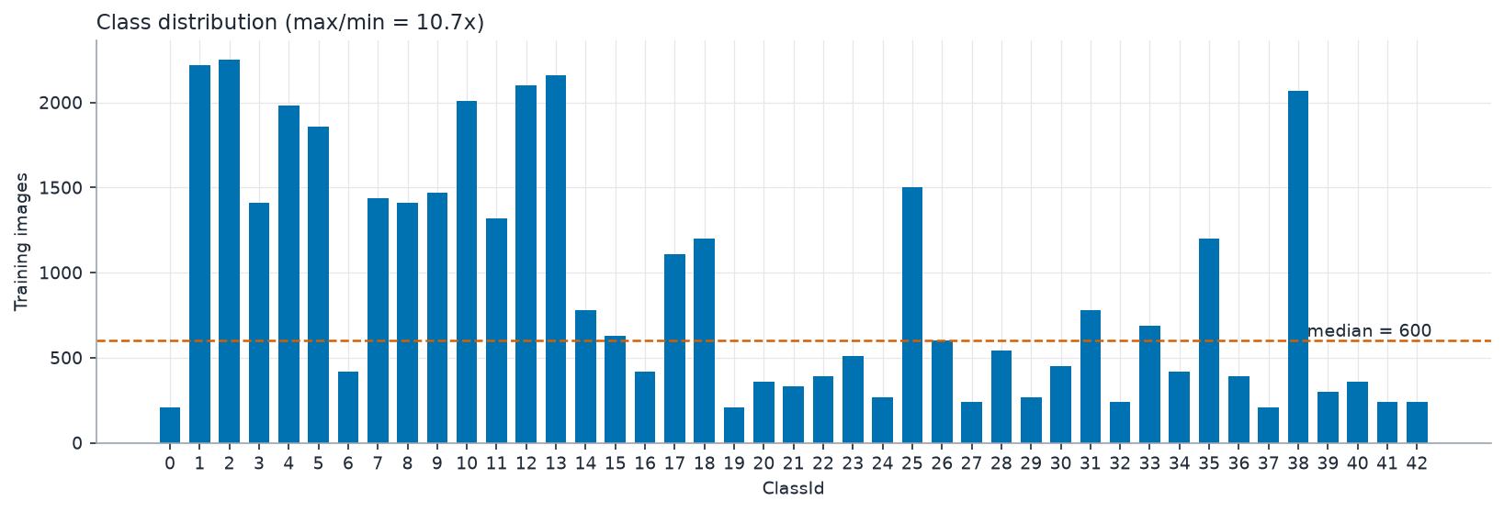
Images per class (measured)
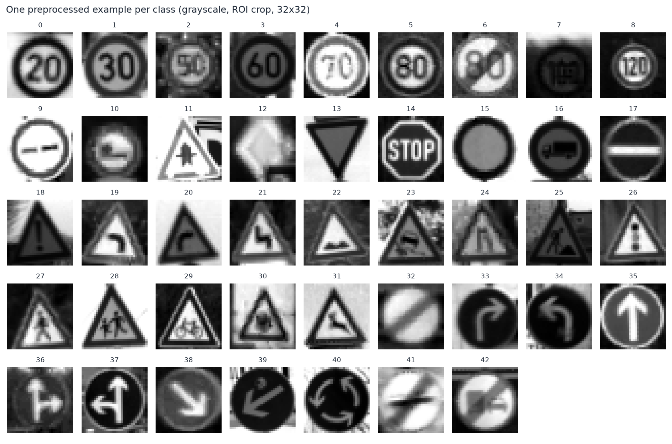
One random image per class
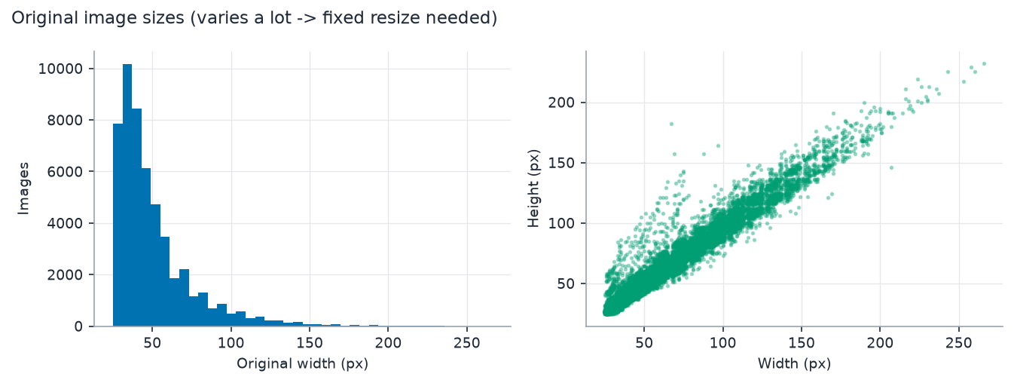
Original image sizes (resizing to one size is required)

Dataset limitations
- All images are from German roads; other countries use different sign designs.
- ~30 frames per physical sign are highly correlated -> splitting by sign (group) is mandatory.
- Images are already cropped to the sign (with a small border); there is no detection task.
- Strong class imbalance is typical of GTSRB (see Stage 5 for the measured ratio).
- Small, blurry or dark images carry little information at 32x32 pixels.

