Stage 5 - Data Balancing
RoadEye - Traffic Sign Recognition Using HOG Features and SVM
Machine Learning (3CS101CC24) - Nirma University, Institute of Technology - B.Tech CSE, Semester 5
Student: [name / roll number - add before submission]
Run scope: full_dataset | Generated: 2026-10-10

Class-distribution analysis (training split)
Imbalance statistics (measured)
Statistic | Value
Imbalance ratio (max/min class count) | 12.00
Smallest class | class 37 (150 images)
Largest class | class 2 (1800 images)
Normalised entropy (1 = balanced) | 0.927
Severity (rule: <=1.5 balanced, <=3 mild, <=10 moderate, else severe) | severe

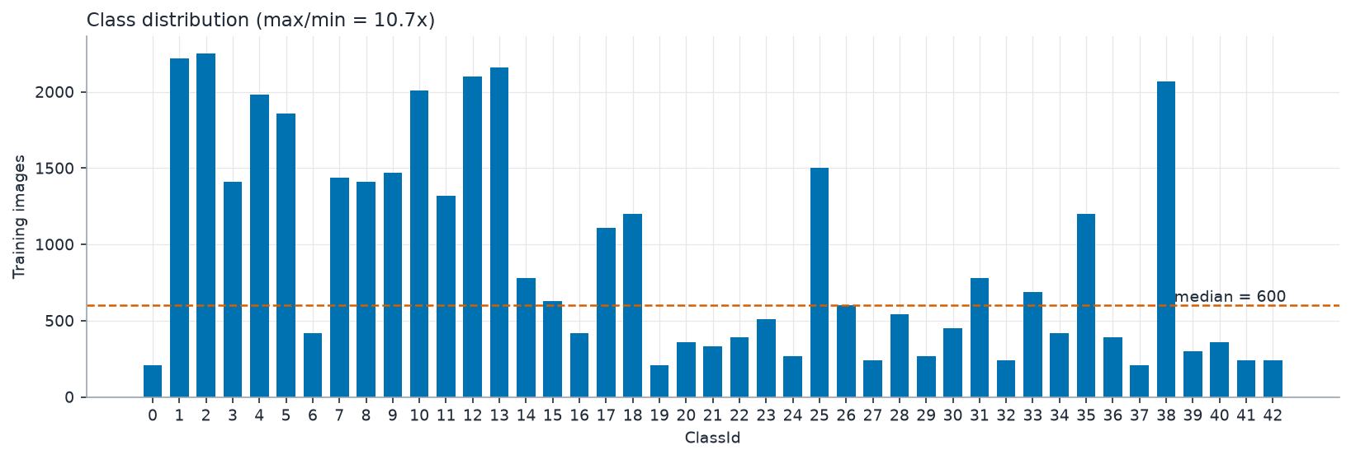
Class distribution

Strategy selection
Strategy is chosen by experiment, not by habit: the default HOG SVM is trained with class_weight=None and class_weight='balanced' on the training split and the two are compared on the VALIDATION split by macro-F1.
Balancing experiment (validation split)
class_weight | Val accuracy | Val macro-F1 | Val balanced accuracy
None | 0.9471 | 0.9335 | 0.9264
balanced | 0.9479 | 0.9361 | 0.9309

Decision: Imbalance ratio 12.00 (severe). class_weight='balanced' vs None compared on the validation split by macro-F1 -> selected class_weight=balanced.
Selected class_weight: balanced (applies to SVM and Decision Tree; KNN has no class weights).

Why alternatives were not used
- SMOTE / synthetic oversampling: interpolating HOG vectors does not create valid sign images and risks leakage if done before splitting; not needed when class weights suffice.
- Random oversampling: duplicates training samples, increases training time and over-fitting risk.
- Undersampling: discards scarce real data from already small classes.

Confirmation of no leakage
Balancing decisions use the training split for fitting and the validation split for the comparison. Validation and test data are never resampled or re-weighted. Macro-averaged metrics are used so that rare classes count as much as frequent ones.

