Stage 6 - Exploratory Data Analysis
RoadEye - Traffic Sign Recognition Using HOG Features and SVM
Machine Learning (3CS101CC24) - Nirma University, Institute of Technology - B.Tech CSE, Semester 5
Student: [name / roll number - add before submission]
Run scope: full_dataset | Generated: 2026-10-10

Questions asked
- Univariate: how many images per class, which sizes, how bright/contrasty are the images?
- Bivariate: does image size relate to class? Which classes look alike?
- Anomalies: dark, low-contrast, very small images.
- Which findings should change preprocessing or modelling?
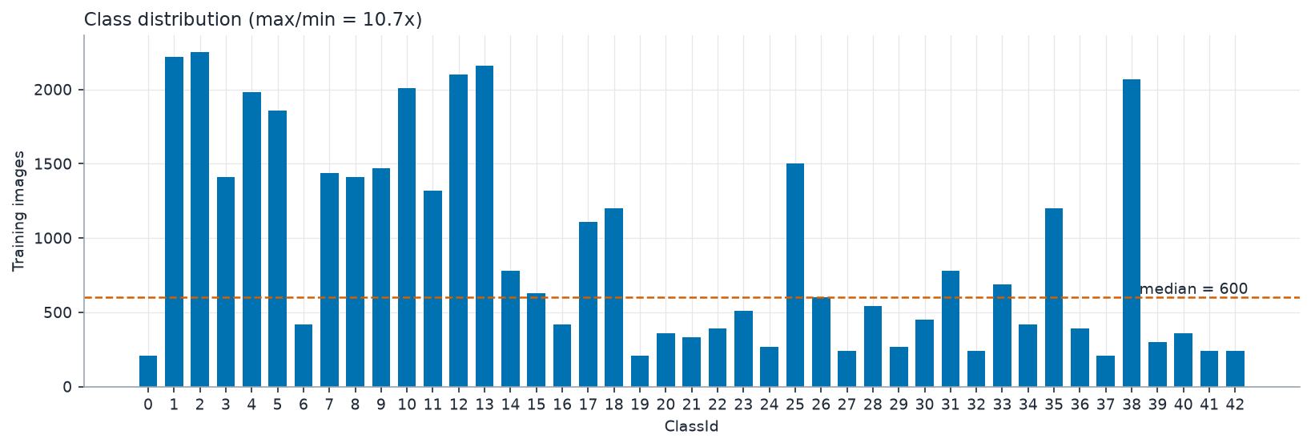
Class distribution (target)
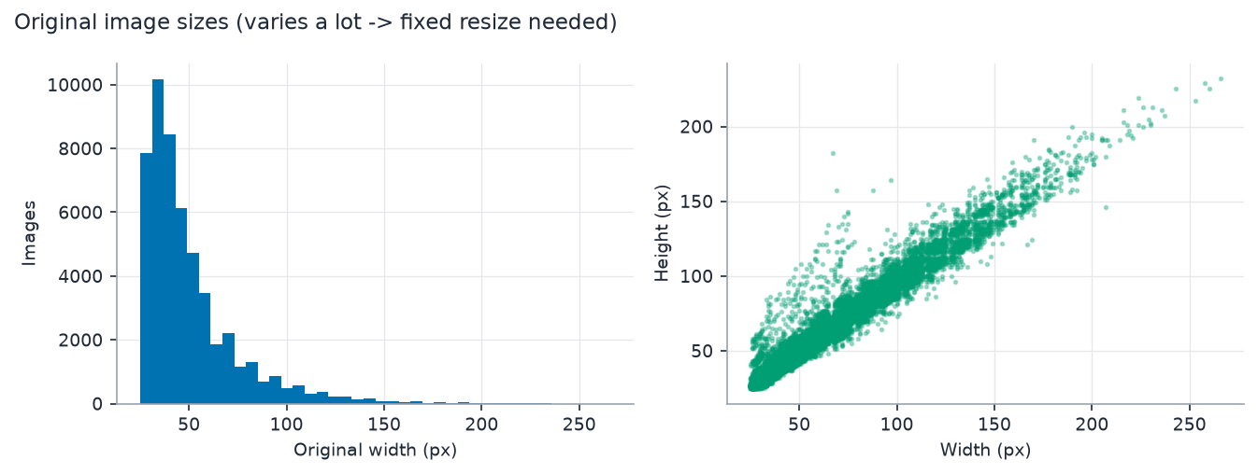
Image size distribution
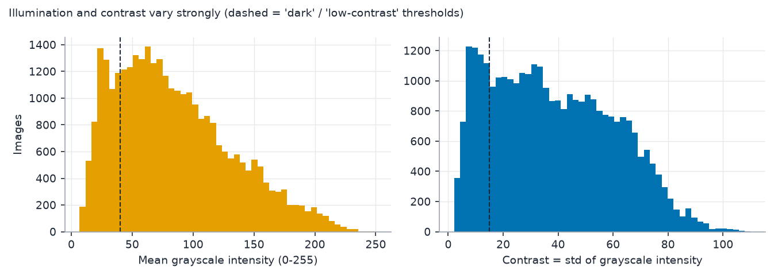
Brightness and contrast (training split)
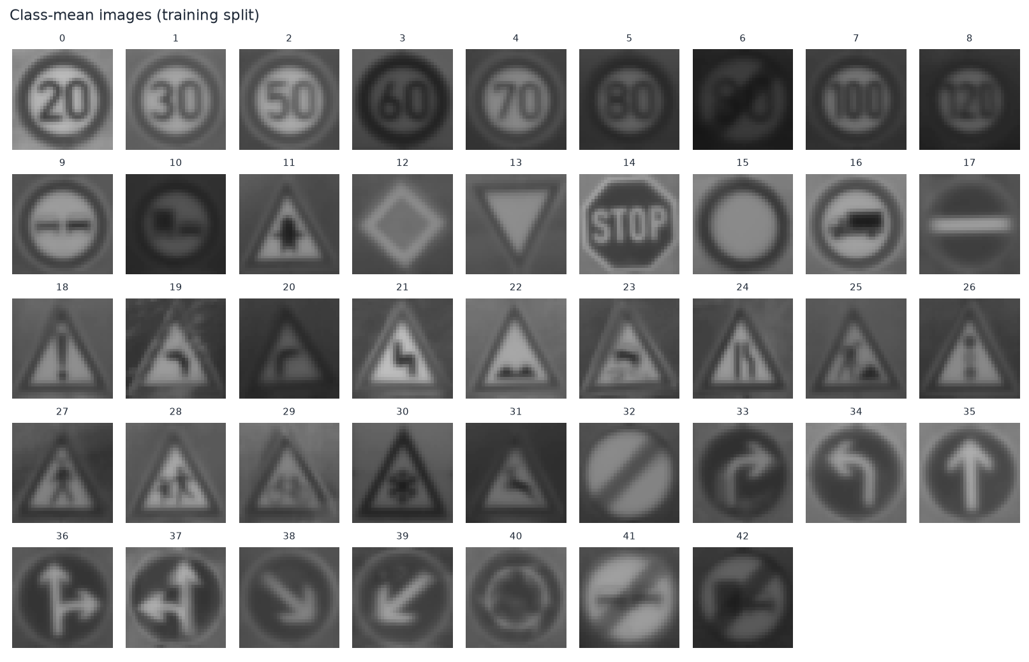
Class-mean images (training split)
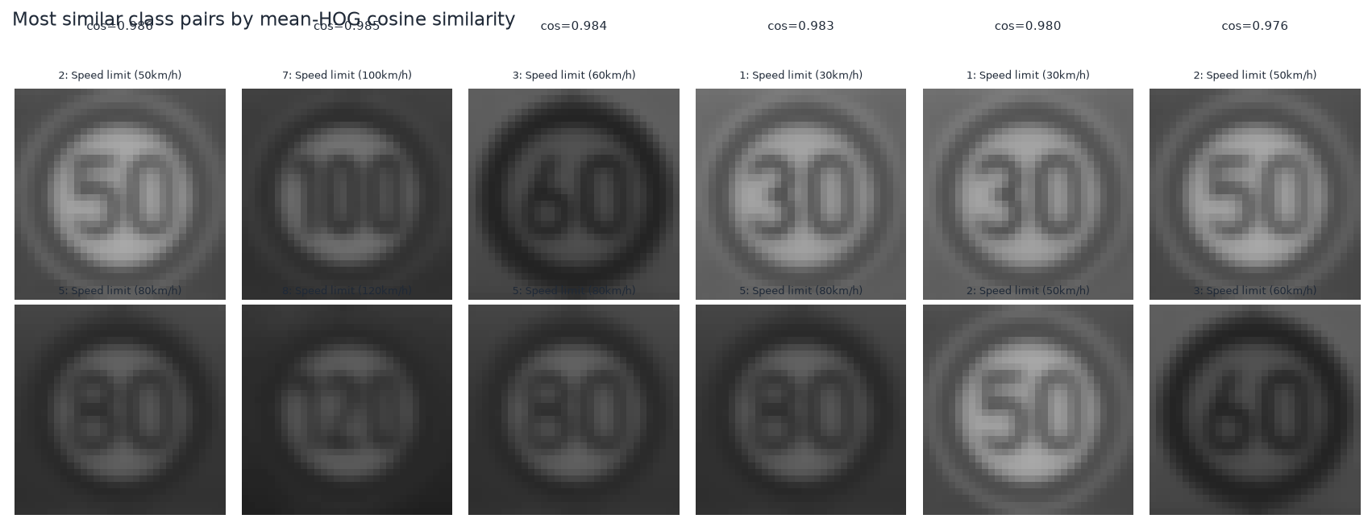
Most similar class pairs (training split)
Most similar classes by mean-HOG cosine similarity
Class A | Name A | Class B | Name B | Cosine similarity
2 | Speed limit (50km/h) | 5 | Speed limit (80km/h) | 0.986
7 | Speed limit (100km/h) | 8 | Speed limit (120km/h) | 0.985
3 | Speed limit (60km/h) | 5 | Speed limit (80km/h) | 0.984
1 | Speed limit (30km/h) | 5 | Speed limit (80km/h) | 0.983
1 | Speed limit (30km/h) | 2 | Speed limit (50km/h) | 0.980
2 | Speed limit (50km/h) | 3 | Speed limit (60km/h) | 0.976
1 | Speed limit (30km/h) | 3 | Speed limit (60km/h) | 0.976
18 | General caution | 26 | Traffic signals | 0.973

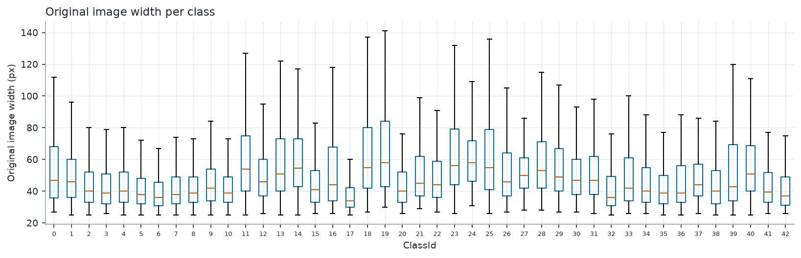
Original size per class

Measured observations
- Training images flagged dark (mean grey level < 40): 6281; low contrast (std < 15): 5780 of 31379.
- Spearman correlation between class size and median original width: -0.13.
- Most similar pair by class-mean HOG cosine similarity: class 2 (Speed limit (50km/h)) and class 5 (Speed limit (80km/h)), cos = 0.986.

Observations -> decisions
EDA-driven decisions
Observation | Decision
Image sizes vary widely | Resize to a single size
Lighting varies; colour not essential | Grayscale + HOG block normalisation
Unequal class counts | Validate class_weight on the validation split
Frames per sign are near-identical | Group-aware split and CV
Some classes look alike | Expect and analyse confusions; report macro-F1 and per-class results

