Stage 7 - Feature Engineering / Selection
RoadEye - Traffic Sign Recognition Using HOG Features and SVM
Machine Learning (3CS101CC24) - Nirma University, Institute of Technology - B.Tech CSE, Semester 5
Student: [name / roll number - add before submission]
Run scope: full_dataset | Generated: 2026-10-10

Representations compared
Feature representations
Representation | Definition | Dimensions
Raw pixels | flattened normalised 32x32 grayscale image | 1,024
HOG | 9 orientations, 4x4 pixels per cell, 2x2 cells per block, L2-Hys block normalisation | 1,764

How HOG works
- Compute image gradients (magnitude and direction) at every pixel.
- Split the image into cells; per cell build a histogram of gradient directions weighted by magnitude.
- Group cells into overlapping blocks and normalise each block (L2-Hys) to reduce sensitivity to local contrast/brightness.
- Concatenate all block vectors into one feature vector.

Why HOG suits traffic signs
- Signs are characterised by outlines (circle, triangle, octagon) and inner pictograms - both are edge structures that HOG encodes.
- Block normalisation reduces the effect of illumination changes, a major variation source in GTSRB.
- It is compact and fast, and needs no training (unlike learned CNN features) - appropriate for a classical-ML syllabus.
- Limitation: HOG is not rotation or scale invariant and loses colour; at small image sizes fine digits are only a few pixels wide.

HOG parameters
HOG configuration
Parameter | Value | Reason
Image size | 32x32 | balance between detail and speed
orientations | 9 | standard Dalal-Triggs setting
pixels_per_cell | (4, 4) | cell large enough for stable histograms, small enough for pictograms
cells_per_block | (2, 2) | overlapping blocks for local normalisation
block_norm | L2-Hys | robust normalisation

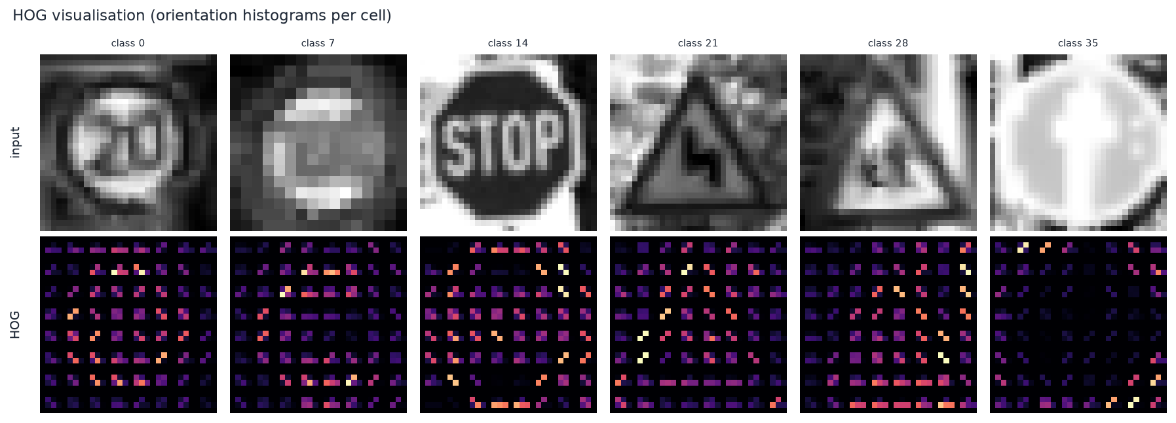
HOG visualisation for sample training images
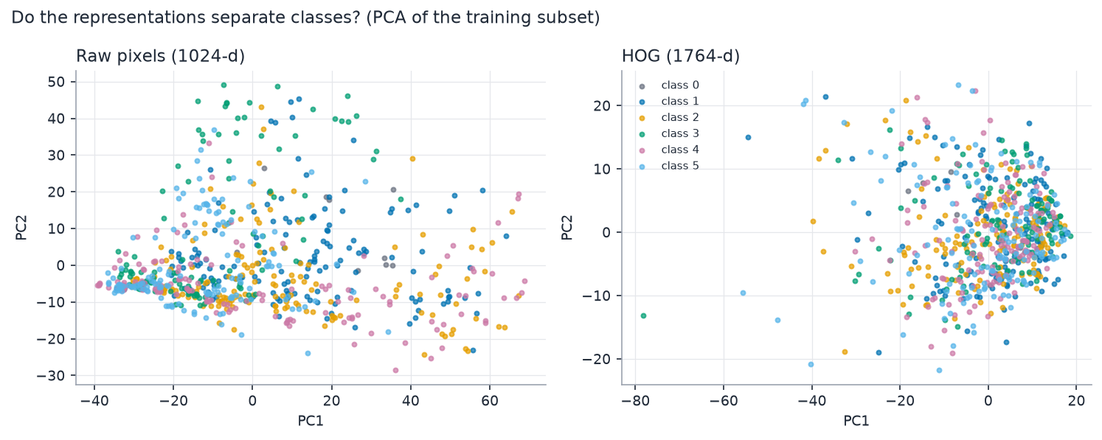
Raw pixels vs HOG: dimensionality and PCA variance

Feature scaling and selection
StandardScaler (zero mean, unit variance) is fitted on the training split only and applied to validation/test. No feature selection was applied: HOG vectors are compact, selection on evaluation data risks leakage, and the RBF SVM copes with correlated features. HOG parameters were fixed a priori (not tuned on the test split) and are stored in model_metadata.json so the app reproduces them exactly.

