Stage 8 - Baseline Model
RoadEye - Traffic Sign Recognition Using HOG Features and SVM
Machine Learning (3CS101CC24) - Nirma University, Institute of Technology - B.Tech CSE, Semester 5
Student: [name / roll number - add before submission]
Run scope: full_dataset | Generated: 2026-10-10

Baseline definition
Raw pixels + SVM: grayscale 32x32 image, flattened, standardised, default RBF SVM (C=1, gamma='scale'). It uses the same split, scaler type and class-weight decision as the proposed model.

Why a baseline is required
Without a reference point, a high score cannot be interpreted. The baseline shows what a model achieves *without* feature engineering, so the benefit of HOG can be measured instead of assumed.

Configuration and training procedure
- Features: raw normalised pixels (1,024 dimensions)
- Scaler fitted on training data only; SVC(kernel='rbf', C=1.0, gamma='scale')
- class_weight: balanced
- random_state: 42
- Trained on the training split; evaluated on the validation split (test untouched)

Baseline metrics (measured)
Baseline performance
Metric | Training | Validation
accuracy | 0.9049 | 0.7151
precision_macro | 0.9148 | 0.7070
recall_macro | 0.9362 | 0.6552
f1_macro | 0.9168 | 0.6550

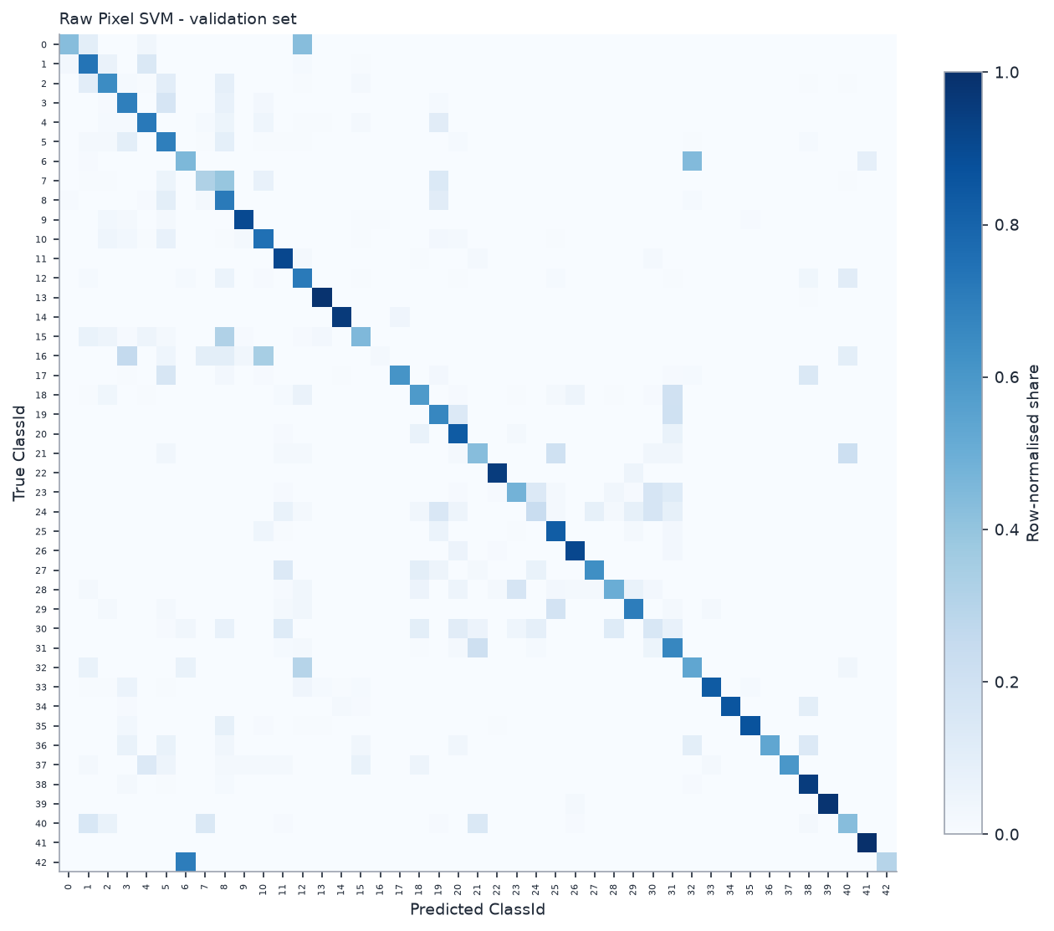
Baseline confusion matrix (validation, row-normalised)

Limitations
- Pixel values are sensitive to brightness, contrast and small shifts.
- High dimensionality relative to information content.
- No explicit shape/edge description.

