Stage 9 - ML Modelling and Model Comparison
RoadEye - Traffic Sign Recognition Using HOG Features and SVM
Machine Learning (3CS101CC24) - Nirma University, Institute of Technology - B.Tech CSE, Semester 5
Student: [name / roll number - add before submission]
Run scope: full_dataset | Generated: 2026-10-10

Models and why they were selected
Model selection rationale
Model | Why | Assumption / weakness
KNN | Simplest instance-based learner; strong baseline in feature space | Local similarity is meaningful; slow prediction, scale sensitive, no model
Decision Tree | Interpretable, scale invariant | Axis-aligned splits suffice; high variance / over-fits
SVM (RBF) | Maximum-margin classifier; effective on medium-size high-dimensional data; the proposed model | Smooth non-linear boundary; scale sensitive; training cost grows with samples

Fairness of the comparison
Same cleaned data, same group-aware split, same HOG features, same StandardScaler (fit on train), same metrics; all models are scored on the validation split for selection (table 1). After every model is frozen, the same models are evaluated once on the untouched test split (table 2).

Table 1 - validation split (used for selection)
Model comparison - validation
Model | Features | Accuracy | Precision (macro) | Recall (macro) | F1 (macro) | Training time (s) | Inference time (s)
Raw Pixel SVM | Raw pixels (1024-d) | 0.7151 | 0.7070 | 0.6552 | 0.6550 | 108.80 | 95.542
HOG KNN | HOG (1764-d) | 0.9033 | 0.9146 | 0.8755 | 0.8842 | 0.02 | 2.962
HOG Decision Tree | HOG (1764-d) | 0.7791 | 0.7687 | 0.7620 | 0.7603 | 74.31 | 0.008
HOG SVM | HOG (1764-d) | 0.9479 | 0.9561 | 0.9309 | 0.9361 | 134.99 | 115.785
Tuned HOG KNN | HOG (1764-d) | 0.9047 | 0.9162 | 0.8760 | 0.8852 | 0.42 | 3.390
Tuned HOG Decision Tree | HOG (1764-d) | 0.7700 | 0.7514 | 0.7450 | 0.7430 | 180.48 | 0.010
Tuned HOG SVM | HOG (1764-d) | 0.9487 | 0.9570 | 0.9295 | 0.9356 | 141.19 | 111.961

Table 2 - test split (evaluated once)
Model comparison - test
Model | Features | Accuracy | Precision (macro) | Recall (macro) | F1 (macro) | Training time (s) | Inference time (s)
Raw Pixel SVM | Raw pixels (1024-d) | 0.7227 | 0.6967 | 0.6763 | 0.6664 | 108.80 | 147.313
HOG KNN | HOG (1764-d) | 0.8837 | 0.8657 | 0.8373 | 0.8451 | 0.02 | 4.957
HOG Decision Tree | HOG (1764-d) | 0.7496 | 0.7115 | 0.6928 | 0.6981 | 74.31 | 0.012
HOG SVM | HOG (1764-d) | 0.9391 | 0.9508 | 0.9063 | 0.9246 | 134.99 | 177.176
Tuned HOG KNN | HOG (1764-d) | 0.8850 | 0.8723 | 0.8398 | 0.8483 | 0.42 | 4.924
Tuned HOG Decision Tree | HOG (1764-d) | 0.7370 | 0.7079 | 0.6862 | 0.6927 | 180.48 | 0.012
Tuned HOG SVM | HOG (1764-d) | 0.9408 | 0.9521 | 0.9069 | 0.9256 | 141.19 | 177.091

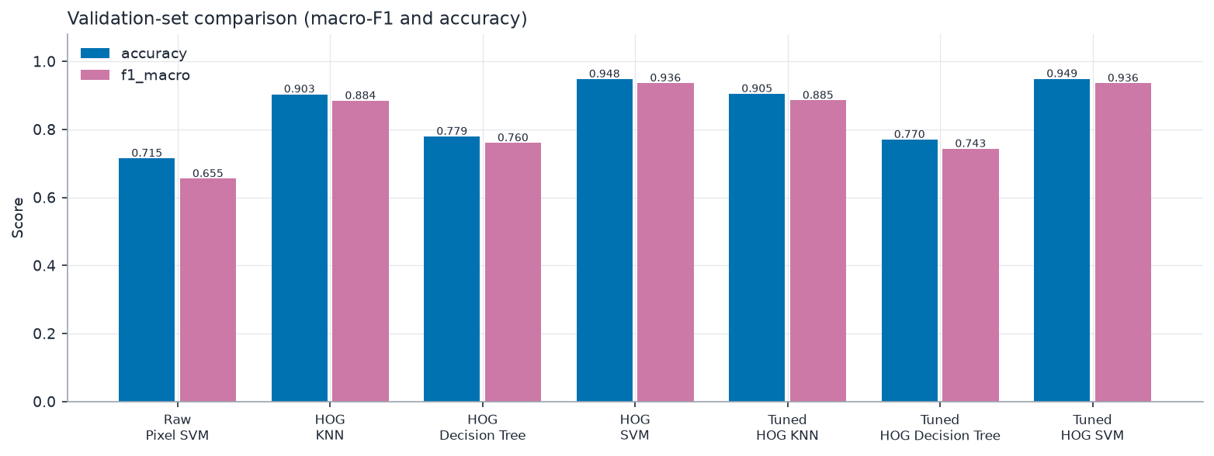
Validation comparison
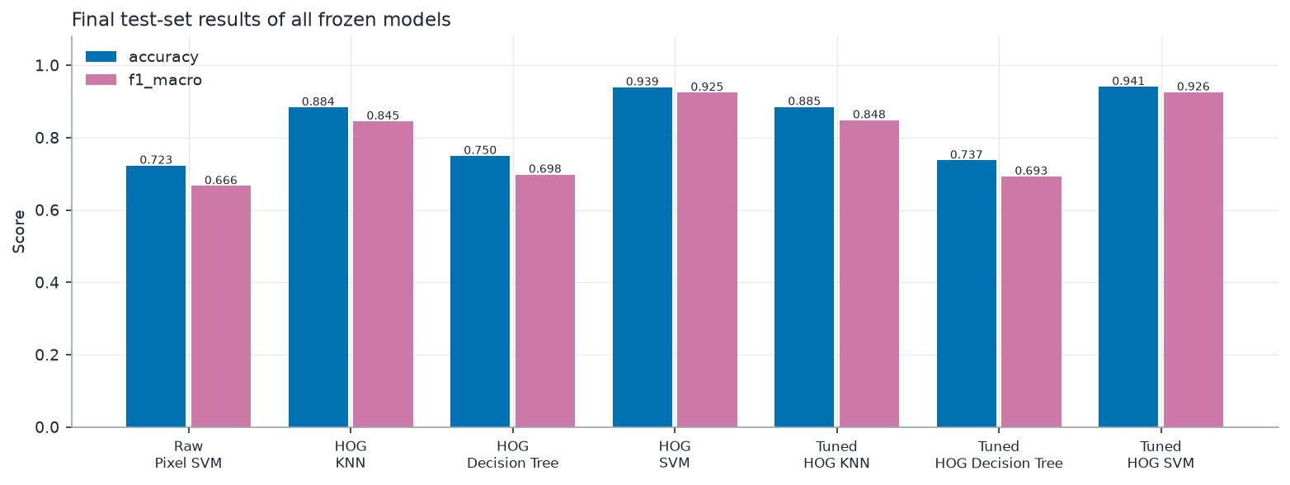
Test comparison

Winner (chosen by code, not by hand)
Selection metric: f1_macro on the validation split. Best default HOG classifier: HOG SVM. Best row overall (validation): HOG SVM.

Research answers (measured)
On the untouched test split, HOG + SVM reached macro-F1 0.9246 (accuracy 0.9391) versus 0.6664 (accuracy 0.7227) for raw pixels + SVM with identical SVM settings and split. The difference is +0.2582 macro-F1 and +0.2164 accuracy, i.e. HOG improved classification quality relative to raw pixels. HOG also used 1764 features instead of 1024.
Test macro-F1 with identical HOG features and default settings: HOG KNN 0.8451, HOG Decision Tree 0.6981, HOG SVM 0.9246. Winner on the test split: HOG SVM; winner on the validation split (the split used for selection): HOG SVM.

Why the winner performed better/worse - expected behaviour from theory
- Theory suggests the RBF SVM suits dense, high-dimensional HOG vectors because the margin maximisation and kernel give a smooth boundary that generalises from limited samples per class.
- KNN depends on Euclidean distances in a 1764-dimensional space where distances become less discriminative; it also stores all training data and predicts slowly.
- A single Decision Tree splits on single HOG bins and typically over-fits correlated high-dimensional features.
- These are expectations; the measured tables above decide the actual ranking and any deviation must be discussed in the report.

