Stage 10 - Hyperparameter Tuning
RoadEye - Traffic Sign Recognition Using HOG Features and SVM
Machine Learning (3CS101CC24) - Nirma University, Institute of Technology - B.Tech CSE, Semester 5
Student: [name / roll number - add before submission]
Run scope: full_dataset | Generated: 2026-10-10

GridSearchCV set-up
Tuning set-up
Item | Value
Search method | GridSearchCV (exhaustive) over Pipeline(StandardScaler -> SVC)
Data used | training split only
Cross-validation | 3-fold StratifiedGroupKFold (stratified by class, grouped by physical sign)
Scoring metric | macro-F1
Search space | [{'kernel': ['rbf'], 'C': ['1', '10', '100'], 'gamma': ['scale', '0.001', '0.01']}]
Candidates | 9

Why this design: the scaler sits inside the cross-validated pipeline (re-fitted per fold, no leakage); group-aware folds stop near-identical frames from straddling folds; macro-F1 treats all classes equally; the grid is deliberately modest (kernel, C, gamma) to stay computationally reasonable.

Results (measured)
Best configuration
Item | Value
Best parameters | {'C': 10, 'gamma': 'scale', 'kernel': 'rbf'}
Best CV macro-F1 | 0.7768
CV std | 0.0172
Grid-search wall time (s) | 1429

Top SVM candidates
Rank | Parameters | CV macro-F1 | Train macro-F1
1 | C=10, gamma=scale, kernel=rbf | 0.7768 +/- 0.0172 | 1.0000
1 | C=100, gamma=scale, kernel=rbf | 0.7768 +/- 0.0172 | 1.0000
3 | C=1, gamma=scale, kernel=rbf | 0.7736 +/- 0.0166 | 0.9995
4 | C=10, gamma=0.001, kernel=rbf | 0.7031 +/- 0.0126 | 1.0000
4 | C=100, gamma=0.001, kernel=rbf | 0.7031 +/- 0.0126 | 1.0000
6 | C=1, gamma=0.001, kernel=rbf | 0.6987 +/- 0.0107 | 0.9997
7 | C=10, gamma=0.01, kernel=rbf | 0.0091 +/- 0.0076 | 1.0000
7 | C=100, gamma=0.01, kernel=rbf | 0.0091 +/- 0.0076 | 1.0000

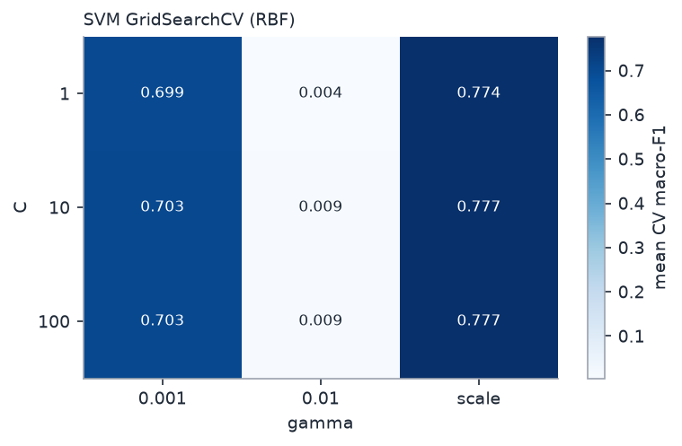
SVM grid search results

Before vs after tuning (validation split)
Effect of tuning
Model | Validation macro-F1
HOG SVM (default) | 0.9361
Tuned HOG SVM | 0.9356
Change | -0.0004

KNN and Decision Tree were tuned with small grids as well (results in results/metrics/grid_search_knn.csv and grid_search_decision_tree.csv), so the final comparison does not pit a tuned SVM against untuned rivals.

Why the final configuration was selected
The parameters with the highest mean CV macro-F1 on the training data were selected; the refit model was then scored once on the validation split. The test split played no role in tuning.

