Stage 11 - Validation & Evaluation
RoadEye - Traffic Sign Recognition Using HOG Features and SVM
Machine Learning (3CS101CC24) - Nirma University, Institute of Technology - B.Tech CSE, Semester 5
Student: [name / roll number - add before submission]
Run scope: full_dataset | Generated: 2026-10-10

Validation strategy
- Train / validation / test split (group-aware, stratified, seed 42); test untouched until the end.
- 3-fold StratifiedGroupKFold cross-validation on the training split for tuning.
- Training and validation scores reported separately to expose over-fitting.
- Final test evaluation performed once after model selection (audit log: results/logs/test_evaluation_log.txt).

Why macro-F1
GTSRB is imbalanced; accuracy can be high even if rare signs are ignored. Macro-F1 averages per-class F1 (harmonic mean of precision and recall) with equal weight, so it measures performance on every class.

Final metrics - Tuned HOG + SVM (measured)
Final evaluation
Metric | Train | Validation | Test
accuracy | 1.0000 | 0.9487 | 0.9408
precision_macro | 1.0000 | 0.9570 | 0.9521
recall_macro | 1.0000 | 0.9295 | 0.9069
f1_macro | 1.0000 | 0.9356 | 0.9256
f1_weighted | 1.0000 | 0.9478 | 0.9401
balanced_accuracy | 1.0000 | 0.9295 | 0.9069

Generalisation gap (train - test macro-F1): 0.0744.
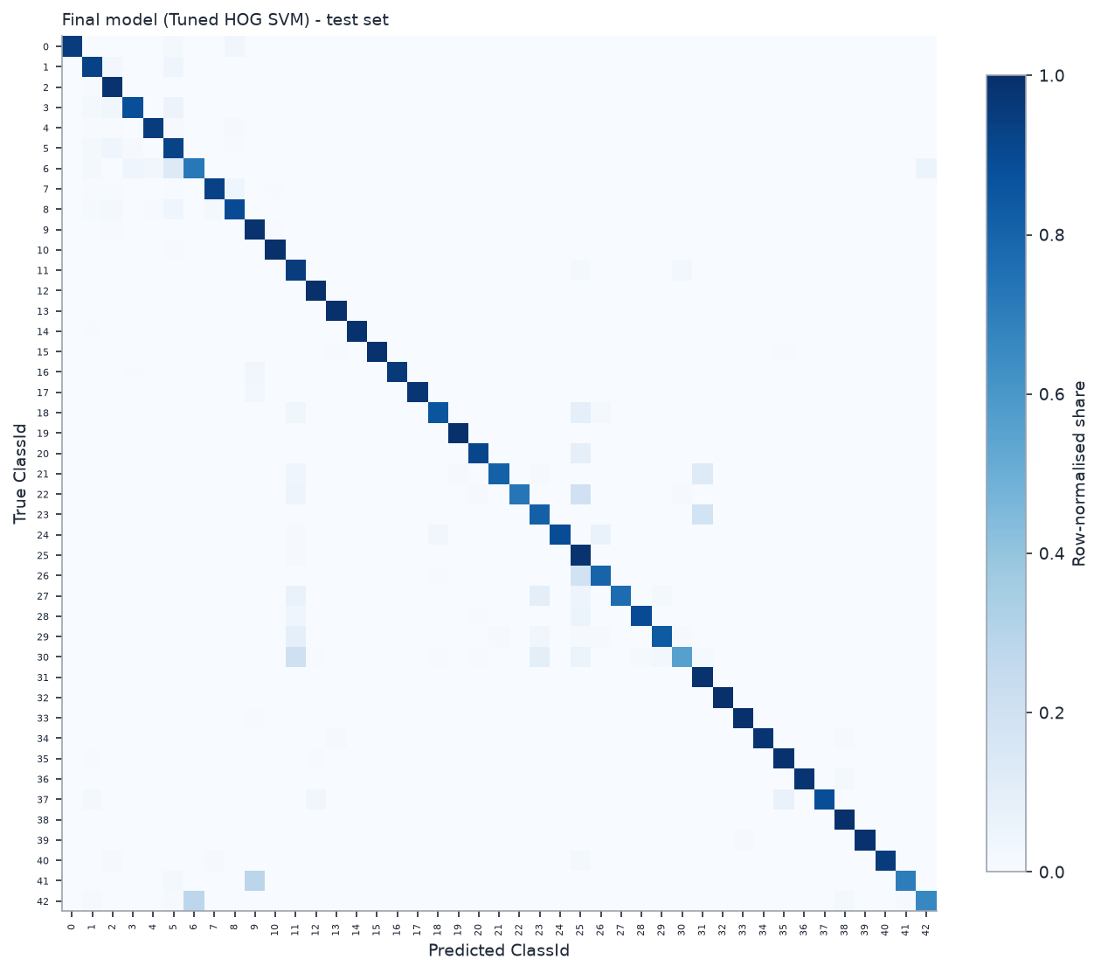
Final confusion matrix (test, row-normalised)
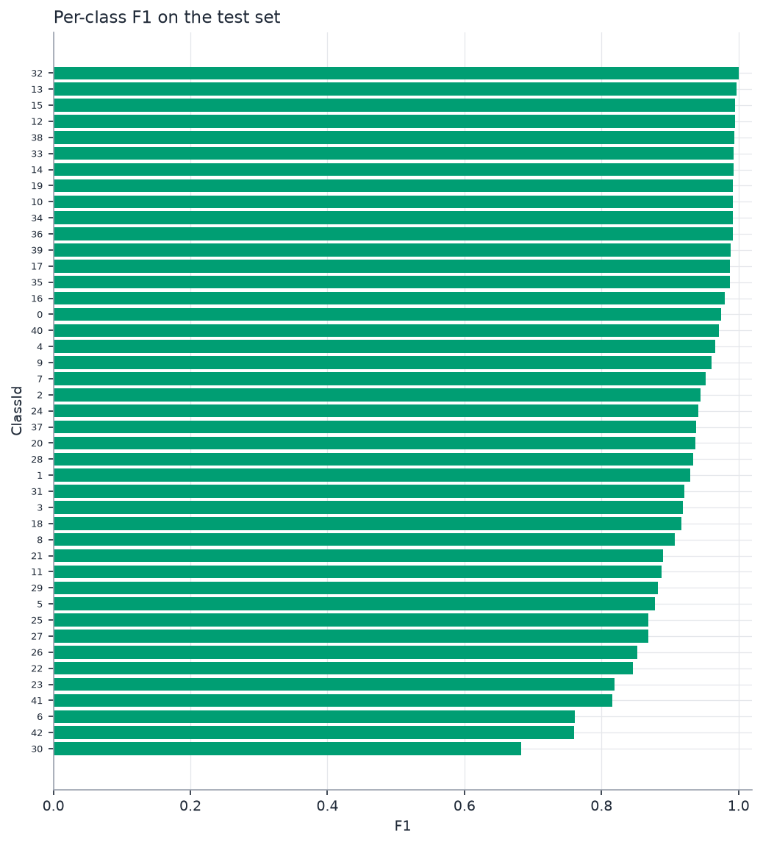
Per-class F1 (test)

Class-wise performance - ten weakest classes
Weakest classes (test)
Class | Name | Precision | Recall | F1 | Support
30 | Beware of ice/snow | 0.875 | 0.560 | 0.683 | 150
42 | End of no passing by vehicles over 3.5 metric tons | 0.882 | 0.667 | 0.759 | 90
6 | End of speed limit (80km/h) | 0.806 | 0.720 | 0.761 | 150
41 | End of no passing | 0.977 | 0.700 | 0.816 | 60
23 | Slippery road | 0.824 | 0.813 | 0.819 | 150
22 | Bumpy road | 1.000 | 0.733 | 0.846 | 120
26 | Traffic signals | 0.911 | 0.800 | 0.852 | 180
27 | Pedestrians | 1.000 | 0.767 | 0.868 | 60
25 | Road work | 0.775 | 0.988 | 0.868 | 480
5 | Speed limit (80km/h) | 0.838 | 0.922 | 0.878 | 630

Error analysis
748 of 12630 test images were misclassified (error rate 0.0592). The most frequent confusion is class 18 (General caution) predicted as class 25 (Road work), 35 time(s). 39.6% of the errors are between two speed-limit classes. Error rate by original image size: <30: 0.132 (n=1354); 30-39: 0.067 (n=4191); 40-49: 0.046 (n=2758); 50-69: 0.040 (n=2507); 70+: 0.034 (n=1820). Spearman correlation between training-class size and per-class recall: 0.36.
Most frequent confusions (test)
True class | Predicted as | Count
18: General caution | 25: Road work | 35
26: Traffic signals | 25: Road work | 35
30: Beware of ice/snow | 11: Right-of-way at the next intersection | 31
1: Speed limit (30km/h) | 5: Speed limit (80km/h) | 29
23: Slippery road | 31: Wild animals crossing | 28
3: Speed limit (60km/h) | 5: Speed limit (80km/h) | 26
5: Speed limit (80km/h) | 2: Speed limit (50km/h) | 25
42: End of no passing by vehicles over 3.5 metric tons | 6: End of speed limit (80km/h) | 25

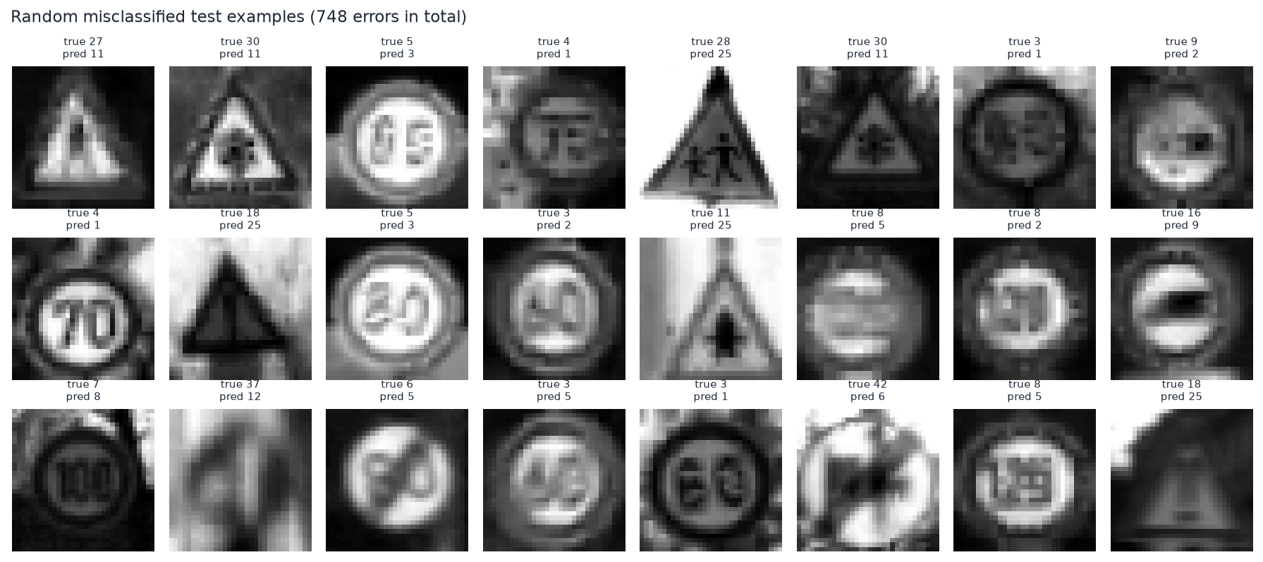
Random sample of misclassified test images

Generalisation discussion
A small difference between validation and test scores indicates that model selection did not over-fit the validation split; a large train-test gap indicates over-fitting. The split is by physical sign, so the test score estimates performance on *unseen signs from the same recording conditions*. It does not estimate performance on other countries, other cameras, full street scenes or adversarial conditions.

