RoadEye - Final Report
Traffic Sign Recognition Using HOG Features and SVM - Machine Learning Innovative Assignment
Machine Learning (3CS101CC24) - Nirma University, Institute of Technology - B.Tech CSE, Semester 5
Student: [name / roll number - add before submission]
Run scope: full_dataset | Generated: 2026-10-10

1. Abstract
RoadEye classifies cropped German traffic signs (GTSRB, 43 classes) with classical machine learning. A leakage-safe pipeline (sign-grouped splits, scaler fitted on training data only, official test set untouched until the end) compares raw pixels with HOG features (RQ1) and KNN, Decision Tree and SVM classifiers on identical HOG features (RQ2), tunes them with GridSearchCV and evaluates the final tuned HOG + SVM once on the test set. Final test accuracy 0.9408, macro-F1 0.9256 on 12,630 test images. On the untouched test split, HOG + SVM reached macro-F1 0.9246 (accuracy 0.9391) versus 0.6664 (accuracy 0.7227) for raw pixels + SVM with identical SVM settings and split. The difference is +0.2582 macro-F1 and +0.2164 accuracy, i.e. HOG improved classification quality relative to raw pixels. HOG also used 1764 features instead of 1024. Test macro-F1 with identical HOG features and default settings: HOG KNN 0.8451, HOG Decision Tree 0.6981, HOG SVM 0.9246. Winner on the test split: HOG SVM; winner on the validation split (the split used for selection): HOG SVM. The system is an educational study and is not safety-certified.

2. Introduction
This report follows the twelve-stage pipeline of the IA guidelines. Each stage is listed with its applicability; every major decision is justified in Appendix A (what / why / how / what changed / how validated).
# | Stage | Applicable? | Where
1 | Problem definition & use case | Applicable | Section 3
2 | Data acquisition & understanding | Applicable | Section 4
3 | Data preparation | Applicable (corrupt/label/duplicate checks) | Section 5
4 | Data preprocessing | Applicable (grayscale, resize, scaling; no missing values/categoricals - justified) | Section 6
5 | Data balancing | Applicable - measured, decided by validation experiment | Section 7
6 | EDA | Applicable | Section 8
7 | Feature engineering / selection | Applicable (HOG; selection deliberately not used) | Section 9
8 | Baseline model | Applicable | Section 10
9 | ML modelling | Applicable (KNN, Decision Tree, SVM) | Sections 11-12
10 | Hyper-parameter tuning | Applicable (GridSearchCV) | Section 13
11 | Validation & evaluation | Applicable | Sections 14-16
12 | Use case, impact & limitations | Applicable | Sections 17-20

Central story: GTSRB -> preprocessing -> raw-pixel baseline -> HOG -> KNN / Decision Tree / SVM -> SVM GridSearchCV -> final evaluation -> error analysis -> Streamlit application.

3. Problem Definition

Project title
RoadEye - Traffic Sign Recognition Using HOG Features and SVM

Background
Traffic signs encode the rules of the road in a compact visual language of shape, colour and pictogram. Driver-assistance systems (ADAS), road-asset inventories and navigation-map updates all need software that can recognise which sign is shown in an image. Modern solutions often use deep neural networks; this project deliberately studies the *classical machine-learning* route - hand-engineered features plus a conventional classifier - because it is transparent, cheap to train and lets us measure the contribution of each design decision.

Problem statement
Given a cropped colour photograph of a single traffic sign, predict which of the 43 GTSRB sign categories it belongs to, and determine experimentally (a) whether HOG feature engineering improves on raw pixels and (b) which syllabus classifier (KNN, Decision Tree, SVM) works best on the same HOG features.

Motivation
- Road-safety relevance: sign misreading is a known failure source for driver-assistance functions.
- Educational value: the project exercises the full ML pipeline - data audit, leakage-safe splitting, feature engineering, baseline, model comparison, tuning, evaluation and deployment demo.
- Low-resource: classical models train in minutes on a laptop CPU and are easy to explain and reproduce.

Real-world use case
A sign-recognition module that receives an already-localised sign crop (from a detector or from a map-survey tool) and returns the sign class, e.g. to cross-check a speed-limit database or to flag a missing/damaged sign in a road-asset survey. A Streamlit demo shows this single-image classification.

Stakeholders
- Road users and drivers (safety benefit)
- Road authorities / asset managers (sign inventory and maintenance)
- Driver-assistance and map-data developers (recognition component)
- Course instructors and the student (assessment and learning)

Machine-learning formulation
ML formulation
Item | Definition
Task | Supervised multiclass image classification
Input (x) | RGB image of one sign -> grayscale 32x32 -> HOG feature vector
Output (y) | class id in {0, ..., 42} (sign category)
Learning problem | learn f(x) = y from labelled examples; generalise to unseen physical signs
Primary metric | macro-F1 (also accuracy, macro-precision, macro-recall, confusion matrix)

Constraints
- Syllabus: classical models only (KNN, Decision Tree, SVM); deep learning appears only as future scope.
- One-week scope and laptop-class compute (no GPU).
- No data leakage; test set used exactly once; all results measured by running the code.

Scope and out-of-scope
- In scope: classification of cropped sign images; HOG vs raw pixels; KNN vs Decision Tree vs SVM; GridSearchCV; Streamlit demo.
- Out of scope: sign detection/localisation, video, real-time operation, CNN/YOLO models, deployment to vehicles or the cloud, safety certification.

Expected impact
A reproducible, fully documented reference implementation showing how far classical features can go on a standard benchmark, with an honest account of its errors and limitations.

Research questions
- RQ1: Does HOG feature engineering improve traffic-sign classification compared with raw pixels (Raw Pixels + SVM vs HOG + SVM)?
- RQ2: Which of KNN, Decision Tree and SVM performs best on the same HOG features? (Determined experimentally - not assumed.)

4. Dataset

Dataset source and licence / usage terms
GTSRB is a public benchmark published for research on traffic-sign recognition. The licence / usage statement of the exact copy used must be read from the page it was downloaded from (the official site or a mirror such as Kaggle, which states its own licence). See DATASET_DOWNLOAD.md and LICENSE_NOTICE.md. The dataset is used here only for non-commercial coursework; it is not redistributed inside the project ZIP.

Dataset summary (measured)
Dataset summary - generated by Notebook 01
Property | Value
Source | German Traffic Sign Recognition Benchmark (GTSRB), Institut fuer Neuroinformatik, Ruhr-Universitaet Bochum
Reference | J. Stallkamp, M. Schlipsing, J. Salmen, C. Igel. Man vs. computer: Benchmarking machine learning algorithms for traffic sign recognition. Neural Networks 32 (2012) 323-332.
Official page | https://benchmark.ini.rub.de/
Version used (this run) | GTSRB - German Traffic Sign Recognition Benchmark (Final Training + Final Test + Test GT) - run mode: full_dataset
Image files indexed | 51,839
Readable images | 51,839
Number of classes | 43
Physical signs (tracks) | 1,307
File formats | ['.ppm']
Image width (min / median / max) | 25 / 43.0 / 266
Image height (min / median / max) | 25 / 43.0 / 232
Total size (MB) | 484.9
Target variable | class_id (0-42) = folder name; cross-checked with official GT-xxxxx.csv

Why GTSRB?
- Recognised benchmark with a published protocol, so results are meaningful and comparable.
- 43 classes with real-world variation (illumination, blur, scale, partial occlusion).
- Large enough for classical ML and small enough (images of at most a few hundred pixels) for a laptop.

Target definition and class distribution
The target is the sign category (43 classes: speed limits, prohibitory, warning, mandatory and end-of-restriction signs). The distribution is shown below and analysed in Stage 5.
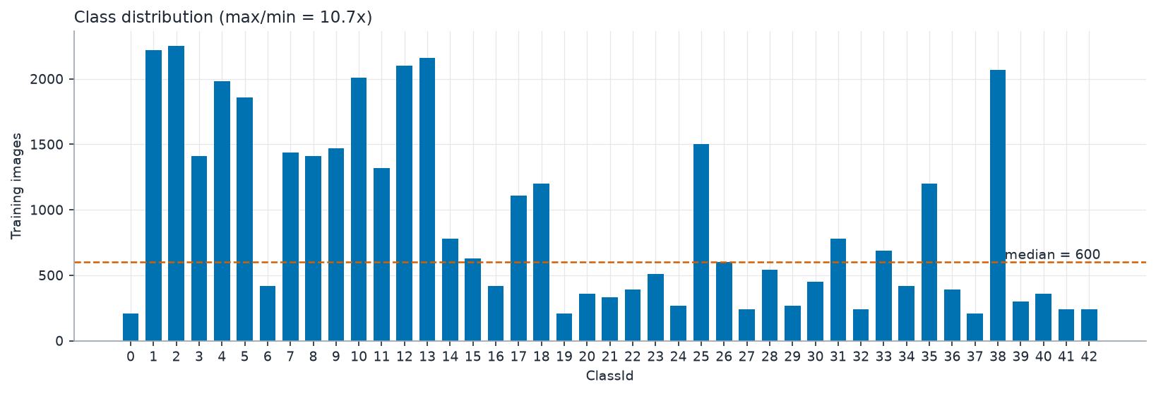
Images per class (measured)
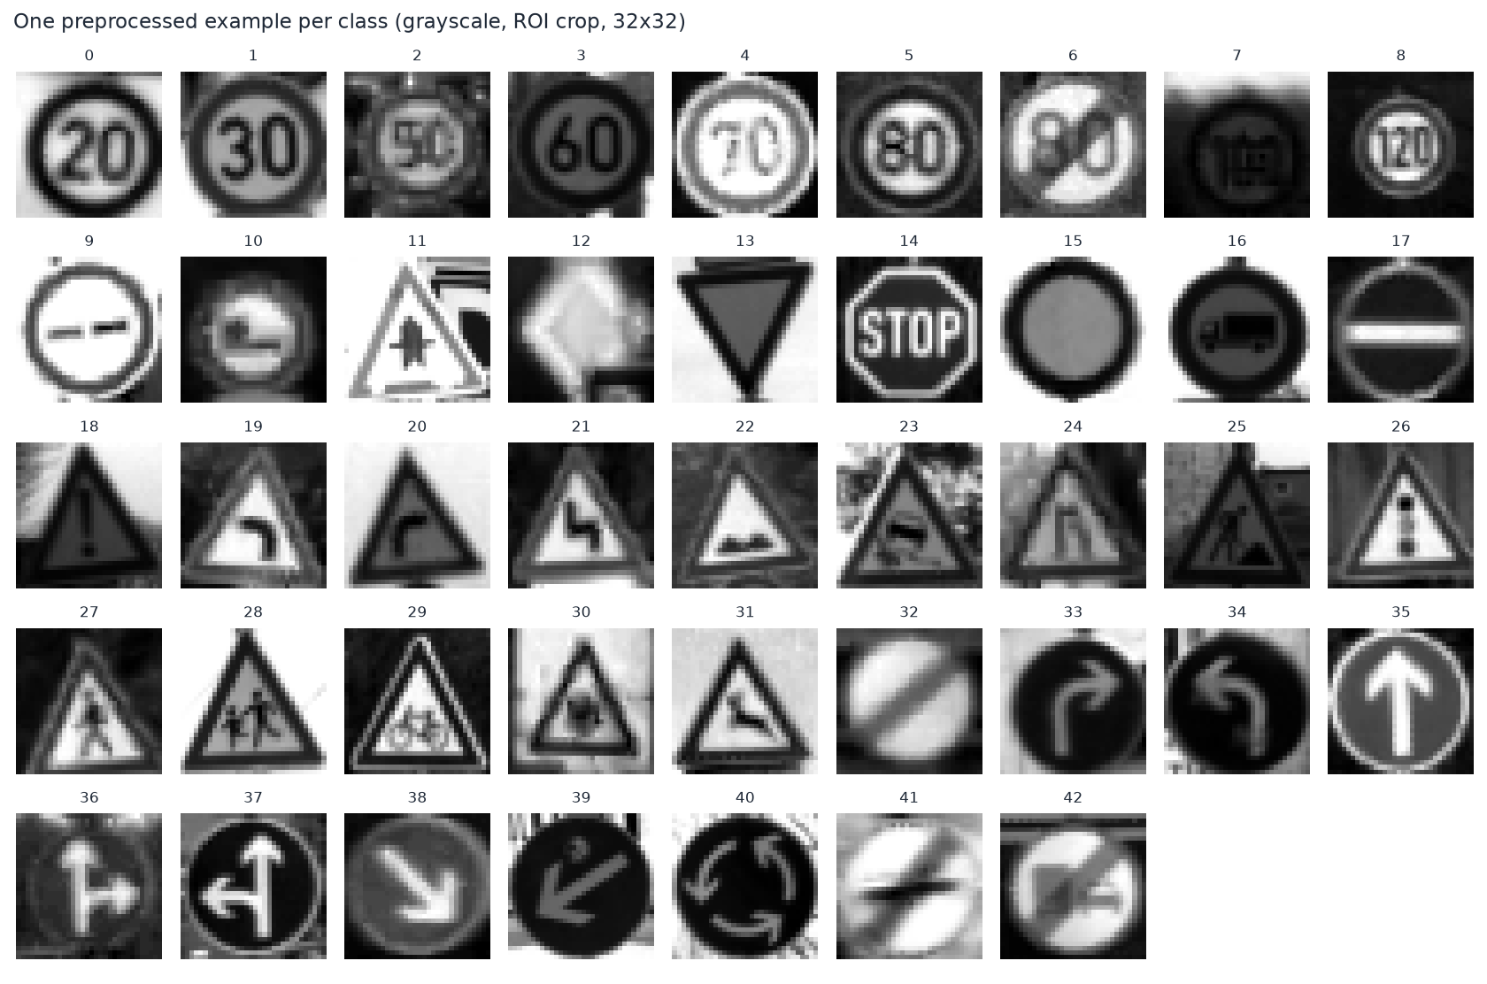
One random image per class
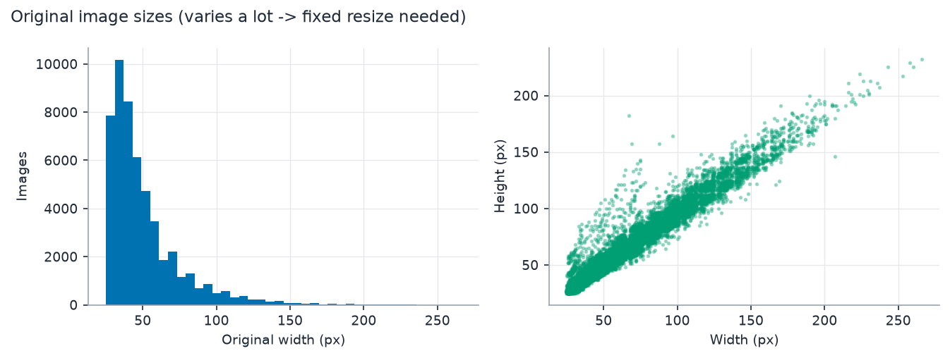
Original image sizes (resizing to one size is required)

Dataset limitations
- All images are from German roads; other countries use different sign designs.
- ~30 frames per physical sign are highly correlated -> splitting by sign (group) is mandatory.
- Images are already cropped to the sign (with a small border); there is no detection task.
- Strong class imbalance is typical of GTSRB (see Stage 5 for the measured ratio).
- Small, blurry or dark images carry little information at 32x32 pixels.

5. Data Preparation

Raw data structure
Images are organised as one folder per class (00000 ... 00042); in the official archive each folder also holds a semicolon-separated GT-xxxxx.csv. File names encode the physical-sign track and frame (<track>_<frame>.ppm).

Cleaning steps
- Corrupted files: every file is fully decoded; unreadable files are logged and removed.
- Label validation: the class label is the folder name; the official CSV ClassId is an independent cross-check; disagreements are removed.
- Duplicate checking: MD5 hash of the file bytes. Identical bytes with different labels are removed entirely; identical bytes with the same label keep one copy. Near-duplicates (consecutive frames of one sign) are genuine samples and are kept - they are handled by the group-aware split.
- Image resizing and organisation: images are resized to 32x32 in Stage 4 and cached in data/processed/ as arrays aligned to split.csv.

Before / after sample counts (measured)
Data cleaning log
Step | Count
Files indexed (before) | 51,839
Removed: unreadable / corrupt | 0
Removed: folder label disagrees with official CSV | 0
Removed: byte-identical files with conflicting labels | 0
Removed: redundant exact duplicates (first copy kept) | 0
Samples after cleaning | 51,839
Data scope | full dataset

Train / validation / test split
Test set: official_gtsrb_test_set. It is separated first and not touched again until the final evaluation. The remaining training pool is split into training and validation (~80/20) with StratifiedGroupKFold (random seed 42); the group is the physical sign (class + track). Splitting by sign prevents near-identical frames from appearing in both training and validation, which would inflate every score. Because folds contain whole signs, the fractions are approximate.
Split sizes (measured)
Subset | Images | Share | Classes | Physical signs
train | 31,379 | 60.5% | 43 | 1,046
val | 7,830 | 15.1% | 43 | 261
test | 12,630 | 24.4% | 43 | 12,630

Leakage check (no shared file path, physical sign or identical image bytes between subsets): True.

6. Preprocessing

Preprocessing pipeline
Preprocessing steps
Step | What | Why it is needed
ROI crop | crop to the sign's region of interest given in the official CSV (removes the ~10% border) | keeps the sign, drops background
Grayscale | RGB -> 1 channel | HOG relies on gradients; removes colour variation; fewer values
Resize | 32x32 with INTER_AREA | fixed-length feature vector; INTER_AREA is the correct filter for shrinking
Pixel normalisation | uint8 -> float32 in [0, 1] | numerical range; no information is learned from data
HOG extraction | 9 orientations, 4x4 pixels per cell, 2x2 cells per block, L2-Hys block normalisation | edge-orientation descriptor robust to illumination
Feature scaling | StandardScaler fitted on TRAIN only | SVM and KNN are scale sensitive; leakage-free

Missing values, outliers, encoding
- Missing values: image data has no missing cells; unreadable files are the equivalent and are removed (Stage 3).
- Outliers/anomalies: very small, dark or low-contrast images are quantified in EDA; they are real signs, so they are kept (removing them would bias the test set towards easy images).
- Encoding: the target is already an integer class id (0-42); no categorical encoding of features is needed.

Measured effect
Preprocessing summary
Item | Value
Samples after cleaning + preprocessing | 51,839
Raw-pixel features | 1,024
HOG features | 1,764

Data-leakage prevention
- Split first, fit afterwards: scaler, class-weight decision, models and GridSearchCV see the training split only.
- Inside GridSearchCV the scaler is part of the pipeline, so it is re-fitted on each fold's training part.
- Preprocessing steps that learn nothing from data (grayscale, resize, /255, HOG) are applied identically to all subsets.
- No feature selection or balancing used validation/test information; the test split is evaluated once (audit log in results/logs/).

7. Data Balancing

Class-distribution analysis (training split)
Imbalance statistics (measured)
Statistic | Value
Imbalance ratio (max/min class count) | 12.00
Smallest class | class 37 (150 images)
Largest class | class 2 (1800 images)
Normalised entropy (1 = balanced) | 0.927
Severity (rule: <=1.5 balanced, <=3 mild, <=10 moderate, else severe) | severe

Class distribution

Strategy selection
Strategy is chosen by experiment, not by habit: the default HOG SVM is trained with class_weight=None and class_weight='balanced' on the training split and the two are compared on the VALIDATION split by macro-F1.
Balancing experiment (validation split)
class_weight | Val accuracy | Val macro-F1 | Val balanced accuracy
None | 0.9471 | 0.9335 | 0.9264
balanced | 0.9479 | 0.9361 | 0.9309

Decision: Imbalance ratio 12.00 (severe). class_weight='balanced' vs None compared on the validation split by macro-F1 -> selected class_weight=balanced.
Selected class_weight: balanced (applies to SVM and Decision Tree; KNN has no class weights).

Why alternatives were not used
- SMOTE / synthetic oversampling: interpolating HOG vectors does not create valid sign images and risks leakage if done before splitting; not needed when class weights suffice.
- Random oversampling: duplicates training samples, increases training time and over-fitting risk.
- Undersampling: discards scarce real data from already small classes.

Confirmation of no leakage
Balancing decisions use the training split for fitting and the validation split for the comparison. Validation and test data are never resampled or re-weighted. Macro-averaged metrics are used so that rare classes count as much as frequent ones.

8. EDA

Questions asked
- Univariate: how many images per class, which sizes, how bright/contrasty are the images?
- Bivariate: does image size relate to class? Which classes look alike?
- Anomalies: dark, low-contrast, very small images.
- Which findings should change preprocessing or modelling?
Class distribution (target)
Image size distribution
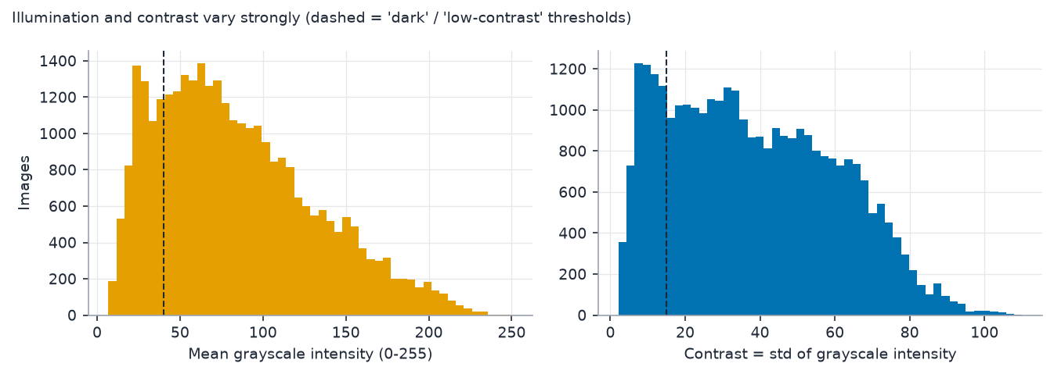
Brightness and contrast (training split)
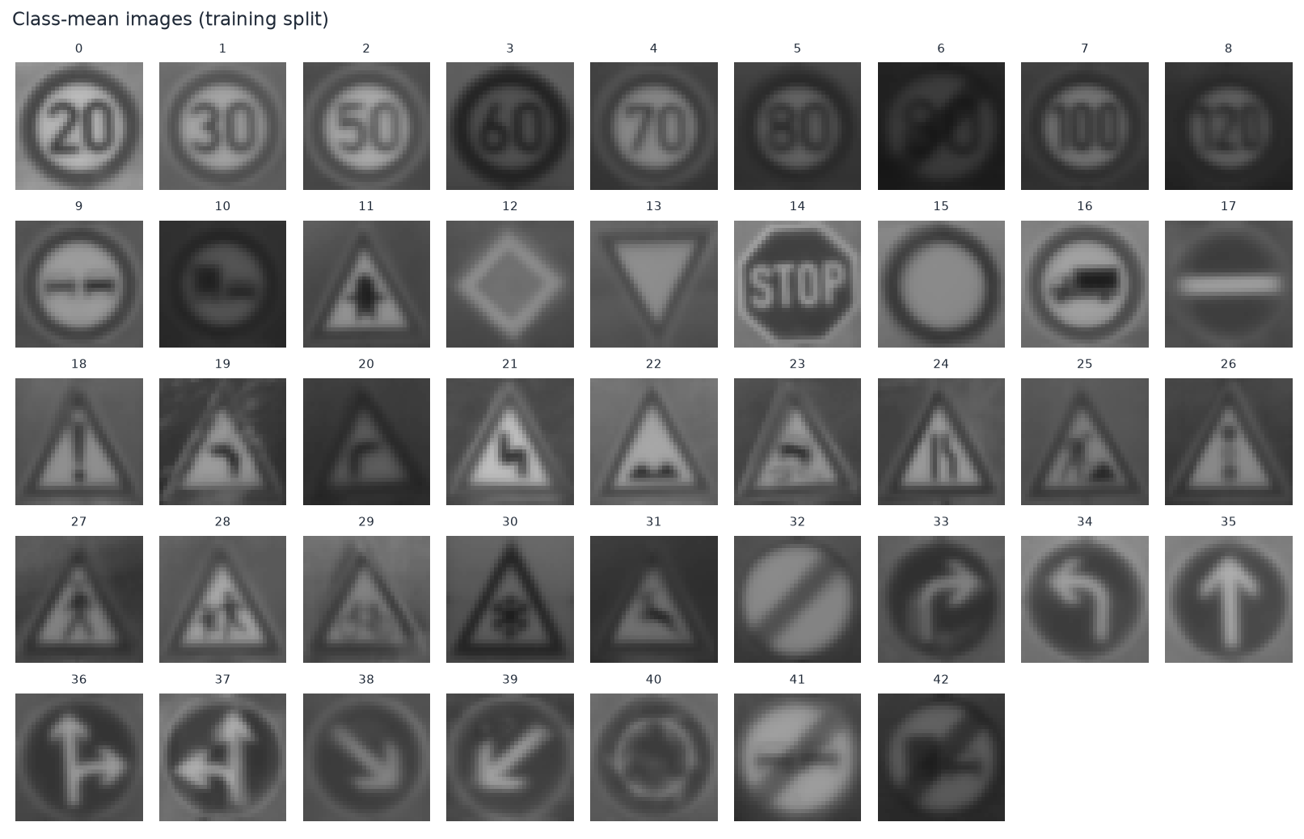
Class-mean images (training split)
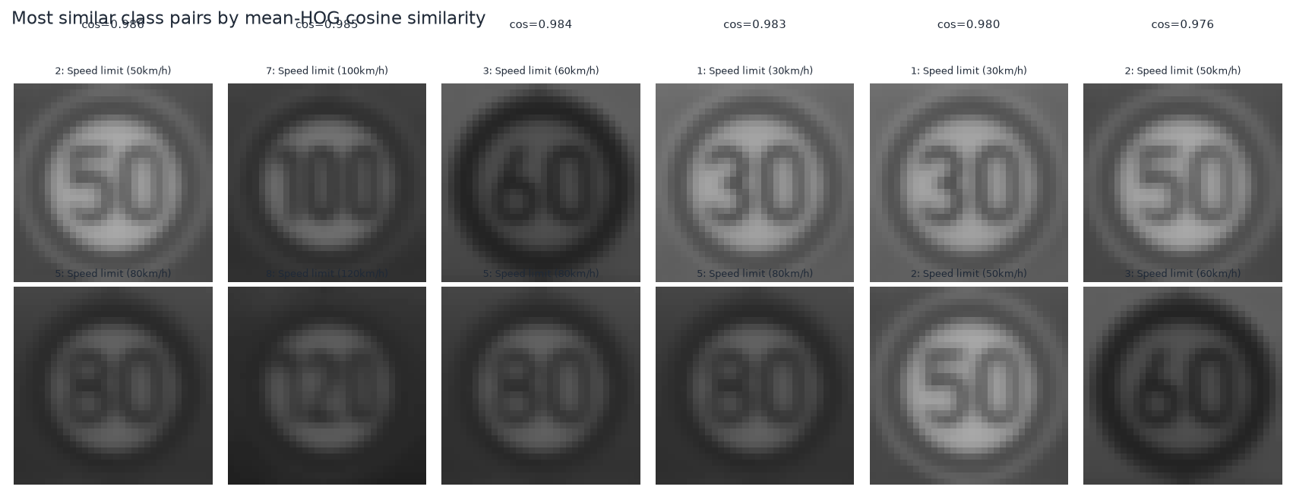
Most similar class pairs (training split)
Most similar classes by mean-HOG cosine similarity
Class A | Name A | Class B | Name B | Cosine similarity
2 | Speed limit (50km/h) | 5 | Speed limit (80km/h) | 0.986
7 | Speed limit (100km/h) | 8 | Speed limit (120km/h) | 0.985
3 | Speed limit (60km/h) | 5 | Speed limit (80km/h) | 0.984
1 | Speed limit (30km/h) | 5 | Speed limit (80km/h) | 0.983
1 | Speed limit (30km/h) | 2 | Speed limit (50km/h) | 0.980
2 | Speed limit (50km/h) | 3 | Speed limit (60km/h) | 0.976
1 | Speed limit (30km/h) | 3 | Speed limit (60km/h) | 0.976
18 | General caution | 26 | Traffic signals | 0.973

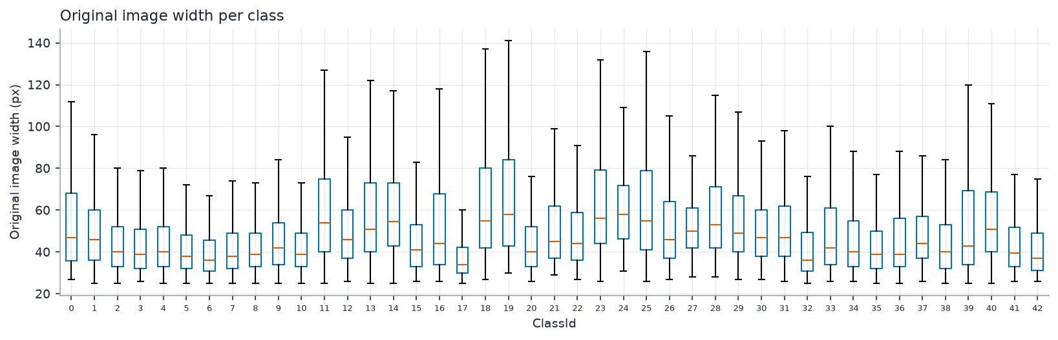
Original size per class

Measured observations
- Training images flagged dark (mean grey level < 40): 6281; low contrast (std < 15): 5780 of 31379.
- Spearman correlation between class size and median original width: -0.13.
- Most similar pair by class-mean HOG cosine similarity: class 2 (Speed limit (50km/h)) and class 5 (Speed limit (80km/h)), cos = 0.986.

Observations -> decisions
EDA-driven decisions
Observation | Decision
Image sizes vary widely | Resize to a single size
Lighting varies; colour not essential | Grayscale + HOG block normalisation
Unequal class counts | Validate class_weight on the validation split
Frames per sign are near-identical | Group-aware split and CV
Some classes look alike | Expect and analyse confusions; report macro-F1 and per-class results

9. Feature Engineering

Representations compared
Feature representations
Representation | Definition | Dimensions
Raw pixels | flattened normalised 32x32 grayscale image | 1,024
HOG | 9 orientations, 4x4 pixels per cell, 2x2 cells per block, L2-Hys block normalisation | 1,764

How HOG works
- Compute image gradients (magnitude and direction) at every pixel.
- Split the image into cells; per cell build a histogram of gradient directions weighted by magnitude.
- Group cells into overlapping blocks and normalise each block (L2-Hys) to reduce sensitivity to local contrast/brightness.
- Concatenate all block vectors into one feature vector.

Why HOG suits traffic signs
- Signs are characterised by outlines (circle, triangle, octagon) and inner pictograms - both are edge structures that HOG encodes.
- Block normalisation reduces the effect of illumination changes, a major variation source in GTSRB.
- It is compact and fast, and needs no training (unlike learned CNN features) - appropriate for a classical-ML syllabus.
- Limitation: HOG is not rotation or scale invariant and loses colour; at small image sizes fine digits are only a few pixels wide.

HOG parameters
HOG configuration
Parameter | Value | Reason
Image size | 32x32 | balance between detail and speed
orientations | 9 | standard Dalal-Triggs setting
pixels_per_cell | (4, 4) | cell large enough for stable histograms, small enough for pictograms
cells_per_block | (2, 2) | overlapping blocks for local normalisation
block_norm | L2-Hys | robust normalisation

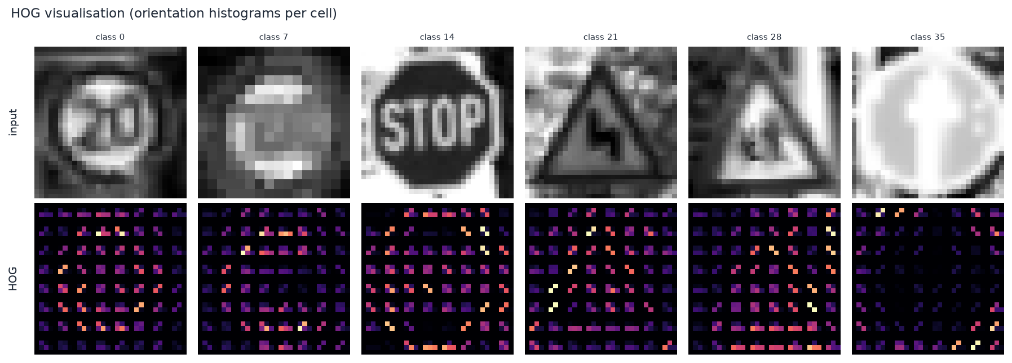
HOG visualisation for sample training images
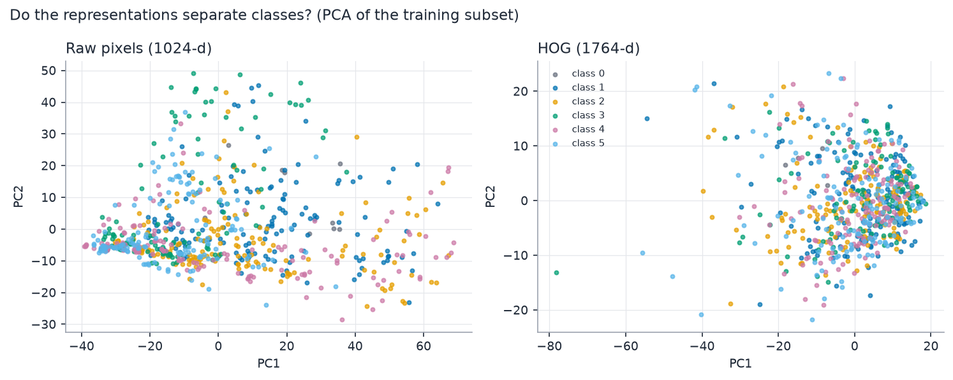
Raw pixels vs HOG: dimensionality and PCA variance

Feature scaling and selection
StandardScaler (zero mean, unit variance) is fitted on the training split only and applied to validation/test. No feature selection was applied: HOG vectors are compact, selection on evaluation data risks leakage, and the RBF SVM copes with correlated features. HOG parameters were fixed a priori (not tuned on the test split) and are stored in model_metadata.json so the app reproduces them exactly.

10. Baseline

Baseline definition
Raw pixels + SVM: grayscale 32x32 image, flattened, standardised, default RBF SVM (C=1, gamma='scale'). It uses the same split, scaler type and class-weight decision as the proposed model.

Why a baseline is required
Without a reference point, a high score cannot be interpreted. The baseline shows what a model achieves *without* feature engineering, so the benefit of HOG can be measured instead of assumed.

Configuration and training procedure
- Features: raw normalised pixels (1,024 dimensions)
- Scaler fitted on training data only; SVC(kernel='rbf', C=1.0, gamma='scale')
- class_weight: balanced
- random_state: 42
- Trained on the training split; evaluated on the validation split (test untouched)

Baseline metrics (measured)
Baseline performance
Metric | Training | Validation
accuracy | 0.9049 | 0.7151
precision_macro | 0.9148 | 0.7070
recall_macro | 0.9362 | 0.6552
f1_macro | 0.9168 | 0.6550

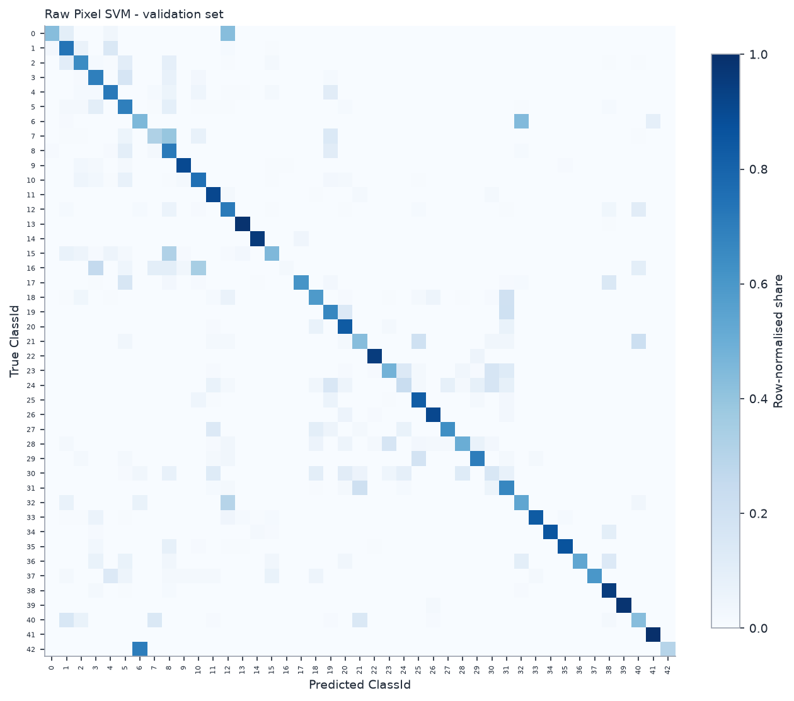
Baseline confusion matrix (validation, row-normalised)

Limitations
- Pixel values are sensitive to brightness, contrast and small shifts.
- High dimensionality relative to information content.
- No explicit shape/edge description.

11. Model Development

Models and why they were selected
Model selection rationale
Model | Why | Assumption / weakness
KNN | Simplest instance-based learner; strong baseline in feature space | Local similarity is meaningful; slow prediction, scale sensitive, no model
Decision Tree | Interpretable, scale invariant | Axis-aligned splits suffice; high variance / over-fits
SVM (RBF) | Maximum-margin classifier; effective on medium-size high-dimensional data; the proposed model | Smooth non-linear boundary; scale sensitive; training cost grows with samples

12. Model Comparison

Fairness of the comparison
Same cleaned data, same group-aware split, same HOG features, same StandardScaler (fit on train), same metrics; all models are scored on the validation split for selection (table 1). After every model is frozen, the same models are evaluated once on the untouched test split (table 2).

Table 1 - validation split (used for selection)
Model comparison - validation
Model | Features | Accuracy | Precision (macro) | Recall (macro) | F1 (macro) | Training time (s) | Inference time (s)
Raw Pixel SVM | Raw pixels (1024-d) | 0.7151 | 0.7070 | 0.6552 | 0.6550 | 108.80 | 95.542
HOG KNN | HOG (1764-d) | 0.9033 | 0.9146 | 0.8755 | 0.8842 | 0.02 | 2.962
HOG Decision Tree | HOG (1764-d) | 0.7791 | 0.7687 | 0.7620 | 0.7603 | 74.31 | 0.008
HOG SVM | HOG (1764-d) | 0.9479 | 0.9561 | 0.9309 | 0.9361 | 134.99 | 115.785
Tuned HOG KNN | HOG (1764-d) | 0.9047 | 0.9162 | 0.8760 | 0.8852 | 0.42 | 3.390
Tuned HOG Decision Tree | HOG (1764-d) | 0.7700 | 0.7514 | 0.7450 | 0.7430 | 180.48 | 0.010
Tuned HOG SVM | HOG (1764-d) | 0.9487 | 0.9570 | 0.9295 | 0.9356 | 141.19 | 111.961

Table 2 - test split (evaluated once)
Model comparison - test
Model | Features | Accuracy | Precision (macro) | Recall (macro) | F1 (macro) | Training time (s) | Inference time (s)
Raw Pixel SVM | Raw pixels (1024-d) | 0.7227 | 0.6967 | 0.6763 | 0.6664 | 108.80 | 147.313
HOG KNN | HOG (1764-d) | 0.8837 | 0.8657 | 0.8373 | 0.8451 | 0.02 | 4.957
HOG Decision Tree | HOG (1764-d) | 0.7496 | 0.7115 | 0.6928 | 0.6981 | 74.31 | 0.012
HOG SVM | HOG (1764-d) | 0.9391 | 0.9508 | 0.9063 | 0.9246 | 134.99 | 177.176
Tuned HOG KNN | HOG (1764-d) | 0.8850 | 0.8723 | 0.8398 | 0.8483 | 0.42 | 4.924
Tuned HOG Decision Tree | HOG (1764-d) | 0.7370 | 0.7079 | 0.6862 | 0.6927 | 180.48 | 0.012
Tuned HOG SVM | HOG (1764-d) | 0.9408 | 0.9521 | 0.9069 | 0.9256 | 141.19 | 177.091

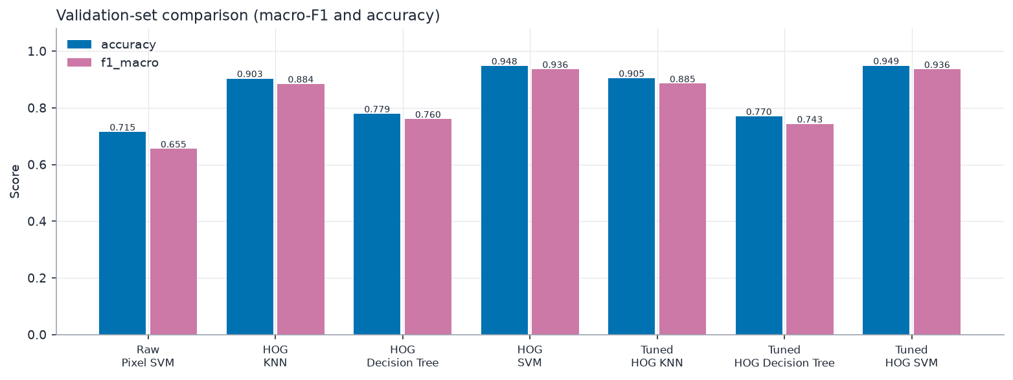
Validation comparison
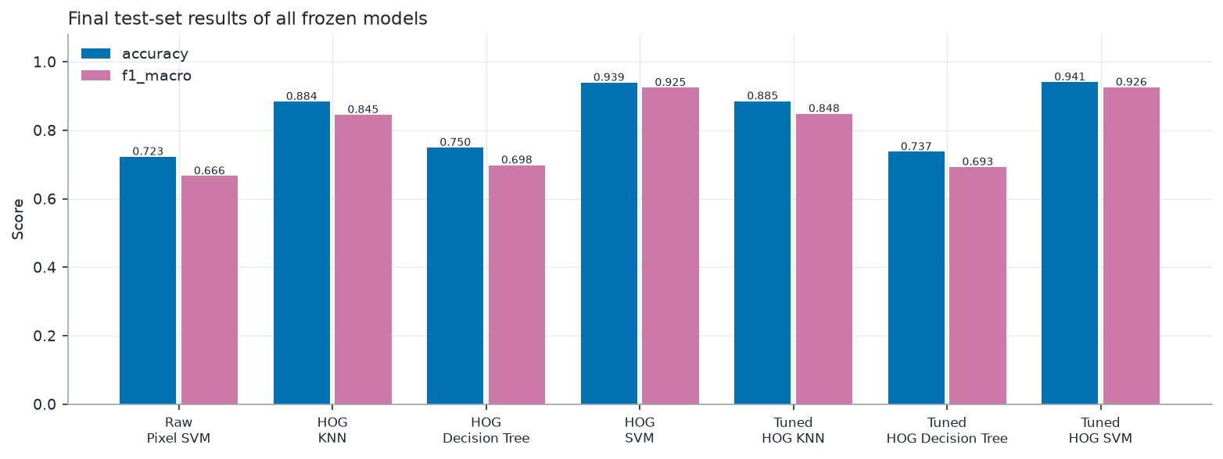
Test comparison

Winner (chosen by code, not by hand)
Selection metric: f1_macro on the validation split. Best default HOG classifier: HOG SVM. Best row overall (validation): HOG SVM.

Research answers (measured)
On the untouched test split, HOG + SVM reached macro-F1 0.9246 (accuracy 0.9391) versus 0.6664 (accuracy 0.7227) for raw pixels + SVM with identical SVM settings and split. The difference is +0.2582 macro-F1 and +0.2164 accuracy, i.e. HOG improved classification quality relative to raw pixels. HOG also used 1764 features instead of 1024.
Test macro-F1 with identical HOG features and default settings: HOG KNN 0.8451, HOG Decision Tree 0.6981, HOG SVM 0.9246. Winner on the test split: HOG SVM; winner on the validation split (the split used for selection): HOG SVM.

Why the winner performed better/worse - expected behaviour from theory
- Theory suggests the RBF SVM suits dense, high-dimensional HOG vectors because the margin maximisation and kernel give a smooth boundary that generalises from limited samples per class.
- KNN depends on Euclidean distances in a 1764-dimensional space where distances become less discriminative; it also stores all training data and predicts slowly.
- A single Decision Tree splits on single HOG bins and typically over-fits correlated high-dimensional features.
- These are expectations; the measured tables above decide the actual ranking and any deviation must be discussed in the report.

13. Hyperparameter Tuning

GridSearchCV set-up
Tuning set-up
Item | Value
Search method | GridSearchCV (exhaustive) over Pipeline(StandardScaler -> SVC)
Data used | training split only
Cross-validation | 3-fold StratifiedGroupKFold (stratified by class, grouped by physical sign)
Scoring metric | macro-F1
Search space | [{'kernel': ['rbf'], 'C': ['1', '10', '100'], 'gamma': ['scale', '0.001', '0.01']}]
Candidates | 9

Why this design: the scaler sits inside the cross-validated pipeline (re-fitted per fold, no leakage); group-aware folds stop near-identical frames from straddling folds; macro-F1 treats all classes equally; the grid is deliberately modest (kernel, C, gamma) to stay computationally reasonable.

Results (measured)
Best configuration
Item | Value
Best parameters | {'C': 10, 'gamma': 'scale', 'kernel': 'rbf'}
Best CV macro-F1 | 0.7768
CV std | 0.0172
Grid-search wall time (s) | 1429

Top SVM candidates
Rank | Parameters | CV macro-F1 | Train macro-F1
1 | C=10, gamma=scale, kernel=rbf | 0.7768 +/- 0.0172 | 1.0000
1 | C=100, gamma=scale, kernel=rbf | 0.7768 +/- 0.0172 | 1.0000
3 | C=1, gamma=scale, kernel=rbf | 0.7736 +/- 0.0166 | 0.9995
4 | C=10, gamma=0.001, kernel=rbf | 0.7031 +/- 0.0126 | 1.0000
4 | C=100, gamma=0.001, kernel=rbf | 0.7031 +/- 0.0126 | 1.0000
6 | C=1, gamma=0.001, kernel=rbf | 0.6987 +/- 0.0107 | 0.9997
7 | C=10, gamma=0.01, kernel=rbf | 0.0091 +/- 0.0076 | 1.0000
7 | C=100, gamma=0.01, kernel=rbf | 0.0091 +/- 0.0076 | 1.0000

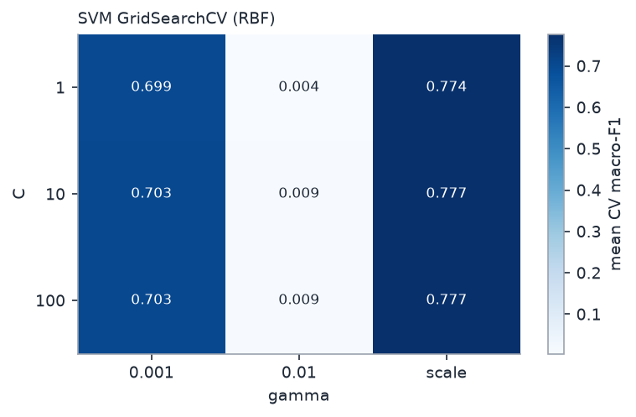
SVM grid search results

Before vs after tuning (validation split)
Effect of tuning
Model | Validation macro-F1
HOG SVM (default) | 0.9361
Tuned HOG SVM | 0.9356
Change | -0.0004

KNN and Decision Tree were tuned with small grids as well (results in results/metrics/grid_search_knn.csv and grid_search_decision_tree.csv), so the final comparison does not pit a tuned SVM against untuned rivals.

Why the final configuration was selected
The parameters with the highest mean CV macro-F1 on the training data were selected; the refit model was then scored once on the validation split. The test split played no role in tuning.

14. Validation

Validation strategy
- Train / validation / test split (group-aware, stratified, seed 42); test untouched until the end.
- 3-fold StratifiedGroupKFold cross-validation on the training split for tuning.
- Training and validation scores reported separately to expose over-fitting.
- Final test evaluation performed once after model selection (audit log: results/logs/test_evaluation_log.txt).

Why macro-F1
GTSRB is imbalanced; accuracy can be high even if rare signs are ignored. Macro-F1 averages per-class F1 (harmonic mean of precision and recall) with equal weight, so it measures performance on every class.

15. Final Evaluation

Final metrics - Tuned HOG + SVM (measured)
Final evaluation
Metric | Train | Validation | Test
accuracy | 1.0000 | 0.9487 | 0.9408
precision_macro | 1.0000 | 0.9570 | 0.9521
recall_macro | 1.0000 | 0.9295 | 0.9069
f1_macro | 1.0000 | 0.9356 | 0.9256
f1_weighted | 1.0000 | 0.9478 | 0.9401
balanced_accuracy | 1.0000 | 0.9295 | 0.9069

Generalisation gap (train - test macro-F1): 0.0744.
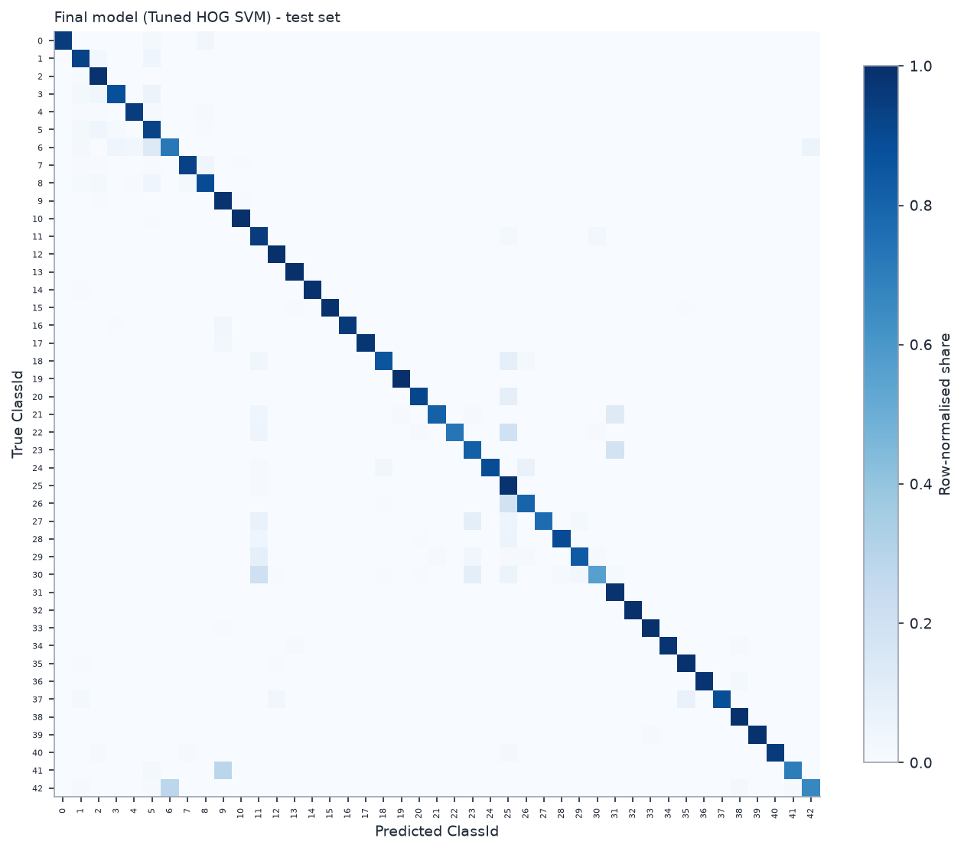
Final confusion matrix (test, row-normalised)
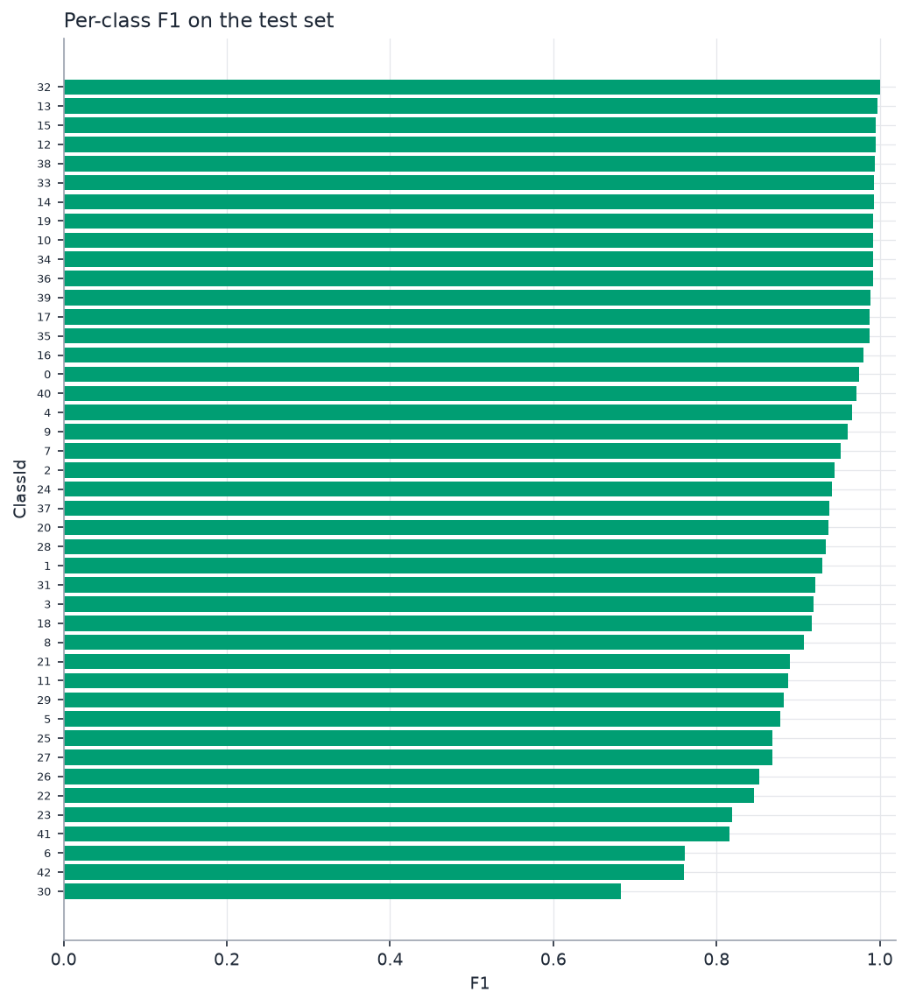
Per-class F1 (test)

Class-wise performance - ten weakest classes
Weakest classes (test)
Class | Name | Precision | Recall | F1 | Support
30 | Beware of ice/snow | 0.875 | 0.560 | 0.683 | 150
42 | End of no passing by vehicles over 3.5 metric tons | 0.882 | 0.667 | 0.759 | 90
6 | End of speed limit (80km/h) | 0.806 | 0.720 | 0.761 | 150
41 | End of no passing | 0.977 | 0.700 | 0.816 | 60
23 | Slippery road | 0.824 | 0.813 | 0.819 | 150
22 | Bumpy road | 1.000 | 0.733 | 0.846 | 120
26 | Traffic signals | 0.911 | 0.800 | 0.852 | 180
27 | Pedestrians | 1.000 | 0.767 | 0.868 | 60
25 | Road work | 0.775 | 0.988 | 0.868 | 480
5 | Speed limit (80km/h) | 0.838 | 0.922 | 0.878 | 630

16. Error Analysis

Error analysis
748 of 12630 test images were misclassified (error rate 0.0592). The most frequent confusion is class 18 (General caution) predicted as class 25 (Road work), 35 time(s). 39.6% of the errors are between two speed-limit classes. Error rate by original image size: <30: 0.132 (n=1354); 30-39: 0.067 (n=4191); 40-49: 0.046 (n=2758); 50-69: 0.040 (n=2507); 70+: 0.034 (n=1820). Spearman correlation between training-class size and per-class recall: 0.36.
Most frequent confusions (test)
True class | Predicted as | Count
18: General caution | 25: Road work | 35
26: Traffic signals | 25: Road work | 35
30: Beware of ice/snow | 11: Right-of-way at the next intersection | 31
1: Speed limit (30km/h) | 5: Speed limit (80km/h) | 29
23: Slippery road | 31: Wild animals crossing | 28
3: Speed limit (60km/h) | 5: Speed limit (80km/h) | 26
5: Speed limit (80km/h) | 2: Speed limit (50km/h) | 25
42: End of no passing by vehicles over 3.5 metric tons | 6: End of speed limit (80km/h) | 25

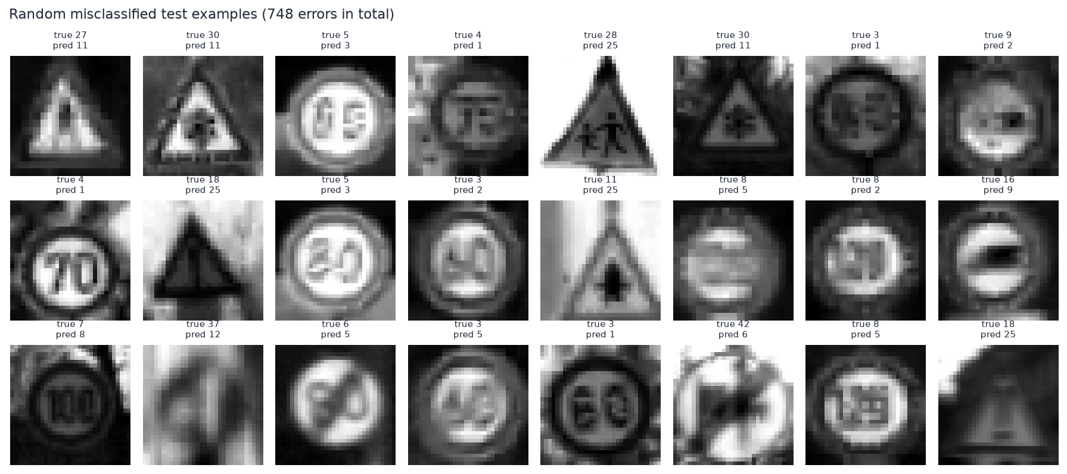
Random sample of misclassified test images

Generalisation discussion
A small difference between validation and test scores indicates that model selection did not over-fit the validation split; a large train-test gap indicates over-fitting. The split is by physical sign, so the test score estimates performance on *unseen signs from the same recording conditions*. It does not estimate performance on other countries, other cameras, full street scenes or adversarial conditions.

17. Application
A Streamlit app (app/app.py) loads models/svm/best_svm_model.joblib, scaler.joblib and model_metadata.json, applies the same preprocessing + HOG functions as training, predicts the class and shows the top-3 SVM decision scores (explicitly not probabilities) with a safety disclaimer. Launch: `streamlit run app/app.py`.

Practical use cases
- Sign-classification module behind a detector in a driver-assistance prototype.
- Road-asset inventory: classify sign crops collected by survey vehicles.
- Education: transparent example of a complete classical-ML pipeline.

18. Impact

Benefits
- Fast to train and run on a CPU; small model files.
- Interpretable pipeline - every step can be inspected and explained.
- Reproducible: fixed seeds, cached features, one-command pipeline, tests.

Stakeholders
Road users, road authorities, ADAS/map developers, and students/instructors (see Stage 1).

Risks
- Misclassification of safety-relevant signs (e.g. speed limits, stop/yield) could mislead a downstream system.
- Over-trust in the output: the app shows decision scores, not calibrated probabilities.
- Distribution shift: other countries, weather, night, damaged or graffitied signs.

Ethical considerations
- Safety: results must not be used to justify deployment in vehicles.
- Data: public benchmark, no personal data intended; some images may incidentally contain background scenes - used only for coursework under the dataset terms.
- Honesty: all numbers are measured; external code/models are credited (EXTERNAL_RESOURCES.md).
- Generalisation claims are limited to what was tested.

19. Limitations

Limitations
- Classifier only - requires an already-cropped sign; no detection.
- Trained and tested on German signs from one benchmark.
- HOG is not rotation/scale invariant and loses colour; low resolution (32x32) hides fine details such as digits.
- No evaluation on real-time video, motion blur sequences or adversarial inputs.
- Test results estimate performance on unseen signs of the same benchmark only.

Why this system is NOT safety-certified
Safety-critical automotive software requires systematic hazard analysis, requirements traceability, validation on representative data from the intended operating domain, and certification under standards such as ISO 26262 and ISO 21448 (SOTIF). None of this was performed. RoadEye is an educational prototype.

20. Future Scope

Future work
- Add sign detection (sliding window / region proposals) in front of the classifier.
- Higher resolution, colour features (HSV histograms), HOG + colour, PCA, probability calibration.
- Deep learning (CNN) as a comparison - outside the current syllabus scope.
- Evaluate on other datasets/countries, night and weather conditions; calibration and rejection of unknown signs.
- Ensemble methods and error-driven augmentation for the weakest classes.

21. Conclusion
On the untouched test split, HOG + SVM reached macro-F1 0.9246 (accuracy 0.9391) versus 0.6664 (accuracy 0.7227) for raw pixels + SVM with identical SVM settings and split. The difference is +0.2582 macro-F1 and +0.2164 accuracy, i.e. HOG improved classification quality relative to raw pixels. HOG also used 1764 features instead of 1024.
Test macro-F1 with identical HOG features and default settings: HOG KNN 0.8451, HOG Decision Tree 0.6981, HOG SVM 0.9246. Winner on the test split: HOG SVM; winner on the validation split (the split used for selection): HOG SVM.
All values above were produced by running the code; the test set was evaluated once after the models were frozen.

22. References
- J. Stallkamp, M. Schlipsing, J. Salmen, C. Igel. Man vs. computer: Benchmarking machine learning algorithms for traffic sign recognition. Neural Networks 32 (2012) 323-332.
- N. Dalal, B. Triggs. Histograms of oriented gradients for human detection. CVPR 2005.
- C. Cortes, V. Vapnik. Support-vector networks. Machine Learning 20 (1995) 273-297.
- F. Pedregosa et al. Scikit-learn: Machine learning in Python. JMLR 12 (2011) 2825-2830.
- S. van der Walt et al. scikit-image: image processing in Python. PeerJ 2:e453 (2014).
- T. Mitchell. Machine Learning. TMH (course text book).
- Course policy and IA guidelines: Machine Learning 3CS101CC24, Nirma University (2025-26).

23. External Resources / Academic Integrity Declaration
Dataset. GTSRB, official archives (see DATASET_DOWNLOAD.md); the licence/usage terms of the copy actually downloaded must be confirmed on its page (LICENSE_NOTICE.md).
Reference repositories were read as material only. No code, model or result from them is part of this project or presented as ours. The code, experiments, tuning, evaluation and results are independently produced by running this repository.
Repository | Commit inspected | Pretrained model used? | Licence file | Observation
omarbasha19/Computer-Vision-Traffic-Sign-Recognition | d7827562 | no | none found | The notebook loads 'svm_model.pkl' but this file is NOT in the repository, so no pretrained model could be obtained from it.
ZhouJiaHuan/traffic-sign-detection | 6e96c4e8 | present, not used | none found | 7-class label space for a different traffic-sign dataset; HOG window 64x64 vs our 32x32; no GTSRB label mapping exists.
davidakhihiero/traffic-sign-classification | 429fa6ce | no | MIT | MATLAB .mat model: cannot be evaluated with scikit-learn; preprocessing/split not identical to ours.
nakul3112/Traffic-sign-recognition | 5cda53bd | no | BSD-3-Clause | Different dataset/label scheme (template signs + driving video), default OpenCV HOG window; metadata incomplete for a fair comparison.

Reference model was inspected as an external implementation, but direct numerical comparison was not performed because the original preprocessing/split/model metadata does not allow a scientifically fair comparison.
Use of AI assistance. AI-assisted tools were used for coding and documentation support. The student remains responsible for verifying and being able to explain every part of the project (IA guidelines, section 9). [Edit this statement to match your own use before submitting.]

Appendix A. Technical Decisions and Justifications

Why GTSRB?
Question | Answer
WHAT? | Use the German Traffic Sign Recognition Benchmark.
WHY? | Recognised benchmark, 43 classes, real variation, laptop-sized.
HOW? | Folder-per-class loader + audit (src/data_loader.py, src/data_validation.py).
WHAT CHANGED? | All results are comparable to the literature's benchmark setting.
HOW WAS IT VALIDATED? | Audit of counts, sizes, labels, duplicates (Notebook 01).

Why grayscale?
Question | Answer
WHAT? | Convert RGB to one channel.
WHY? | HOG uses gradients; colour adds lighting variation and 3x the data.
HOW? | cv2.cvtColor in preprocess_image().
WHAT CHANGED? | Smaller, more illumination-robust inputs.
HOW WAS IT VALIDATED? | Consistent features between training and app (test_model_pipeline.py).

Why 32x32 resizing?
Question | Answer
WHAT? | Resize every image to one size.
WHY? | Fixed-length vectors; sizes vary strongly in GTSRB.
HOW? | cv2.resize INTER_AREA.
WHAT CHANGED? | Uniform feature length.
HOW WAS IT VALIDATED? | Image-size EDA (Notebook 02); HOG length test.

Why HOG?
Question | Answer
WHAT? | Use HOG features for the main model.
WHY? | Signs are edge/shape objects; HOG encodes edges and is illumination-robust.
HOW? | skimage.feature.hog (9 orientations, 4x4 pixels per cell, 2x2 cells per block, L2-Hys block normalisation).
WHAT CHANGED? | Features: raw pixels -> HOG.
HOW WAS IT VALIDATED? | Validated by RQ1: macro-F1 0.6664 (raw) -> 0.9246 (HOG) on test.

Why scaling?
Question | Answer
WHAT? | StandardScaler fitted on the training split.
WHY? | SVM and KNN are scale/distance sensitive.
HOW? | src.preprocessing.fit_scaler(); scaler inside the CV pipeline for GridSearchCV.
WHAT CHANGED? | Comparable feature ranges; leakage-free.
HOW WAS IT VALIDATED? | Notebook 03 prints train vs val statistics proving the scaler was not fitted on val/test.

Why the selected split?
Question | Answer
WHAT? | Official test set held out; training pool split ~80/20 into train/validation, stratified and grouped by sign (seed 42).
WHY? | ~30 frames per sign are near-identical; random splits leak.
HOW? | StratifiedGroupKFold in src/split_data.py.
WHAT CHANGED? | Test accuracy estimates performance on unseen signs.
HOW WAS IT VALIDATED? | verify_no_leakage(): no shared index, no shared sign between train and validation, identical-file counts reported.

Why this balancing strategy?
Question | Answer
WHAT? | Selected class_weight = balanced.
WHY? | Imbalance measured; SMOTE on HOG is not meaningful; class weights alter only the loss.
HOW? | Validation-set comparison of class_weight None vs balanced (stage_balancing in src/pipeline.py).
WHAT CHANGED? | Weights applied to SVM/Decision Tree training.
HOW WAS IT VALIDATED? | Validation macro-F1 comparison (results/metrics/balancing.json).

Why SVM?
Question | Answer
WHAT? | SVM (RBF) is the main model.
WHY? | Maximum-margin classifier effective on high-dimensional features.
HOW? | sklearn.svm.SVC, tuned with GridSearchCV.
WHAT CHANGED? | Proposed model.
HOW WAS IT VALIDATED? | Compared with KNN and Decision Tree on identical features (RQ2).

Why KNN?
Question | Answer
WHAT? | Include K-Nearest Neighbours.
WHY? | Syllabus instance-based learner; simple reference.
HOW? | KNeighborsClassifier on scaled HOG.
WHAT CHANGED? | Comparison model.
HOW WAS IT VALIDATED? | Same split/features/metrics as the others.

Why Decision Tree?
Question | Answer
WHAT? | Include a Decision Tree.
WHY? | Syllabus, interpretable, scale invariant.
HOW? | DecisionTreeClassifier (class-weighted if selected).
WHAT CHANGED? | Comparison model.
HOW WAS IT VALIDATED? | Same split/features/metrics as the others.

Why GridSearchCV?
Question | Answer
WHAT? | Tune C, kernel and gamma (and small grids for KNN/Tree).
WHY? | Defaults are arbitrary; syllabus technique; modest grid is affordable.
HOW? | GridSearchCV over Pipeline with StratifiedGroupKFold, scoring macro-F1.
WHAT CHANGED? | Default SVM -> tuned SVM.
HOW WAS IT VALIDATED? | CV on training data only; before/after on validation; test untouched.

Why macro-F1?
Question | Answer
WHAT? | Primary selection metric.
WHY? | Imbalanced multiclass: accuracy can hide poor rare-class performance.
HOW? | sklearn precision_recall_fscore_support(average='macro').
WHAT CHANGED? | Model selection and tuning use macro-F1.
HOW WAS IT VALIDATED? | Accuracy, balanced accuracy, weighted-F1 and per-class tables reported alongside.

Why a baseline?
Question | Answer
WHAT? | Raw-pixel SVM baseline.
WHY? | A reference is needed to interpret gains from HOG.
HOW? | Same pipeline minus HOG.
WHAT CHANGED? | Quantifies the effect of feature engineering.
HOW WAS IT VALIDATED? | RQ1 on the same split and SVM settings.

