RoadEye - Presentation Outline
Slide-by-slide outline (15 slides)
Machine Learning (3CS101CC24) - Nirma University, Institute of Technology - B.Tech CSE, Semester 5
Student: [name / roll number - add before submission]
Run scope: full_dataset | Generated: 2026-10-10

Slide 1: Title
- RoadEye - Traffic Sign Recognition using HOG features and SVM
- Machine Learning Innovative Assignment - Nirma University
- [Student name] | [Roll no.] | [Date]
Speaker note: Introduce the project in one sentence: classical ML pipeline on GTSRB.

Slide 2: Problem
- Input: cropped photo of one traffic sign; output: one of 43 classes
- Supervised multiclass image classification
- RQ1: does HOG beat raw pixels? RQ2: KNN vs Decision Tree vs SVM on the same HOG features?
Speaker note: State the two research questions clearly - the whole talk answers them.

Slide 3: Motivation
- Sign recognition supports driver assistance and road-asset inventories
- Classical ML: cheap, transparent, reproducible - good for studying design decisions
- Not safety-certified: an educational prototype
Speaker note: Mention scope: no detection, no deep learning.

Slide 4: Dataset
- GTSRB (Stallkamp et al., 2012); this run: GTSRB - German Traffic Sign Recognition Benchmark (Final Training + Final Test + Test GT) - run mode: full_dataset
- Images: 51,839; classes: 43; physical signs: 1,307
- ~30 frames per physical sign -> group-aware split
Speaker note: Show class_distribution.png.
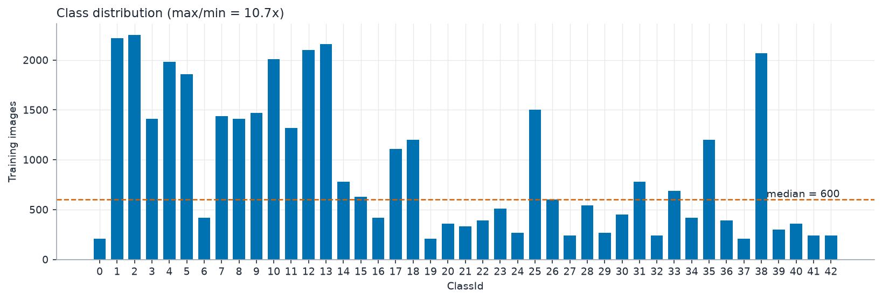
Suggested visual: class_distribution.png

Slide 5: Data preparation
- Cleaned: 51,839 -> 51,839 images (unreadable, label conflicts, exact duplicates removed)
- Official test set held out; train/validation split ~80/20 grouped by sign, seed 42
- Leakage check: True
Speaker note: Explain why a random split would leak.

Slide 6: EDA
- Sizes vary -> resize; lighting varies -> grayscale + HOG normalisation
- Imbalance ratio (train): 12.00
- Similar classes (e.g. speed limits) expected to be confused
Speaker note: Show eda_similar_classes.png.
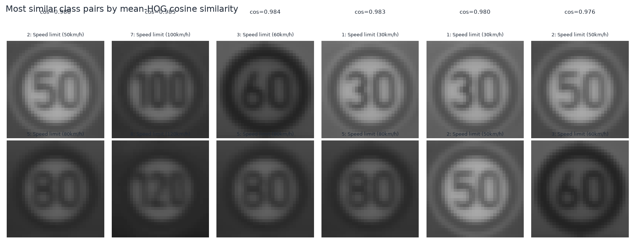
Suggested visual: eda_similar_classes.png

Slide 7: HOG feature engineering
- 9 orientations, 4x4 pixels per cell, 2x2 cells per block, L2-Hys block normalisation
- 1,764 HOG features vs 1,024 raw pixels
- Scaler fitted on training data only
Speaker note: Explain cells, orientation histograms, block normalisation.
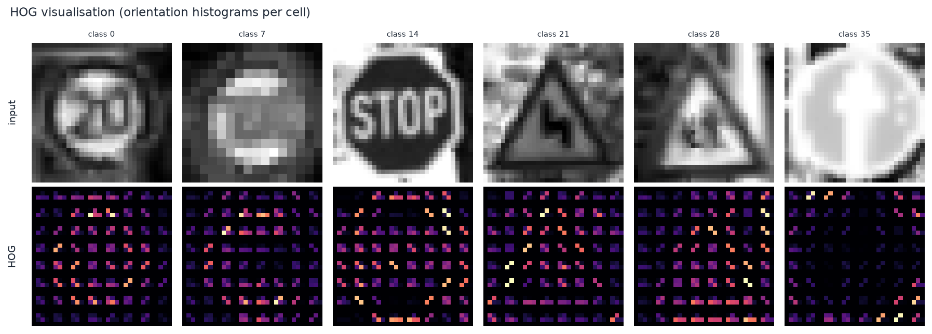
Suggested visual: hog_visualization.png

Slide 8: Baseline
- Raw pixels -> StandardScaler -> RBF SVM
- Validation macro-F1: 0.6550
- Same split and SVM settings as the HOG model
Speaker note: Why a baseline matters.
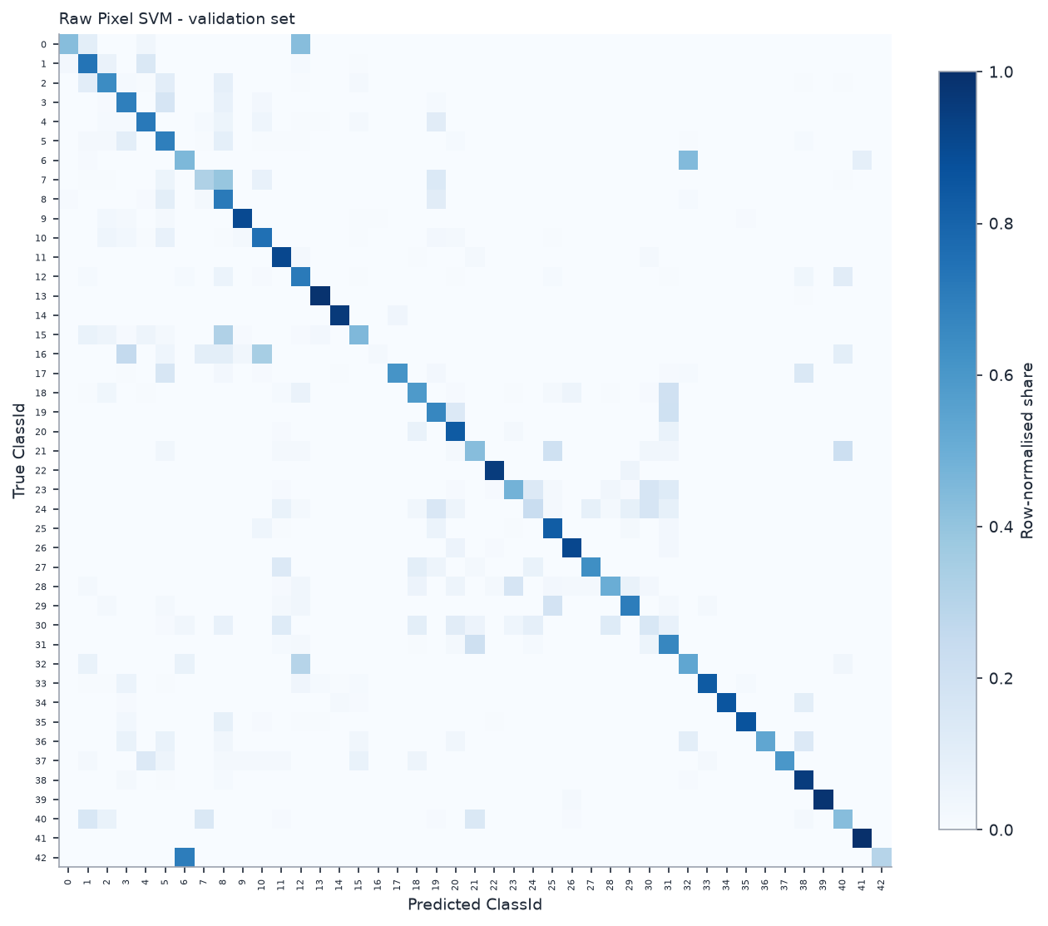
Suggested visual: baseline_confusion_matrix.png

Slide 9: Model comparison
- HOG + KNN / Decision Tree / SVM, validation macro-F1 scores: HOG KNN 0.8842; HOG Decision Tree 0.7603; HOG SVM 0.9361
- Winner (automatic): HOG SVM
Speaker note: State honestly if SVM did not win.
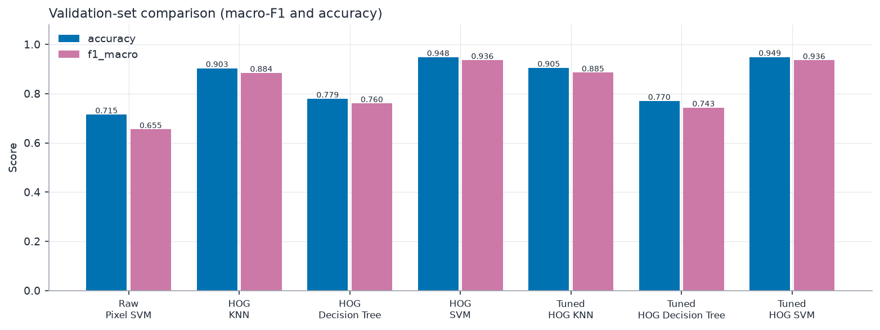
Suggested visual: model_performance_comparison.png

Slide 10: Hyperparameter tuning
- GridSearchCV, 3-fold StratifiedGroupKFold on training data, scoring macro-F1
- Best parameters: {'C': 10, 'gamma': 'scale', 'kernel': 'rbf'}
- Best CV macro-F1: 0.7768
Speaker note: Scaler is inside the CV pipeline.
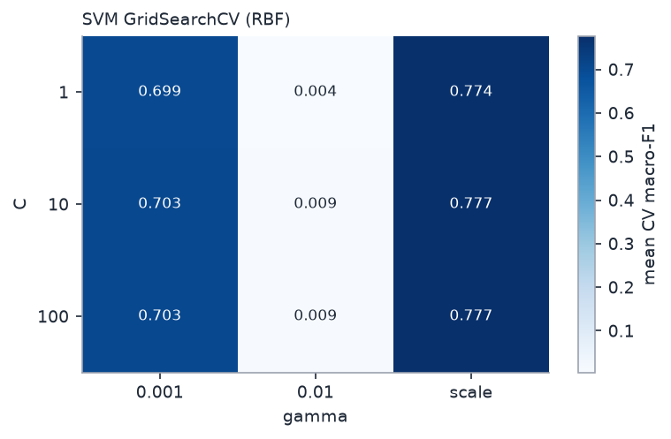
Suggested visual: grid_search_svm.png

Slide 11: Final results
- Test accuracy: 0.9408; macro-F1: 0.9256
- RQ1: HOG vs raw macro-F1 difference: +0.2582
- Test set evaluated once, after model selection
Speaker note: Final confusion matrix.
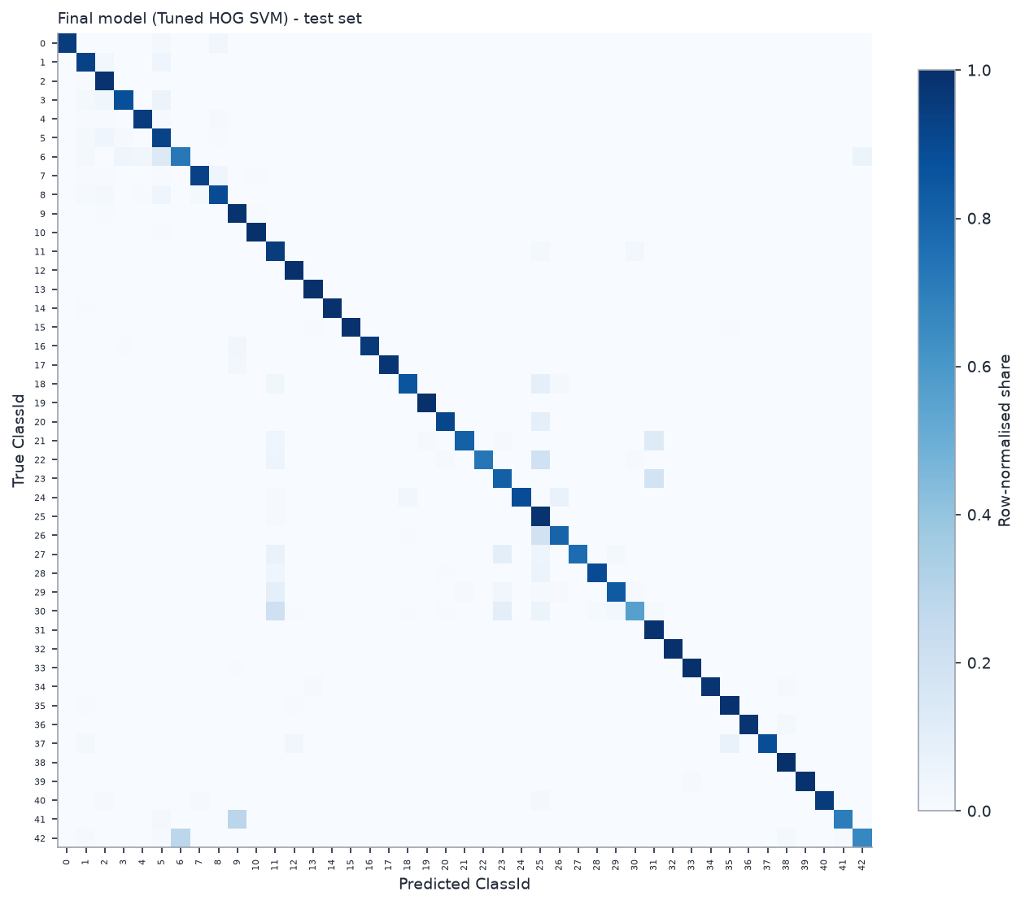
Suggested visual: final_confusion_matrix.png

Slide 12: Error analysis
- 748 errors / 12630 test images
- Look-alike classes, small/blurry images, rare classes
- Misclassified examples shown
Speaker note: Link errors back to the EDA similarity analysis.
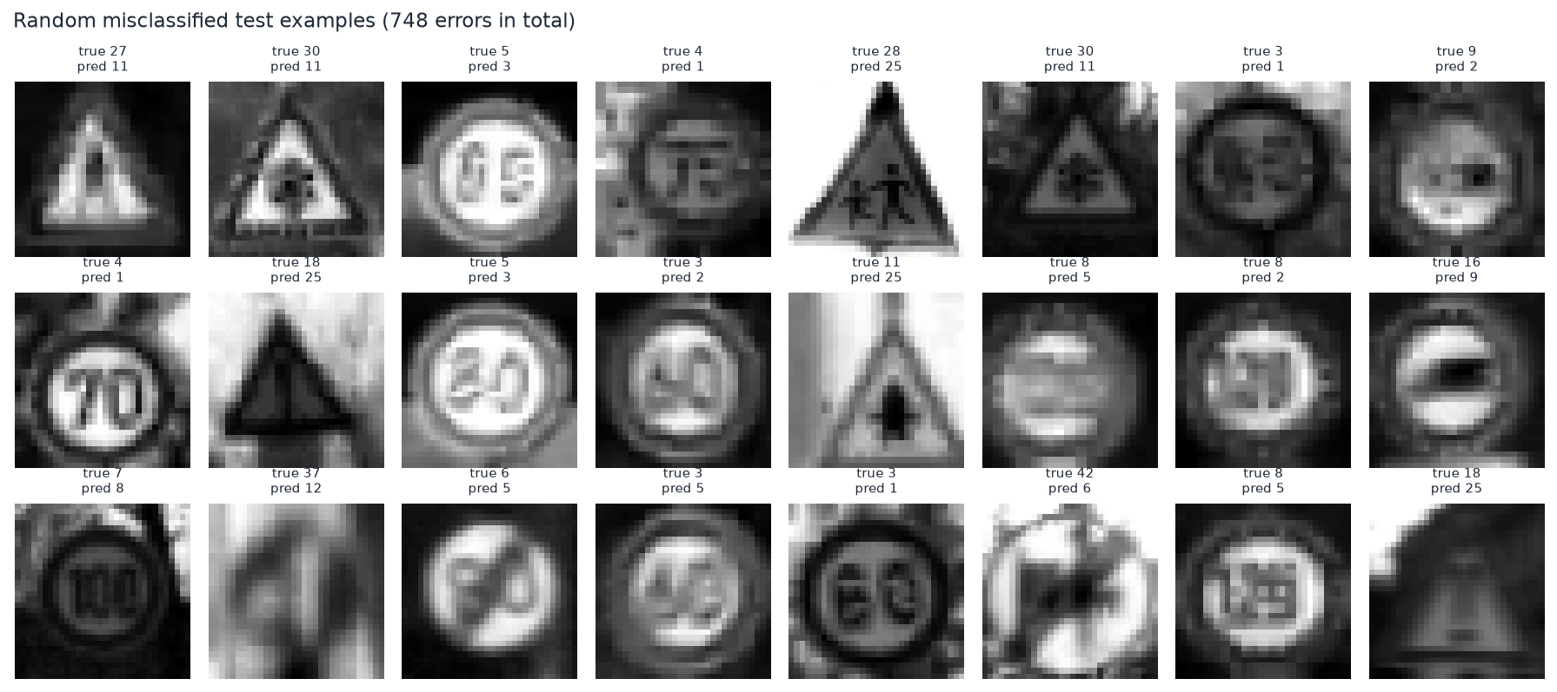
Suggested visual: misclassified_examples.png

Slide 13: Streamlit demo
- Upload -> preview -> same preprocessing + HOG -> SVM prediction
- Shows decision scores, not probabilities
- Disclaimer: not safety-certified
Speaker note: Live demo: streamlit run app/app.py

Slide 14: Limitations
- Classifier only (no detection); German signs only; 32x32 loses fine detail
- HOG not rotation/scale invariant; colour discarded
- Not evaluated on video, night or other countries
Speaker note: Be upfront.

Slide 15: Future scope & conclusion
- Detection stage, colour+HOG, PCA, calibration; CNN as future comparison (outside syllabus)
- Answer RQ1 and RQ2 with the measured numbers
- Reproducible pipeline: one command
Speaker note: Close with the two answers.

