SignalRChatApp - Documentation

Overview
SignalRChatApp is a sample real-time chat application that demonstrates how to build a browser-based chat UI with Blazor Web Assembly and an ASP.NET Core SignalR hub. The project is split into a client (Blazor Web Assembly), a server hub (ASP.NET Core SignalR), and a shared contract library for models. The purpose of the application is to show real-time messaging, per-client conversation history (in-memory for the demo), and basic unread-message indicators.

Projects / Components
- ChatContractsLibrary - shared models: `ConnectedUser`, `ChatMessage`.
- HubServer - ASP.NET Core SignalR hub (`ChatHub.cs`) that manages connected users and routes messages. In the demo, it also keeps an in-memory message history.
- BlazorChatApp.Client - Blazor WebAssembly client that hosts UI components: `ConnectedUsersComponent.razor`, `ChatComponent.razor`, and connection logic in `Home.razor`.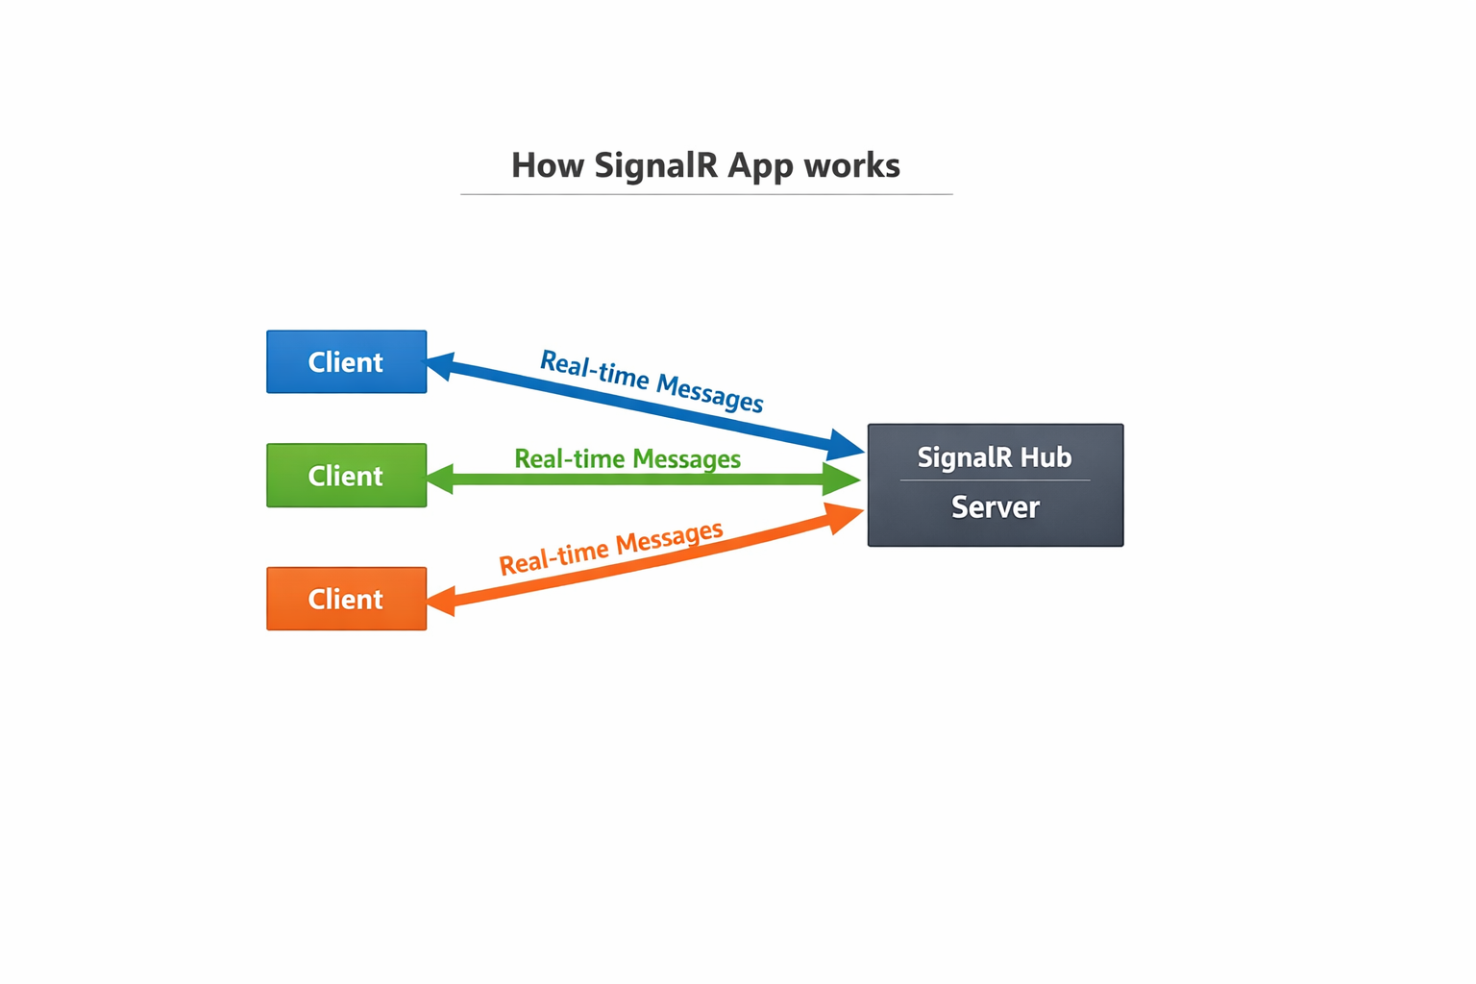
How it works (end-to-end)
1. Client startup: the Blazor client builds a `HubConnection` using `HubConnectionBuilder().WithUrl(...)` and includes `userId` and `userName` as query parameters. The connection is started asynchronously (`Start Async`).
2. OnConnectedAsync (server): when the hub receives a new connection it reads `userId`/`userName` from the query string and registers a `ConnectedUser` (in-memory) including the connection id. The hub notifies the caller with a system message and broadcasts updated user lists.
3. Sending messages: from the client the user composes a message and calls a hub method `ForwardMessage(fromUserId, toConnectionId, message) ` (client invokes the server method).
4. ForwardMessage (server): the server records the message in an in-memory `_messageHistory` collection, forwards the message to the recipient connection using `Clients.Client(toConnectionId).ReceiveMessage(...)`, and then pushes updated tailored user lists to clients so history is available.
5. Receiving messages: the client receives `ReceiveMessage` events, updates local conversation lists shown in `ChatComponent`, optionally plays a notification sound (JS interop), and updates unread counters shown in `ConnectedUsersComponent`.
Key technologies used
- Blazor WebAssembly: client-side UI using reusable Razor components, data binding, and JS interop.
- ASP.NET Core SignalR: real-time bi-directional messaging between clients and server.
- C# (async/await): asynchronous programming for non-blocking IO on both client and server.
- Shared DTOs: POCO models in `ChatContractsLibrary` used by both client and server.
- In-memory storage (demo): `_connectedUsers` and `_messageHistory` stored in memory with simple locking for thread-safety.
Important concepts demonstrated
- SignalR Hubs and Hub methods: Hub methods like `OnConnectedAsync`, `OnDisconnectedAsync` and custom `ForwardMessage` provide server-side entry points. `Clients.Client(...).ReceiveMessage(...)` and `Clients.All.UpdateUserList(...)` push events back to connected clients.
- Real-time push vs. HTTP request/response: Traditional web communications rely on client-initiated HTTP requests (request/response), which are not ideal for real-time updates. Alternatives like polling request the server repeatedly to check for updates (inefficient) or long-polling keep connections open. SignalR abstracts a persistent connection (via Web Sockets, Server-Sent Events, or Long Polling fallback) enabling the server to push events to clients instantly. The app uses SignalR, so messages and user-list updates are delivered in real time without repeated client polling.
- HubConnection on the client: In Blazor, `HubConnection` is used to call server methods (`InvokeAsync`) and register handlers (`On<...>`) to receive messages. The connection lifecycle is asynchronous and resilient to reconnects (manual reconnection logic can be added).
- Async/Await: Both client and server use asynchronous methods (`async Task`, `await`) for network IO and SignalR calls. This ensures the server thread pool and browser UI threads are not blocked. Examples: `await hubConnection.StartAsync()`, `await Clients.Client(...).ReceiveMessage(...)`, `await hubConnection.InvokeAsync(...)`.
- Thread-safety and locking: The hub demo uses `lock` around shared in-memory lists to avoid concurrent modifications from different Hub threads. In production this should be replaced with a persistent store and appropriate concurrency control.
- Per-client tailored data: The hub builds and sends a tailored `UpdateUserList` to each client that includes conversation messages relevant to that client. This minimizes client-side filtering and makes it easy for the client to render a conversation history.
Why SignalR is a good fit for this app
- Low-latency, server-initiated notifications: Chat requires immediate delivery of messages and presence updates; SignalR allows the server to push events to clients as they happen.
- Simple programming model: Developers call hub methods and register handlers instead of implementing custom WebSocket code. SignalR handles transport negotiation (Web Sockets / SSE / Long Polling).
- Scalable patterns available: SignalR integrates with backplanes (Redis, Azure SignalR Service) for scaling across multiple server instances when needed (demo uses in-memory storage only).
SignalR vs. other approaches (short)_par- Polling: Regular HTTP polling is inefficient and increases server load and latency.
- Long-polling: Works but more complex and less efficient than native WebSocket-based transport; SignalR can fall back to long-polling where needed.
- Raw Web Sockets: Powerful and low-level but require more custom code for connection management, messaging protocols, reconnection, and fallback strategies. SignalR provides a higher-level abstraction and simpler API.
Production considerations and improvements
- Persistence: Replace in-memory `_messageHistory` with a durable store (SQL/NoSQL). Persist messages with metadata (timestamps, status, message id).
Quick glossary
- Hub: Server-side component in SignalR that defines methods clients can call and can call clients back.
- HubConnection: Client-side object used to connect to a SignalR hub and to send/receive messages.
- Clients.Client(connectionId): Server API to address a specific connected client by connection id.
- InvokeAsync: Client or server call that invokes a hub method and awaits a response (if any).
- OnConnectedAsync / OnDisconnectedAsync: Hub lifecycle methods triggered when clients connect or disconnect.

Conclusion
SignalRChatApp demonstrates how Blazor Web Assembly and ASP.NET Core SignalR can be combined to build an interactive real-time chat application with minimal boilerplate. SignalR provides a high-level real-time abstraction that simplifies server push notifications and reduces the complexity compared to raw Web Sockets or polling. For production use, the demo should be extended with persistent storage, authentication, scaling infrastructure, and improved message state handling.

