Comparing Attention Mechanisms in YOLOv8n for Apple Surface Defect Detection
Ved Waghela and Manish Gadia
School of Computer Science, University of Auckland, New Zealand

Abstract - Small surface defects are difficult to localise because damaged regions can resemble normal apple texture. This study compares unmodified YOLOv8n with Squeeze-and-Excitation, Convolutional Block Attention Module and Coordinate Attention under a controlled training budget. A single attention module is inserted after the same stride-16 backbone block in each variant. The 710-image SSDA dataset is divided into 500 training, 106 validation and 104 test images using similarity and capture-time grouping. All four architectures are trained for 50 epochs with three matched seeds, and checkpoints are selected using validation mAP50-95. CBAM achieves the highest mean test mAP50-95, 42.11% with a sample standard deviation of 0.58 percentage points, compared with 40.70% and 1.03 points for the baseline. Its improvement is positive for all three seeds, but median forward-pass latency increases from 6.586 to 7.113 ms on an RTX 2050. Class-wise analysis shows that scratches remain harder than pest damage. The results support a modest, configuration-specific accuracy advantage for CBAM, rather than a universal ranking of attention mechanisms. Small sample size, heuristic grouping and controlled backgrounds limit generalisation.
Index Terms - apple defects, YOLOv8n, attention, controlled comparison, detection, inference latency.

I Introduction
Fruit inspection requires more than deciding whether a whole image contains a good or bad apple. A useful localisation system should identify the region associated with a defect so that a downstream inspection process can examine its position and extent. Computer vision offers several routes to this goal, including classification, detection and segmentation. The recent survey by Rojas Santelices et al. [1] places these tasks within a broad inspection literature. Our study addresses bounding-box detection of visible surface defects, not fruit freshness prediction, internal damage assessment or commercial grading.
The practical difficulty is that a defect may occupy only a small fraction of an image. Its colour and texture may be close to those of surrounding peel, and a detector can confuse a weak mark with normal surface variation. A classification dataset organised into fresh and rotten apple folders cannot directly test this localisation problem because it does not provide defect-region boxes. We therefore use SSDA, which contains annotations for scratches and pest damage [2], [3]. This choice connects the network comparison to local defects rather than to the broad appearance of an entire fruit.
Attention is a plausible modification, but its usefulness cannot be assumed from its name or from results obtained on a different task. SE recalibrates channels, CBAM combines channel and spatial gating, and Coordinate Attention preserves directional position information [4]-[6]. Each introduces a different transformation of the same feature tensor. Our objective is to compare these established mechanisms, not to propose a new attention module or to claim that attention has not previously been used in agricultural vision.

A Research question and working hypothesis
The research question is: which of SE, CBAM and Coordinate Attention, added at one fixed YOLOv8n backbone location, provides the most useful trade-off between defect-detection accuracy and computational cost on SSDA? The working hypothesis is that selective feature weighting can improve localisation within a fixed training budget, while spatially informed gating may incur more execution cost than channel-only gating. This is an exploratory architectural hypothesis, not a preregistered significance test. The final protocol was frozen before the additional seeds and before test evaluation, but after the initial seed-42 validation comparison had been inspected.
We answer the question through twelve runs: four architectures, three seeds and 50 epochs per run. Training, checkpoint selection and evaluation are separated. Mean test accuracy, variation across seeds, class-specific AP and measured forward latency are reported together. Controlled backgrounds do not support a claim about robustness to orchard illumination, blur or clutter, so these earlier proposal objectives are deliberately excluded from the completed study.
The contribution is a reproducible, narrowly scoped comparison with explicit data-handling and implementation checks. It includes a grouped split intended to reduce obvious related-image overlap, matched training settings, direct verification that attention survives checkpoint loading, and analysis of both favourable and unfavourable outcomes. CBAM gives the highest mean test mAP50-95 in this configuration, but its latency rises and its scratch performance remains limited. These qualifications are part of the answer, not exceptions to it.

II Related Work

Fruit-inspection studies differ in sensing modality, annotation granularity and deployment objective. These distinctions matter when selecting a baseline. The survey in [1] covers classification and inspection approaches, but an image-level decision cannot reveal how precisely a small damaged region is localised. Agarla et al. [7] formulate apple inspection as defect segmentation, giving spatial information beyond a binary label. Segmentation is useful when area estimation is central; it also requires a different annotation and evaluation pipeline from the bounding-box comparison undertaken here.
Liang et al. [8] combine semantic segmentation with a pruned YOLOv4 detector for grading defective apples. Their system illustrates that region localisation and computational efficiency can be considered together rather than optimising a single accuracy score. However, a multi-component grading pipeline does not isolate the effect of one attention mechanism. Its reported outcome should not be treated as an expected score for our RGB defect-box dataset. We retain the accuracy-cost motivation while restricting architectural changes to one location in an otherwise fixed detector.
HAFREE [2] is particularly relevant because it addresses subtle apple defects and introduces the SSDA benchmark. Its heatmap-based detector is an alternative formulation, rather than an attention ablation of YOLOv8n. The archived dataset release [3] makes an existing annotated collection available without requiring this project to create a new labelling scheme. We use a different grouped partition from the released train-validation split. Accordingly, we do not compare our AP numerically with published HAFREE results or claim to reproduce that benchmark.
SE [4] learns channel-wise weights from globally pooled features. CBAM [5] applies channel and spatial attention sequentially. Coordinate Attention [6] pools along separate axes and encodes directional position information. These mechanisms provide distinct inductive biases, but their original results do not establish which is best for small apple defects. ECA-Net [9] further demonstrates that channel attention can be designed without the same dimensionality reduction as SE. It is relevant to future efficiency studies, but including it here would broaden the comparison beyond the approved three-module scope.
The detector implementation is also part of the experimental definition. We use the pinned Ultralytics release 8.3.203 [10], rather than referring only to the generic name YOLOv8. COCO [11] supplies the pretraining task underlying the shared checkpoint; it is not the evaluation dataset for this study. AdamW [12] provides the optimiser used for all architectures. These choices are held constant to reduce avoidable differences between runs, not because they were shown to be optimal for SSDA.
Bouthillier et al. [13] emphasise that benchmark conclusions depend on variation from multiple stages of a learning pipeline. This motivates reporting repeated training seeds and paired differences rather than selecting one favourable run. Our three-seed design remains limited: it does not estimate variability across independent orchards, dataset partitions or hyperparameter searches. The resulting contribution is a controlled local comparison with stated uncertainty, not evidence that all remaining sources of variation have been resolved.

A Position of this study
The literature supports several ways to improve inspection: changing sensors, segmentation targets, feature extractors or deployment compression. Our question is narrower. With the data, base detector and training budget fixed, we change only the attention block and measure the consequences. This distinction avoids an unsupported claim that controlled attention comparisons are absent from the entire literature. The useful evidence is the specific comparison produced here, including its implementation details, class differences, runtime cost and failure cases.

III Dataset and Experimental Partition
TABLE I Dataset partition and defect annotations
Partition | Images | Scratch | Pest damage
Training | 500 | 437 | 619
Validation | 106 | 93 | 130
Test | 104 | 94 | 139
Total | 710 | 624 | 888

A Dataset provenance and task definition
The SSDA v1.0.0 release contains 710 apple images [3]. The downloaded source is fixed to commit 71fc44fa3358e5cbc0a59d574d38762aaefd676b. Images depict apples with local surface defects against controlled backgrounds. The working task has two classes: scratch and pest damage. These are defect-region annotations; a prediction box should surround the affected region, not the entire apple. The archived release is attributed to its creator and used under its recorded CC BY 4.0 terms. The source files are preserved unchanged.
The downloaded label files contain numeric class IDs. Their interpretation was inferred from exact agreement with the HAFREE author preprint's Table 5: the original training split has 500 class-0 and 716 class-1 boxes, and the original validation split has 124 and 172. These counts correspond to scratch and pest damage. This is count-based evidence, not a recovered author-supplied class-ID dictionary. The mapping is therefore documented as an assumption that should be independently confirmed before reuse in a larger study.
Preparation checks image readability, label format, class IDs, box coordinates and file hashes. One box extends slightly below the image boundary. It is clipped in the working copy and the change is recorded in the audit; original annotations are retained. Working labels are written with ten decimal places. The final collection contains 1,512 boxes and no healthy-image negatives. Consequently, the experiment cannot estimate the false-rejection rate of an operational stream containing healthy fruit.

B Grouping related images
A random image split can place closely related captures in different partitions. We group candidates before assignment using a graph. Two images are connected when they have identical decoded RGB pixels and dimensions; or a 63-bit perceptual-hash distance no greater than four together with normalised RGB-thumbnail RMSE no greater than 0.08; or the same camera identifier and capture times within two seconds. Visual descriptors use 32 by 32 thumbnails. The perceptual hash thresholds the 63 non-DC coefficients from an 8 by 8 low-frequency DCT region relative to their median.
Connected components remain intact. This procedure gives 637 groups, with at most 15 images in a group. In the original partition, 38 candidate-pair edges cross the training-validation boundary. They are not 38 proven duplicate images, and the grouping rules do not establish physical-apple identity. Different views of one apple can remain unlinked; conversely, visually similar independent apples may be grouped. The procedure reduces identifiable overlap without claiming to eliminate every possible dependency.

C Assignment and isolation checks
Groups are assigned with split seed 20261016, targeting image and class-box proportions of 70%, 15% and 15%. Groups containing any of the 16 previously exposed smoke-test images are forced into training. Remaining groups are shuffled, stably ordered from largest to smallest, then assigned greedily to minimise the sum of squared deviations from target counts, normalised by total image and class-box counts. The achieved counts appear in Table I; whole-group assignment prevents exact target ratios.
A frozen manifest records file hashes, label hashes, source partition, group and final partition. Every training run verifies the manifest and list contents. Independent checks confirm group isolation, unique image membership, expected counts and exclusion of prior smoke images from validation and test. These checks establish consistency with this partition, not general independence of all physical fruit. Because the partition differs from the published benchmark, all model comparisons in this report are internal to the same frozen split.

IV Attention Architectures
TABLE II Fixed attention configurations and unfused parameter counts
Model | Configuration | Added | Total
Baseline | No added module | 0 | 3,011,238
SE | Reduction 16 | 2,048 | 3,013,286
CBAM | Reduction 16; 7x7 gate | 2,284 | 3,013,522
Coordinate | Reduction 32; min width 8 | 3,352 | 3,014,590

A Shared detector and insertion point
The baseline is the two-class YOLOv8n detector from Ultralytics 8.3.203 [10]. Each attention variant adds exactly one module after the output of backbone C2f layer 6, the stride-16 P4 stage. At a 640 by 640 input, this tensor has 128 channels and spatial dimensions 40 by 40. The attended tensor feeds both the following backbone stage and the existing P4 skip connection into the neck. No additional attention is inserted in the detection head, and the detection losses are unchanged.
This position is a preselected engineering compromise: it retains more spatial detail than a stride-32 stage while avoiding the higher cost of an earlier, larger feature map. We did not search insertion sites or prove that this location is optimal. The treatment is therefore a complete module configuration at this site, not an abstract comparison of mechanisms independent of reduction ratio, activation or position. Table II reports the actual unfused parameter counts used consistently across models.

B Squeeze and excitation
For a feature tensor X with C channels and height H and width W, SE [4] computes a channel descriptor $z_{c} = \frac{1}{HW}\sum_{i=1}^{H}{\sum_{j=1}^{W}{X_{cij}}}$. A two-layer bottleneck produces $g = σ(W_{2} ReLU(W_{1}z))$, and the output is $Y_{cij} = X_{cij}g_{c}$. Here, σ denotes the sigmoid function. In our implementation, the bottleneck uses bias-free 1 by 1 convolutions with reduction 16. Thus C = 128 gives eight hidden channels. The same channel gate applies at every spatial position, so SE does not explicitly construct a location-dependent mask.

C Convolutional block attention
CBAM [5] first combines global average and maximum descriptors through a shared bottleneck: g_c = sigmoid(MLP(AvgPool(X)) + MLP(MaxPool(X))). Channel-refined features X1 = X multiplied by g_c are then pooled across channels using a maximum and a mean. Their concatenation passes through a 7 by 7 convolution and a sigmoid to form a spatial gate. The final output multiplies X1 by that gate. Our shared bottleneck has biases and reduction 16. The spatial convolution is bias-free and followed by batch normalisation with epsilon 0.00001 and momentum 0.01, following the authors' reference design. These details matter when comparing implementations with the same module name.

D Coordinate Attention
Coordinate Attention [6] computes one descriptor by averaging across width and another by averaging across height. These retain one spatial coordinate each. Their concatenation is encoded using a shared 1 by 1 convolution, batch normalisation and Hardswish, then split into height and width branches. Separate sigmoid gates yield $Y_{cij} = X_{cij}g_{h}(c,i)g_{w}(c,j)$. Reduction 32 and a minimum hidden width of eight give eight hidden channels here. Directional pooling provides position-sensitive weighting without constructing CBAM's full two-dimensional spatial gate.

E Controlled transfer and implementation checks
All variants begin from the same COCO-pretrained checkpoint [11], not from the trained fruit baseline. An AttentionC2f subclass preserves the original block's parameters and state-dictionary names while applying the new module to its output. The custom trainer constructs the intended architecture before transferring matching weights. Attention initialisation uses a temporary CPU random-number context so that adding a module does not advance that shared random stream. This control does not guarantee identical augmentation sequences or bitwise hardware determinism.
Tests check known constant-gate outputs, unchanged shared weights, non-square forward passes, finite attention gradients, checkpoint round trips, fused inference agreement and trainer reconstruction. Each variant also completed a one-epoch full-data pilot. These checks reduce the risk of comparing a model whose attention is disconnected or silently lost on reload. They establish implementation behaviour, not the scientific superiority of any module.

V Training and Reproducibility
TABLE III Shared training settings
Setting | Value
Architecture / initialisation | YOLOv8n / shared COCO weights
Budget / seeds | 50 epochs / 42, 43, 44
Input / physical batch | 640 pixels / 4 images
Optimiser / initial learning rate | AdamW / 0.001
Final LR factor / weight decay | 0.01 / 0.0005
Warm-up / nominal batch | 3 epochs / 64
Precision / early stopping | FP32 / disabled
Mosaic | Enabled; disabled for last 10 epochs
Selection | Highest validation mAP50-95

A Matched training budget
The experiment consists of four architectures trained with seeds 42, 43 and 44, giving twelve 50-epoch runs. Table III defines the shared settings. Seed 42 was completed first, followed by the additional matched seeds. Every run uses the same partition, initial checkpoint, image size, optimiser configuration and augmentation policy. We do not select the most favourable seed, tune a separate learning rate for an attention variant, or extend training for only one model. Fifty epochs is a fixed resource budget rather than a claim of complete convergence.
AdamW [12] is used with initial learning rate 0.001, final learning-rate factor 0.01 and configured weight decay 0.0005. The scheduler is the pinned trainer's non-cosine schedule. Warm-up lasts three epochs; the saved momentum setting is 0.937 and warm-up bias learning rate is 0.1. The physical batch size is four. The framework's nominal batch setting remains 64, with its built-in accumulation and optimiser scaling behaviour. Reporting only batch four would conceal this distinction. The original framework behaviour is retained equally for all models.
Detection augmentations include horizontal flip probability 0.5, translation 0.1, scale 0.5 and HSV factors 0.015, 0.7 and 0.4. Rotation, shear, perspective, vertical flip, mixup, cutmix and copy-paste are disabled. Mosaic probability is initially 1.0 and mosaic is disabled during the last ten epochs. Multiscale training and rectangular training batches are disabled. Validation images are not subjected to these training augmentations. Configuration fields used only for other tasks are not interpreted as active detection augmentations.

B Checkpoint selection and evaluation order
The selected checkpoint is the one with highest validation mAP50-95 according to the pinned trainer. In this version, checkpoint fitness assigns its weight to mAP50-95, rather than to mAP50 alone. The 104-image test partition is not used to select checkpoints or alter training. After all twelve runs complete, each saved best checkpoint is re-evaluated on validation and test data under the same settings. The report uses these re-evaluated values for its final tables.
Earlier progress summaries used the best row of the training CSV. Small differences from final validation numbers can occur because saved checkpoint weights are serialised at reduced precision and subsequently loaded for evaluation. We therefore do not mix CSV maxima with re-evaluated scores in the final comparison. The test evaluation is the endpoint of this study; subsequent model choices based on these outcomes would require a new independent test set.

C Software and execution environment
Runs use Python 3.13.5, PyTorch 2.8.0 with CUDA 12.8, torchvision 0.23.0 and Ultralytics 8.3.203. The device is an NVIDIA GeForce RTX 2050 with 4 GB memory. Training uses FP32, zero data-loader workers, no image cache and the deterministic setting enabled. These settings describe the local experiment; the school cluster was not used. Training jobs execute sequentially, avoiding concurrent GPU training as a source of resource contention.
Each run saves its arguments, resolved packages, code snapshots, CSV metrics and best and last checkpoints. Queue checks verify that completed runs have 50 recorded epochs, matching package versions and matching split hashes. The experiment checks original model-source hashes between jobs. Independent data-integrity checks pass again after final evaluation. These records support auditing but do not by themselves establish reproducibility on another device or software release.

D Reproduction assets
The local project archive contains the training and evaluation code, attention-module implementations, split-generation and checking scripts, saved checkpoints, and experimental results. The frozen manifest and checkpoint hashes document the data partition and evaluated models. Custom checkpoints require attention.py to be importable; they cannot be evaluated using an unmodified stock command alone. The software versions and experimental settings are specified above. No public repository is available at the time of submission.

VI Evaluation Methodology
TABLE IV Evaluation stages and their roles
Stage | Fixed rule | Purpose
Checkpoint selection | Validation mAP50-95 | Choose epoch, not model settings
Final accuracy | All 12 checkpoints; test split | Estimate held-out detection performance
Error diagnostics | Confidence 0.25; IoU 0.5 | Inspect geometric and class errors
GPU timing | Seed 42; batch 1; three blocks | Measure architecture forward cost

A Accuracy metrics
The primary metric is mAP50-95, the mean average precision across the two classes and IoU thresholds from 0.50 to 0.95 in steps of 0.05, using the pinned evaluator. AP summarises the precision-recall curve; it is not the fraction of test images classified correctly. IoU is the intersection area of predicted and annotated boxes divided by their union. A stricter IoU threshold requires closer agreement in position and size. We also report mAP50 because a module can change loose-threshold detection and precise localisation differently.
For each class c and threshold t, let AP(c,t) denote average precision. The primary score is mAP50-95 = (1/20) sum over c in {scratch, pest damage} and t in {0.50, 0.55, ..., 0.95} of AP(c,t). Per-class AP50 and AP50-95 reveal whether an overall gain applies equally to scratches and pest damage. The classes receive equal weight in mAP even though their box counts differ. This avoids treating the more numerous pest annotations as the sole determinant of the headline result.
Validation and test evaluation use 640-pixel inputs, batch four, FP32, GPU 0, confidence 0.001, NMS IoU 0.7 and a maximum of 300 detections, without test-time augmentation. The low confidence threshold is used to retain predictions for the precision-recall calculation. It is not the confidence threshold used in the diagnostic counts below. Keeping these settings explicit prevents a visually cleaner set of high-confidence boxes from being mistaken for an improved AP score.

B Variation across training seeds
For the three matched training seeds, let $x_{i}$ denote a model’s score in run i. We report the arithmetic mean and sample standard deviation: $\overline{x} = \frac{1}{3}\sum_{i=1}^{3}{x_{i}}, s = \sqrt{\frac{1}{2}\sum_{i=1}^{3}{{(x_{i} − \overline{x})}^{2}}}$. The standard deviation describes variation across the three training runs. It is not a confidence interval, and the three runs share the same test images. We also compute paired differences d_s = x_attention,s - x_baseline,s. A positive mean difference accompanied by mixed signs is less consistent than a positive difference at every tested seed.
The repeated-seed design addresses one source of variation highlighted in [13], but not dataset-sampling or acquisition variability. We do not report a significance claim from three seeds, and we do not treat individual boxes or images as independent training repetitions. No multiple-testing correction or confirmatory hypothesis test is asserted. The interpretation is descriptive: whether gains recur in these matched runs, how large they are, and what cost accompanies them.

C Fixed-threshold error diagnostics
Predictions are separately generated at confidence 0.25 and NMS IoU 0.7. For each image, pairwise box IoUs are computed. Candidate pairs with IoU at least 0.5 are matched one-to-one by maximum-cardinality geometric assignment, using IoU as the tie-breaking objective. Matching initially ignores class. Matched pairs are divided into correct-class and wrong-class detections; unmatched annotations and unmatched predictions are counted separately. The implementation uses linear assignment and includes synthetic checks for empty sets, extra boxes and class mismatches.
These diagnostic counts are intentionally distinct from the evaluator's AP matching and class-aware precision or recall. A wrong-class geometric match is not counted again as an unmatched annotation. Extra predictions can include genuine model errors, overlapping boxes or annotation disagreements. The first six fixed test-list entries are saved for each seed-42 model without selecting successful examples. Their purpose is to illustrate mechanisms of error, not to estimate dataset-wide performance from a few images.

D Computational-cost protocol
Unfused parameter counts describe storage-related model complexity. Latency is measured separately using fused FP32 evaluation models and a fixed GPU tensor of shape 1 by 3 by 640 by 640. Seed-42 checkpoints are chosen in advance for architecture timing. Each of three blocks uses 50 warm-up and 200 timed forward passes, with CUDA events and synchronisation. Model order is rotated across blocks. We report pooled median and p95 latency plus the standard deviation of block medians. Timing excludes file I/O, preprocessing, host transfers and NMS; it is not end-to-end throughput. FLOPs are omitted because generic hook counters can miss functional attention operations.

VII Detection Results
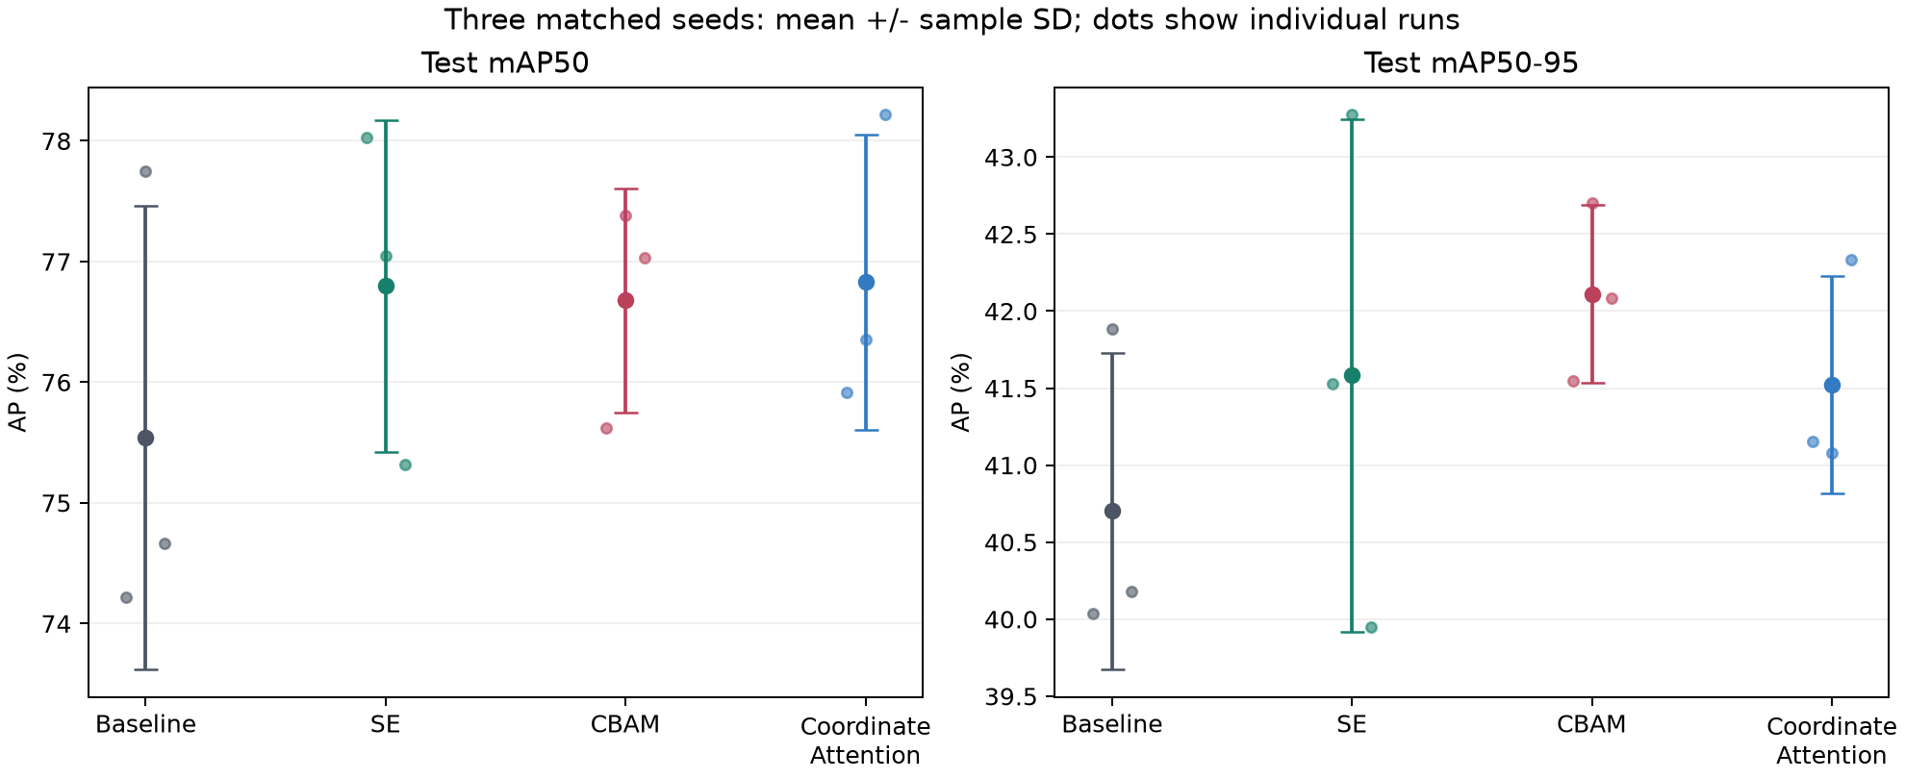
Fig. 1. Held-out test AP across seeds 42, 43 and 44. Large markers show means, bars show sample standard deviations, and small markers show individual runs. These are not confidence intervals.
TABLE V Final accuracy across three seeds in percent
Model | Val AP50-95 | Test AP50 | Test AP50-95
YOLOv8n | 41.38 +/- 0.55 | 75.54 +/- 1.92 | 40.70 +/- 1.03
+ SE | 42.08 +/- 1.14 | 76.80 +/- 1.37 | 41.58 +/- 1.66
+ CBAM | 42.27 +/- 1.07 | 76.68 +/- 0.93 | 42.11 +/- 0.58
+ Coordinate Attention | 42.16 +/- 0.28 | 76.83 +/- 1.22 | 41.52 +/- 0.70

Table V and Fig. 1 compare re-evaluated saved checkpoints. CBAM has the highest mean test mAP50-95, 42.11%, compared with 40.70% for baseline, 41.58% for SE and 41.52% for Coordinate Attention. Its mean improvement over baseline is 1.41 percentage points, not 1.41 percent relative improvement. The corresponding relative increase is approximately 3.46%. None of these values should be described as image-classification accuracy.
The three CBAM-minus-baseline differences are +1.51, +0.81 and +1.90 percentage points. This consistent direction is more informative than the original seed-42 validation comparison alone. Nevertheless, three positive differences on the same partition do not establish statistical significance or imply that CBAM will win on another dataset. The sample standard deviation is 0.58 points for CBAM and 1.03 for baseline, but estimating population stability from three observations remains uncertain.
SE improves mean test mAP50-95 by 0.88 points but has the largest observed standard deviation, 1.66 points. Its seed-44 difference from baseline is -0.23 points. Coordinate Attention improves the mean by 0.82 points, with a negative paired difference of -0.81 at seed 43. Thus all three attention configurations improve the mean in this experiment, but only CBAM improves the primary score for every matched seed. Reporting only the best seed would hide these distinctions.
The ranking changes slightly at IoU 0.50. Coordinate Attention has the highest mean mAP50, 76.83%, followed closely by SE at 76.80% and CBAM at 76.68%. Those differences are small compared with their seed variation. CBAM's stronger mAP50-95 does not mean it dominates all definitions of detection performance. The evidence is consistent with a favourable stricter-localisation trade-off, but we do not infer the causal feature behaviour of the attention maps from AP alone.
Validation means are close: 41.38% for baseline and 42.08-42.27% for attention variants on the primary metric. Final conclusions use the held-out test scores, not whichever split gives a larger gain. The test means are generally lower than validation, but the gap is not a universal correction factor. Both sets are small and differ in their grouped image membership.

VIII Class Performance and Computational Cost
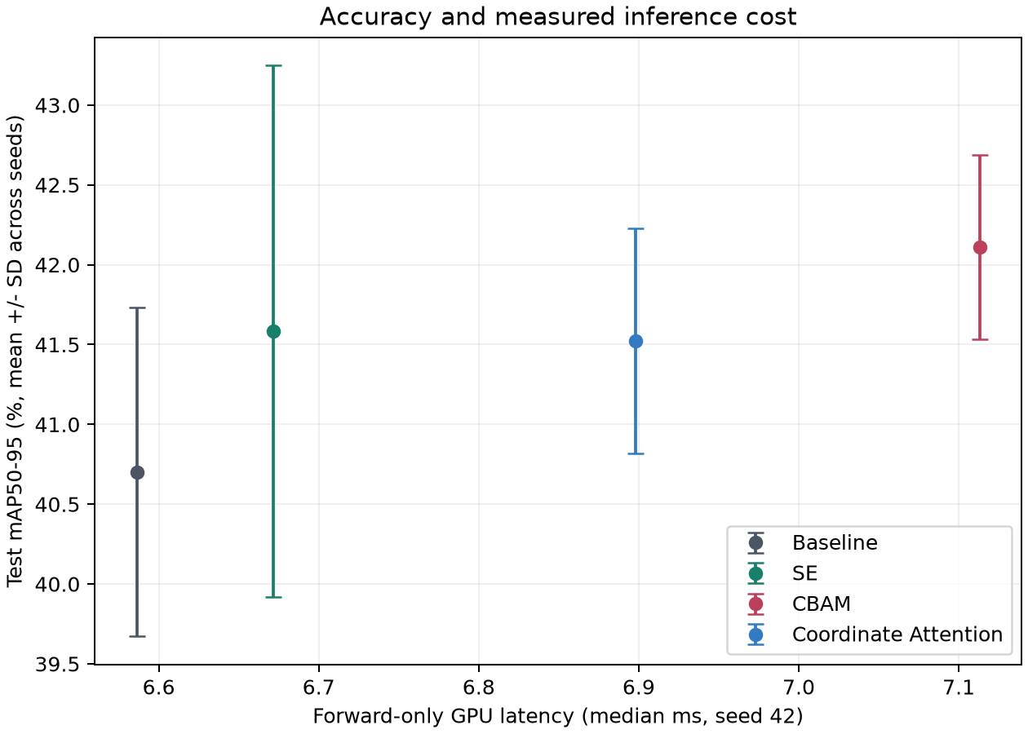
Fig. 2. Mean test mAP50-95 against measured median forward-only latency. Vertical bars are sample SD across training seeds. Latency uses the fixed seed-42 checkpoints; no latency confidence interval is implied.
TABLE VI Test AP50-95 by class in percent
Model | Scratch | Pest damage
YOLOv8n | 32.10 +/- 1.48 | 49.30 +/- 0.78
+ SE | 32.43 +/- 2.16 | 50.74 +/- 1.17
+ CBAM | 32.94 +/- 2.18 | 51.28 +/- 1.14
+ Coordinate Attention | 32.02 +/- 2.18 | 51.02 +/- 1.00

Scratches are consistently harder than pest damage (Table VI). Baseline mean AP50-95 is 32.10% for scratches and 49.30% for pest damage. CBAM raises these to 32.94% and 51.28%, respectively. Its overall improvement is therefore not confined to one class, but the larger absolute gain is in pest damage. The class gap remains substantial; attention does not resolve the problem of subtle scratch localisation.
SE achieves 32.43% scratch AP50-95 and 50.74% pest AP50-95. Coordinate Attention achieves 32.02% and 51.02%. The latter scratch mean is slightly below baseline, despite its positive overall mean. This is why an overall AP improvement should not be rewritten as an improvement for every defect category. Differences in defect appearance or annotation consistency are plausible explanations, but the present experiment does not identify their causal contributions.
Median forward latency is 6.586 ms for baseline, 6.671 ms for SE, 7.113 ms for CBAM and 6.898 ms for Coordinate Attention. Relative to baseline, this is approximately 1.3%, 8.0% and 4.7% additional time. CBAM adds only 2,284 parameters, about 0.076% of baseline, yet has a noticeably larger relative execution overhead. Pooling, element-wise gates, kernel launches and memory access are not captured by parameter count alone. The benchmark measures their combined effect under one execution setup, not each operation separately.
The latency p95 values are 9.674, 9.704, 9.996 and 9.270 ms in the same model order. Standard deviations of block medians are 0.011, 0.017, 0.081 and 0.033 ms. Median and tail rankings therefore need not coincide. We do not interpret the lower Coordinate Attention p95 as proof of universally better tail behaviour: there are only three blocks on a laptop, and thermal state and system activity remain uncontrolled influences.
Fig. 2 makes the decision conditional on the intended objective. CBAM is the strongest mean-AP50-95 option in this study if an approximately 8% forward-time increase is acceptable. SE offers a smaller measured overhead but less consistent AP gains. Coordinate Attention's slightly higher mAP50 does not offset every other difference automatically. There is no deployment-specific utility function or conveyor throughput target in this project, so a single operationally optimal model cannot be claimed.

IX Learning Behaviour and Failure Analysis
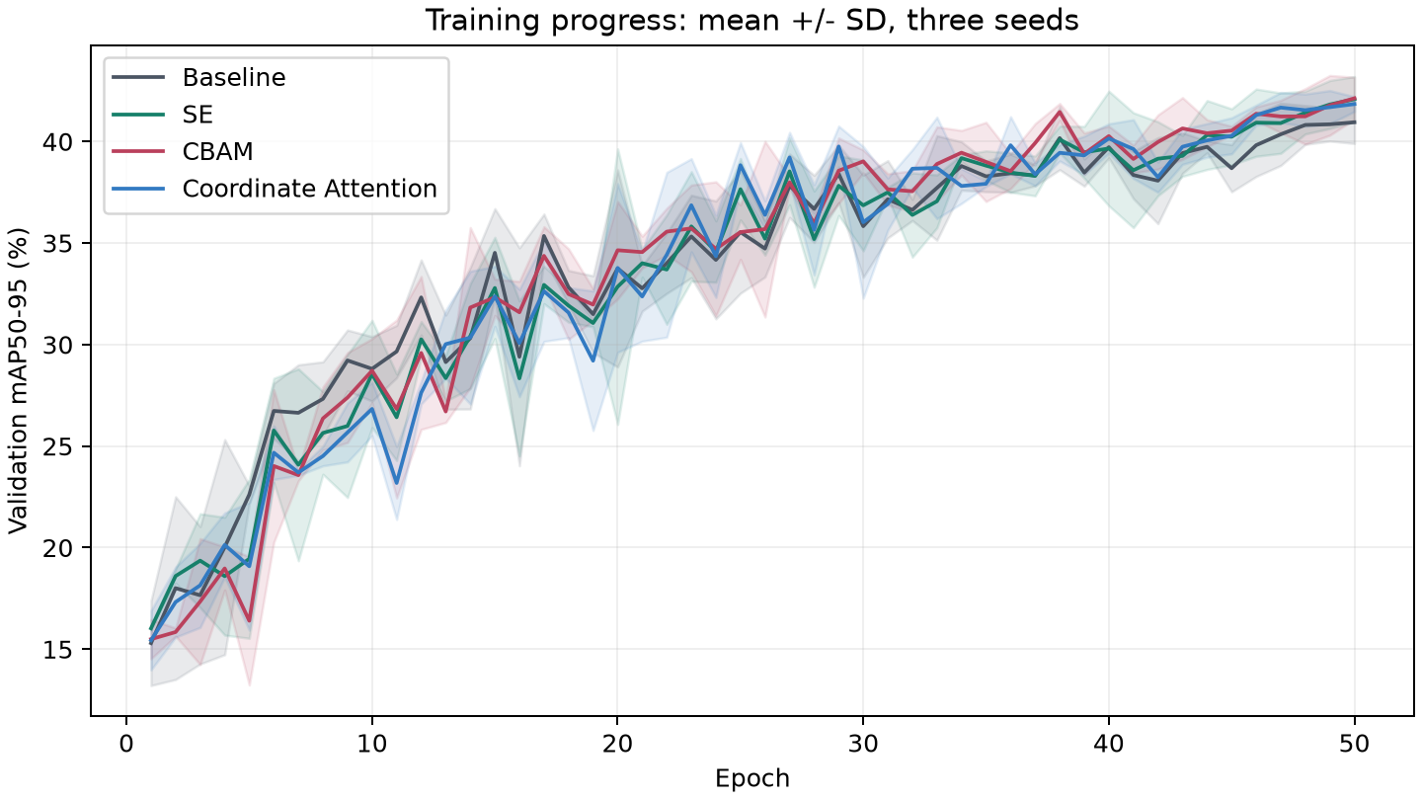
Fig. 3. Validation learning curves over 50 epochs. Lines are means across three seeds and shaded regions show sample SD. These training-monitoring curves are not final test curves.
TABLE VII Mean fixed-threshold diagnostic counts per test run
Model | Correct | Wrong class | Missed | Extra
Baseline | 175.0 | 5.0 | 53.0 | 76.0
SE | 175.3 | 4.3 | 53.3 | 57.0
CBAM | 174.3 | 5.3 | 53.3 | 57.3
Coordinate | 175.0 | 5.0 | 53.0 | 55.7

The curves in Fig. 3 rise quickly early in training and remain variable through the middle epochs. Differences between models are small relative to some of the shaded variation. Scores still improve near the end of the fixed budget. Accordingly, these runs compare performance after equal training opportunity, not performance after guaranteed convergence. Extending only the apparent winner would change the comparison and would require a separately specified experiment.
Table VII uses the geometric diagnostic definition from Section VI, with confidence 0.25 and IoU 0.5. The baseline averages 76.0 unmatched predictions, compared with 57.0 for SE, 57.3 for CBAM and 55.7 for Coordinate Attention. Unmatched annotations remain approximately 53 for every model. This suggests that the changed prediction sets contain fewer extras at this display threshold, rather than showing a large reduction in missed annotations. The result must not be equated with improved precision at every confidence level.
CBAM's correct-class geometric count is slightly lower than baseline despite its higher AP. There is no contradiction: the diagnostic uses one threshold and class-agnostic geometric assignment, whereas AP integrates ranked predictions across thresholds with class-aware evaluation. Model confidence and box localisation can change without increasing the number of thresholded correct matches. This distinction is important when deciding which figure or metric supports a particular claim.
The fixed qualitative example in Fig. 4 illustrates residual misses, overlapping predictions and a prediction without a corresponding annotation. Section X examines these errors alongside the aggregate diagnostic counts.
A further limitation is the absence of healthy-image negatives. Extra boxes observed on already defective apples are not an estimate of the probability of rejecting a healthy apple. That operational question would require representative healthy examples and an explicit image-level rejection rule. Likewise, no defect-size-stratified AP was computed, so lower scratch AP cannot be attributed exclusively to small box size. Visual impressions should not substitute for a measured size analysis.
No attention-map visualisation, feature attribution or causal intervention was performed. We therefore describe CBAM as achieving better measured localisation performance in this configuration, rather than saying that it demonstrably learned to focus on the damaged peel. The latter would require additional evidence. The saved predictions and diagnostics support a bounded analysis of outputs, which is sufficient for identifying concrete future experiments without inventing an internal explanation.

X Qualitative Case Study
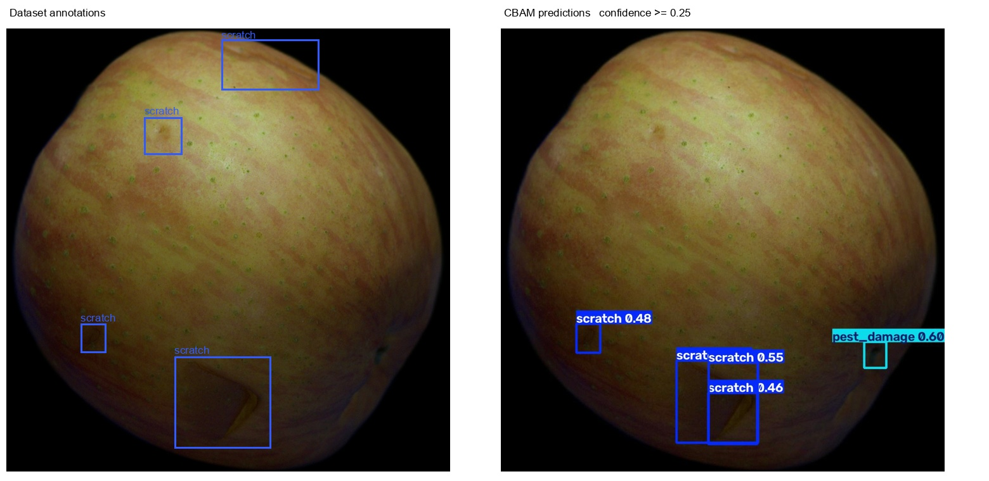
Fig. 4. Fourth image in the frozen test list. Left: dataset annotations. Right: CBAM seed-42 predictions at confidence 0.25. Blue denotes scratch and cyan denotes pest damage. The image was not chosen by model score; this is one of the fixed first-six previews.

A Relating the image to the diagnostic counts
Fig. 4 examines one concrete failure case rather than only displaying visually convincing detections. The annotated image contains several scratch regions at different positions. Some are weak marks near the upper surface, while a larger damaged area appears toward the bottom. The prediction panel detects parts of the lower damage but does not recover all annotated regions. A higher overall AP score therefore does not imply that CBAM has solved difficult individual images.
The overlapping boxes near the lower damaged region illustrate a localisation ambiguity. A model can assign more than one box to portions of a defect, and NMS at IoU 0.7 does not necessarily remove all of them. Boxes can overlap visually yet remain below that suppression threshold, especially when one surrounds only a small part of a larger region. This explanation is consistent with the output geometry, but it is not a measured attribution of every unmatched prediction in the dataset.
The upper misses also require careful interpretation. Absence from the confidence-0.25 panel can mean that no sufficiently confident prediction survived, rather than that the network produced no low-confidence candidate at all. AP was computed separately with confidence 0.001. Lowering the visualisation threshold after seeing this example would change the displayed error pattern, but would not improve the frozen model or its previously computed AP. We retain the fixed threshold to keep the qualitative comparison reproducible.

B Annotation disagreements
The right-edge pest-damage prediction has no corresponding ground-truth box in that region. Under the diagnostic definition, an unmatched prediction contributes to the extra count. It would be premature to infer that the visible region is certainly healthy: a reference annotation is the evaluation target, not an infallible biological judgement. Conversely, visual plausibility is not a reason to remove an unfavourable prediction from the evaluation. The reported scores use the annotations consistently for every model.
A future annotation audit should be blinded to model identity and include independent reviewers. It could distinguish uncertain class labels, missing regions and disagreement over box extent. Such an audit should create a versioned annotation set and a new comparison, rather than modifying only the examples that make a preferred model look worse. This is particularly relevant where scratches blend into peel texture and bounding-box boundaries do not correspond to a sharply defined object.

C What this example does not establish
This figure does not establish how frequently each error occurs or why the learned feature representation failed. Frequency is addressed by the full test-set metrics and diagnostic counts. Causality would require additional experiments, such as attention-map inspection or controlled interventions, none of which are claimed here. The purpose of the figure is to make the remaining limitation tangible: the detector can localise some damage while missing nearby weak regions and producing additional boxes in the same image.

XI Discussion Conclusion and Future Work

A Answer to the research question
Within this fixed YOLOv8n configuration, CBAM gives the highest mean held-out mAP50-95 and positive gains relative to baseline for all three seeds. The mean gain is 1.41 percentage points at an approximately 8% increase in median forward-only latency. That is the principal empirical answer. It supports CBAM as an accuracy-oriented candidate for this dataset and insertion site, not as a universally best attention module. SE remains a plausible lower-overhead choice, while Coordinate Attention provides the highest mean AP50 by a small margin.
The working hypothesis receives partial, descriptive support. All attention variants improve mean test mAP50-95, but SE and Coordinate Attention do not improve it at every seed. CBAM's spatial component is compatible with its measured advantage, yet the experiment does not isolate channel attention from spatial attention inside CBAM. Different module configurations, including biases and normalisation, are part of the treatment. A causal claim that spatial gating alone produces the gain would exceed the design.

B Threats to validity
Internal comparisons are strengthened by fixed data, matching budgets, common pretrained weights and explicit loading tests. Nevertheless, one seed-42 validation round was observed before the additional-seed protocol was frozen. The study should not be described as wholly preregistered. Model settings were held unchanged during the completed three-seed experiment, and no test-driven tuning followed. This distinction separates a reasonable exploratory course project from a confirmatory trial.
External validity is limited by 710 images from a controlled acquisition setting, two defect classes and no healthy negatives. Heuristic grouping does not certify independence of physical apples. A different capture session, cultivar or labelling convention could change the ranking. The inferred class-ID mapping and the single clipped annotation are disclosed rather than treated as invisible preprocessing. Test results from the new partition are not directly comparable with the published SSDA benchmark.
Statistical uncertainty also remains. Three seeds describe local training variation on one split; they do not provide a reliable estimate of performance across possible data collections. Similar mean scores and overlapping variation warrant caution. Latency is forward-only on one GPU and one tensor shape, not application throughput. FLOPs, corruption robustness, energy use, model export and camera-to-decision latency were not evaluated. No claims about these aspects follow from the current measurements.

C Priorities for further work
The first priority is a verified fruit-identity or capture-session split with healthy negatives. That would test whether the observed gains survive stronger independence controls and whether extra detections cause false rejection. The second is an equal-budget placement study at earlier and later feature stages, followed by an equal-parameter or equal-latency comparison. Such work would distinguish the module's inductive bias from the particular insertion site and bottleneck configuration used here.
A longer research project could then evaluate defect-size strata, annotation agreement and controlled illumination or blur perturbations. Corruptions should be applied under a protocol fixed before examining outcomes and should not be presented as equivalent to new orchard data. Finally, end-to-end timing on the intended deployment device should include decoding, resizing, transfer, NMS and the grading decision. These extensions follow directly from the limitations observed here rather than adding unrelated architectures simply to enlarge a benchmark.

D Conclusion
This study shows that an attention comparison can be informative without proposing a new module. Controlled repeated runs reveal a modest CBAM advantage, a measurable runtime cost and persistent difficulty with scratches. The strongest conclusion is conditional: for a single stride-16 insertion into YOLOv8n under the tested SSDA partition and training budget, CBAM offers the best mean primary detection metric, while alternatives may be preferable when overhead or a different metric matters. Preserving this conditional interpretation is more useful than declaring attention uniformly beneficial.

Author Contributions and AI Assistance
Ved Waghela led the project, the experimental work and preparation of the report. Manish Gadia contributed background literature research. Generative AI assisted with implementation, execution support, analysis preparation and draft development. The authors are responsible for the accuracy of the reported methods, results and interpretations.

References
[1] I. Rojas Santelices, S. Cano, F. Moreira, and A. Pena Fritz, "Artificial vision systems for fruit inspection and classification: Systematic literature review," Sensors, vol. 25, no. 5, Art. no. 1524, 2025.
[2] N. B. N. Han et al., "HAFREE: A heatmap-based anchor-free detector for apple defect detection," IEEE Access, vol. 12, pp. 182799-182813, 2024.
[3] B. N. H. Nguyen, "Surface Subtle Defects Apple dataset," version 1.0.0, Zenodo, Apr. 2024.
[4] J. Hu, L. Shen, and G. Sun, "Squeeze-and-excitation networks," in Proc. CVPR, 2018, pp. 7132-7141.
[5] S. Woo, J. Park, J.-Y. Lee, and I. S. Kweon, "CBAM: Convolutional block attention module," in Proc. ECCV, 2018, pp. 3-19.
[6] Q. Hou, D. Zhou, and J. Feng, "Coordinate attention for efficient mobile network design," in Proc. CVPR, 2021, pp. 13713-13722.
[7] M. Agarla, P. Napoletano, and R. Schettini, "Quasi real-time apple defect segmentation using deep learning," Sensors, vol. 23, no. 18, Art. no. 7893, 2023.
[8] X. Liang et al., "Real-time grading of defect apples using semantic segmentation combination with a pruned YOLO V4 network," Foods, vol. 11, no. 19, Art. no. 3150, 2022.
[9] Q. Wang et al., "ECA-Net: Efficient channel attention for deep convolutional neural networks," in Proc. CVPR, 2020, pp. 11534-11542.
[10] Ultralytics, "Ultralytics," software release v8.3.203, 2025. Accessed: Oct. 19, 2026.
[11] T.-Y. Lin et al., "Microsoft COCO: Common objects in context," in Proc. ECCV, 2014, pp. 740-755.
[12] I. Loshchilov and F. Hutter, "Decoupled weight decay regularization," in Proc. ICLR, 2019.
[13] X. Bouthillier et al., "Accounting for variance in machine learning benchmarks," Proc. Mach. Learn. Syst., vol. 3, pp. 747-769, 2021.

