Customer Churn Analysis
ABC Communications Ltd.
AnalystLab Africa — Week 1 Data Analytics Project
Prepared by: Junior Data Analyst

1. Business Understanding Report 3
Why Churn Matters 3
Churn in the Telecom Industry 3
Project Scope & Objectives 4
2. Data Loading & Inspection 4
3. Business Data Analysis 5
3.1. Churn Rate by Contract Type 5
3.2. Churn Rate by Payment Method 6
3.3. Churn Rate by Online Security Status 7
3.4. Overall Churn Split 8
3.5. Customer Base Composition: Dependents 9
3.6. Distribution of Tenure 10
3.7. Distribution of Monthly Charges 11
3.8. Tenure Distribution by Churn Status 12
3.9 Correlation Heatmap 12
4. Business Insights 14
Insights 14
Business Risks 14
Business Opportunities 15
5. Business Recommendations 16

Business Understanding Report

Why Churn Matters
Customer churn erodes ABC Communications' return on its customer acquisition investment. Resources spent on marketing, onboarding, and retention are only recovered over the customer's lifetime; when a customer leaves prematurely, that investment is only partially recovered, and the company must incur fresh acquisition costs to replace lost revenue — making retention significantly more cost-effective than acquisition.

Churn in the Telecom Industry
Telecom churn differs from churn in many other industries because customers are typically locked into recurring monthly billing relationships rather than one-off purchases, making churn a continuous risk rather than a single decision point. Several factors are specific to this industry: contract structure (month-to-month customers can leave with far less friction than those on 1- or 2-year contracts), service bundling (customers with multiple services — internet, phone, streaming add-ons — tend to be more embedded and costlier to leave), and tenure (new customers, still evaluating the service, churn at much higher rates than long-tenured ones who have already demonstrated loyalty). Because switching providers is relatively easy — often just a new SIM or router — telecom companies compete heavily on both price and service reliability, which makes retention efforts, rather than pricing alone, a critical lever for reducing churn.

Project Scope & Objectives
This project aims to identify the key factors driving customer churn at ABC Communications and translate those findings into actionable retention strategies. The analysis examines churn patterns across customer demographics, contract types, tenure, service subscriptions, and payment methods to determine which segments are most at risk. By combining data quality assessment, exploratory analysis, and visualization, this report surfaces concrete insights into who is churning and why, culminating in targeted recommendations that management can act on to reduce future customer loss and protect long-term revenue.

Data Loading & Inspection
The dataset (Telco Customer Churn) was inspected for structure, quality, and consistency before any analysis was performed. Key findings:
- 7,043 customer records across 21 columns; no duplicate customer IDs.
- 11 records (0.16%) had blank TotalCharges values, all corresponding to customers with tenure = 0 (newly signed customers not yet billed). These were set to 0, consistent with no completed billing cycle.
- SeniorCitizen was retained in its original numeric (0/1) format to support correlation analysis, with a separate readable label field created for charting.
- Six service-related columns (e.g. OnlineSecurity, TechSupport) contain a third category, “No internet service,” which was kept distinct from “No” since it reflects a structurally different customer (no internet at all) rather than a customer who has internet but declined the add-on.
- Overall baseline churn rate: 26.5% (1,869 of 7,043 customers).

Business Data Analysis
Nine visualizations were produced to explore churn drivers across contract terms, payment behavior, service adoption, and customer tenure.

3.1. Churn Rate by Contract Type
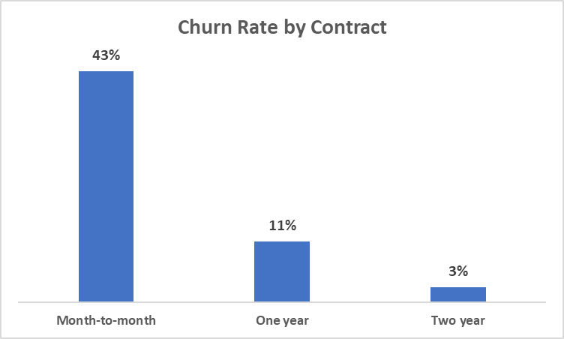
Month-to-month customers churn at 42.7%, compared to 11.3% for one-year and just 2.8% for two-year contracts. This gap likely reflects the lack of commitment inherent in month-to-month plans — customers can leave at any time with no penalty, whereas longer contracts create switching friction that keeps customers in place. Contract length is one of the strongest levers ABC has for reducing churn.

3.2. Churn Rate by Payment Method
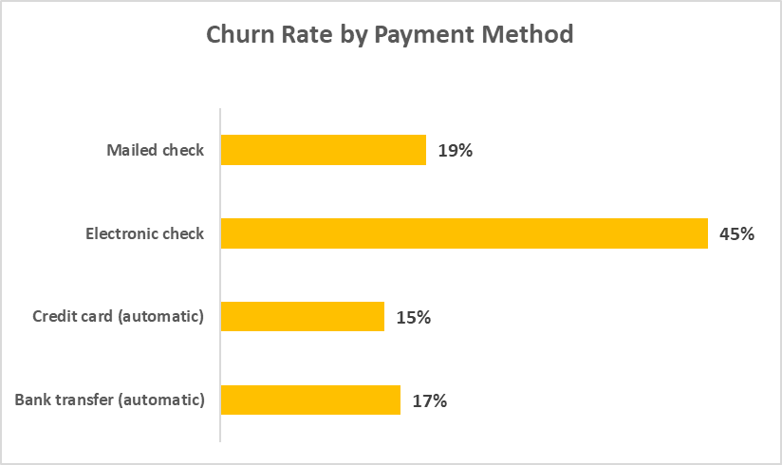
Electronic check has the highest churn rate at 45.3%, more than double every other payment method — bank transfer (16.7%), credit card (15.2%), and mailed check (19.1%). Automatic payment methods cluster at the lowest churn rates, likely because they require no ongoing action from the customer, while manual payment requires re-engagement every billing cycle.

3.3. Churn Rate by Online Security Status
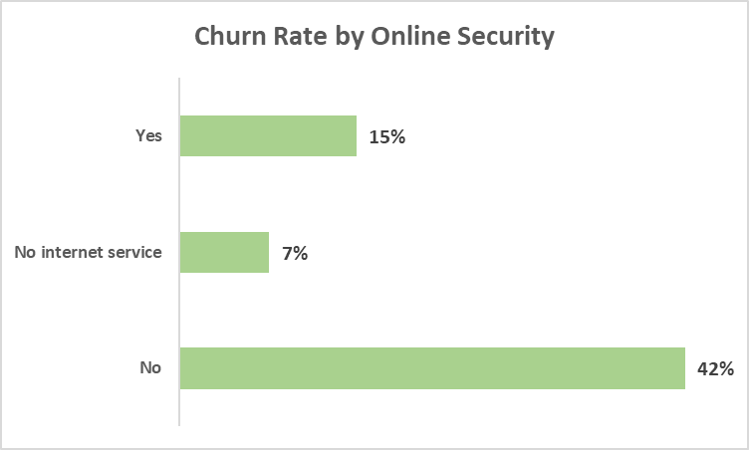
Customers who have internet but declined online security churn at 41.8% — nearly triple the rate of customers with no internet service at all (7.4%), and well above customers who added security (14.6%). This suggests that add-on adoption correlates with stronger customer engagement, and that phone-only customers represent a simpler, lower-risk relationship.

3.4. Overall Churn Split
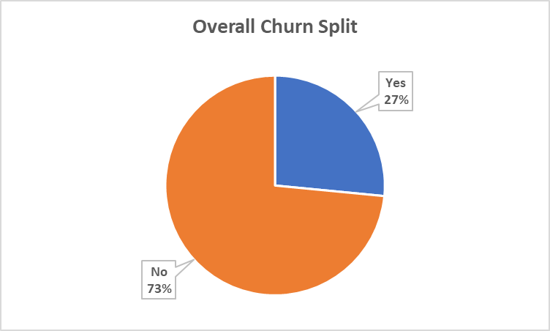
26.5% of ABC's customer base has churned, confirming a substantial and costly churn problem — roughly 1 in 4 customers is being lost. This is the baseline against which every segment above is compared.

3.5. Customer Base Composition: Dependents
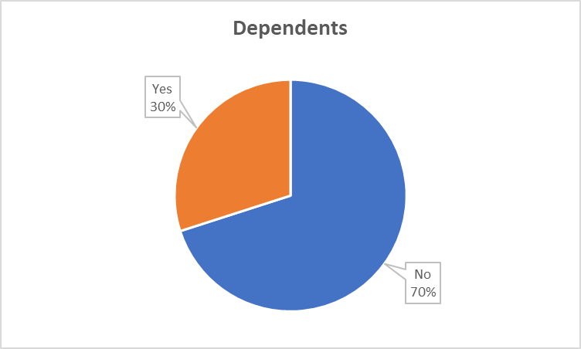
Only 30% of ABC's customers have dependents, while 70% do not. Household structure may influence churn behavior — customers without dependents may have less at stake in maintaining stable service — though this would need to be validated with a churn cross-tab rather than assumed from composition alone.

3.6. Distribution of Tenure
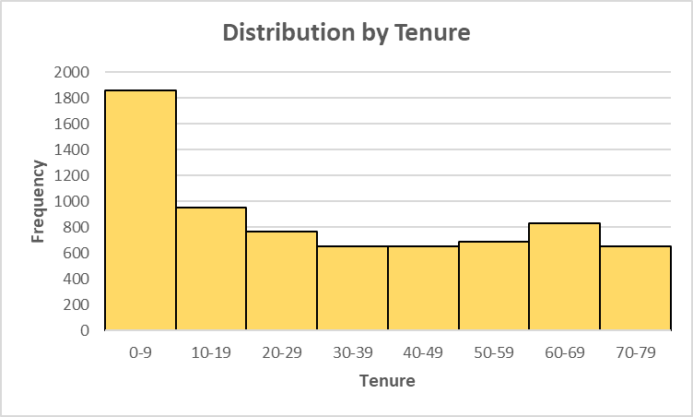
The tenure distribution is bimodal rather than simply skewed, with a large cluster of customers concentrated in the earliest tenure range (0–9 months) and a second, smaller peak in the 60–69 month range. This suggests churn risk is not evenly distributed across the customer lifecycle: a large volume of customers are still in their earliest, most vulnerable months, while those who survive this initial period settle into long-term loyalty. Early-relationship retention efforts likely offer the highest return.

3.7. Distribution of Monthly Charges
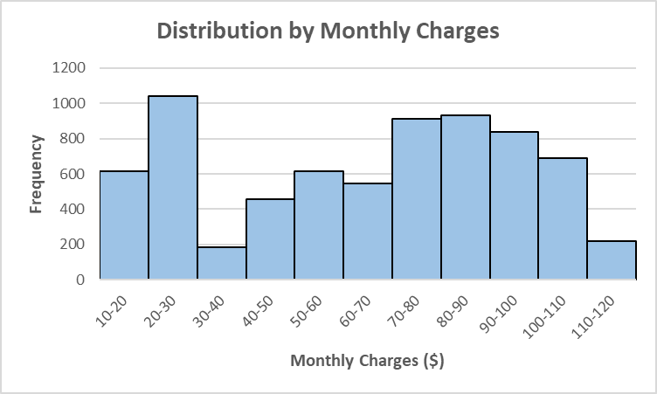
Monthly charges also show a bimodal distribution, with a low-spend cluster (~$20–$30, phone-only or minimal service) and a high-spend cluster (~$80–$90, bundled internet plus add-ons). Churn risk is not simply a function of bill size — the lowest-spend group (phone-only) has the lowest churn rate, while the mid-to-high spend group without protective add-ons has the highest, suggesting engagement with add-on services matters more than price alone.

3.8. Tenure Distribution by Churn Status
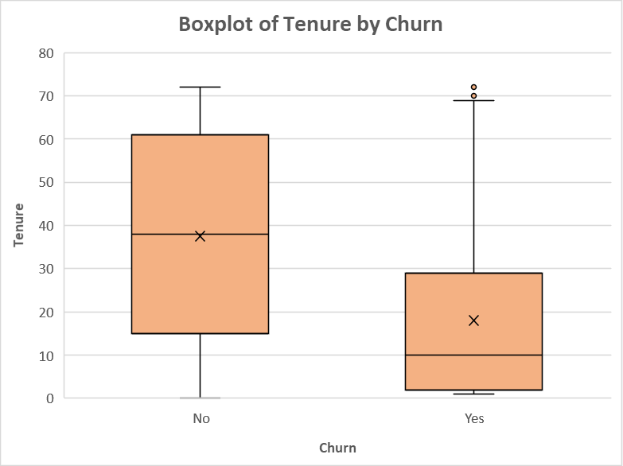
Churned customers have a median tenure of just 10 months, compared to 38 months for retained customers. The spread differs sharply as well: retained customers' tenure is widely distributed (interquartile range: 15–61 months), while churned customers are tightly clustered in a narrow early window (interquartile range: 2–29 months) — confirming that churn is heavily concentrated in the first couple of years rather than spread evenly across a customer's lifetime.

3.9 Correlation Heatmap

 | SeniorCitizen | Tenure | MonthlyCharges | TotalCharges | ChurnNum
SeniorCitizen | 1
Tenure | 0.016566878 | 1
MonthlyCharges | 0.220173339 | 0.2479 | 1
TotalCharges | 0.103006184 | 0.826178 | 0.651173832 | 1
ChurnNum | 0.150889328 | -0.35223 | 0.193356422 | -0.198324263 | 1

Tenure has the strongest relationship with churn (-0.35) among the numeric variables, confirming the histogram and box plot findings: longer-tenured customers are meaningfully less likely to churn. TotalCharges also shows a negative correlation with churn (-0.20), but this is largely a byproduct of its strong correlation with tenure (0.83) rather than an independent effect. Tenure stands out as the single strongest numeric predictor of churn risk in this dataset.

Business Insights

Insights
- Month-to-month customers churn at 42.7%, compared to 11.3% for one-year and 2.8% for two-year contracts — a gap that likely reflects the lack of commitment inherent in short-term plans.
- Senior citizens churn at 41.7%, nearly double the rate of non-seniors (23.6%) — the largest gap of any single demographic factor in this dataset.
- Customers who pay manually (electronic check or mailed check) churn at 34.7%, more than double the rate of customers on automatic payment methods (16.0%).
- Customers without online security churn at 41.8%, compared to just 14.6% for those who have it — and nearly half of all customers (49.7%) currently fall into the higher-risk “No” group.
- Tenure is the strongest numeric predictor of churn (correlation: -0.35). Churned customers have a median tenure of 10 months versus 38 months for retained customers, and the tenure distribution is bimodal — a large early-tenure cluster and a smaller long-tenured, loyal cluster.

Business Risks
- With month-to-month customers making up the largest share of ABC's customer base (~55%), this segment represents a concentrated and ongoing revenue exposure — nearly half of these customers are likely to churn without any structural incentive keeping them in place.
- A large share of ABC's customer base still pays manually, meaning this payment friction — however minor it feels — is actively contributing to a meaningful share of total churn.
- Because churn is heavily concentrated in the earliest months of the customer relationship, ABC faces an ongoing “leaky bucket” problem — a large volume of newly acquired customers are lost before they reach the loyalty stage where churn risk drops sharply, undermining the return on every dollar spent on acquisition.

Business Opportunities
ABC could design targeted incentives (loyalty discounts, bundled pricing, or perks) to migrate month-to-month customers toward one- or two-year contracts, directly reducing churn in the highest-risk segment.
Since the underlying cause of higher senior churn isn't confirmed by this data, ABC should investigate directly (e.g., a short survey or support-ticket review) — but a reasonable first step would be offering simplified, bundled service packages or dedicated support for senior customers.
Because such a large portion of the customer base lacks online security, proactively offering or bundling this add-on represents a high-reach retention lever — even a modest uptake could meaningfully reduce overall churn given the size of this group.

5. Business Recommendations
- Launch targeted incentives (loyalty discounts, bundled pricing, or perks) to migrate month-to-month customers toward one- or two-year contracts, directly reducing churn in the highest-risk segment.
- Offer simplified, bundled service packages or dedicated support for senior customers, paired with a short survey or support-ticket review to confirm the underlying cause of their elevated churn.
- Proactively offer or bundle online security with internet plans; given nearly half of customers currently lack this add-on, even modest uptake could meaningfully reduce overall churn.
- Launch a structured onboarding and early-engagement program for the first 90 days of the customer relationship — including a welcome check-in call, proactive troubleshooting outreach, and loyalty milestone incentives at the 6- and 12-month marks — since churn is heavily concentrated in this early window.
- Launch a targeted campaign encouraging electronic and mailed check customers to switch to automatic payment (bank transfer or credit card), using a small bill credit or fee waiver as a switching incentive.

These recommendations are each directly traceable to a specific, verified finding from the analysis above and are ranked by ease of implementation and expected impact on ABC Communications' overall churn rate.

