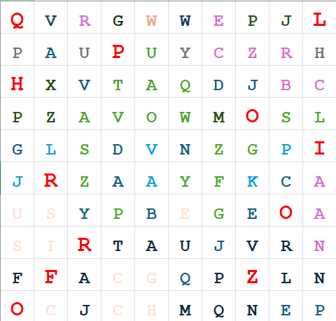
Here the highlighted letters are the password to steghide. So we enter “steghide extract -sf chal.jpg” and then “QLPHOIRORFZO” as the passphrase to get the flag.txt file
