HeavyLog
Driver Work Logbook

User Manual
Version 1.0 — March 2026

Personal fatigue management reference tool for Australian heavy vehicle drivers
Not an official or NHVR-approved work diary

1. Introduction

1.1 What Is HeavyLog?
HeavyLog is a personal fatigue management reference tool designed for Australian heavy vehicle drivers. It helps you informally track your work and rest activities against NHVR (National Heavy Vehicle Regulator) fatigue guidelines, including both Standard Hours and Basic Fatigue Management (BFM) schemes.
The app records exact timestamps for all activities, calculates your remaining work and rest obligations in real time, and provides clear visual alerts when you are approaching or exceeding fatigue limits.
⚠ Important
HeavyLog is NOT an official or NHVR-approved electronic work diary. It is a personal reference tool only. You must still maintain a compliant work diary as required under the Heavy Vehicle National Law (HVNL).

1.2 Key Features
- Real-time fatigue dashboard with colour-coded status cards
- Support for both Standard Hours and BFM fatigue schemes
- Exact timestamp recording for all work and rest activities
- Automatic calculation of remaining work time across multiple rolling windows
- Break and rest countdowns with clear visual warnings
- GPS location capture for log entries (tap to use)
- CSV export and import of your complete activity log
- Fully offline — no internet connection, account or login required
- All data stored locally on your device only

2. Getting Started

2.1 Installing HeavyLog
- Open the Google Play Store on your Android device.
- Search for HeavyLog.
- Tap Install and wait for the download to complete.
- Open the app. No account or registration is needed.

2.2 Setting Up Your Profile
Before you start logging activities, set up your driver profile in the Profile tab:
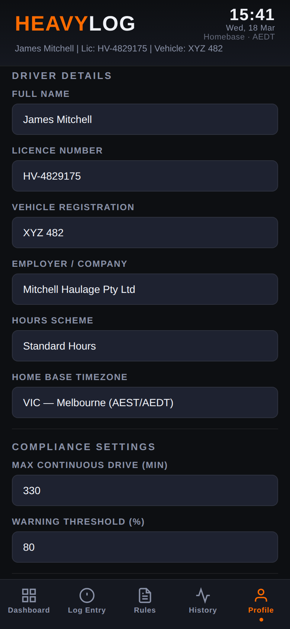
Figure 1 — Profile tab with driver details and settings
Field | Description
Full Name | Your full name as it appears on your licence
Licence Number | Your heavy vehicle licence number
Vehicle Registration | Registration number of your primary vehicle
Employer / Company | The company you drive for (or your business name)
Hours Scheme | Choose Standard Hours or BFM
Home Base Timezone | Your home base timezone for fatigue calculations
Max Continuous Drive | Maximum continuous driving time in minutes
Warning Threshold | Percentage at which amber warnings appear (default 80%)

Tip
Set your fatigue scheme and home base timezone first, as these affect how your dashboard calculations work.

3. The Dashboard
The Dashboard is your main screen. It shows your current fatigue status at a glance with colour-coded cards that update in real time.
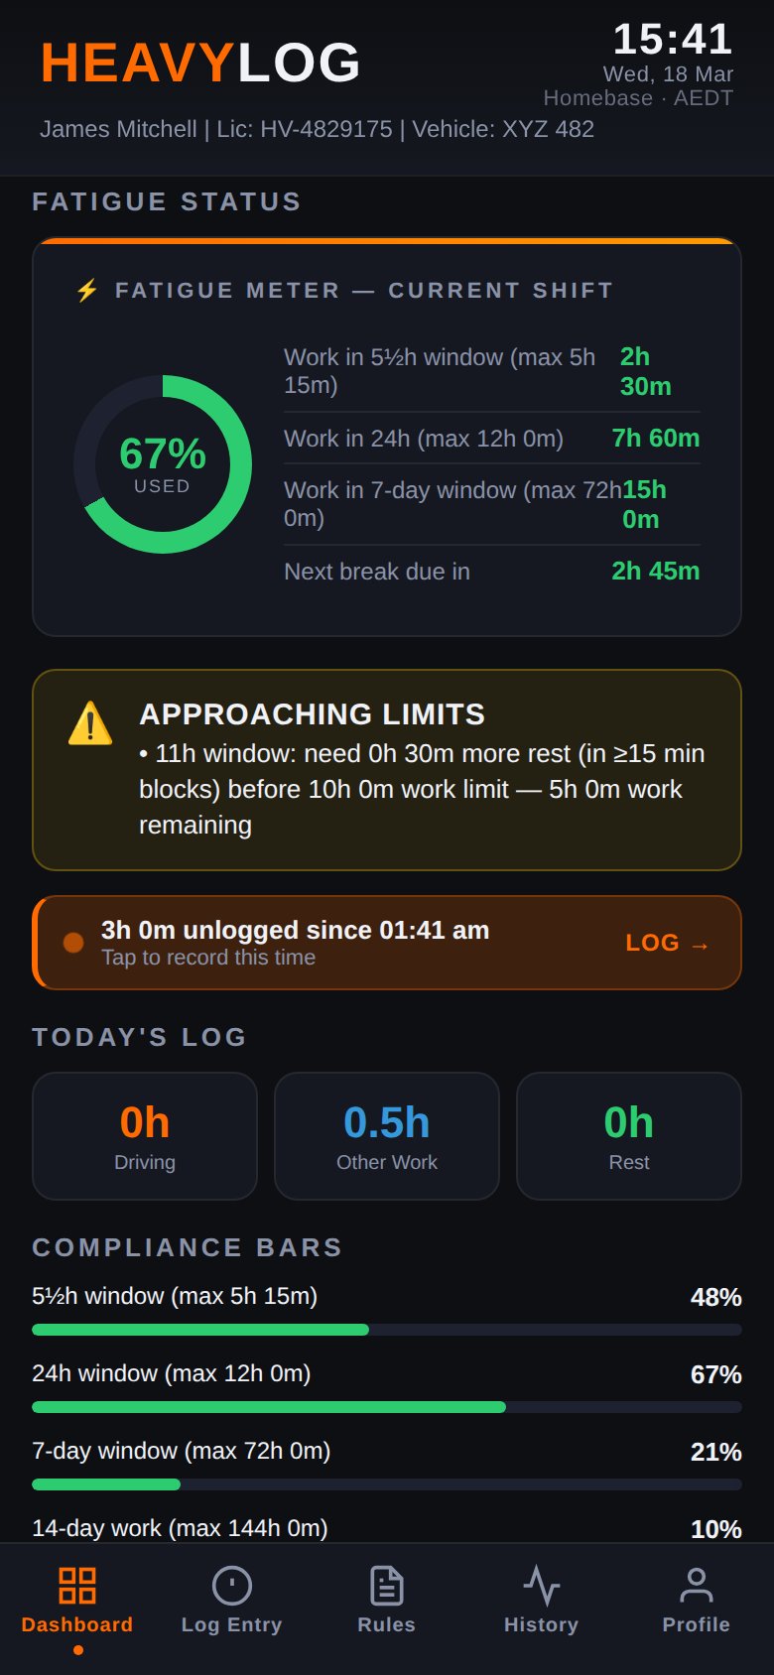
Figure 2 — Dashboard showing fatigue meter, alert banner, today’s log and compliance bars

3.1 Fatigue Meter
The circular gauge at the top shows your overall fatigue usage as a percentage. The gauge changes colour as you approach limits: green when safe, yellow/amber when approaching, and red when exceeded.
Next to the gauge, key statistics show your work time in the short window, 24-hour window, 7-day window, and when your next break is due.

3.2 Alert Banner
Below the fatigue meter, an alert banner shows your overall compliance status:
- COMPLIANT (green) — All fatigue limits are within safe range
- APPROACHING LIMITS (yellow) — One or more windows approaching a limit. Plan your next rest soon.
- FATIGUE BREACH (red) — A limit has been exceeded. Stop work and take required rest.

3.3 Today’s Log Summary
Three summary cards show your total Driving, Other Work, and Rest hours for the current day.

3.4 Compliance Bars
Horizontal progress bars show your usage percentage across each fatigue window (5½h, 24h, 7-day, 14-day). Bars change from green to yellow to red as you approach limits.

4. Logging Activities

4.1 Activity Types
HeavyLog tracks four types of activity:
Activity | Description | Counts As
Driving | Time spent driving the heavy vehicle | Work
Other Work | Non-driving tasks (loading, paperwork, checks) | Work
Short Break | Short rest breaks during a shift (15–30 min) | Rest
Major Rest | Continuous rest period (night rest, 7h+) | Rest

4.2 Selecting and Starting an Activity
From the Log Entry tab, select the activity type you want to start, then tap the orange START ACTIVITY button.
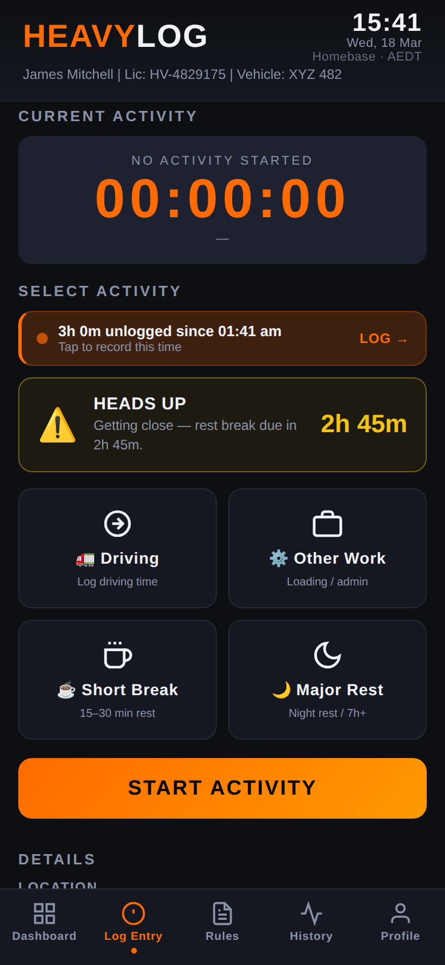
Figure 3 — Log Entry tab with activity buttons and HEADS UP warning

4.3 Setting the Start Time
After tapping START ACTIVITY, a modal appears where you can set the exact start time. The app defaults to the current time, but you can adjust the hour, minute and date if you need to log a past activity.
The modal also shows any approaching fatigue limits so you can make an informed decision before starting work.
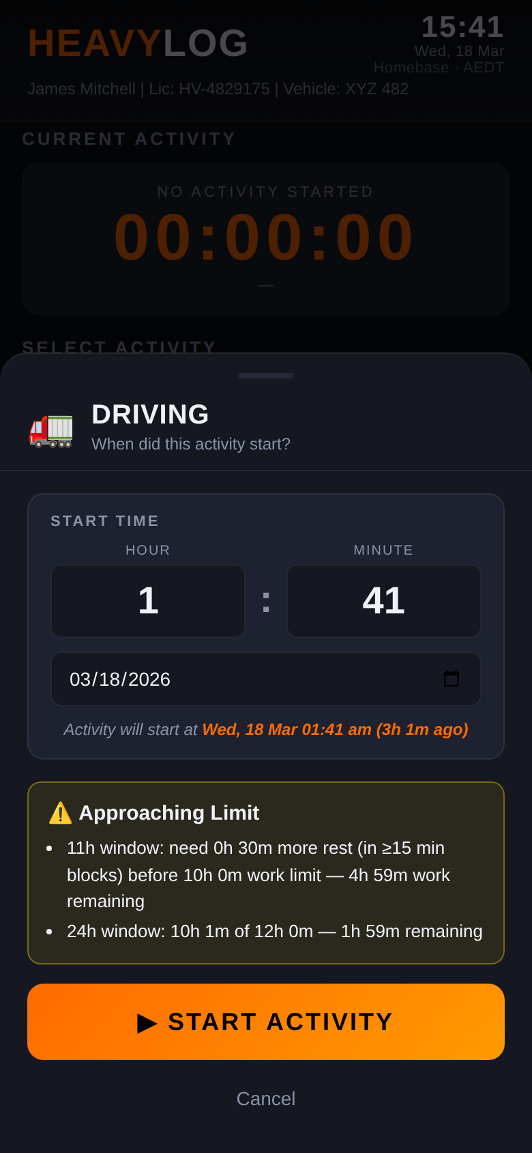
Figure 4 — Start time modal with approaching limit warnings

4.4 Stopping an Activity
When you finish an activity, tap the STOP button. You will be prompted to enter details:
- Location — Tap the 📍 button to auto-fill GPS, or type manually
- Vehicle Rego / Fleet No. — Pre-filled from your profile
- Odometer — Enter current reading (km)
- Trailer No. — Pre-filled from your profile
- Note — Any additional notes
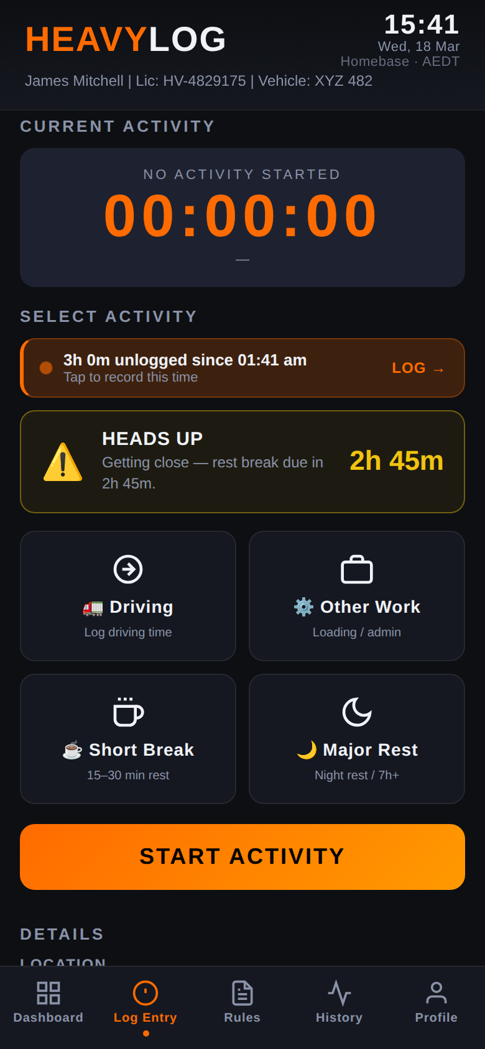
Figure 5 — Activity details fields (location, vehicle, odometer, trailer, notes)

4.5 GPS Location
When you tap the locate button, HeavyLog requests your device’s GPS position and fills in the location field. Key points:
- Location is only accessed when you explicitly tap the button
- GPS coordinates are stored as text in your log entry only
- No location data is ever transmitted to any server
- You can deny the permission and type locations manually

5. Fatigue Rules Reference
The Rules tab provides a built-in reference for NHVR fatigue rules. You can switch between Standard Hours and BFM using the tabs at the top.
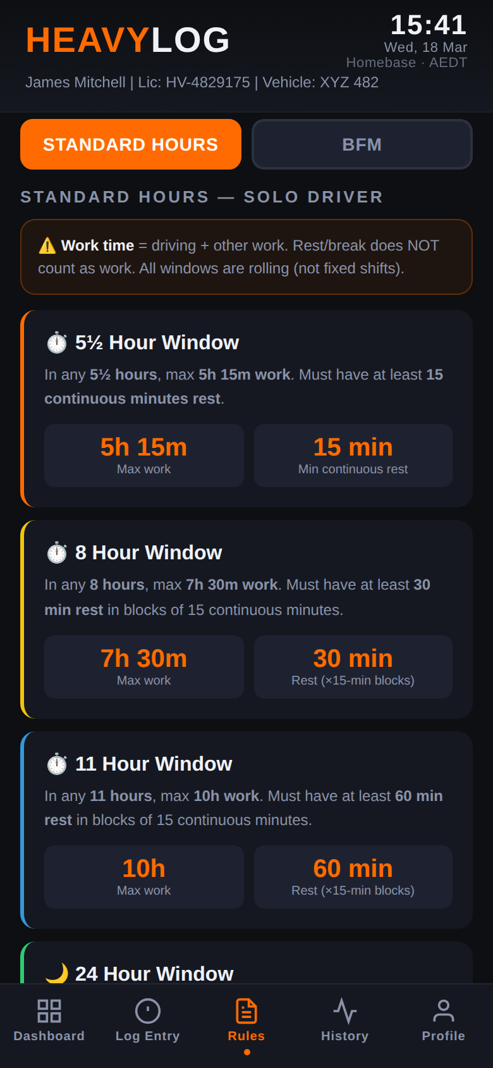
Figure 6 — Rules tab showing Standard Hours fatigue windows

5.1 Standard Hours
Rule | Limit | Required Rest
5½h window | 5h 15m of work | 15 min continuous rest
8h window | 7h 30m of work | 30 min rest (in 15-min blocks)
11h window | 10h of work | 60 min rest (in 15-min blocks)
24h window | 12h of work | Remaining time as rest
7-day rest | Unconditional | 24h continuous rest every 7 days

5.2 Basic Fatigue Management (BFM)
Rule | Limit | Required Rest
6¼h window | 6h of work | 30 min continuous rest
9h window | 8h of work | Remaining time as rest
12h window | 11h of work | Remaining time as rest
24h window | 14h of work | Remaining time as rest
Major rest | 7h continuous | Qualifies as major rest
84h cumulative | 84h since last 24h rest | 24h continuous rest required

⚠ Important
These tables are a simplified reference. The actual NHVR rules contain additional detail, exemptions and conditions. HeavyLog calculates against these guidelines as a personal aid — it does not replace official regulatory guidance.

5.3 How HeavyLog Calculates Fatigue
HeavyLog uses exact timestamps (not 15-minute block rounding) for all calculations. The 15-minute rounding rule under NHVR only applies to handwritten work diaries — electronic systems record and calculate with precise times.
The app continuously scans rolling time windows to determine how much work and rest you have accumulated. When a window approaches its limit, the dashboard card changes colour and the alert banner updates.

6. History
The History tab shows your complete log of recorded activities, grouped by date. Each entry displays the activity type, time, duration, location, vehicle details and notes.
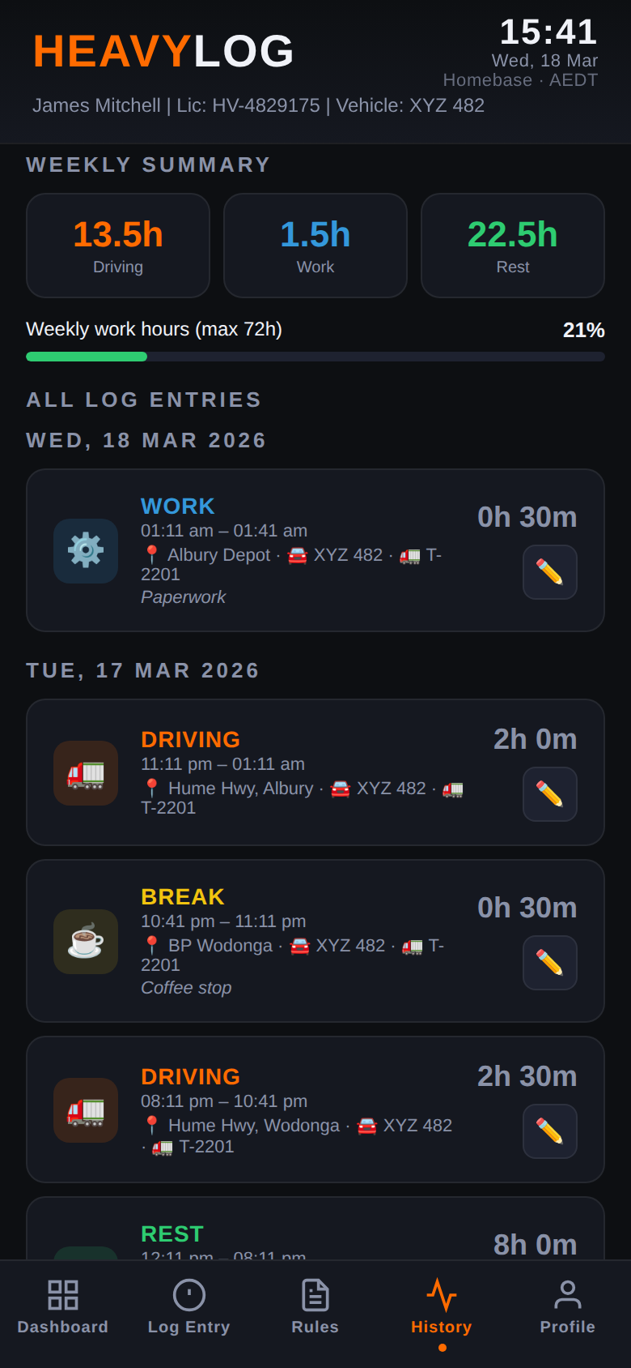
Figure 7 — History tab with weekly summary and log entries

6.1 Weekly Summary
At the top, three summary cards show your total Driving, Work and Rest hours for the current week, along with a progress bar showing your weekly work hours against the maximum.

6.2 Browsing and Editing Entries
Entries are listed in reverse chronological order (most recent first). Each entry shows the activity icon, type, times, location, vehicle rego, trailer number and duration. Tap the pencil icon to edit an entry.
Changes to past entries will cause the dashboard to recalculate your fatigue status automatically.

7. Exporting and Importing Data

7.1 Exporting Your Log (CSV)
You can export your complete activity log as a CSV file at any time:
- Go to the Profile tab.
- Tap EXPORT LOGBOOK.
- The CSV file will be saved to your device. You can share it via email, cloud storage or any other method.

The exported CSV includes: activity type, start/end times, duration, location, odometer, vehicle rego, fleet number, trailer number, notes, and driver details.

7.2 Importing a Log (CSV)
- Go to the Profile tab.
- Tap IMPORT LOGBOOK (CSV).
- Select the CSV file from your device.
- HeavyLog will map the columns and import the entries into your log.

Tip
Export your log regularly as a backup. If you uninstall the app or clear app data, all log entries are permanently deleted.

7.3 Clearing All Data
The CLEAR ALL DATA button in the Profile tab permanently deletes all log entries, profile information and settings. This action cannot be undone.
⚠ Warning
Always export your log before clearing data. Once cleared, your entries cannot be recovered.

8. Tips and Best Practices

8.1 Keep Your Log Accurate
Log every activity as it happens. Starting and stopping activities promptly ensures your fatigue calculations are accurate. Avoid entering activities retrospectively unless correcting an error.

8.2 Export Regularly
Make a habit of exporting your log at least weekly. The CSV export serves as your backup and can be useful for cross-referencing with your official work diary.

8.3 Monitor Dashboard Alerts
Pay attention to the amber/yellow warning cards. These give you advance notice that you are approaching a limit, allowing you to plan your next rest break before hitting a red limit.

8.4 Check Your Rest Countdowns
When on a break or rest period, the dashboard shows a countdown of how much rest you still need before you can resume work.

8.5 Keep Your Device Secure
Since all data is stored on your device, your log security depends on your device security. Use a screen lock, keep your OS updated, and do not share your device with untrusted persons.

8.6 Remember Your Legal Obligations
HeavyLog is a personal reference tool. It does not replace your legal obligation to maintain an official NHVR-compliant work diary. Always ensure you meet your legal requirements separately.

9. Troubleshooting

9.1 Dashboard Shows Unexpected Alerts
If a status card shows a warning you don’t expect, check your recent log entries in the History tab. A missed stop, overlapping entry or incorrect time can affect calculations. Edit the incorrect entry and the dashboard will recalculate.

9.2 GPS Location Not Working
Ensure you have granted location permission to HeavyLog in Settings > Apps > HeavyLog > Permissions. Also check that your device’s location services (GPS) are turned on.

9.3 Data Lost After Reinstall
If you uninstall and reinstall the app, locally stored data is removed. This is why regular CSV exports are essential. Use the Import function to restore your log from a previous export.

9.4 CSV Import Errors
Ensure the CSV file matches the format produced by HeavyLog’s export. Common issues include modified column headers, incorrect date formats, or extra columns. Use the original exported file without manual edits where possible.

10. Data and Privacy
HeavyLog is designed with privacy as a core principle:
- All data is stored locally on your device only — nothing is uploaded to any server
- No account, login or registration is required
- No analytics, crash reports or advertising identifiers are collected
- GPS location is only accessed when you explicitly tap the locate button
- The app operates entirely offline
For full details, see the HeavyLog Privacy Policy available on the Google Play Store listing.

11. Legal Notices
Disclaimer: HeavyLog is provided as a personal reference tool only, on an “as is” basis with no warranties of any kind. It is not approved, endorsed or recognised by the NHVR, the Australian Government, or any State or Territory transport authority.
We make no representation that HeavyLog is accurate, complete or current with NHVR regulations. We accept no responsibility for any compliance breach, fine, penalty or legal consequence arising from use of or reliance on this app.
Users are solely responsible for ensuring their own compliance with all applicable laws and regulations, including maintaining an official NHVR-compliant work diary.

HeavyLog — Personal Driver Reference Tool | User Manual | March 2026

