Exit Interviews
Where to find it: Side menu > Exit Interviews
Use this page to understand why people leave, in aggregate. It summarises what departing employees said in their exit interviews: reasons for leaving, whether they would return, ratings on training, fairness and workload, and free-text comments, for resignations in the selected period. Individual responses are never identified.

Step 1 - Choose the period and your scope
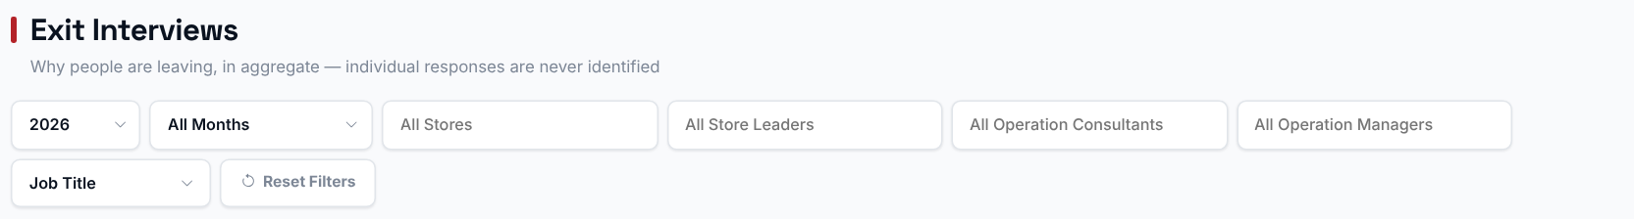
Choosing a Store, Store Leader, Operation Consultant or Operation Manager filters every chart, table and comment on this page to just that selection. The Year/Months filter scopes everything to resignations that happened in that period.

Step 2 - Read the headline numbers
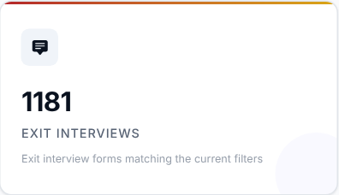 | 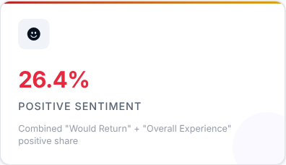 |  | 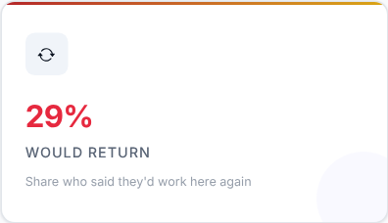

What to look at: Positive Sentiment and Would Return - together they tell you how people feel when they leave.

Step 3 - Read the Smart Insights
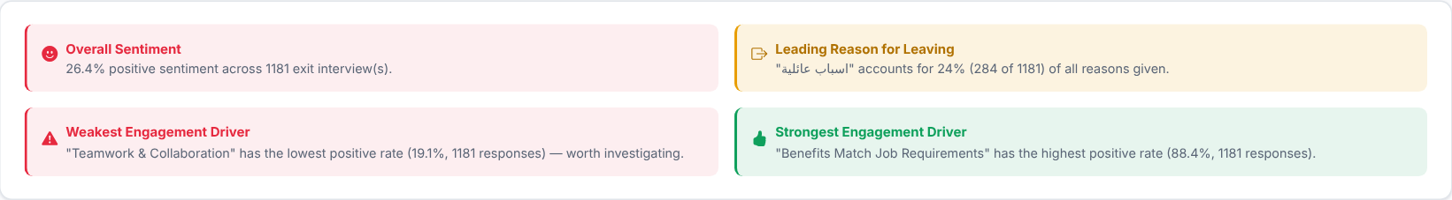
Automatic takeaways worked out from the exit interviews for your current filters.

Step 4 - Why do people leave?
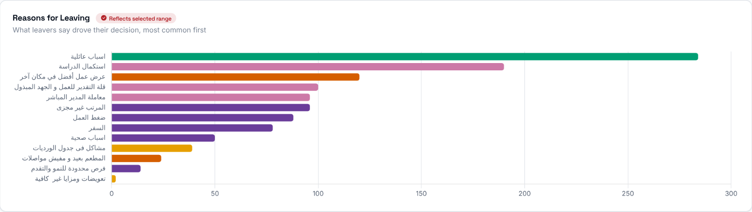
The reasons employees gave for resigning, ranked by how often each was cited.
Then decide: the top reasons are where your retention effort should go first.
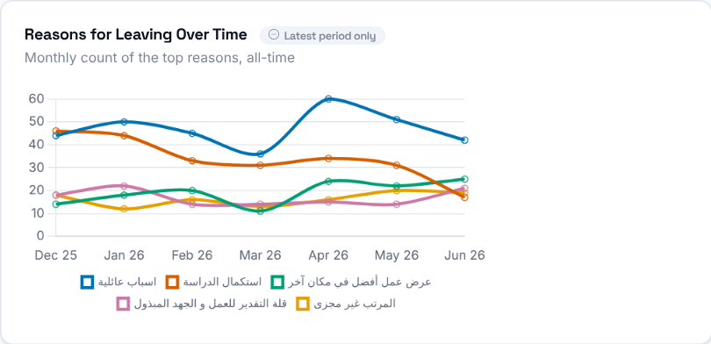 | How the top resignation reasons have trended month over month.

Step 5 - Would they come back?
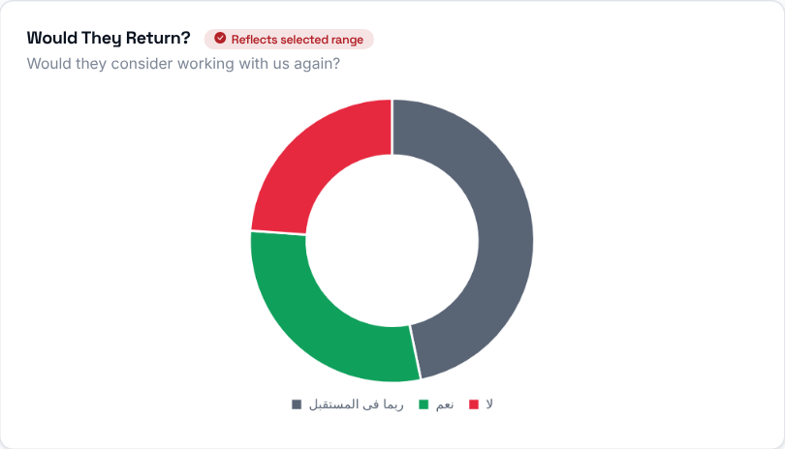  Whether departing employees said they would consider returning to work here in the future. | 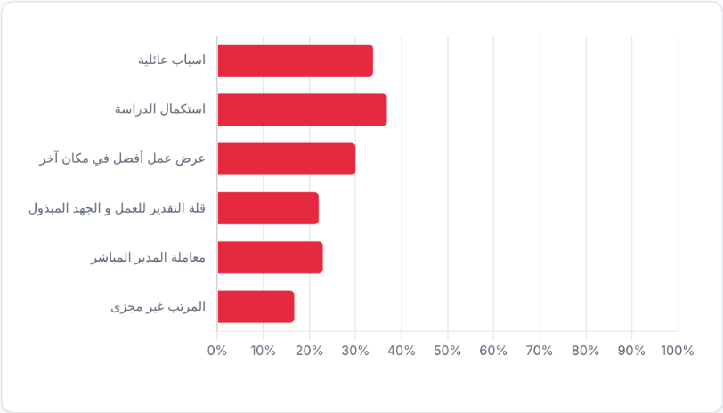  For each top reason, the share of people who said they would work here again. It shows which reasons tend to be "final" and which are more circumstantial.

Step 6 - How did they rate their experience?
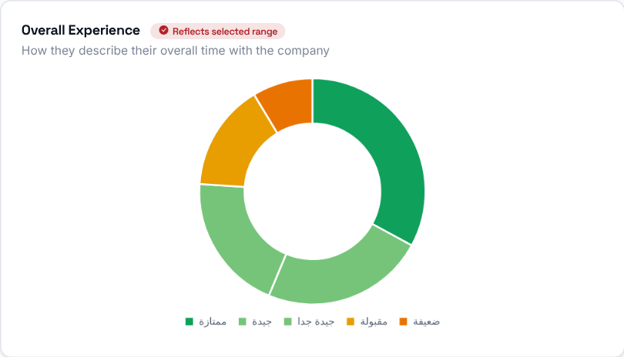  How departing employees rated their overall experience working here. | 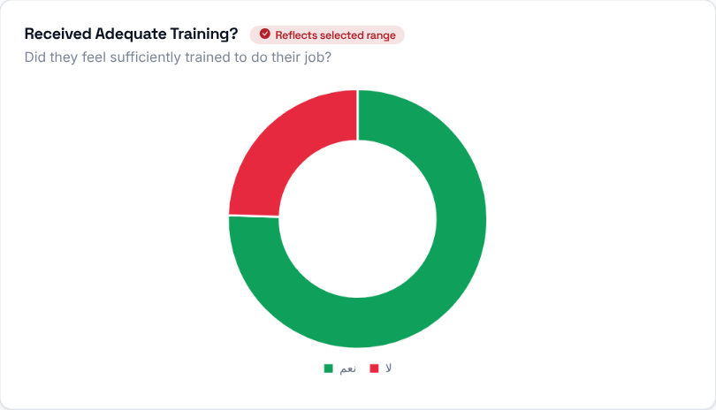  How departing employees rated the training they received.

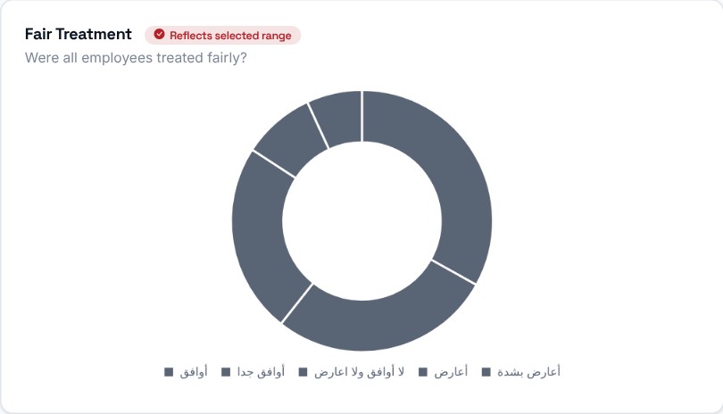 | How departing employees rated whether they were treated fairly.

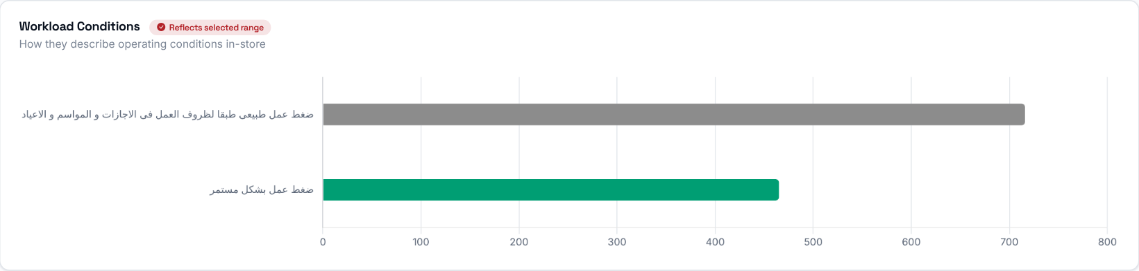
How departing employees rated their workload and working conditions.
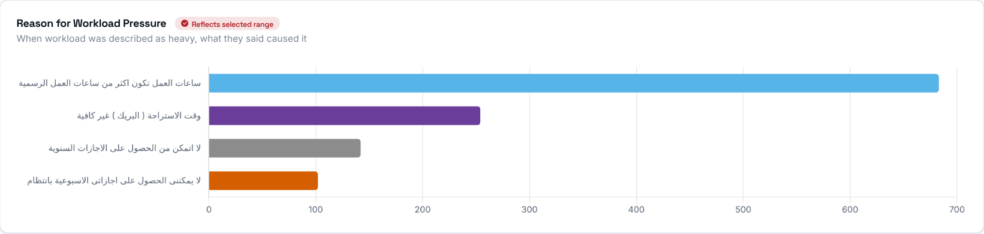
Among employees who cited work pressure as a reason for leaving, a breakdown of what specifically they pointed to.

Step 7 - Who is leaving?
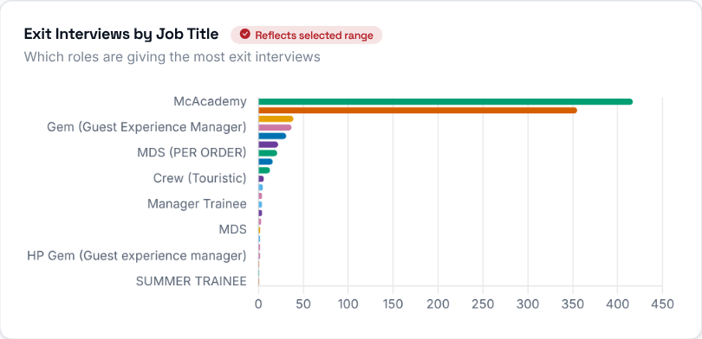 | Exit interview responses grouped by the departing employee's job title.

Step 8 - Engagement drivers
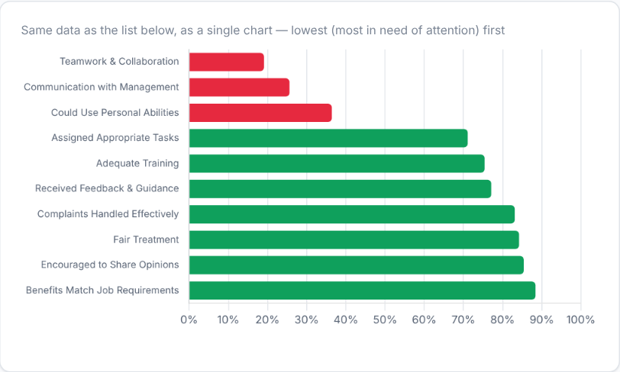 | 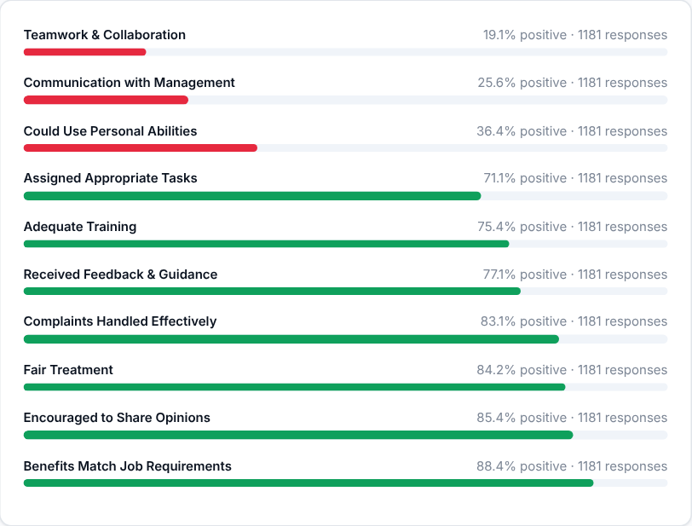
The share of people who answered positively on each engagement driver, lowest first, shown as a chart and as the same list. The drivers at the top need the most attention.
Then decide: pick the lowest one or two drivers and agree with the Operation Consultant what will change in the stores concerned.

Step 9 - Read what people wrote
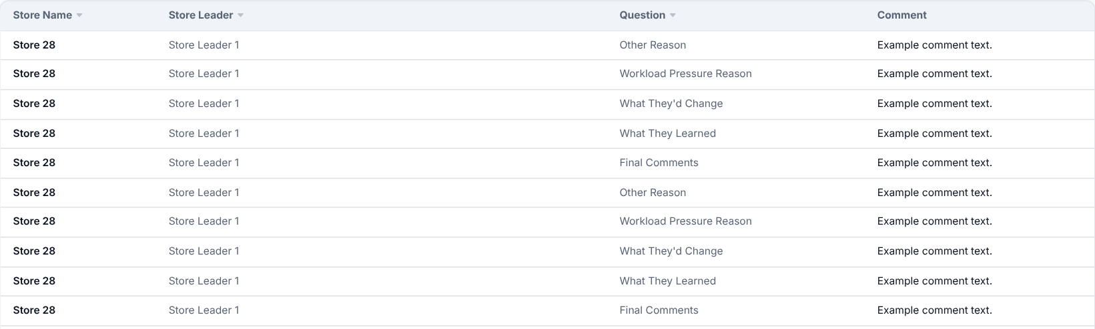
The free-text comments departing employees left in their exit interview, searchable and filterable by question.
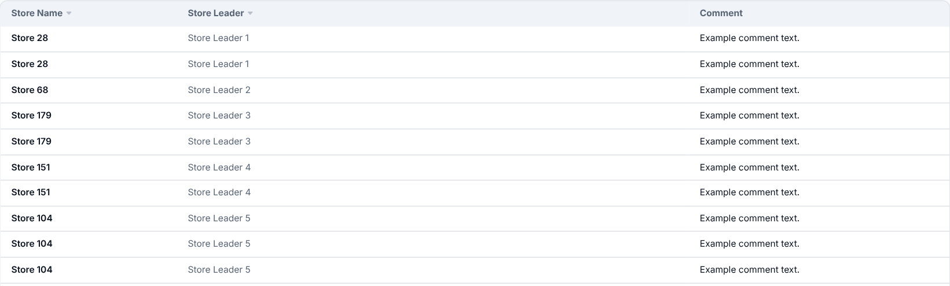
What departing employees said they would change about the job or store, sorted by store and date - a separate free-text field from the general comments table above.

