Turnover
Where to find it: Side menu > Turnover
Use this page to understand who is leaving and where. It tracks how many employees resigned and how that compares with headcount, broken down by month, job title, tenure, payroll group, gender and store. The cards at the top summarise the selected period; everything below drills into it.

Step 1 - Choose the period and your scope
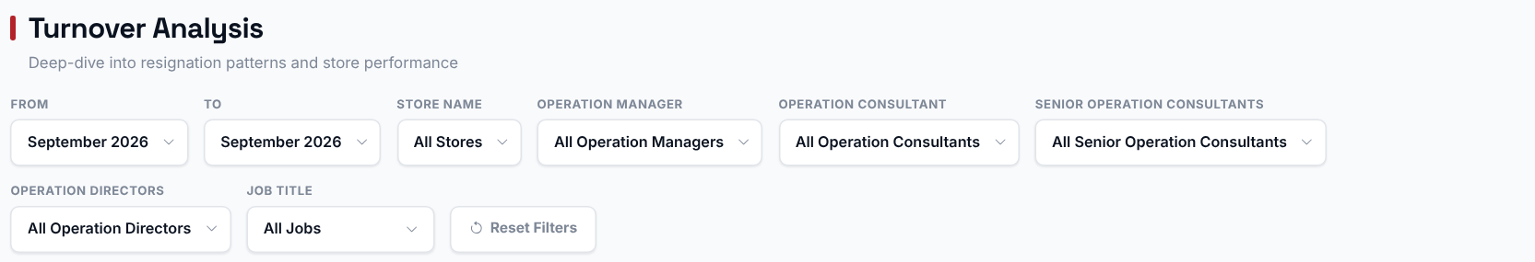
Pick a Store, Operation Manager, Operation Consultant, Senior Operation Consultant or Operation Director or Job and the cards, the charts and the matrix switch to that selection. The Store filter does not narrow the store table, the Operation Consultant / Director / Manager / Senior Consultant tables, or the Trend vs Prior Period card, which always cover all the stores you can access. The From/To period narrows the cards, the job title / tenure / payroll / gender charts, the store table and the leader tables.
Good to know: the "Turnover Rate by Month" chart always shows every uploaded month. The "Monthly Turnover Trend" chart and the full matrix always show every month from the From year to the latest upload, whatever From/To month you pick, because they are built to show trends over time.

Step 2 - Read the headline numbers
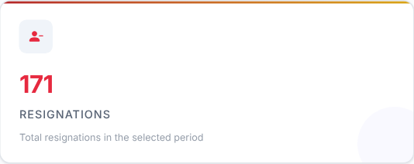 | 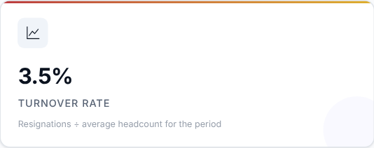 | 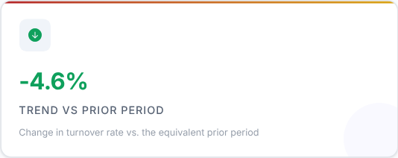

Card | What it shows
Resignations | Total resignations in the selected period.
Turnover Rate | Resignations divided by the average headcount for the period.
Trend vs Prior Period | The change in turnover rate compared with the equivalent prior period.

What to look at: Turnover Rate and its trend. A green downward arrow means turnover improved against the prior period.

Step 3 - Is turnover seasonal?
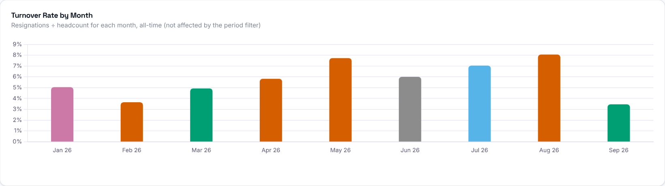

Turnover rate for every uploaded month (one bar per month and year). Each bar = (resignations that month / headcount that month) x 100. This chart ignores the From/To filter, so you can see long-term seasonality; the Store, leader and Job filters still apply.
What to look at: months that regularly stand out.
Then decide: prepare extra hiring and retention effort ahead of the months that are usually worst.

Step 4 - Who is leaving?
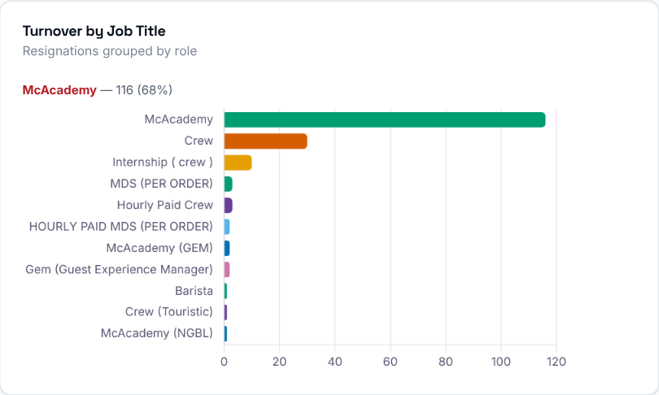  Resignations in the selected period grouped by job title.  What to look at: which roles are losing the most people. | 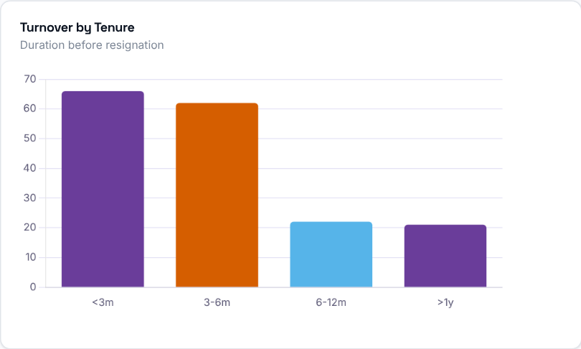  Resignations grouped by how long the employee had worked (under 3 months, 3-6 months, and so on).  What to look at: whether people leave early or after a longer stay.

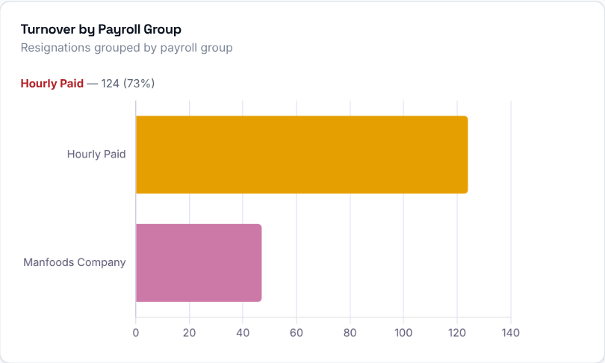  Resignations grouped by payroll group for the selected period. | 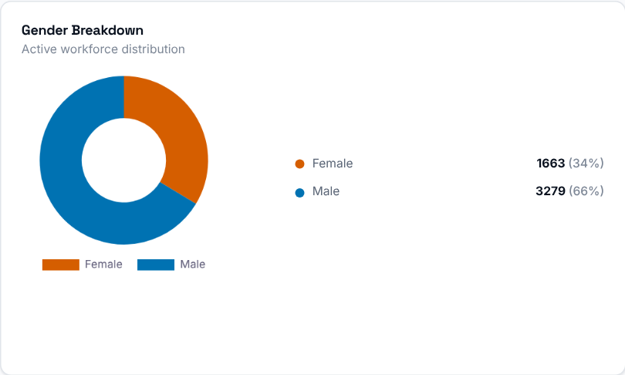  Gender split of the active employees in the selected period (each month in the From-To range added together), shown as a doughnut with counts and percentages on the side.

Step 5 - Why are they leaving?

The reasons given in exit interviews, grouped by reason. Only employees who completed an exit interview are counted, not every resignation. The period filter applies only when From and To are in the same year; otherwise all exit interviews are used.
Then decide: the biggest reason is where your retention effort should go first.

Step 6 - Is the trend improving?
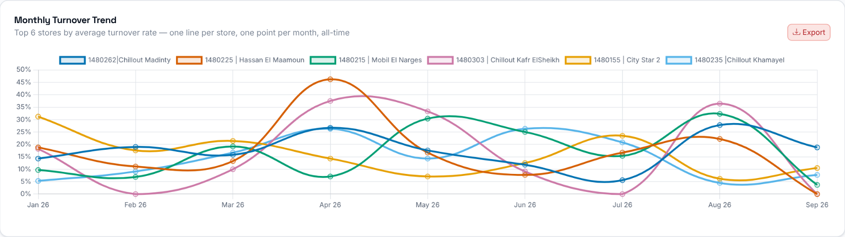
Month-by-month turnover rate of the 6 stores with the highest average rate (or of the selected store), from the From year to the latest upload, whatever To period you pick.

Step 7 - Which stores lose the most people?
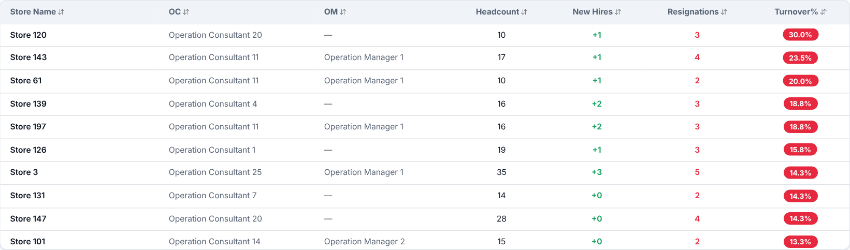
Every store with employees in the selected period, with its headcount (added up over the months of the range), new hires, resignations and turnover rate (resignations / average headcount x 100). Rows start sorted by Turnover% (highest first). Click a column header to sort.
What to look at: stores with the highest Turnover% and with resignations well above their new hires.
Then decide: talk to the Operation Consultant of the stores at the top and agree actions with them.

Step 8 - Who should you talk to?
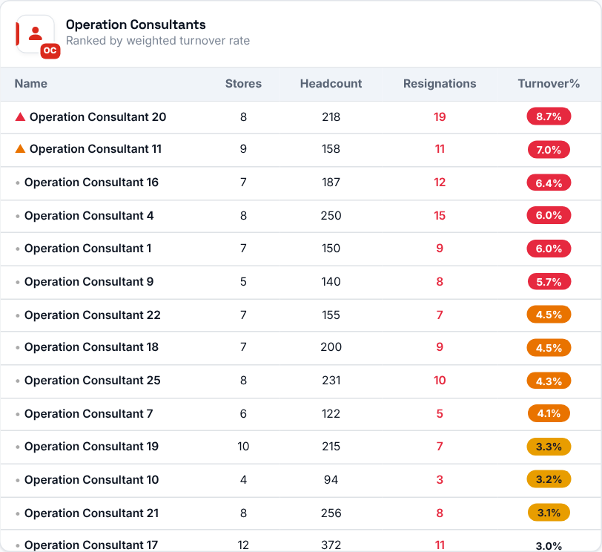 | 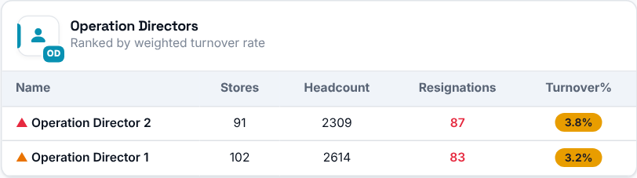  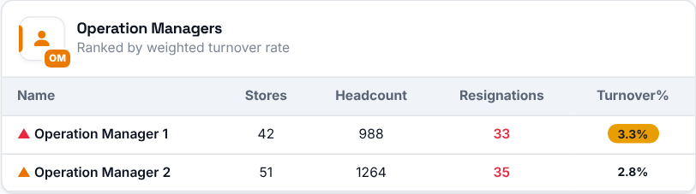  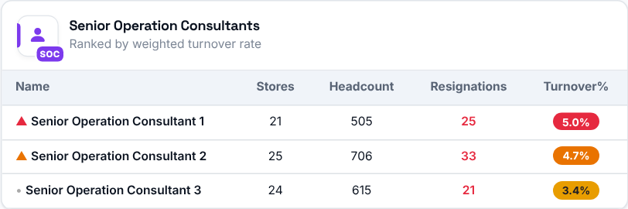
Operation Consultants, Directors, Managers and Senior Consultants ranked by their weighted average turnover rate: the sum of resignations across all their stores divided by the sum of average headcount across those stores - not a simple average of each store's rate.

Step 9 - Spot the pattern store by store
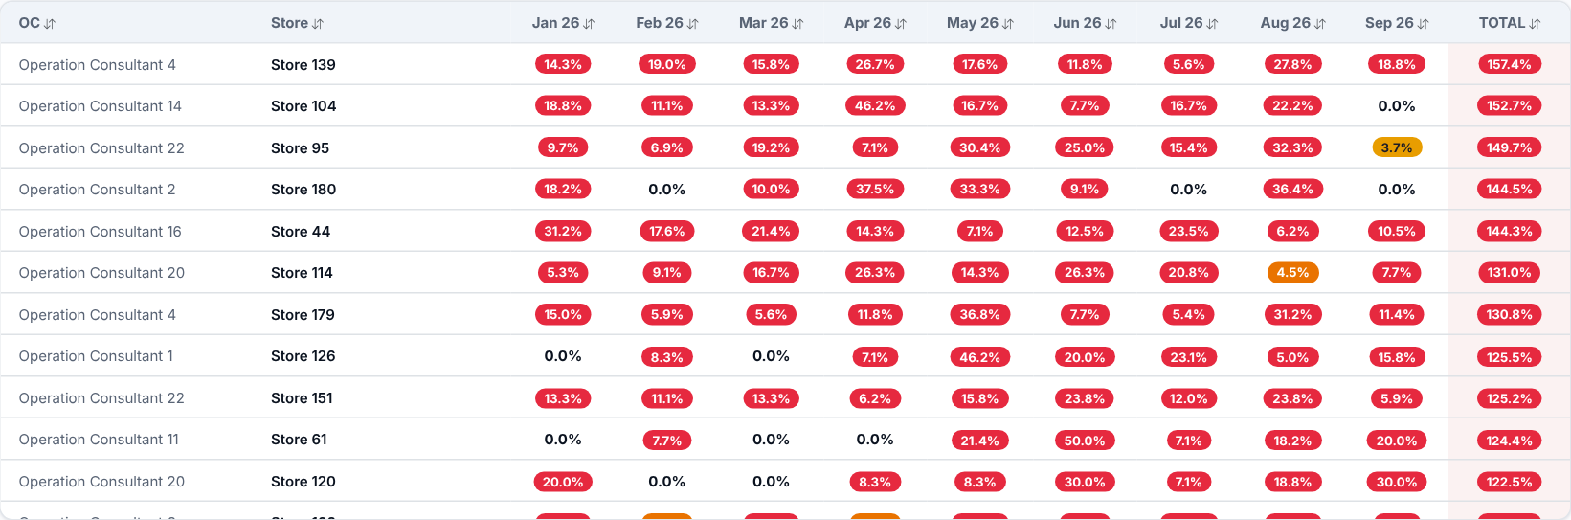
A full matrix of every store against every period from the selected year to the latest upload. It always shows the full year range, not just the From/To filter.
What to look at: stores with a high rate in many months in a row - they have a lasting problem, not a one-off.

