Scorecard
Where to find it: Side menu > Scorecard
Use this page to compare Store Leaders. It scores every Store Leader (and rolls that up by Operation Consultant and Operation Manager) on four metrics: Turnover Rate, Early Leaver (90-Day) Rate, 180-Day Retention Rate and Exit Sentiment, so leadership performance can be ranked and tracked over time, not just store performance.

Step 1 - Choose the period and your reporting line
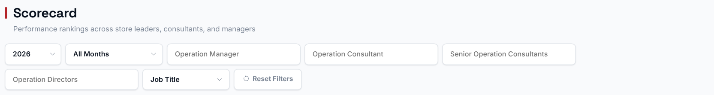
Choosing an Operation Manager, Operation Consultant, Senior Operation Consultant or Operation Director filters the ranking and the rollups to just their reporting line. The Year/Months filter sets which period's data feeds every metric on the page.

Step 2 - Read the headline numbers
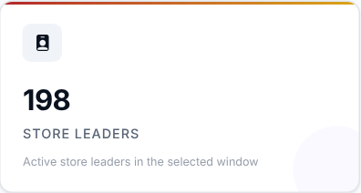 | 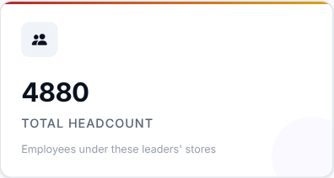 | 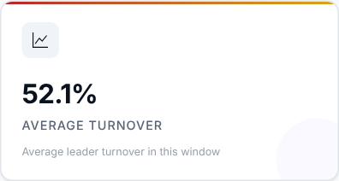 | 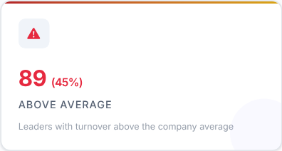

What to look at: Average Turnover and how many leaders are Above Average.

Step 3 - Read the Smart Insights
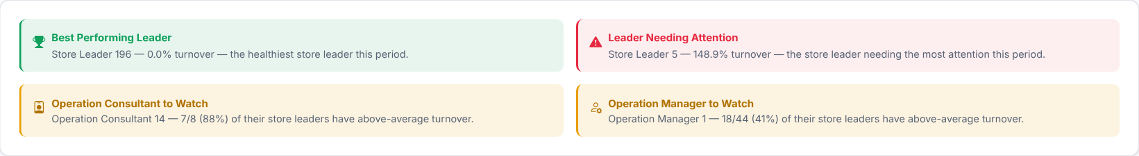
Automatic takeaways, such as the best performing leader, worked out from the ranking below.

Step 4 - Rank the Store Leaders
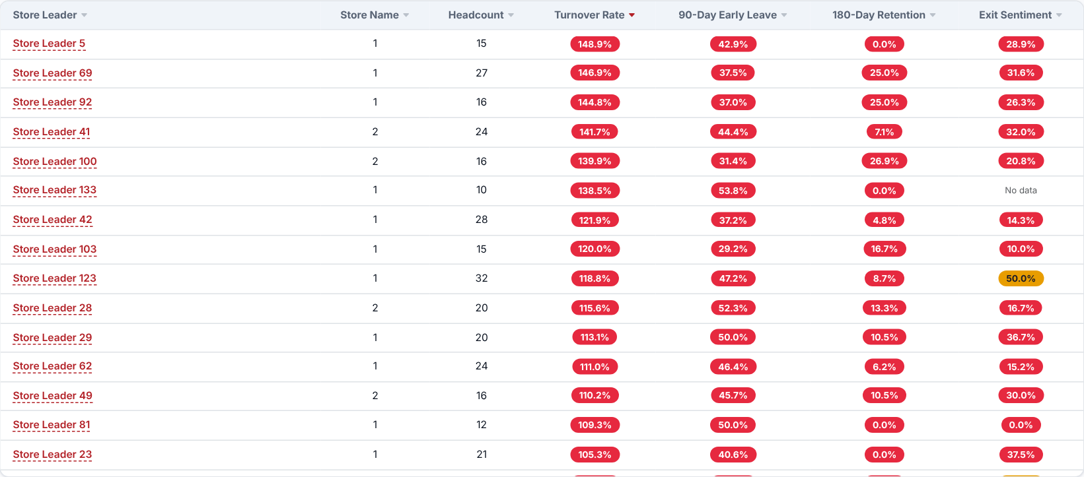
Every Store Leader ranked by Turnover Rate, Early Leaver Rate, 180-Day Retention Rate and Exit Sentiment side by side. It is sorted with the worst Turnover Rate first by default - click any column header to re-sort, and use the search box to find a leader.
Use the "Track a Store Leader" search box above the ranking to pick a leader and see their turnover rate trend over time across every store they have led, including a marker where they were transferred between stores, so a change in rate can be told apart from a change of store. (Clicking a leader's name in the ranking opens their own page instead - see below.)
What to look at: leaders who are weak on several of the four metrics at once, not just one.
Then decide: agree support or coaching with the Operation Consultant of the leaders at the top of the list.

Step 5 - Who oversees the weakest leaders?
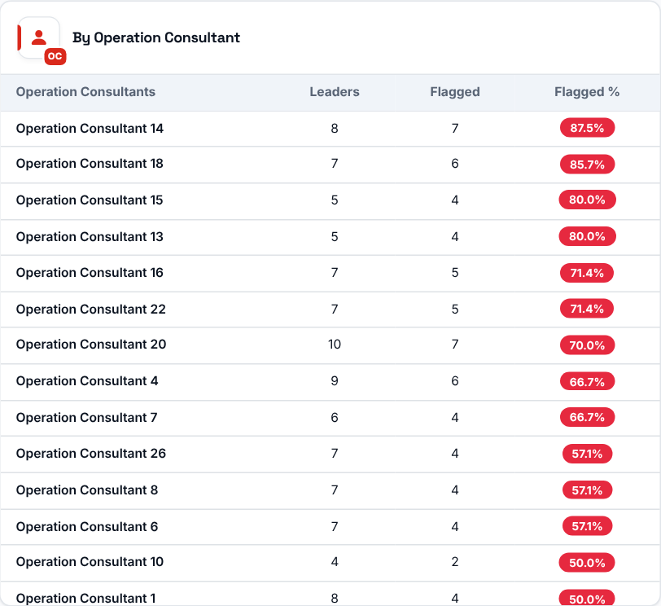 | 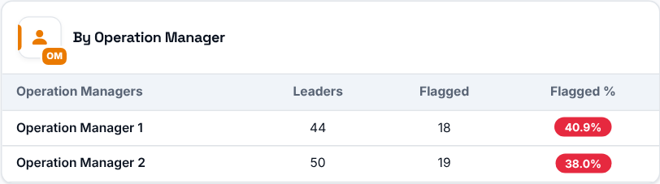  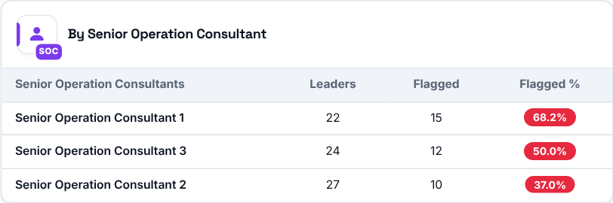  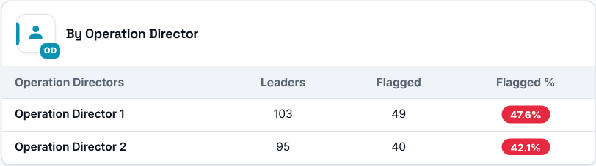
For each Operation Consultant, Operation Manager, Senior Operation Consultant and Operation Director: how many Store Leaders they oversee, how many of those leaders are "flagged" (their Turnover Rate is above the average Turnover Rate of all leaders in the selected period) and what percentage that represents.

Inside a Store Leader (Store Leader Profile)
Click a Store Leader's name in the ranking to open their own page, called Store Leader Tracking. It gives the history, performance, workforce movement and exit sentiment for that one leader in the period you selected on the Scorecard, across every store they led in that period. Use "Back to Scorecard" at the top to return.
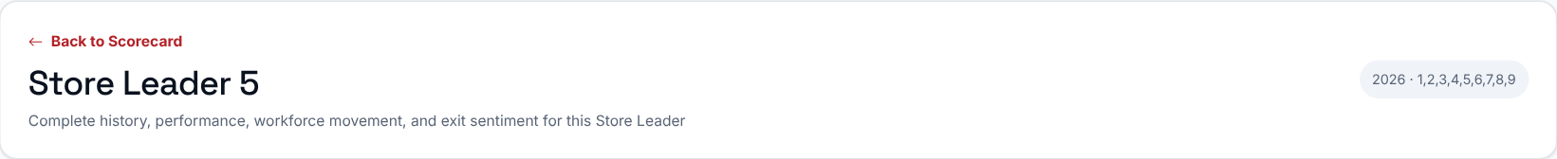
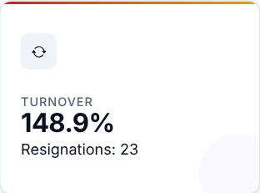 | 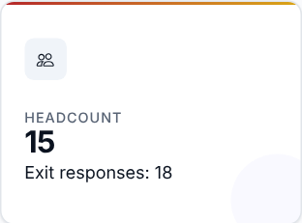 | 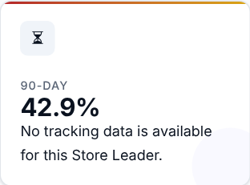 | 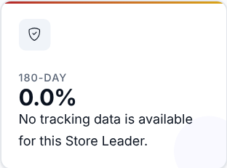
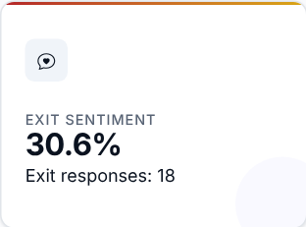

The five cards repeat the four scorecard metrics (Turnover, 90-Day, 180-Day retention and Exit Sentiment) plus the headcount. Turnover shows the number of resignations beneath it, and Headcount and Exit Sentiment show the number of exit responses.

Turnover and headcount, store by store
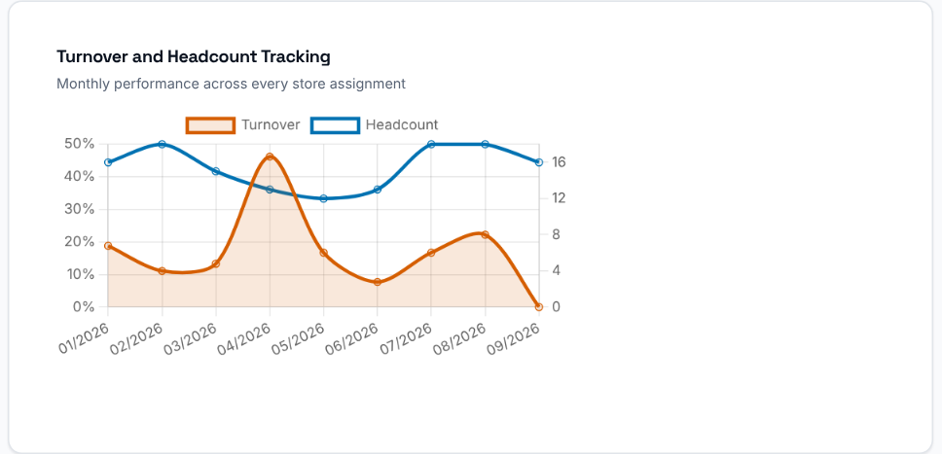  Monthly turnover rate and headcount across every store assignment, drawn as two lines. Transfers are not marked on the chart; they are flagged with a "Transferred here" badge in the assignment history table beside it, so a change in the rate can be told apart from a change of store. | 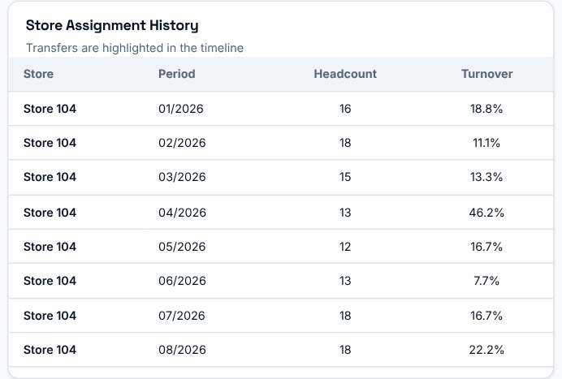  The store assignment history lists each store, period, headcount and turnover for the leader. Transfers are highlighted in the timeline.

What leaving employees say about this leader's stores
Anonymous exit-interview signals for the stores this leader runs.
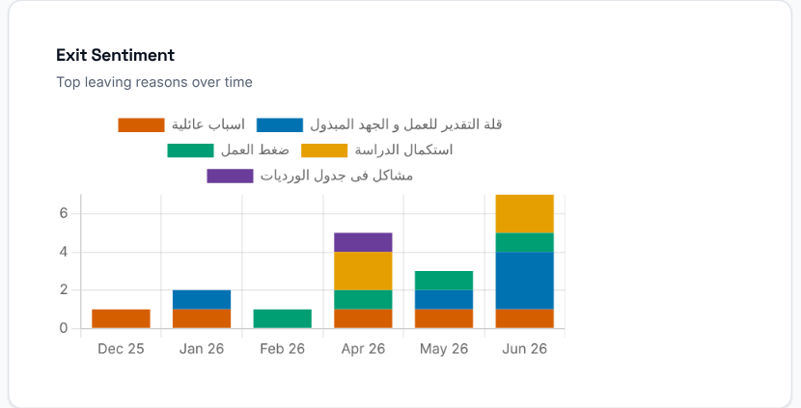  Exit Sentiment: the top leaving reasons over time. | 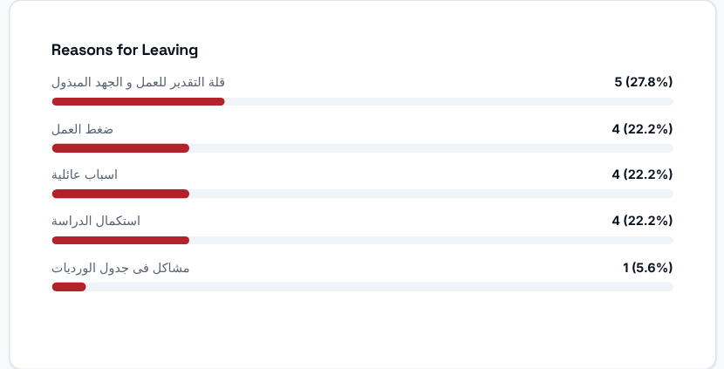  Reasons for Leaving: the reasons employees gave for resigning.

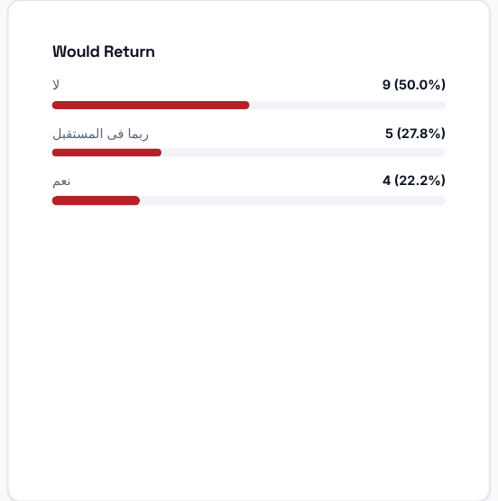  Would Return: whether leaving employees would consider coming back. | 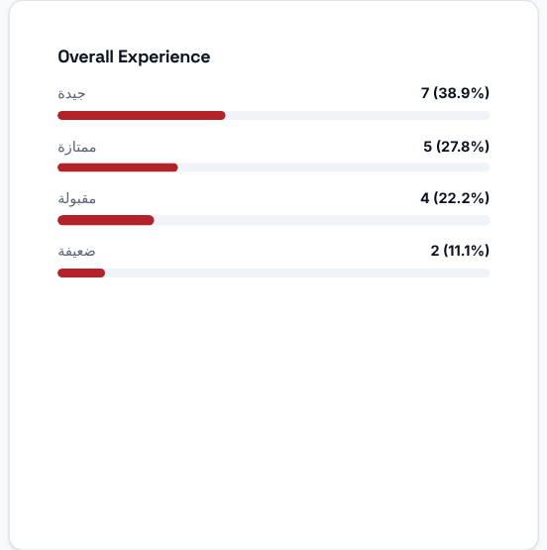  Overall Experience: how leaving employees rated their experience.

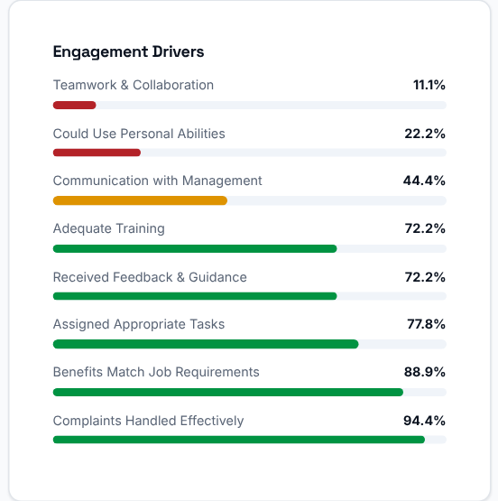  Engagement Drivers: the share who answered positively on each driver, lowest first. | 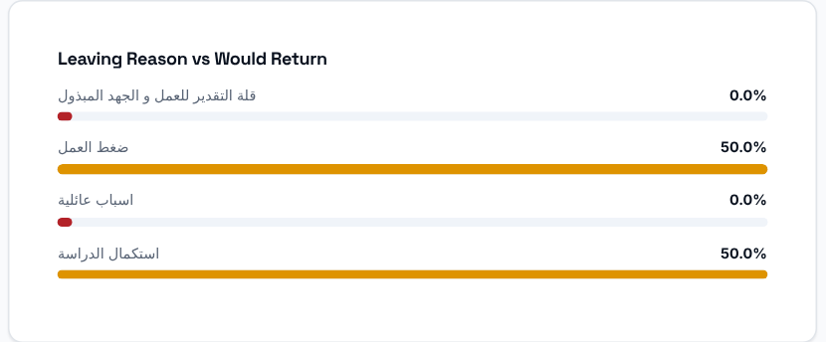  Leaving Reason vs Would Return: for each top reason, the share who said they would work here again.

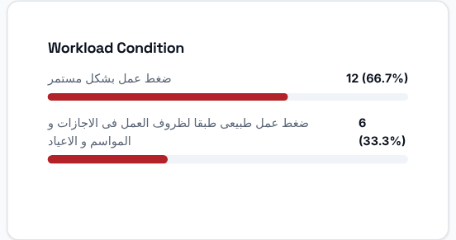  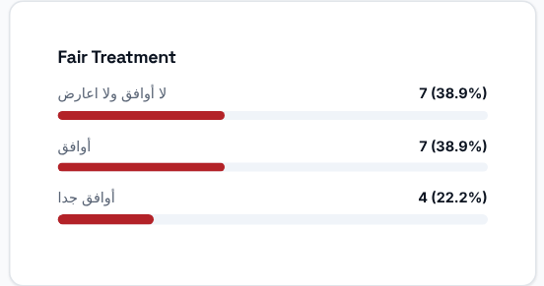 | 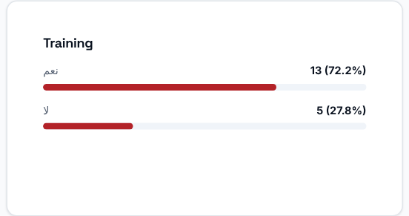
Workload Condition, Training and Fair Treatment: how leaving employees rated each of them.
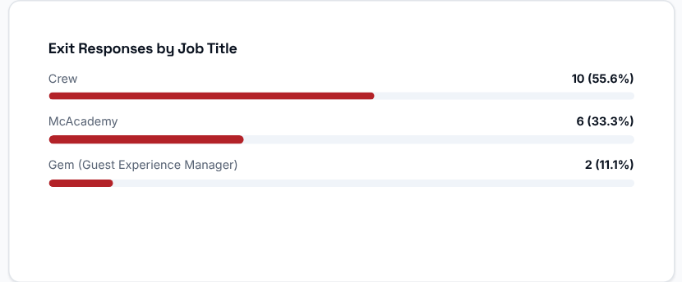 | Exit Responses by Job Title: the exit responses grouped by the leaving employee's job title.

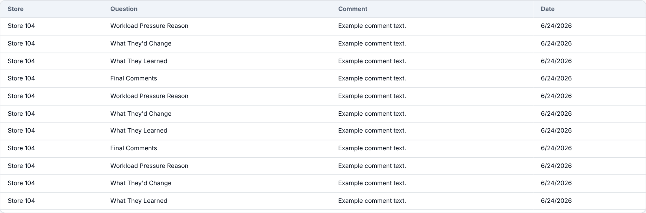
Anonymous Exit Comments: the free-text comments left in exit interviews for this leader's stores, with the store, the question, the comment and the date.
What to look at: whether a drop in the leader's turnover or a rise in exit sentiment lines up with a transfer to another store.
Then decide: use this page to prepare a fair, evidence-based conversation with the leader and their Operation Consultant.

