
McDonald's Egypt
Human Resources
Crew Insights Hub
User Guide
For Operations Leaders
Version 1.0 | October 2026

Contents
No table of contents entries found.

Quick Reference
One line per page: what it is for, and what to look at first. Most pages have filters at the top (period, store, Operation Manager, Operation Consultant, and so on), and almost every page has a red lightbulb "Page Guide" button at the top right that explains the page.
Page | Use it to | Look at first
Workforce Overview | See who works for you right now | Total headcount, tenure mix, store table
Workforce Planning | Compare planned headcount with actual | Fill Rate, Shortage, stores marked Understaffed
Hiring Forecast | Plan hires month by month | Busiest month, next 3 months
Crew Trainers | Check the 1-trainer-per-6-crew rule | Trainers vs the rule, stores with no trainers
Turnover | See who is leaving and where | Turnover Rate, reasons, stores at the top
90-Day Turnover | See new hires who leave within 90 days | 90-Day Rate, by store
Comparisons | Compare two periods | Change in Turnover Rate and 90-Day Rate
Retention | See how long people stay | 6-month retention, tenure cards
Exit Interviews | Understand why people leave | Positive sentiment, top reasons, engagement drivers
Early Warning | Spot people who may be about to leave | High-Risk table
Scorecard | Rank Store Leaders on four metrics | Turnover rate, Above Average leaders, flagged consultants/managers
Action Center | Follow store health and open Action Plans | Critical stores, tier, stalled plans
Stores | Browse every store at a glance | Health badge on each store card
Reports | Download Excel reports | Pick the report card you need

Tips
- On pages that have filters, pick a store, manager or consultant and the charts and tables on that page follow your choice.
- Where a table column header shows a sort arrow, click it to sort (click again to reverse).
- Open your avatar menu (top right) to switch between English and Arabic, or between light and dark mode.
- Charts: hover over a bar or point to see its exact value.

Workforce Overview
Where to find it: Side menu > Workforce Overview
Use this page to answer one question: who works for me right now, and is the team in good shape? It is a snapshot of your active headcount, so most charts here count current employees, not resignations (that is the Turnover page).

Step 1 - Choose your scope
Pick a Store, Operation Manager, Operation Consultant, Senior Operation Consultant, Operation Director or Job, and the cards and charts switch to that selection (the Store filter does not narrow the "Headcount by Store" table, which lists all the stores in your selection). Press Reset Filters to return to the full picture.
Good to know: when you pick a From/To range, Total Headcount, New Hires and Resignations are added up over the months of the range, and the breakdown charts add up each month in the range. The "Headcount by Store" table uses only the To month. The Headcount Over Time chart ignores the To month and always shows every month from the From year to the latest upload.

Step 2 - Read the headline numbers
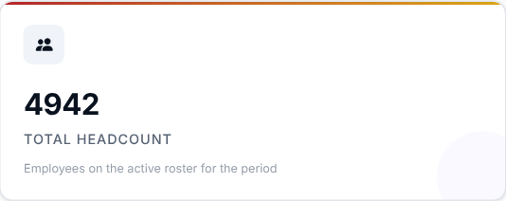 | 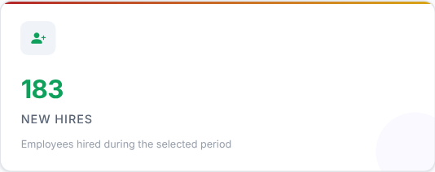 | 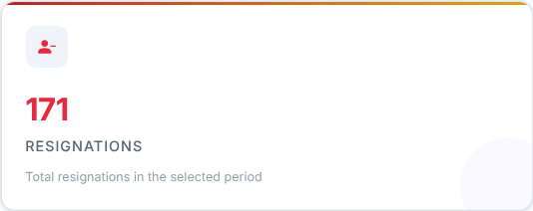

What to look at: compare New Hires with Resignations.
Then decide: if resignations are higher than hires, your headcount is shrinking. Check the trend chart below to see whether this is new.

Step 3 - Is the headcount going the right way?
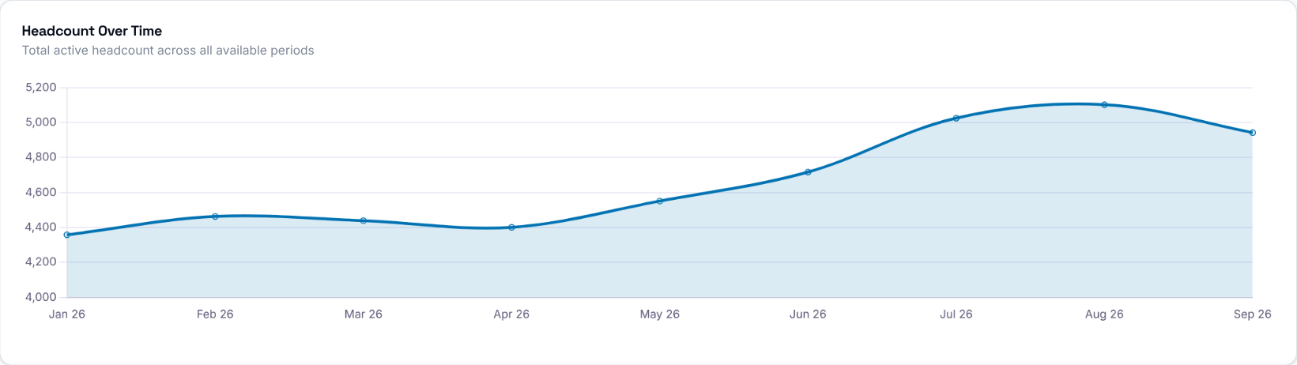
What to look at: the direction of the line over the year.
Then decide: a falling line means you are losing people faster than you add them. Use the filters to find which store or manager the drop comes from.

Step 4 - Is the team experienced enough?
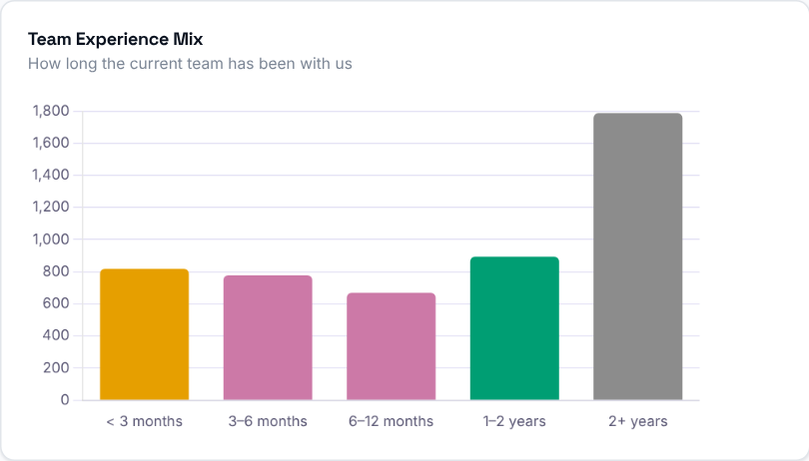 | What to look at: how tall the "< 3 months" and "3-6 months" bars are compared with "2+ years".  Then decide: a large share of new people means more coaching and closer follow-up. A team that is mostly 2+ years is stable, but check that you are still hiring for the future.

Step 5 - Who is on the team?
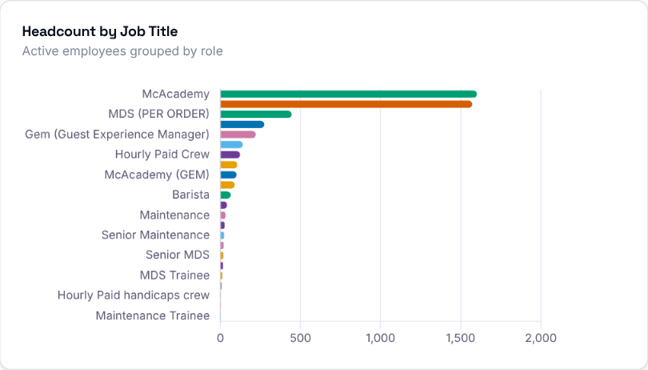  What to look at: which roles carry most of your headcount, and whether a role you depend on looks thin. | 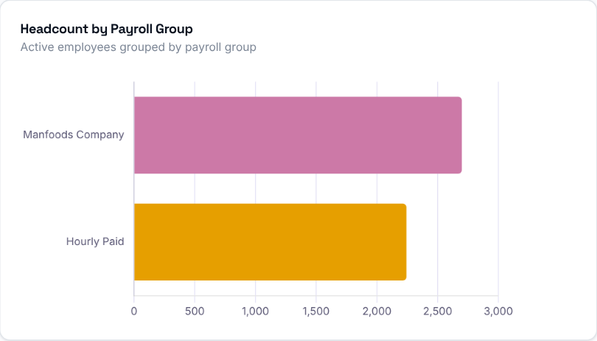  What to look at: the split between payroll groups.

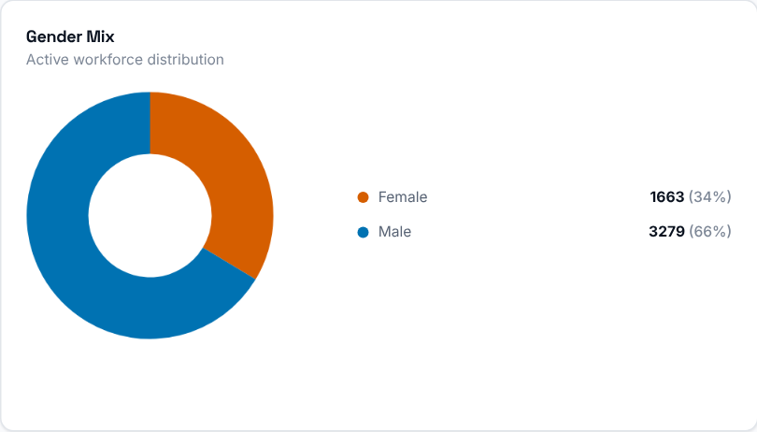 | What to look at: the gender split of the current team, with counts and percentages.

Step 6 - Which stores need attention?
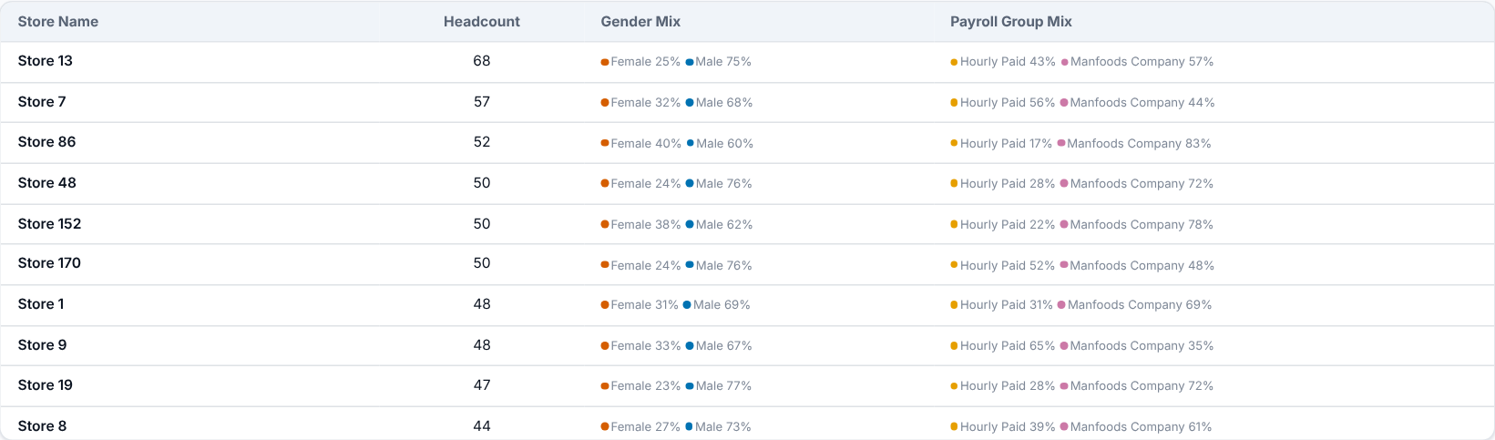
What to look at: each store's headcount, with its gender and payroll group mix.
Then decide: compare stores with each other. A store with a much smaller team than similar stores is worth a conversation with its manager.

Step 7 - Who should you talk to first?
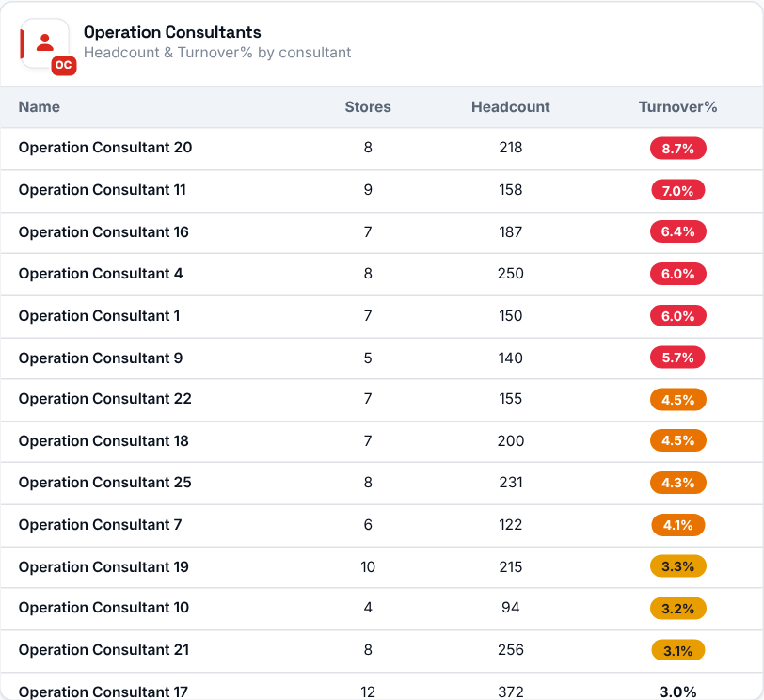 | 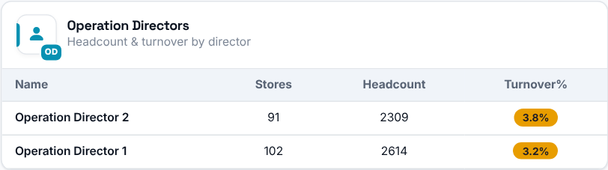  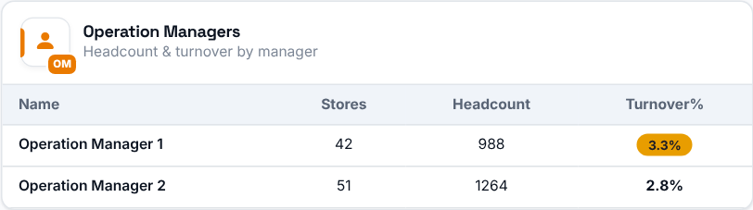  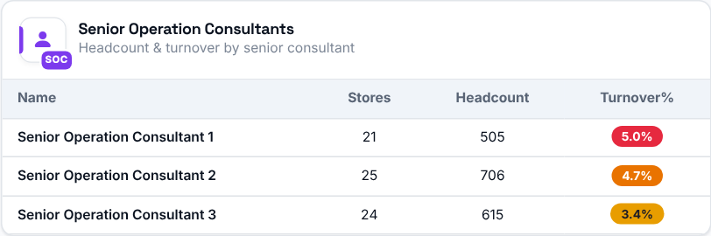
What to look at: Turnover% next to each person's headcount. It is weighted across all their stores, and the colored badge highlights the higher rates.
Then decide: start your conversations with the people whose Turnover% is highest, then filter the page by that person to see which of their stores drives it.

Workforce Planning
Where to find it: Side menu > Workforce Planning
Use this page to see whether you have the people you planned for. It compares the headcount you planned (the job projection) with the headcount that actually works for you, by job title and by store, for the month you pick. It shows where you are short, by how much, and roughly how many hires are needed. Only stores that have a projection for the month are compared.

Step 1 - Choose the month and your scope
Year and Month pick the period (only months that have a projection are listed). Store, Job title and the Operation Consultant / Manager / Senior Consultant / Director selectors narrow every number, chart and table on the page. You only see the stores you have access to.
Good to know: for a future month there is no active-employee roster yet, so the page shows the projection only.

Step 2 - Read the headline numbers
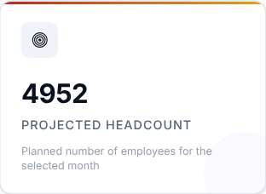 | 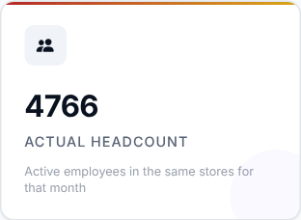 | 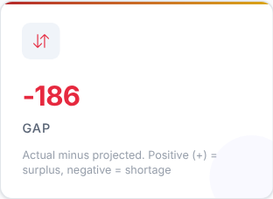 | 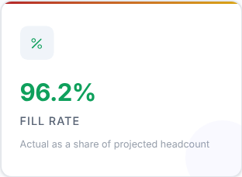
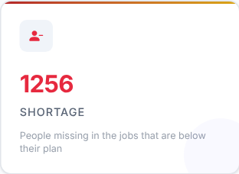 | 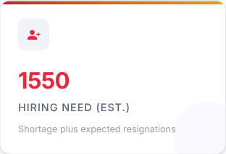

Card | What it shows
Projected Headcount | The planned number of employees for the selected month.
Actual Headcount | Active employees in the same stores for that month.
Gap | Actual minus projected. A positive (+) number is a surplus, a negative number is a shortage.
Fill Rate | Actual as a share of projected headcount.
Shortage | The people missing in the jobs that are below their plan. A surplus in one job never covers another (the two Crew Trainer jobs are the only exception: within a store they are counted together).
Hiring Need (est.) | The estimated hires required: the shortage plus the expected resignations.

What to look at: Fill Rate and Shortage first, then Gap.
Then decide: a low Fill Rate means you are short. Treat Hiring Need as your first estimate of how many people to recruit. Remember that the Gap can hide real shortages, because a job above its plan offsets a job below it - the Shortage card does not.

Step 3 - Read the Smart Insights
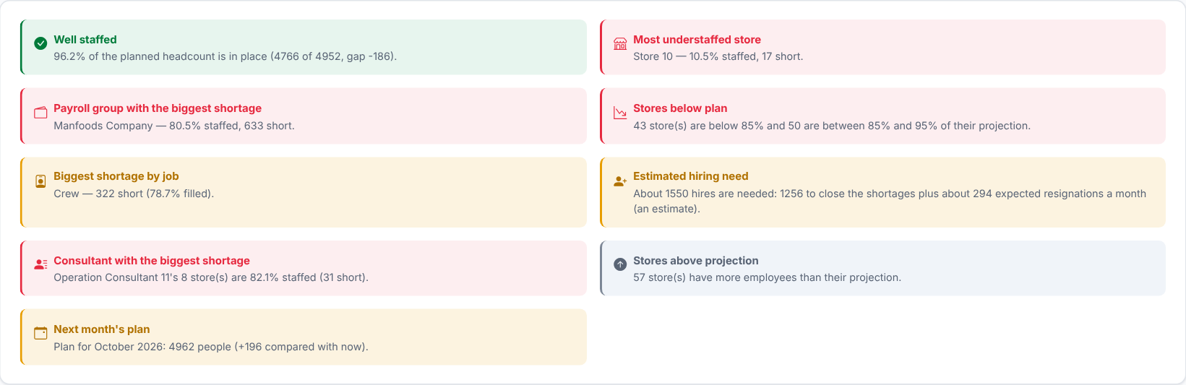
Automatic takeaways worked out from the numbers on this page for your current filters: overall staffing, the most understaffed store, the biggest shortage by job, the payroll group with the lowest fill rate, how many stores are below 95% of their projection (understaffed and watch), the estimated hiring need, the consultant whose stores have the lowest fill rate, stores above projection and next month's plan. They update whenever you change a filter.
Then decide: read these first for a quick summary, then use the charts and tables below to dig into each point.

Step 4 - Which jobs are short?
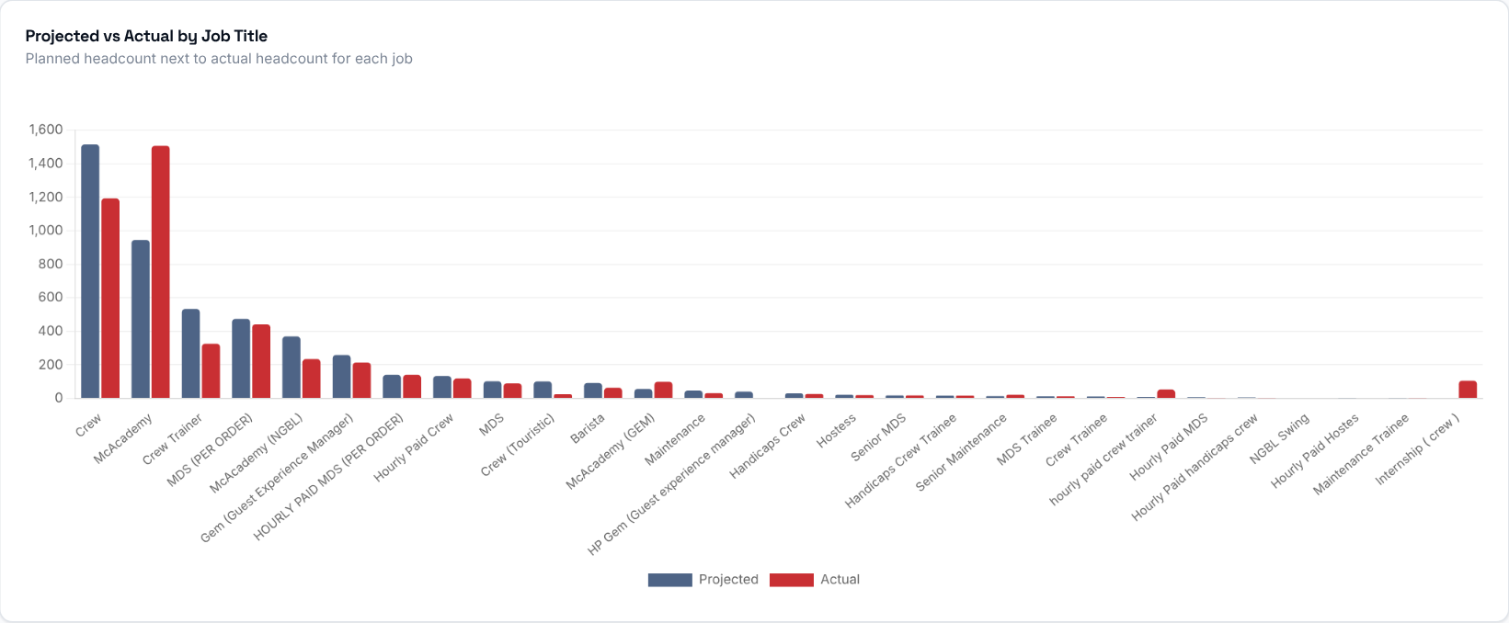
Planned and actual headcount side by side for each job title. Hover a bar to see the gap, fill rate and hiring need for that job.
What to look at: jobs where the actual bar is clearly lower than the planned bar.
Then decide: those are the jobs to prioritise in recruitment.

Step 5 - How is reality tracking against the plan?
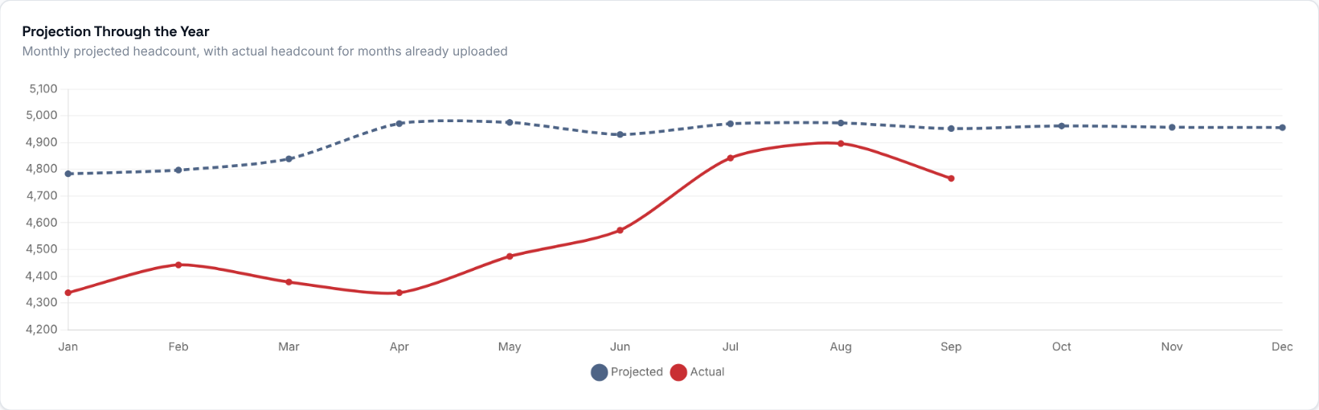
Projected headcount for every month of the selected year that has a projection (dashed line) and actual headcount for the months that already have an uploaded roster (solid line).
What to look at: whether the solid line is moving towards the dashed line or away from it.

Step 6 - Payroll groups
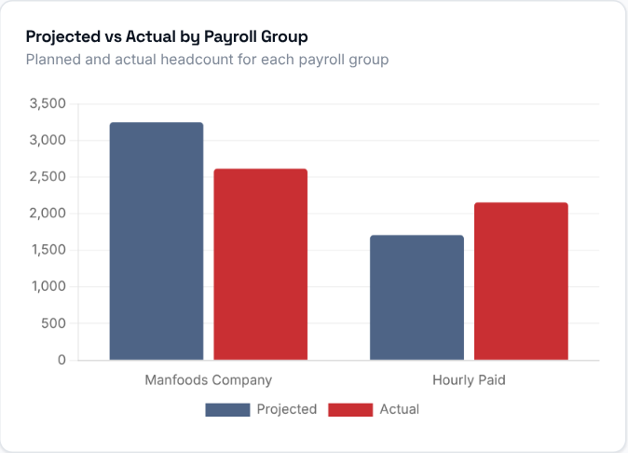 | 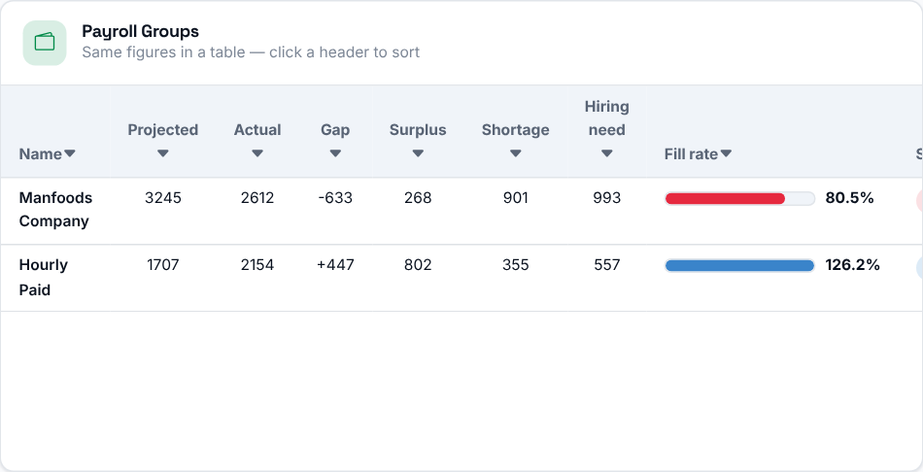
Planned and actual headcount for each payroll group, with the same numbers in a table you can sort by clicking a header. A job that is not in the Job Payroll Groups list and that nobody works in yet has no known payroll group and is listed as Unassigned.

Step 7 - Which stores need attention?
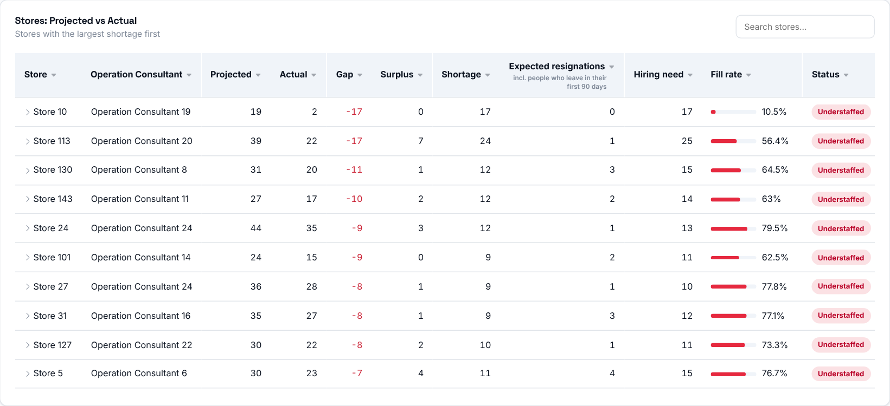
Every store with a projection for the month, most negative Gap first. Click a column header to sort (click again to reverse). The search box also matches the consultant's name. Click a store to open its jobs and see where its numbers come from.
Status | Fill rate
On track | 95-100% filled
Watch | 85-95% filled
Understaffed | below 85% filled
Overstaffed | above 100% filled

What to look at: stores marked Understaffed, then check their Shortage and Hiring need.
Then decide: open the store to see which jobs are missing people, and discuss a hiring plan with its Operation Consultant.
The numbers are calculated like this:

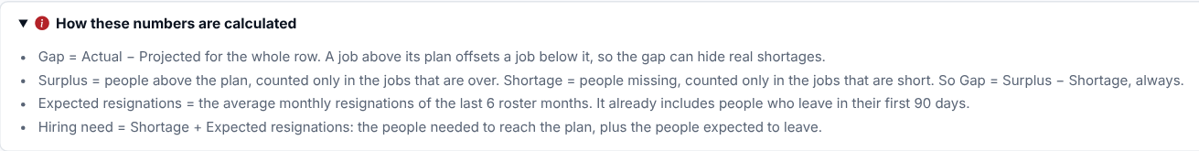

Step 8 - Who should you talk to?
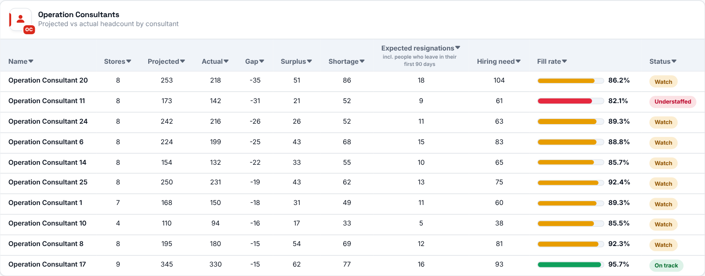
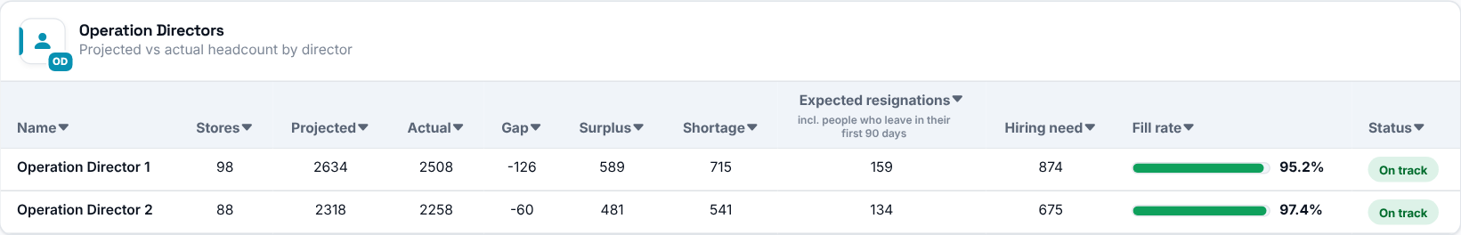
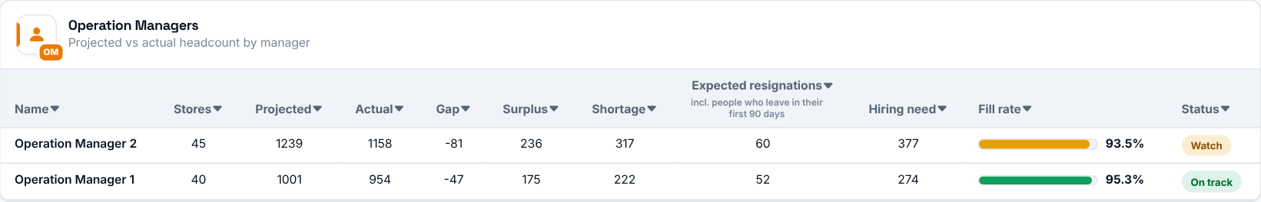
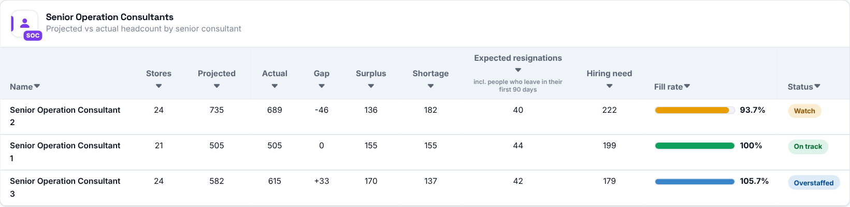
The same figures rolled up by the people responsible for the stores: Operation Consultants, Directors, Managers and Senior Consultants. Each row shows how many stores it covers, their projected and actual headcount, the gap, the shortage, the expected resignations, the hiring need and a bar showing the fill rate.
Bar colour | Fill rate
Green | 95-100%
Amber | 85-95%
Red | below 85%
Blue | above 100%

Then decide: start with the people whose bar is red, then filter the page by that person to see their stores.

Hiring Forecast
Where to find it: Side menu > Hiring Forecast
Use this page to plan recruitment ahead. It shows how many people each store needs to hire in each month of the year. The figures are an estimate based on past resignations and the projection - they are not a hiring order, and they change as new employee lists and projections are uploaded.

Step 1 - Choose your scope
Year, Store, Job title and the Operation Consultant / Manager / Senior Consultant / Director selectors narrow the table and its totals. You only see the stores you have access to.
Good to know: the Month filter focuses the summary cards, the Smart Insights and the jobs card on one month, and highlights that month in the monthly chart (the other bars fade). The main table and the leader tables always show the whole year.

Step 2 - Read the summary cards
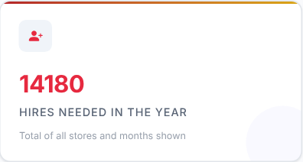 | 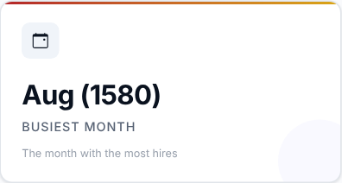 | 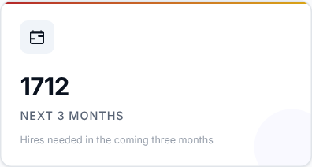 | 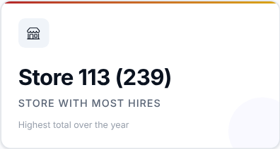

Card | What it shows
Hires needed in the year | Total of all stores and months shown.
Busiest month | The month with the most hires.
Next 3 months | Hires needed in the coming three months (from this month on when you look at the current year).
Store with most hires | The store with the highest total over the year. It only shows when the table is viewed by store.

Then decide: plan your recruitment capacity around the busiest month and the next three months.

Step 3 - Read the Smart Insights
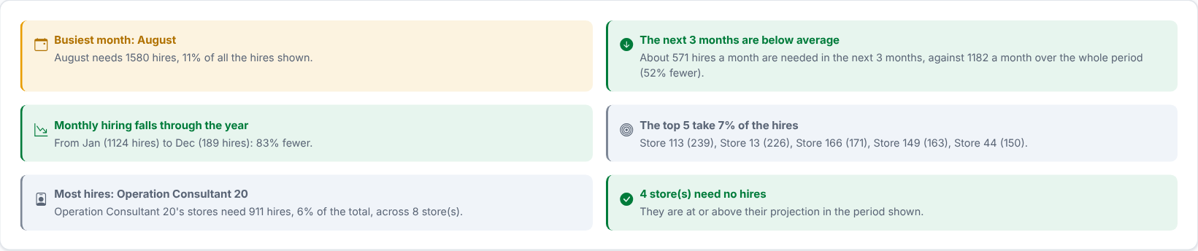
A few plain sentences worked out from the table: the busiest month, whether the next 3 months are above or below the monthly average, whether monthly hiring rises or falls through the year, how concentrated the hiring is, and the consultant whose stores need the most hires. They follow your filters and the "View by" choice.

Step 4 - When are the hires needed?
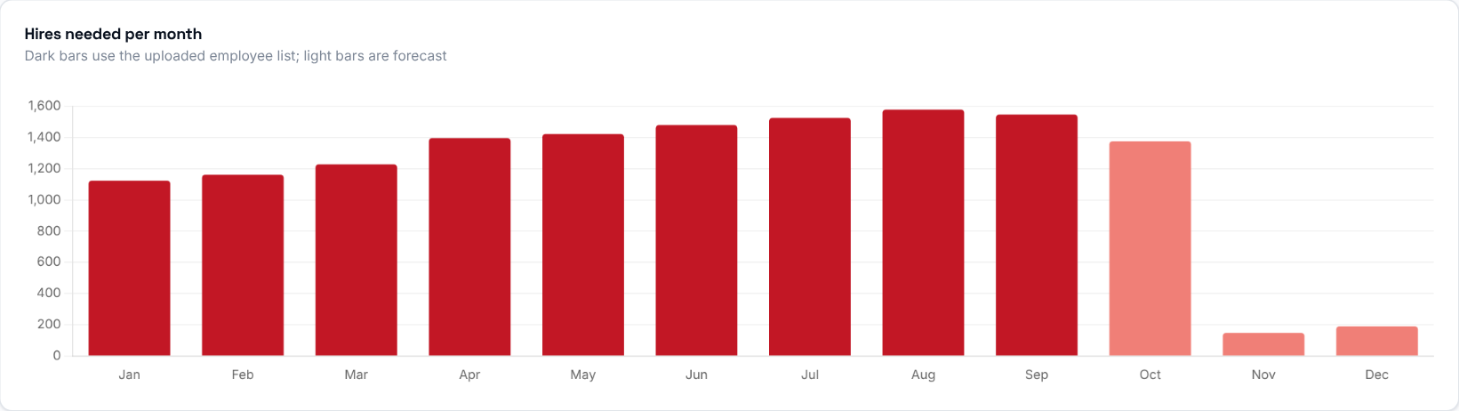
Hires needed in each month. Dark bars are months that already have an uploaded employee list; light bars are forecast. Hover a bar to see the month and its number.
What to look at: which months stand out, and how the light (forecast) bars compare with the dark ones.

Step 5 - Which jobs do you need to hire for?

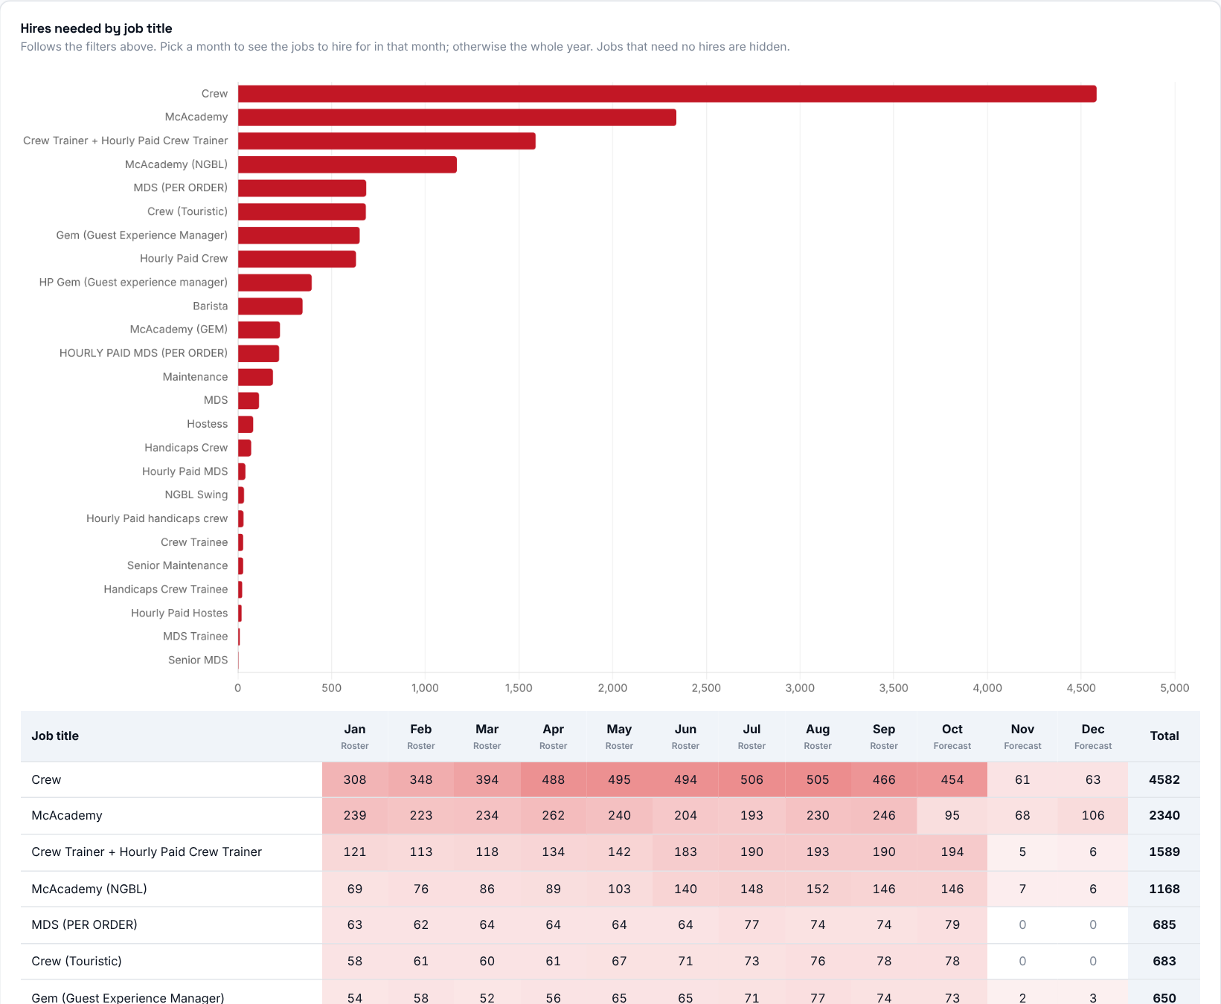

Hires needed by job title, following the filters above. Pick a month to see the jobs to hire for in that month; otherwise the whole year is shown. Jobs that need no hires are hidden.

Step 6 - Read the main table
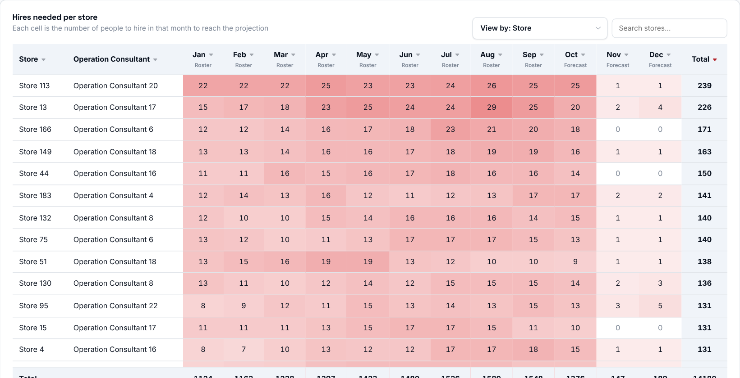
Each cell is the number of people to hire in that month to reach the projection. Use "View by" above the table to group the rows by store (with its Operation Consultant), job, payroll group or Operation Consultant - the totals stay the same, only the grouping changes.
- One column per month and a Total at the end. The last row adds up every row.
- The darker the red, the more hires that month. A dash means there is nothing to forecast for that month: the projection has no data for it, or there is no employee list to start from.
- "Roster" months use the uploaded employee list; "Forecast" months are estimated from the latest roster.
- Click a column title to sort, and use the search box to find a row.
Then decide: start with the stores at the top (largest total) and the darkest months, and agree a recruitment plan with the responsible Operation Consultant.
Good to know: for months that already have an uploaded employee list, hires = shortage + expected resignations (per store and job, as on Workforce Planning). Later months are simulated from the latest list: people expected to resign leave, then hires fill up to that month's projection. Expected resignations already include people who leave in their first 90 days.

Step 7 - Who is responsible?
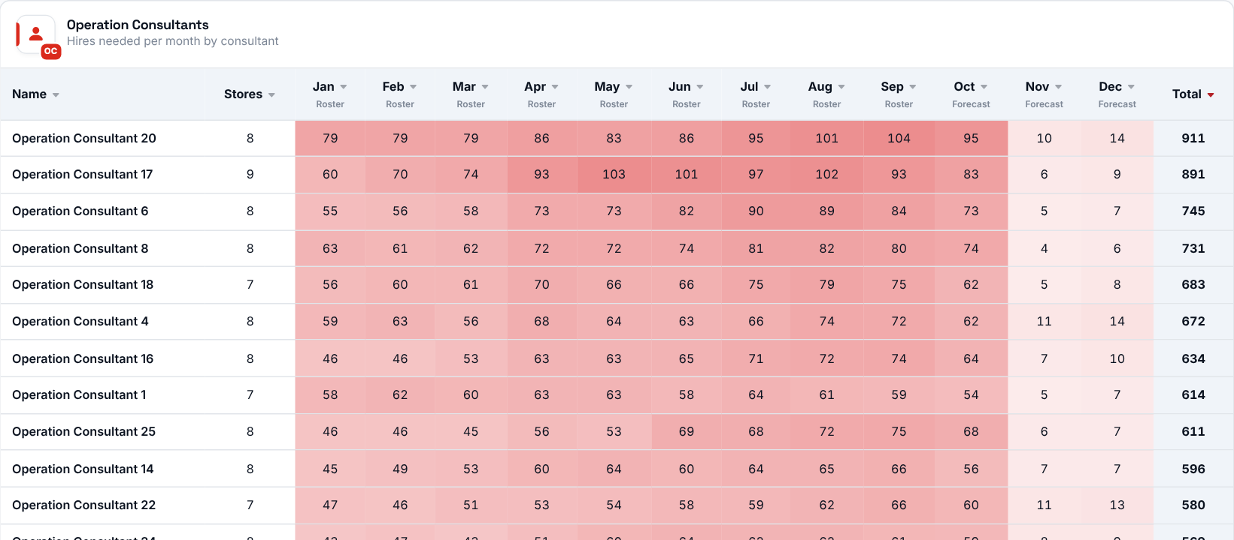
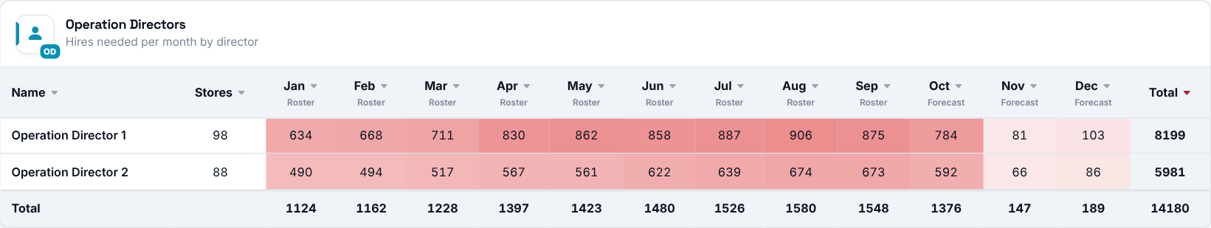
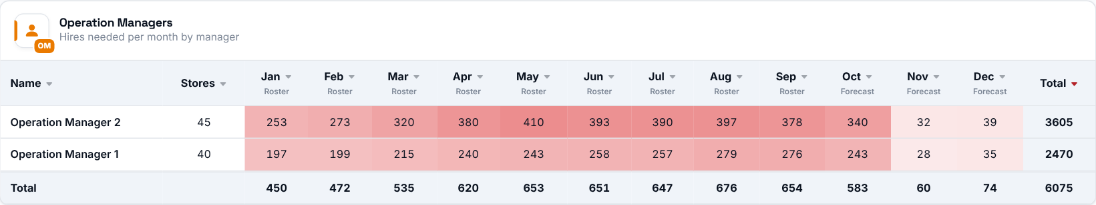
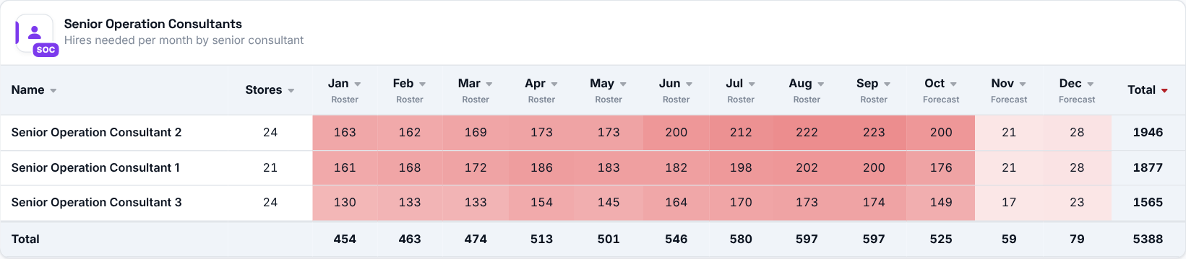

The same hires per month, rolled up by Operation Consultant, Director, Manager and Senior Consultant, with the number of stores each covers. These tables are always grouped by store, whatever "View by" is set to.

Crew Trainers
Where to find it: Side menu > Crew Trainers
Use this page to check whether your stores have enough Crew Trainers. It compares the trainers you have with the rule of one trainer for every 6 crew-level employees, and with the projection, and shows who joined or left the trainer list.

Step 1 - Choose the month and your scope
Year and Month pick one of the months that have an uploaded trainer list. Store and the Operation Consultant / Manager / Senior Consultant / Director selectors narrow every number and table on the page. You only see the stores you have access to.

Step 2 - Read the summary cards
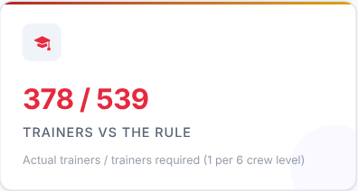 | 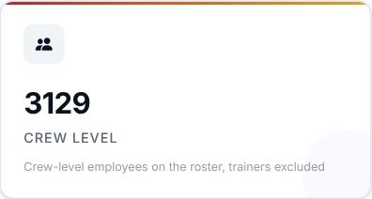 | 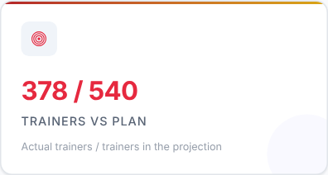 | 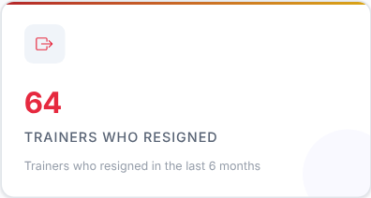

Card | What it shows
Trainers vs the rule | Actual trainers over the trainers required (one per 6 crew-level employees).
Crew level | Roster employees in jobs marked Crew Level in Job Payroll Groups, trainers excluded.
Trainers vs plan | Actual trainers over the trainers in the projection.
Trainers who resigned | Trainers who were on a trainer list and resigned in the last 6 roster months.

What to look at: Trainers vs the rule first - when the first number is lower than the second you have fewer trainers than the rule asks for.

Step 3 - Read the Smart Insights
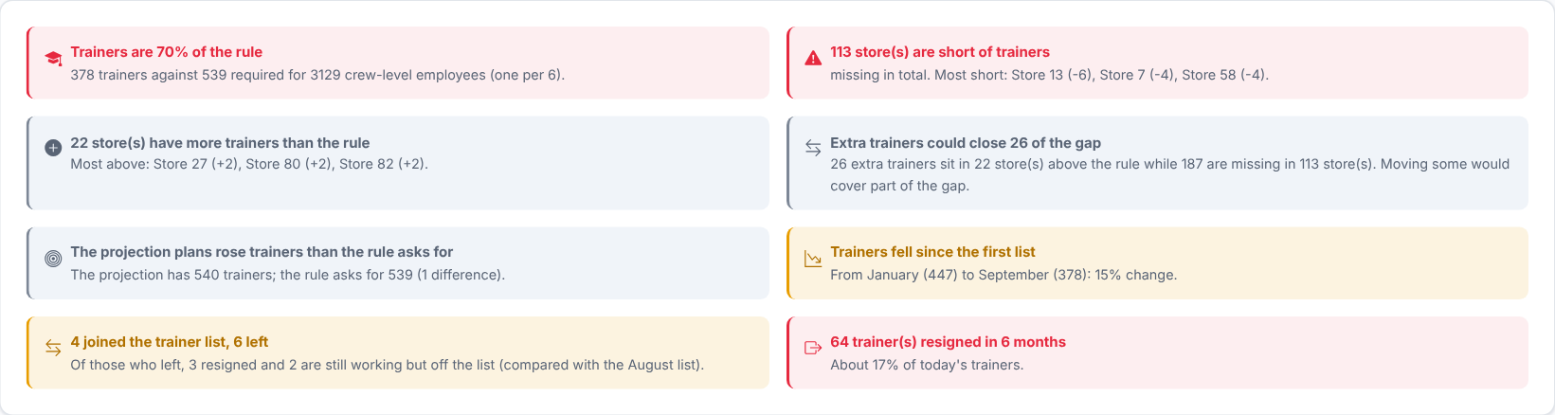
Plain sentences worked out from the numbers on the page: trainers against the rule, the stores most short or above it, whether extra trainers could cover gaps, how the list changed and how many trainers resigned. They follow your filters.
Then decide: if some stores have extra trainers while others are short, consider moving trainers between them before recruiting new ones.

Step 4 - How are trainers moving through the year?
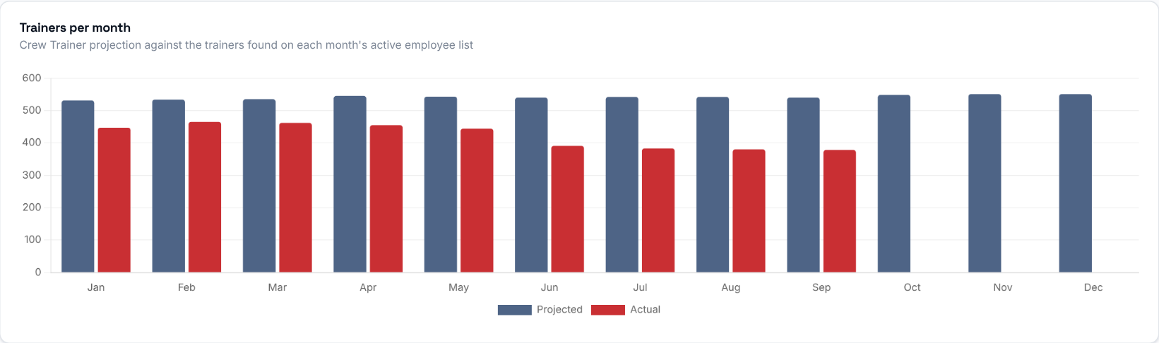
Projected against actual Crew Trainers for each month that has a projection. Actual is the people on the uploaded list who are also on that month's active employee list; a month without a roster has no actual bar.
What to look at: whether the actual bar follows the projected bar or falls away from it.

Step 5 - How many stores are short?
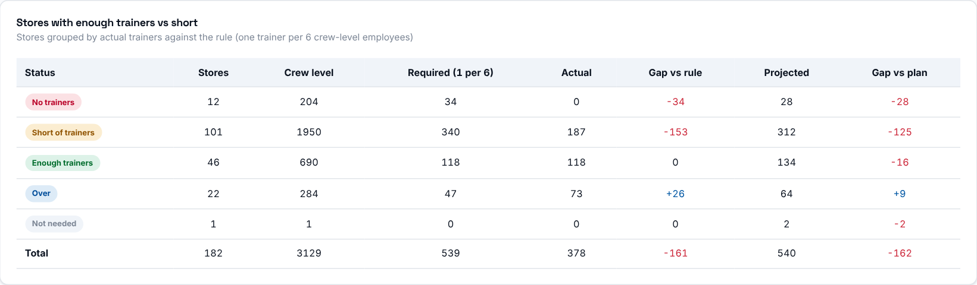
Stores grouped by how many trainers they have against the rule: Over (more than required), Enough (exactly), Short (fewer), No trainers (required but none) and Not needed (none required and none present). Each group shows its stores, crew level, required, actual, gap vs rule, projected and gap vs plan.
What to look at: the No trainers and Short groups.

Step 6 - Which stores need trainers?
Column | Meaning
Crew level | The people the trainers train.
Required | Crew level divided by 6, rounded to the nearest whole number (a half rounds up).
Actual | Actual trainers in the store.
Gap vs rule | Actual minus required. Negative = short of trainers, positive = over.
Projected / Gap vs plan | The trainers in the projection, and actual minus projected.
Status | Over, Enough, Short, No trainers, or Not needed (none required and none present).

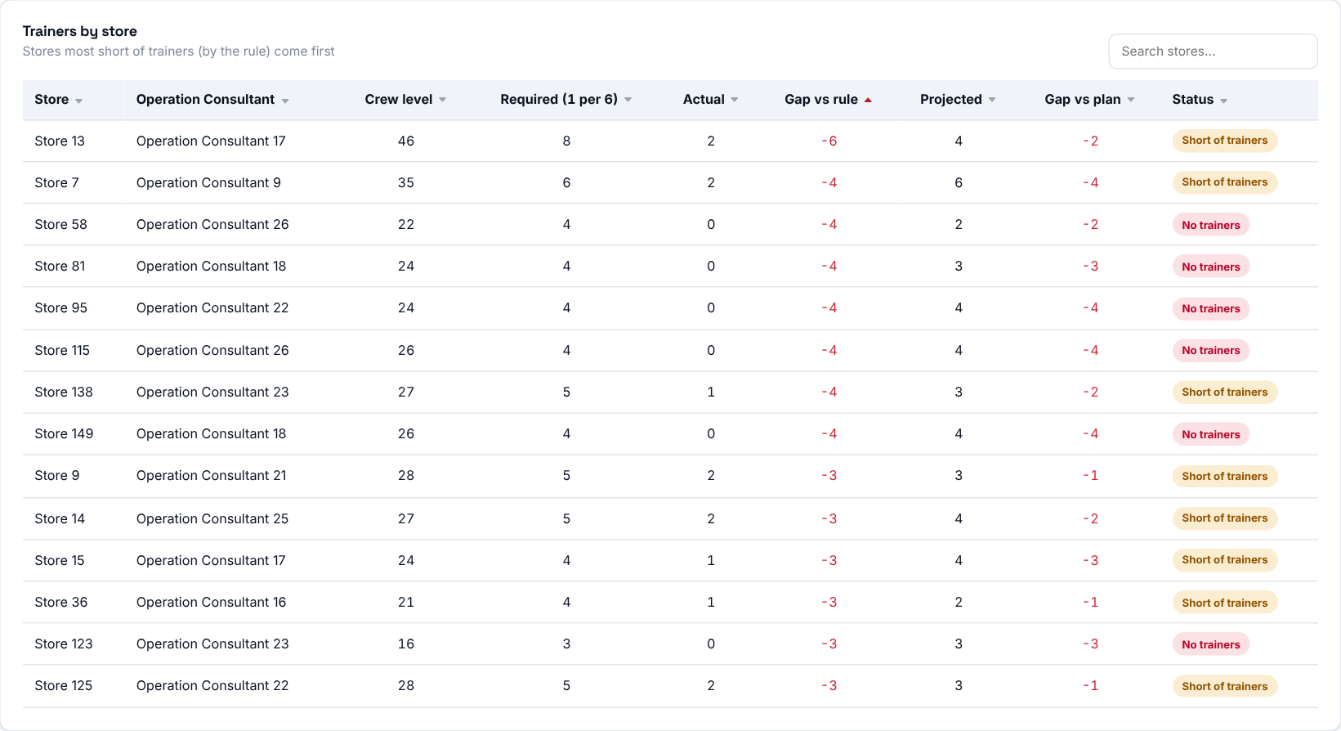
Stores with a projection for the month are listed, most short come first. Click a column title to sort, and use the search box to find a store or a consultant.
Then decide: agree with the responsible Operation Consultant how the top stores will reach the required number of trainers.

Step 7 - Who joined or left the trainer list?
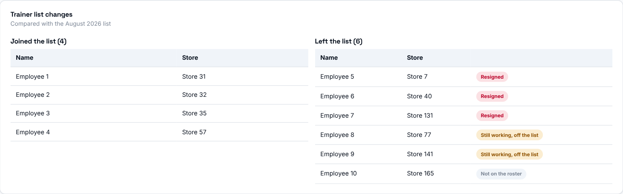
Who joined and who left the trainer list compared with the previous uploaded list. For people who left, the status tells you why: Resigned (they appear in the resignations), Still working, off the list (still on this month's active list, so the allowance was removed or they moved), or Not on the roster.
What to look at: people marked "Still working, off the list" - they may be trainers that moved or lost their allowance by mistake.

Step 8 - Who is responsible?
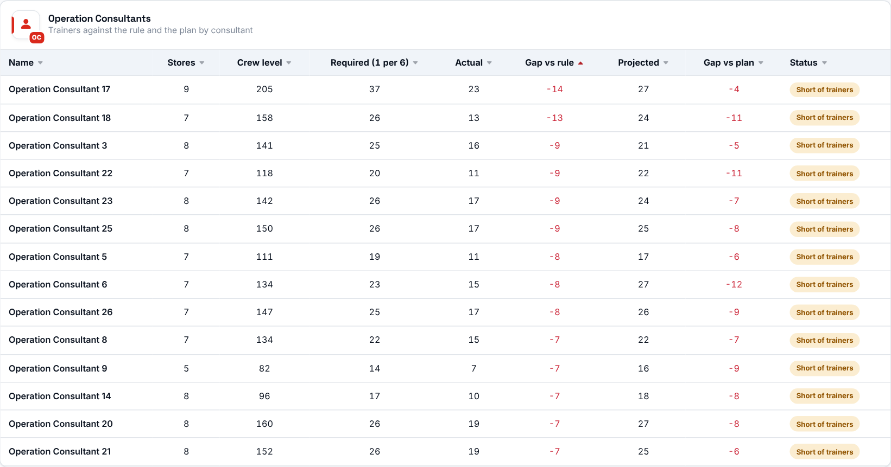
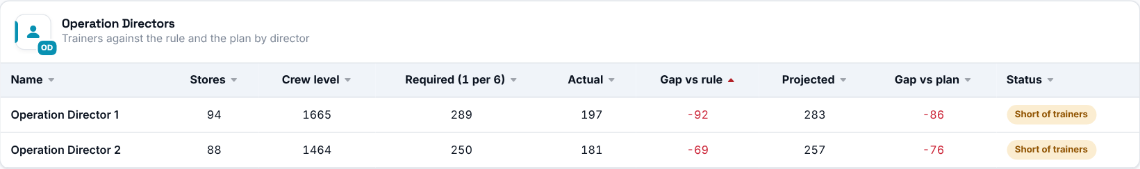
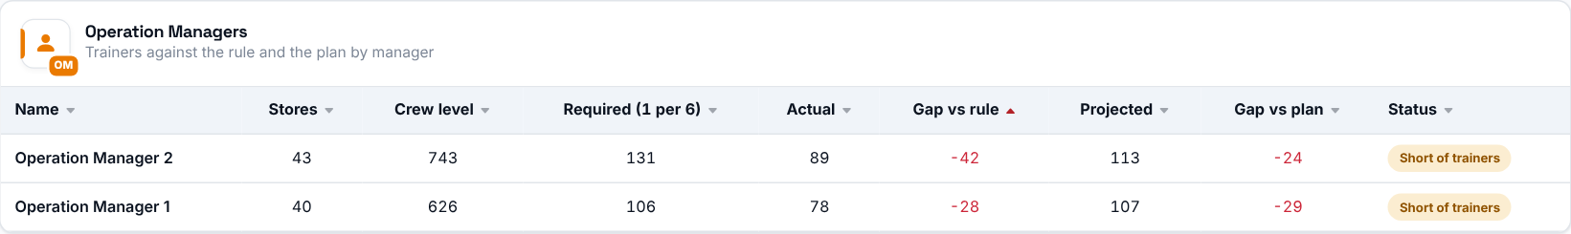
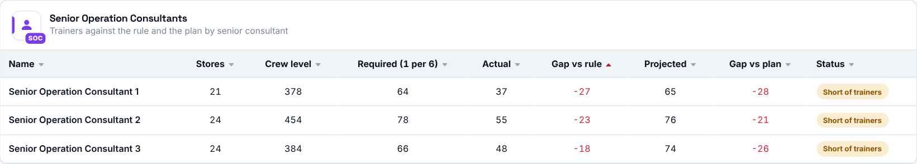
The same figures rolled up by Operation Consultant, Director, Manager and Senior Consultant, with the number of stores each covers.

Turnover
Where to find it: Side menu > Turnover
Use this page to understand who is leaving and where. It tracks how many employees resigned and how that compares with headcount, broken down by month, job title, tenure, payroll group, gender and store. The cards at the top summarise the selected period; everything below drills into it.

Step 1 - Choose the period and your scope
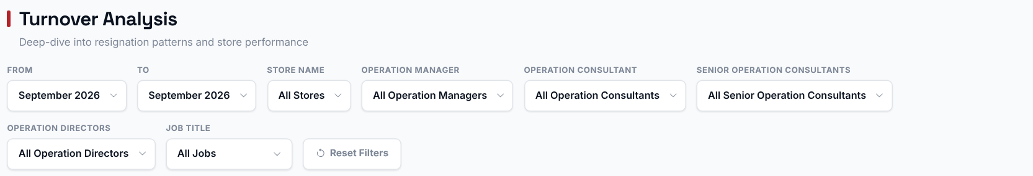
Pick a Store, Operation Manager, Operation Consultant, Senior Operation Consultant or Operation Director or Job and the cards, the charts and the matrix switch to that selection. The Store filter does not narrow the store table, the Operation Consultant / Director / Manager / Senior Consultant tables, or the Trend vs Prior Period card, which always cover all the stores you can access. The From/To period narrows the cards, the job title / tenure / payroll / gender charts, the store table and the leader tables.
Good to know: the "Turnover Rate by Month" chart always shows every uploaded month. The "Monthly Turnover Trend" chart and the full matrix always show every month from the From year to the latest upload, whatever From/To month you pick, because they are built to show trends over time.

Step 2 - Read the headline numbers
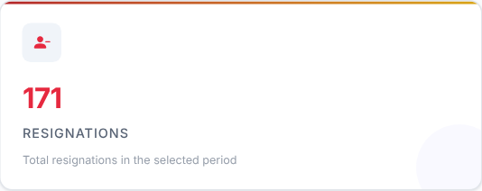 | 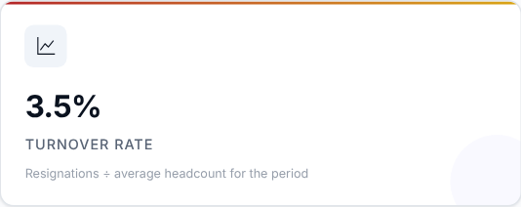 | 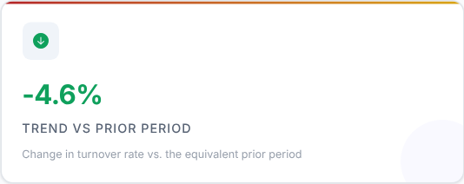

Card | What it shows
Resignations | Total resignations in the selected period.
Turnover Rate | Resignations divided by the average headcount for the period.
Trend vs Prior Period | The change in turnover rate compared with the equivalent prior period.

What to look at: Turnover Rate and its trend. A green downward arrow means turnover improved against the prior period.

Step 3 - Is turnover seasonal?
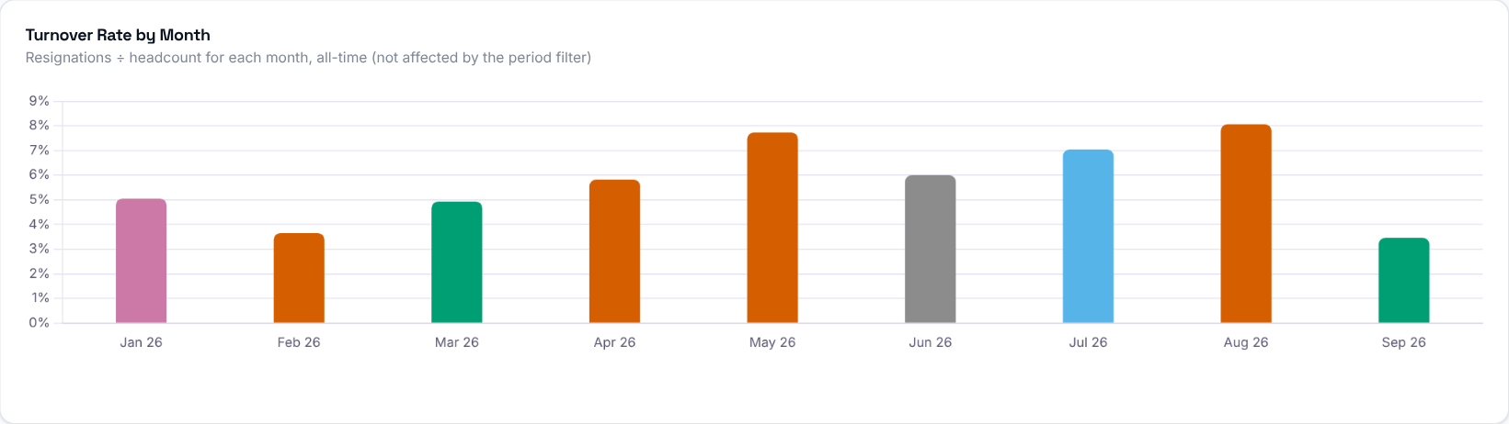

Turnover rate for every uploaded month (one bar per month and year). Each bar = (resignations that month / headcount that month) x 100. This chart ignores the From/To filter, so you can see long-term seasonality; the Store, leader and Job filters still apply.
What to look at: months that regularly stand out.
Then decide: prepare extra hiring and retention effort ahead of the months that are usually worst.

Step 4 - Who is leaving?
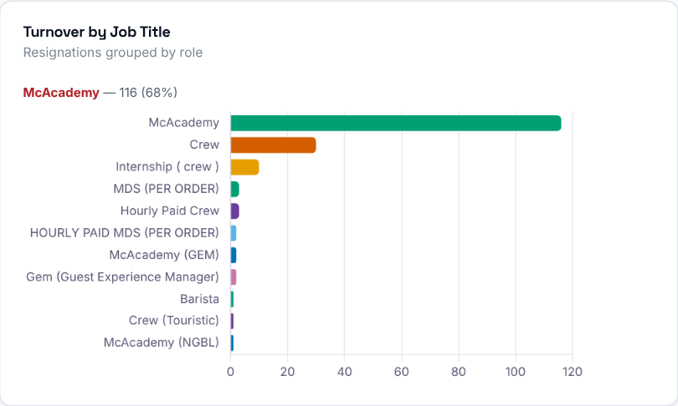  Resignations in the selected period grouped by job title.  What to look at: which roles are losing the most people. | 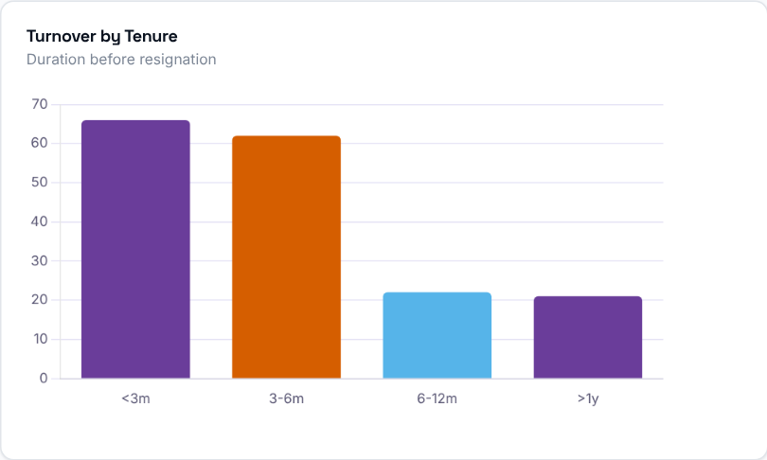  Resignations grouped by how long the employee had worked (under 3 months, 3-6 months, and so on).  What to look at: whether people leave early or after a longer stay.

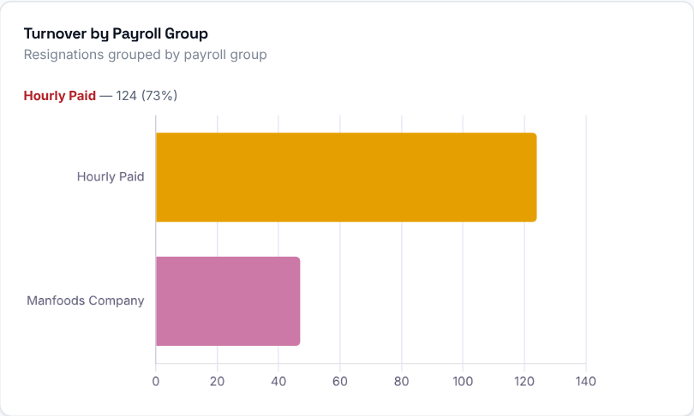  Resignations grouped by payroll group for the selected period. | 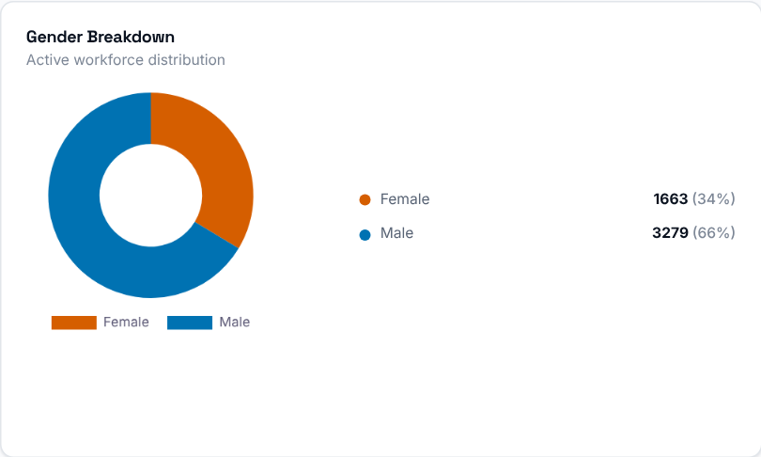  Gender split of the active employees in the selected period (each month in the From-To range added together), shown as a doughnut with counts and percentages on the side.

Step 5 - Why are they leaving?

The reasons given in exit interviews, grouped by reason. Only employees who completed an exit interview are counted, not every resignation. The period filter applies only when From and To are in the same year; otherwise all exit interviews are used.
Then decide: the biggest reason is where your retention effort should go first.

Step 6 - Is the trend improving?
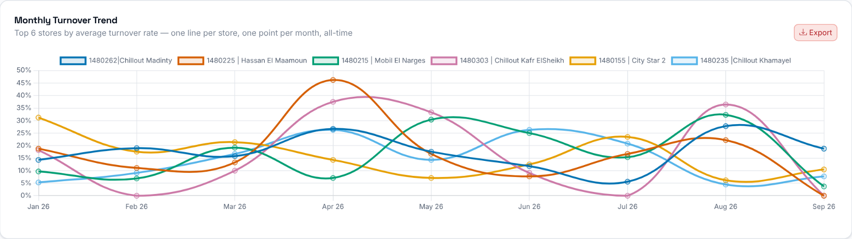
Month-by-month turnover rate of the 6 stores with the highest average rate (or of the selected store), from the From year to the latest upload, whatever To period you pick.

Step 7 - Which stores lose the most people?
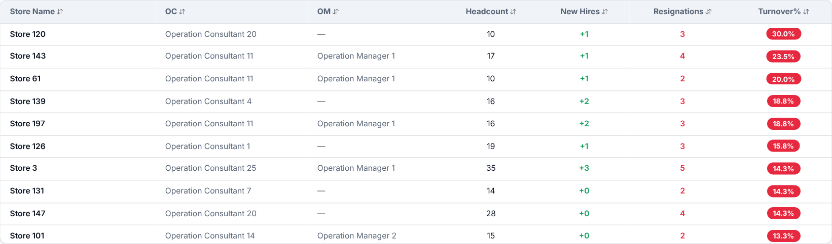
Every store with employees in the selected period, with its headcount (added up over the months of the range), new hires, resignations and turnover rate (resignations / average headcount x 100). Rows start sorted by Turnover% (highest first). Click a column header to sort.
What to look at: stores with the highest Turnover% and with resignations well above their new hires.
Then decide: talk to the Operation Consultant of the stores at the top and agree actions with them.

Step 8 - Who should you talk to?
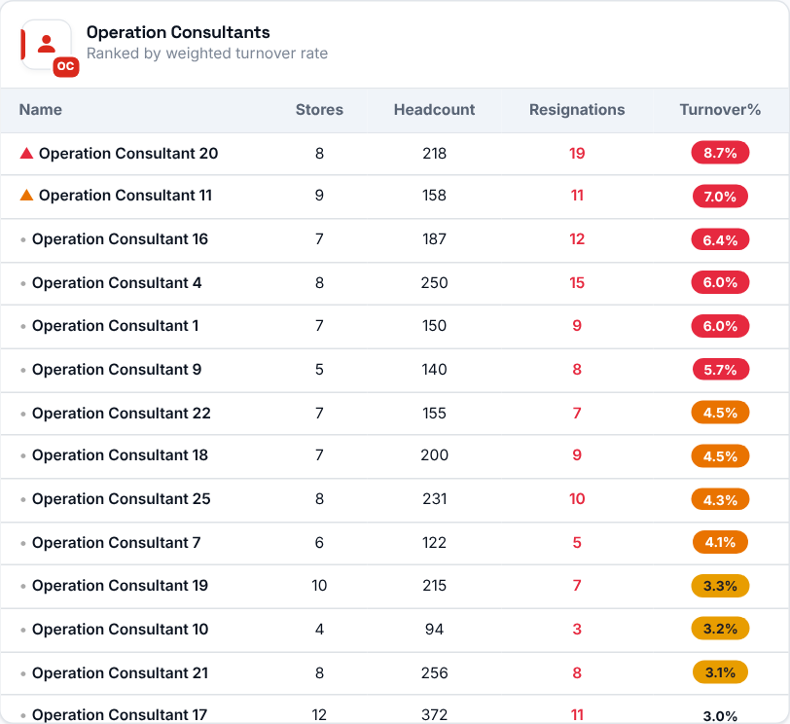 | 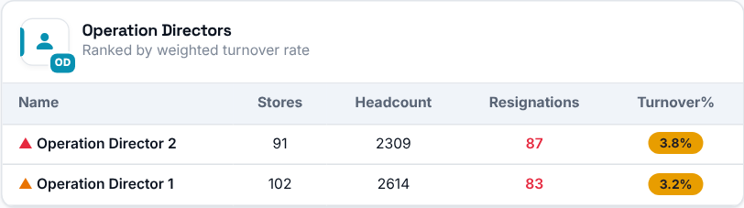  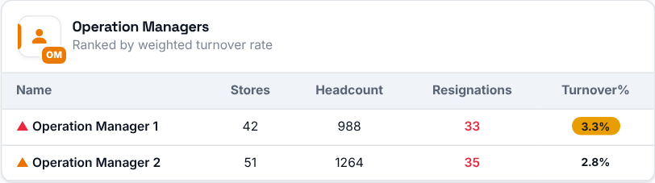  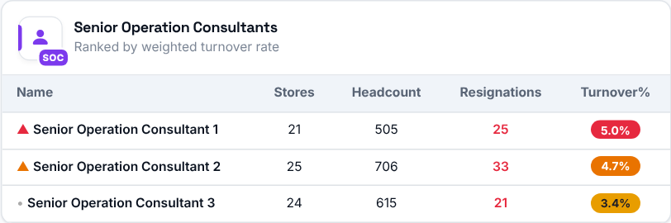
Operation Consultants, Directors, Managers and Senior Consultants ranked by their weighted average turnover rate: the sum of resignations across all their stores divided by the sum of average headcount across those stores - not a simple average of each store's rate.

Step 9 - Spot the pattern store by store
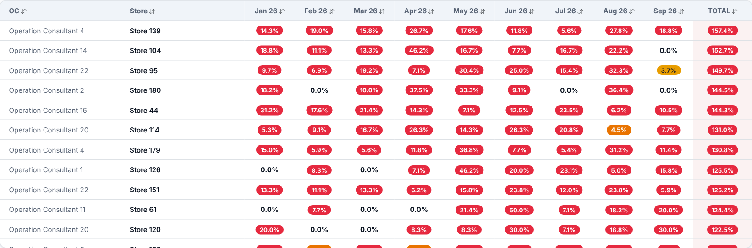
A full matrix of every store against every period from the selected year to the latest upload. It always shows the full year range, not just the From/To filter.
What to look at: stores with a high rate in many months in a row - they have a lasting problem, not a one-off.

90-Day Turnover
Where to find it: Side menu > 90-Day Turnover
Use this page to see how many new hires leave within their first 90 days. It tracks "early leavers": employees hired in a given month (a cohort) who resigned within their first 90 days. The 90-Day Rate = early leavers / total new hires in that cohort x 100. A cohort is marked "Provisional" until 90 days after the end of its hiring month (for several months: the latest one), because its final rate can still change.

Step 1 - Choose the cohort and your scope
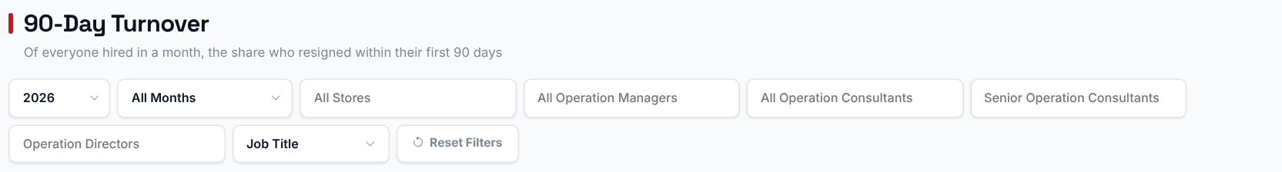
The month selector picks which hiring cohort(s) to look at. Everything on the page, except the trend chart and the Full Data Table (both always show every cohort), is scoped to the cohort(s) you select. Choosing a Store, Operation Manager, Operation Consultant, Senior Operation Consultant, Operation Director or Job Title filters every chart and table to just that selection.

Step 2 - Read the headline numbers
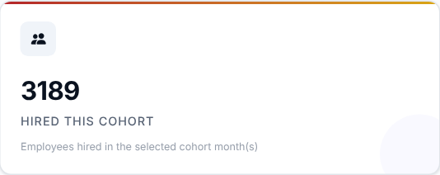 | 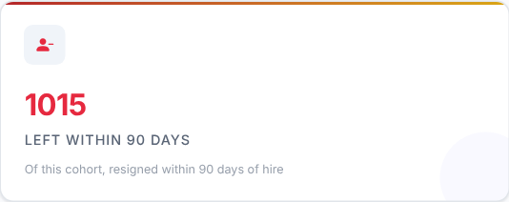 | 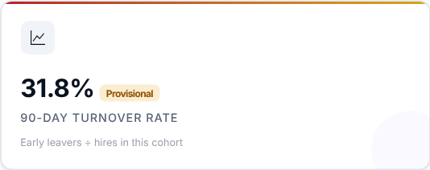

What to look at: the 90-Day Turnover Rate: early leavers divided by hires in the cohort.
Then decide: a high rate means many new people do not stay past their first three months - look at hiring quality, onboarding and training before looking at anything else.

Step 3 - Which hiring months stick better?
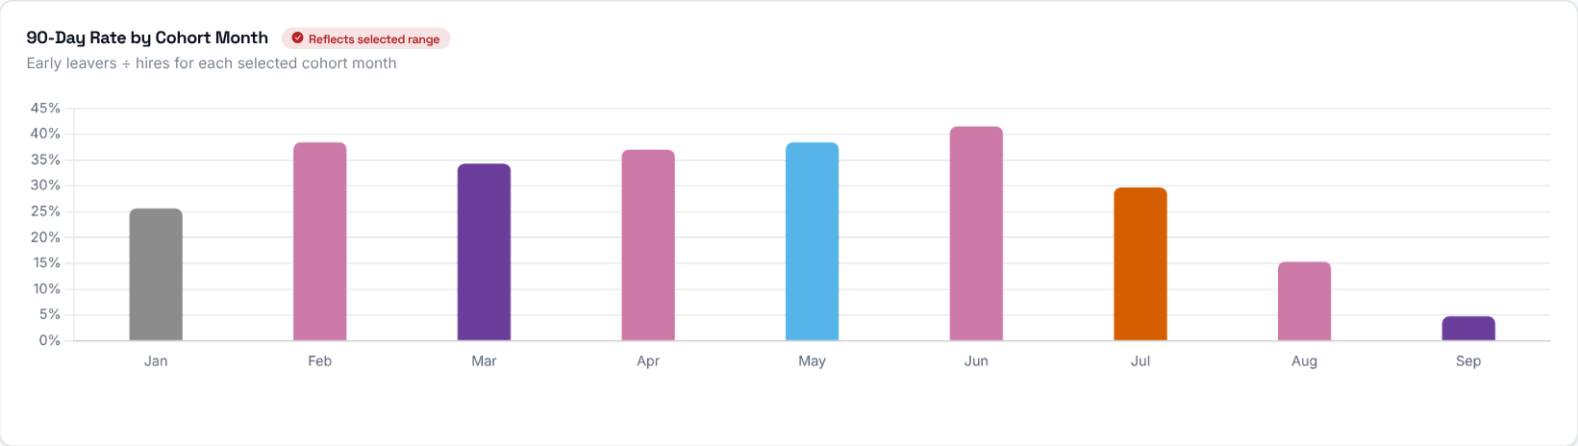
The 90-Day Rate for each monthly hiring cohort (people hired that month), so you can compare how "sticky" different hiring months have been.

Step 4 - Is the trend improving?
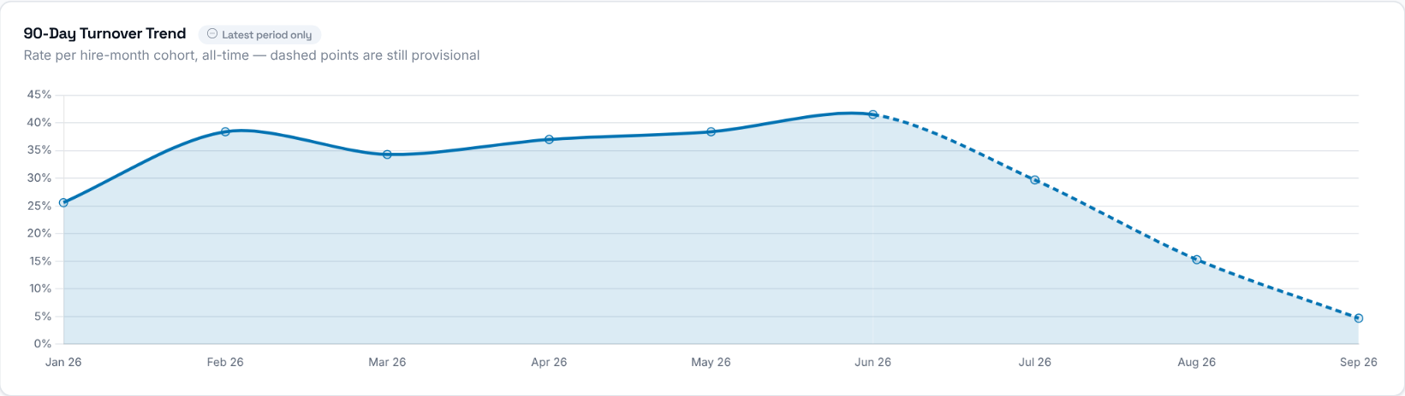
The 90-Day Rate for every monthly hiring cohort since the first hires in the data. It ignores the Year and Months selection, but still follows the Store, manager and Job Title filters. Dashed segments are cohorts that are still provisional.

Step 5 - Which stores lose their new hires?
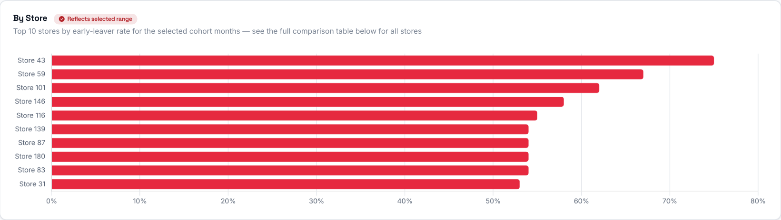
The 90-Day Rate for each store in the selected cohort(s). The chart shows the top 10 stores by early-leaver rate; the full comparison is in the table below.
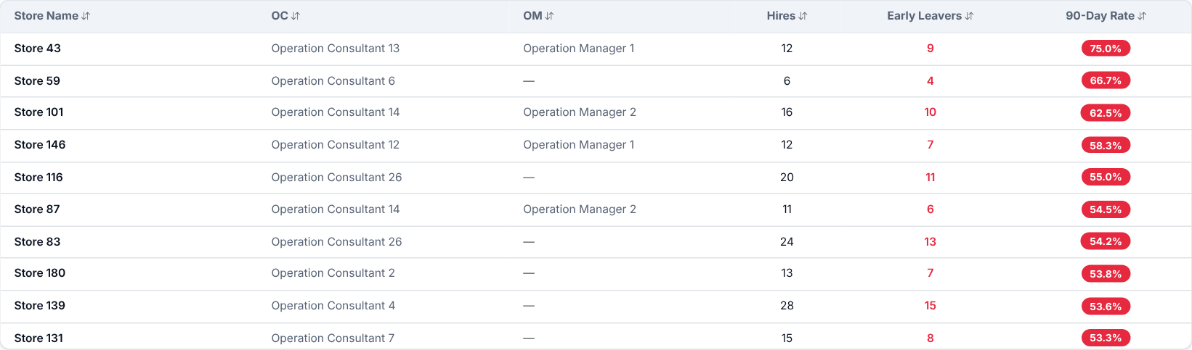
Every store with its total hires, early leavers and 90-Day Rate for the selected cohort(s). Click a column header to sort.
Then decide: talk to the Operation Consultant of the stores at the top and review how new hires are welcomed and trained there.

Step 6 - Why do new hires leave?
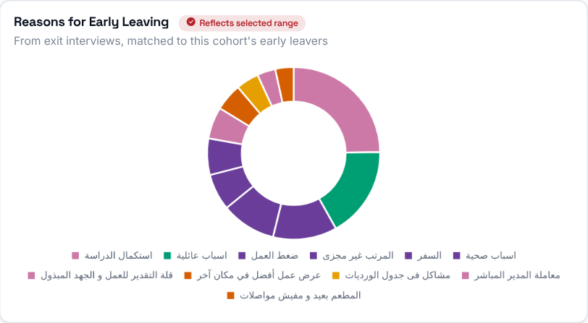 | The reasons given in exit interviews by employees who resigned within their first 90 days (early leavers with no exit interview are not counted).

Step 7 - Who leaves early?
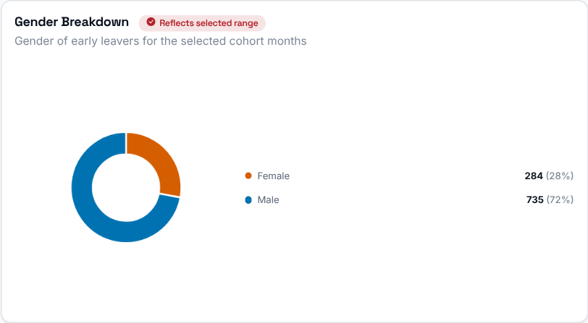  Gender split of the early leavers in the selected cohort(s). | 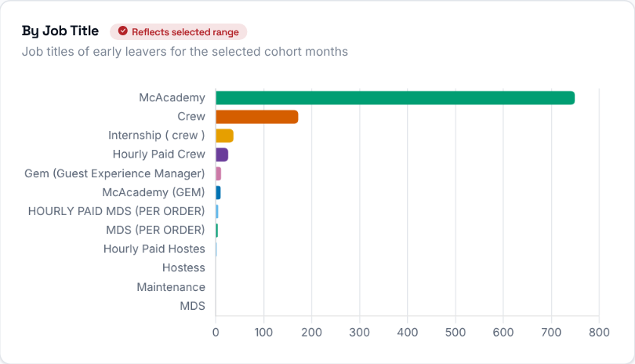  Early leavers grouped by job title.

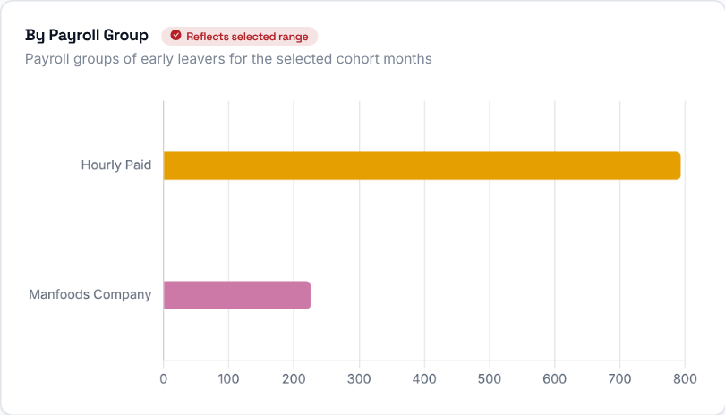 | Early leavers grouped by payroll group.

Step 8 - Who should you talk to?
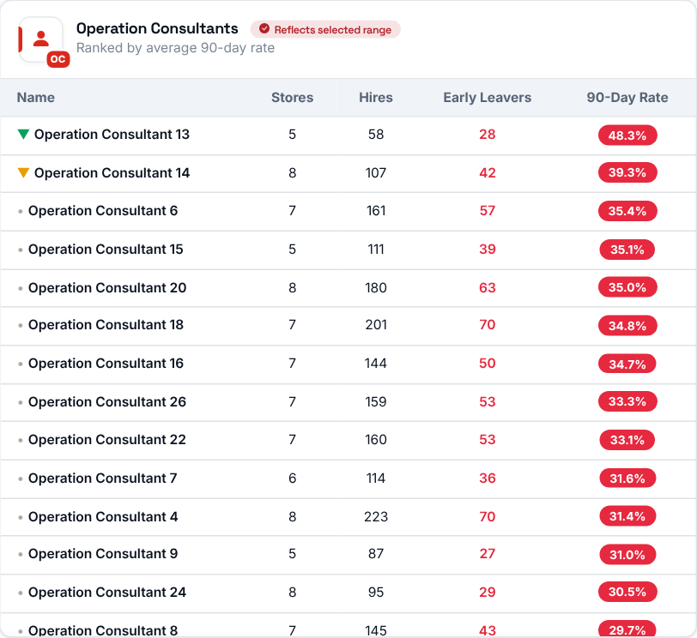 | 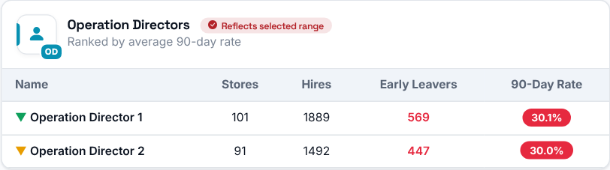  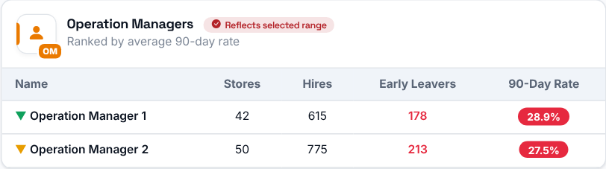  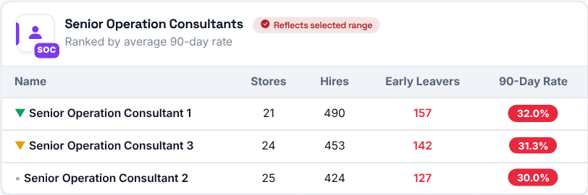
Operation Consultants, Senior Operation Consultants, Operation Directors and Operation Managers ranked, highest 90-Day Rate first, by their stores' combined rate (early leavers / hires across all their stores) for the selected cohort(s).

Step 9 - Spot the pattern store by store
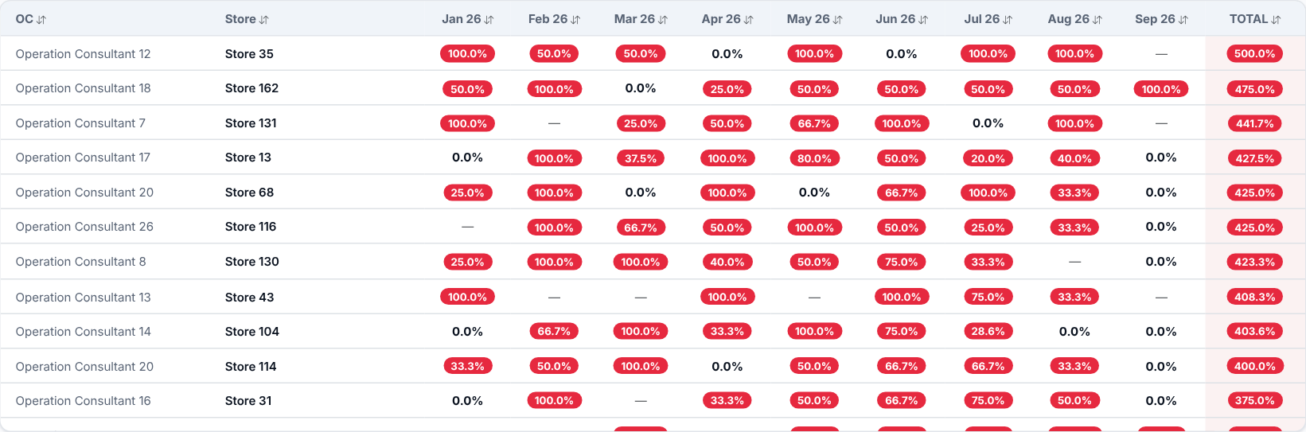
Every store's 90-Day Rate for each hiring month (all cohorts), one row per store and one column per month, plus a Total column that adds up the monthly rates. Use it to spot stores whose rates are consistently high, or improving or worsening over time. Search by store or Operation Consultant; click any column header to sort.

Step 10 - Who exactly left?
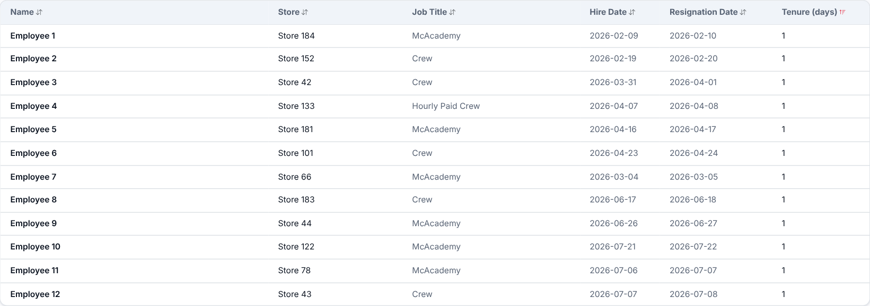
The individual employees who resigned within their first 90 days in the selected cohort(s): name, store, job title, hire and resignation dates, and how many days they lasted. Click a column header to sort.
What to look at: very short tenures (a few days) - these usually point to a problem in hiring or the first-day experience rather than in the job itself.

Comparisons
Where to find it: Side menu > Comparisons
Use this page to see whether things got better or worse. It compares two periods side by side, Period A and Period B, each with its own independent filters. Every card, chart and table shows both periods together; the headline cards, Smart Insights and the store table also show the change between them (A minus B).

Step 1 - Choose the two periods
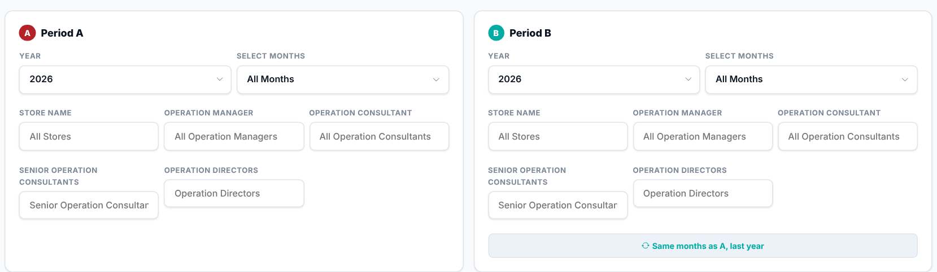
Period A and Period B each have their own year, months, store, Operation Manager, Operation Consultant, Senior Operation Consultant and Operation Director filters - they do not have to match. The "Same months as A, last year" button fills Period B with the same filters as Period A but one year earlier, which is the quickest way to compare year over year.

Step 2 - Read the Smart Insights
Up to three automatic cards: whether the Turnover Rate and the 90-Day Rate improved or worsened from Period B to Period A, and (only when both periods use All Stores) the store whose Turnover Rate moved the most.

Step 3 - Compare the headline numbers
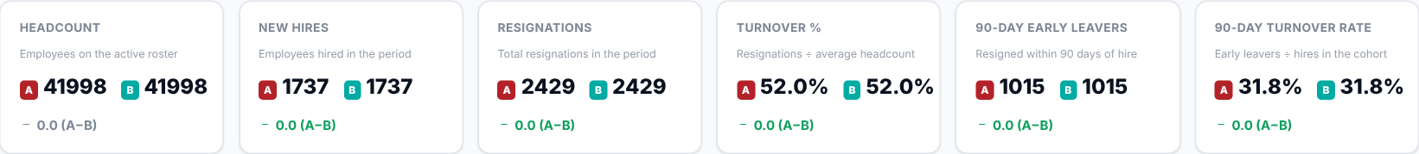
Headcount, New Hires, Resignations, Turnover Rate, Early Leavers and 90-Day Rate for Period A and Period B side by side, each with the change A minus B. Green means A is better than B (more hires, fewer resignations or leavers, lower rates); Headcount is not coloured. With several months selected, Headcount adds up each month's roster.
What to look at: the Turnover Rate and 90-Day Rate changes first - they tell you immediately whether retention improved.

Step 4 - Which stores got better or worse?
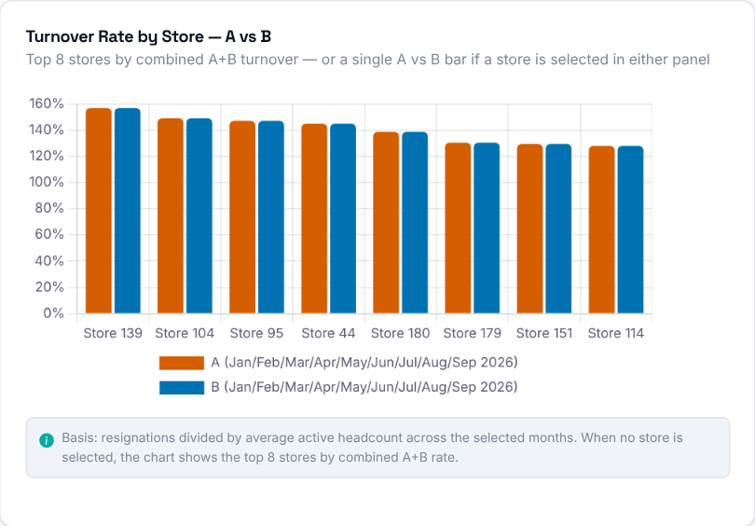  Turnover Rate per store for Period A vs Period B, as paired bars. When neither period has a store selected, the chart shows the top 8 stores by combined A+B rate; if either period has a store selected, it shows a single Overall pair. | 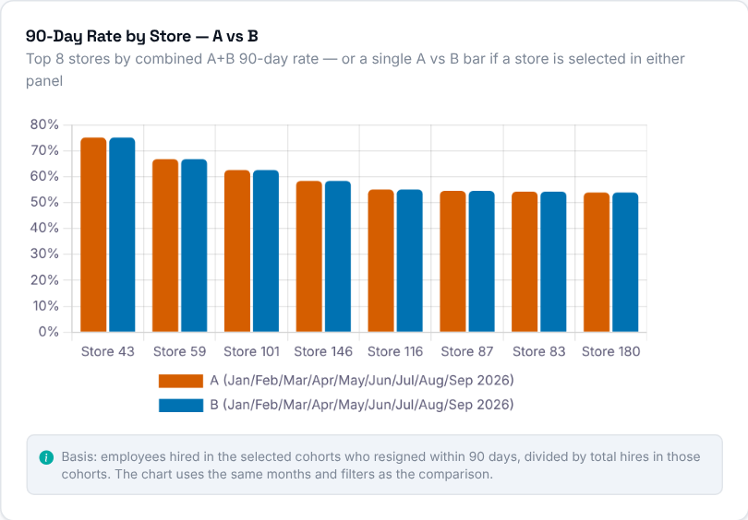  90-Day Rate per store for Period A vs Period B, as paired bars (top 8 stores by combined A+B rate when neither period has a store selected, otherwise a single Overall pair), using the same months and filters as the comparison.  Then decide: stores where the Period B bar is much higher than Period A need a conversation with their Operation Consultant.

Step 5 - Headcount and resignations
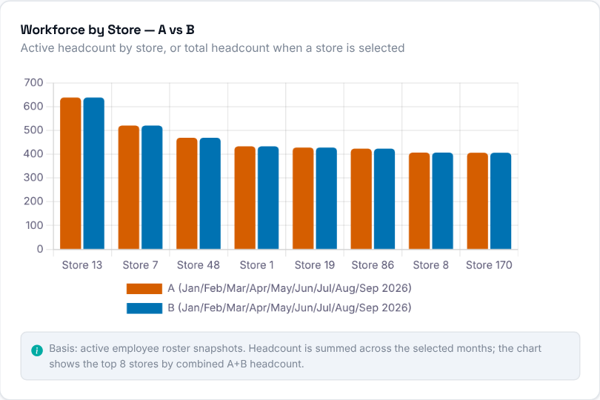  Active headcount per store for Period A vs Period B, as paired bars (top 8 stores by combined A+B; the months of a period are added together), or one overall pair when either period has a store selected. | 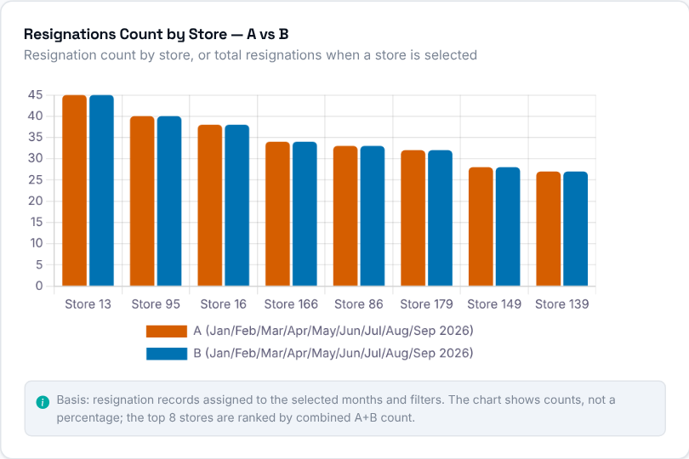  Resignation count per store for Period A vs Period B (top 8 stores by combined A+B), or one overall pair when either period has a store selected. It shows counts, not a percentage.

Step 6 - Are people staying longer?
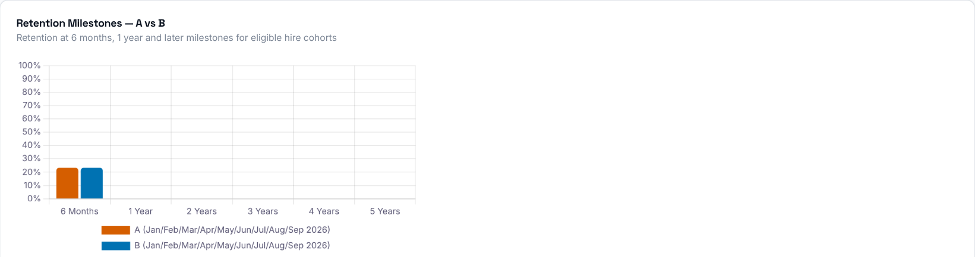
Retention rate at the 6-month, 1-year and 2-5-year milestones for Period A vs Period B, based on employees hired in the selected months who are old enough (or already resigned) at each milestone; a milestone with no eligible hires has no bar.

Step 7 - Why are people leaving?
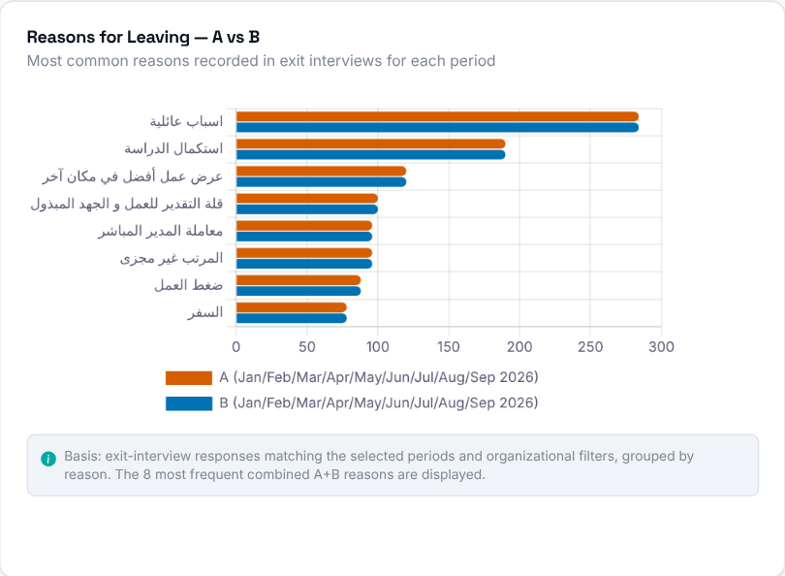  The 8 most common reasons recorded in exit interviews (by combined A+B count), Period A vs Period B, so you can see whether the same reasons dominate or the mix shifted. | 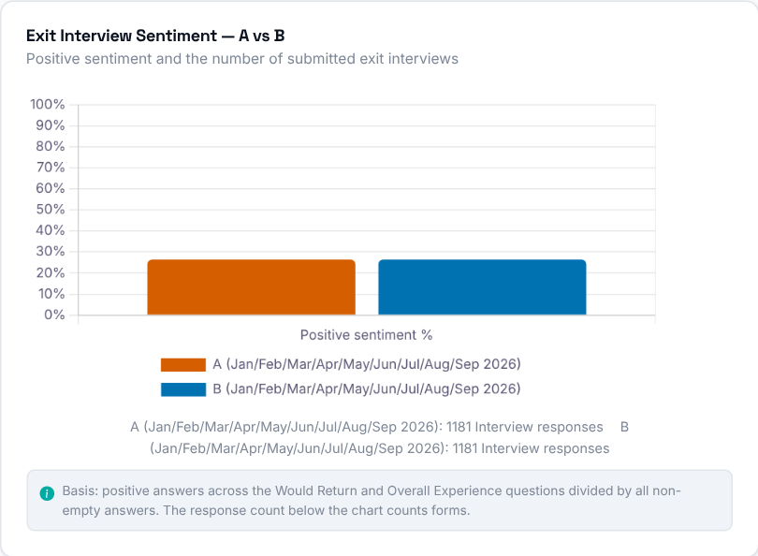  Positive exit-interview sentiment (the positive share of the Would Return and Overall Experience answers) and how many interviews were submitted, Period A vs Period B.

Step 8 - Store by store
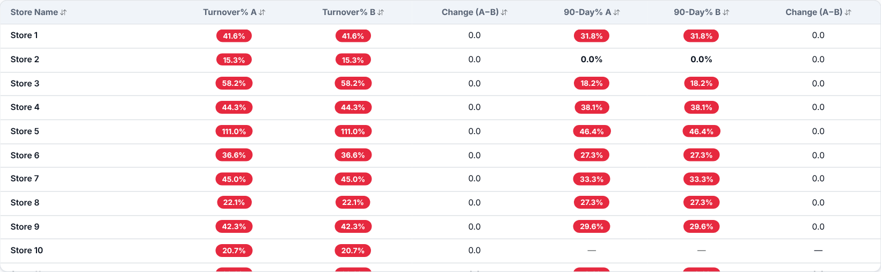
Every store with its Turnover Rate and 90-Day Rate in both periods, plus the change (A minus B) for each. It is shown only when both periods use "All Stores". Click a column header to sort.

Retention
Where to find it: Side menu > Retention
Use this page to see how long employees stay - the opposite lens from Turnover. Most charts are snapshots of today's active team: how long people have been on the job, using 6 months (180 days) as the main benchmark. Two parts look at the past instead: the Smart Insights (hire-cohort retention) and the all-time "how soon people leave" chart.

Step 1 - Choose the hires and your scope
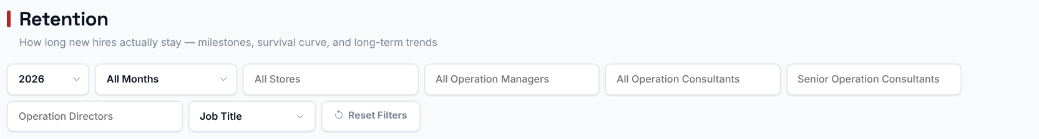
Choosing a Store, Operation Manager, Operation Consultant, Senior Operation Consultant, Operation Director or Job Title filters every chart and table to just that selection. The Year/Months filter only affects the Smart Insights (which hires they look at); every chart shows the current team from the latest roster, except the monthly hiring chart, which starts at the selected year.

Step 2 - Read the Smart Insights
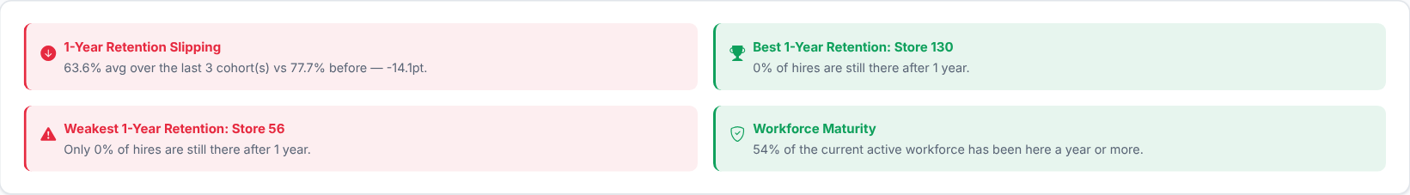
Up to four automatic takeaways: whether 1-year retention of recent hiring months is improving or slipping, the best store (and the weakest, if under 50%) for 1-year retention among employees hired in the selected months, and the share of today's team with more than a year of service. Read these first, then use the charts below.

Step 3 - How experienced is today's team?
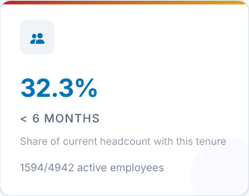 | 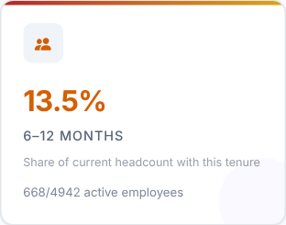 | 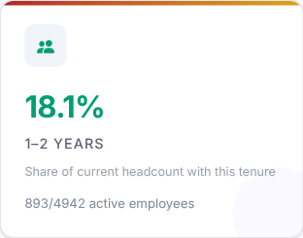 | 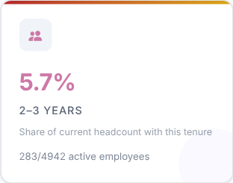
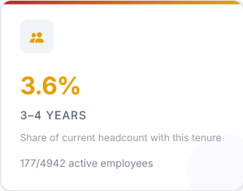 | 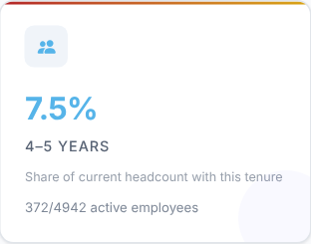 | 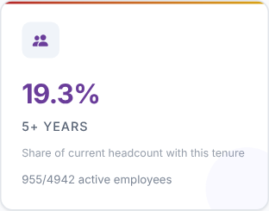

Each card shows the share of today's active headcount currently in a tenure band (under 6 months, 6-12 months, 1-2 years ... 5+ years); the bands add up to 100%. It is a snapshot of team experience, not a survival rate, and it ignores the Months filter.
What to look at: how large the "< 6 months" card is compared with the longer-tenure cards.
Then decide: a large new-joiner share means more coaching and closer follow-up in the coming months.

Step 4 - Where do people drop off?
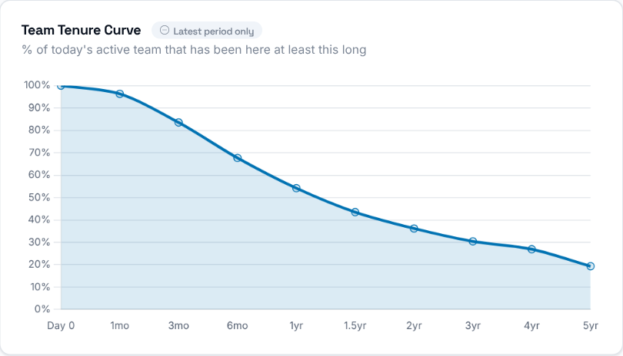 | The Team Tenure Curve shows, for each tenure mark (Day 0, 1, 3, 6 months, 1, 1.5, 2, 3, 4 and 5 years), the percentage of today's active employees who have been on the job at least that long. It describes the current team, not hires over time, and it ignores the Months filter.

Step 5 - Which stores keep their people?
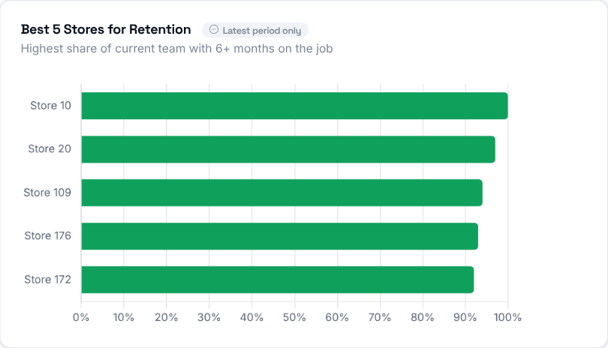  The 5 stores with the highest share of their current team that has 6+ months on the job. | 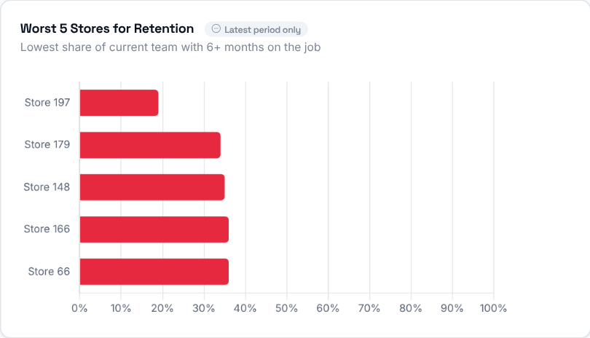  The 5 stores with the lowest share of their current team that has 6+ months on the job - worth a closer look.

Step 6 - Who stays?
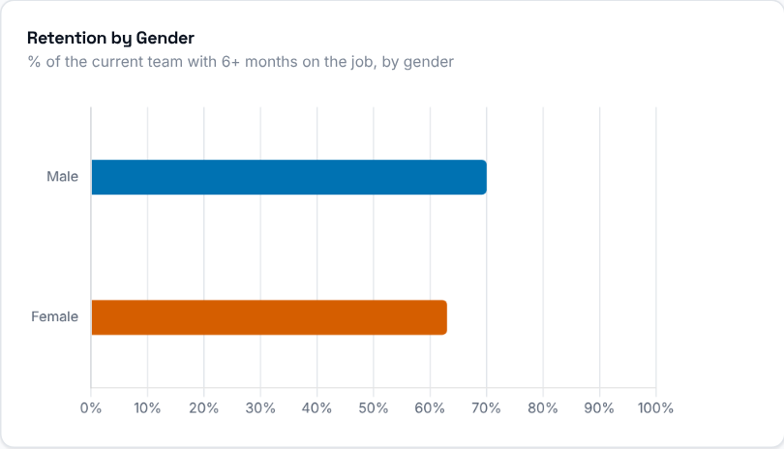  Share of the current team with 6+ months on the job, split by gender. | 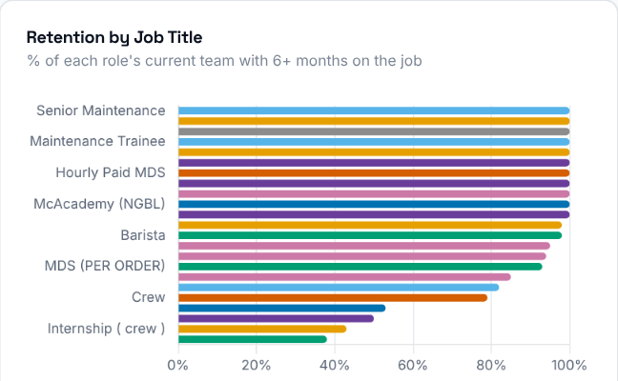  Share of each job title's current team that has been on the job 6+ months.

Step 7 - Average tenure
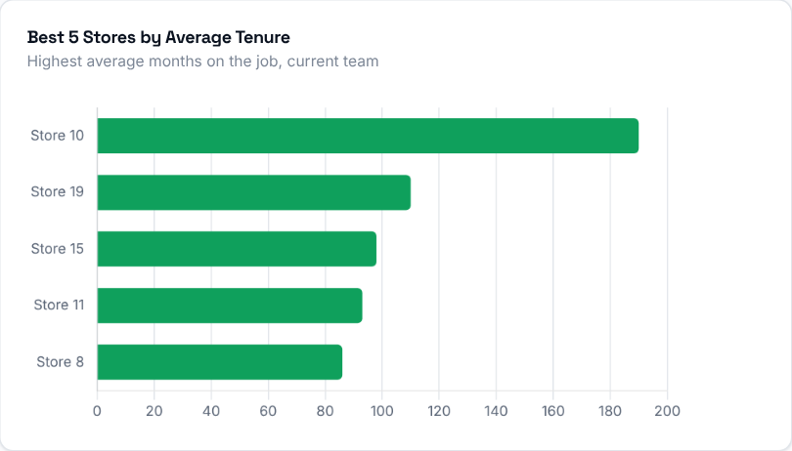 | 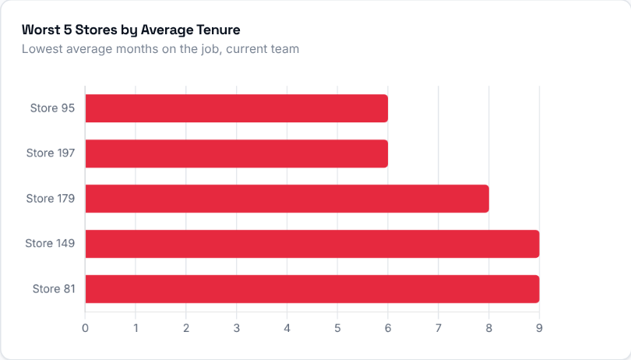
The 5 stores with the highest and the 5 with the lowest average tenure of their current team, in months.
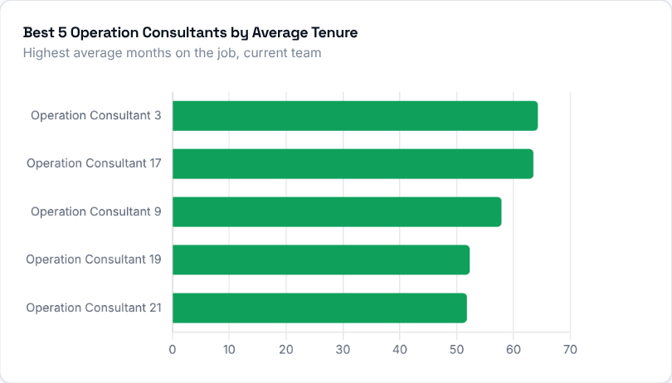 | 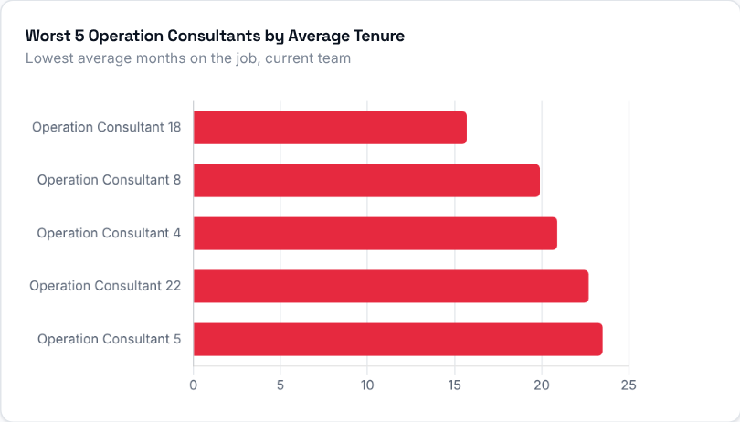
The 5 Operation Consultants with the highest and the 5 with the lowest average tenure across their stores' current teams.

Step 8 - When do people leave, and how much are we hiring?
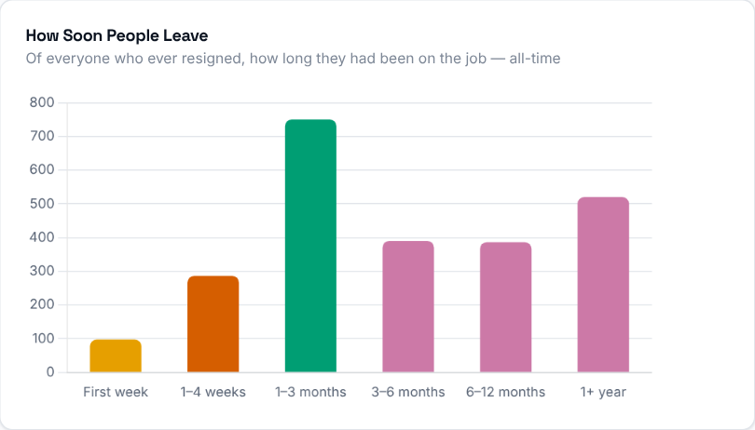  Of everyone who ever resigned (all-time, not limited to the selected period), how long they had been on the job before leaving. It shows whether people tend to leave early or after settling in. | 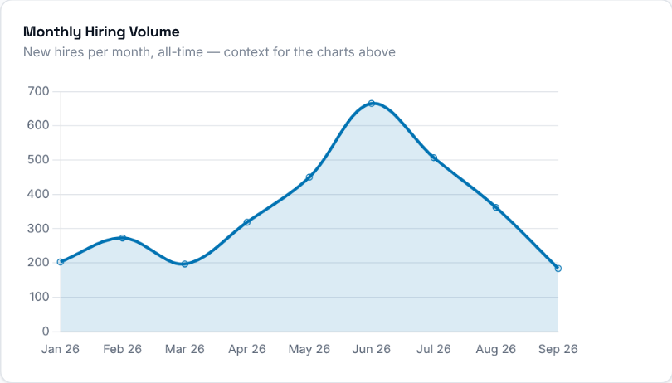  New hires per month from the selected year onward (everyone hired that month, including people who have since left; it ignores the Months filter) - context for reading the retention charts alongside how much hiring was actually happening.

Step 9 - Store by store
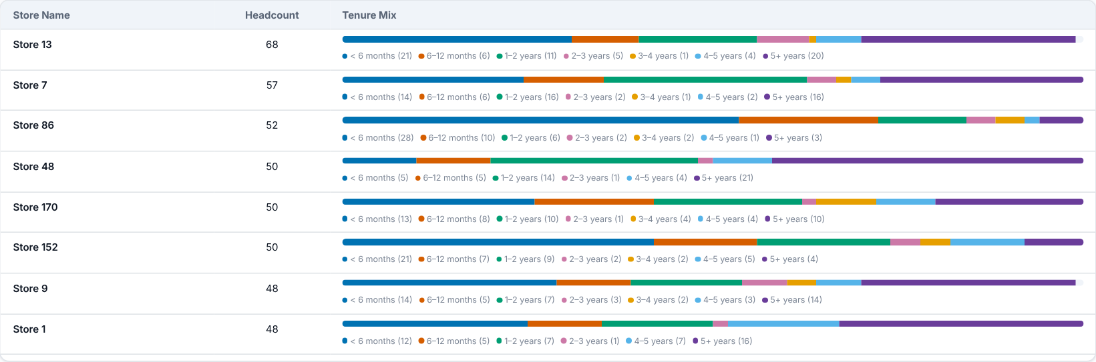
Every store's headcount on the latest roster and a tenure-band mix (how many employees fall in each tenure range), so you can see whether a store's team is mostly new or mostly experienced.

Step 10 - Who should you talk to?
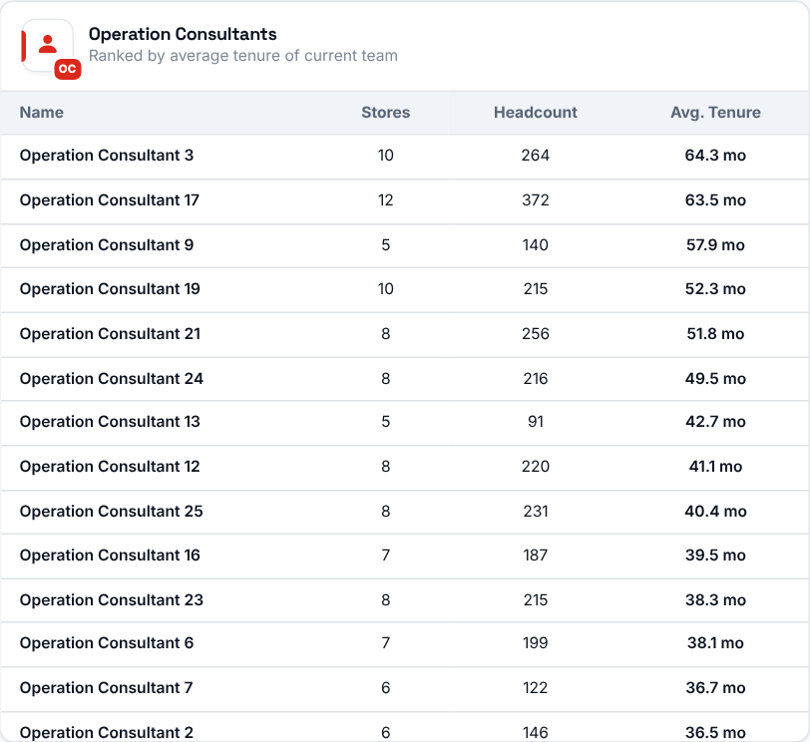 | 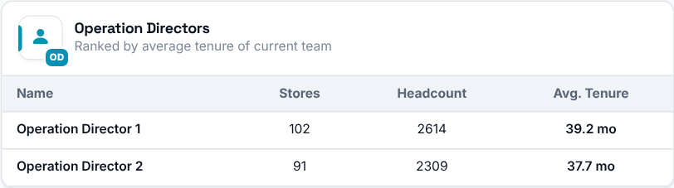  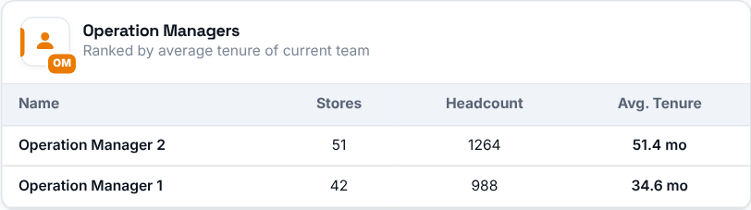  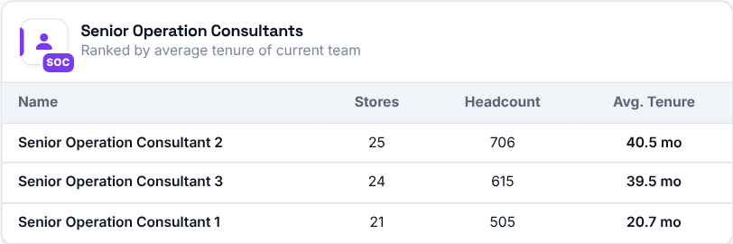
Operation Consultants, Senior Operation Consultants, Operation Directors and Operation Managers ranked, longest average tenure first, by the average tenure (in months) of the current team across all their stores.

Exit Interviews
Where to find it: Side menu > Exit Interviews
Use this page to understand why people leave, in aggregate. It summarises what departing employees said in their exit interviews: reasons for leaving, whether they would return, ratings on training, fairness and workload, and free-text comments, for the selected period (based on the employee's resignation date, or the form's completion date when no resignation is matched). Individual responses are never identified.

Step 1 - Choose the period and your scope
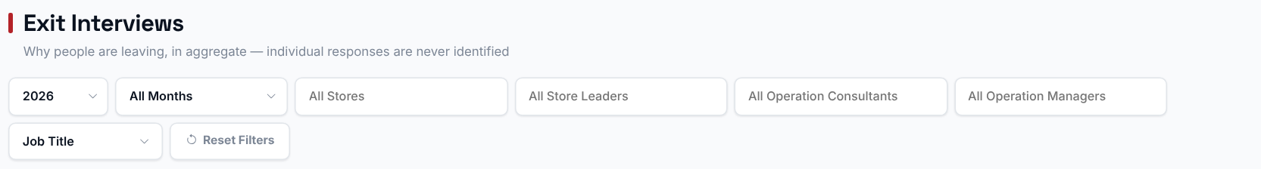
Choosing a Store, Store Leader, Operation Consultant, Operation Manager or Job Title filters every chart, table and comment on this page to just that selection. The Year/Months filter scopes everything to that period, except the reasons-trend chart, which always shows the full history.

Step 2 - Read the headline numbers
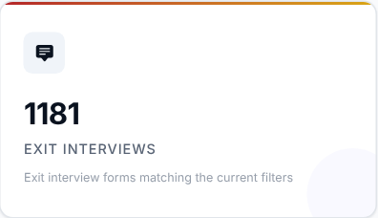 | 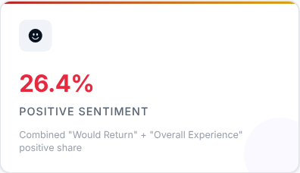 | 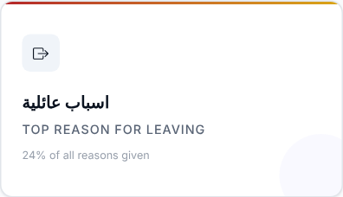 | 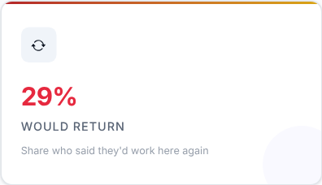

What to look at: Positive Sentiment and Would Return - together they tell you how people feel when they leave.

Step 3 - Read the Smart Insights
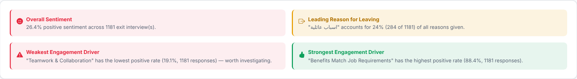
Up to four automatic takeaways worked out from the exit interviews for your current filters: overall positive sentiment, the leading reason for leaving, and the weakest and strongest engagement drivers. Positive Sentiment is the positive share of the Would Return and Overall Experience answers.

Step 4 - Why do people leave?
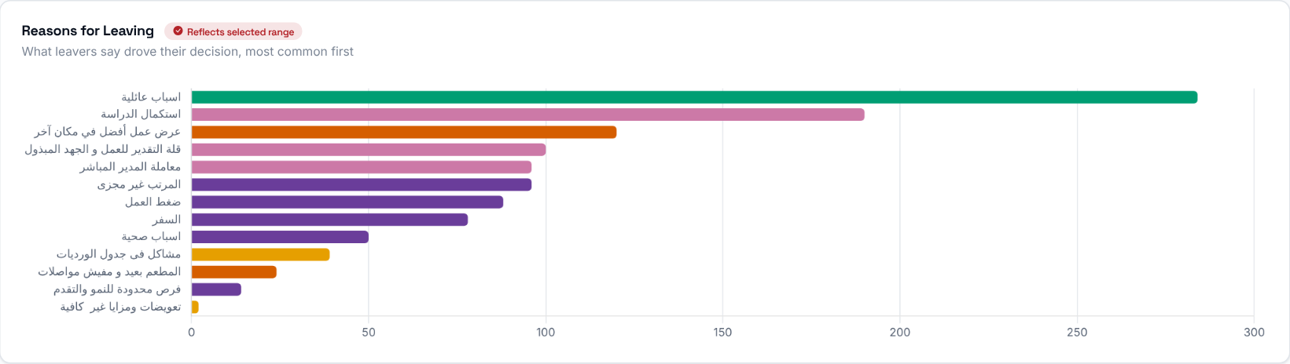
The reasons employees gave for resigning, ranked by how often each was cited.
Then decide: the top reasons are where your retention effort should go first.
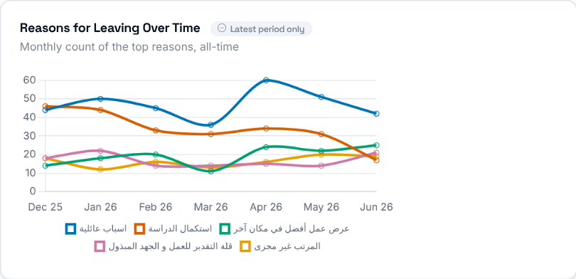 | How the 5 most common resignation reasons (all-time) have trended month over month. It ignores the Year/Months and Job Title filters but follows Store, Store Leader, Operation Consultant and Operation Manager.

Step 5 - Would they come back?
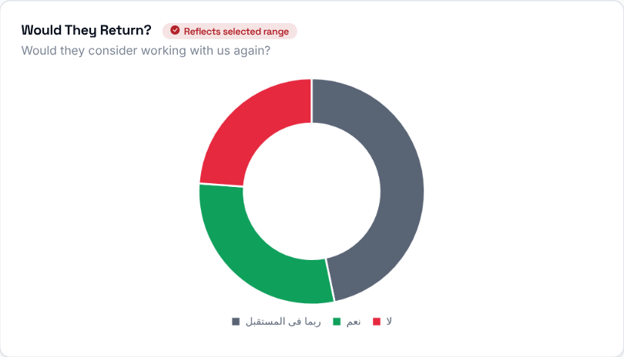  Whether departing employees said they would consider returning to work here in the future. | 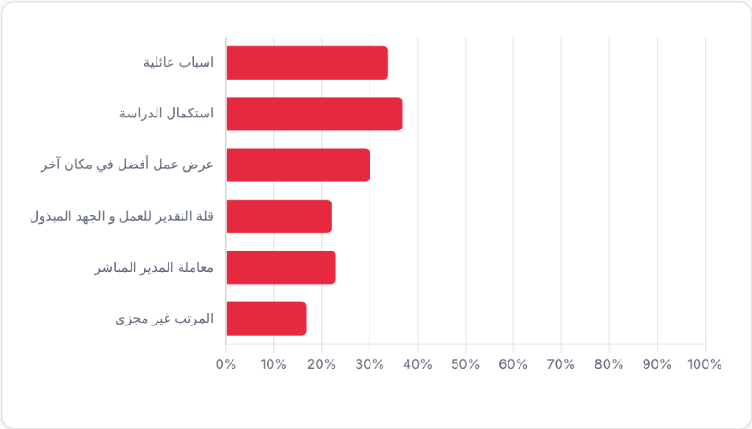  For the 6 most common reasons (each with at least 2 interviews), the share of people who answered Yes to returning. It shows which reasons tend to be "final" and which are more circumstantial.

Step 6 - How did they rate their experience?
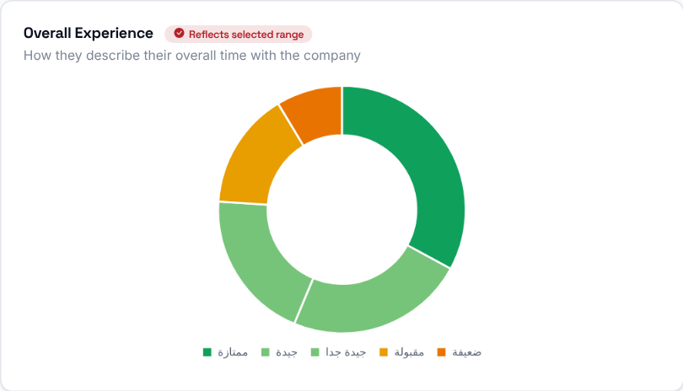  How departing employees rated their overall experience working here. | 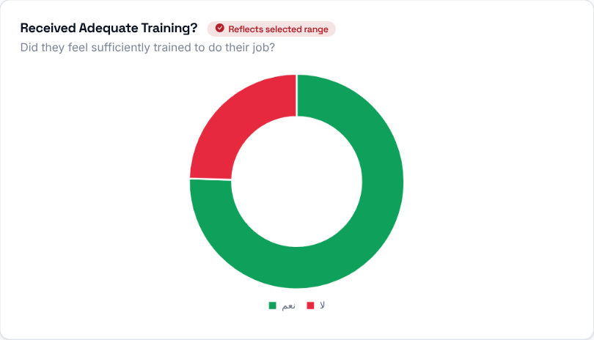  How departing employees rated the training they received.

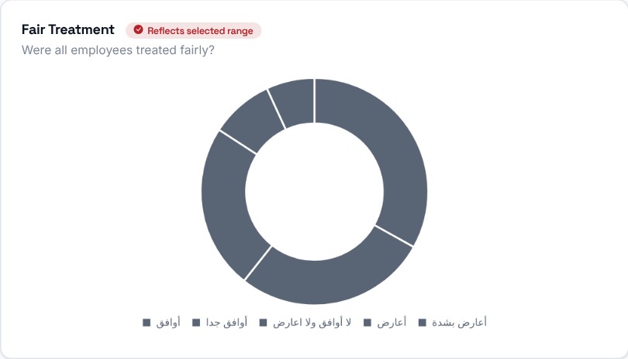 | How departing employees rated whether they were treated fairly.

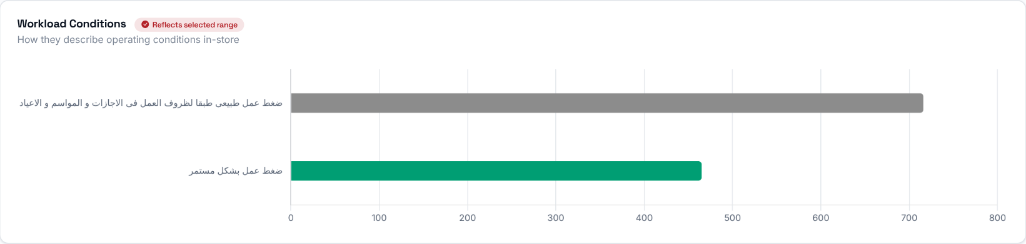
How departing employees rated their workload and working conditions.
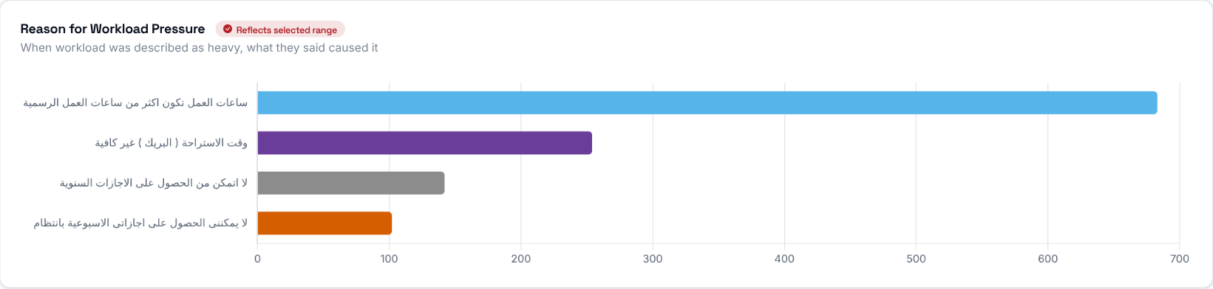
A breakdown of the specific work-pressure reasons written in the exit interviews (interviews with no work-pressure answer are not counted).

Step 7 - Who is leaving?
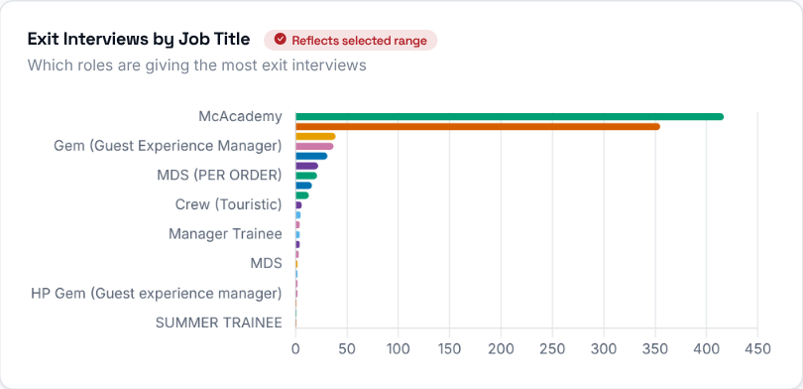 | Exit interview responses grouped by the departing employee's job title.

Step 8 - Engagement drivers
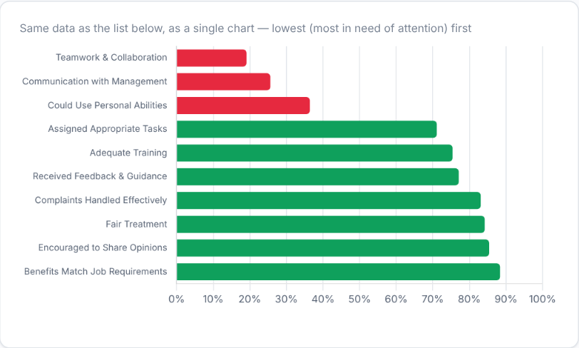 | 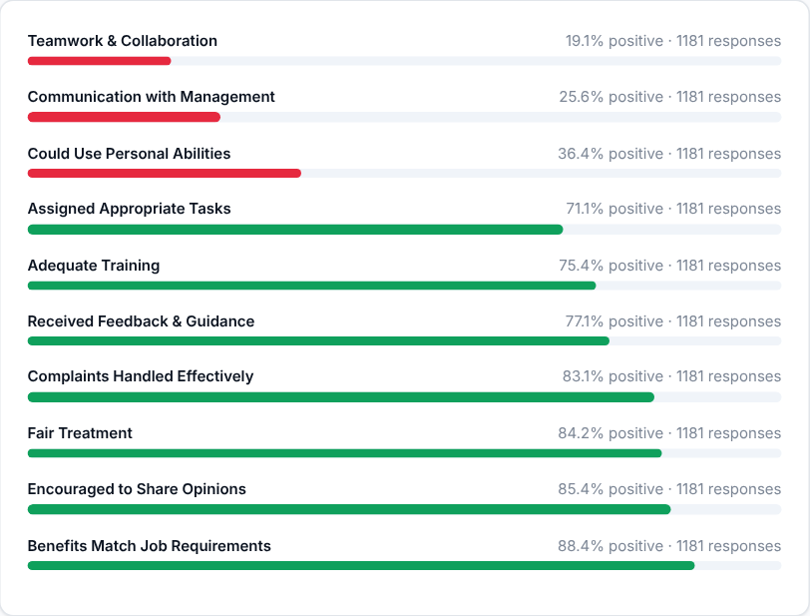
The share of people who answered positively on each engagement driver, lowest first, shown as a chart and as the same list. Bars are green at 70%+ positive, amber at 40-69% and red below 40%. The drivers at the top need the most attention.
Then decide: pick the lowest one or two drivers and agree with the Operation Consultant what will change in the stores concerned.

Step 9 - Read what people wrote
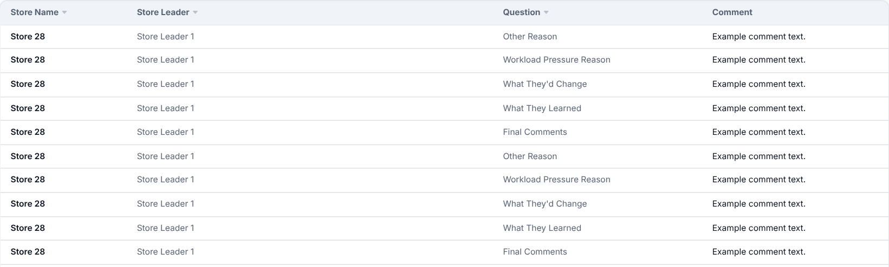
The free-text comments departing employees left (reasons given as "other", work-pressure reason, what they would change, what they learned, final comments), with store and store leader, searchable by text, store or question and filterable by question.
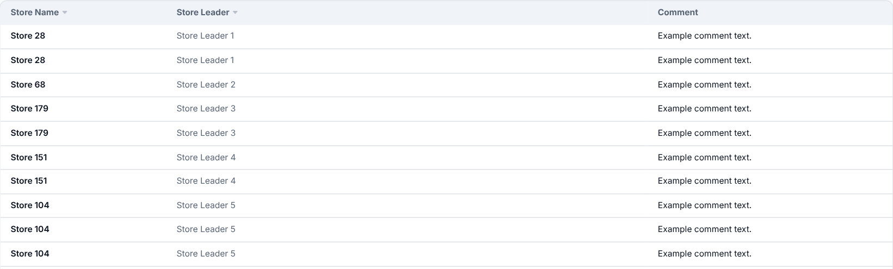
What departing employees said they would change about the job or store, newest first (click Store or Store Leader to re-sort); the same answers also appear in the Comments table above, under the question "What They'd Change".

Early Warning
Where to find it: Side menu > Early Warning
Use this page to spot people who may be about to leave, before they actually do. It flags currently active employees who statistically resemble people who resigned in the past. Each flagged employee gets a 1-5 star risk score built from several weighted signals; employees with no matching signal are not listed. Higher stars mean higher predicted risk. Everyone flagged counts as "watch-listed" (cards and charts); those at 4-5 stars appear in the High-Risk table and the rest (1-3 stars) in the Watch List table.

Step 1 - Choose your scope
Choosing a Store or Job Title filters every card, chart and table to that selection. The Year/Months filter picks which monthly roster the risk scores are calculated on (the latest selected month). Because risk is about currently active employees, it is normally left on the latest period; the trend chart ignores it.

Step 2 - Read the headline numbers
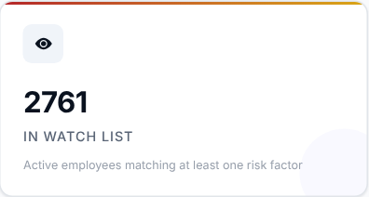 | 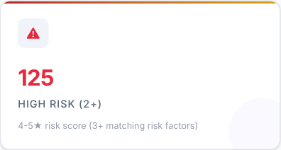 | 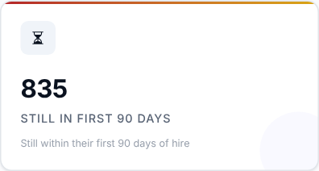 | 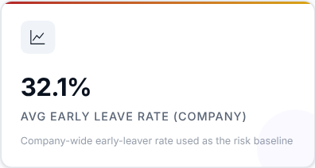

What to look at: High Risk (the people at 4-5 stars) first, then how many are still inside their role's new-hire window (90 days by default, 30-180 days by role). The fourth card shows the company-wide early-leave rate used as the baseline.

Step 3 - Read the Smart Insights
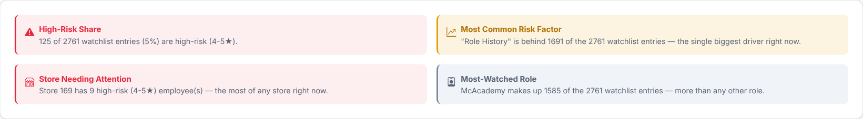
Automatic takeaways worked out from the watch list for your current filters.

Step 4 - What is driving the risk?
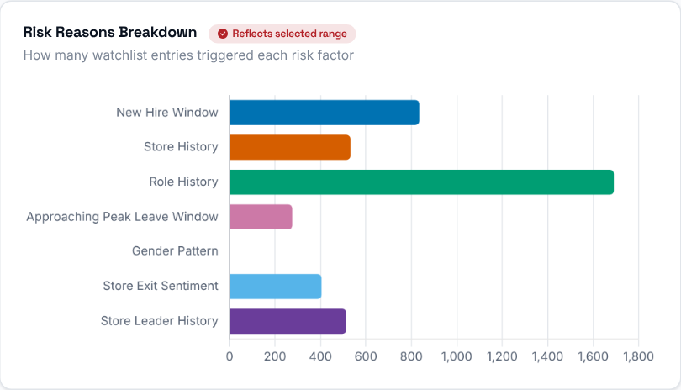  Which risk signal (reason) is driving flags most often across the watch list right now. | 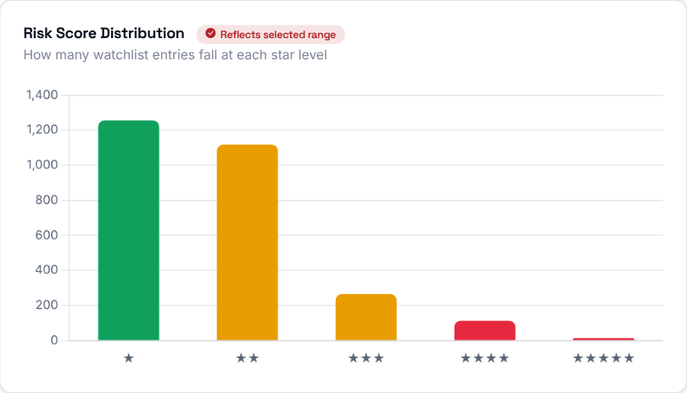  How many watch-listed employees fall into each star rating (1 through 5), so you can see the overall risk distribution.

Step 5 - Where is the risk?
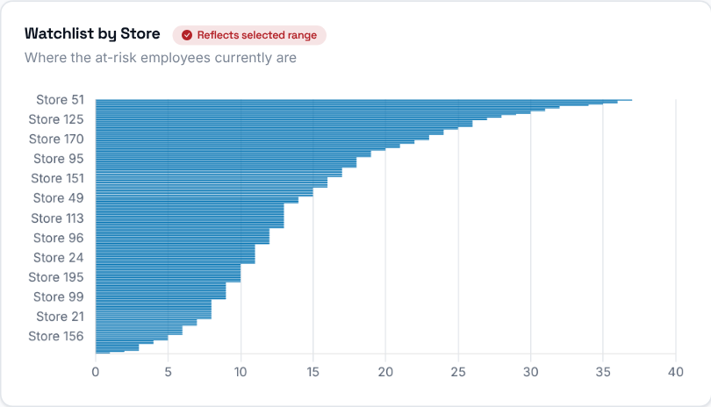  Watch-listed employees grouped by store, so you can see which stores carry the most flight-risk headcount right now. | 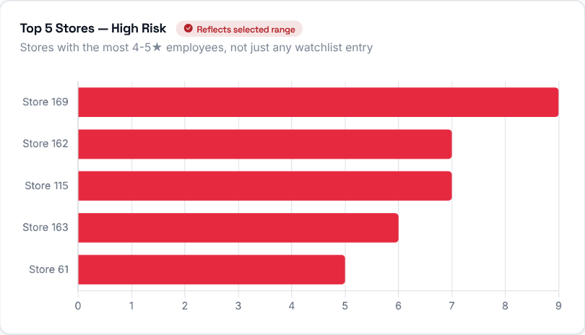  The 5 stores with the most highest-risk (4-5 star) employees.

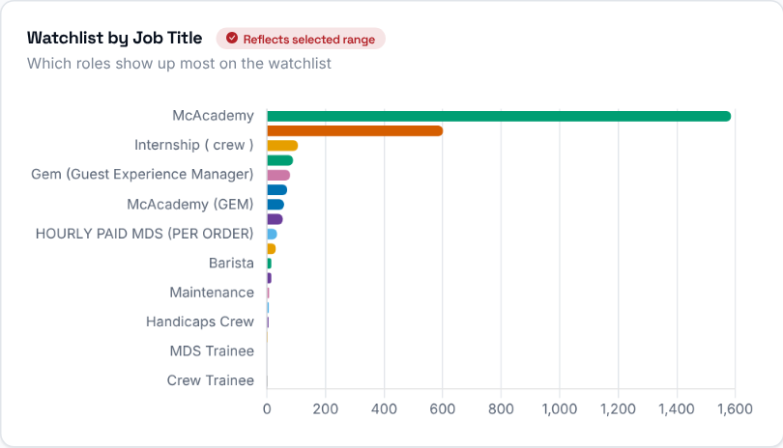 | Watch-listed employees grouped by job title.  Then decide: start with the stores at the top of the high-risk chart and talk to their Operation Consultants.

Step 6 - Is the watch list growing?
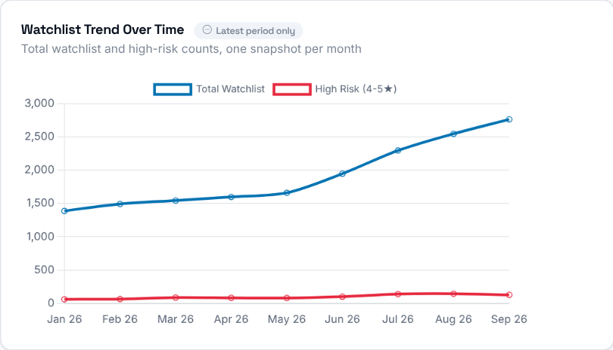 | Two lines, the total watch list and the High Risk (4-5 star) count, for every available month. It ignores the Year/Months filter.

Step 7 - Who needs attention first?
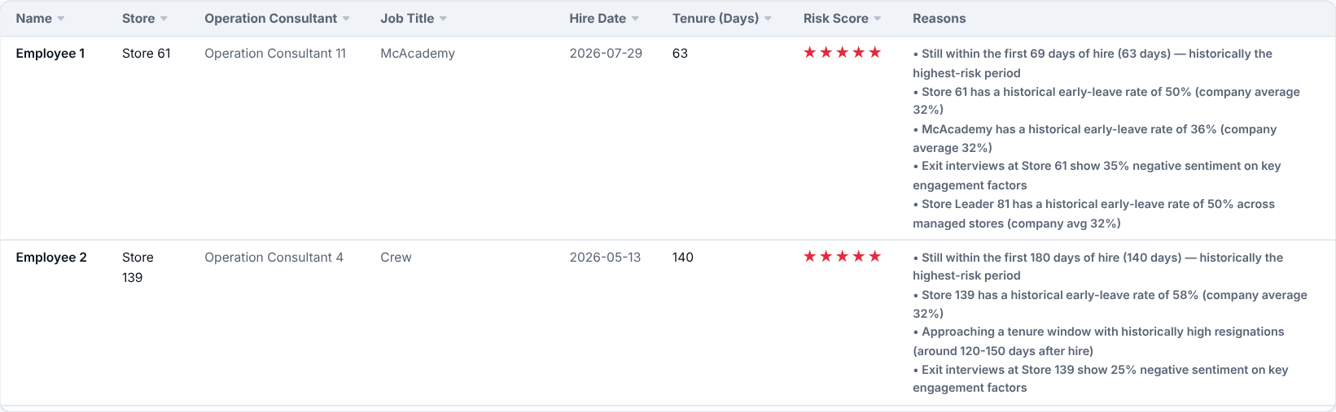
Employees at 4-5 stars - the most urgent list - with their store, Operation Consultant, role, hire date, tenure so far, star score and the specific reasons that flagged them.
Then decide: make sure someone speaks to each of these employees soon, and look at what the listed reasons suggest (for example a store or role with a history of early leavers).
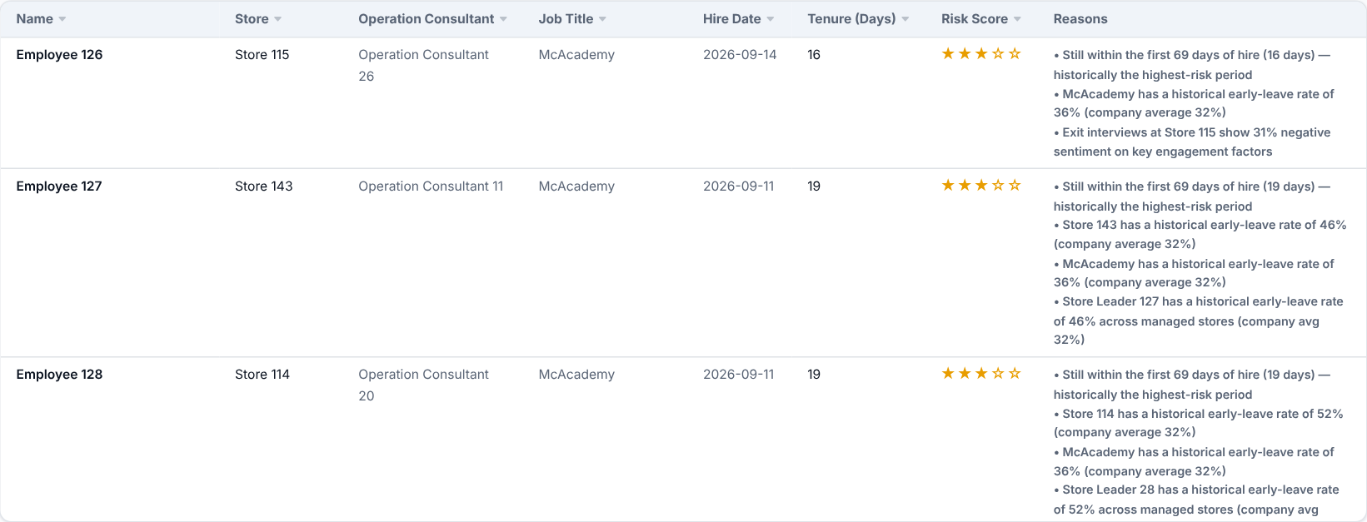
The Watch List: every flagged employee at 1-3 stars (those at 4-5 stars are in the High-Risk table above, so no one is listed twice). It is sortable and searchable (name, store, consultant, job title), with the same columns as the High-Risk table.

How the star rating is calculated
Every flagged employee starts at 0 points and gains points for each risk factor below that applies to them. The total (the risk score) is then mapped to a 1-5 star rating. 4-5 stars is what the High-Risk table and charts use. The history-based factors only use employees hired on or after 1 January 2026.
Risk score | Stars / level
1 | 1 star - Low
2 - 3 | 2 stars - Low-Medium
4 | 3 stars - Medium
5 - 6 | 4 stars - High Risk
7+ | 5 stars - High Risk

Factor | Points and when it applies
New Hire Window | 1-3 points: tenure falls within the role's new-hire window (30-180 days by role): under 40% of it elapsed = 1 point, 40-74% = 2, 75% or more = 3.
Store History | 1-3 points: the store's 90-day early-leave rate is well above the average store (1, 1.5 or 2 standard deviations above it).
Role History | 1-3 points: the job title's 90-day early-leave rate is well above the average job title (1, 1.5 or 2 standard deviations above it).
Peak Resignation Window | 1-2 points: tenure is approaching (1 point) or inside (2 points) the store's/role's historical peak resignation window, which only applies after the first 90 days.
Gender History | 1 point: the employee's gender group has a 90-day early-leave rate well above the average across gender groups.
Exit Interview Score | 1-2 points: the store's exit interviews (at least 3) show above-average negative answers (workload, fairness, communication, training).
Store Leader History | 1 point: the store leader's historical early-leave rate, across every store they have led, is well above average.

Scorecard
Where to find it: Side menu > Scorecard
Use this page to compare Store Leaders. It scores every Store Leader (and rolls that up by Operation Consultant and Operation Manager) on four metrics: Turnover Rate, Early Leaver (90-Day) Rate, 180-Day Retention Rate and Exit Sentiment, so leadership performance can be ranked and tracked over time, not just store performance.

Step 1 - Choose the period and your reporting line
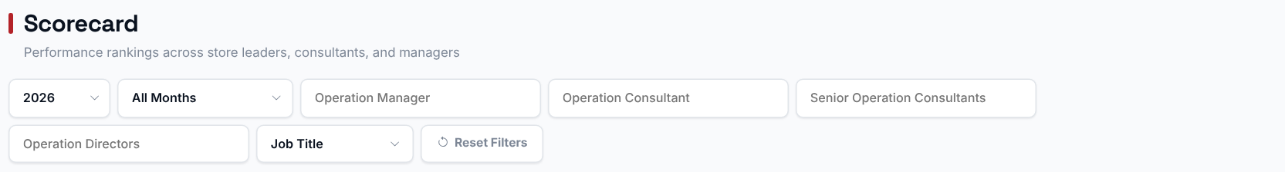
Choosing an Operation Manager, Operation Consultant, Senior Operation Consultant or Operation Director filters the ranking and the rollups to just their reporting line. The Year/Months filter sets which period's data feeds every metric on the page.

Step 2 - Read the headline numbers
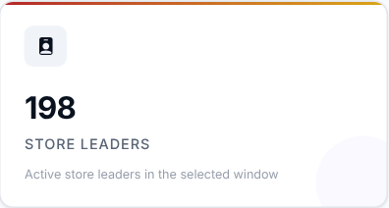 | 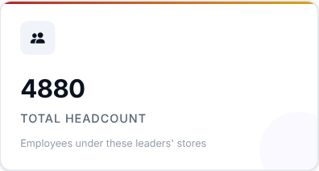 | 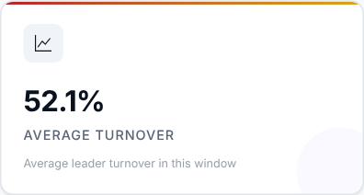 | 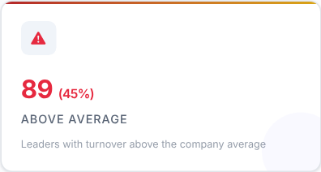

What to look at: Average Turnover and how many leaders are Above Average.

Step 3 - Read the Smart Insights
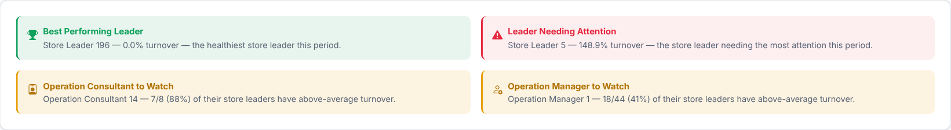
Automatic takeaways, such as the best performing leader, worked out from the ranking below.

Step 4 - Rank the Store Leaders
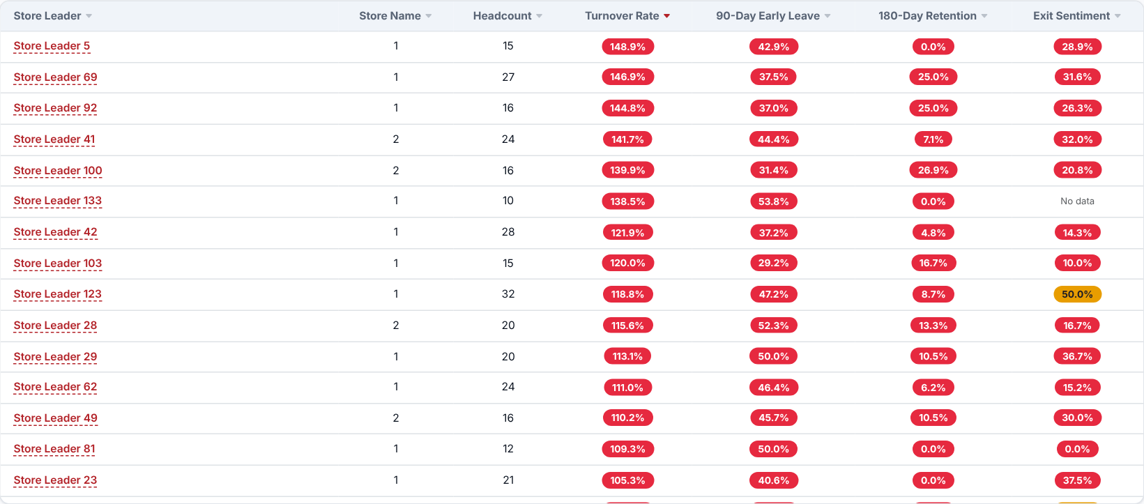
Every Store Leader ranked by Turnover Rate, Early Leaver Rate, 180-Day Retention Rate and Exit Sentiment side by side. It is sorted with the worst Turnover Rate first by default - click any column header to re-sort, and use the search box to find a leader.
Use the "Track a Store Leader" search box above the ranking to pick a leader and see their turnover rate trend over time across every store they have led, including a marker where they were transferred between stores, so a change in rate can be told apart from a change of store. (Clicking a leader's name in the ranking opens their own page instead - see below.)
What to look at: leaders who are weak on several of the four metrics at once, not just one.
Then decide: agree support or coaching with the Operation Consultant of the leaders at the top of the list.

Step 5 - Who oversees the weakest leaders?
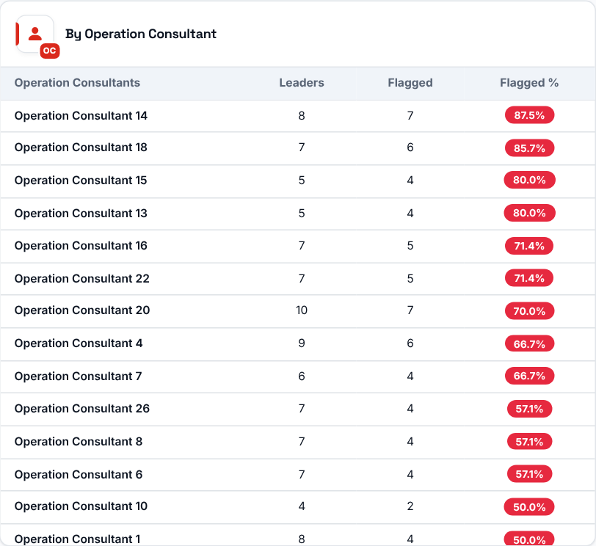 | 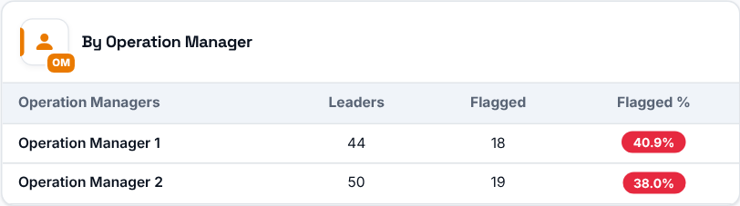  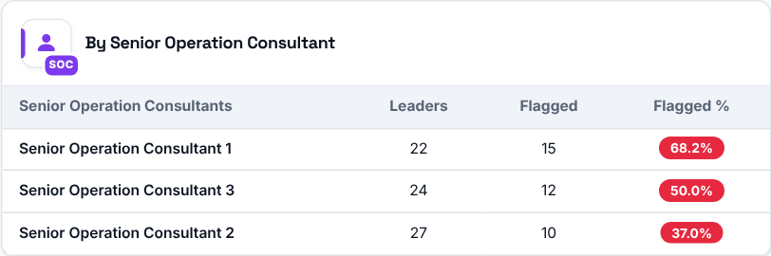  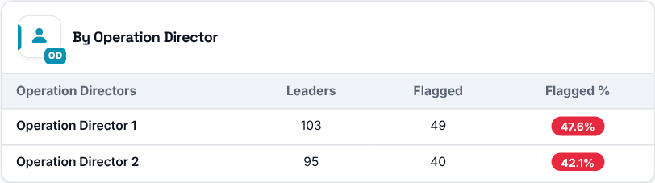
For each Operation Consultant, Operation Manager, Senior Operation Consultant and Operation Director: how many Store Leaders they oversee, how many of those leaders are "flagged" (their Turnover Rate is above the average Turnover Rate of all leaders in the selected period) and what percentage that represents.

Inside a Store Leader (Store Leader Profile)
Click a Store Leader's name in the ranking to open their own page, called Store Leader Tracking. It gives the history, performance, workforce movement and exit sentiment for that one leader in the period you selected on the Scorecard, across every store they led in that period. Use "Back to Scorecard" at the top to return.
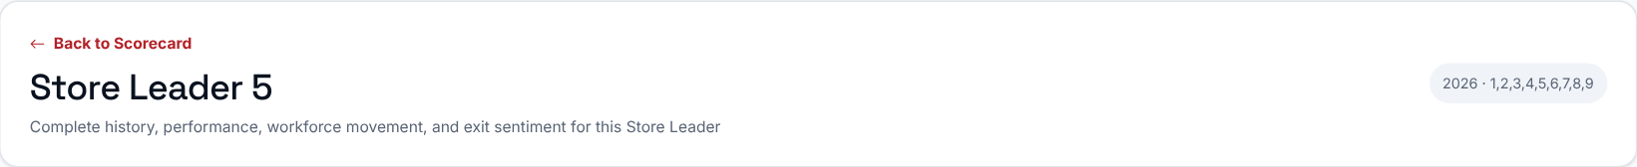
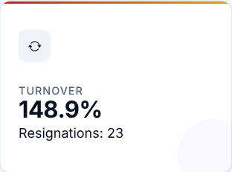 | 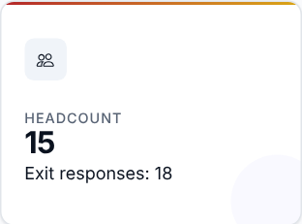 | 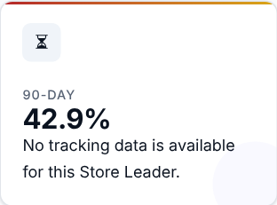 | 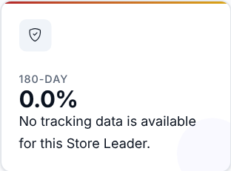
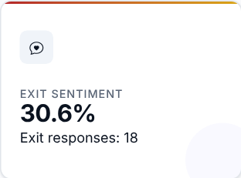

The five cards repeat the four scorecard metrics (Turnover, 90-Day, 180-Day retention and Exit Sentiment) plus the headcount. Turnover shows the number of resignations beneath it, and Headcount and Exit Sentiment show the number of exit responses.

Turnover and headcount, store by store
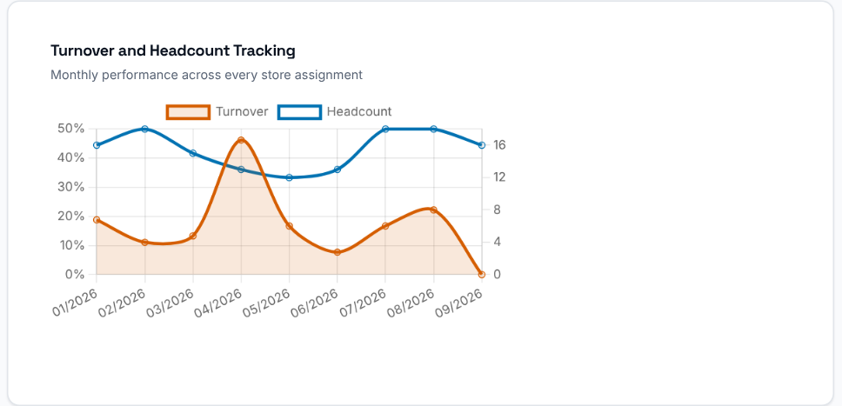  Monthly turnover rate and headcount across every store assignment, drawn as two lines. Transfers are not marked on the chart; they are flagged with a "Transferred here" badge in the assignment history table beside it, so a change in the rate can be told apart from a change of store. | 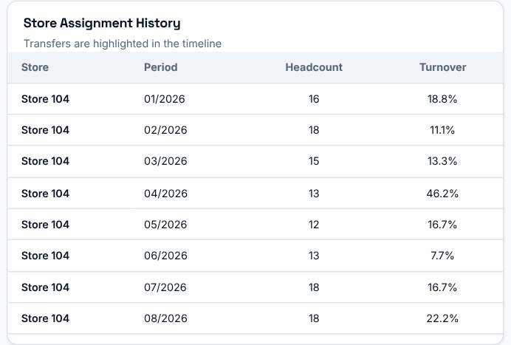  The store assignment history lists each store, period, headcount and turnover for the leader. Transfers are highlighted in the timeline.

What leaving employees say about this leader's stores
Anonymous exit-interview signals for the stores this leader runs.
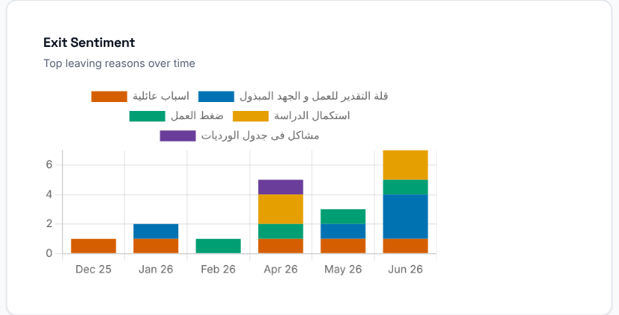  Exit Sentiment: the top leaving reasons over time. | 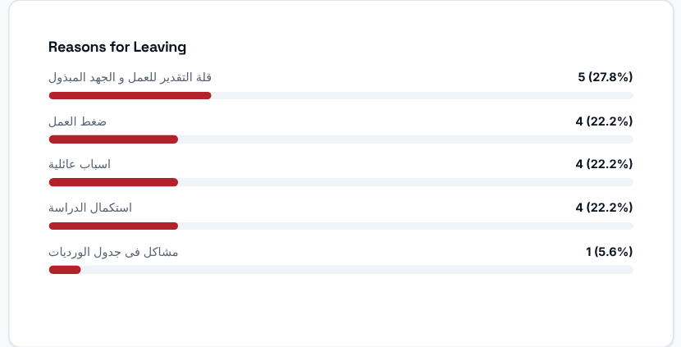  Reasons for Leaving: the reasons employees gave for resigning.

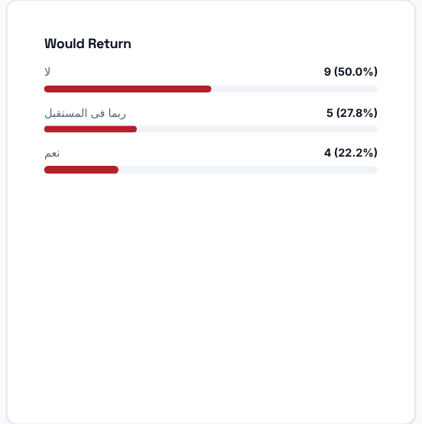  Would Return: whether leaving employees would consider coming back. | 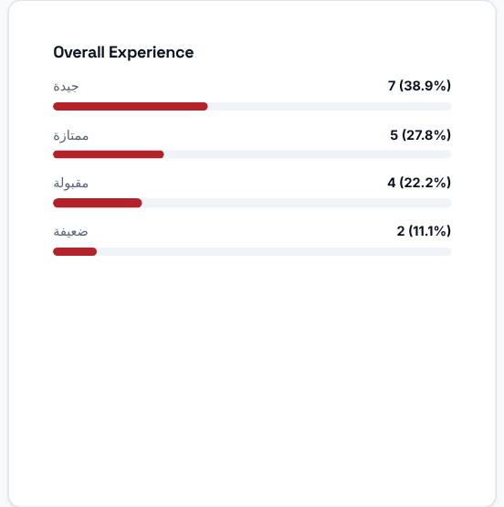  Overall Experience: how leaving employees rated their experience.

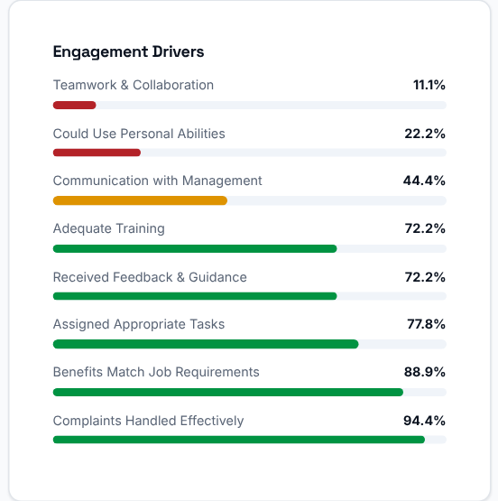  Engagement Drivers: the share who answered positively on each driver, lowest first. | 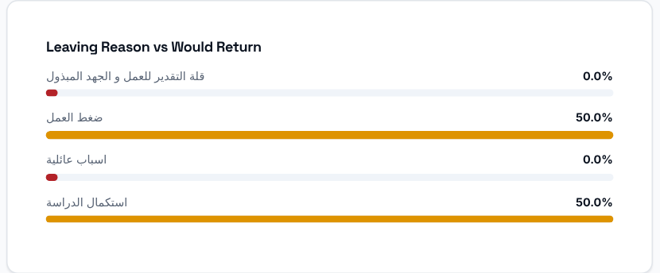  Leaving Reason vs Would Return: for each top reason, the share who said they would work here again.

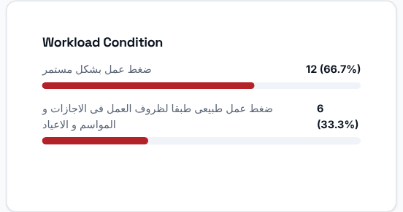  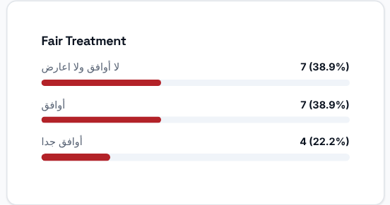 | 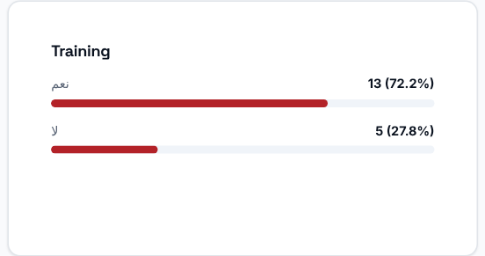
Workload Condition, Training and Fair Treatment: how leaving employees rated each of them.
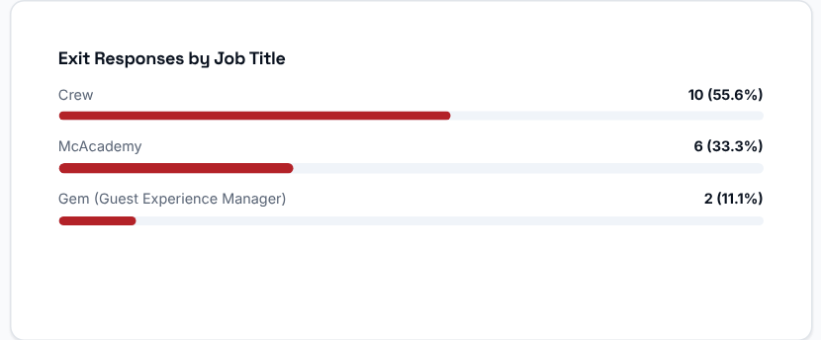 | Exit Responses by Job Title: the exit responses grouped by the leaving employee's job title.

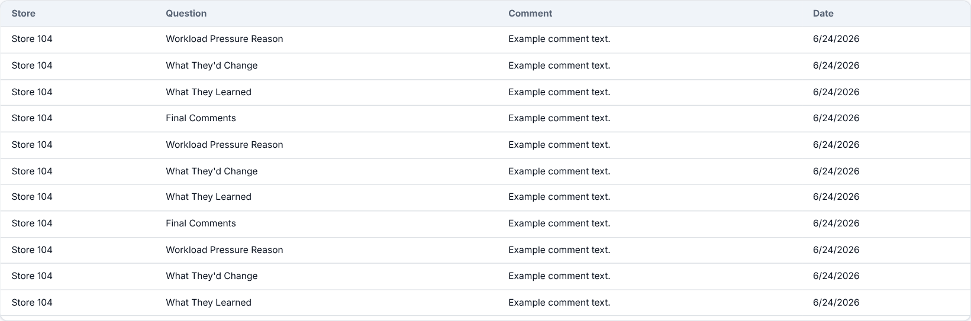
Anonymous Exit Comments: the free-text comments left in exit interviews for this leader's stores, with the store, the question, the comment and the date.
What to look at: whether a drop in the leader's turnover or a rise in exit sentiment lines up with a transfer to another store.
Then decide: use this page to prepare a fair, evidence-based conversation with the leader and their Operation Consultant.

Action Center
Where to find it: Side menu > Action Center
Use this page as your worklist of stores that need action. It scores every store you can access on a Store Health Index - a single 0-100 score where 100 means healthy - and lists them all, ranked by impact-weighted priority. Stores that tripped one of the 7 detection signals also have an Action Plan opened, shown in the Plan column. This page always shows the current state of open and resolved plans, so there is no period filter.

Step 1 - Read the headline numbers
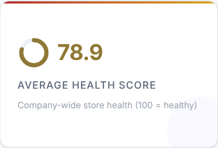 | 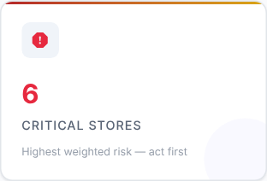 | 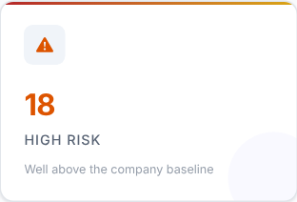 | 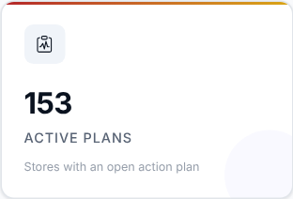
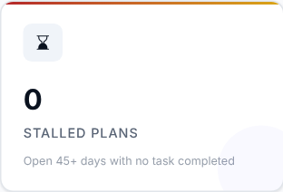 | 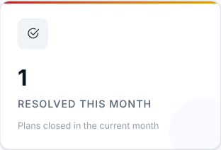

Card | What it shows
Average Health Score | Company-wide store health (100 = healthy).
Critical Stores | Highest weighted risk - act first.
High Risk | Well above the company baseline.
Active Plans | Stores with an open action plan.
Stalled Plans | Open 45+ days with no task completed.
Resolved This Month | Plans closed in the current month.

What to look at: Critical Stores and Stalled Plans first.
Then decide: critical stores need action first; stalled plans need someone to follow up with the owner.

Step 2 - Read the Smart Insights
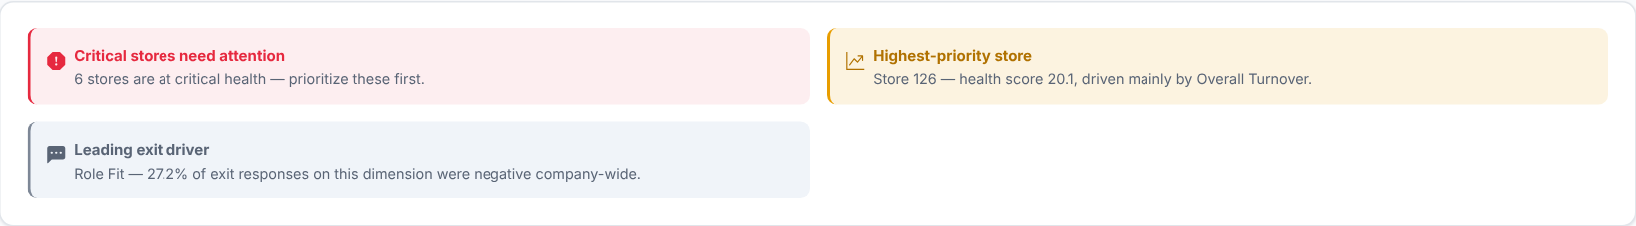
Automatic takeaways about the stores that need attention, worked out from the same data.

Step 3 - What is dragging health down?
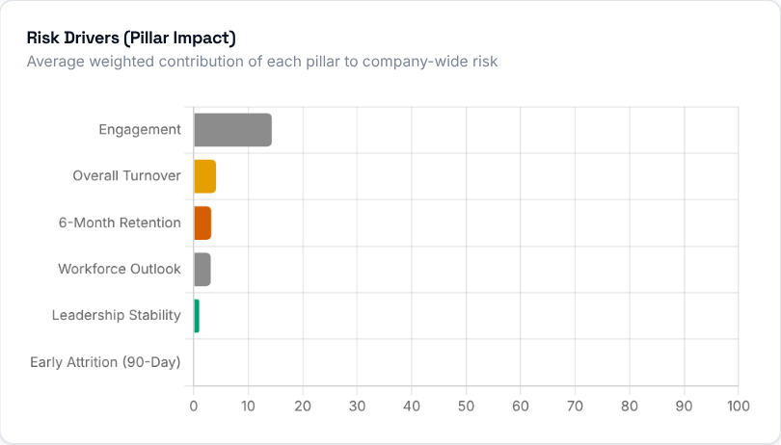  Risk Drivers show the average weighted contribution of each pillar to company-wide risk, so you can see which dimension (turnover, engagement, leadership...) is pulling health down across the network. The Store Health Index is built from six weighted pillars: Overall Turnover (24%), Early Attrition (20%), Engagement (18%), 6-Month Retention (16%), Workforce Outlook (12%) and Leadership Stability (10%). | 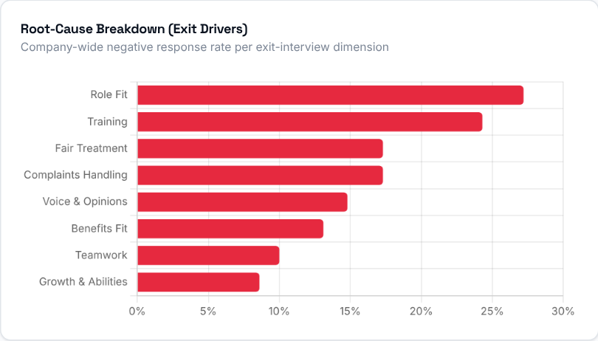  The Root-Cause Breakdown shows the company-wide negative-response rate for each exit-interview dimension (fairness, workload, communication, training...). It replaces a vague "culture" label with the specific driver that leaving employees actually flagged.

Step 4 - Which stores need action?
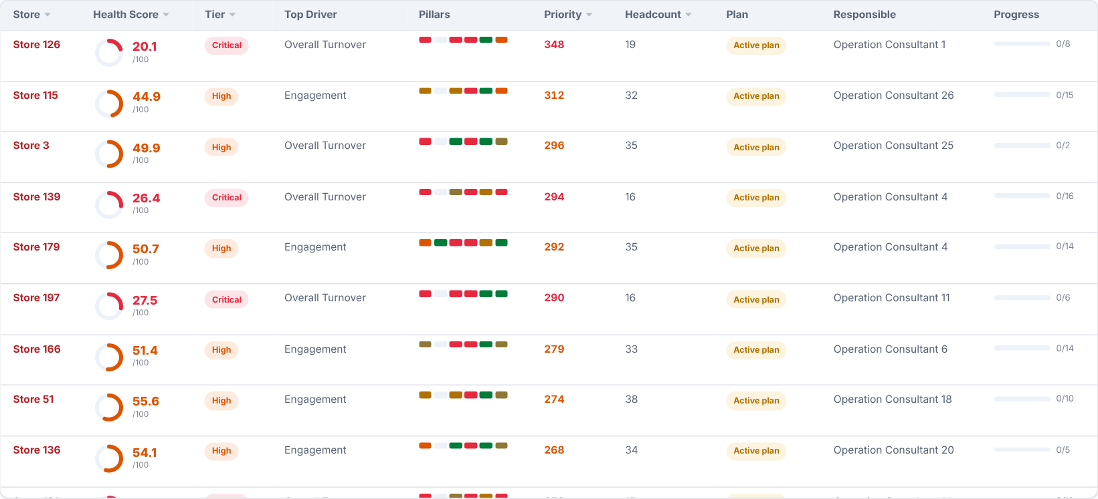
The store scorecard: health score, tier, top driving pillar, the pillar strip, impact-weighted priority, headcount, plan status, the responsible person and task progress. Click the Store, Health Score, Tier, Priority or Headcount header to sort (default: Priority, highest first), and use the search box to filter by store or responsible name. Open a store for its full breakdown and its Weighted Action Plan.
What to look at: stores in the Critical tier, and their Top Driver.
Then decide: agree with the responsible person what will be done about the top driver, and check progress at your next visit.

Step 5 - Are plans being opened and resolved?
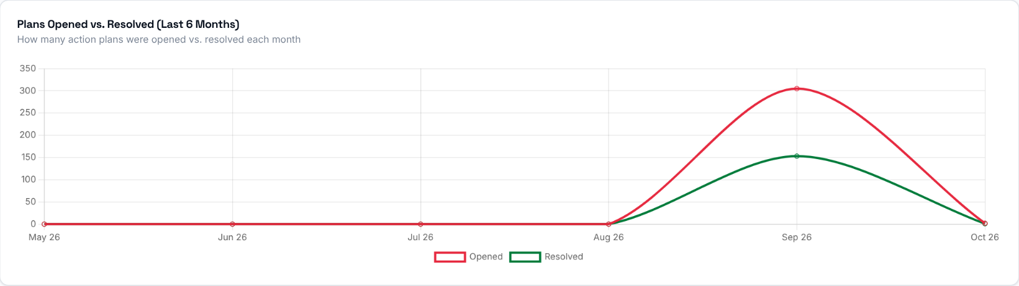
Plans opened against plans resolved over the last 6 months. If more plans open than close, open plans are piling up.

How an Action Plan is created
An Action Plan opens automatically the first time any one of these 7 signals fires for a store that has no plan open, each time uploaded data is processed:
Signal | When it fires
High Overall Turnover | Headcount of 5 or more and overall turnover rate at or above 15%.
Early Turnover (90 Days) | 3 or more hires in a non-provisional period and an early-leaver rate at or above 30%.
Low 6-Month Retention | 3 or more hires and 6-month retention below 70%.
Leadership Instability | 2 or more different Store Leaders recorded in the trailing 6 months.
Low Exit Sentiment | 2 or more exit interviews with positive sentiment below 50%.
Reason Concentration | 2 or more exit-interview reason responses where one reason is cited in 50% or more of them.
Early-Warning Watchlist | 2 or more currently active employees flagged high-risk.

A store only ever has one Active plan at a time: a new signal firing while a plan is open is added to that same plan. Severity (Medium / High / Critical) is worked out from how many signals are on the plan. If High Overall Turnover is the only real signal, the system adds a "No Dominant Driver" note that also counts, so such a plan starts at High. Each plan gets a Target Resolution Date when it opens - 90 days out, or 30 days if it is already Critical - and resolves automatically once its store shows no signals for 2 consecutive evaluated periods.

Inside a store (Action Center Detail)
Click a store in the scorecard to open its own page. It is the single-store drill-down behind one row of the Action Center table: what specifically got flagged, the store's current metrics, its severity and Target Resolution Date, the recommended actions, and a place to track progress and leave notes until the plan is resolved. This page always shows one specific store. Use "Back" at the top to return.
The header shows the store with its plan status (for example Active plan), its severity (for example Critical) and, where it applies, a label such as Chronic.

Store Health Index
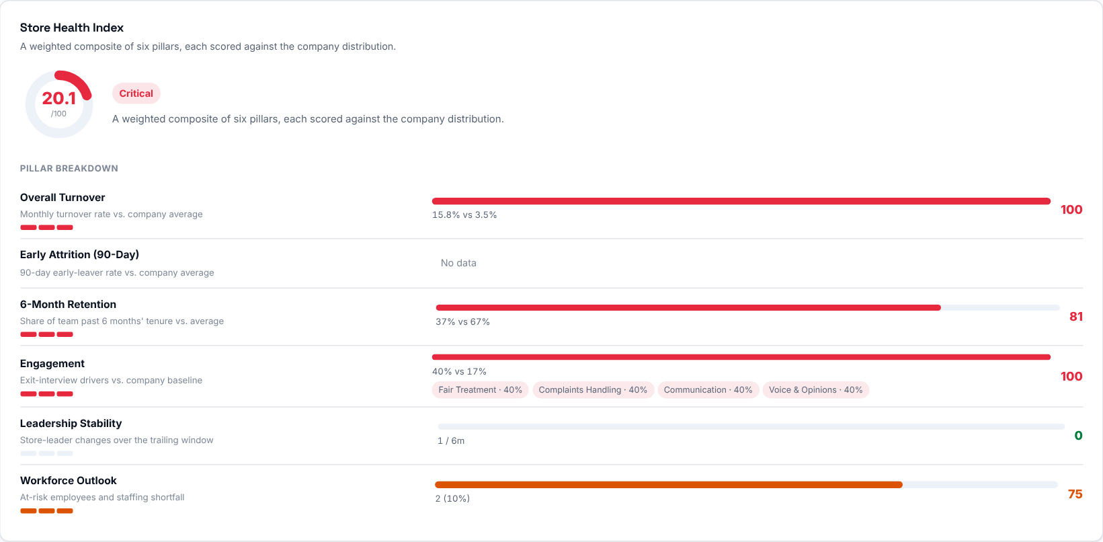
The store's health score (0-100, 100 = healthy) with its tier, and the six pillars behind it: Overall Turnover, Early Attrition (90-Day), 6-Month Retention, Engagement, Leadership Stability and Workforce Outlook. Each pillar shows the evidence behind it, for example this store's turnover against the company average. The Engagement pillar lists the specific exit-interview drivers that scored worst.

Weighted Action Plan
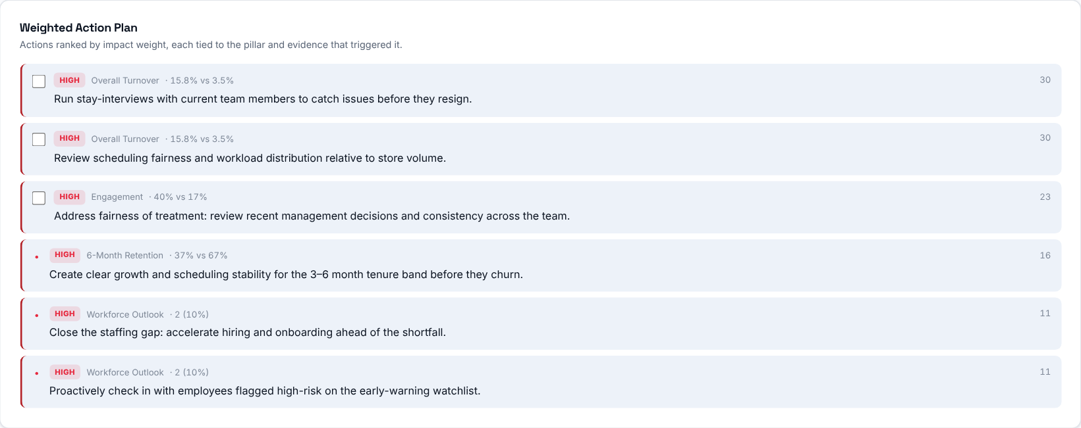
Concrete actions ordered by impact weight, each tied to the pillar and the evidence that triggered it. Where the store has an open plan, matching actions can be checked off and stay in sync with its recommendations.
Then decide: start from the top of the list - those actions have the biggest impact on the store's health.

Where the store stands
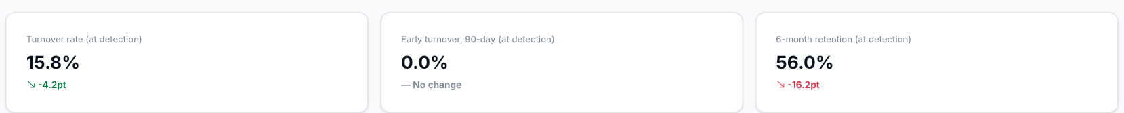
The store's latest Turnover Rate, Early Leaver (90-Day) Rate and Retention Rate, each with the change versus the baseline recorded when the plan was opened.
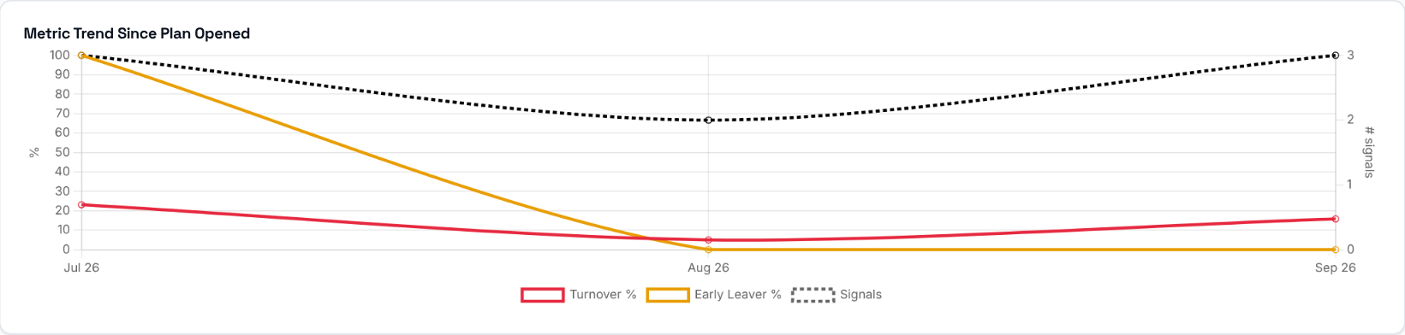
A chart of Turnover %, Early-Leaver % and the number of signals at each monthly snapshot since the plan was opened (shown once there are at least two snapshots), so you can see whether the situation is improving.
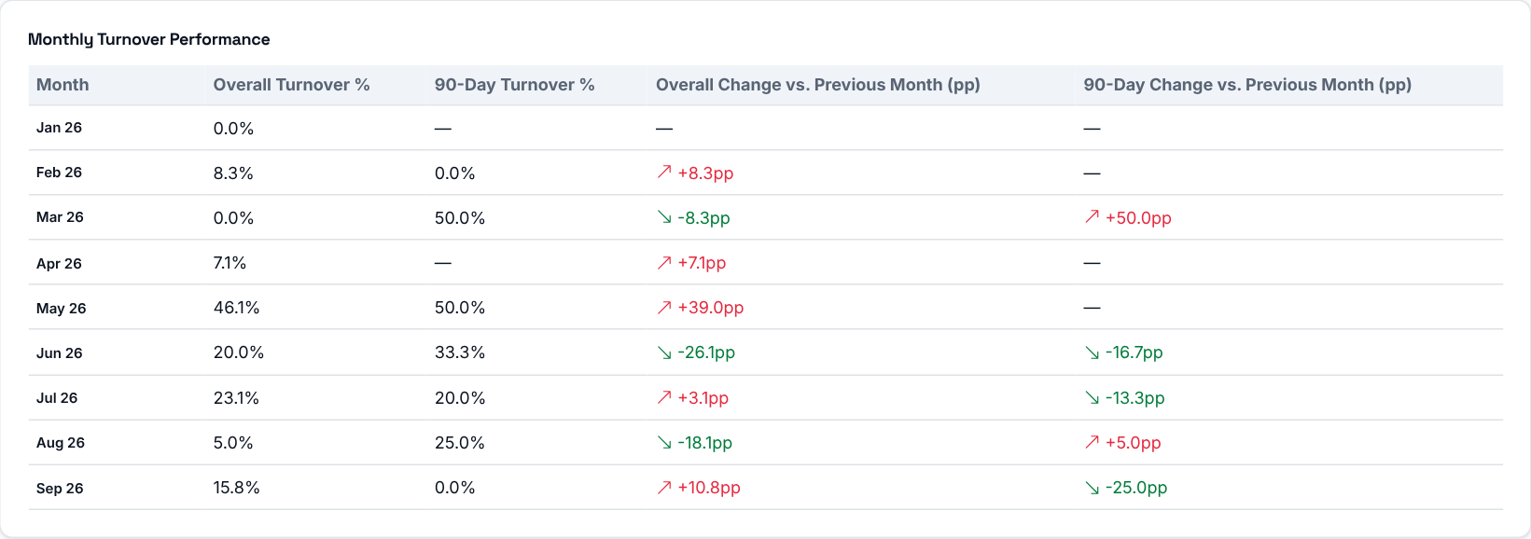
Overall Turnover % and 90-Day Turnover % for every month the store has data, each with the change versus the previous month in percentage points.
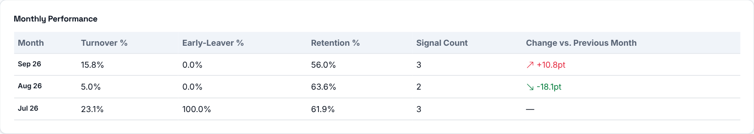
Every recorded monthly snapshot as a table: Turnover %, Early-Leaver %, Retention %, signal count and the change in Turnover % versus the previous month.

Ownership and follow-up
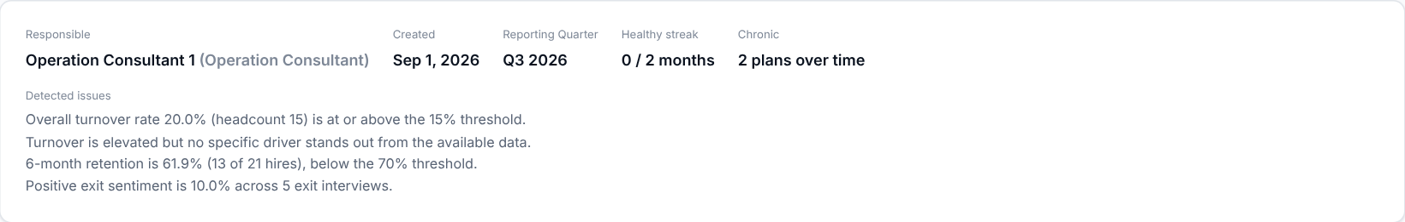
The responsible person, when the plan was created and its reporting quarter, the healthy streak (months without signals), whether it is chronic, and the plain-language explanation of exactly what was detected and why the store was flagged. Admins can assign the plan to a name and set the target resolution date; everyone else sees the same assignment read-only.
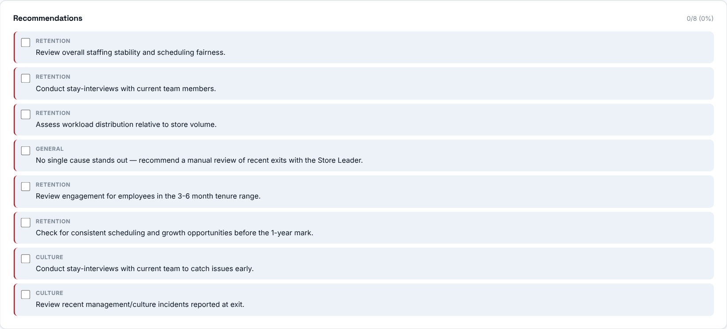
Suggested actions for this store's specific issues, each labelled with its theme (for example Retention or Culture). They can be checked off as they are completed, and the progress is shown at the top.
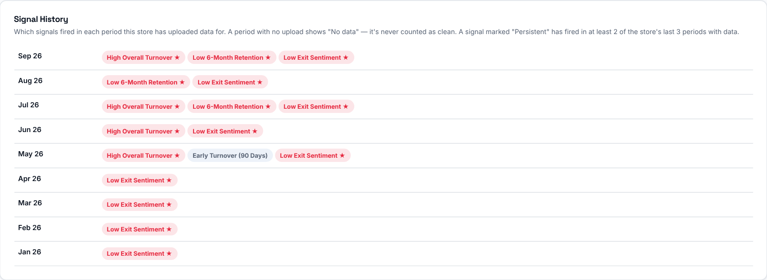
Which detection signals fired in each period, so you can see whether the problem is persistent or recent.
A running log of follow-up notes on the plan: who wrote each one, when, and their role. Admins can also close a plan manually, with a required reason, once the underlying issue has been addressed.

Stores
Where to find it: Side menu > Stores
Use this page as a directory of every store. Each store has a card showing its headcount, turnover rate, resignations, Operation Consultant and a health status at a glance, for the selected period.

Step 1 - Choose the period and your scope
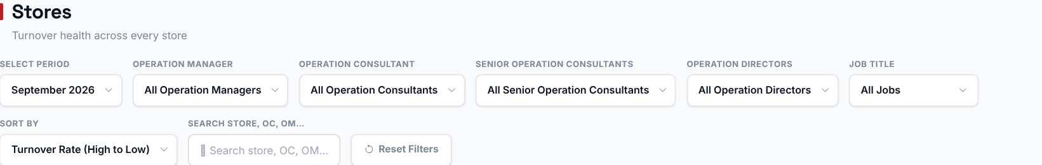
The period selector picks which month's snapshot is shown. Choosing an Operation Manager, Operation Consultant, Senior Operation Consultant or Operation Director filters the cards to just their stores. The Sort dropdown only changes the order of the cards. The search box hides cards that do not match a store, Operation Consultant or Operation Manager name; neither changes the underlying figures.

Step 2 - Read the company-wide totals
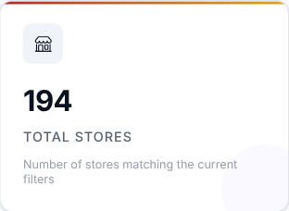 | 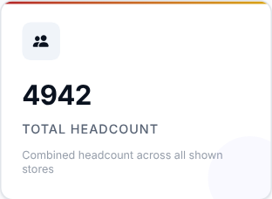 | 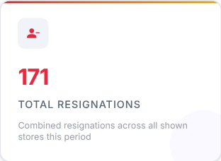 | 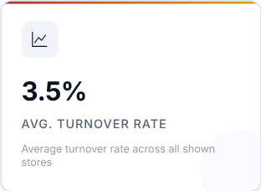
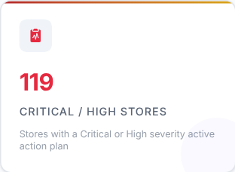 | 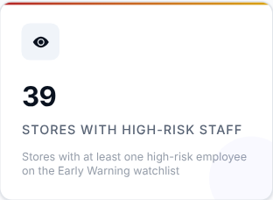

Totals for the selected period across every store: number of stores, headcount, resignations and the average turnover rate (the simple average of the store rates). Two further totals show the current position regardless of the period: how many stores have an active Critical or High severity action plan, and how many have high-risk (4-5 star) employees on the Early Warning list.

Step 3 - Read the Smart Insights
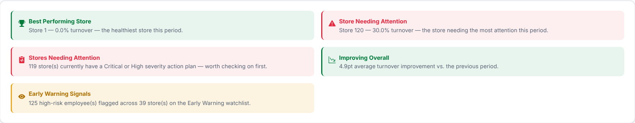
Automatic takeaways: the best performing store, the store needing the most attention, how many stores have a Critical or High action plan, the change in average turnover against the previous period, and the Early Warning signals. Best and worst store are picked only among stores with 3 or more employees.

Step 4 - Browse the store cards
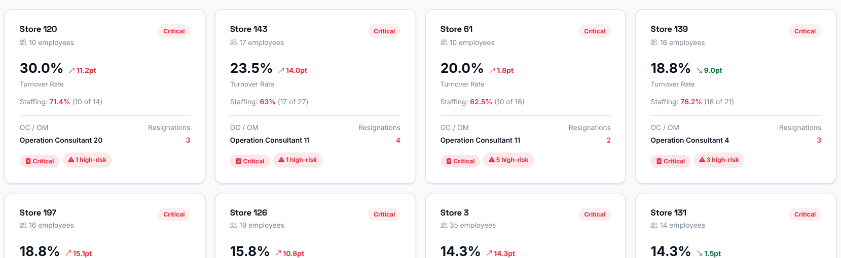
One card per store. Each card shows:
- the store name, its number of employees and a health badge (Healthy / Watch / Critical) based on its turnover rate against the thresholds configured in Settings;
- the turnover rate, with the change against the previous period;
- its Operation Consultant and its resignations;
- badges such as the action plan severity and the number of high-risk employees;
- when the store has a projection for the selected month, its staffing: actual headcount as a percentage of projected headcount - green (95-100%), amber (85-95%), red (below 85%) or blue (above 100%).
If the store has an open action plan, the card links to that store's Action Center detail.
What to look at: cards marked Critical, and a staffing figure in red.
Then decide: sort the cards by Turnover Rate (high to low), which is the default, and start with the first row.

Inside a store (Store Profile)
Click a store card to open the store's own page. It is a 360-degree profile for one store: use it to understand the store's current workforce position, turnover and early-leaver pattern, risk signals, exit-interview themes and action-plan progress without leaving the store. Use "Back" at the top to return to the list.
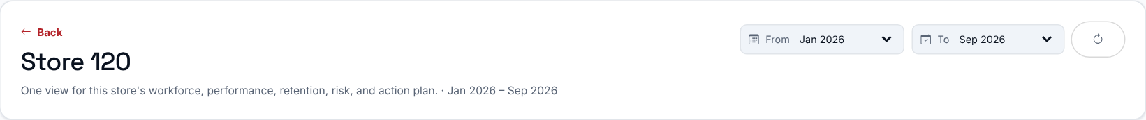
The To selector sets the month used for the headline numbers; the From and To selectors together set the range of the trend charts and monthly tables. Changing tabs keeps the same store and period.

Branch Health Command Center
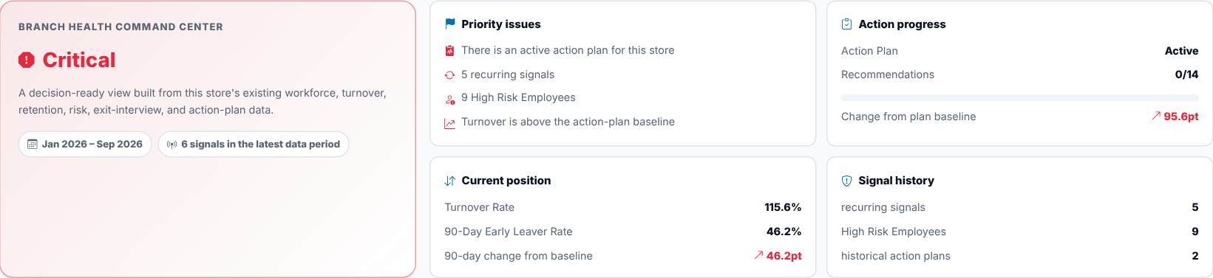
A decision-ready summary built from the selected period's current numbers together with the store's action-plan baseline, recurring signals and high-risk employees: the overall status (for example Critical), the priority issues, the current position, the action progress and the signal history. The status is a decision aid, not a new metric or data source.
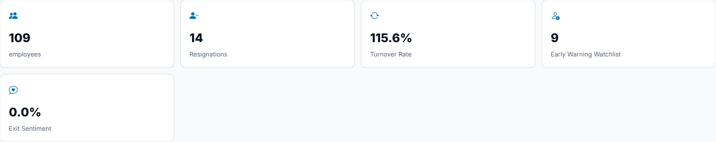
Headline numbers for the store and period: employees, resignations, turnover rate, Early Warning watchlist and exit sentiment.
What to look at: the status and the "Priority issues" list first.
The tabs below split the profile into the same topics you already know from the main pages.

Overview tab
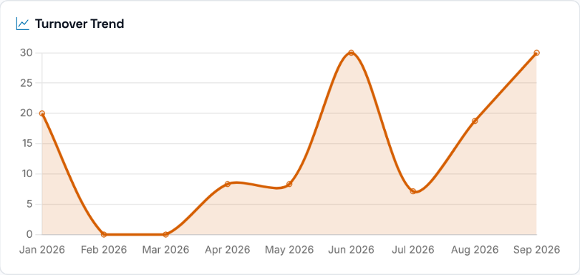 | 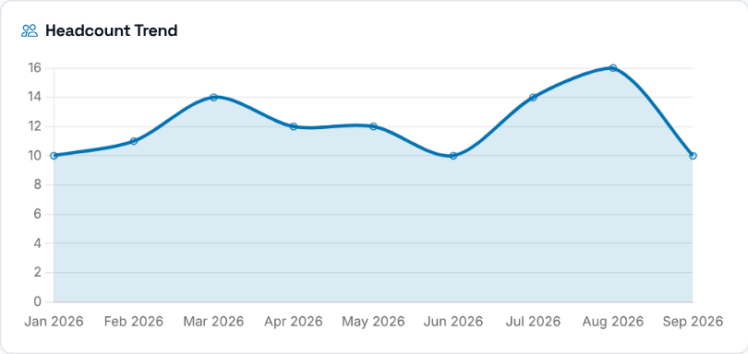
The store's Turnover Trend, and next to it the Headcount Trend over the same history.
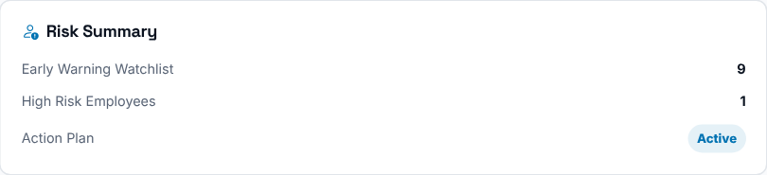 | 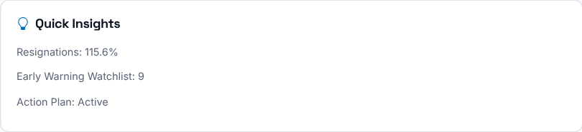
A short Risk Summary (Early Warning watchlist, high-risk employees and the action plan) and a few auto-generated Quick Insights worth a first look.

Workforce Overview tab
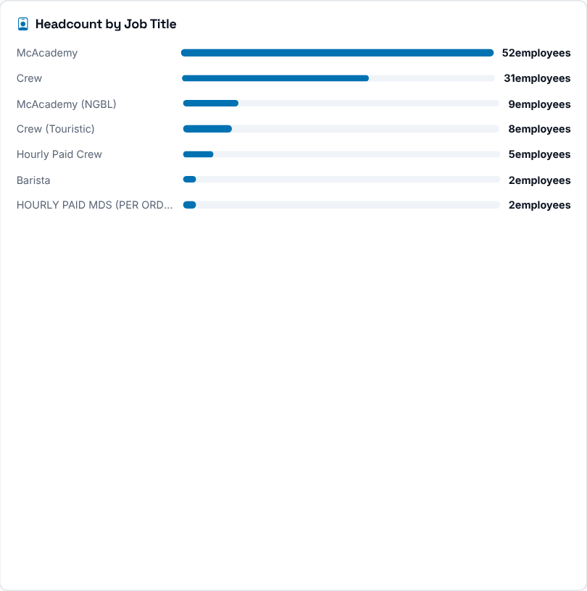 | 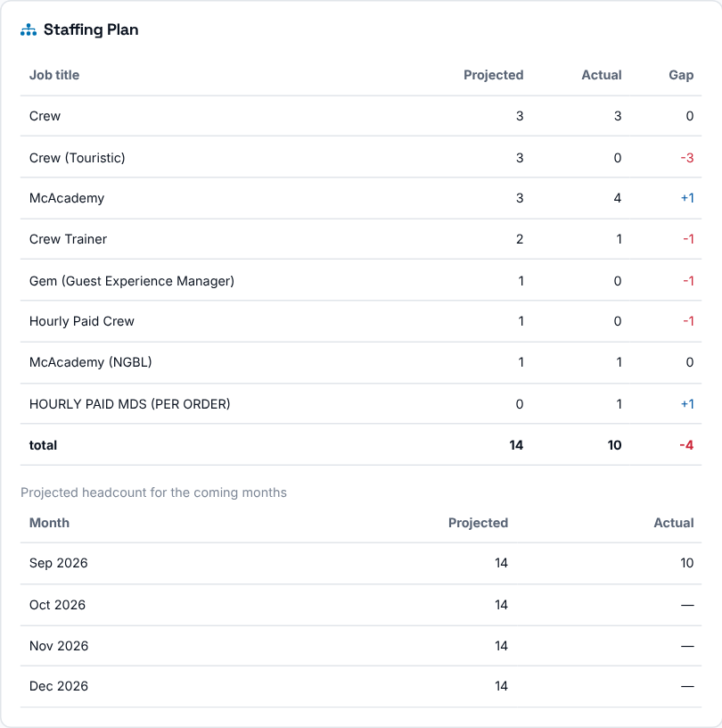
Who is currently in the store and how the team is distributed: headcount by job title, payroll group, tenure and gender. The Staffing Plan card compares the store's projected headcount with its actual headcount by job title (gap = actual - projected: + is a surplus, - a shortage) for the end of the selected period, and lists the projected headcount for the coming months. If no job projection has been uploaded for this store for the selected month, the card shows "No projection for this store in the selected month".
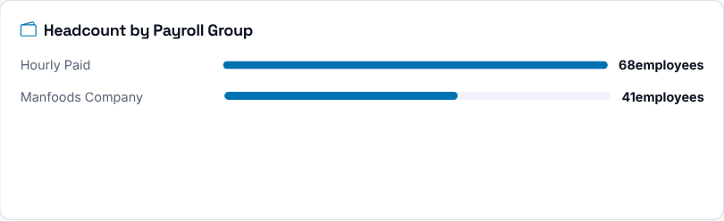  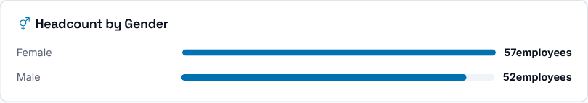 | 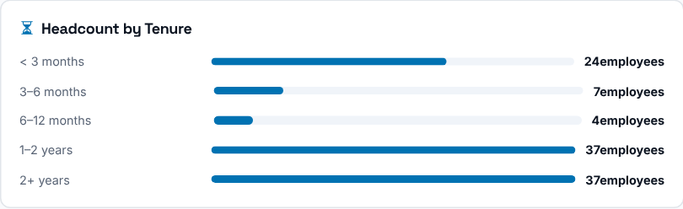

Turnover tab
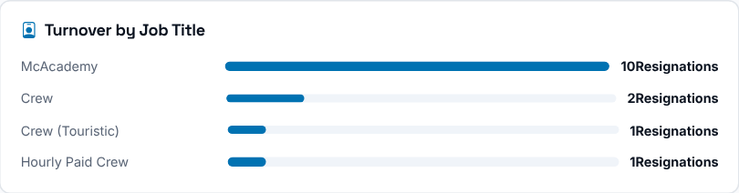
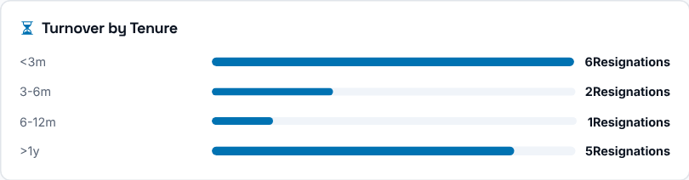
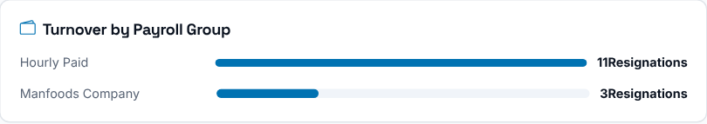
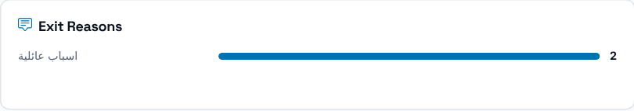
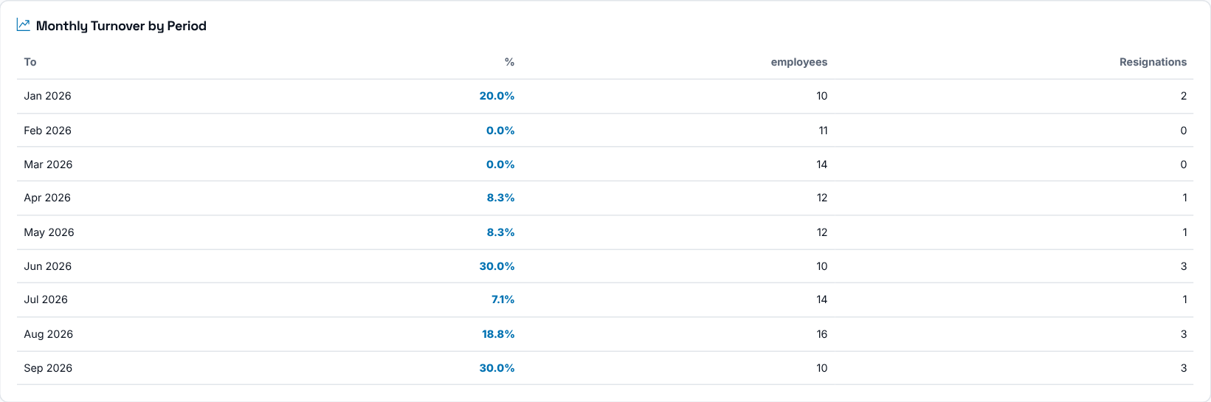
Turnover by job title, tenure and payroll group, the exit reasons, and a month-by-month table of headcount, resignations and turnover rate between the From and To periods. Compare the current rate with the trend and the action-plan baseline before deciding whether the issue is new or recurring.

Retention tab
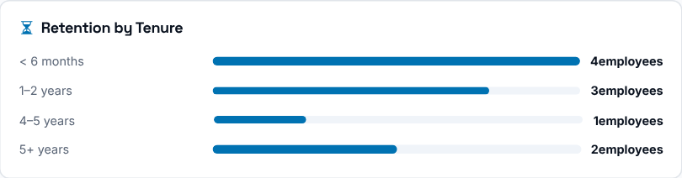  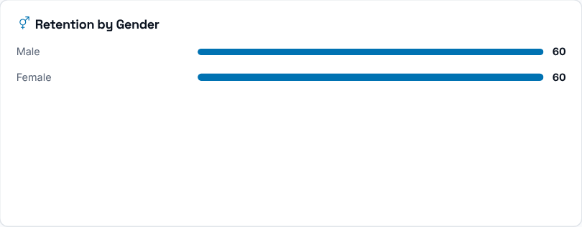 | 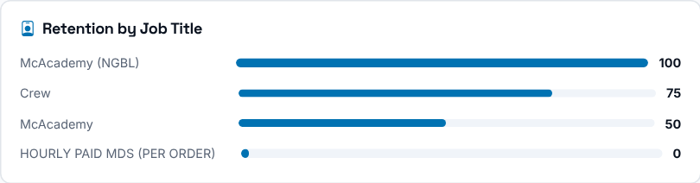  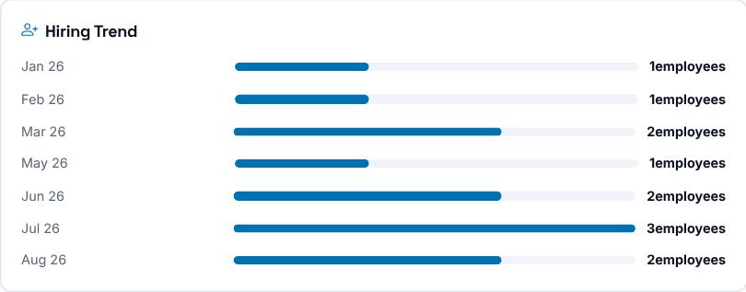
How long this store's current team stays: the tenure-band mix, retention by job title and gender, and the monthly hiring trend. It is the flip side of the Turnover tab.

90-Day Turnover tab
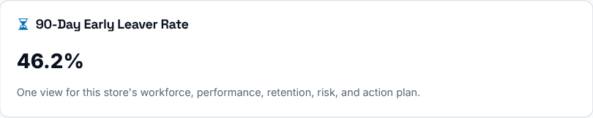
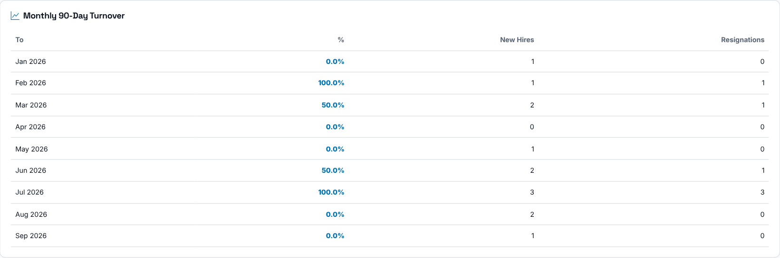
The store's 90-Day early-leaver rate for the selected period and a monthly table of the rate, new hires and early leavers. It helps distinguish an onboarding or early-tenure pattern from broader store turnover.

Early Warning tab
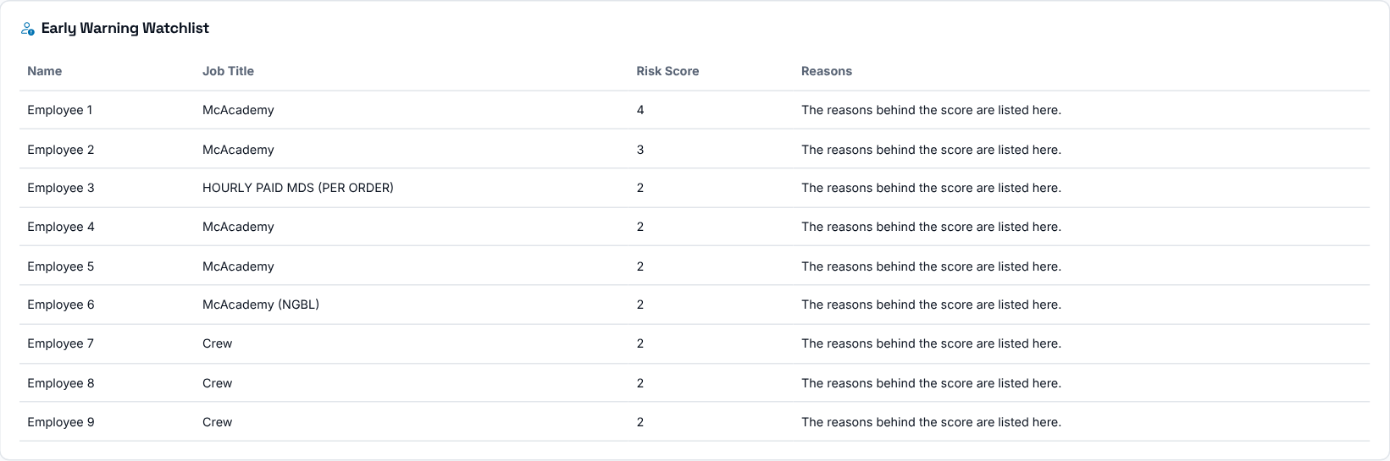
Who in the store is on the watchlist, with the job title, the risk score and the reasons behind the score. Use it to decide which employees to speak to first.

Exit Interviews tab
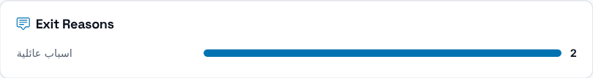
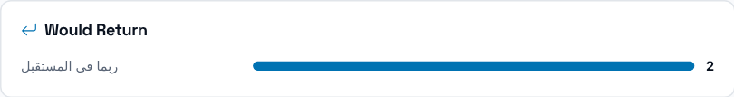
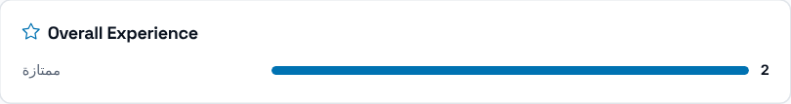
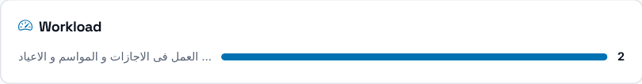
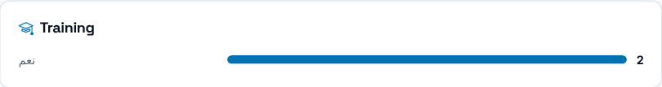
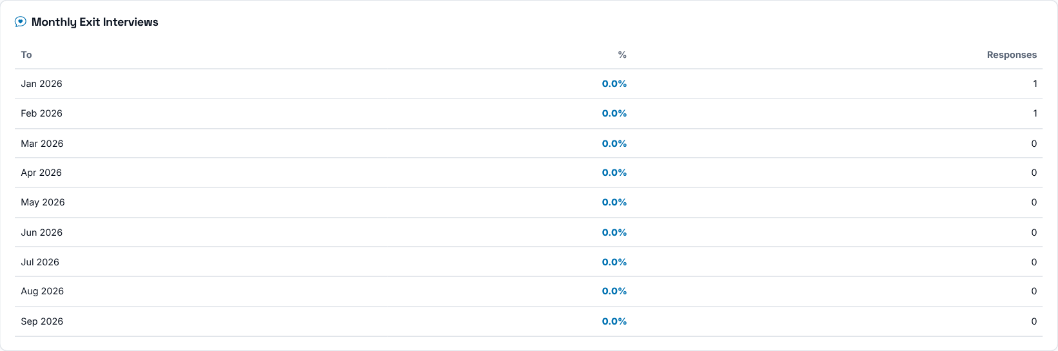
Resignation reasons, return intent, overall experience, workload and training ratings, and a monthly table of positive sentiment and number of responses for this store and the selected period. Use it to add context to the numbers on the other tabs.

Action Center tab
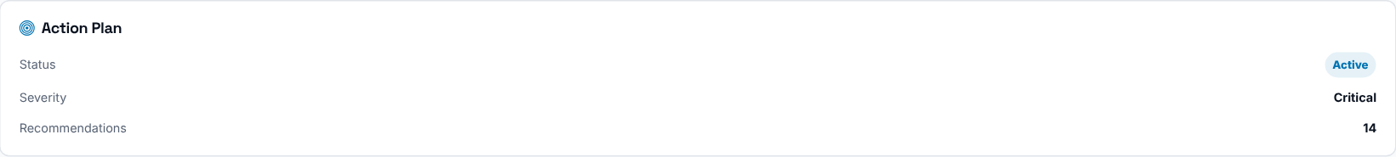
A summary of the store's latest Action Plan: its status, severity and number of recommendations. For the full plan, open the store in the Action Center. Plan progress, recurring signals and the change from the plan baseline are shown in the Branch Health Command Center at the top.

Store Leaders tab
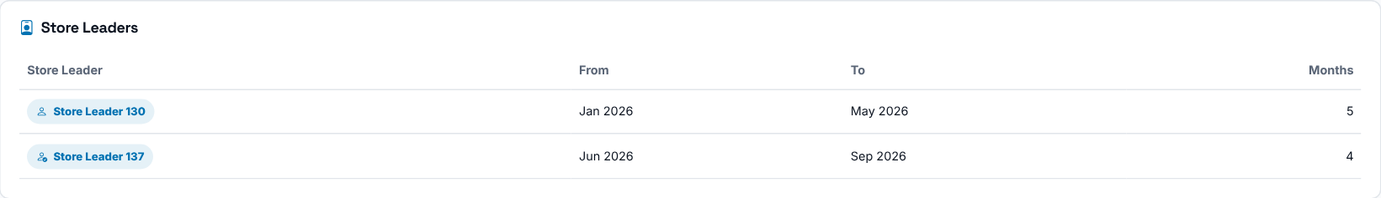
Every Store Leader who has run this store, the period each led it and how many months that covers. The current leader is marked, so you can line up a leadership change with a shift in the store's numbers.
Then decide: when a store looks Critical, read the Overview and Turnover tabs first, then check Early Warning and Store Leaders to find what changed.

Reports
Where to find it: Side menu > Reports
Use this page to download Excel reports. It is a catalog of the downloadable reports available to you, grouped by section. Click any card to open that report's own page, where you pick a period and filters before downloading. This index page itself has no filters - it is just a directory.

Store Operations
Report | What it contains
Action Center | Per-store action-plan status: severity, signals, age, ownership and task progress for every accessible store.
Stores Overview | Every store's headcount, turnover, Action Center status and Early Warning high-risk count for the selected month - the single cross-page view of store health.
Crew Trainers | Trainers against the plan and the 1-trainer-per-6-crew rule for the selected month, by store and by the people responsible, the year's trend, and who joined or left the trainer list.

Workforce & Hiring
Report | What it contains
Workforce | Employee-level roster plus active workforce composition for the selected month (headcount by job title, payroll group, tenure and gender, gender count by store) plus the headcount trend over time.
Workforce Planning | Projected vs actual headcount by job and store: summary, by store, by job, by consultant and manager, the full data sheet and ready-made Excel pivot tables.
Workforce Planning - Detailed Data | The full flat data sheet (one row per store, job and month) and the pivot tables behind the Workforce Planning report. It is large: download it only when you need to analyse the raw rows.
Hiring Forecast | Hires needed per month for a year, by store, job, payroll group and by the people responsible for the stores, with the roster and forecast months marked.

Turnover
Report | What it contains
Turnover | Company-wide turnover trend across every uploaded period, the latest period broken down by store, the full resignation list, and aggregated breakdowns by job title and tenure.
Turnover Trend Matrix | One row per store and one column per month, showing Turnover % across all available periods from the selected year onward, with a Total column (the sum of the monthly rates).
90-Day Turnover | Cohort trend, full list of early leavers, by-store rates and aggregated reasons across all available periods.
90-Day Trend Matrix | One row per store and one column per hire-cohort month, showing the 90-day early-leave rate across all available cohorts, with a Total column (the sum of the cohort rates).

Comparison
Report | What it contains
Comparison | Side-by-side Period A vs Period B: headcount, new hires, resignations, turnover rate and 90-day early-leave rate, company-wide and per store.
OC / OM Comparison | Stores, headcount, resignations and average turnover rate rolled up by Operation Consultant, Operation Manager, Senior Operation Consultant and Operation Director.

Performance & Risk
Report | What it contains
Retention | Milestone rates (90 days to 5 years), survival curve, multi-year trend, store leaderboard and workforce tenure distribution.
Scorecard | KPI rankings for Store Leaders, Operation Consultants and Operation Managers: turnover, 90-day, retention and exit sentiment.
Early Warning | At-risk employee watchlist with star risk scores (7 scoring criteria), flagged reasons, hire date and tenure, filterable by period, store and operations leadership.

Exit Interviews
Report | What it contains
Exit Interviews Report | Reasons for leaving, engagement drivers, workload ratings, overall experience and anonymous comments, aggregated across all periods matching the selected filters.

Then decide: open the report you need, choose the period and filters on its page, and download it.

Inside a report (Report Detail)
Click a report card to open that report's own page. It generates one downloadable Excel workbook. It does not show charts on screen: the filters on the page control exactly what data is written into the Excel file when you download it, so the export matches what you need. Use "Back" at the top to return to the list.
Which filters appear depends on the report: a period or year/months selector, Store / Operation Manager / Operation Consultant / Senior Operation Consultant / Operation Director and Job title filters, or, for comparison-style reports, two independent Period A / Period B panels. Leave a filter empty for "all". Reset Filters clears them.
Whatever you set is built into the Excel file the moment you click Download Excel. To get a different slice of the data, change a filter and download again.
Good to know: some reports are large (for example Workforce Planning - Detailed Data). Download those only when you need the raw rows.

Contact
For questions about the portal or the figures you see in it, please contact:
Who | Email
Human Resources - Compensation & Benefits | bcteam@mcdegypt.com

