Action Center
Where to find it: Side menu > Action Center
Use this page as your worklist of stores that need action. It scores every store you can access on a Store Health Index - a single 0-100 score where 100 means healthy - and lists the stores that tripped one of the 7 detection signals and got an Action Plan opened. This page always shows the current state of open and resolved plans, so there is no period filter.

Step 1 - Read the headline numbers
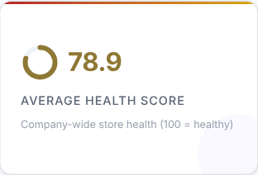 | 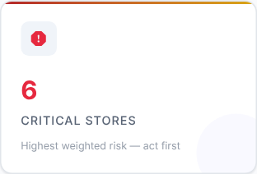 | 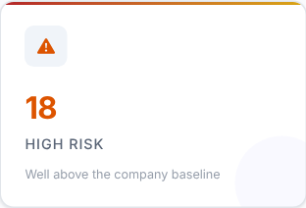 | 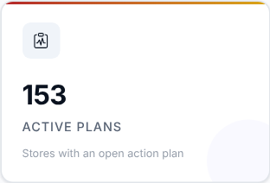
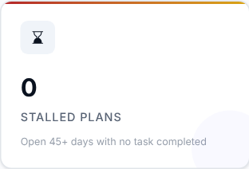 | 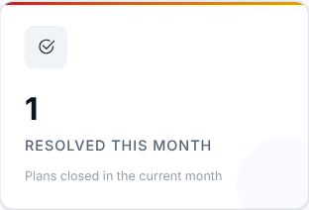

Card | What it shows
Average Health Score | Company-wide store health (100 = healthy).
Critical Stores | Highest weighted risk - act first.
High Risk | Well above the company baseline.
Active Plans | Stores with an open action plan.
Stalled Plans | Open 45+ days with no task completed.
Resolved This Month | Plans closed in the current month.

What to look at: Critical Stores and Stalled Plans first.
Then decide: critical stores need action first; stalled plans need someone to follow up with the owner.

Step 2 - Read the Smart Insights
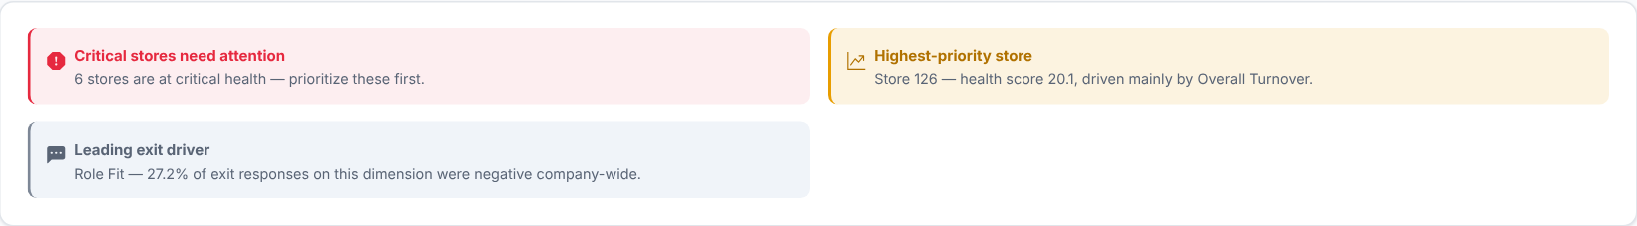
Automatic takeaways about the stores that need attention, worked out from the same data.

Step 3 - What is dragging health down?
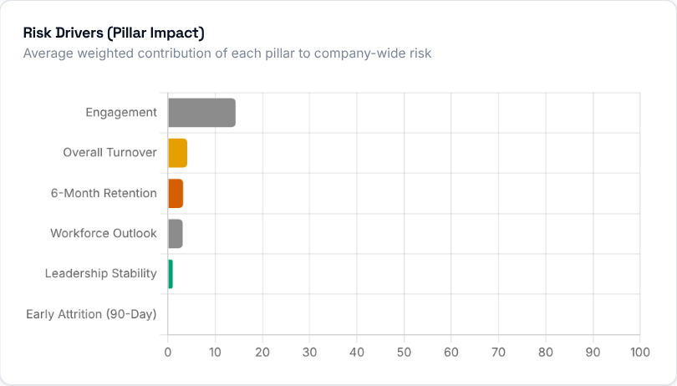  Risk Drivers show the average weighted contribution of each pillar to company-wide risk, so you can see which dimension (turnover, engagement, leadership...) is pulling health down across the network. The Store Health Index is built from six weighted pillars: Overall Turnover (24%), Early Attrition (20%), Engagement (18%), 6-Month Retention (16%), Workforce Outlook (12%) and Leadership Stability (10%). | 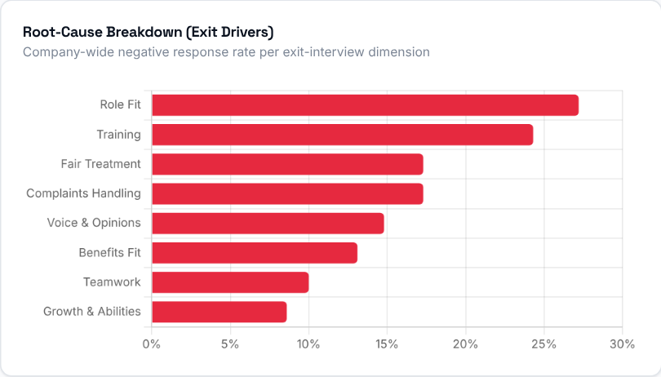  The Root-Cause Breakdown shows the company-wide negative-response rate for each exit-interview dimension (fairness, workload, communication, training...). It replaces a vague "culture" label with the specific driver that leaving employees actually flagged.

Step 4 - Which stores need action?
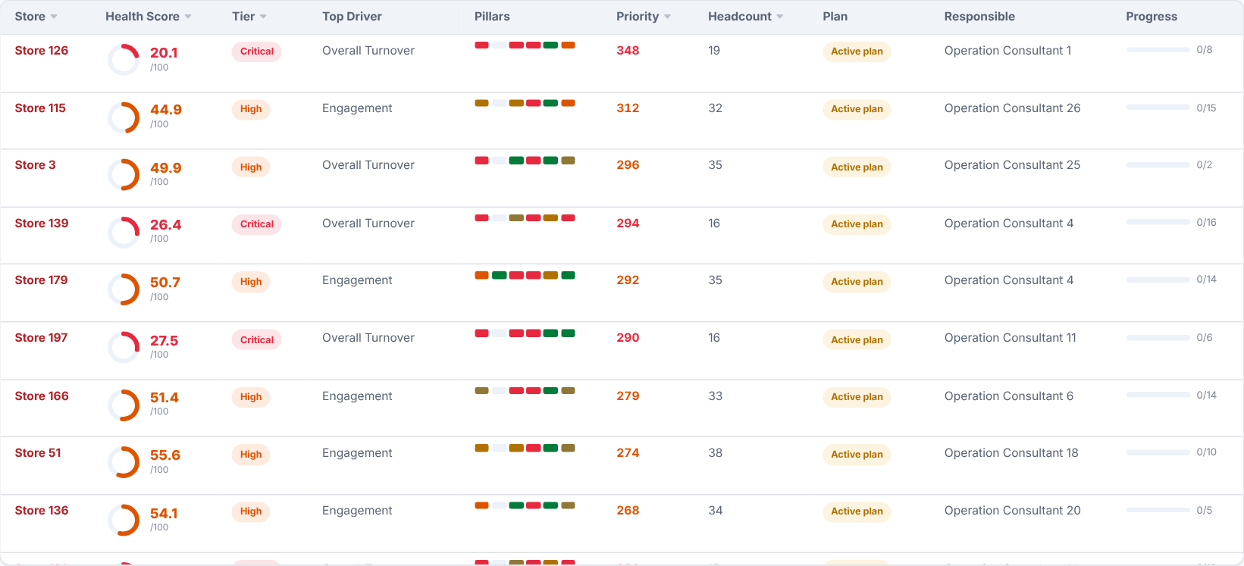
The store scorecard: health score, tier, top driving pillar, the pillar strip, impact-weighted priority, headcount, plan status, the responsible person and task progress. Click a column header to sort, and use the search box to filter by store or responsible name. Open a store for its full breakdown and its Weighted Action Plan.
What to look at: stores in the Critical tier, and their Top Driver.
Then decide: agree with the responsible person what will be done about the top driver, and check progress at your next visit.

Step 5 - Are plans being opened and resolved?
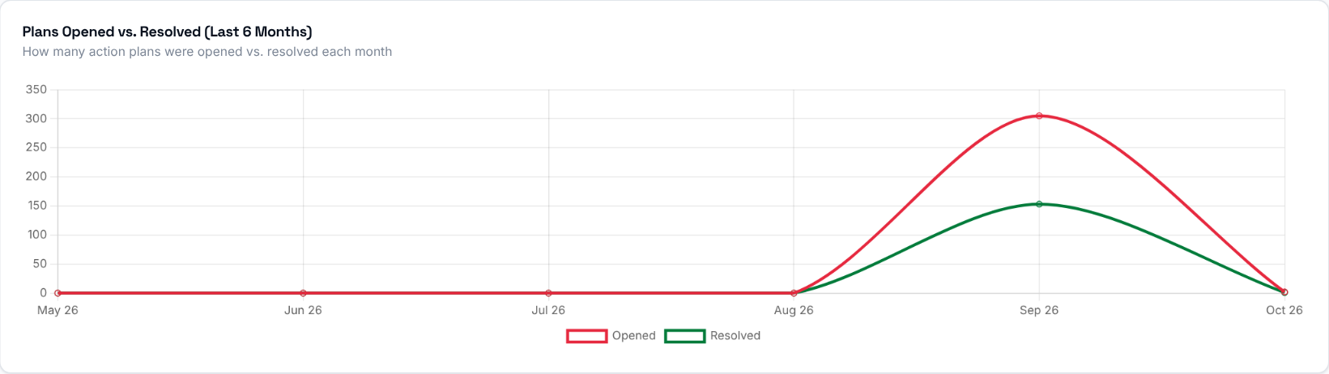
Plans opened against plans resolved over the last 6 months. If more plans open than close, open plans are piling up.

How an Action Plan is created
An Action Plan opens automatically the first time any one of these 7 signals fires for a store that has no plan open, using that period's uploaded data:
Signal | When it fires
High Overall Turnover | Headcount of 5 or more and overall turnover rate at or above 15%.
Early Turnover (90 Days) | 3 or more hires in a non-provisional period and an early-leaver rate at or above 30%.
Low 6-Month Retention | 3 or more hires and 6-month retention below 70%.
Leadership Instability | 2 or more different Store Leaders recorded in the trailing 6 months.
Low Exit Sentiment | 2 or more exit interviews with positive sentiment below 50%.
Reason Concentration | 2 or more exit-interview reason responses where one reason is cited in 50% or more of them.
Early-Warning Watchlist | 2 or more currently active employees flagged high-risk.

A store only ever has one Active plan at a time: a new signal firing while a plan is open is added to that same plan. Severity (Medium / High / Critical) is worked out from how many signals are on the plan. Each plan gets a Target Resolution Date when it opens - 90 days out, or 30 days if it is already Critical - and resolves automatically once its store shows no signals for 2 consecutive evaluated periods. See the Action Plan Guide, next, for the full explanation.

Inside a store (Action Center Detail)
Click a store in the scorecard to open its own page. It is the single-store drill-down behind one row of the Action Center table: what specifically got flagged, the store's current metrics, its severity and Target Resolution Date, the recommended actions, and a place to track progress and leave notes until the plan is resolved. This page always shows one specific store. Use "Back" at the top to return.
The header shows the store with its plan status (for example Active plan), its severity (for example Critical) and, where it applies, a label such as Chronic.

Store Health Index
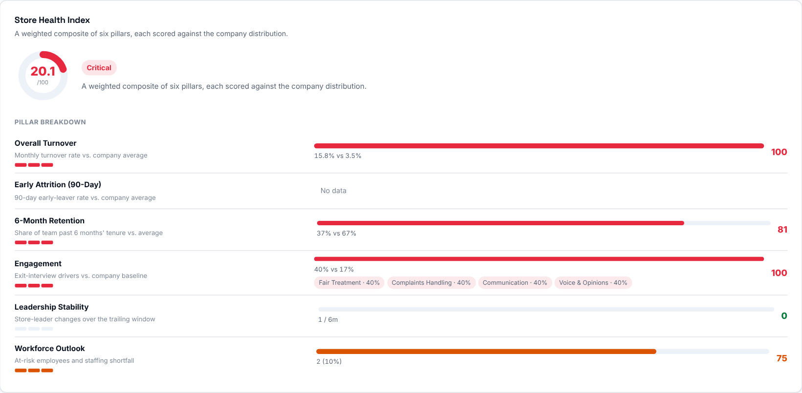
The store's health score (0-100, 100 = healthy) with its tier, and the six pillars behind it: Overall Turnover, Early Attrition (90-Day), 6-Month Retention, Engagement, Leadership Stability and Workforce Outlook. Each pillar shows the evidence behind it, for example this store's turnover against the company average. The Engagement pillar lists the specific exit-interview drivers that scored worst.

Weighted Action Plan
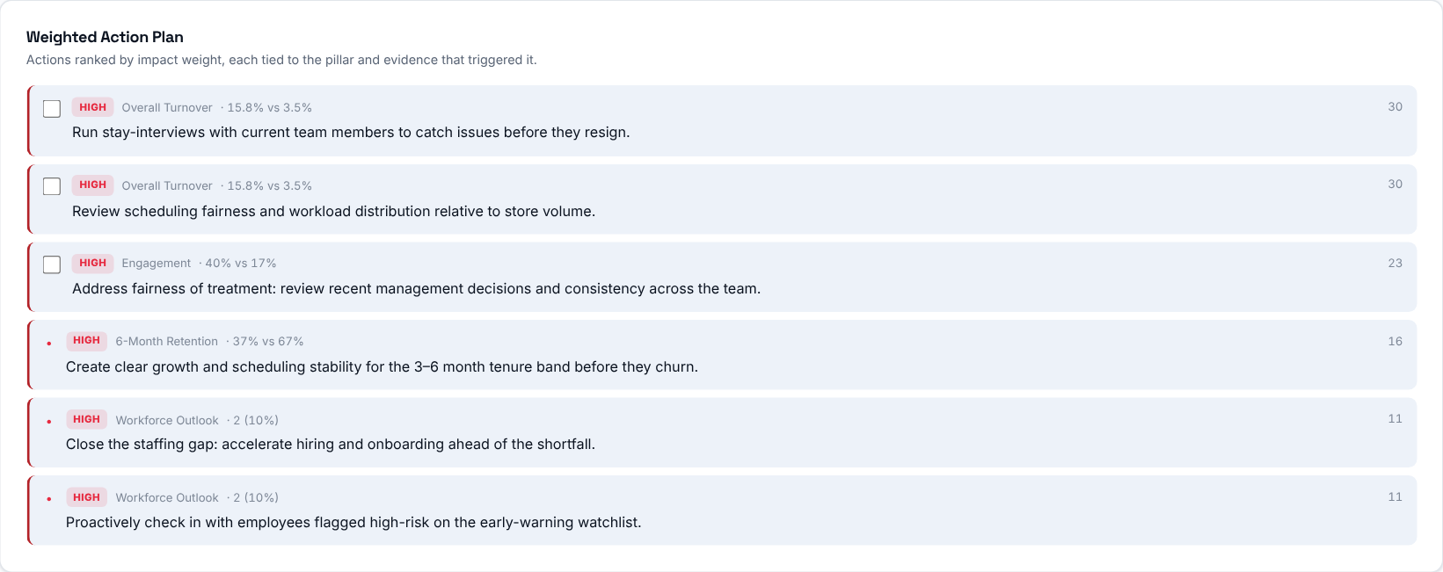
Concrete actions ordered by impact weight, each tied to the pillar and the evidence that triggered it. Where the store has an open plan, matching actions can be checked off and stay in sync with its recommendations.
Then decide: start from the top of the list - those actions have the biggest impact on the store's health.

Where the store stands
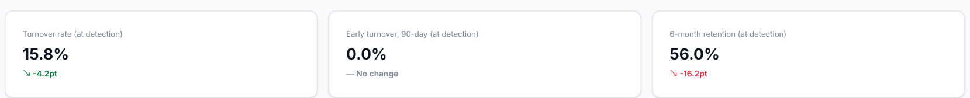
The store's Turnover Rate, Early Leaver (90-Day) Rate and Retention Rate at detection, each with the change versus the prior period.
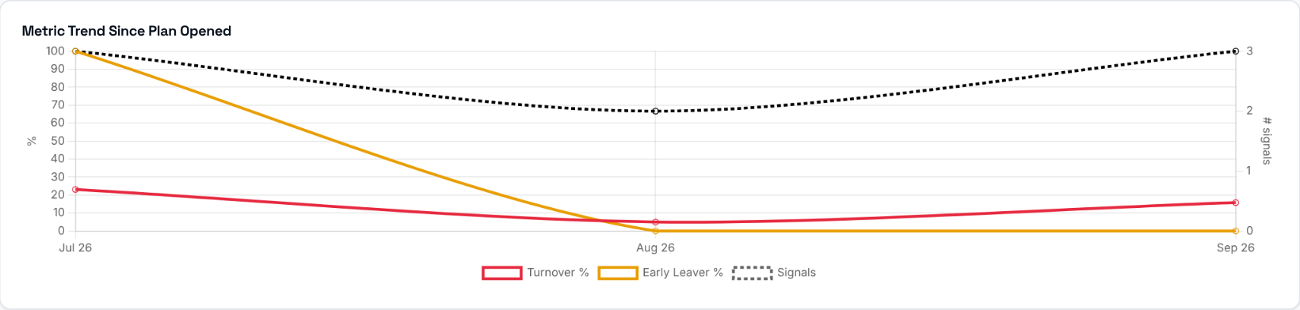
How the flagged metric(s) have trended since the plan was opened, so you can see whether the situation is improving.
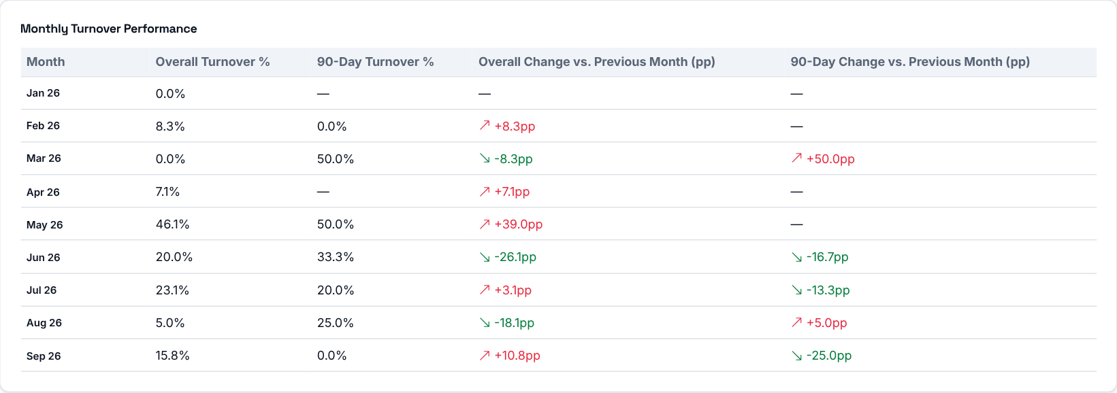
Overall Turnover % and 90-Day Turnover % for every month the store has data, each with the change versus the previous month in percentage points.
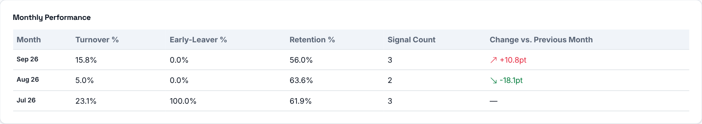
Every recorded monthly snapshot as a table: Turnover %, Early-Leaver %, Retention %, signal count and the change in Turnover % versus the previous month.

Ownership and follow-up
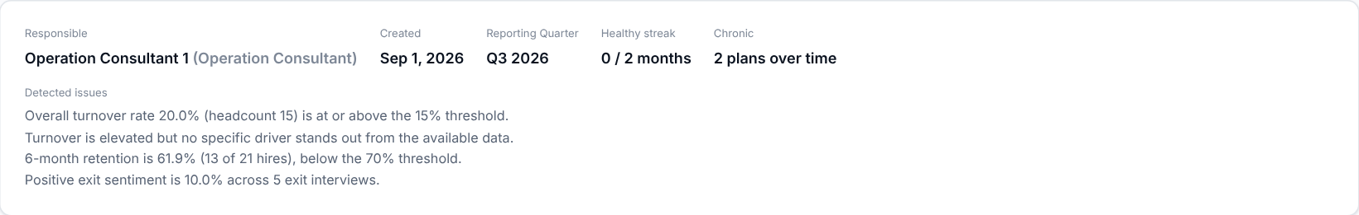
The responsible person, when the plan was created and its reporting quarter, the healthy streak (months without signals), whether it is chronic, and the plain-language explanation of exactly what was detected and why the store was flagged. Admins can assign the plan to a name and set the target resolution date; everyone else sees the same assignment read-only.
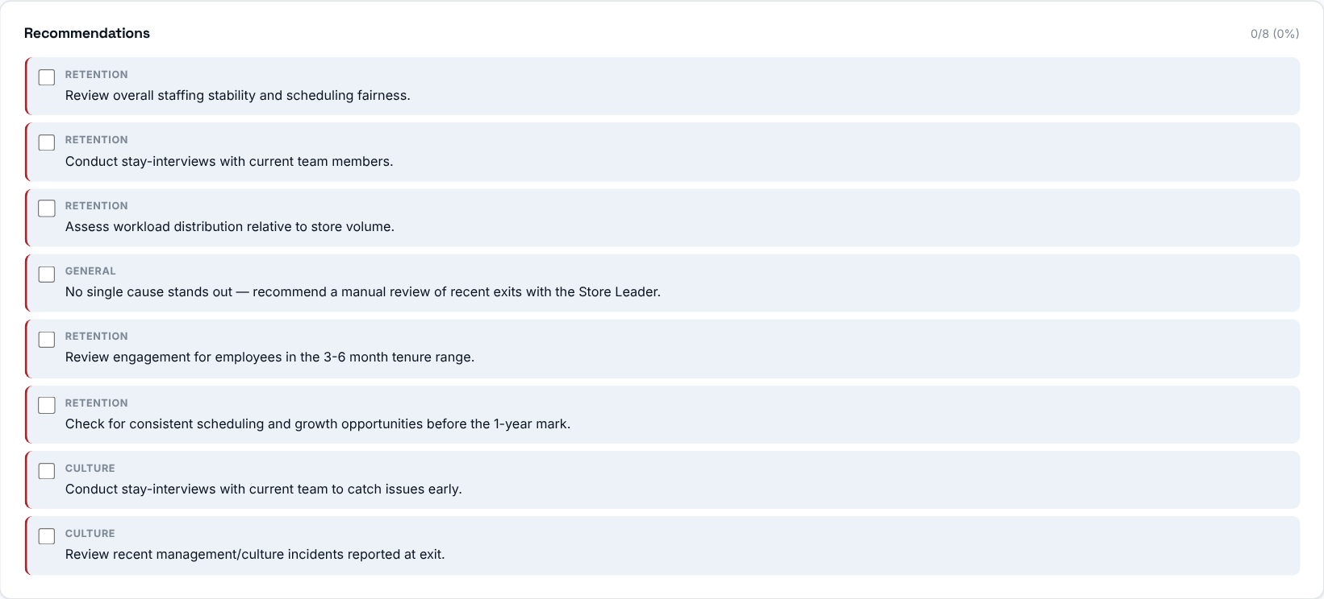
Suggested actions for this store's specific issues, grouped by theme (for example Retention or Culture). They can be checked off as they are completed, and the progress is shown at the top.
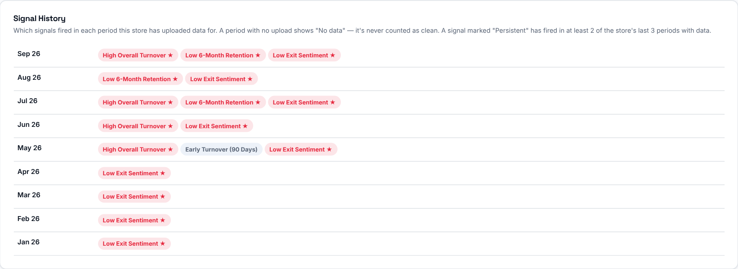
Which detection signals fired in each period, so you can see whether the problem is persistent or recent.
A running log of follow-up notes on the plan: who wrote each one, when, and their role. Admins can also close a plan manually, with a required reason, once the underlying issue has been addressed.

