Comparisons
Where to find it: Side menu > Comparisons
Use this page to see whether things got better or worse. It compares two periods side by side, Period A and Period B, each with its own independent filters. Every card, chart and table shows both periods together plus the change between them.

Step 1 - Choose the two periods
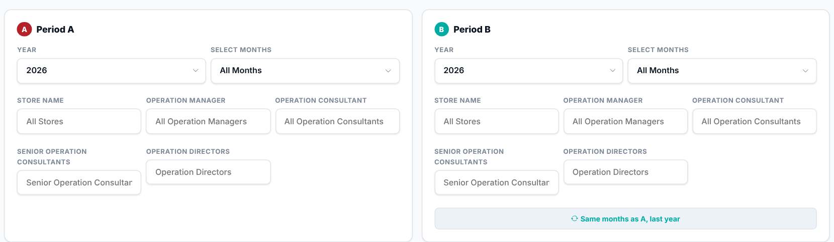
Period A and Period B each have their own year, months, store, Operation Manager, Operation Consultant, Senior Operation Consultant and Operation Director filters - they do not have to match. The "Same months as A, last year" button fills Period B with the same filters as Period A but one year earlier, which is the quickest way to compare year over year.

Step 2 - Read the Smart Insights
Automatic sentences that summarise how Period A compares with Period B for your current filters.

Step 3 - Compare the headline numbers
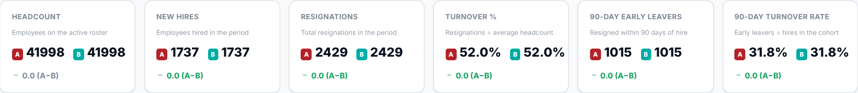
Headcount, New Hires, Resignations, Turnover Rate, Early Leavers and 90-Day Rate for Period A and Period B side by side, each with the change between them and whether that change is an improvement or not.
What to look at: the Turnover Rate and 90-Day Rate changes first - they tell you immediately whether retention improved.

Step 4 - Which stores got better or worse?
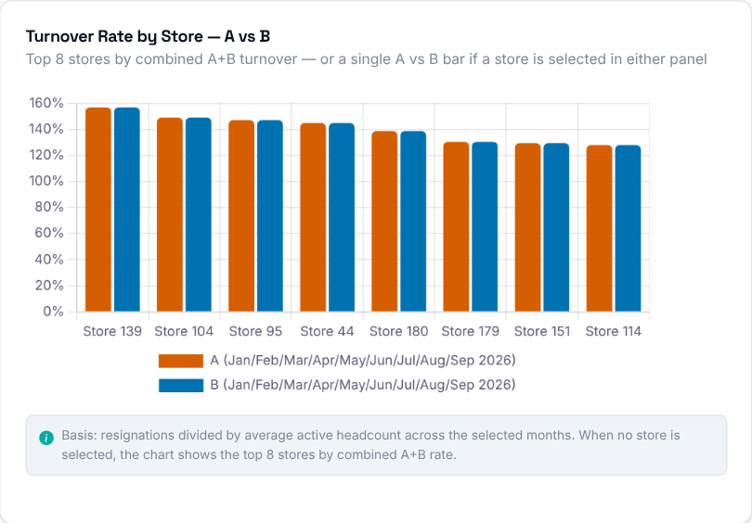  Turnover Rate per store for Period A vs Period B, as paired bars. When no store is selected, the chart shows the top 8 stores by combined A+B rate. | 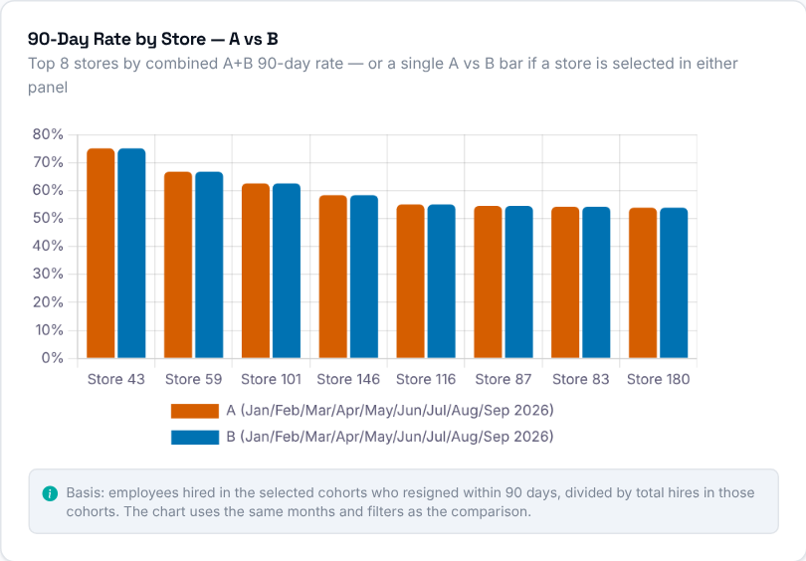  90-Day Rate per store for Period A vs Period B, as paired bars, using the same months and filters as the comparison.  Then decide: stores where the Period B bar is much higher than Period A need a conversation with their Operation Consultant.

Step 5 - Headcount and resignations
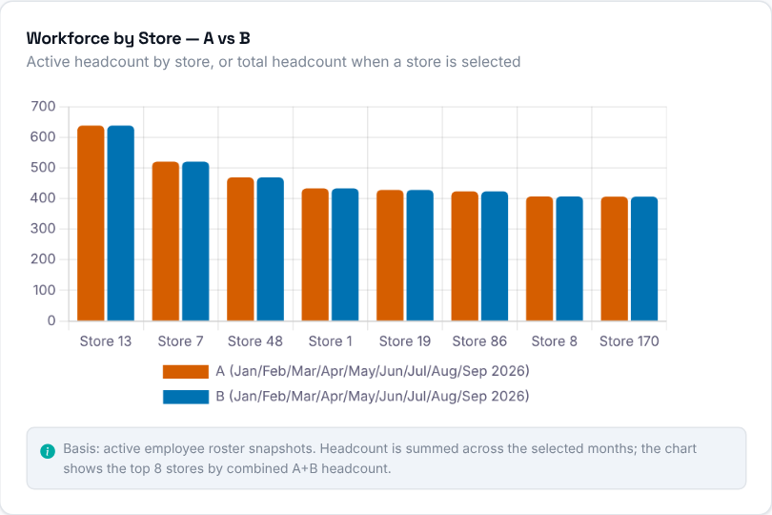  Active headcount per store for Period A vs Period B, as paired bars - or the total headcount for both periods when a single store is selected. | 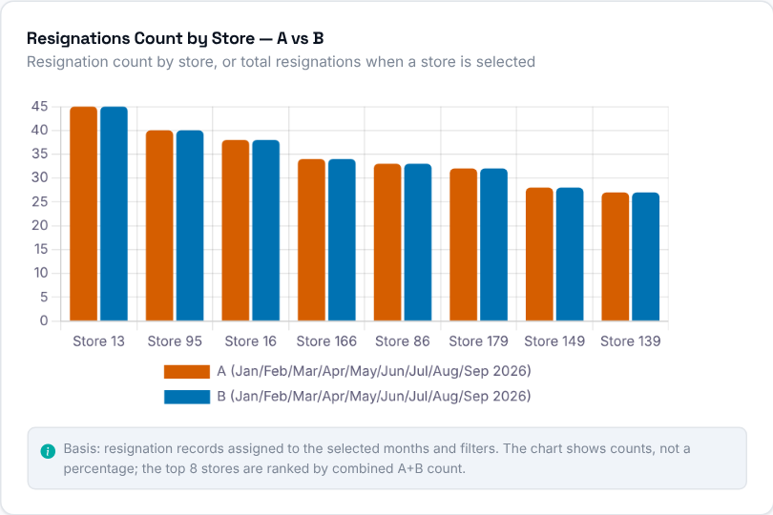  Resignation count per store for Period A vs Period B. It shows counts, not a percentage.

Step 6 - Are people staying longer?
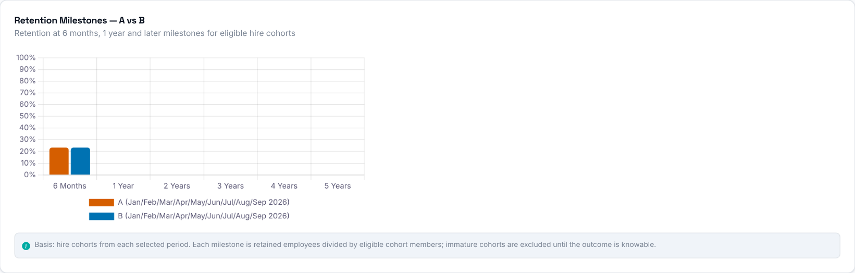
Retention rate at the 6-month, 1-year and later milestones for Period A vs Period B, for hire cohorts old enough to be eligible at each milestone.

Step 7 - Why are people leaving?
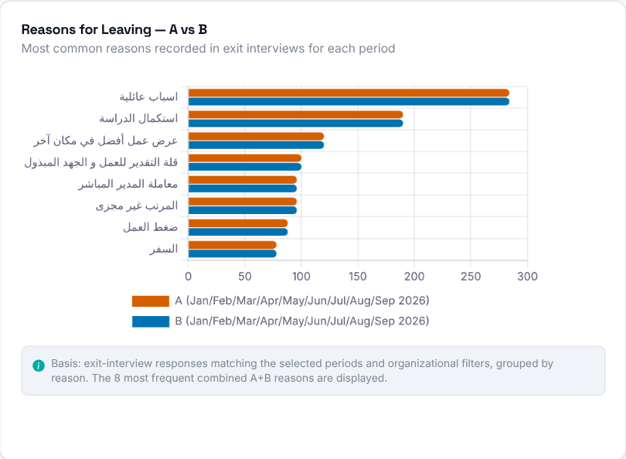  The most common reasons recorded in exit interviews, Period A vs Period B, so you can see whether the same reasons dominate or the mix shifted. | 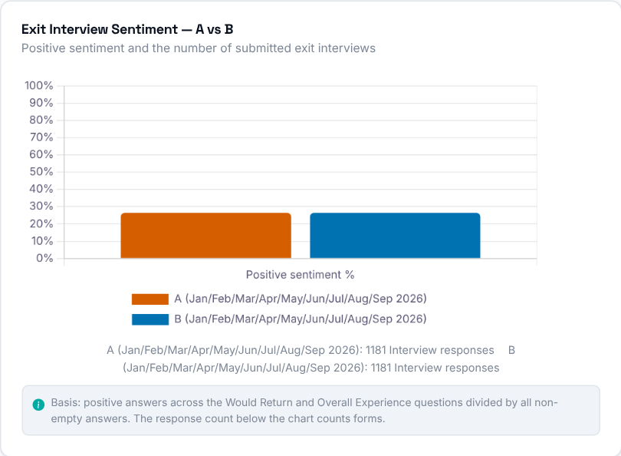  Positive exit-interview sentiment and how many interviews were submitted, Period A vs Period B.

Step 8 - Store by store
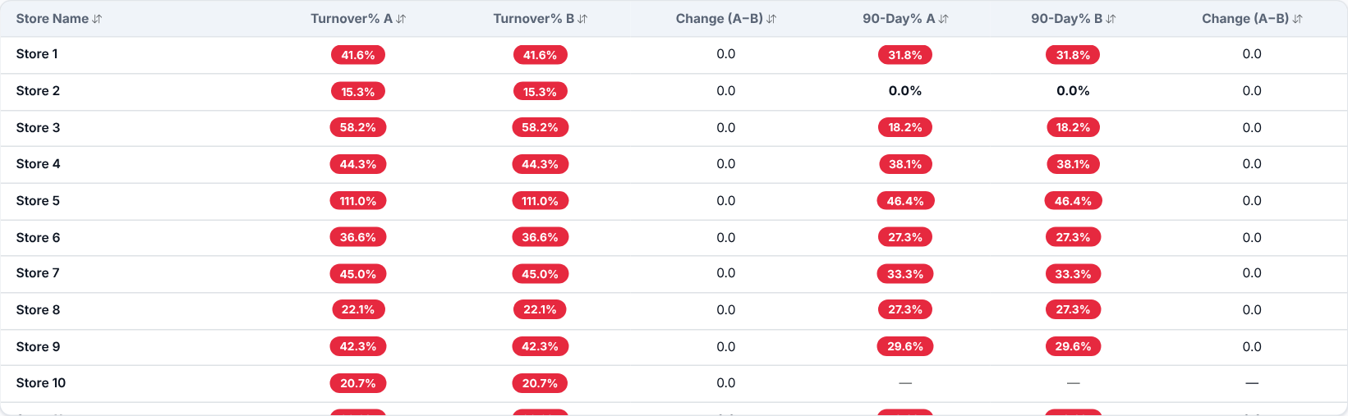
Every store with its Turnover Rate and 90-Day Rate in both periods, plus the change between them. It is shown when both periods use "All Stores". Click a column header to sort.

