Action Plan Guide
Where to find it: Side menu > Action Center > Action Plan Guide
This is the portal's own reference page. It explains, in plain business language, how the Action Center works end to end: how every store's Store Health Index is computed from six weighted pillars, how the specific root cause behind each pillar is surfaced (including the real exit-interview drivers rather than a vague "culture" label), how a formal Action Plan is triggered and tracked, and how a weighted, evidence-linked action plan is generated and eventually closed. It is read-only and does not change any data or settings.

What is on the page
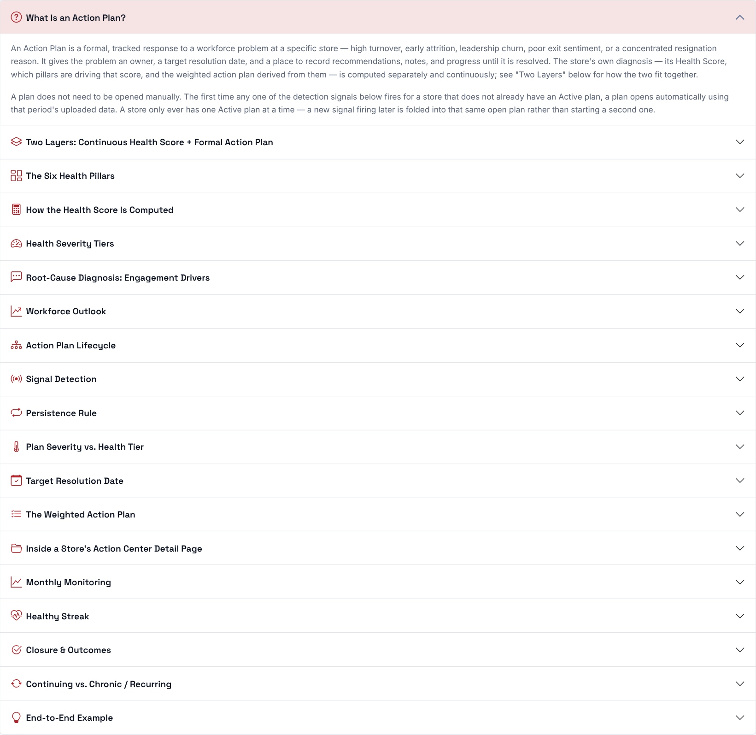
The page is a list of sections. Click a section title to open it, and click it again to close it.
Section | What it explains
What Is an Action Plan? | What a formal Action Plan is.
Two Layers: Continuous Health Score + Formal Action Plan | The difference between the health score every store always has, and the formal plan that opens only when a signal fires.
The Six Health Pillars | The six pillars behind the Store Health Index and their weights.
How the Health Score Is Computed | How each pillar is compared with the company average and combined into a 0-100 score.
Health Severity Tiers | The tiers a health score falls into (Critical, High, Medium, Low, Healthy).
Root-Cause Diagnosis: Engagement Drivers | How the exit-interview drivers behind the engagement pillar are surfaced.
Workforce Outlook | How the number of high-risk employees and a store being below its projected headcount feed the health score.
Action Plan Lifecycle | The stages a plan goes through, from signal to closure.
Signal Detection and Persistence Rule | The 7 signals that can open a plan, and when a signal counts as persistent.
Plan Severity vs. Health Tier | Why a plan's severity and a store's health tier are two different things.
Target Resolution Date | How the target date is set (90 days, or 30 days if the plan is already Critical).
The Weighted Action Plan | How concrete actions are ranked by impact.
Inside a Store's Action Center Detail Page | What you will find when you open a store.
Monthly Monitoring, Healthy Streak, Closure & Outcomes | How a plan is tracked, and how and when it closes.
Continuing vs. Chronic / Recurring | How repeated plans are labelled.
End-to-End Example | A worked example from signal to closure.

Then decide: read "What Is an Action Plan?" and "The Six Health Pillars" first, then use the rest as a reference whenever a number on the Action Center page raises a question.

