Q-CLASH PRO: REAL-TIME MULTIPLAYER QUIZ ARENA
Production-Ready Kahoot Clone — Technical Project Report
Hackathon 2.0 @ SJEC
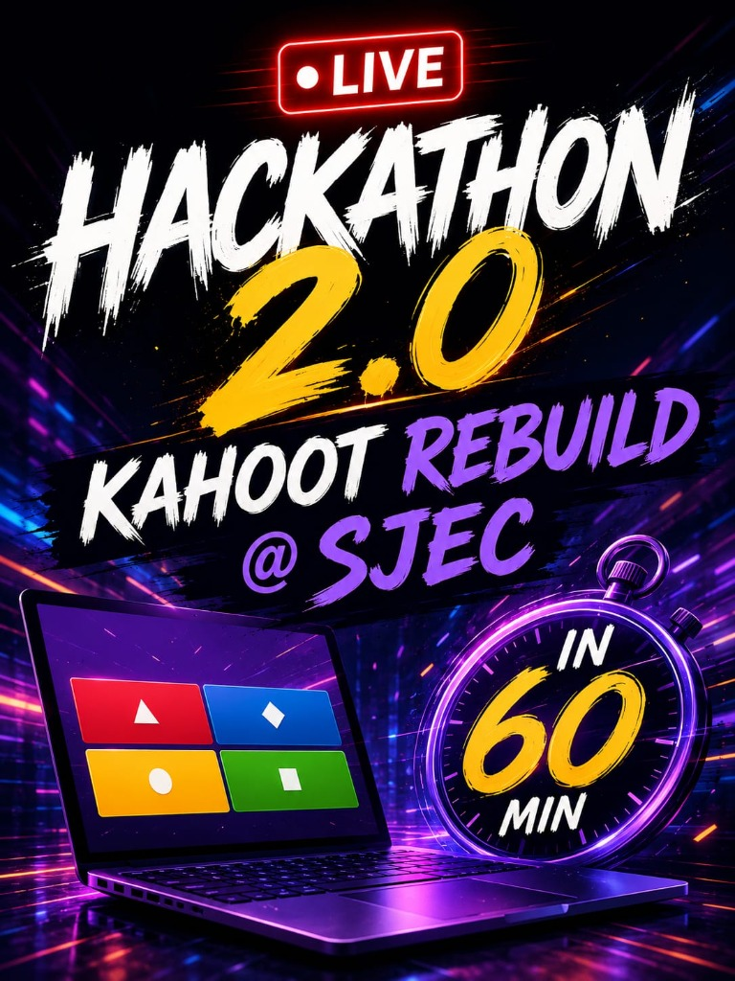

1. Abstract
Q-Clash Pro is a production-ready clone of Kahoot providing real-time multiplayer quizzes. Engineered during the 60-minute Hackathon 2.0 @ SJEC, the platform enables hosts to conduct live, synchronized quiz battles. Players join using a unique game PIN from different computers or mobile devices without needing app installation or login. The system utilizes WebSockets (Socket.IO) for instant score updates, live leaderboards, timers, and synchronized gameplay across all connected devices.
2. Problem Statement & Solution
Traditional quiz and assessment tools suffer from latency lag, complex sign-up hurdles for participants, and rigid question structures. Q-Clash Pro solves these issues by establishing a full-duplex WebSocket architecture (Socket.IO) emitting state updates in <15ms. It offers zero-installation mobile join via room PIN, scannable QR codes, or auto-filling shareable URLs (supporting local network IP 10.173.101.180 and public Pinggy/Ngrok tunnels).
3. Introduction & Key Objectives
The application replicates the complete Kahoot experience using modern web technologies, providing a fast, interactive, and responsive platform. It includes host authentication, quiz management, live hosting, detailed game reports, search functionality, and a fully responsive UI that works seamlessly across desktops, laptops, tablets, and mobile devices.
Key Objectives:
• Build a real-time multiplayer quiz platform.
• Support cross-device gameplay using game PIN and shareable URL links.
• Provide live leaderboard rankings and Top 3/5 podium finale.
• Preload 12 default quiz topics with 15 questions per topic (180 total questions).
• Deliver responsive, scalable event-driven architecture.
4. Key Features
Host Dashboard & Library: Manage, edit, delete, duplicate, import/export JSON quizzes.
12 Preloaded Default Topics: 180 questions spanning Science, Technology, Geography, History, Movies, Gaming, Music, Sports, Food, Logic, Wildlife, and Automotive.
10 Question Formats: Multiple Choice, Multi-Select, True/False, Poll, Type Answer, Ordering Puzzle, Slider Guess, and Fill in Blanks.
Web Audio Synthesizer: Native browser Web Audio API generating click FX, timer ticks, correct chimes, wrong buzzes, and victory fanfare.
Host Game Controls: Live response bar chart distribution, pause/resume, extend timer (+10s), skip question, kick player, and lock lobby.
Participant Link Sharing: Shareable URL generator supporting local network IP and public tunnel domains.
5. Technology Stack
Layer | Technology Used
Frontend Core | React 18, Vite 5, Lucide Icons, Framer Motion, Canvas Confetti
Backend Core | Node.js v22, Express 4, Socket.IO 4.8, CORS
Real-Time Transport | WebSockets & HTTP Long-Polling
Audio & QR Engine | Native Web Audio API & Custom Canvas QR Generator
Styling & Design System | Vanilla CSS + Tailwind CSS (Glassmorphism, Dark Mode)

6. Algorithm & Time Complexity Analysis
The platform is engineered for linear scalability during live gaming sessions:
Room Lookup: O(1) - Hash Map indexing retrieves room state instantly by 4-letter PIN.
Answer Evaluation: O(1) - Answer correctness and speed bonus (0-1000 pts) computed in constant time.
Leaderboard Ranking: O(N log N) - Participant rankings sorted after each question (where N is player count).
State Broadcast: O(1) - Broadcasting state updates to connected sockets via Socket.IO room channels.
7. System Workflow & Database Design
System Workflow:
1. Host starts session -> Backend generates 4-letter PIN -> Room enters LOBBY state.
2. Players open link/PIN -> Socket joins room channel -> Roster updates live.
3. Host clicks START GAME -> State becomes QUESTION -> Timer ticks across all screens.
4. Timer expires / All submit -> State becomes REVEAL -> Correct answer & bar distribution shown.
5. Host advances -> State becomes LEADERBOARD -> Standings table updates.
6. All questions complete -> State becomes FINISHED -> Top 3 Podium & CSV/PDF export enabled.
In-Memory Database Entities:
• Users (userId, name, email, password, role)
• Quizzes (quizId, title, category, coverColor, questions)
• Questions (questionId, type, question, options, correctAnswer, timeLimit, points)
• GameSessions (roomCode, hostSocketId, quiz, state, currentQuestionIndex, isLocked)
• Participants (playerId, nickname, score, streak, connected)
8. Verification & Testing Matrix
Test Scenario | Expected Result | Status
Join with Valid PIN | Player joins room lobby instantly | PASS
Auto-Fill URL Join | Room code pre-filled from ?room=CODE parameter | PASS
Real-Time Answer Submit | Host response bar chart updates live | PASS
Timer Expiration & Reveal | Correct answer highlighted with sound FX | PASS
Leaderboard & Finale Podium | Scores sort correctly; podium displays top winners | PASS

9. Source Code Highlights
Server Entry & Socket Room Engine (server/index.js)
import express from 'express';
import { createServer } from 'http';
import { Server } from 'socket.io';
import cors from 'cors';
import { roomManager } from './rooms.js';
import { quizStore } from './quizStore.js';
const app = express();
app.use(cors({ origin: '*' }));
app.use(express.json());
const httpServer = createServer(app);
const io = new Server(httpServer, { cors: { origin: '*' } });
function broadcastRoomState(roomCode) {
const room = roomManager.getRoom(roomCode);
if (!room) return;
io.to(`host:${room.code}`).emit('room-state-update', roomManager.getHostState(roomCode));
io.to(`room:${room.code}`).emit('player-room-update', roomManager.getPlayerState(roomCode));
}
io.on('connection', (socket) => {
socket.on('room:create', ({ quizId, quiz: clientQuiz }, callback) => {
const quiz = (quizId ? quizStore.getById(quizId) : null) || clientQuiz;
const room = roomManager.createRoom(socket.id, quiz);
socket.join(`host:${room.code}`);
callback({ success: true, roomCode: room.code });
broadcastRoomState(room.code);
});
socket.on('room:join', ({ roomCode, nickname }, callback) => {
const { room, player } = roomManager.joinRoom(roomCode, nickname, socket.id);
socket.join(`room:${room.code}`);
callback({ success: true, playerKey: player.id, nickname: player.nickname, roomCode: room.code });
broadcastRoomState(room.code);
});
});
httpServer.listen(3001, '0.0.0.0', () => console.log('Server live on port 3001'));

Dynamic Scoring & Speed Bonus Engine (server/scoring.js)
export function evaluateAnswer(question, playerAnswer, timeSpentMs, timeLimitSec) {
if (playerAnswer === null || playerAnswer === undefined) return { isCorrect: false, scoreEarned: 0 };
let isCorrect = false;
const basePoints = question.points || 1000;
if (question.type === 'multiple_choice' || question.type === 'true_false') {
isCorrect = Number(playerAnswer) === Number(question.correctAnswer);
}
if (!isCorrect) return { isCorrect: false, scoreEarned: 0 };
const totalTimeMs = (timeLimitSec || 20) * 1000;
const ratio = Math.max(0, Math.min(1, timeSpentMs / totalTimeMs));
const speedBonus = Math.round(basePoints * (1 - ratio));
return { isCorrect: true, scoreEarned: basePoints + speedBonus };
}

10. Output Screenshots
Figure 1: Q-Clash Pro Landing Page & Multiplayer Arena Hero
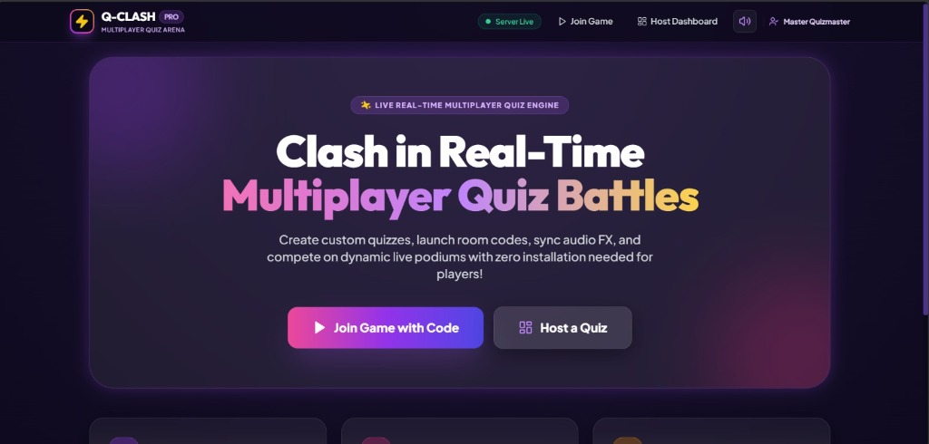
Figure 2: Host Quiz Library (12 Default Topics Preloaded)
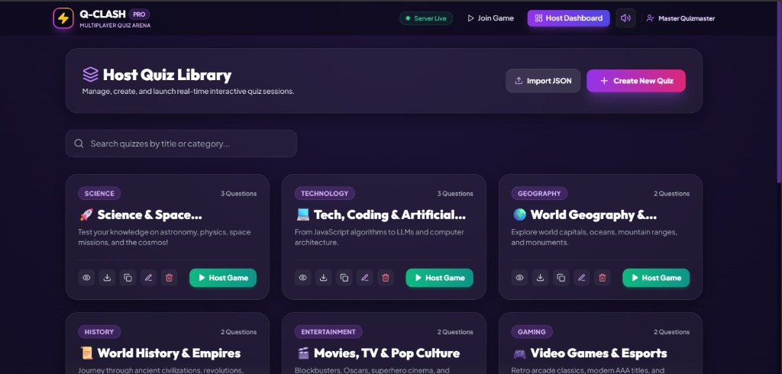
Figure 3: Active Host Room Lobby (PIN & Shareable Join Link)
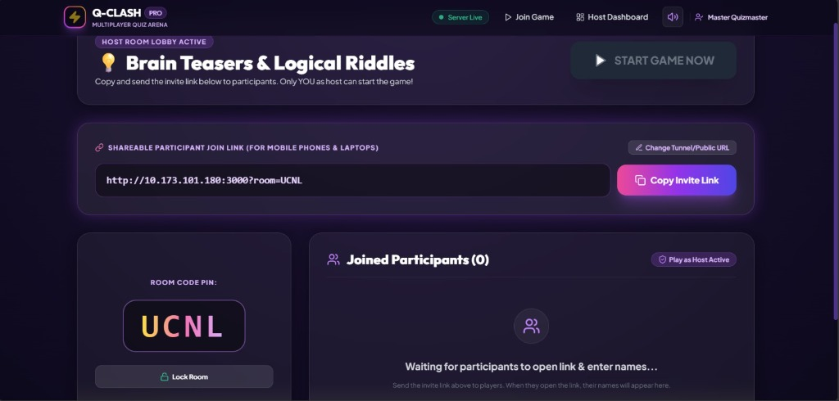
Figure 4: Live Question Screen with Countdown Timer
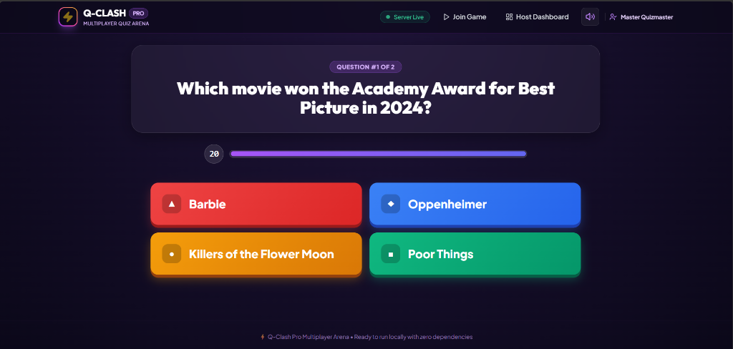
Figure 5: Live Player Scoreboard & Standings View
