# 1. Implement below Program using Java Concepts

# a. Create a class name as ReadAnWriteDate

# b. Read the data from Excel Sheet (Use Apache POI) and should have below columns and should contain data

# Name, Courses, Fee

# Kirk, Java, $100

# Dan, Python, $100

# c. Use Collections concept to store the reading data and display it in console.

Path : /comprehensive_1/src/test/java/org/lUS/comprehensive_1/Assinment_1.java

**public** **class** Assinment_1 {

**public** **static** **void** main(String[] args) **throws** IOException {

// **TODO** Auto-generated method stub

**try**

{

ArrayList data =**new** ArrayList();

FileInputStream file = **new** FileInputStream("src\\main\\java\\Assignment1.xlsx");

XSSFWorkbook wb = **new** XSSFWorkbook(file);

XSSFSheet ws = wb.getSheetAt(0);

Iterator<Row> rowIterator = ws.iterator();

**while** (rowIterator.hasNext())

{

Row row = rowIterator.next();

Iterator<Cell> cellIterator = row.cellIterator();

**while** (cellIterator.hasNext())

{

Cell cell = cellIterator.next();

**switch** (cell.getCellType())

{

**case** ***NUMERIC***:

System.***out***.print(cell.getNumericCellValue()+"\t");

data.add(cell.getNumericCellValue());

**break**;

**case** ***STRING***:

System.***out***.print(cell.getStringCellValue()+ "\t");

data.add(cell.getStringCellValue());

**break**;

}

}

System.***out***.println();

}

System.***out***.println("Reading File Completed.");

System.***out***.print("data in List:\n" + data.get(0)+"\t"+ data.get(1)+"\t"+data.get(2)+"\n"+data.get(3)+"\t"+data.get(4)+"\t"+data.get(5)+"\n"+data.get(6)+"\t"+data.get(7)+"\t"+data.get(8));

file.close();

}

**catch** (Exception ex)

{

ex.printStackTrace();

}

}

# 2. Implement below program using Python.

# a. Create a class Name as ReadAndWriteData

# b. Read the Data from CSV File and should have below three Columns and should contain data

# Name, SkillSet, Experience

# Kirk, Java, 10 Years

# Dan, Python, 5 Years

# c. Build a Data Structure to display the data, which contains in CSV Fil

Path: /comprehensive_1/src/test/java/org/lUS/comprehensive_1/ReadAndWriteData.py

import csv

class ReadAndWriteData:

with open('Python_Assignment2.csv', 'r') as file:

reader = csv.reader(file)

data = list(reader)

print(data)

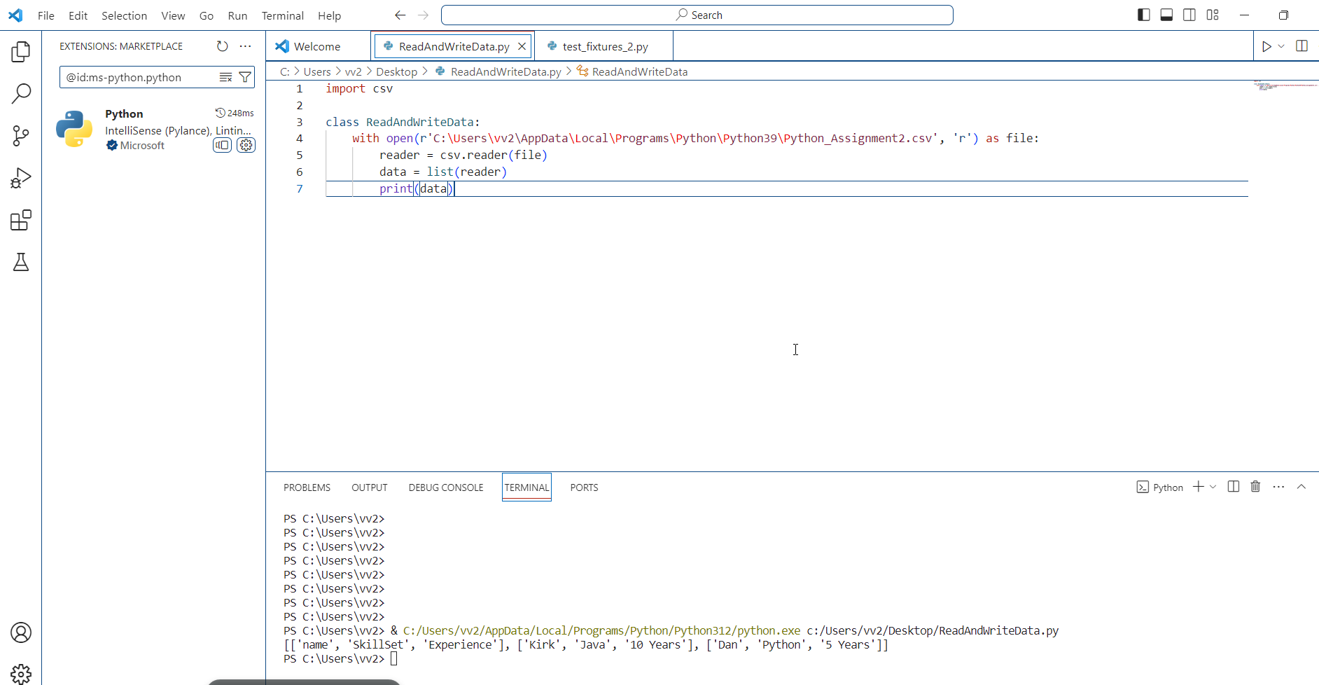

# 3. Launch a below browser in Chrome and verify below conditions using Selenium (Use XPaths to Identify Web Elements) with Java https://www.automationanywhere.com/

# a. Automation Anywhere logo should be present

# b. Verify Request demo button is present and verify if it is clickable or not

path: /comprehensive_1/src/test/java/org/lUS/comprehensive_1/Assignment_3.java

**public** **class** Assignment_3 {

**public** **static** **void** main(String[] args) **throws** InterruptedException {

WebDriver driver = **new** ChromeDriver();

driver.manage().window().maximize();

driver.get("https://www.automationanywhere.com/");

driver.manage().timeouts().implicitlyWait(Duration.*ofSeconds*(5));

**boolean** cookies = driver.findElement(By.*id*("onetrust-accept-btn-handler")).isDisplayed();

**if** (cookies == **true**) {

driver.findElement(By.*id*("onetrust-accept-btn-handler")).click();

}

**boolean** logName = driver

.findElement(By.*xpath*("//img[@src='/sites/default/files/images/default-images/logo-aa-new.svg']"))

.isDisplayed();

System.***out***.println("logo is present " + logName);

**boolean** requestDemo = driver

.findElement(By.*xpath*("//a[@class='coh-link coh-style-solid-orange-button btn-link']")).isDisplayed();

System.***out***.println("Request Demo button is avalilable " + requestDemo);

WebDriverWait wt = **new** WebDriverWait(driver, Duration.*ofSeconds*(6));

wt.until(ExpectedConditions

.*elementToBeClickable*(By.*xpath*("//a[@class='coh-link coh-style-solid-orange-button btn-link']")));

driver.close();

}

}

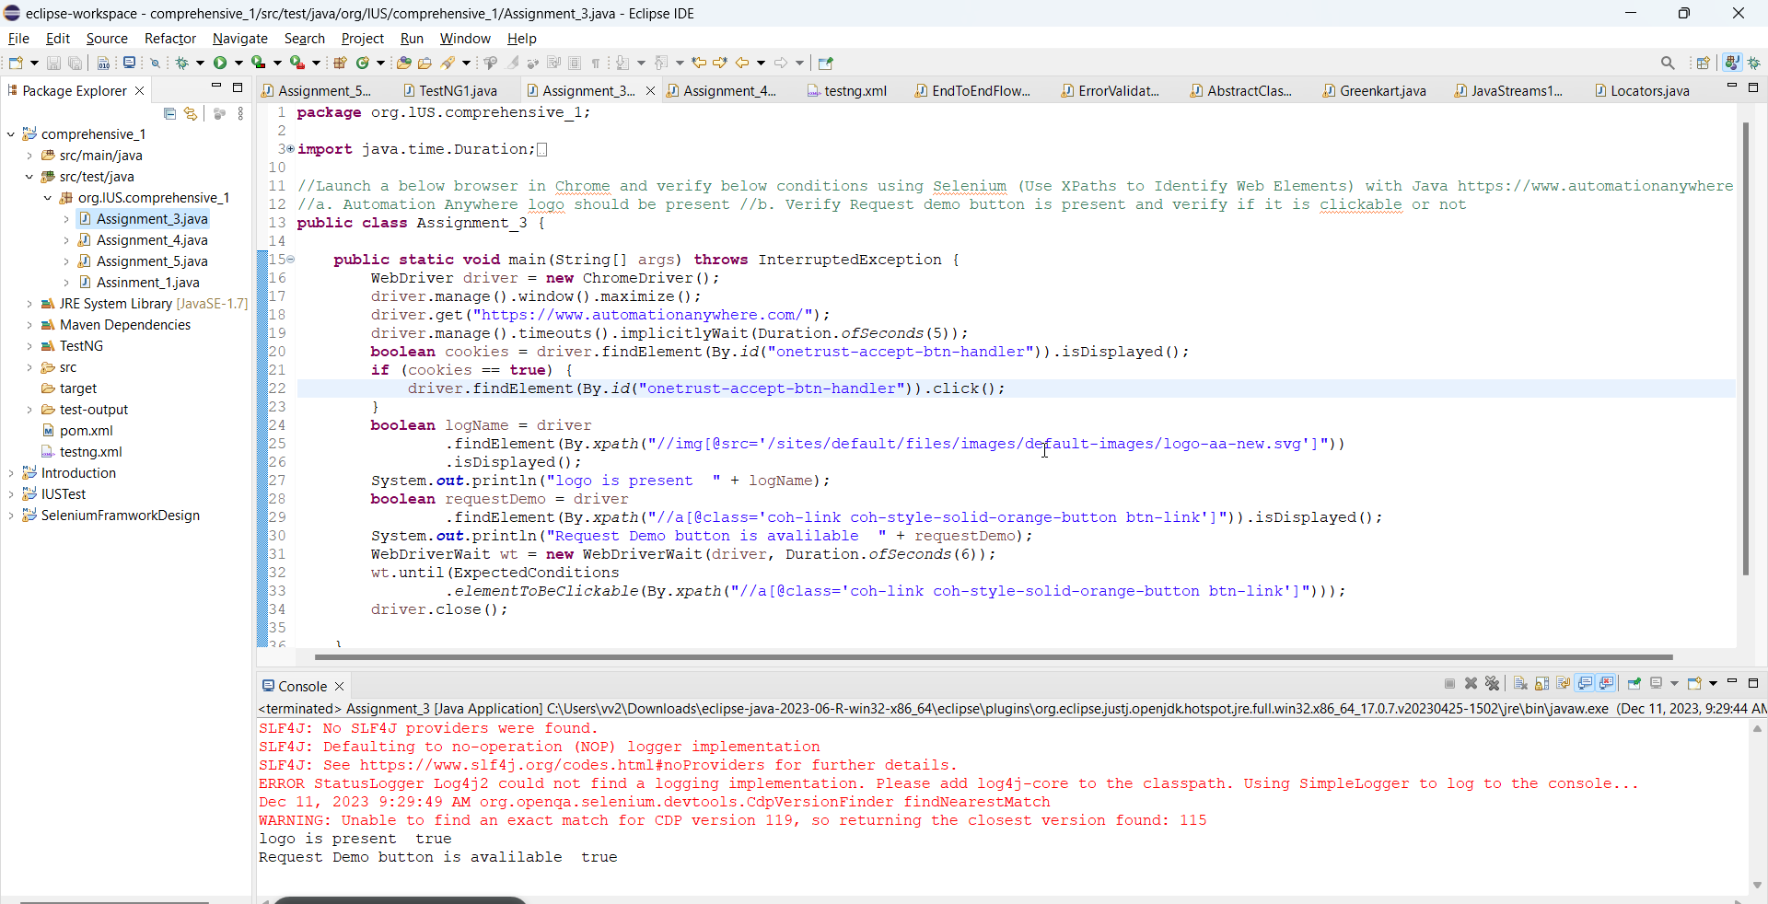

# 4. Launch a below browser in Chrome and verify below conditions using Selenium (Use XPaths to Identify Web Elements) with Java https://www.automationanywhere.com/

# Verify below list is present on home page and click on each and every link and verify that it is navigating to the proper page

# Products b. Solutions c. Resources d. Beyond RPA e. Company

Path: /comprehensive_1/src/test/java/org/lUS/comprehensive_1/Assignment_4.java

**public** **class** Assignment_4 {

**public** **static** **void** main(String[] args) **throws** InterruptedException {

WebDriver driver = **new** ChromeDriver();

driver.manage().window().maximize();

driver.manage().timeouts().implicitlyWait(Duration.*ofSeconds*(5));

driver.get("https://www.automationanywhere.com/");

**boolean** cookies = driver.findElement(By.*id*("onetrust-accept-btn-handler")).isDisplayed();

**if** (cookies == **true**) {

driver.findElement(By.*id*("onetrust-accept-btn-handler")).click();

}

**for** (**int** i = 0; i <= 4; i++) {

System.***out***.println(driver.findElements(By

.*xpath*("//ul[@class='coh-menu-list-container coh-unordered-list menu-level-1 coh-ce-646fa54d']/li"))

.get(i).getText());

// String clickOnLink = Keys.chord(Keys.CONTROL,Keys.ENTER);

driver.findElements(By

.*xpath*("//ul[@class='coh-menu-list-container coh-unordered-list menu-level-1 coh-ce-646fa54d']/li"))

.get(i).click();

System.***out***.println(driver.getTitle());

driver.navigate().back();

}

driver.close();

}

}

# 5. Implement 3 and 4 Programs using TestNG Concepts and write it using @Test annotation.

# And add TestNG Attributes – priority, enabled and timeOut to run the programs.

# Run the program with enabled attribute value as either true or false

# Run the program with timeOut Attribute values

# And run 3 and 4 Programs from TestNG.xml file and verify the generated test reports.

Path :/comprehensive_1/src/test/java/org/lUS/comprehensive_1/Assignment_5.java

XML file : /comprehensive_1/testng.xml

**public** **class** Assignment_5 {

@Test(enabled = **true**)

**public** **void** automationanywhere() **throws** InterruptedException {

WebDriver driver = **new** ChromeDriver();

driver.manage().window().maximize();

driver.manage().timeouts().implicitlyWait(Duration.*ofSeconds*(5));

driver.get("https://www.automationanywhere.com/");

**boolean** cookies = driver.findElement(By.*id*("onetrust-accept-btn-handler")).isDisplayed();

**if** (cookies == **true**) {

driver.findElement(By.*id*("onetrust-accept-btn-handler")).click();

}

**boolean** logName = driver

.findElement(By.*xpath*("//img[@src='/sites/default/files/images/default-images/logo-aa-new.svg']"))

.isDisplayed();

System.***out***.println("logo is present " + logName);

**boolean** requestDemo = driver

.findElement(By.*xpath*("//a[@class='coh-link coh-style-solid-orange-button btn-link']")).isDisplayed();

System.***out***.println("Request Demo button is avalilable " + requestDemo);

WebDriverWait wt = **new** WebDriverWait(driver, Duration.*ofSeconds*(6));

wt.until(ExpectedConditions

.*elementToBeClickable*(By.*xpath*("//a[@class='coh-link coh-style-solid-orange-button btn-link']")));

driver.close();

}

@Test(priority = 1)

**public** **void** AllLinks() **throws** InterruptedException {

WebDriver driver = **new** ChromeDriver();

driver.manage().window().maximize();

driver.manage().timeouts().implicitlyWait(Duration.*ofSeconds*(5));

driver.get("https://www.automationanywhere.com/");

**boolean** cookies = driver.findElement(By.*id*("onetrust-accept-btn-handler")).isDisplayed();

**if** (cookies == **true**) {

driver.findElement(By.*id*("onetrust-accept-btn-handler")).click();

}

**for** (**int** i = 0; i <= 4; i++) {

System.***out***.println(driver.findElements(By

.*xpath*("//ul[@class='coh-menu-list-container coh-unordered-list menu-level-1 coh-ce-646fa54d']/li"))

.get(i).getText());

// String clickOnLink = Keys.chord(Keys.CONTROL,Keys.ENTER);

driver.findElements(By

.*xpath*("//ul[@class='coh-menu-list-container coh-unordered-list menu-level-1 coh-ce-646fa54d']/li"))

.get(i).click();

System.***out***.println(driver.getTitle());

driver.navigate().back();

}

driver.close();

}

@Test(timeOut = 5000)

**public** **void** AllLinks1() **throws** InterruptedException {

WebDriver driver = **new** ChromeDriver();

driver.manage().window().maximize();

driver.manage().timeouts().implicitlyWait(Duration.*ofSeconds*(5));

driver.get("https://www.automationanywhere.com/");

**boolean** cookies = driver.findElement(By.*id*("onetrust-accept-btn-handler")).isDisplayed();

**if** (cookies == **true**) {

driver.findElement(By.*id*("onetrust-accept-btn-handler")).click();

}

**for** (**int** i = 0; i <= 4; i++) {

System.***out***.println(driver.findElements(By

.*xpath*("//ul[@class='coh-menu-list-container coh-unordered-list menu-level-1 coh-ce-646fa54d']/li"))

.get(i).getText());

// String clickOnLink = Keys.chord(Keys.CONTROL,Keys.ENTER);

driver.findElements(By

.*xpath*("//ul[@class='coh-menu-list-container coh-unordered-list menu-level-1 coh-ce-646fa54d']/li"))

.get(i).click();

System.***out***.println(driver.getTitle());

driver.navigate().back();

}

driver.close();

}

@Test(enabled = **false**)

**public** **void** automationanywhere1() **throws** InterruptedException {

WebDriver driver = **new** ChromeDriver();

driver.manage().window().maximize();

driver.manage().timeouts().implicitlyWait(Duration.*ofSeconds*(5));

driver.get("https://www.automationanywhere.com/");

**boolean** cookies = driver.findElement(By.*id*("onetrust-accept-btn-handler")).isDisplayed();

**if** (cookies == **true**) {

driver.findElement(By.*id*("onetrust-accept-btn-handler")).click();

}

**boolean** logName = driver

.findElement(By.*xpath*("//img[@src='/sites/default/files/images/default-images/logo-aa-new.svg']"))

.isDisplayed();

System.***out***.println("logo is present " + logName);

**boolean** requestDemo = driver

.findElement(By.*xpath*("//a[@class='coh-link coh-style-solid-orange-button btn-link']")).isDisplayed();

System.***out***.println("Request Demo button is avalilable " + requestDemo);

WebDriverWait wt = **new** WebDriverWait(driver, Duration.*ofSeconds*(6));

wt.until(ExpectedConditions

.*elementToBeClickable*(By.*xpath*("//a[@class='coh-link coh-style-solid-orange-button btn-link']")));

driver.close();

}

}

XML file

<?xml version="1.0" encoding="UTF-8"?>

<!DOCTYPE suite SYSTEM "https://testng.org/testng-1.0.dtd">

<suite name="Suite">

<test thread-count="5" name="Test">

<classes>

<class name="org.lUS.comprehensive_1.Assignment_5"/>

</classes>

</test> <!-- Test -->

</suite> <!-- Suite -->

## 7. Create a branch name as comprehensive_basic_2 in GitHub and implement all the above programs in that branch and push the code into the same branch. Share the GitHub details to evaluate. Write the git commands accordingly.

<https://github.com/veena988/comprehensive_basic_>2

# 8 Create a collection in Postman and create positive and negative cases for below API. And use get method to get valid responses.

# Verify the HTTP Status Codes, while running Positive and Negative Test Cases.

# To validate the HTTP Status Codes and responses use Assertions concept in PostMan <https://restcountries.com/v3.1/name/India>

Path : /comprehensive_1/src/test/java/org/lUS/comprehensive_1/Comprehensive_Assignment.postman_collection.json

# 9. Implement below steps in JMeter

# 1. Create a Test Plan

# 2. Create a Thread Group and Add Number of Threads (Count is 2)

# 3. Add HTTP Request (Use https protocol) and URL as https://www.w3schools.com/

# 4. Add HTML Assertions

# 5. Add Error Threshold as zero

# 6. Add Warning Threshold count

# 7. Run the Script

Path : /comprehensive_1/src/test/java/org/lUS/comprehensive_1/Assignment9.jmx



