Excel Driven Execution

Prerequisites :-
- Directories “Temp” and “Temp1” should be present in “TestResultLogs” folder .

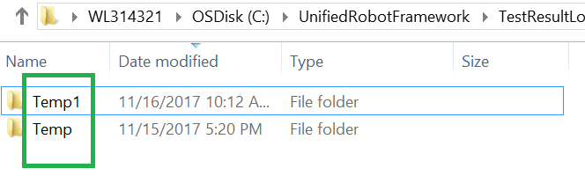

- The name of test cases should not contain spaces . ex. Use “Create_customer” instead of “Create Customer”.

- At Suite level , “Suite Setup” should have call to “Create_Log_Files” keyword .

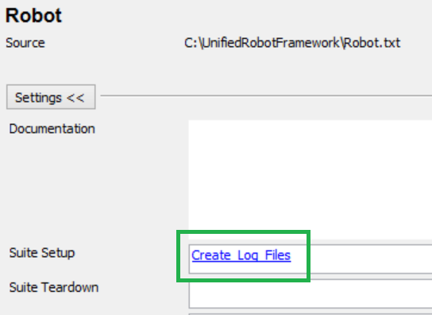

- In testcase “Excel_Driven_Execution” , “Teardown” should have call to “AfterExecutionProcessing” keyword.

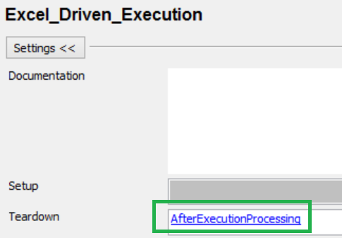
- Each test case should have call to keyword “RecordTCStatus” in Teardown .
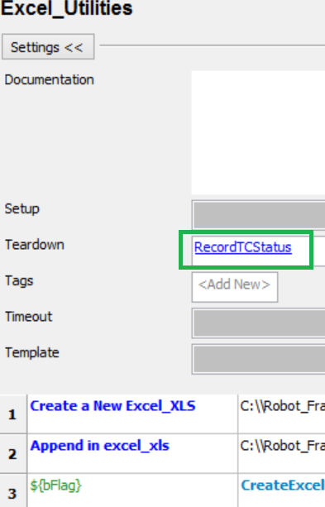

- Data should be loaded in the beginning of each testcase using “LoadTestData” keyword .

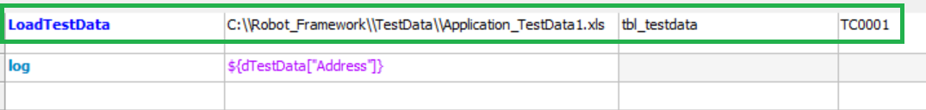

Test Execution

- Select modules for execution :-
Open module selection file. Which is kept at “C:\Robot_Framework\Layer_Test\TestConfig\Application_Modules.xlsx”
Here, we have 2 active modules, namely “A_TC_Controller” and “B_TC_Controller”.
ModuleName | ModuleDescription | Active
A_TC_Controller | Module Description Test | Yes
B_TC_Controller | Module Description Test | Yes
C_TC_Controller | Module Description Test | No
D_TC_Controller | Module Description Test | No

- Select Test cases for execution from controller file :-
We have selected some test cases from both the files.
These files are also placed in “C:\Robot_Framework\Layer_Test\TestConfig” directory.
Automation_Test_Case_Name | TCID | Active
SampleTestCase | TC0001 | Yes
Excel_Utilities | TC0002 | Yes
newtc | TC0003 | No
File_Functions | TC0004 | No

- Now, in “C:\Robot_Framework\TestData\lib_Config.py”. Set the flag for ALM updating of test cases “ALMUpdateTestCaseStatus” to “Yes/No” as per your requirement.
If setting it to “Yes”, check/update value of other ALM configuration variables (ALMPath, ALMUserName, ALMPassword, ALMDomain, ALMProject, ALMTestSetFolderPath and ALMTestSetName)

- In the above specified file, set variable “ALMAttachLogFile” to “Yes/No” .If you want to attach execution log file to ALM testset.

- If you want to create defects in Jira automatically after test execution then in the “lib_Config.py” file. Set “CreateDefectInJira” to “Yes”.

- If you want to send test result in E-mail to all the stack holders after test execution then in the “lib_Config.py” file. Set “SendLogInEmail” to “Yes”.

- Now, you are ready for execution. This can be done in 4 ways :-
    - From RIDE: - Select and run “Excel_Driven_Execution” test case.
    - From CMD :- Running “C:\Robot_Framework\Batch\RobotRegression.bat”
    - From Task Scheduler :- You can schedule “C:\Robot_Framework\Batch\RobotRegression.bat”
    - By double clicking on “C:\Robot_Framework\Batch\RobotRegression.bat”

- After execution, Go to “C:\Robot_Framework\TestResultLogs” directory and open newest directory.

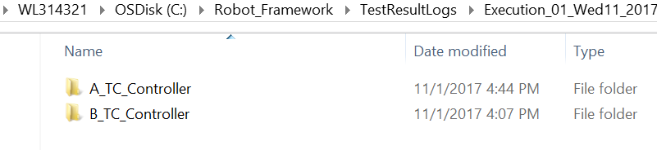

- You will find individual folder for each module. Inside this directory, you will find Log file.

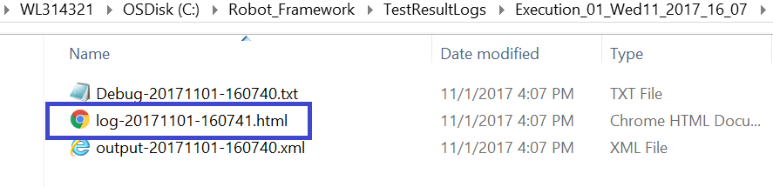

- The test result of the module can be checked in this Log file.

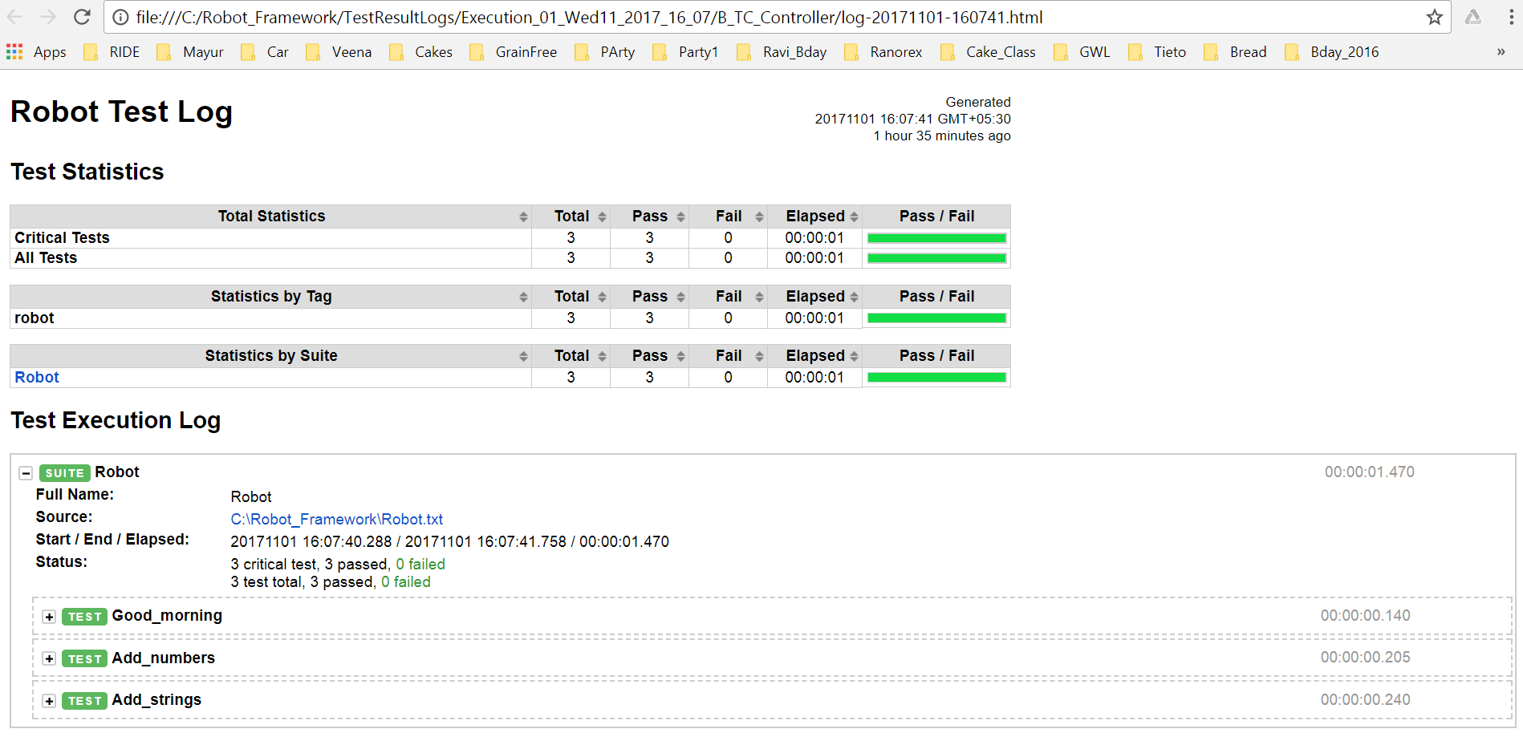

- Go to ALM and check the status of test cases.

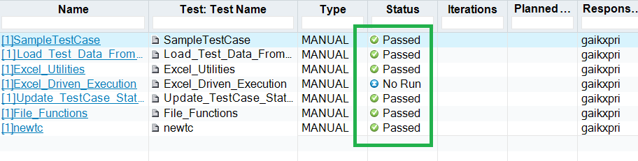

- You can also check logs from ALM :-

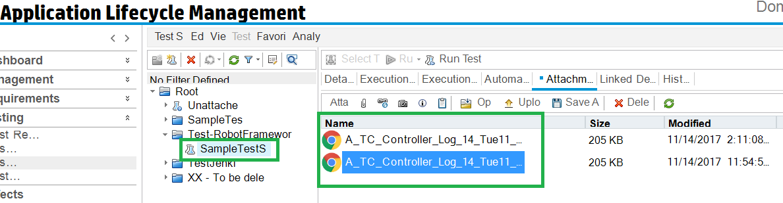

- Go to “C:\UnifiedRobotFramework\Defects” and check the latest Defect log. IT will have list of all the defects logged into Jira as well as logs for details.

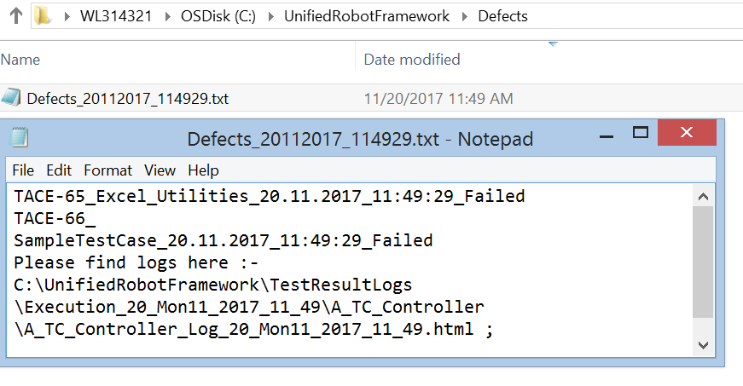

- Check your mails for result of test execution with attached log. For each module, you will be getting 1 separate Email.

